**GoogleApp play store application dataset analysis.**

# Detailed UML diagram of classes

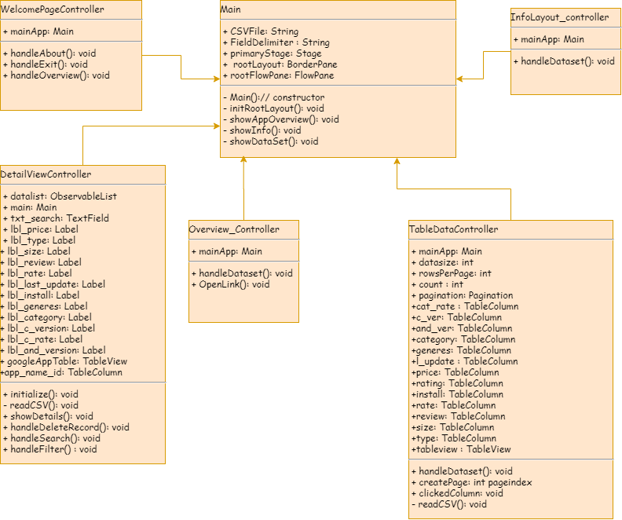

Figure 1 class diagram

Above class diagram represents the classes that I created to perform different operation. **Main** class is the master class where all controller class such as DetailViewController, WelcomePageController, InfoLayout_Controller, OverviewController and TableDataController are called.

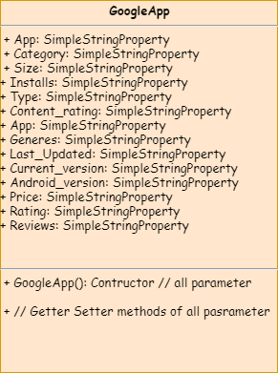

Figure 2 Model class

Fig.2 represents GoogleApp class which is Model class which store the csv file elements and data.

# Screen Shots of application

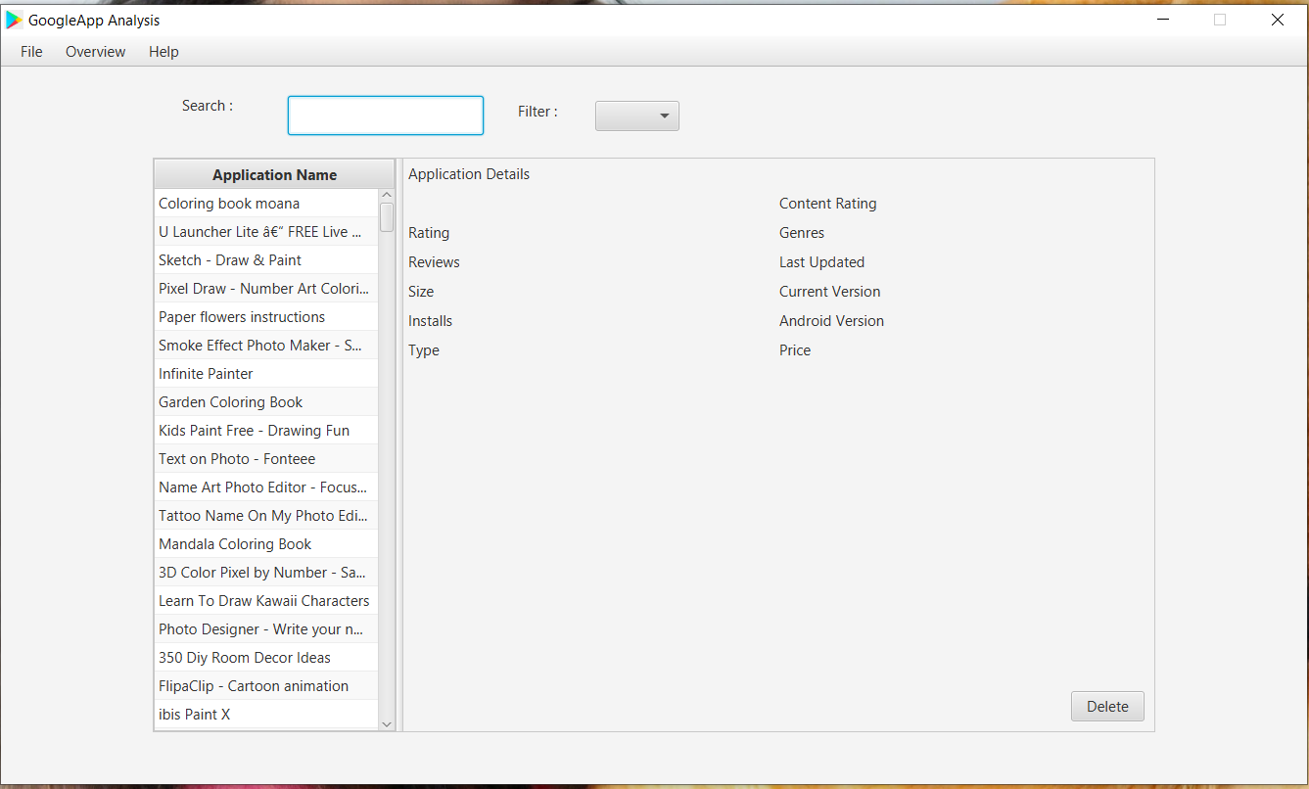

Figure Read Data from CSV file

Fig.3 shows the read csv data and load into GUI layout. Data load in to tableview.

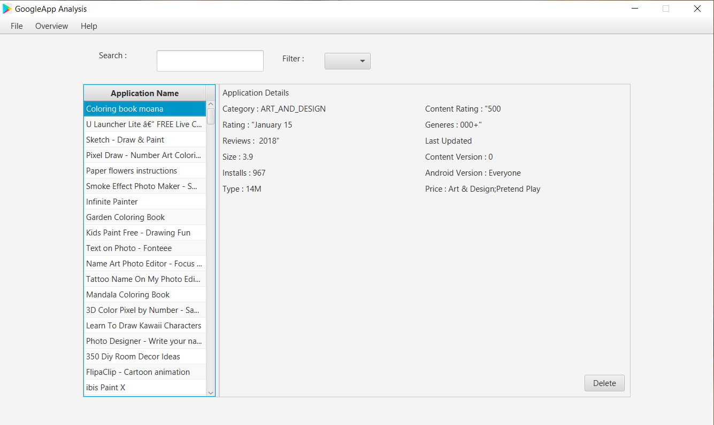

Figure Display detail of records in table view

Fig.4 display details of records. Once you click on application name it with display the detail of records.

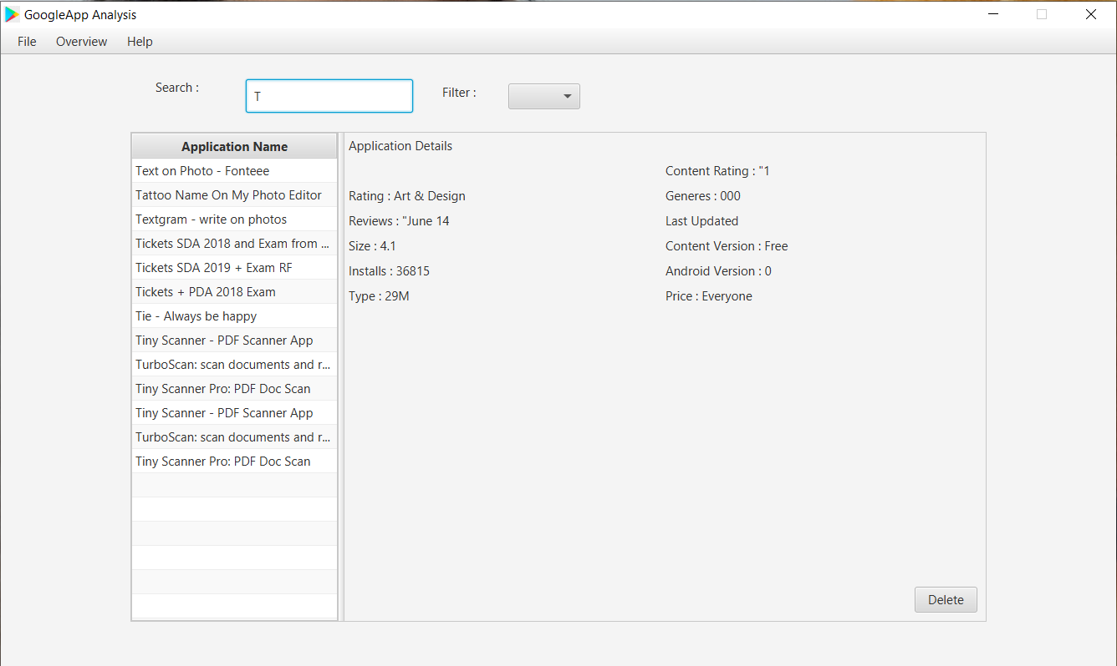

Figure Perform Search operation

Fig.5 shows the search operation. When you type letter in search textfield, it will display the result.

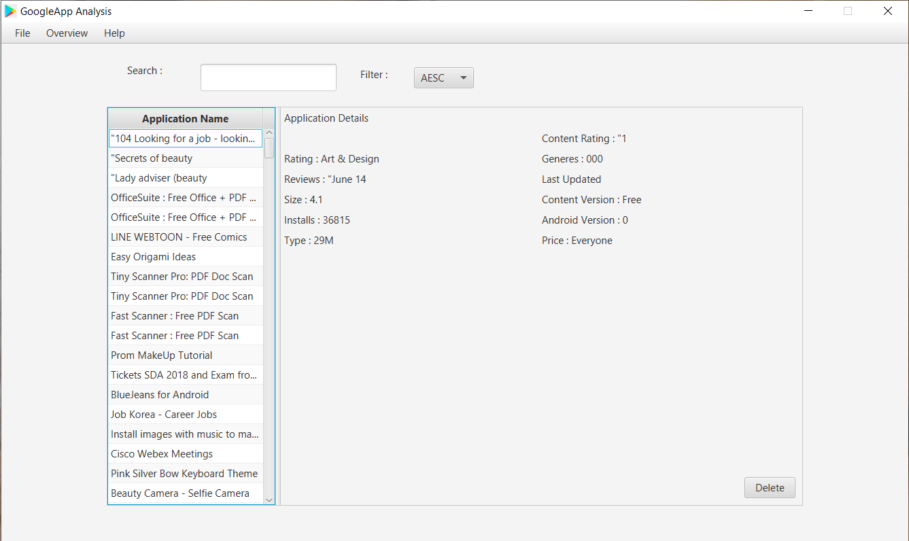

Figure Sort Records in ascending order

It shows the sorting and filtering to the records. For filer data, it has two option AESC (ascending), and DESC (Descending).

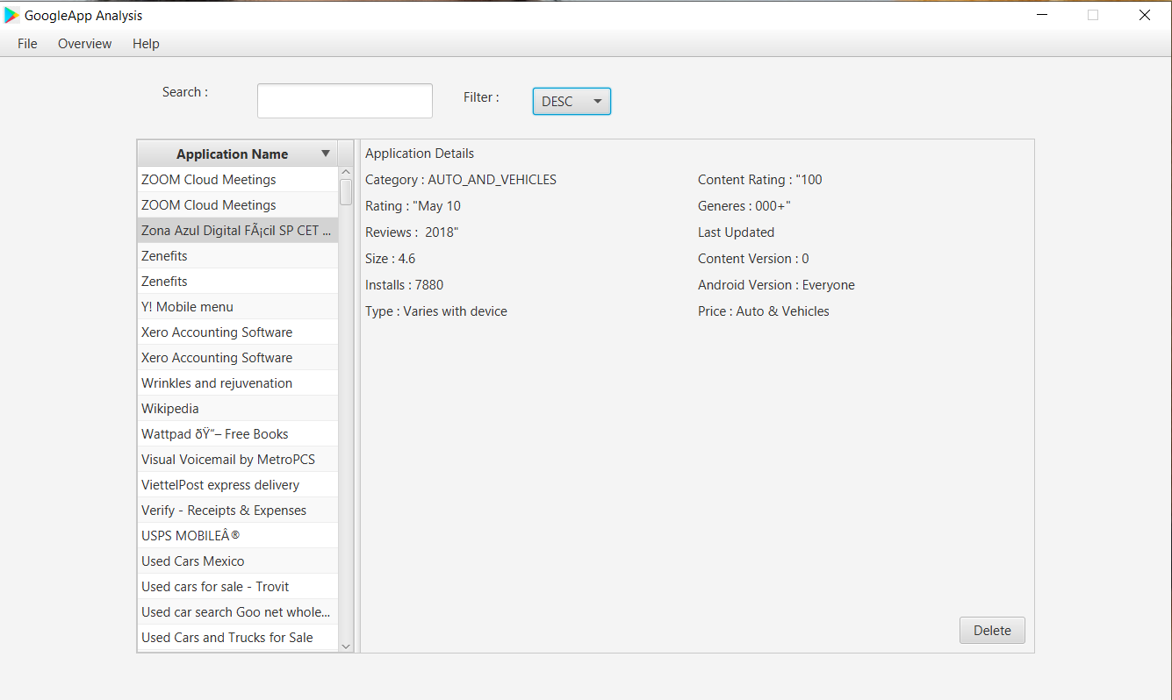

Figure Sort records in descending order

It displays data in a descending order.

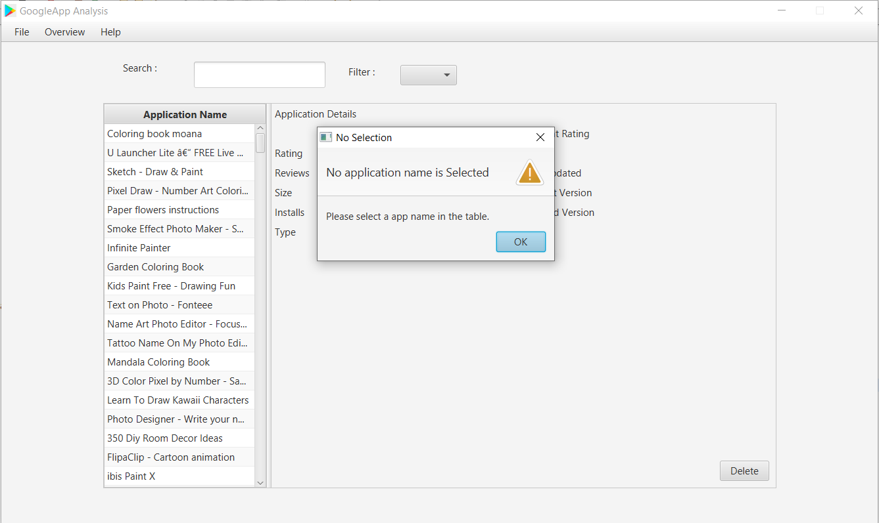

Figure Perform delete operation

Fig.8 shows the delete operation on records. However, user must need to select records that they want to delete. If they do not select, then alert dialogue box pop up on screen with the message “Please select a app name in the table”.

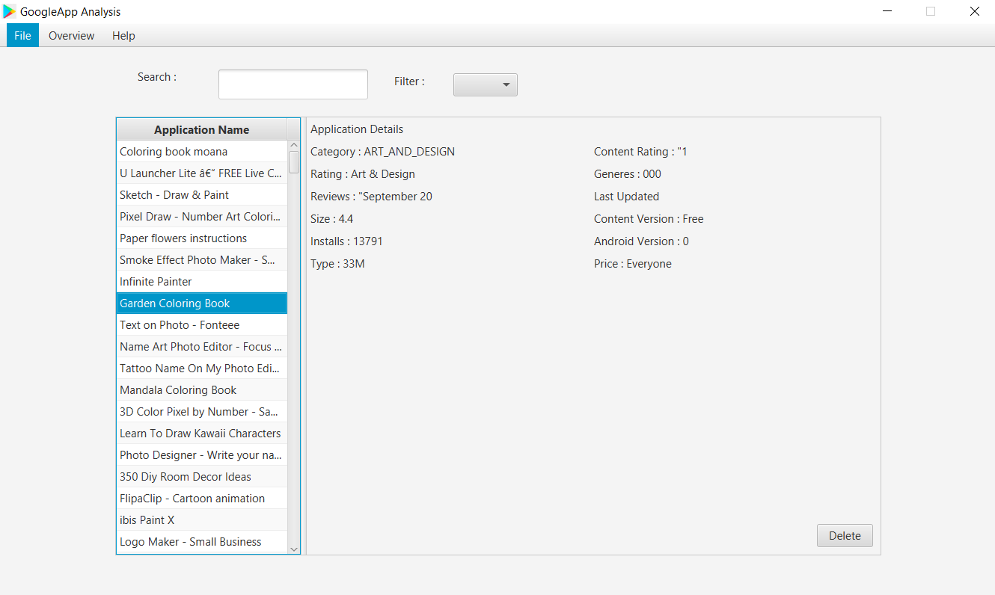

Figure Select record to perform delete operation

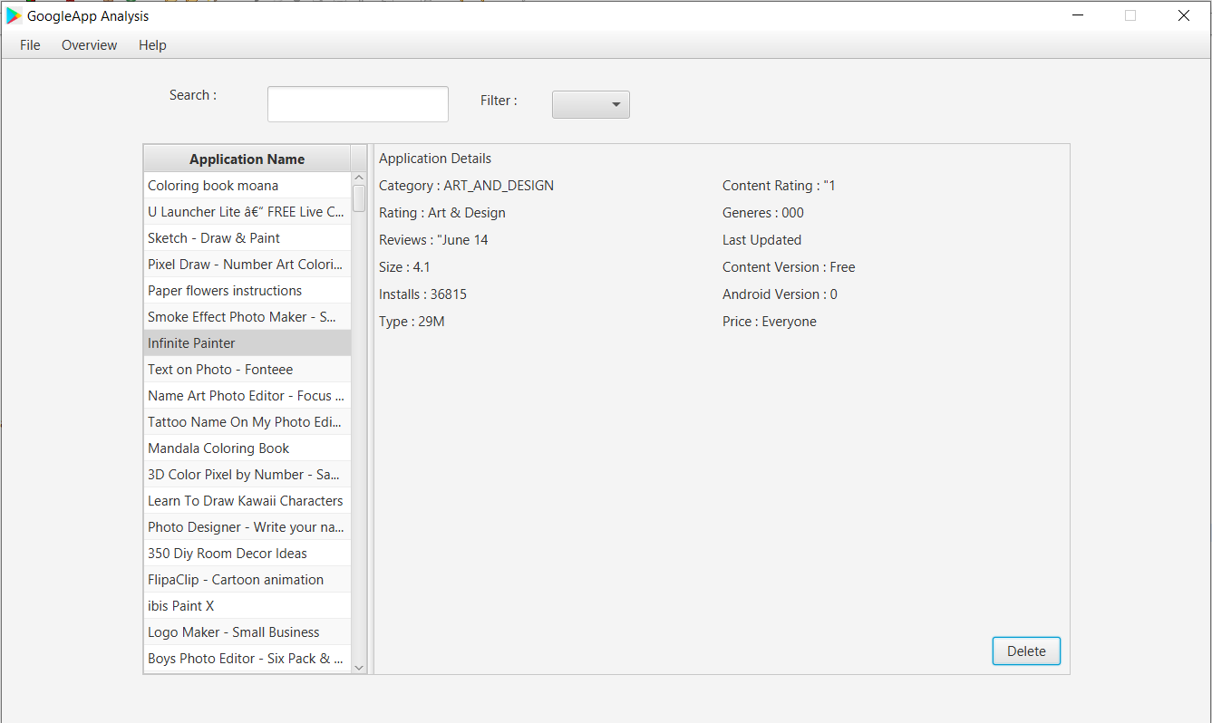

Figure Successfully delete record

Fig.9 and 10 shows the delete operation, when you select records and press delete button it will remove the records. You can see difference in this two images.

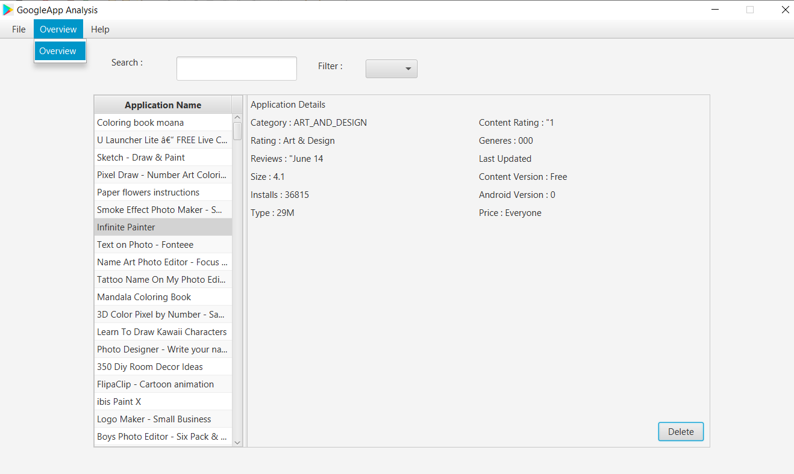

Figure Open overview menu to see details of dataset

Overview menu redirect user if they want to know information regarding dataset.

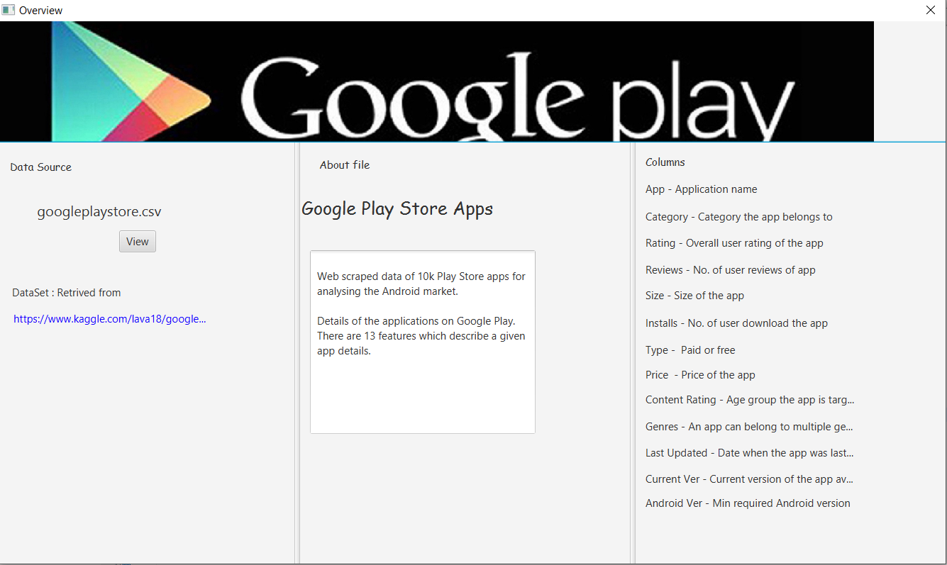

Figure Information about Data Set

Once user press on overview it displays Fig.12 window. It describes the short description about data set in the middle. On the right-hand side, it shows the different 13 features of dataset. On the left-hand side, it opens the whole document in a table format as shown in below fig.13, when click on view button.

It also provides a hyperlink to redirect on original dataset when it comes from. As you can see in below fig.14.

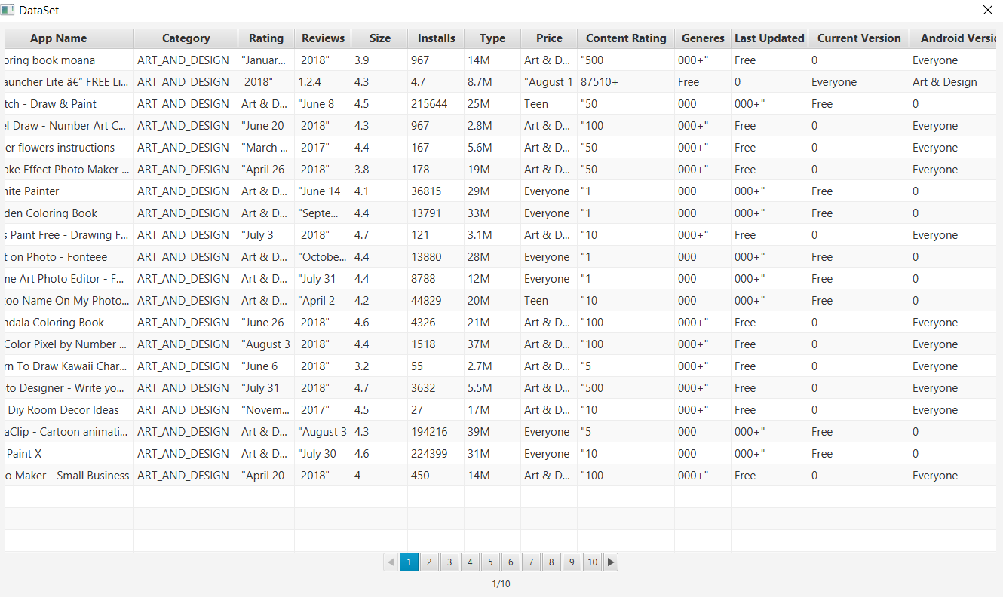

Figure Open Data on Table format with pagination

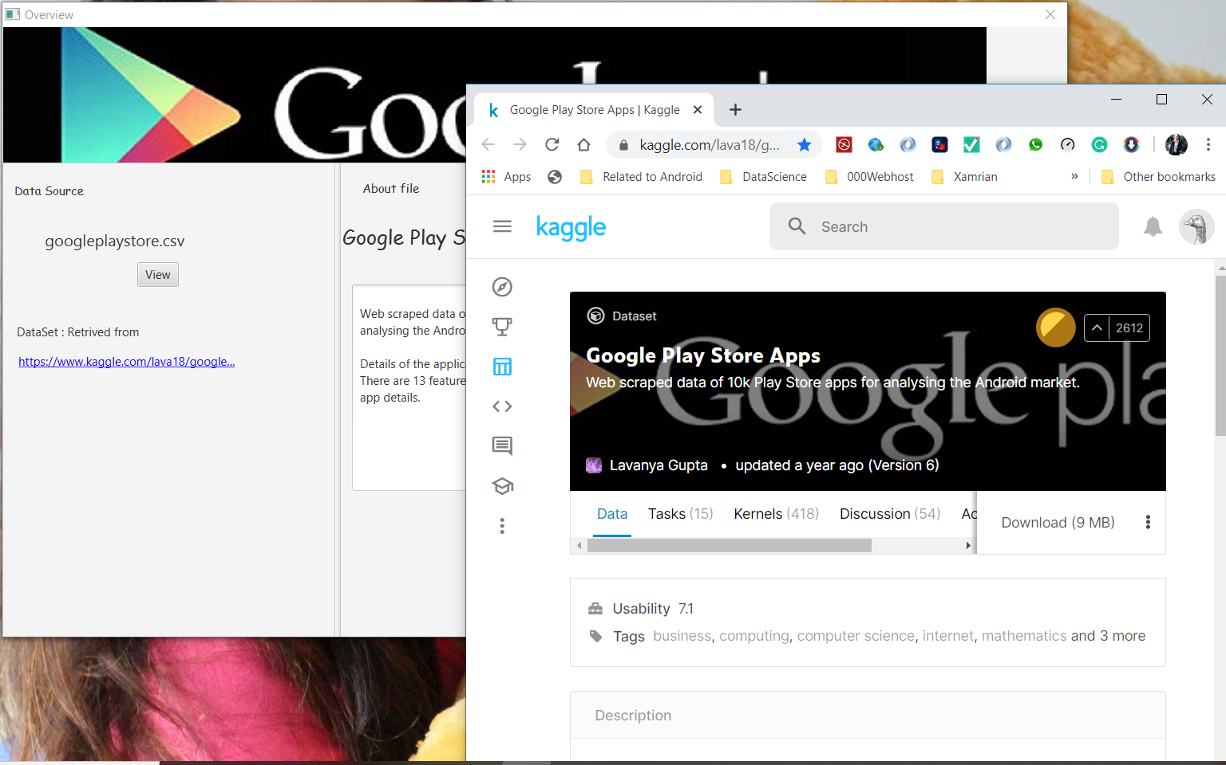

Figure Hyperlink to redirect original data set

# Unit Test

I have used JavaFX Observable list instead of ArrayList to load data into table. Therefore, for sorting and filtering data I used FilteredList and SortedList class which will wrap my observable list object and compared different parameter that needs to be sort and filter. Due to this I’m unable to test calculation methods in my Test case because of built in logic.

String expected = "https://www.kaggle.com/lava18/google-play-store-apps#googleplaystore.csv";

String actual = "https://www.kaggle.com/lava18/google-play-store-apps#googleplaystore.csv";

@Test

**void** testOpen_hyperlink() {

Overview_Controller detail = **new** Overview_Controller();

detail.open_hyperlink(actual);

*assertEquals*(expected, actual);

}

Above code check the method which will open the hyperlink and redirect to the relevant given address.

[Note: Due to raw data on dataset I can’t able to perform Math operation. However, I tried to clean dataset using reg. expression but I’m not successful with this. Below is the code that I used to clean my dataset while I load csv file using BufferReader. I tried to remove special characters such as +,””.]

String currentline = line.replace("+", "");

currentline = line.replace("{1}\"", "");

String[] fields = currentline.split(FieldDelimiter, -1);