**Teleprompter**

Install nodejs from <https://nodejs.org/dist/v23.6.0/node-v23.6.0-x64.msi>

Use Casparcg server from here <https://drive.google.com/file/d/1V1LZWQmss2O4gqG5wVSHLuW2J9Y8SDoj/view?usp=drive_link>

Unzip the software with 7z <https://7-zip.org/a/7z2409-x64.exe>

Double click start Prompter.bat file from unzipped teleprompter folder

Open <http://localhost:3000> in browser

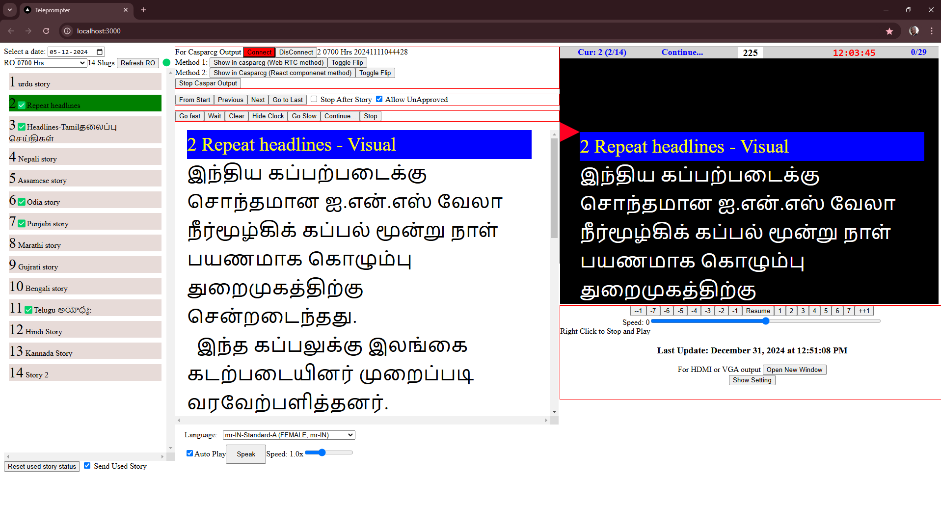

Select date, runorder name, double click on required slug name, click on required speed like 1 to start. Right click to stop and play with previous speed.

Teleprompter can be seen vertically scrolling on screen in the software itself.

1. Output can be found by clicking ‘open new window’ button. That will open a new window with teleprompter content, Then Drag it to second screen, maximise it by double clicking on title bar, then double clicking in the content. Right click to flip, again right click or double click to unflip.
2. Casparcg output can be found by either clicking on ‘show in casparcg (Web RTC Method) button or ‘Show in caspacrg (React component method)’. We need to double click required slug again for casparcg output in React component method. Click ‘Toggle flip’ button to flip and again click to unflip.
3. When in WebRTC method software should be in maximized state, and in active tab, nothing should be there over it.
4. When in HDMI or VGA method Software should be in active tab.

