Copyright Transfer and Declaration for the IJSRED
Title: Automated Privacy Policy Compliance Verification Using Dynamic Network Traffic Analysis

Author(s) Name(s): Vimlesh Shivnath Mourya; Maya Nair

Corresponding Author's name, address, affiliation and e-mail:

Maya Nair, Department of Computer Science, SIES College of Arts, Science and Commerce (Autonomous), Mumbai, India; mayan@sies.edu.in

The transfer of copyright gives IJSRED the right to develop, promote, distribute, sell, and archive a body of scientific works throughout the world. The Author hereby grants and assigns to IJSRED all rights in and to Author’s work in and contributions to the Work. In connection with this assignment, the Author acknowledges that IJSRED will have the right to print, publish, create derivative works, and sell the Work throughout the world, all rights in and to all revisions or versions or subsequent editions of the Work in all languages and media throughout the world. The author(s), reserve the following rights:

- All proprietary rights other than copyrights, such as patent rights,
- The right to use all or part of this article, including tables and figures in future works of their own, provided that the proper acknowledgment is made to the Publisher as copyright holder, and
- The right to make copies of this article for his/her own use, but not for sale.

Intellectual properties and scientific inventions published with IJSRED are protected under International and Federal Copyright Laws and Treaties. Permission to make digital or hard copies of part or all of this work for personal or classroom use is granted without fee provided that copies are not made or distributed for profit or commercial advantage and that copies bear this notice and the full citation on the first page. Copyrights for components of this work owned by others than IJSRED must be honored. Abstracting with credit is permitted. To copy otherwise, to republish, to post on servers or to redistribute to lists, requires prior specific permission and/or a fee. If Scientific and academic research publishing receives any complaints about the published paper is a copied article, IJSRED deserves the rights to remove the article from the journal, without any prior information to the author.

Author’s Declaration:
I assure that the work does not violate any proprietary or personal rights of others (including, without limitation, any copyrights or privacy rights); that the Work is factually accurate and contains no matter libelous or otherwise unlawful; that I have substantially participated in the creation of the Work and that it represents my original work sufficient for me to claim authorship. I further warrant and represent that I have no financial interest in the subject matter of the Work or any affiliation with an organization or entity with a financial interest in the subject matter of the Work, other than as previously disclosed to the Association. If any plagiarism found in my camera-ready paper after Publication, I am the whole responsible not IJSRED Journal or Board members.
I have the consent of each author to transfer and assign any and all right, title, and interest, including copyright of the article referenced above. I hereby assign and transfer to the IJSRED Journal copyright and all rights under it. I further confirm that this article has not been published elsewhere, nor is it under consideration by any other publisher.
Signature: 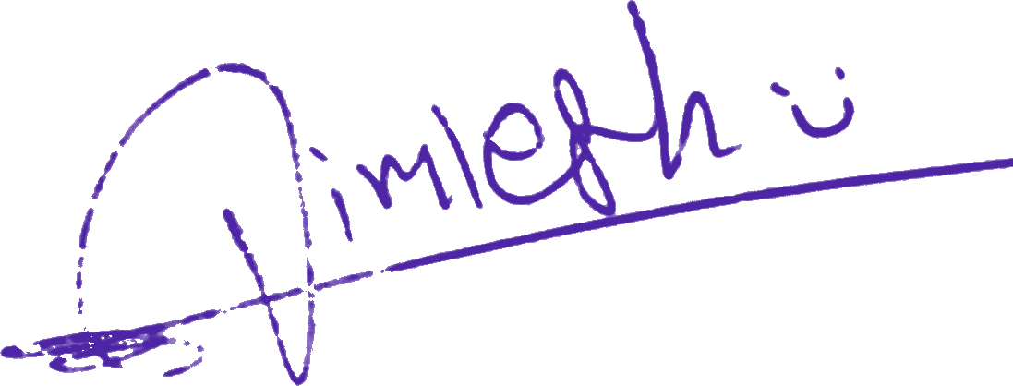 Date: 15 October 2026
* Kindly send scanned copy of completed and duly signed form by email to editorijsred@gmail.com.

