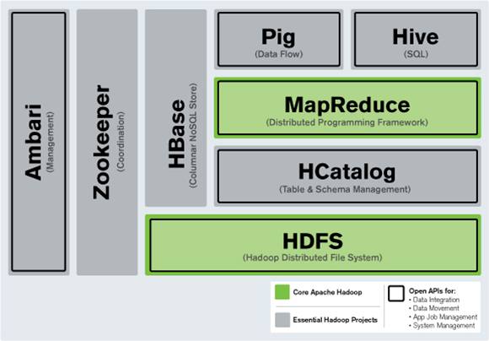

The sudden increase in the volume of data from the order of gigabytes to zettabytes has created the need for a more organized file system for storage and processing of data. The demand stemming from the data market has brought Hadoop in the limelight making it one of biggest players in the industry. Hadoop Distributed File System (HDFS), the commonly known file system of Hadoop and Hbase (Hadoop’s database) are the most topical and advanced data storage and management systems available in the market.

**What are HDFS and HBase?**

HDFS is fault-tolerant by design and supports rapid data transfer between nodes even during system failures. HBase is a non-relational and open source Not-Only-SQL database that runs on top of Hadoop. HBase comes under CP type of CAP (Consistency, Availability, and Partition Tolerance) theorem.

HDFS is most suitable for performing batch analytics. However, one of its biggest drawbacks is its inability to perform real-time analysis, the trending requirement of the IT industry. HBase, on the other hand, can handle large data sets and is not appropriate for batch analytics. Instead, it is used to write/read data from Hadoop in real-time.

Both HDFS and HBase are capable of processing structured, semi-structured as well as un-structured data. HDFS lacks an in-memory processing engine slowing down the process of data analysis; as it is using plain old MapReduce to do it. HBase, on the contrary, boasts of an in-memory processing engine that drastically increases the speed of read/write.

HDFS is very transparent in its execution of data analysis.  HBase, on the other hand, being a NoSQL database in tabular format, fetches values by sorting them under different key values.

**Enhanced Understanding with Use Cases for HDFS & HBase**

**Use Case 1 – Cloudera optimization for European bank using HBase**

HBase is ideally suited for real-time environments and this can be best demonstrated by citing the example of our client, a renowned European bank. To derive critical insights from the logs from application/web servers, we implemented solution in Apache Storm and Apache Hbase together. Given the huge velocity of data, we opted for HBase over HDFS; as HDFS does not support real-time writes. The results were overwhelming; it reduced the query time from 3 days to 3 minutes.

**Use Case 2 – Analytics solution for global CPG player using HDFS & MapReduce**

With our global beverage player client, the primary objective was to perform batch analytics to gain SKU level insights, and involved recursive/sequential calculations. HDFS and MapReduce frameworks were better suited than complex Hive queries on top of Hbase. MapReduce was used for data wrangling and to prepare data for subsequent analytics.  Hive was used for custom analytics on top of data processed by MapReduce. The results were impressive; as there was a drastic reduction in the time taken to generate custom analytics – 3 days to 3 hours.

To offer a reasonable comparison between HDFS and HBase, the following points need to be emphasized on:

|  |  |
| --- | --- |
| **HDFS** | **HBase** |
| HDFS is a Java-based file system utilized for storing large data sets. | HBase is a Java based Not Only SQL database |
| HDFS has a rigid architecture that does not allow changes. It doesn’t facilitate dynamic storage. | HBase allows for dynamic changes and can be utilized for standalone applications. |
| HDFS is ideally suited for write-once and read-many times use cases | HBase is ideally suited for random write and read of data that is stored in HDFS. |

HCatalog supports reading and writing files in any format for which a Hive SerDe (serializer-deserializer) can be written. By default, HCatalog supports RCFile, CSV, JSON, and SequenceFile formats. To use a custom format, you must provide the InputFormat, OutputFormat, and SerDe.

HCatalog is built on top of the Hive metastore and incorporates components from the Hive DDL. HCatalog provides read and write interfaces for Pig and MapReduce and uses Hive’s command line interface for issuing data definition and metadata exploration commands.

It also presents a REST interface to allow external tools access to Hive DDL (Data Definition Language) operations, such as “create table” and “describe table”.

HCatalog presents a relational view of data. Data is stored in tables and these tables can be placed into databases. Tables can also be partitioned on one or more keys. For a given value of a key (or set of keys) there will be one partition that contains all rows with that value (or set of values).

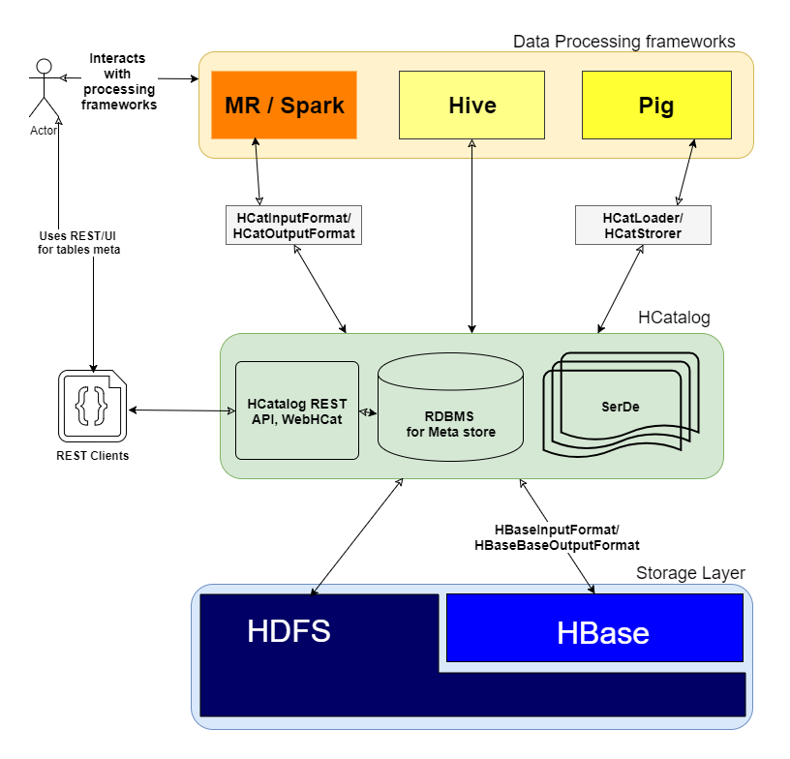

**Q: how exactly it works?**

As you mentioned "*HCatalog is a table and storage management layer for Hadoop*" Which gives high level abstraction to other frameworks like MR, Spark and Pig by performing I/O operations to Distributed storage layer for Hive tables.

HCatalog comprises 3 key elements

1. **SerDe** : Serialization and deserialization lib to process various data formats.
2. **Meta store DB** : Uses to stores the schema of Hive tables.
3. **WebHCat/HCatalog REST** : UI/REST layer on top of meta store DB for web clients.

**Q: how to use it?**

Once HCatalog installed and running successfully you do the following on CLI

usage: hcat { -e "<query>" | -f "<filepath>" }

[ -g "<group>" ] [ -p "<perms>" ]

[ -D"<name> = <value>" ]

-D <property = value> use hadoop value for given property

-e <exec> hcat command given from command line

-f <file> hcat commands in file

-g <group> group for the db/table specified in CREATE statement

-h,--help Print help information

-p <perms> permissions for the db/table specified in CREATE statement

Example:

./hcat –e "SELECT * FROM employee;"