X = [1 3 0.5 2.5 2]; % vector

pie(X) % show graph with slicer

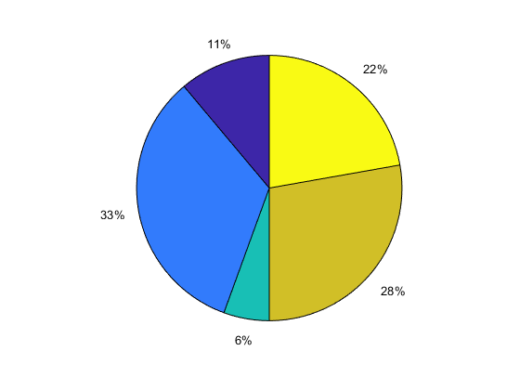

Offset the second and fourth pie slices by setting the corresponding explode elements to 1.

explode = [0 1 0 1 0];

pie(X,explode)

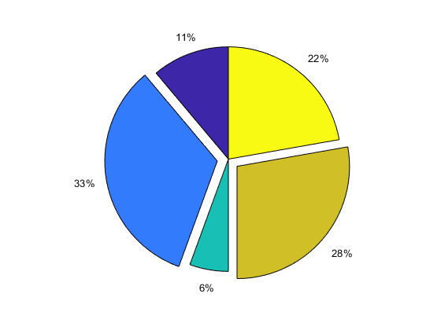

X = 1:3;[ 1 2 3]

labels = {'Taxes','Expenses','Profit'};

pie(X,labels)

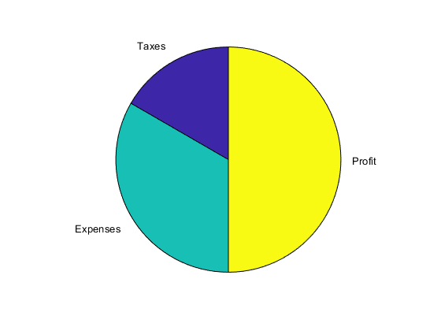

To plot the graph of a function, you need to take the following steps −

* Define **x**, by specifying the **range of values** for the variable **x**, for which the function is to be plotted
* Define the function, **y = f(x)**
* Call the **plot** command, as **plot(x, y)**

Following example would demonstrate the concept. Let us plot the simple function **y = x** for the range of values for x from 0 to 100, with an increment of 5.

Create a script file and type the following code −

x = [0:5:100];

y = x;

plot(x, y)

When you run the file, MATLAB displays the following plot −

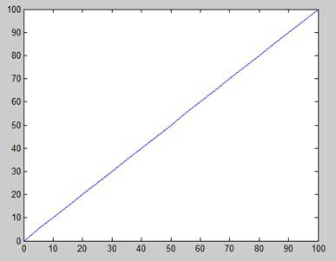

Let us take one more example to plot the function y = x2. In this example, we will draw two graphs with the same function, but in second time, we will reduce the value of increment. Please note that as we decrease the increment, the graph becomes smoother.

Create a script file and type the following code −

x = [1 2 3 4 5 6 7 8 9 10];

x = [-100:20:100];

y = x.^2;

plot(x, y)

When you run the file, MATLAB displays the following plot −

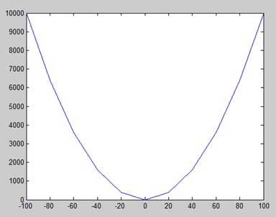

Change the code file a little, reduce the increment to 5 −

x = [-100:5:100];

y = x.^2;

plot(x, y)

MATLAB draws a smoother graph −

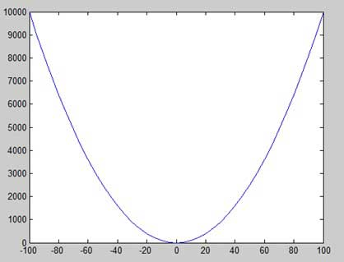

Adding Title, Labels, Grid Lines and Scaling on the Graph

MATLAB allows you to add title, labels along the x-axis and y-axis, grid lines and also to adjust the axes to spruce up the graph.

* The **xlabel** and **ylabel** commands generate labels along x-axis and y-axis.
* The **title** command allows you to put a title on the graph.
* The **grid on** command allows you to put the grid lines on the graph.
* The **axis equal** command allows generating the plot with the same scale factors and the spaces on both axes.
* The **axis square** command generates a square plot.

Example

Create a script file and type the following code −

x = [0:0.01:10];

y = sin(x);

plot(x, y), xlabel('x'), ylabel('Sin(x)'), title('Sin(x) Graph'),

grid on, axis equal

MATLAB generates the following graph −

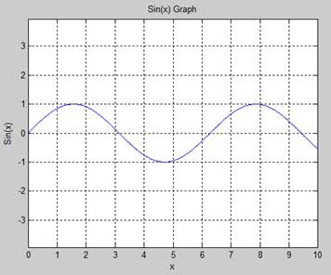

Drawing Multiple Functions on the Same Graph

You can draw multiple graphs on the same plot. The following example demonstrates the concept −

Example

Create a script file and type the following code −

x = [0 : 0.01: 10];

y = sin(x);

g = cos(x);

plot(x, y, x, g, '.-'), legend('Sin(x)', 'Cos(x)')

MATLAB generates the following graph −

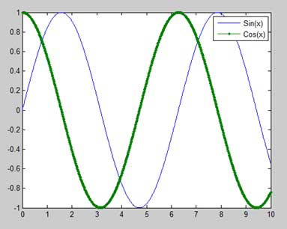

Setting Colors on Graph

MATLAB provides eight basic color options for drawing graphs. The following table shows the colors and their codes −

|  |  |
| --- | --- |
| **Code** | **Color** |
| w | White |
| k | Black |
| b | Blue |
| r | Red |
| c | Cyan |
| g | Green |
| m | Magenta |
| y | Yellow |

Example

Let us draw the graph of two polynomials

* f(x) = 3x4 + 2x3+ 7x2 + 2x + 9 and
* g(x) = 5x3 + 9x + 2

Create a script file and type the following code −

x = [-10 : 0.01: 10];

y = 3*x.^4 + 2 * x.^3 + 7 * x.^2 + 2 * x + 9;

g = 5 * x.^3 + 9 * x + 2;

plot(x, y, 'r', x, g, 'g')

When you run the file, MATLAB generates the following graph −

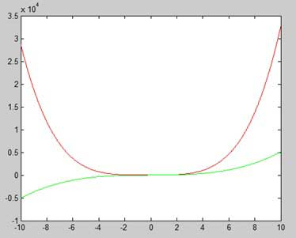

Setting Axis Scales

The **axis** command allows you to set the axis scales. You can provide minimum and maximum values for x and y axes using the axis command in the following way −

axis ( [xmin xmax ymin ymax] )

The following example shows this −

Example

Create a script file and type the following code −

x = [0 : 0.01: 10];

y = exp(-x).* sin(2*x + 3);

plot(x, y), axis([0 10 -1 1])

When you run the file, MATLAB generates the following graph −

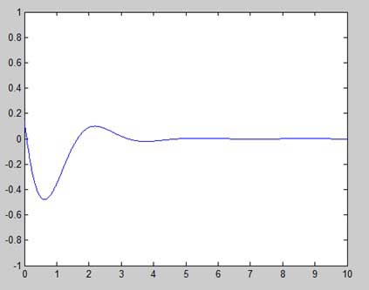

Generating Sub-Plots

When you create an array of plots in the same figure, each of these plots is called a subplot. The **subplot** command is used for creating subplots.

Syntax for the command is −

subplot(m, n, p)

where, *m* and *n* are the number of rows and columns of the plot array and *p*specifies where to put a particular plot.

Each plot created with the subplot command can have its own characteristics. Following example demonstrates the concept −

Example

Let us generate two plots −

y = e−1.5xsin(10x)

y = e−2xsin(10x)

Create a script file and type the following code −

x = [0:0.01:5];

y = exp(-1.5*x).*sin(10*x);

subplot(1,2,1)

plot(x,y), xlabel('x'),ylabel('exp(–1.5x)*sin(10x)'),axis([0 5 -1 1])

y = exp(-2*x).*sin(10*x);

subplot(1,2,2)

plot(x,y),xlabel('x'),ylabel('exp(–2x)*sin(10x)'),axis([0 5 -1 1])

When you run the file, MATLAB generates the following graph −

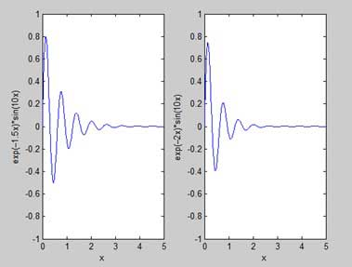

This chapter will continue exploring the plotting and graphics capabilities of MATLAB. We will discuss −

* Drawing bar charts
* Drawing contours
* Three dimensional plots

Drawing Bar Charts

The **bar** command draws a two dimensional bar chart. Let us take up an example to demonstrate the idea.

Example

Let us have an imaginary classroom with 10 students. We know the percent of marks obtained by these students are 75, 58, 90, 87, 50, 85, 92, 75, 60 and 95. We will draw the bar chart for this data.

Create a script file and type the following code −

x = [1:10];

y = [75, 58, 90, 87, 50, 85, 92, 75, 60, 95];

bar(x,y), xlabel('Student'),ylabel('Score'),

title('First Sem:')

print -deps graph.eps

When you run the file, MATLAB displays the following bar chart −

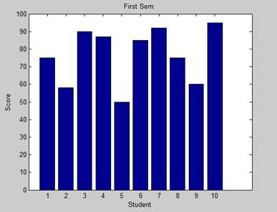

Drawing Contours

A contour line of a function of two variables is a curve along which the function has a constant value. Contour lines are used for creating contour maps by joining points of equal elevation above a given level, such as mean sea level.

MATLAB provides a **contour** function for drawing contour maps.

Example

Let us generate a contour map that shows the contour lines for a given function g = f(x, y). This function has two variables. So, we will have to generate two independent variables, i.e., two data sets x and y. This is done by calling the **meshgrid** command.

The **meshgrid** command is used for generating a matrix of elements that give the range over x and y along with the specification of increment in each case.

Let us plot our function g = f(x, y), where −5 ≤ x ≤ 5, −3 ≤ y ≤ 3. Let us take an increment of 0.1 for both the values. The variables are set as −

[x,y] = meshgrid(–5:0.1:5, –3:0.1:3);

Lastly, we need to assign the function. Let our function be: x2 + y2

Create a script file and type the following code −

[x,y] = meshgrid(-5:0.1:5,-3:0.1:3); %independent variables

g = x.^2 + y.^2; % our function

contour(x,y,g) % call the contour function

print -deps graph.eps

When you run the file, MATLAB displays the following contour map −

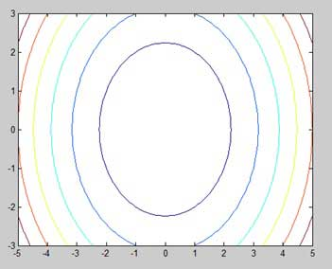

Let us modify the code a little to spruce up the map

[x,y] = meshgrid(-5:0.1:5,-3:0.1:3); %independent variables

g = x.^2 + y.^2; % our function

[C, h] = contour(x,y,g); % call the contour function

set(h,'ShowText','on','TextStep',get(h,'LevelStep')*2)

print -deps graph.eps

When you run the file, MATLAB displays the following contour map −

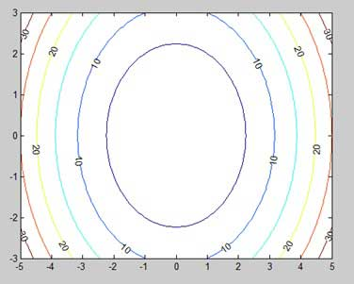

Three Dimensional Plots

Three-dimensional plots basically display a surface defined by a function in two variables, g = f (x,y).

As before, to define g, we first create a set of (x,y) points over the domain of the function using the **meshgrid** command. Next, we assign the function itself. Finally, we use the **surf** command to create a surface plot.

The following example demonstrates the concept −

Example

Let us create a 3D surface map for the function g = xe-(x2 + y2)

Create a script file and type the following code −

[x,y] = meshgrid(-2:.2:2);

g = x .* exp(-x.^2 - y.^2);

surf(x, y, g)

print -deps graph.eps

When you run the file, MATLAB displays the following 3-D map −

