MATLAB provides command for working with transforms, such as the Laplace and Fourier transforms. Transforms are used in science and engineering as a tool for simplifying analysis and look at data from another angle.

For example, the Fourier transform allows us to convert a signal represented as a function of time to a function of frequency. Laplace transform allows us to convert a differential equation to an algebraic equation.

MATLAB provides the **laplace**, **fourier** and **fft** commands to work with Laplace, Fourier and Fast Fourier transforms.

The Laplace Transform

The Laplace transform of a function of time f(t) is given by the following integral −

Laplace Transform

Laplace transform is also denoted as transform of f(t) to F(s). You can see this transform or integration process converts f(t), a function of the symbolic variable t, into another function F(s), with another variable s.

Laplace transform turns differential equations into algebraic ones. To compute a Laplace transform of a function f(t), write −

laplace(f(t))

Example

In this example, we will compute the Laplace transform of some commonly used functions.

Create a script file and type the following code −

syms s t a b w

laplace(a)

laplace(t^2)

laplace(t^9)

laplace(exp(-b*t))

laplace(sin(w*t))

laplace(cos(w*t))

When you run the file, it displays the following result −

ans =

1/s^2

ans =

2/s^3

ans =

362880/s^10

ans =

1/(b + s)

ans =

w/(s^2 + w^2)

ans =

s/(s^2 + w^2)

The Inverse Laplace Transform

MATLAB allows us to compute the inverse Laplace transform using the command **ilaplace**.

For example,

ilaplace(1/s^3)

MATLAB will execute the above statement and display the result −

ans =

t^2/2

Example

Create a script file and type the following code −

syms s t a b w

ilaplace(1/s^7)

ilaplace(2/(w+s))

ilaplace(s/(s^2+4))

ilaplace(exp(-b*t))

ilaplace(w/(s^2 + w^2))

ilaplace(s/(s^2 + w^2))

When you run the file, it displays the following result −

ans =

t^6/720

ans =

2*exp(-t*w)

ans =

cos(2*t)

ans =

ilaplace(exp(-b*t), t, x)

ans =

sin(t*w)

ans =

cos(t*w)

The Fourier Transforms

Fourier transforms commonly transforms a mathematical function of time, f(t), into a new function, sometimes denoted by or F, whose argument is frequency with units of cycles/s (hertz) or radians per second. The new function is then known as the Fourier transform and/or the frequency spectrum of the function f.

Example

Create a script file and type the following code in it −

syms x

f = exp(-2*x^2); %our function

ezplot(f,[-2,2]) % plot of our function

FT = fourier(f) % Fourier transform

When you run the file, MATLAB plots the following graph −

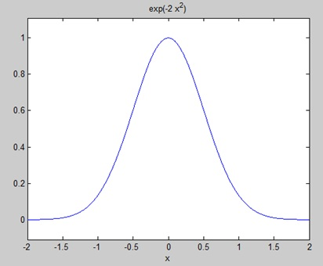

The following result is displayed −

FT =

(2^(1/2)*pi^(1/2)*exp(-w^2/8))/2

Plotting the Fourier transform as −

ezplot(FT)

Gives the following graph −

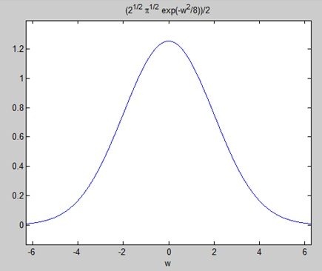

Inverse Fourier Transforms

MATLAB provides the **ifourier** command for computing the inverse Fourier transform of a function. For example,

f = ifourier(-2*exp(-abs(w)))

MATLAB will execute the above statement and display the result −

f =

-2/(pi*(x^2 + 1))