**What You’ll Do**

* Create a simple tabular report to list open suggestions.
* Create a summary report with a report chart.
* Create a simple dashboard based on the summary report.
* Try the reports and dashboards in the Salesforce mobile app.

The Suggestion Box app you created includes a Reports tab and a Dashboards tab, where you can create, edit, and run reports and dashboards. These features make an app more useful by providing the business with valuable insights.

**Step 1: Create a Tabular Report**

Let’s start with a simple tabular report to show the number of suggestions received and the status of each one. A tabular report presents data in simple rows and columns, much like a spreadsheet. You can use it to show column summaries, like sum, average, maximum, and minimum.

1. Click the App Launcher icon and select **Suggestion Box** app. Select the Reports tab, click **New Report**.
2. In the Quick Find box, enter **Suggestions**. In the Other Reports folder, choose **Suggestions**. If you don't see the Suggestions report type, go back to Setup and click **Object Manager**. Next to Suggestion, click **Edit**. Under Optional Features, check **Allow Reports**. Click **Save**. Then go back and create the report.
3. Click **Create**.
4. In the Report Builder, notice that the Suggestion Name field is already on the report. In the preview screen, you can see the sample Suggestion records you created in previous steps.
5. From the Fields pane, in the Suggestion: Info folder, drag **Status** and **Number of Days Open** onto the preview and drop them to the right of the Suggestion Name field.
6. Set a row limit for this report so that it doesn’t get out of hand. From the Add dropdown menu next to Filters, choose **Row Limit**.

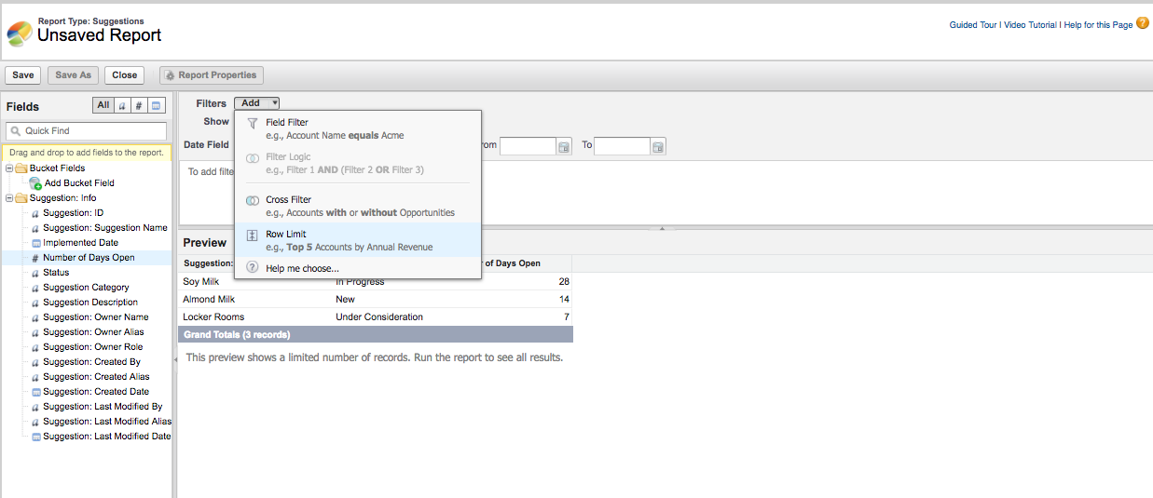

1. Click **OK** to accept the default 10-row limit.
2. To make sure that you’re viewing only suggestions that still need to be implemented, click **Add** next to Filters and set the filter to **Status Not Equal To Implemented**. Click **OK**.

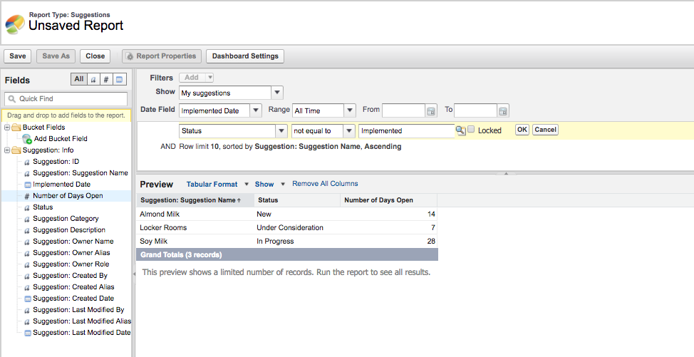

1. Click the **Dashboard Settings** button at the top.
2. For the Name field, choose **Status**.
3. For the Value field, choose **Number of Days Open** and then click **OK**. *(Steps 9, 10, and 11 are needed only if the tabular report is used in a dashboard.)*
4. Click **Save**, and name your report **Suggestions: Status of Open Suggestions**.
5. In the Report Folder dropdown list, select **Unfiled Public Reports** so that everyone can access it. (If you don’t want this report to be accessible to everyone, create a folder and give different people different levels of access to it.)
6. Click **Save** and then **Run Report**.

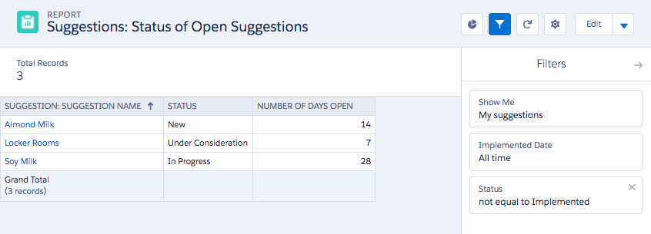

**Step 2: Create a Summary Report and a Report Chart**

It’s often a good idea to give users a visual way to understand the data in your report. Tabular reports don’t include charts, so let’s copy the report and make a Summary report. Then, you can add a chart.

1. From the Report Results view of the **Suggestions: Status of Open Suggestions** report, click **the dropdown on the right** and choose **Save As**.
2. Type **Suggestions: By Status** as the report name
3. Choose the **Make Public** radio button.
4. Click **Create**.
5. Click **Edit**.
6. Click **Tabular Format** and choose **Summary**. If presented with a warning message, click **Yes** to proceed.
7. Drag the **Status** field column to the shaded area labeled **Drop a field here to create a grouping**.

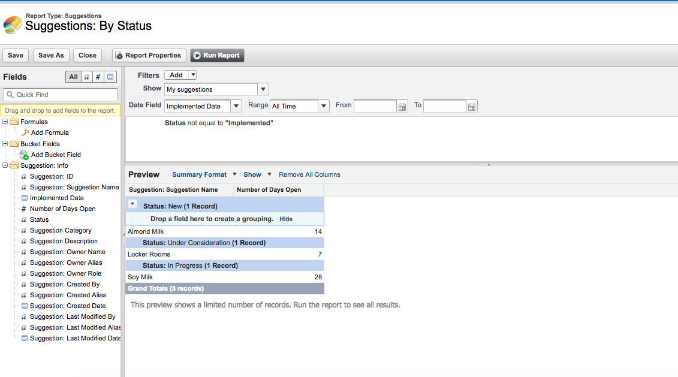

1. Click **Save** and then **Run Report** which leads to the Report Results view, click the **Pie button** to Add chart to this report.
2. Click on the **gear** icon and choose **Donut chart**.
3. In the **Chart Title** type **Suggestions Status** and in **Value** dropdown, choose **Record Count**.
4. Click the dropdown next to Edit button and then click **Save**.

The doughnut chart displays above the report results and shows the total number of open suggestions by status.

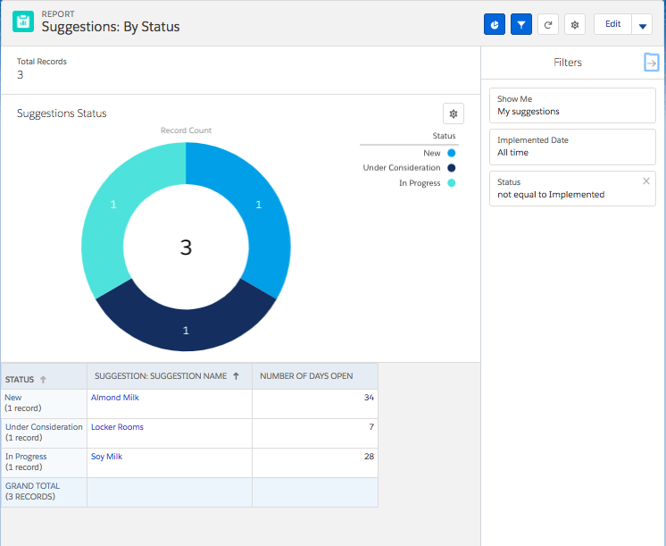

**Step 3: Create a Dashboard**

Dashboards in Salesforce are like a dashboard in your car, showing you important information at a glance. Dashboards can show data in charts, gauges, tables, metrics, or other formats (using a Visualforce page). Dashboards are powered by reports.

1. Go to the **Dashboard** tab and click **New Dashboard**.
2. Type the Dashboard Name as **Suggestions Dashboard** and create it on the default Private Dashboards folder.
3. Click the **+Component** button at the top right to add a component.
4. In the Report Search, look for **Suggestions: By Status**. Click **Select**.
5. Choose the donut chart and scroll down to edit the Title as **Suggestions By Status**. 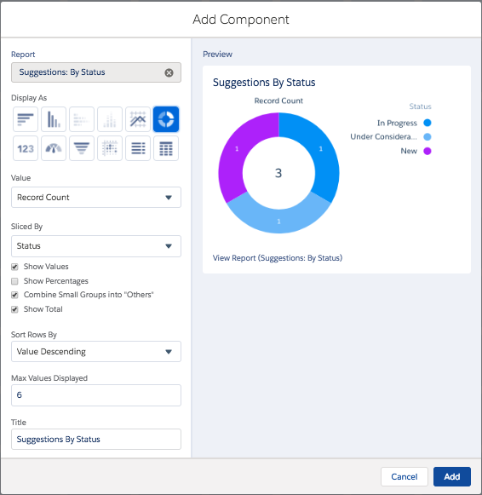
6. Click **Add**
7. Click **Done** and then **Save**.
8. The Dashboard appears as:

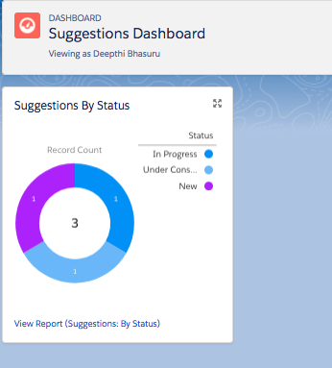

**Step 4: Try Out the Mobile App**

You are now a mobile app developer! This is a simple but complete app, and from here you can continue to add functionality or build another app with these skills. Let's see how these reports and dashboards look in the Salesforce mobile app.

1. Click the Navigation bar icon icon to open the left navigation bar.
2. Scroll down and click **Reports** in the Apps section to display the reports that you recently viewed.
3. Click either of the reports that you created.
4. Sort the columns, and click a row in the report to test its functionality.
5. Now let’s try the dashboard. Click the Navigation bar icon icon to open the left navigation bar.
6. Click **Dashboards** to display the dashboards that you recently viewed.
7. Click the **Suggestions Dashboard**. You should see something like this:

