SAP FI Dunning Process and Configuration

In SAP FI, Dunning plays a vital role in Accounts receivables. Dunning is similar to reminder notice to our business partners for their overdue/open items or outstanding balances. Dunning letter summarizes overdue invoices record and asks for payment to be made. We configure dunning program for accounts receivable and accounts payable. Dunning Program includes following configuration steps:

* Dunning procedure,
* Dunning level,
* Dunning Areas.

**Dunning procedure** controls the path of dunning to the customer and vendor through the system. We can define our own dunning procedure as per our convenience. Transaction code: FBMP.

**Dunning level** defines dunning text; maximum nine dunning levels are available. As the dunning level increases, text will also change as consistent to make payment.

**Dunning area** means the client/company/company code in which we are working on dunning program. If we don’t want to run dunning program at company code level then we can also run dunning program at organizational level like, sales organization.

SAP provides additional functions in dunning like dunning charges to customer or vendors. In SAP, we can do changes in dunning program like dunning level, dunning data, and dunning area. SAP also provides dunning block facility for special customers.

**Path for SAP Dunning in IMG**  
Financial Accounting > Accounts Receivable and Accounts Payable > Business Transactions > Dunning.

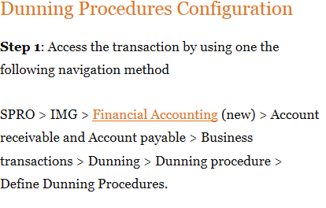

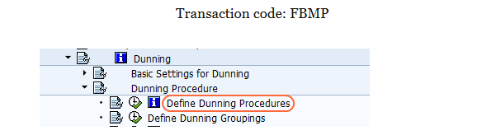

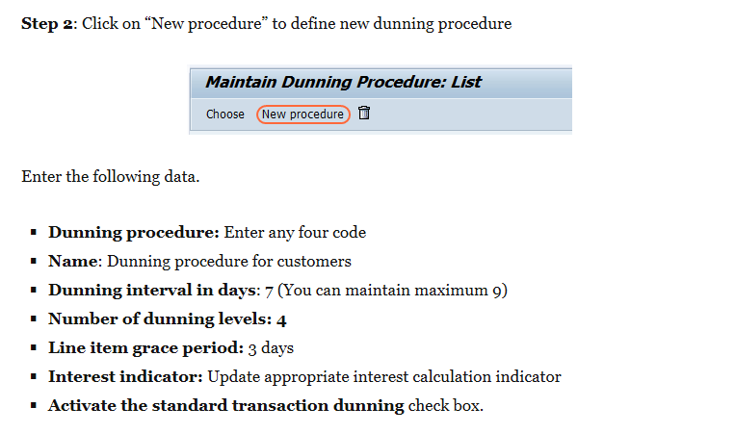

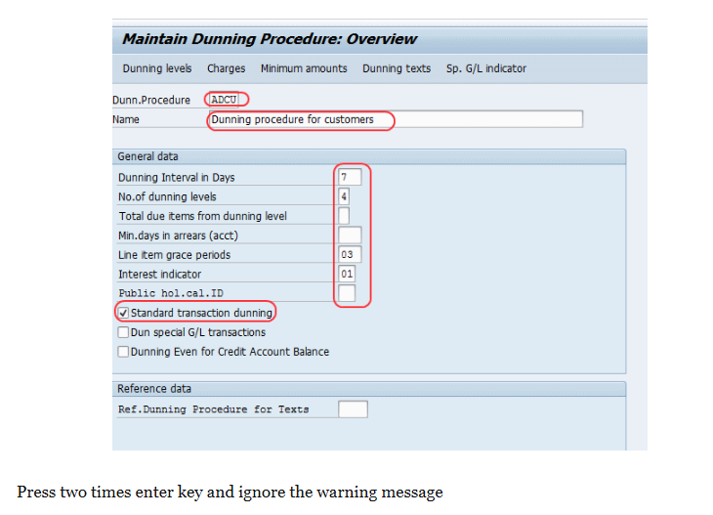

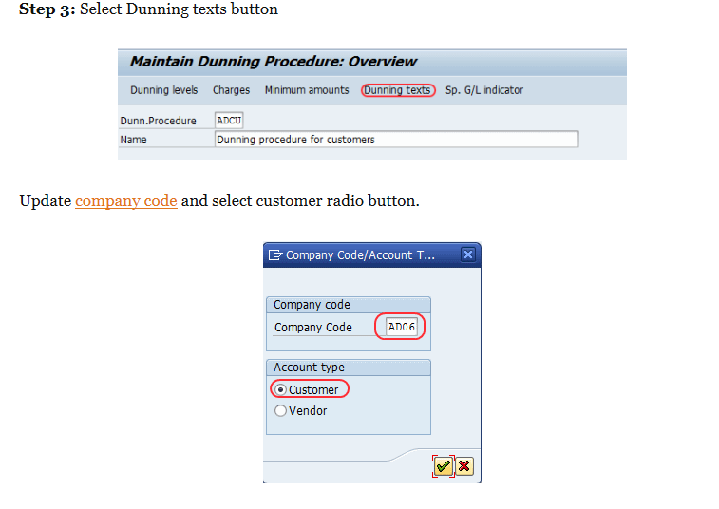

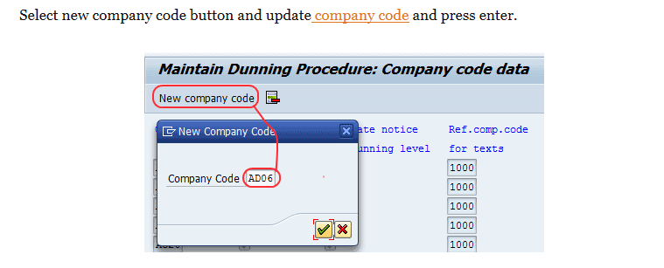

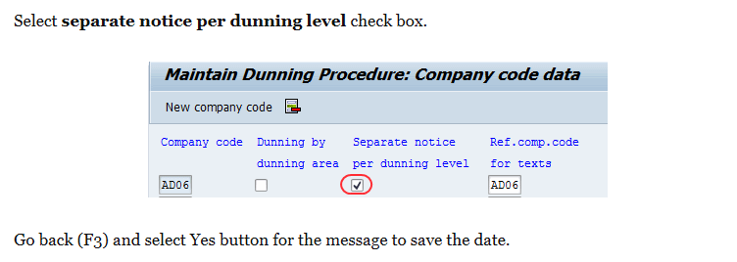

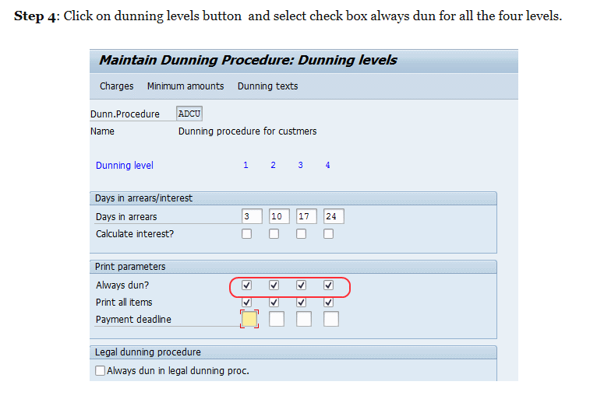

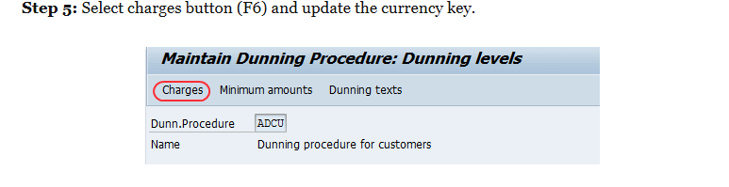

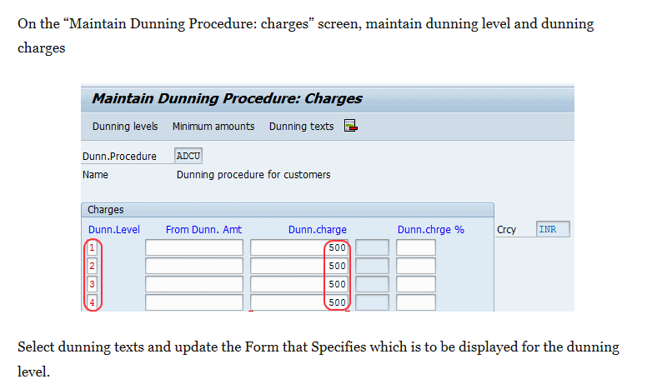

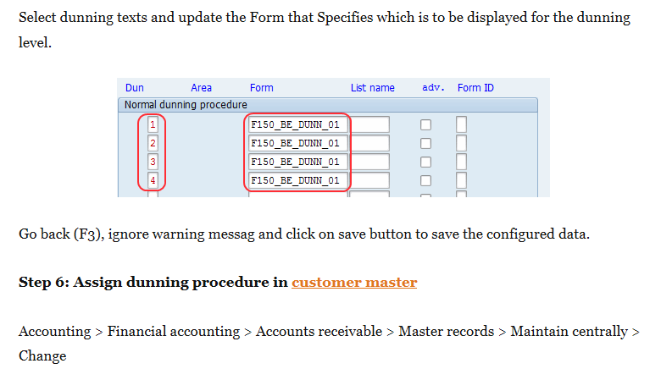

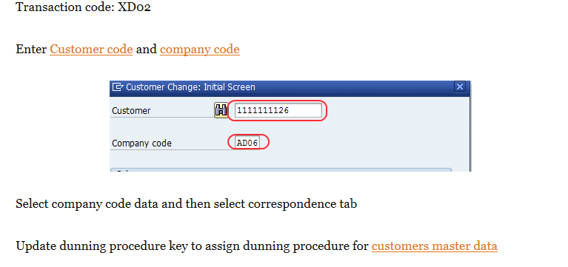

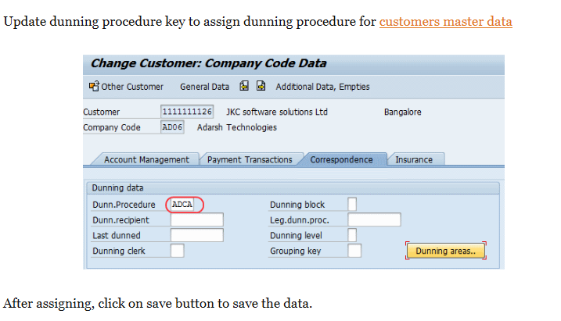

**Dunning**  
  
It is the process of Correspondence with the Customer/Vendor about pending bills ( in sap as we call it open items). In SAP we can schedule the Dunning Process and maintain different Dunning Levels for Dunning run.The Dunning process involves the following steps:

1. Entering Parameters in the dunning program.The parameters of old dunning run can be copied and dates can be adjusted.
2. The Dunning run selects the accounts, examines them for overdue items, checks if they have to be dunned, and assigns dunning levels to them.All dunning data is stored in a dunning proposal.
3. The Dunning Proposal can be edited ,deleted and recreated as often as necessary until the dunning clerk is satisfied with the result.
4. If desired ,this step can be skipped and the dunning run can be followed directly by the printout of dunning notices.
5. In One Click,Dunning notices are printed and dunning data is updated in the master records and associated documents.

We will perform a Complete Dunning run  as a background scheduled job- Enter the Transaction F150 in the SAP Command Field

[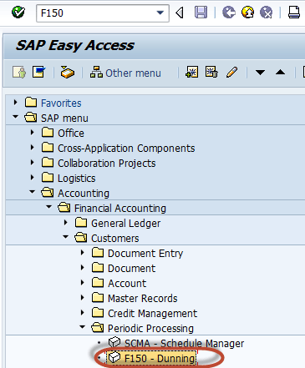](http://www.guru99.com/images/sap/2012/08/Dunning02.png)

In the next screen ,Enter the Following

1. Enter the Dunning run date
2. Enter the Dunning run Identification

[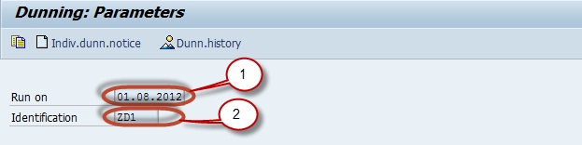](http://www.guru99.com/images/sap/2012/09/Dunning.jpg)

In the Parameters Tab

1. Enter the Dunning Date
2. Enter the Date upto which the documents for dunning are to be considered
3. Enter the Company Code for dunning
4. Enter customers and vendors to be dunned

[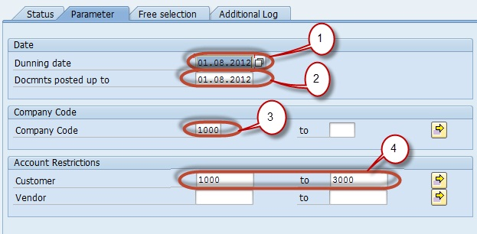](http://www.guru99.com/images/sap/2012/09/Dunning1.jpg)

Save the Dunning Parameters

[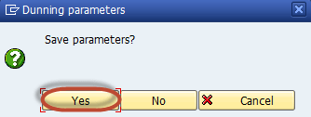](http://www.guru99.com/images/sap/2012/08/Dunning03.png)

Schedule the Dunning run by pressing the Schedule button

[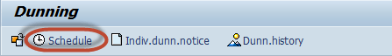](http://www.guru99.com/images/sap/2012/08/Dunning04.png)

In the next screen select the printer to print the dunning notices generated

[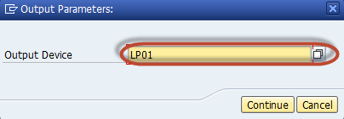](http://www.guru99.com/images/sap/2012/08/Dunning05.png)

In the next screen schedule the time of dunning run

[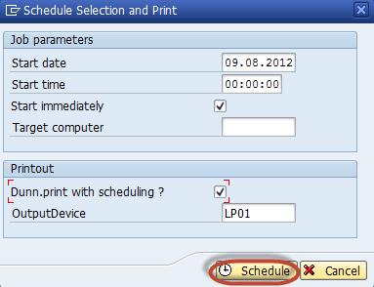](http://www.guru99.com/images/sap/2012/08/Dunning06.png)

Check the Status of the Dunning run

[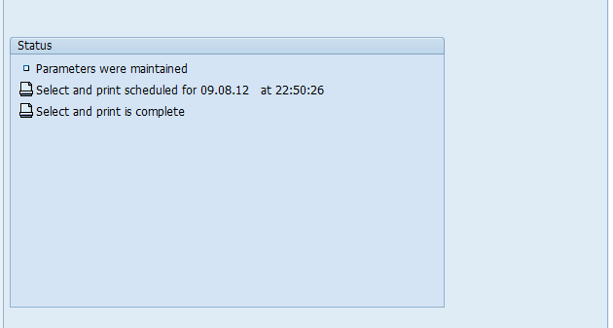](http://www.guru99.com/images/sap/2012/08/Dunning08.png)

We can check the Dunning Notice in Spool Requests

[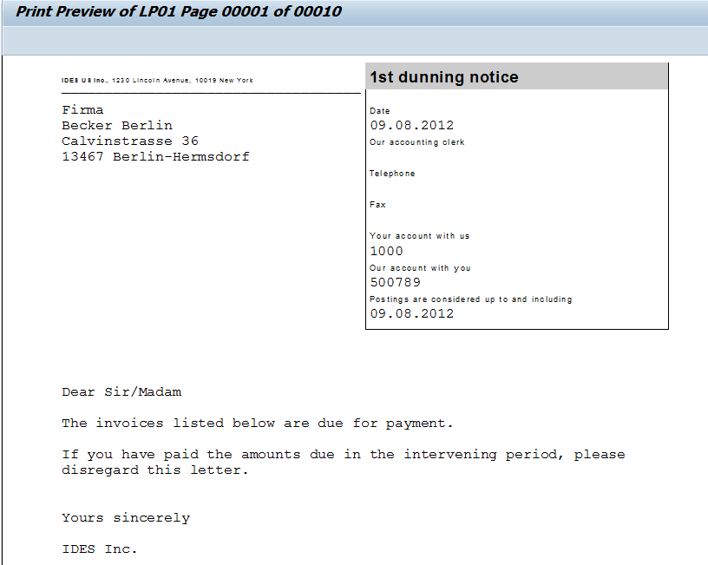](http://www.guru99.com/images/sap/2012/08/Dunning09.png)

[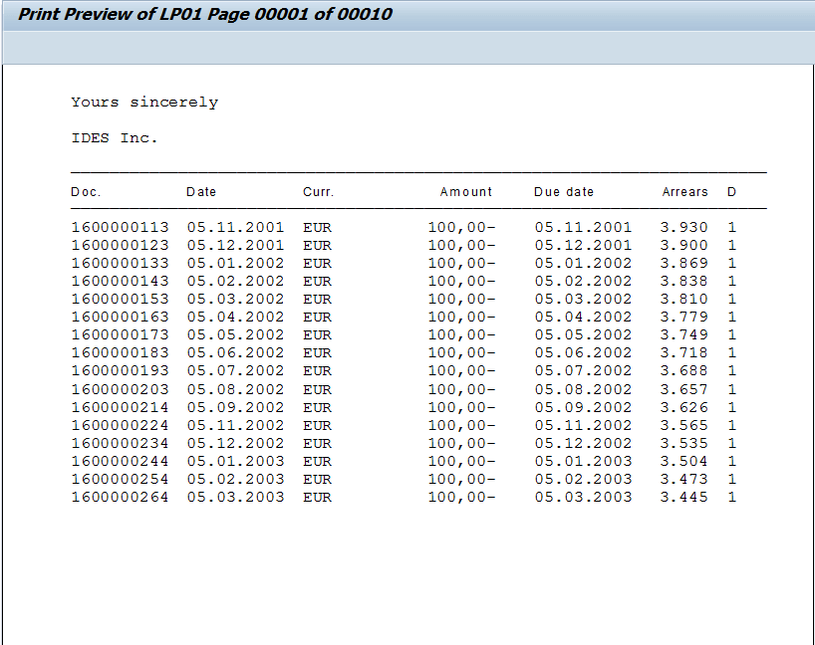](http://www.guru99.com/images/sap/2012/08/Dunning10.png)

[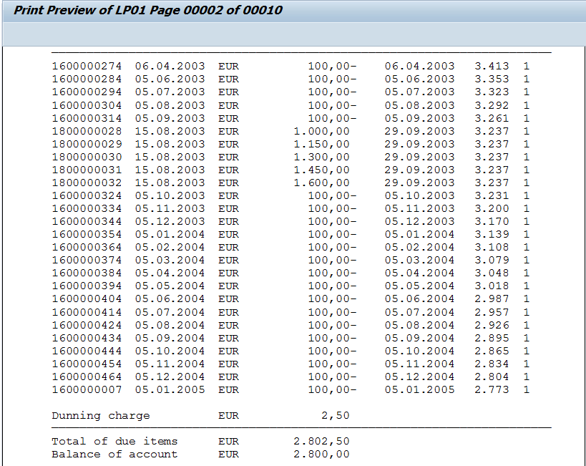](http://www.guru99.com/images/sap/2012/08/Dunning11.png)