Controlling

SAP Controlling (CO) is another important SAP module offered to an organization. It supports coordination, monitoring, and optimization of all the processes in an organization. SAP CO involves recording both the consumption of production factors and the services provided by an organization.

SAP CO includes managing and configuring master data that covers cost and profit centers, internal orders, and other cost elements and functional areas.

The main purpose of SAP controlling module is planning. It enables you to determine variances by comparing actual data with plan data and thus enables you to control business flows in your organization.

SAP CO Integration with Financial Accounting

Both SAP CO and SAP FI modules are independent components in a SAP system. The data flow between these components takes place on a regular basis.

Data flows relevant to cost flows to Controlling from Financial Accounting. At the same time, the system assigns the costs and revenues to different CO account assignment objects, such as cost centers, business processes, projects or orders.

SAP CO – Submodules

The key submodules of SAP controlling system are listed below −

* **Cost Element Accounting** − Cost and Revenue Element Accounting provides you with an overview of the costs and revenues that occur in an organization. Most of the values are moved automatically from Financial Accounting to Controlling. Cost and Revenue Element Accounting only calculates costs which either do not have another expense or only one expense in Financial Accounting.
* **Cost Center Accounting** − Cost Center Accounting is used for controlling purposes within your organization.
* **Activity-Based-Accounting** − It is used to analyze cross-departmental business processes.
* **Internal Orders** − Internal orders in SAP CO are used to collect and control according to the job that incurred them. You can assign budgets for these jobs that is system monitored to ensure that they are not exceeded from the set budgets.
* **Product Cost Controlling** − It calculates the cost for manufacture a product, or to provide a service. It allows you to calculate the price at which you can profitably marketed it.
* **Profitability Analysis** − It is used to analyze the profit or loss of an organization by individual market segments. Profitability Analysis provides a basis for decisionmaking. For example, it is used to determine price, conditioning, customer, distribution channel, and market segment.
* **Profit Center Accounting** − It is used to evaluate profit or loss of individual, independent areas within an organization. These areas are responsible for their costs and revenues.

SAP CO - Cost Center

A Cost Center is defined as a component in an organization that adds to the cost and indirectly adds to the profit of the organization. Examples include Marketing and Customer Service.

A company can classify a business unit in three ways −

* Profit center,
* Cost center, or
* Investment center.

The simple and straightforward division in an organization can be classified as cost center because cost is easy to measure.

Cost Center Hierarchy

The hierarchy of a cost center looks as follows −

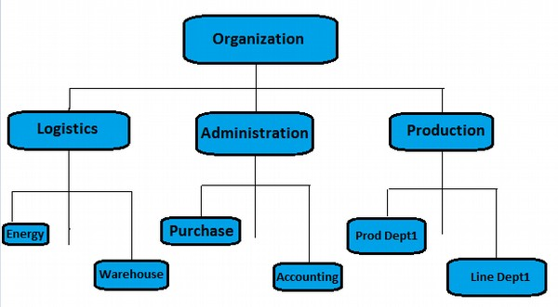

SAP CO - Create Cost Center

To create a cost center, use the **T-code** KS01. It will open the following window.

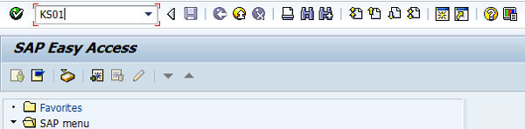

Enter the Controlling Area in the next screen and click the tick mark.

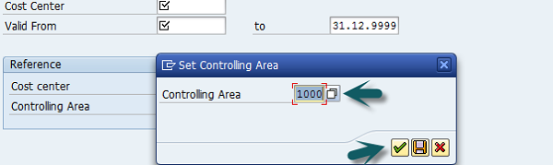

In the next window, enter the following details and click the Master Data.

* New cost center number.
* Validity dates of the new cost center.

You can also create a new cost center with a reference.

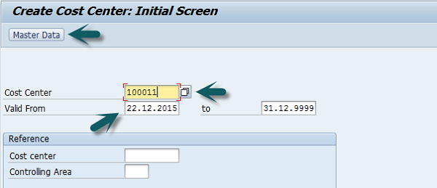

Once you click Master Data, a new window will open. Enter the following details in the basic data tab −

* Enter the name of the new cost center.
* Enter a description for the new cost center.
* Enter the User and Person Responsible.
* Cost Center Category.
* Hierarchy area.
* Company Code.
* Profit Center.

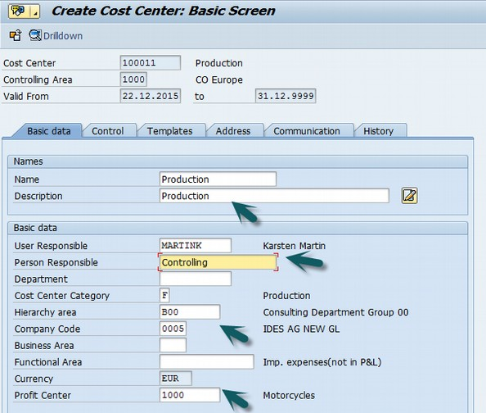

Next, click the Control tab and select the correct indicator.

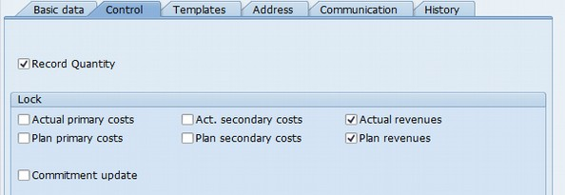

At the end, click the save icon at the top.

Cost Center Icon

SAP CO - Post to a Cost Center

To post to a cost center, use the **T-code** FB50. It will take you to the following window.

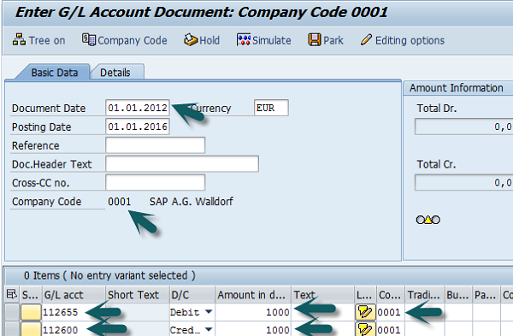

In this window, you need to enter the following details −

* Document date
* Company code
* G/L Account for the Debit Entry which is to be posted to the Cost Center
* Debit Amount
* Cost Center in which the Amount is to be posted
* G/L Account for Credit Entry
* Credit Amount

Click the Save button at the top to post to this cost center.

SAP CO - Internal Orders

SAP CO internal order monitors the parts of the costs and in a few cases, it also monitors the revenues of the organization.

You can create an internal order to monitor the costs of a time-restricted job or the costs for the production of activities. Internal orders can also be used for the long-term monitoring of costs.

Investment cost related to fixed assets are monitored using Investment orders.

Period-related accrual calculation between expenses in FI and the costing-based costs debited in Cost Accounting are monitored using Accrual orders.

Costs and revenues incurred for activities for external partners or for internal activities that do not form a part of the core business for your organization are monitored using order with revenues.

How to create an Internal Order in SAP CO?

Use the **T-code** KO04 or go to Accounting → Controlling → Internal Orders → Master Data → Order Manager.

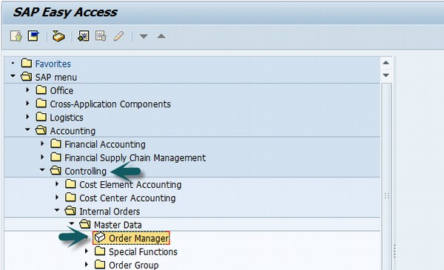

In the next screen, input the controlling area as shown below −

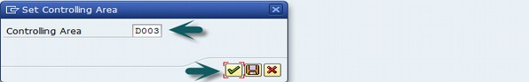

Click the Create button at the top to create a new internal order and enter the order type.

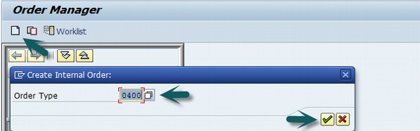

In the next window, enter the following details −

* Company Code
* Business area
* Object Class of the Order
* Profit Center
* Cost Center responsible for the internal order

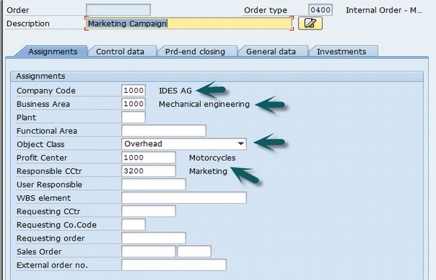

After entering the above details, click the Save button at the top to create the internal order.

Create Internal Order

SAP CO - Settlement of IO

An internal order is used as an interim collector of costs and is used for planning, monitoring, and controlling the processes. When the job has been completed, you settle the costs to one or more receivers like cost centers, fixed assets, etc.

How to perform settlement of IO to Cost Centers?

Use the **T-code**: KO02 or Go to Accounting → Controlling → Internal Orders → Master Data → Special Functions → Change.

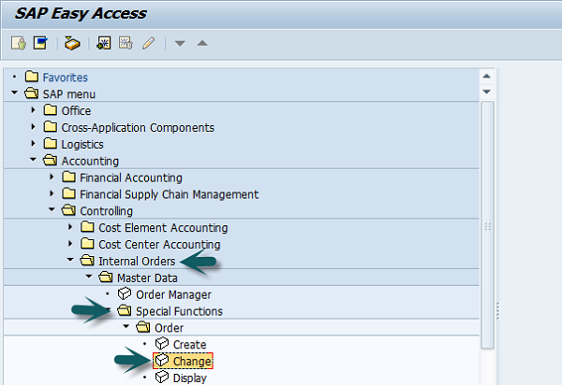

A new window will open. Enter the Order number for which settlement is to be done.

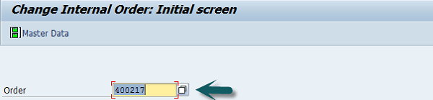

Click the Settlement rule button at the top −

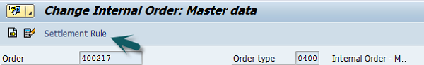

Enter the following details −

* In Category column, enter 'CTR' for the cost center.
* In Settlement receiver Column, enter the Cost Center in which the Order is to be settled.
* Enter the percentage amount which is to be settled.
* In Settlement type, enter 'PER' for periodic settlement.

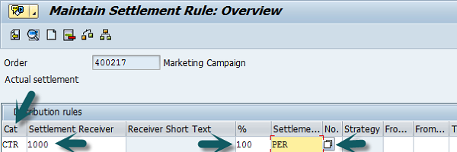

Click the save button at the top to save the settlement rule and come back to the main screen.

Enter the **T-code** KO88 and input the following details −

* Order for which the settlement rule is maintained.
* Period for settlement.
* Fiscal Year.
* Uncheck the Test Run.
* Click on the Execute Button to run the settlement.

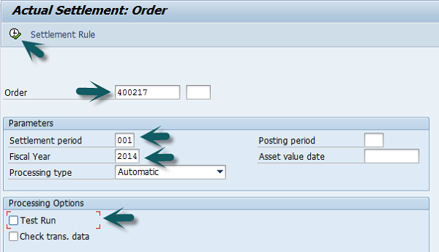

A new window will open with a Settlement display message. Click the Continue button to complete the processing.

SAP CO - Profit Center

SAP CO Profit Center is used for managing internal controlling. When you divide your company into profit centers, it allows you to delegate responsibility to decentralized units and treat them as separate companies in a company. It also allows you to calculate key figures in cost accounting like ROI, Cash flow, etc.

Profit Center is a part of Enterprise Controlling module and is integrated with a new General Ledger Accounting.

Key Features of SAP CO Profit Center

Profit Center Accounting is used to determine profit for internal areas of responsibility. It lets you determine profits and losses using either period accounting or the cost-of-sales approach.

It allows you to analyze fixed assets by profit center, thus using them as investment centers. It allows to expand profit centers to investment centers.

Why Do We Create Profit Center?

The main aim of creating a Profit Center in SAP CO is to analyze the cost of a product line or a business unit.

You can also generate P&L accounts according to a Profit Center and also generate balance sheets, however a Profit Center should only be used for internal reporting purpose.

The key components of a profit center include – name of the profit center, the controlling area under which it is assigned, time period, person responsible for the profit center, standard hierarchy, etc.

How to Create a Profit Center?

Use the **T-code** KE51 or go to Accounting → Controlling → Profit Center Accounting → Master Data → Profit Center → Individual Processing → Create.

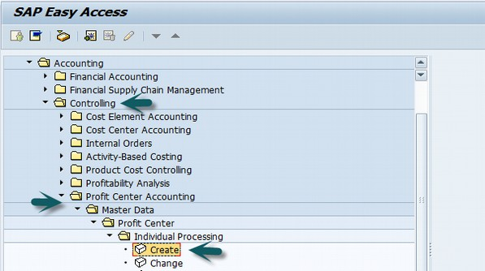

In the next screen, enter the controlling area in which the profit center is to be created and click the tick mark.

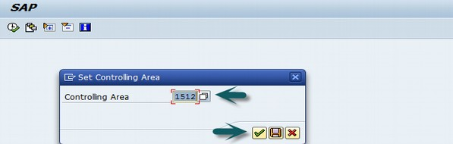

In the next screen, enter the unique profit center ID and click Master Data.

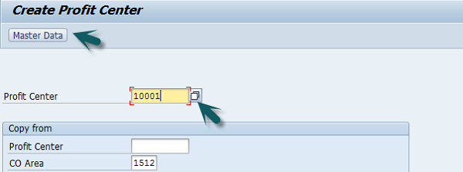

A new window will open where you need to input the following details −

* Profit center name and a short description of the profit center.
* Person responsible for the profit center.
* Profit center group for which the profit center belongs to.

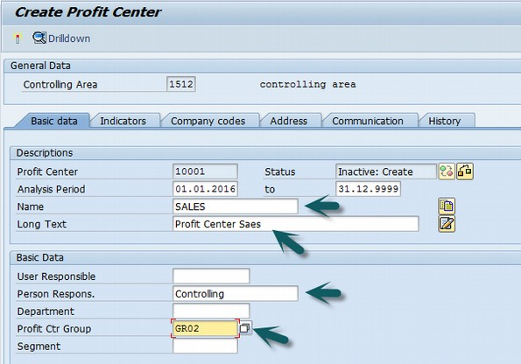

Click the Save icon at the top to create the profit center in inactive mode. To activate the profit center, click the icon as shown in the following screenshot.

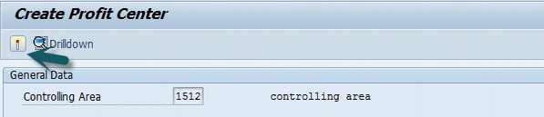

How to Create a Profit Center Group?

Use the **T-code** KCH1 or go to Accounting → Controlling → Profit Center Accounting → Master Data → Profit Center Group → Create.

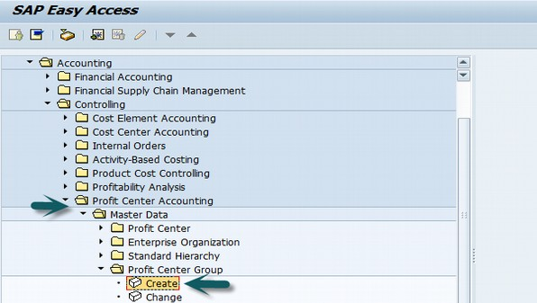

Enter the Controlling Area in which the Profit Center is to be created.



Enter the Unique Profit Center Group Id as shown below and press Enter.

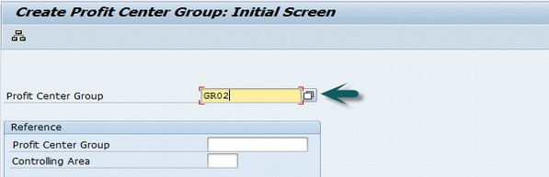

Enter the short description for the profit center group and click the Save icon at the top.

SAP CO - Postings to Profit Center

To post to a Profit Center, use the **T-code** FB50. It will take you to the following window.

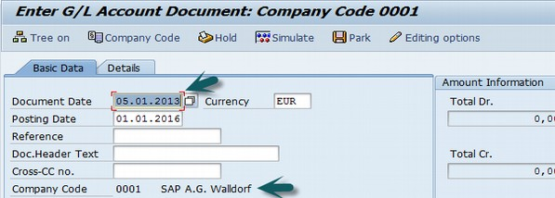

Enter the Document date and the Company code. Thereafter, provide input data in the fields as shown in the following screenshot.

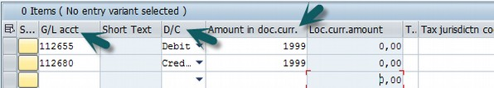

After entering the line items, select the debit line item and click the button Detail Item button. Refer the following screenshot.

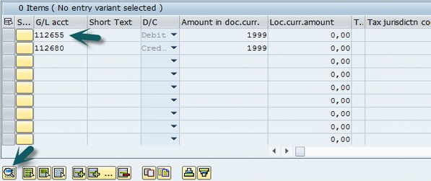

A new window will open. Enter the Profit Center and click the Save icon at the top.

SAP CO - Profit Center Standard Hierarchy

SAP CO Profit Center standard hierarchy, known as **tree structure,** that contains all the profit centers in a controlling area.

If you want to create/change the structure of a standard hierarchy, it can be done at two places −

* In the Profit Center Accounting
* In Customizing for Profit Center Accounting

How to Create Profit Center Standard Hierarchy?

Use the **T-code** KCH1 or go to Accounting → Controlling → Profit Center Accounting → Master Data → Standard Hierarchy → Create.

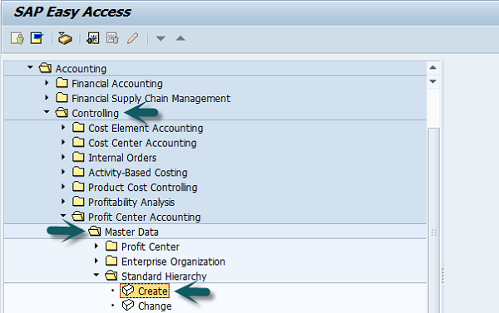

In the next screen, enter the Controlling Area for which you want to create a Standard hierarchy.



Enter the Profit Center Group and click Hierarchy at the top and enter the sub-nodes of the Profit Center Standard Hierarchy.

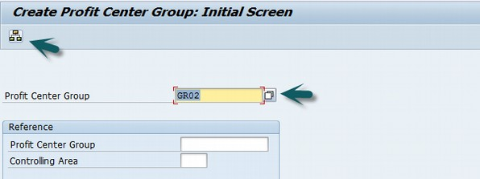

Click the Lower level button to create a hierarchy. Click the Profit center to assign a Profit Center group.

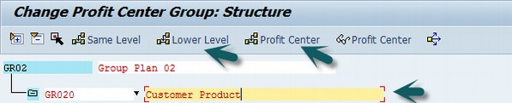

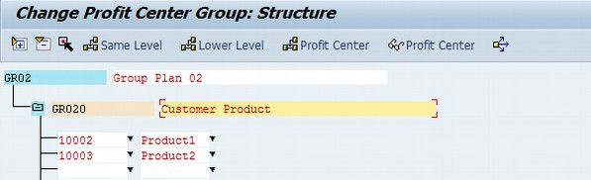

Click the Save button at the top and you will get a confirmation message.

Profit Center Groups