**Regression analysis**

In statistics, **regression analysis** is a statistical process for estimating the relationships among variables. It includes many techniques for modeling and analyzing several variables, when the focus is on the relationship between a dependent variable and one or more independent variables (or 'predictors'). More specifically, regression analysis helps one understand how the typical value of the dependent variable (or 'criterion variable') changes when any one of the independent variables is varied, while the other independent variables are held fixed. Most commonly, regression analysis estimates the conditional expectation of the dependent variable given the independent variables – that is, the average value of the dependent variable when the independent variables are fixed. Less commonly, the focus is on a quantile, or other location parameter of the conditional distribution of the dependent variable given the independent variables. In all cases, the estimation target is a function of the independent variables called the **regression function**. In regression analysis, it is also of interest to characterize the variation of the dependent variable around the regression function which can be described by a probability distribution.

Regression analysis is widely used for prediction and forecasting, where its use has substantial overlap with the field of machine learning. Regression analysis is also used to understand which among the independent variables are related to the dependent variable, and to explore the forms of these relationships. In restricted circumstances, regression analysis can be used to infer causal relationships between the independent and dependent variables. However this can lead to illusions or false relationships, so caution is advisable;[1] for example, correlation does not imply causation.

Many techniques for carrying out regression analysis have been developed. Familiar methods such as linear regression and ordinary least squares regression are parametric, in that the regression function is defined in terms of a finite number of unknown parameters that are estimated from the data. Nonparametric regression refers to techniques that allow the regression function to lie in a specified set of functions, which may be infinite-dimensional.

The performance of regression analysis methods in practice depends on the form of the data generating process, and how it relates to the regression approach being used. Since the true form of the data-generating process is generally not known, regression analysis often depends to some extent on making assumptions about this process. These assumptions are sometimes testable if a sufficient quantity of data is available. Regression models for prediction are often useful even when the assumptions are moderately violated, although they may not perform optimally. However, in many applications, especially with small effects or questions of causality based on observational data, regression methods can give misleading results

**Chapter Outline**  
    1.0 Introduction  
    1.1 A First Regression Analysis  
    1.2 Examining Data  
    1.3 Simple linear regression  
    1.4 Multiple regression  
    1.5 Transforming variables  
    1.6 Summary  
    1.7 For more information

**1.0 Introduction**

This web book is composed of four chapters covering a variety of topics about using SAS for regression. We should emphasize that this book is about "data analysis" and that it demonstrates how SAS can be used for regression analysis, as opposed to a book that covers the statistical basis of multiple regression.  We assume that you have had at least one statistics course covering regression analysis and that you have a regression book that you can use as a reference (see the Regression With SAS page and our Statistics Books for Loan page for recommended regression analysis books). This book is designed to apply your knowledge of regression, combine it with instruction on SAS, to perform, understand and interpret regression analyses.

This first chapter will cover topics in simple and multiple regression, as well as the supporting tasks that are important in preparing to analyze your data, e.g., data checking, getting familiar with your data file, and examining the distribution of your variables.  We will illustrate the basics of simple and multiple regression and demonstrate the importance of inspecting, checking and verifying your data before accepting the results of your analysis. In general, we hope to show that the results of your regression analysis can be misleading without further probing of your data, which could reveal relationships that a casual analysis could overlook.

In this chapter, and in subsequent chapters, we will be using a data file that was created by randomly sampling 400 elementary schools from the California Department of Education's API 2000 dataset.  This data file contains a measure of school academic performance as well as other attributes of the elementary schools, such as, class size, enrollment, poverty, etc.

You can access this data file over the web by clicking on elemapi.sas7bdat, or by visiting the Regression with SAS page where you can download all of the data files used in all of the chapters of this book.  The examples will assume you have stored your files in a folder called **c:\sasreg**, but actually you can store the files in any folder you choose, but if you run these examples be sure to change **c:\sasreg\** to the name of the folder you have selected.

**1.1 A First Regression Analysis**

Let's dive right in and perform a regression analysis using the variables **api00**, **acs_k3**, **meals** and **full**. These measure the academic performance of the school (**api00**), the average class size in kindergarten through 3rd grade (**acs_k3**), the percentage of students receiving free meals (**meals**) - which is an indicator of poverty, and the percentage of teachers who have full teaching credentials (**full**). We expect that better academic performance would be associated with lower class size, fewer students receiving free meals, and a higher percentage of teachers having full teaching credentials.   Below, we use **proc reg** for running this regression model followed by the SAS output.

**proc reg data="c:\sasreg\elemapi";**

**model api00 = acs_k3 meals full;**

**run;**

The REG Procedure

Model: MODEL1

Dependent Variable: api00 api 2000

Analysis of Variance

Sum of Mean

Source DF Squares Square F Value Pr > F

Model 3 2634884 878295 213.41 <.0001

Error 309 1271713 4115.57673

Corrected Total 312 3906597

Root MSE 64.15276 R-Square 0.6745

Dependent Mean 596.40575 Adj R-Sq 0.6713

Coeff Var 10.75656

Parameter Estimates

Parameter Standard

Variable Label DF Estimate Error t Value Pr > |t|

Intercept Intercept 1 906.73916 28.26505 32.08 <.0001

acs_k3 avg class size k-3 1 -2.68151 1.39399 -1.92 0.0553

meals pct free meals 1 -3.70242 0.15403 -24.04 <.0001

full pct full credential 1 0.10861 0.09072 1.20 0.2321

Let's focus on the three predictors, whether they are statistically significant and, if so, the direction of the relationship. The average class size (**acs_k3**, b=-2.68), is not significant (p=0.0553), but only just so, and the coefficient is negative which would indicate that larger class sizes is related to lower academic performance -- which is what we would expect.   Next, the effect of **meals** (b=-3.70, p<.0001) is significant and its coefficient is negative indicating that the greater the proportion students receiving free meals, the lower the academic performance.  Please note, that we are not saying that free meals are causing lower academic performance.  The **meals** variable is highly related to income level and functions more as a proxy for poverty. Thus, higher levels of poverty are associated with lower academic performance. This result also makes sense.  Finally, the percentage of teachers with full credentials (**full**, b=0.11, p=.2321) seems to be unrelated to academic performance. This would seem to indicate that the percentage of teachers with full credentials is not an important factor in predicting academic performance -- this result was somewhat unexpected.

Should we take these results and write them up for publication?  From these results, we would conclude that lower class sizes are related to higher performance, that fewer students receiving free meals is associated with higher performance, and that the percentage of teachers with full credentials was not related to academic performance in the schools.  Before we write this up for publication, we should do a number of checks to make sure we can firmly stand behind these results.  We start by getting more familiar with the data file, doing preliminary data checking, looking for errors in the data.

**1.2 Examining data**

First, let's use **proc contents** to learn more about this data file.  We can verify how many observations it has and see the names of the variables it contains.

**proc contents data="c:\sasreg\elemapi" ;**

**run;**

The CONTENTS Procedure

Data Set Name: c:\sasreg\elemapi Observations: 400

Member Type: DATA Variables: 21

Engine: V8 Indexes: 0

Created: 4:58 Saturday, January 9, 1960 Observation Length: 83

Last Modified: 4:58 Saturday, January 9, 1960 Deleted Observations: 0

Protection: Compressed: NO

Data Set Type: Sorted: NO

Label:

-----Engine/Host Dependent Information-----

Data Set Page Size: 8192

Number of Data Set Pages: 5

First Data Page: 1

Max Obs per Page: 98

Obs in First Data Page: 56

Number of Data Set Repairs: 0

File Name: c:\sasreg\elemapi.sas7bdat

Release Created: 7.0000M0

Host Created: WIN_NT

-----Alphabetic List of Variables and Attributes-----

# Variable Type Len Pos Label

-----------------------------------------------------------------------------

11 acs_46 Num 3 39 avg class size 4-6

10 acs_k3 Num 3 36 avg class size k-3

3 api00 Num 4 12 api 2000

4 api99 Num 4 16 api 1999

17 avg_ed Num 8 57 avg parent ed

15 col_grad Num 3 51 parent college grad

2 dnum Num 4 8 district number

7 ell Num 3 27 english language learners

19 emer Num 3 73 pct emer credential

20 enroll Num 4 76 number of students

18 full Num 8 65 pct full credential

16 grad_sch Num 3 54 parent grad school

5 growth Num 4 20 growth 1999 to 2000

13 hsg Num 3 45 parent hsg

21 mealcat Num 3 80 Percentage free meals in 3 categories

6 meals Num 3 24 pct free meals

9 mobility Num 3 33 pct 1st year in school

12 not_hsg Num 3 42 parent not hsg

1 snum Num 8 0 school number

14 some_col Num 3 48 parent some college

8 yr_rnd Num 3 30 year round school

We will not go into all of the details of this output.  Note that there are 400 observations and 21 variables.  We have variables about academic performance in 2000 and 1999 and the change in performance, **api00**, **api99** and **growth** respectively. We also have various characteristics of the schools, e.g., class size, parents education, percent of teachers with full and emergency credentials, and number of students.  Note that when we did our original regression analysis it said that there were 313 observations, but the **proc contents** output indicates that we have 400 observations in the data file.

If you want to learn more about the data file, you could use **proc print** to show some of the observations.  For example, below we **proc print** to show the first five observations.

**proc print data="c:\sasreg\elemapi"(obs=5) ;**

**run;**

m s c g

o n o o r m

g y b a a o m l a a e e

a a r m r i c c t e _ d v n a

s d p p o e _ l s s _ _ g _ g f e r l

O n n i i w a e r i _ _ h h c r s _ u m o c

b u u 0 9 t l l n t k 4 s s o a c e l e l a

s m m 0 9 h s l d y 3 6 g g l d h d l r l t

1 906 41 693 600 93 67 9 0 11 16 22 0 0 0 0 0 . 76 24 247 2

2 889 41 570 501 69 92 21 0 33 15 32 0 0 0 0 0 . 79 19 463 3

3 887 41 546 472 74 97 29 0 36 17 25 0 0 0 0 0 . 68 29 395 3

4 876 41 571 487 84 90 27 0 27 20 30 36 45 9 9 0 1.91000 87 11 418 3

5 888 41 478 425 53 89 30 0 44 18 31 50 50 0 0 0 1.50000 87 13 520 3

This takes up lots of space on the page, but does not give us a lot of information.  Listing our data can be very helpful, but it is more helpful if you **list** just the variables you are interested in.  Let's **list** the first 10 observations for the variables that we looked at in our first regression analysis.

**proc print data="c:\sasreg\elemapi"(obs=10) ;**

**var api00 acs_k3 meals full;**

**run;**

Obs api00 acs_k3 meals full

1 693 16 67 76

2 570 15 92 79

3 546 17 97 68

4 571 20 90 87

5 478 18 89 87

6 858 20 . 100

7 918 19 . 100

8 831 20 . 96

9 860 20 . 100

10 737 21 29 96

We see that among the first 10 observations, we have four missing values for **meals**.  It is likely that the missing data for **meals** had something to do with the fact that the number of observations in our first regression analysis was 313 and not 400.

Another useful tool for learning about your variables is **proc means**. Below we use **proc means** to learn more about the variables **api00**, **acs_k3**, **meals**, and **full**.

**proc means data="c:\sasreg\elemapi";**

**var api00 acs_k3 meals full;**

**run;**

The MEANS Procedure

Variable Label N Mean Std Dev Minimum

----------------------------------------------------------------------------

api00 api 2000 400 647.6225000 142.2489610 369.0000000

acs_k3 avg class size k-3 398 18.5477387 5.0049328 -21.0000000

meals pct free meals 315 71.9936508 24.3855697 6.0000000

full pct full credential 400 66.0568000 40.2979258 0.4200000

----------------------------------------------------------------------------

Variable Label Maximum

-------------------------------------------

api00 api 2000 940.0000000

acs_k3 avg class size k-3 25.0000000

meals pct free meals 100.0000000

full pct full credential 100.0000000

-------------------------------------------

We see that the **api00** scores don't have any missing values (because the N is 400) and the scores range from 369-940.  This makes sense since the api scores can range from 200 to 1000.  We see that the average class size (**acs_k3**) had 398 valid values ranging from -21 to 25 and 2 are missing. It seems odd for a class size to be -21. The percent receiving free meals (**meals**) ranges from 6 to 100, but there are only 315 valid values (85 are missing). This seems like a large number of missing values.  The percent with full credentials (**full**) ranges from .42 to 100 with no missing.

We can also use **proc freq** to learn more about any categorical variables, such as **yr_rnd**, as shown below.

**proc freq data="c:\sasreg\elemapi";**

**tables yr_rnd;**

**run;**

year round school

Cumulative Cumulative

yr_rnd Frequency Percent Frequency Percent

-----------------------------------------------------------

0 308 77.00 308 77.00

1 92 23.00 400 100.00

The variable **yr_rnd** is coded 0=No (not year round) and 1=Yes (year round).  Of the 400 schools, 308 are non-year round and 92 are year round, and none are missing.

The above commands have uncovered a number of peculiarities worthy of further examination. For example, let us look further into the average class size by getting more detailed summary statistics for **acs_k3** using **proc univariate**.

**proc univariate data="c:\sasreg\elemapi";**

**var acs_k3;**

**run;**

The UNIVARIATE Procedure

Variable: acs_k3 (avg class size k-3)

Moments

N 398 Sum Weights 398

Mean 18.5477387 Sum Observations 7382

Std Deviation 5.00493282 Variance 25.0493526

Skewness -7.1055928 Kurtosis 53.0136683

Uncorrected SS 146864 Corrected SS 9944.59296

Coeff Variation 26.9840594 Std Error Mean 0.25087461

Basic Statistical Measures

Location Variability

Mean 18.54774 Std Deviation 5.00493

Median 19.00000 Variance 25.04935

Mode 19.00000 Range 46.00000

Interquartile Range 2.00000

Tests for Location: Mu0=0

Test -Statistic- -----p Value------

Student's t t 73.93231 Pr > |t| <.0001

Sign M 193 Pr >= |M| <.0001

Signed Rank S 37839 Pr >= |S| <.0001

Quantiles (Definition 5)

Quantile Estimate

100% Max 25

99% 23

95% 21

90% 21

75% Q3 20

50% Median 19

25% Q1 18

10% 17

5% 16

1% -20

0% Min -21

Extreme Observations

----Lowest---- ----Highest---

Value Obs Value Obs

-21 43 22 365

-21 42 23 36

-21 41 23 79

-20 40 23 361

-20 38 25 274

Missing Values

-----Percent Of-----

Missing Missing

Value Count All Obs Obs

. 2 0.50 100.00

Looking in the section labeled Extreme Observations, we see some of the class sizes are -21 and -20, so it seems as though some of the class sizes somehow became negative, as though a negative sign was incorrectly typed in front of them.   Let's do a **proc freq** for class size to see if this seems plausible.

**proc freq data="c:\sasreg\elemapi";**

**tables acs_k3;**

**run;**

avg class size k-3

Cumulative Cumulative

acs_k3 Frequency Percent Frequency Percent

-----------------------------------------------------------

-21 3 0.75 3 0.75

-20 2 0.50 5 1.26

-19 1 0.25 6 1.51

14 2 0.50 8 2.01

15 1 0.25 9 2.26

16 14 3.52 23 5.78

17 20 5.03 43 10.80

18 64 16.08 107 26.88

19 143 35.93 250 62.81

20 97 24.37 347 87.19

21 40 10.05 387 97.24

22 7 1.76 394 98.99

23 3 0.75 397 99.75

25 1 0.25 398 100.00

Frequency Missing = 2

Indeed, it seems that some of the class sizes somehow got negative signs put in front of them.  Let's look at the school and district number for these observations to see if they come from the same district.   Indeed, they all come from district 140.

**proc print data="c:\sasreg\elemapi";**

**where (acs_k3 < 0);**

**var snum dnum acs_k3;**

**run;**

Obs snum dnum acs_k3

38 600 140 -20

39 596 140 -19

40 611 140 -20

41 595 140 -21

42 592 140 -21

43 602 140 -21

85 116 294 .

306 4534 630 .

Notice that when we looked at the observations where **(acs_k3 < 0)** this also included observations where **acs_k3** is missing (represented as a period).  To be more precise, the above command should exclude such observations like this.

**proc print data="c:\sasreg\elemapi";**

**where (acs_k3 < 0) and (acs_k3 ^= .);**

**var snum dnum acs_k3;**

**run;**

Obs snum dnum acs_k3

38 600 140 -20

39 596 140 -19

40 611 140 -20

41 595 140 -21

42 592 140 -21

43 602 140 -21

Now,  let's look at all of the observations for district 140.

**proc print data="c:\sasreg\elemapi";**

**where (dnum = 140);**

**var snum dnum acs_k3;**

**run;**

Obs snum dnum acs_k3

38 600 140 -20

39 596 140 -19

40 611 140 -20

41 595 140 -21

42 592 140 -21

43 602 140 -21

All of the observations from district 140 seem to have this problem.  When you find such a problem, you want to go back to the original source of the data to verify the values. We have to reveal that we fabricated this error for illustration purposes, and that the actual data had no such problem. Let's pretend that we checked with district 140 and there was a problem with the data there, a hyphen was accidentally put in front of the class sizes making them negative.  We will make a note to fix this!  Let's continue checking our data.

Let's take a look at some graphical methods for inspecting data.  For each variable, it is useful to inspect them using a histogram, boxplot, and stem-and-leaf plot.  These graphs can show you information about the shape of your variables better than simple numeric statistics can. We already know about the problem with **acs_k3**, but let's see how these graphical methods would have revealed the problem with this variable.

First, we show a histogram for **acs_k3**. This shows us the observations where the average class size is negative.

**proc univariate data="c:\sasreg\elemapi";**

**var acs_k3 ;**

**histogram / cfill=gray;**

**run;**

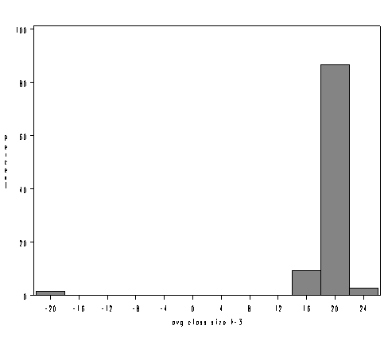

Likewise, a boxplot and stem-and-leaf plot would have called these observations to our attention as well.   In SAS you can use the **plot** option with **proc univariate** to request a boxplot and stem and leaf plot. Below we show just the combined boxplot and stem and leaf plot from this output. You can see the outlying negative observations way at the bottom of the boxplot.

**proc univariate data="c:\sasreg\elemapi" plot;**

**var acs_k3;**

**run;**

Histogram # Boxplot

25+* 1 0

.** 10 |

.**************************** 137 +-----+

.****************************************** 207 *--+--*

.******* 34 |

.* 3 0

.

.

.

.

.

.

.

.

.

.

.

.

.

.

.

.

.* 3 *

-21+* 3 *

----+----+----+----+----+----+----+----+--

* may represent up to 5 counts

We recommend plotting all of these graphs for the variables you will be analyzing. We will omit, due to space considerations, showing these graphs for all of the variables. However, in examining the variables, the stem-and-leaf plot for **full** seemed rather unusual.  Up to now, we have not seen anything problematic with this variable, but look at the stem and leaf plot for **full** below. It shows 104 observations where the percent with a full credential that is much lower than all other observations.  This is over 25% of the schools and seems very unusual.

**proc univariate data="c:\sasreg\elemapi" plot;**

**var full;**

**run;**

Histogram # Boxplot

102.5+*************************** 81 |

.****************** 54 +-----+

92.5+**************** 46 | |

.************ 36 *-----*

82.5+********** 30 | |

.****** 17 | |

72.5+*** 8 | |

.** 6 | + |

62.5+** 4 | |

.** 5 | |

52.5+* 1 | |

.** 4 | |

42.5+* 3 | |

.* 1 | |

32.5+ | |

. | |

22.5+ | |

. | |

12.5+ | |

. | |

2.5+*********************************** 104 +-----+

----+----+----+----+----+----+----+

* may represent up to 3 counts

Let's look at the frequency distribution of **full** to see if we can understand this better.  The values go from 0.42 to 1.0, then jump to 37 and go up from there.   It appears as though some of the percentages are actually entered as proportions, e.g., 0.42 was entered instead of 42 or 0.96 which really should have been 96.

**proc freq data="c:\sasreg\elemapi" ;**

**tables full;**

**run;**

pct full credential

Cumulative Cumulative

full Frequency Percent Frequency Percent

-----------------------------------------------------------------

0.4199999869 1 0.25 1 0.25

0.4499999881 1 0.25 2 0.50

0.4600000083 1 0.25 3 0.75

0.4699999988 1 0.25 4 1.00

0.4799999893 1 0.25 5 1.25

0.5 3 0.75 8 2.00

0.5099999905 1 0.25 9 2.25

0.5199999809 1 0.25 10 2.50

0.5299999714 1 0.25 11 2.75

0.5400000215 1 0.25 12 3.00

0.5600000024 2 0.50 14 3.50

0.5699999928 2 0.50 16 4.00

0.5799999833 1 0.25 17 4.25

0.5899999738 3 0.75 20 5.00

0.6000000238 1 0.25 21 5.25

0.6100000143 4 1.00 25 6.25

0.6200000048 2 0.50 27 6.75

0.6299999952 1 0.25 28 7.00

0.6399999857 3 0.75 31 7.75

0.6499999762 3 0.75 34 8.50

0.6600000262 2 0.50 36 9.00

0.6700000167 6 1.50 42 10.50

0.6800000072 2 0.50 44 11.00

0.6899999976 3 0.75 47 11.75

0.6999999881 1 0.25 48 12.00

0.7099999785 1 0.25 49 12.25

0.7200000286 2 0.50 51 12.75

0.7300000191 6 1.50 57 14.25

0.75 4 1.00 61 15.25

0.7599999905 2 0.50 63 15.75

0.7699999809 2 0.50 65 16.25

0.7900000215 3 0.75 68 17.00

0.8000000119 5 1.25 73 18.25

0.8100000024 8 2.00 81 20.25

0.8199999928 2 0.50 83 20.75

0.8299999833 2 0.50 85 21.25

0.8399999738 2 0.50 87 21.75

0.8500000238 3 0.75 90 22.50

0.8600000143 2 0.50 92 23.00

0.8999999762 3 0.75 95 23.75

0.9200000167 1 0.25 96 24.00

0.9300000072 1 0.25 97 24.25

0.9399999976 2 0.50 99 24.75

0.9499999881 2 0.50 101 25.25

0.9599999785 1 0.25 102 25.50

1 2 0.50 104 26.00

37 1 0.25 105 26.25

41 1 0.25 106 26.50

44 2 0.50 108 27.00

45 2 0.50 110 27.50

46 1 0.25 111 27.75

48 1 0.25 112 28.00

53 1 0.25 113 28.25

57 1 0.25 114 28.50

58 3 0.75 117 29.25

59 1 0.25 118 29.50

61 1 0.25 119 29.75

63 2 0.50 121 30.25

64 1 0.25 122 30.50

65 1 0.25 123 30.75

68 2 0.50 125 31.25

69 3 0.75 128 32.00

70 1 0.25 129 32.25

71 3 0.75 132 33.00

72 1 0.25 133 33.25

73 2 0.50 135 33.75

74 1 0.25 136 34.00

75 4 1.00 140 35.00

76 4 1.00 144 36.00

77 2 0.50 146 36.50

78 4 1.00 150 37.50

79 3 0.75 153 38.25

80 10 2.50 163 40.75

81 4 1.00 167 41.75

82 3 0.75 170 42.50

83 9 2.25 179 44.75

84 4 1.00 183 45.75

85 8 2.00 191 47.75

86 5 1.25 196 49.00

87 12 3.00 208 52.00

88 6 1.50 214 53.50

89 5 1.25 219 54.75

90 9 2.25 228 57.00

91 8 2.00 236 59.00

92 7 1.75 243 60.75

93 12 3.00 255 63.75

94 10 2.50 265 66.25

95 17 4.25 282 70.50

96 17 4.25 299 74.75

97 11 2.75 310 77.50

98 9 2.25 319 79.75

100 81 20.25 400 100.00

Let's see which district(s) these data came from.

**proc freq data="c:\sasreg\elemapi" ;**

**where (full <= 1);**

**tables dnum;**

**run;**

district number

Cumulative Cumulative

dnum Frequency Percent Frequency Percent

---------------------------------------------------------

401 104 100.00 104 100.00

We note that all 104 observations in which **full** was less than or equal to one came from district 401.  Let's see if this accounts for all of the observations that come from district 401.

**proc freq data="c:\sasreg\elemapi" ;**

**where (dnum = 401);**

**tables dnum;**

**run;**

district number

Cumulative Cumulative

dnum Frequency Percent Frequency Percent

---------------------------------------------------------

401 104 100.00 104 100.00

All of the observations from this district seem to be recorded as proportions instead of percentages.  Again, let us state that this is a pretend problem that we inserted into the data for illustration purposes.  If this were a real life problem, we would check with the source of the data and verify the problem.  We will make a note to fix this problem in the data as well.

Another useful graphical technique for screening your data is a scatterplot matrix. While this is probably more relevant as a diagnostic tool searching for non-linearities and outliers in your data, it can also be a useful data screening tool, possibly revealing information in the joint distributions of your variables that would not be apparent from examining univariate distributions.  Let's look at the scatterplot matrix for the variables in our regression model.  This reveals the problems we have already identified, i.e., the negative class sizes and the percent full credential being entered as proportions.

**proc insight data="c:\sasreg\elemapi";**

**scatter api00 acs_k3 meals full * api00 acs_k3 meals full;**

**run;**

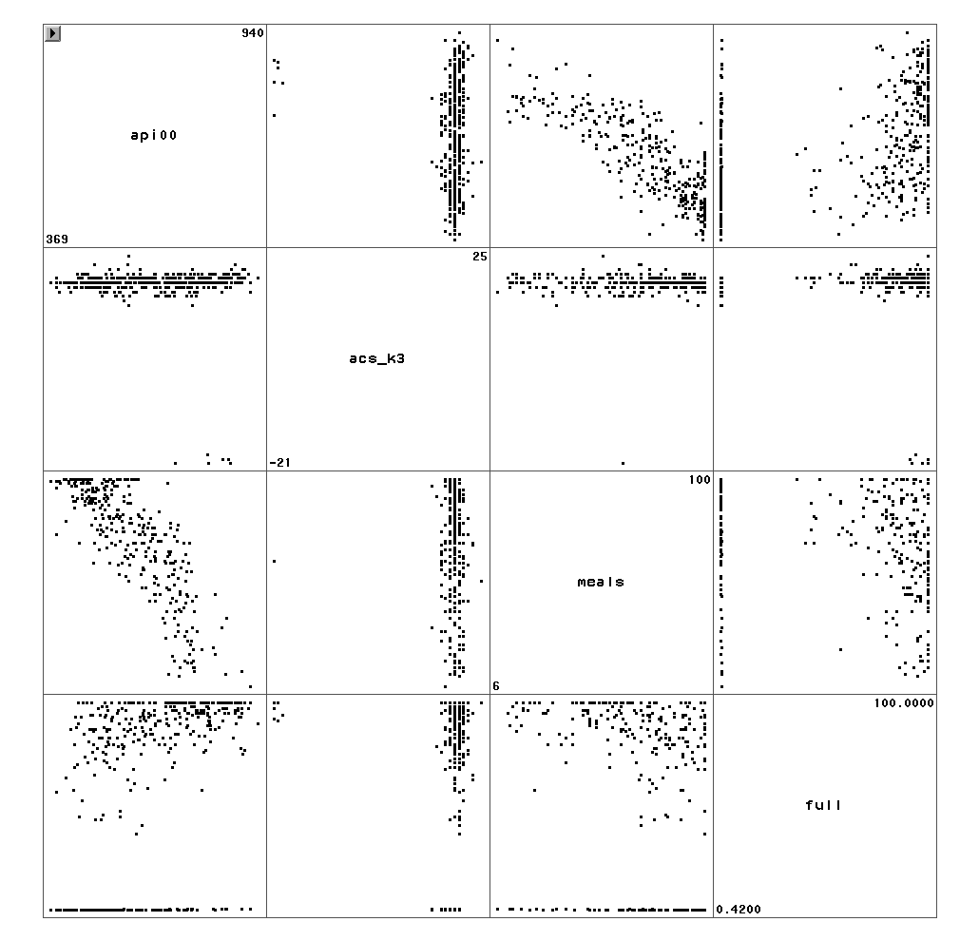

We have identified three problems in our data.  There are numerous missing values for **meals**, there were negatives accidentally inserted before some of the class sizes (**acs_k3**) and over a quarter of the values for **full** were proportions instead of percentages.  The corrected version of the data is called **elemapi2**.  Let's use that data file and repeat our analysis and see if the results are the same as our original analysis. First, let's repeat our original regression analysis below.

**proc reg data="c:\sasreg\elemapi"**

**model api00 = acs_k3 meals full;**

**run;**

Dependent Variable: api00 api 2000

Analysis of Variance

Sum of Mean

Source DF Squares Square F Value Pr > F

Model 3 2634884 878295 213.41 <.0001

Error 309 1271713 4115.57673

Corrected Total 312 3906597

Root MSE 64.15276 R-Square 0.6745

Dependent Mean 596.40575 Adj R-Sq 0.6713

Coeff Var 10.75656

Parameter Estimates

Parameter Standard

Variable Label DF Estimate Error t Value Pr > |t|

Intercept Intercept 1 906.73916 28.26505 32.08 <.0001

acs_k3 avg class size k-3 1 -2.68151 1.39399 -1.92 0.0553

meals pct free meals 1 -3.70242 0.15403 -24.04 <.0001

full pct full credential 1 0.10861 0.09072 1.20 0.2321

Now, let's use the corrected data file and repeat the regression analysis.  We see quite a difference in the results!  In the original analysis (above), **acs_k3** was nearly significant, but in the corrected analysis (below) the results show this variable to be not significant, perhaps due to the cases where class size was given a negative value.  Likewise, the percentage of teachers with full credentials was not significant in the original analysis, but is significant in the corrected analysis, perhaps due to the cases where the value was given as the proportion with full credentials instead of the percent.   Also, note that the corrected analysis is based on 398 observations instead of 313 observations, due to getting the complete data for the **meals** variable which had lots of missing values.

**proc reg data="c:\sasreg\elemapi2";**

**model api00 = acs_k3 meals full ;**

**run;**

Dependent Variable: api00 api 2000

Analysis of Variance

Sum of Mean

Source DF Squares Square F Value Pr > F

Model 3 6604966 2201655 615.55 <.0001

Error 394 1409241 3576.75370

Corrected Total 397 8014207

Root MSE 59.80597 R-Square 0.8242

Dependent Mean 648.46985 Adj R-Sq 0.8228

Coeff Var 9.22263

Parameter Estimates

Parameter Standard

Variable Label DF Estimate Error t Value Pr > |t|

Intercept Intercept 1 771.65811 48.86071 15.79 <.0001

acs_k3 avg class size k-3 1 -0.71706 2.23882 -0.32 0.7489

meals pct free meals 1 -3.68626 0.11178 -32.98 <.0001

full pct full credential 1 1.32714 0.23887 5.56 <.0001

From this point forward, we will use the corrected, **elemapi2**, data file.

So far we have covered some topics in data checking/verification, but we have not really discussed regression analysis itself.  Let's now talk more about performing regression analysis in SAS.  
  
**1.3 Simple Linear Regression**

Let's begin by showing some examples of simple linear regression using SAS. In this type of regression, we have only one predictor variable. This variable may be continuous, meaning that it may assume all values within a range, for example, age or height, or it may be dichotomous, meaning that the variable may assume only one of two values, for example, 0 or 1. The use of categorical variables with more than two levels will be covered in Chapter 3. There is only one response or dependent variable, and it is continuous.

In SAS, the dependent variable is listed immediately after the **model** statement followed by an equal sign and then one or more predictor variables. Let's examine the relationship between the size of school and academic performance to see if the size of the school is related to academic performance.  For this example, **api00** is the dependent variable and **enroll** is the predictor.

**proc reg data="c:\sasreg\elemapi2";**

**model api00 = enroll;**

**run;**

Dependent Variable: api00 api 2000

Analysis of Variance

Sum of Mean

Source DF Squares Square F Value Pr > F

Model 1 817326 817326 44.83 <.0001

Error 398 7256346 18232

Corrected Total 399 8073672

Root MSE 135.02601 R-Square 0.1012

Dependent Mean 647.62250 Adj R-Sq 0.0990

Coeff Var 20.84949

Parameter Estimates

Parameter Standard

Variable Label DF Estimate Error t Value Pr > |t|

Intercept Intercept 1 744.25141 15.93308 46.71 <.0001

enroll number of students 1 -0.19987 0.02985 -6.70 <.0001

Let's review this output a bit more carefully. First, we see that the F-test is statistically significant, which means that the model is statistically significant. The R-squared is .1012 means that approximately 10% of the variance of **api00** is accounted for by the model, in this case, **enroll**. The t-test for **enroll** equals -6.70 , and is statistically significant, meaning that the regression coefficient for **enroll** is significantly different from zero. Note that (-6.70)2 = 44.89, which is the same as the F-statistic (with some rounding error). The coefficient for **enroll** is -.19987, or approximately -0.2, meaning that for a one unit increase in **enroll**, we would expect a 0.2-unit decrease in **api00**. In other words, a school with 1100 students would be expected to have an api score 20 units lower than a school with 1000 students.  The constant is 744.2514, and this is the predicted value when **enroll** equals zero.  In most cases, the constant is not very interesting.  We have prepared an annotated output which shows the output from this regression along with an explanation of each of the items in it.

In addition to getting the regression table, it can be useful to see a scatterplot of the predicted and outcome variables with the regression line plotted.  SAS makes this very easy for you by using the **plot** statement as part of **proc reg**.  For example, below we show how to make a scatterplot of the outcome variable, **api00** and the predictor, **enroll**. Note that the graph also includes the predicted values in the form of the regression line.

**proc reg data="c:\sasreg\elemapi2";**

**model api00 = enroll ;**

**plot api00 * enroll ;**

**run;**

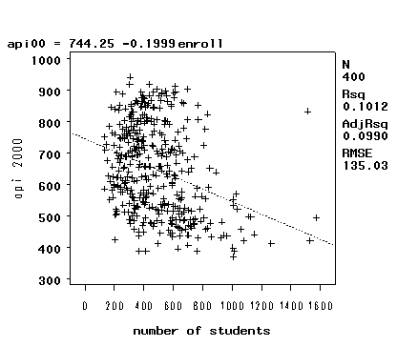

As you see, this one command produces a scatterplot and regression line, and it also includes the regression model with the correlation of the two variables in the title.  We could include a 95% prediction interval using the **pred** option on the plot statement as illustrated below.

**proc reg data="c:\sasreg\elemapi2" ;**

**model api00 = enroll ;**

**plot api00 * enroll / pred;**

**run;**

**quit;**

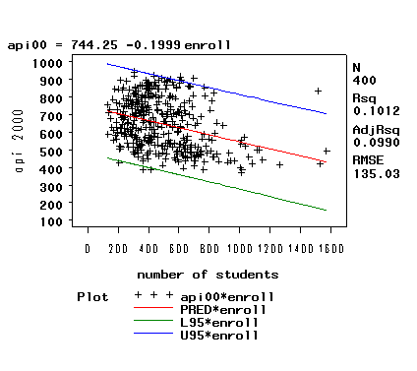

Another kind of graph that you might want to make is a residual versus fitted plot.  As shown below, we can use the **plot** statement to make this graph.  The keywords **residual.** and **predicted.** in this context refer to the residual value and predicted value from the regression analysis and can be abbreviated as **r.** and **p.** .

**proc reg data="c:\sasreg\elemapi2";**

**model api00 = enroll ;**

**plot residual. * predicted. ;**

**run;**

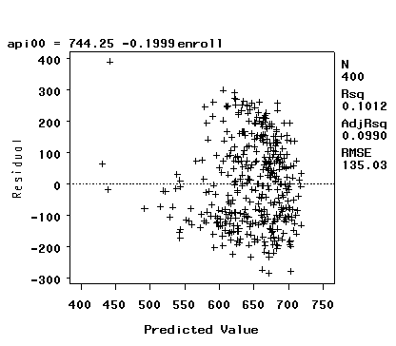

The table below shows a number of other keywords that can be used with the **plot** statement and the statistics they display.

|  |  |
| --- | --- |
| **Keyword** | **Statistic** |
| COOKD. | Cook's D influence statistics |
| COVRATIO. | standard influence of observation on covariance of betas |
| DFFITS. | standard influence of observation on predicted value |
| H. | leverage |
| LCL. | lower bound of 100(1-\alpha)% confidence interval for individual prediction |
| LCLM. | lower bound of 100(1-\alpha)% confidence interval for the mean of the dependent variable |
| PREDICTED. | PRED. | P. | predicted values |
| PRESS. | residuals from refitting the model with current observation deleted |
| RESIDUAL. | R. | residuals |
| RSTUDENT. | studentized residuals with the current observation deleted |
| STDI. | standard error of the individual predicted value |
| STDP. | standard error of the mean predicted value |
| STDR. | standard error of the residual |
| STUDENT. | residuals divided by their standard errors |
| UCL. | upper bound of 100(1-\alpha)% confidence interval for individual prediction |
| UCLM. | upper bound of 100(1-\alpha)% confidence interval for the mean of the dependent variables |

**1.4 Multiple Regression**

Now, let's look at an example of multiple regression, in which we have one outcome (dependent) variable and multiple predictors. For this multiple regression example, we will regress the dependent variable, **api00**, on all of the predictor variables in the data set.

**proc reg data="c:\sasreg\elemapi2" ;**

**model api00 = ell meals yr_rnd mobility acs_k3 acs_46 full emer enroll ;**

**run;**

Dependent Variable: api00 api 2000

Analysis of Variance

Sum of Mean

Source DF Squares Square F Value Pr > F

Model 9 6740702 748967 232.41 <.0001

Error 385 1240708 3222.61761

Corrected Total 394 7981410

Root MSE 56.76810 R-Square 0.8446

Dependent Mean 648.65063 Adj R-Sq 0.8409

Coeff Var 8.75172

Parameter Estimates

Parameter Standard

Variable Label DF Estimate Error t Value Pr > |t|

Intercept Intercept 1 758.94179 62.28601 12.18 <.0001

ell english language learners 1 -0.86007 0.21063 -4.08 <.0001

meals pct free meals 1 -2.94822 0.17035 -17.31 <.0001

yr_rnd year round school 1 -19.88875 9.25844 -2.15 0.0323

mobility pct 1st year in school 1 -1.30135 0.43621 -2.98 0.0030

acs_k3 avg class size k-3 1 1.31870 2.25268 0.59 0.5586

acs_46 avg class size 4-6 1 2.03246 0.79832 2.55 0.0113

full pct full credential 1 0.60972 0.47582 1.28 0.2008

emer pct emer credential 1 -0.70662 0.60541 -1.17 0.2439

enroll number of students 1 -0.01216 0.01679 -0.72 0.4693

Let's examine the output from this regression analysis.  As with the simple regression, we look to the p-value of the F-test to see if the overall model is significant. With a p-value of zero to four decimal places, the model is statistically significant. The R-squared is 0.8446, meaning that approximately 84% of the variability of **api00** is accounted for by the variables in the model. In this case, the adjusted R-squared indicates that about 84% of the variability of **api00** is accounted for by the model, even after taking into account the number of predictor variables in the model. The coefficients for each of the variables indicates the amount of change one could expect in **api00** given a one-unit change in the value of that variable, given that all other variables in the model are held constant. For example, consider the variable **ell**.   We would expect a decrease of 0.86 in the **api00** score for every one unit increase in **ell**, assuming that all other variables in the model are held constant.  The interpretation of much of the output from the multiple regression is the same as it was for the simple regression.  We have prepared an annotated output that more thoroughly explains the output of this multiple regression analysis.

You may be wondering what a 0.86 change in **ell** really means, and how you might compare the strength of that coefficient to the coefficient for another variable, say **meals**. To address this problem, we can use the **stb** option on the **model** statement to request that in addition to the standard output that SAS also display a table of the standardized values, sometimes called beta coefficients.  Below we show just the portion of the output that includes these standardized values.  The beta coefficients are used by some researchers to compare the relative strength of the various predictors within the model. Because the beta coefficients are all measured in standard deviations, instead of the units of the variables, they can be compared to one another. In other words, the beta coefficients are the coefficients that you would obtain if the outcome and predictor variables were all transformed to standard scores, also called z-scores, before running the regression.

**proc reg data="c:\sasreg\elemapi2" ;**

**model api00 = ell meals yr_rnd mobility acs_k3 acs_46 full emer enroll / stb;**

**run;**

Parameter Estimates

Standardized

Variable Label DF Estimate

Intercept Intercept 1 0

ell english language learners 1 -0.14958

meals pct free meals 1 -0.66070

yr_rnd year round school 1 -0.05914

mobility pct 1st year in school 1 -0.06864

acs_k3 avg class size k-3 1 0.01273

acs_46 avg class size 4-6 1 0.05498

full pct full credential 1 0.06380

emer pct emer credential 1 -0.05801

enroll number of students 1 -0.01936

Because these standardized coefficients are all in the same standardized units you can compare these coefficients to assess the relative strength of each of the predictors.  In this example, **meals** has the largest Beta coefficient, -0.66, and **acs_k3** has the smallest Beta, 0.013.  Thus, a one standard deviation increase in **meals** leads to a 0.66 standard deviation decrease in predicted **api00**, with the other variables held constant. And, a one standard deviation increase in **acs_k3**, in turn, leads to a 0.013 standard deviation increase **api00** with the other variables in the model held constant.

In interpreting this output, remember that the difference between the regular coefficients (from the prior output) and the standardized coefficients above is the units of measurement.  For example, to describe the raw coefficient for **ell** you would say  "A one-unit decrease in **ell** would yield a .86-unit increase in the predicted **api00**." However, for the standardized coefficient (Beta) you would say, "A one standard deviation decrease in **ell** would yield a .15 standard deviation increase in the predicted **api00**."

So far, we have concerned ourselves with testing a single variable at a time, for example looking at the coefficient for **ell** and determining if that is significant. We can also test sets of variables, using the **test** command, to see if the set of variables are significant.  First, let's start by testing a single variable, **ell**, using the **test** statement.  Note that the part before the **test** command, **test1:**, is merely a label to identify the output of the test command.  This label could be any short label to identify the output.

**proc reg data="c:\sasreg\elemapi2" ;**

**model api00 = ell meals yr_rnd mobility acs_k3 acs_46 full emer enroll ;**

**test1: test ell =0;**

**run;**

Test TEST1 Results for Dependent Variable api00

Mean

Source DF Square F Value Pr > F

Numerator 1 53732 16.67 <.0001

Denominator 385 3222.61761

If you compare this output with the output from the last regression you can see that the result of the F-test, 16.67, is the same as the square of the result of the t-test in the regression (-4.083^2 = 16.67). Note that you could get the same results if you typed the following since SAS defaults to comparing the term(s) listed to 0.

**proc reg data="c:\sasreg\elemapi2" ;**

**model api00 = ell meals yr_rnd mobility acs_k3 acs_46 full emer enroll / stb;**

**test2: test ell;**

**run;**

Test TEST2 Results for Dependent Variable api00

Mean

Source DF Square F Value Pr > F

Numerator 1 53732 16.67 <.0001

Denominator 385 3222.61761

Perhaps a more interesting test would be to see if the contribution of class size is significant.  Since the information regarding class size is contained in two variables, **acs_k3** and **acs_46**, so we include both of these separated by a comma on the **test** command.  Below we show just the output from the **test** command.

**proc reg data="c:\sasreg\elemapi2" ;**

**model api00 = ell meals yr_rnd mobility acs_k3 acs_46 full emer enroll ;**

**test_class_size: test acs_k3, acs_46;**

**run;**

Test TEST_CLASS_SIZE Results for Dependent Variable api00

Mean

Source DF Square F Value Pr > F

Numerator 2 12742 3.95 0.0200

Denominator 385 3222.61761

The significant F-test, 3.95, means that the collective contribution of these two variables is significant.  One way to think of this, is that there is a significant difference between a model with **acs_k3** and **acs_46** as compared to a model without them, i.e., there is a significant difference between the "full" model and the "reduced" models.

Finally, as part of doing a multiple regression analysis you might be interested in seeing the correlations among the variables in the regression model.  You can do this with **proc corr** as shown below.

**proc corr data="c:\sasreg\elemapi2" ;**

**var api00 ell meals yr_rnd mobility acs_k3 acs_46 full emer enroll ;**

**run;**

Pearson Correlation Coefficients

Prob > |r| under H0: Rho=0

Number of Observations

api00 ell meals yr_rnd mobility

api00 1.00000 -0.76763 -0.90070 -0.47544 -0.20641

api 2000 <.0001 <.0001 <.0001 <.0001

400 400 400 400 399

ell -0.76763 1.00000 0.77238 0.49793 -0.02046

english language learners <.0001 <.0001 <.0001 0.6837

400 400 400 400 399

meals -0.90070 0.77238 1.00000 0.41845 0.21665

pct free meals <.0001 <.0001 <.0001 <.0001

400 400 400 400 399

yr_rnd -0.47544 0.49793 0.41845 1.00000 0.03479

year round school <.0001 <.0001 <.0001 0.4883

400 400 400 400 399

mobility -0.20641 -0.02046 0.21665 0.03479 1.00000

pct 1st year in school <.0001 0.6837 <.0001 0.4883

399 399 399 399 399

acs_k3 0.17100 -0.05565 -0.18797 0.02270 0.04014

avg class size k-3 0.0006 0.2680 0.0002 0.6517 0.4245

398 398 398 398 398

acs_46 0.23291 -0.17330 -0.21309 -0.04207 0.12769

avg class size 4-6 <.0001 0.0005 <.0001 0.4032 0.0110

397 397 397 397 396

full 0.57441 -0.48476 -0.52756 -0.39771 0.02521

pct full credential <.0001 <.0001 <.0001 <.0001 0.6156

400 400 400 400 399

emer -0.58273 0.47218 0.53304 0.43472 0.05961

pct emer credential <.0001 <.0001 <.0001 <.0001 0.2348

400 400 400 400 399

enroll -0.31817 0.40302 0.24103 0.59182 0.10502

number of students <.0001 <.0001 <.0001 <.0001 0.0360

400 400 400 400 399

Pearson Correlation Coefficients

Prob > |r| under H0: Rho=0

Number of Observations

acs_k3 acs_46 full emer enroll

api00 0.17100 0.23291 0.57441 -0.58273 -0.31817

api 2000 0.0006 <.0001 <.0001 <.0001 <.0001

398 397 400 400 400

ell -0.05565 -0.17330 -0.48476 0.47218 0.40302

english language learners 0.2680 0.0005 <.0001 <.0001 <.0001

398 397 400 400 400

meals -0.18797 -0.21309 -0.52756 0.53304 0.24103

pct free meals 0.0002 <.0001 <.0001 <.0001 <.0001

398 397 400 400 400

yr_rnd 0.02270 -0.04207 -0.39771 0.43472 0.59182

year round school 0.6517 0.4032 <.0001 <.0001 <.0001

398 397 400 400 400

mobility 0.04014 0.12769 0.02521 0.05961 0.10502

pct 1st year in school 0.4245 0.0110 0.6156 0.2348 0.0360

398 396 399 399 399

acs_k3 1.00000 0.27078 0.16057 -0.11033 0.10890

avg class size k-3 <.0001 0.0013 0.0277 0.0298

398 395 398 398 398

acs_46 0.27078 1.00000 0.11773 -0.12446 0.02829

avg class size 4-6 <.0001 0.0190 0.0131 0.5741

395 397 397 397 397

full 0.16057 0.11773 1.00000 -0.90568 -0.33769

pct full credential 0.0013 0.0190 <.0001 <.0001

398 397 400 400 400

emer -0.11033 -0.12446 -0.90568 1.00000 0.34309

pct emer credential 0.0277 0.0131 <.0001 <.0001

398 397 400 400 400

enroll 0.10890 0.02829 -0.33769 0.34309 1.00000

number of students 0.0298 0.5741 <.0001 <.0001

398 397 400 400 400

We can see that the strongest correlation with **api00** is **meals** with a correlation in excess of -0.9.  The variables **ell** and **emer** are also strongly correlated with **api00**. All three of these correlations are negative, meaning that as the value of one variable goes down, the value of the other variable tends to go up. Knowing that these variables are strongly associated with **api00**, we might predict that they would be statistically significant predictor variables in the regression model. Note that the number of cases used for each correlation is determined on a "pairwise" basis, for example there are 398 valid pairs of data for **enroll** and **acs_k3**, so that correlation of .1089 is based on 398 observations.

**1.5 Transforming Variables**

Earlier we focused on screening your data for potential errors.  In the next chapter, we will focus on regression diagnostics to verify whether your data meet the assumptions of linear regression.  Here, we will focus on the issue of normality.  Some researchers believe that linear regression requires that the outcome (dependent) and predictor variables be normally distributed. We need to clarify this issue. In actuality, it is the residuals that need to be normally distributed.  In fact, the residuals need to be normal only for the t-tests to be valid. The estimation of the regression coefficients do not require normally distributed residuals. As we are interested in having valid t-tests, we will investigate issues concerning normality.

A common cause of non-normally distributed residuals is non-normally distributed outcome and/or predictor variables.  So, let us explore the distribution of our variables and how we might transform them to a more normal shape.  Let's start by making a histogram of the variable **enroll**, which we looked at earlier in the simple regression.

**proc univariate data="c:\sasreg\elemapi2";**

**var enroll ;**

**histogram / cfill=gray;**

**run;**

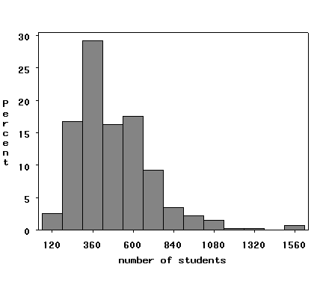

We can use the **normal** option to superimpose a normal curve on this graph and the **midpoints** option to indicate that we want bins with midpoints from 100 to 1500 going in increments of 100.

**proc univariate data="c:\sasreg\elemapi2";**

**var enroll ;**

**histogram / cfill=gray normal midpoints=100 to 1500 by 100;**

**run;**

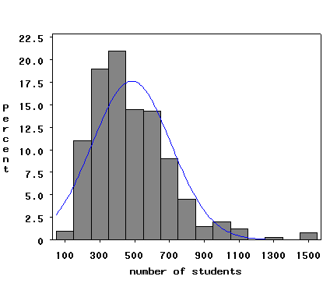

Histograms are sensitive to the number of bins or columns that are used in the display. An alternative to histograms is the kernel density plot, which approximates the probability density of the variable. Kernel density plots have the advantage of being smooth and of being independent of the choice of origin, unlike histograms. You can add a kernel density plot to the above plot with he **kernel** option as illustrated below.

**proc univariate data="c:\sasreg\elemapi2";**

**var enroll ;**

**histogram / cfill=gray normal midpoints=100 to 1500 by 100 kernel;**

**run;**

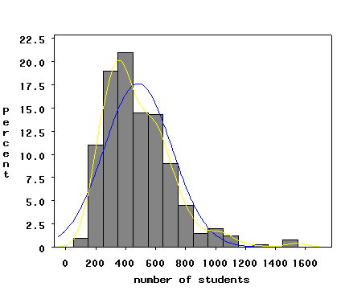

Not surprisingly, the **kdensity** plot also indicates that the variable **enroll** does not look normal.

There are two other types of graphs that are often used to examine the distribution of variables; quantile-quantile plots and normal probability plots.

A quantile-quantile plot graphs the quantiles of a variable against the quantiles of a normal (Gaussian) distribution. Such plots are  sensitive to non-normality near the tails, and indeed we see considerable deviations from normal, the diagonal line, in the tails. This plot is typical of variables that are strongly skewed to the right.

**proc univariate data="c:\sasreg\elemapi2";**

**var enroll ;**

**qqplot / normal;**

**run;**

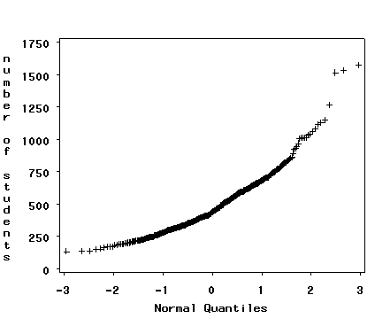

The normal probability plot is also useful for examining the distribution of variables and is sensitive to deviations from normality nearer to the center of the distribution. We will use SAS **proc capability** to get the normal probability plot. Again, we see indications non-normality in **enroll**.

**proc capability data="c:\sasreg\elemapi2" noprint;**

**ppplot enroll ;**

**run;**

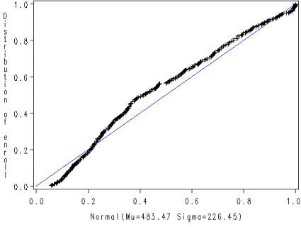

Given the skewness to the right in **enroll**, let us try a log transformation to see if that makes it more normal.  Below we create a variable **lenroll** that is the natural log of **enroll** and then we repeat some of the above commands to see if **lenroll** is more normally distributed.

**data elemapi3;**

**set "c:\sasreg\elemapi2";**

**lenroll = log(enroll);**

**run;**

Now let's try showing a histogram for **lenroll** with a normal overlay and a kernel density estimate.

**proc univariate data=elemapi3 noprint;**

**var lenroll ;**

**histogram / cfill=grayd0 normal kernel (color = red);**

**run;**

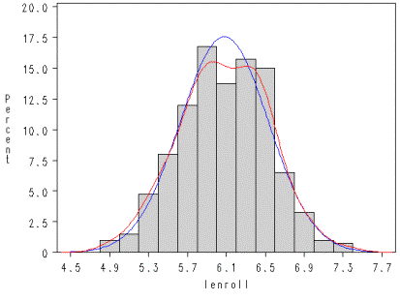

We can see that **lenroll** looks quite normal.  We could then create a quantile-quantile plot and a normal probability plot to further assess whether **lenroll** seems normal, as well as seeing how **lenroll** impacts the residuals, which is really the important consideration.