1. What Is Nagios?
2. How To Install Nagios?
3. How To Add A Remote Server Using NRPE (Nagios Remote Plugin Executor).

**What is Nagios?**

Nagios is used for Continuous monitoring of systems, applications, services, and business processes etc in a DevOps culture. In the event of a failure, Nagios can alert technical staff of the problem, allowing them to begin remediation processes before outages affect business processes, end-users, or customers. With Nagios, you don’t have to explain why an unseen infrastructure outage affect your organization’s bottom line.

## ****Nagios Architecture:****

* Nagios is built on a server/agents architecture.
* Usually, on a network, a Nagios server is running on a host, and Plugins interact with local and all the remote hosts that need to be monitored.
* These plugins will send information to the Scheduler, which displays that in a GUI.

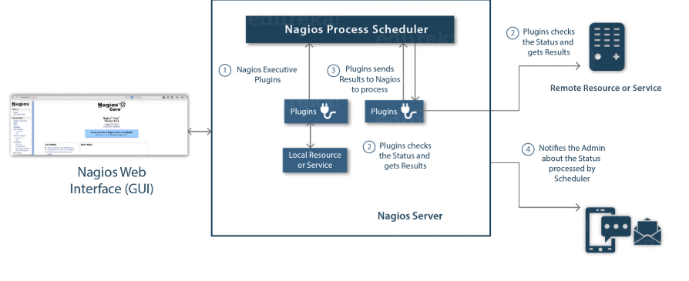

**Install Nagios Core:**

The complete process to install Nagios can be summarized in four steps:

1. Install Required Packages In The Monitoring Server
2. Install Nagios Core, Nagios Plugins And NRPE (Nagios Remote Plugin Executor)
3. Set Nagios Password To Access The Web Interface
4. Install NRPE In Client

**Step – 1: Install Required Packages On The Monitoring Server:**

Visit the website:**http://dl.fedoraproject.org/pub/epel/6/**

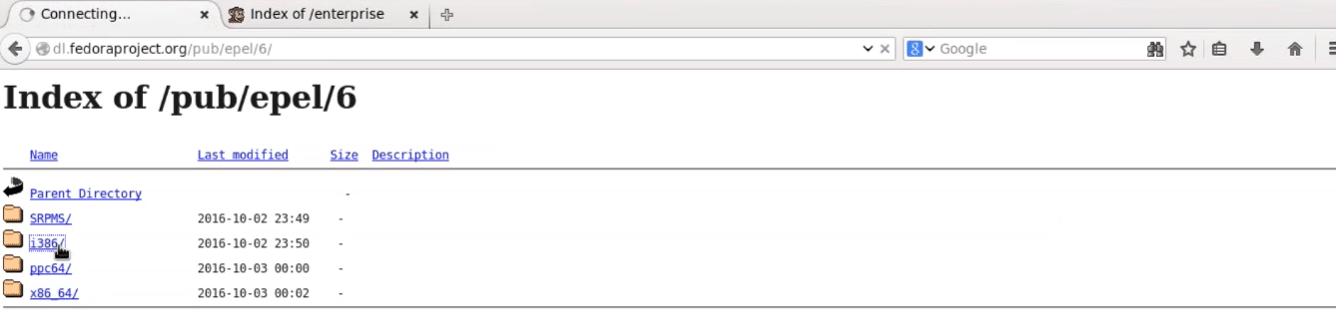

Click on i386, and then you will be redirected to a page.

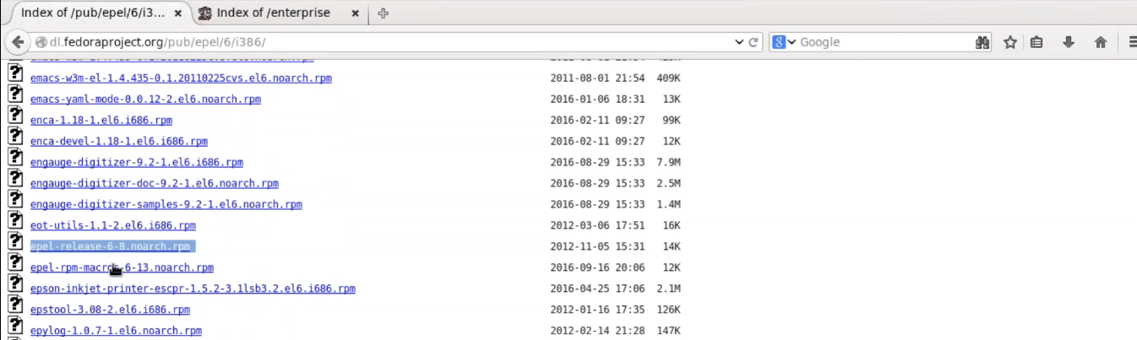

Since I am using CentOS 6, so I will right click and copy the link location of ‘*epel-release-6-8.noarch.rpm*‘, as shown in the above screenshot.

Open the terminal and use *rpm -Uvh*command and paste the link.

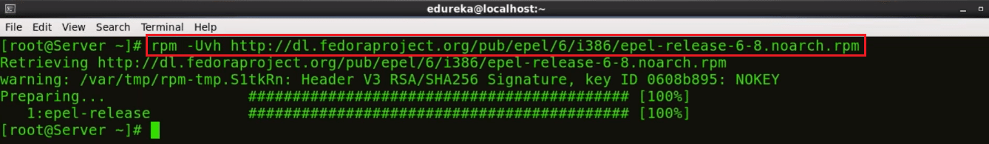

We need to download one more repository, for that visit the website ‘http://rpms.famillecollet.com/enterprise/‘



Right-click and copy the link location for ‘remi-release-6.rpm‘

Again open the terminal and use rpm -Uvh command and paste the link.



Fine, so we are done with the pre-requisites. Let’s proceed to the next step.

## ****Step – 2: Install Nagios Core, Nagios Plugins And NRPE (Nagios Remote Plugin Executor):****

Execute the below command in the terminal:

yum -y install nagios nagios-plugins-all nagios-plugins-nrpe nrpe httpd php

This will install Nagios, Nagios Plugins, Plugins for NRPE, NRPE, Apache and PHP

Apache web server is required to monitor the current web server status.

Php is used to process dynamic content of the site date.



Next, we need to enable Apache and Nagios service:

chkconfig httpd on && chkconfig nagios on



Our next step is to start Nagios and Apache:

service httpd start && service nagios start



Now, I will enable swap memory of at least 1GB. It’s time to create the swap file itself using the dd command:

dd if=/dev/zero of=/swap bs=1024 count=2097152

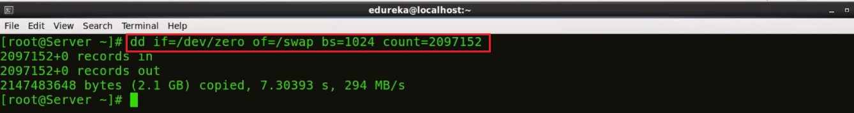Swap is basically used to free some, not so frequently accessed information from RAM, and move it to a specific partition on our hard drive.

Now that you have created the swap partition, use the command *mkswap* to setup the swap partition. This is going to prepare the swap file by creating a linux swap area.

mkswap /swap

To prevent the file from being world-readable, you should set up the correct permissions on the swap file:

chown root. /swap

chmod 0600 /swap

If you see no errors, your swap space is ready to use. To activate it immediately, type:

swapon /swap

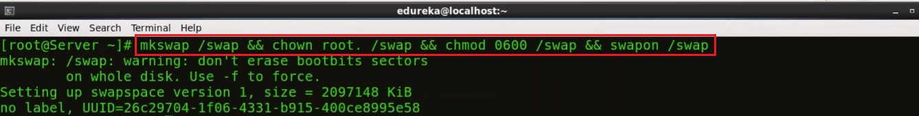

This file will last on the virtual private server until the machine reboots. You can ensure that the swap is permanent by adding it to the fstab file.

echo /swap swap swap defaults 0 0 >> /etc/fstab



The operating system kernel can adjust how often it relies on swap through a configuration parameter known as **swappiness**.

To find the current swappiness settings, type:

cat /proc/sys/vm/swappiness

Swapiness can be a value from 0 to 100. Swappiness near 100 means that the operating system will swap often and usually, too soon. Although swap provides extra resources, RAM is much faster than swap space. Anytime something is moved from RAM to swap, it slows down.

A swappiness value of 0 means that the operating will only rely on swap when it absolutely needs to. We can adjust the swappiness with the sysctl command. To make your VPS automatically apply this setting every time it boots up, you can add the setting to the /etc/sysctl.conf file:

echo vm.swappiness = 0 >> /etc/sysctl.conf && sysctl -p

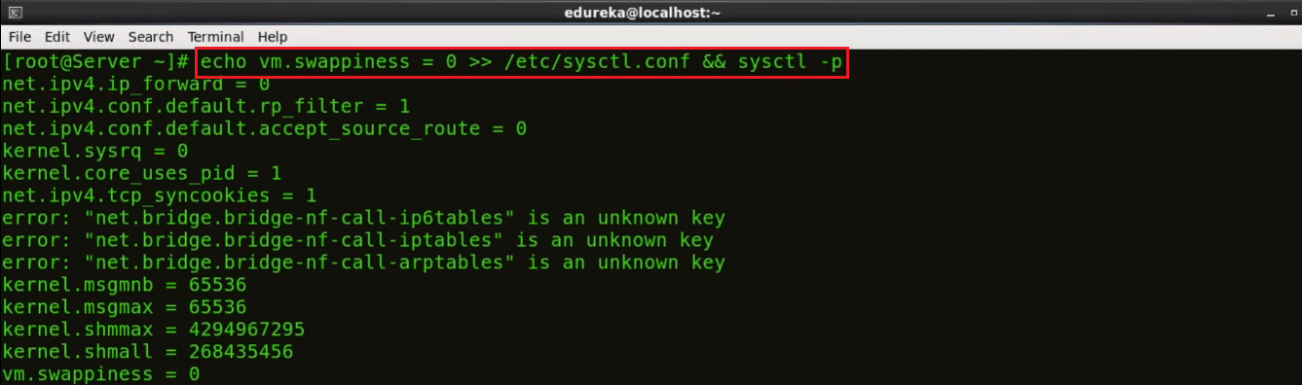

Finally, we are done with the second step.

Let’s proceed further and set Nagios password to access the web interface.

## ****Step – 3: Set Nagios Password To Access The Web Interface:****

Set the password to access the web interface, use the below command:

htpasswd -c /etc/nagios/passwd nagiosadmin

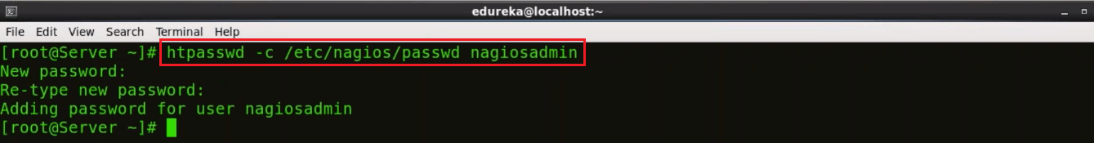

Type the password and confirm it by retyping it.

Now, open the browser. Here, type your public IP or hostname/nagios. Consider the example below:

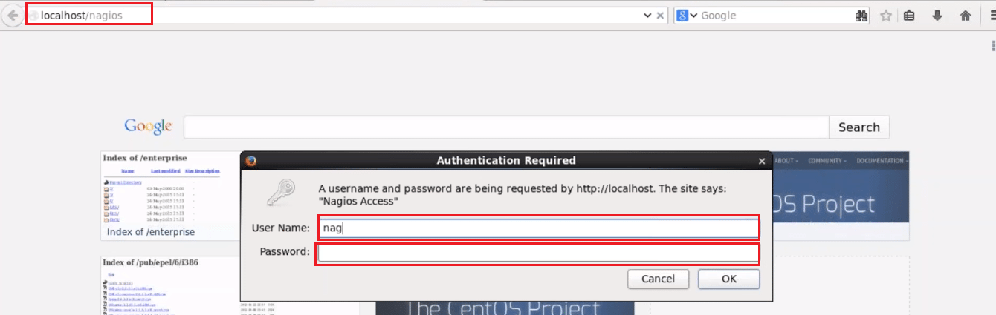

Here, give the user name and password. By default, the user name is nagiosadmin, and password is what you have set in the previous step. Finally, press OK.

You can click on hosts and see the what all hosts your Nagios Core is currently monitoring.

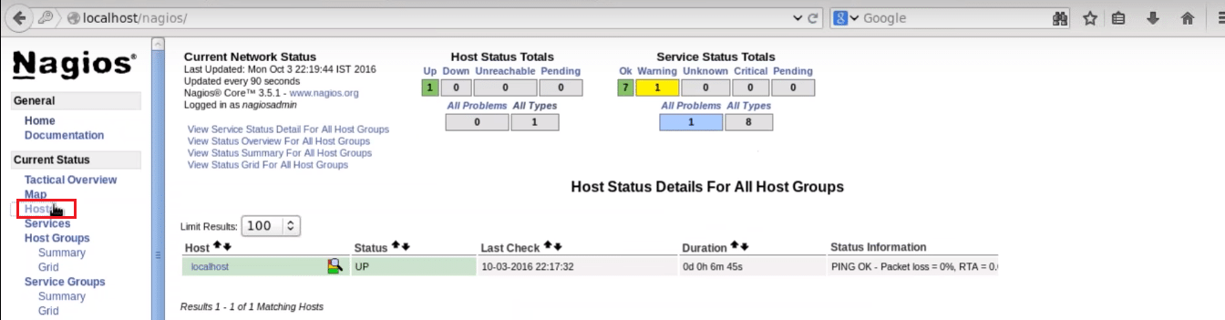

You can notice it is only monitoring one host, i.e. localhost. If I want my Nagios Core to monitor a remote host, I need to install NRPE in that remote host. This brings us to the next step, install NRPE In client/machine that you want Nagios to monitor.

## ****Step – 4: Install NRPE In Client:****

Alrighty then, let’s install NRPE in the client machine.

Firstly, you need to install the required packages like I did on my Nagios server machine. So, just execute the same commands, consider the below screenshots:

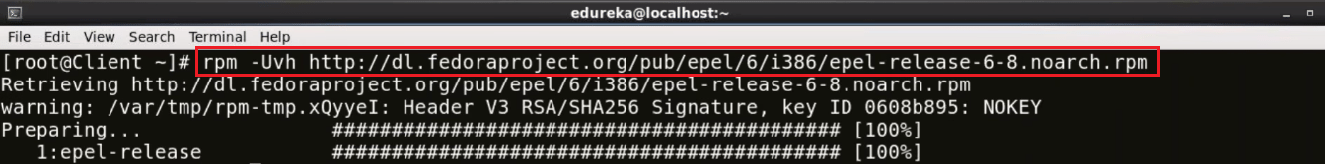

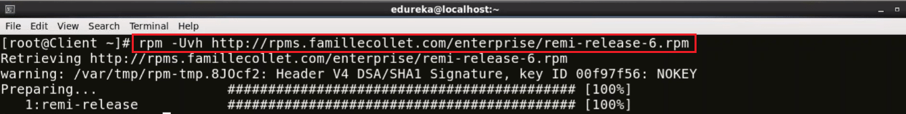

Now install Nagios, Nagios Plugins and NRPE in client:

yum -y install nagios nagios-plugins-all nrpe

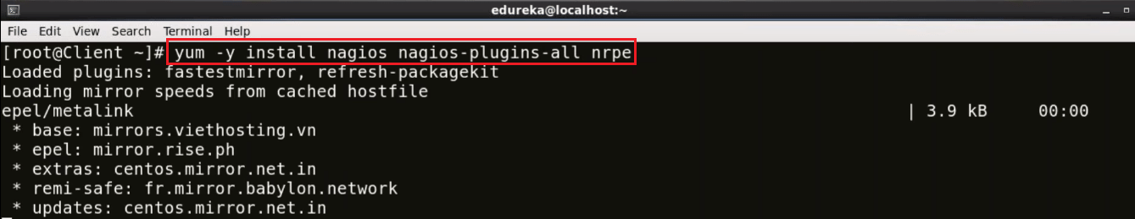

Once it is installed, enable the NRPE service:

chkconfig nrpe on

  
Our next step is to edit the, nrpe.cfg file. I will be using the vi editor, you can choose any other editor also:



You need to add the IP address of your monitoring server, in the allowed host line, consider the below screenshot:

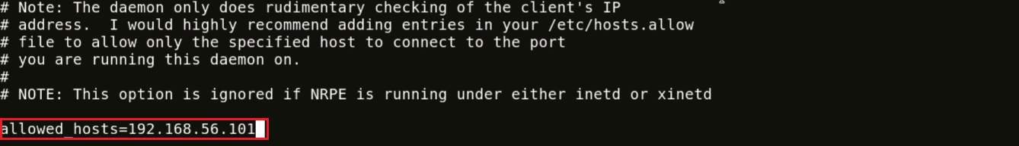

Here, the IP address of my monitoring server is 192.168.56.101.

Now, we need to setup firewall rules to allow connection between monitoring server and client.

iptables -N NRPE

-A option is used to append the new rule to the end of a chain. If you want to put it somewhere else in the chain, you can use the -I option which allows you to specify the position of the new rule.

The below command accepts tcp requests on ports 5666.

iptables -I INPUT -s 0/0 -p tcp --dport 5666 -j NRPE

iptables -I NRPE -s 192.168.56.101 -j ACCEPT

iptables -A NRPE -s 0/0 -j DROP

This will basically configure iptables to accept packets from a particular host, in my case – 192.168.56.101, and drops the packets from other hosts.

Now, I will save these configurations:

/etc/init.d/iptables save



Start NRPE service now.

service nrpe start

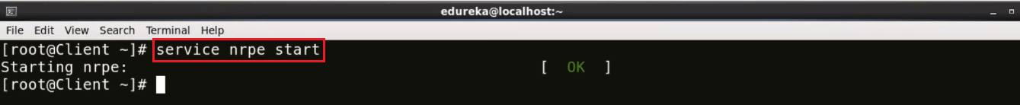

Now go back to the Monitoring server.

Here, I need to edit nagios.cfg file.

vi /etc/nagios/nagios.cfg



Uncomment the the line – cfg_dir = etc/nagios/servers



Make ‘server’ directory, for that use mkdir command.

mkdir /etc/nagios/servers/



Change your working directory to servers.

cd /etc/nagios/servers



Create a new file in this directory with .cfg extension and edit it. I will name it as client.cfg, and I will be using **vi** editor.

vi /etc/nagios/servers/client.cfg



Here add the below lines:

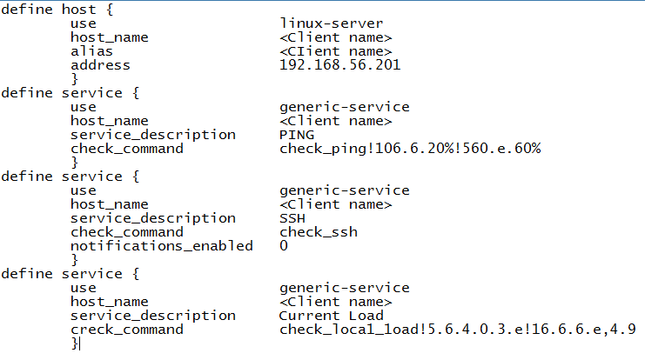This basically includes the kind of services I want to monitor. Give the hostname of the machine and its ip address which you want Nagios to monitor.

Similarly, you can add number of services that you want to monitor. The same configurations can be used to add ‘n’ number of clients.

chown -R nagios. /etc/nagios/

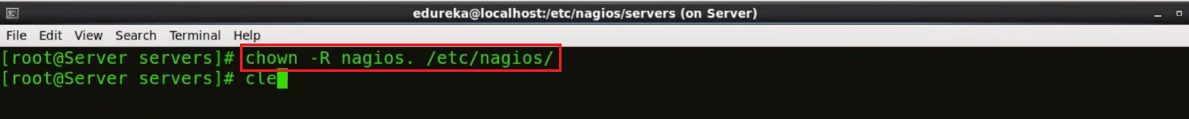

Now, restart Nagios

service nagios restart

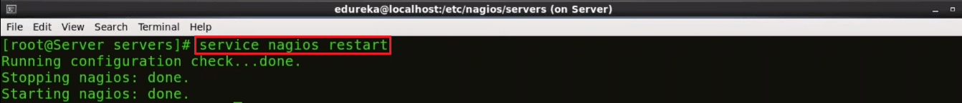

Open the browser and again type the *host name or public ip/nagios/.*In my case it is localhost/nagios/.

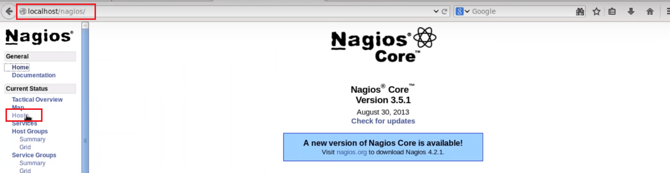

Click on hosts to see all the machines Nagios is currently monitoring.

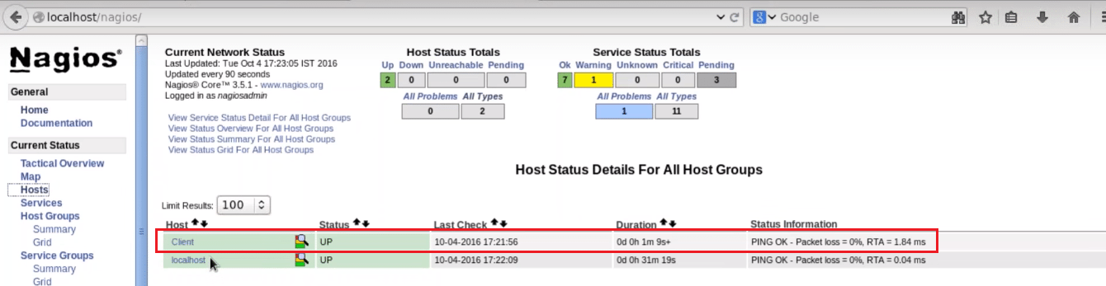

Here you can notice, it is currently monitoring the client machine (hostname of the machine that I want Nagios to monitor). Basically, we have added a remote host using NRPE.