**Upload File in Selenium Webdriver using Autoit**

## Introduction to AutoIT tool

1-AutoIt is freeware automation tool that can work with desktop application too.

2-It uses a combination of keystrokes, mouse movement and window/control manipulation in order to automate tasks in a way not possible or reliable with other languages (e.g. VBScript and SendKeys).

**How to write a script in AutoIT?**

For AutoIt scripting, you should have three things ready.

1-AutoIt Editor- Editor helps us to write AutoIt scripts.

2-Tool Finder (Same as firebug on Firefox) – It will help us to identify the element and check their Attributes.

3- AutoIt Help section- This help you to understand about AutoIt functions and what are the parameter it accepts.

**Step 1**– Navigate to AutoIt  official website  <https://www.autoitscript.com/site/autoit/downloads/>  and go to download section or Click here [Download AutoIt](https://www.autoitscript.com/site/autoit/downloads/)

**Step 2**– Click on Download AutoIt and Install

**Step 3**–  Click on Download Editor and Install.  
[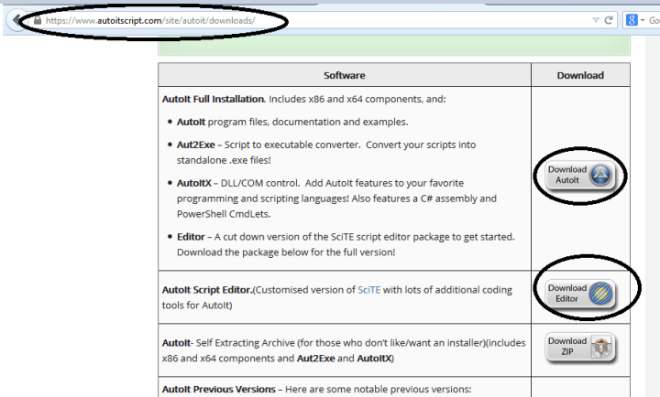](https://i1.wp.com/learn-automation.com/wp-content/uploads/2015/03/3389.png)

**Step 4**– Once both installed in your machine check all is installed correctly.

Note- Generally it goes to C:\Program Files\AutoIt3 location if you do not change it

[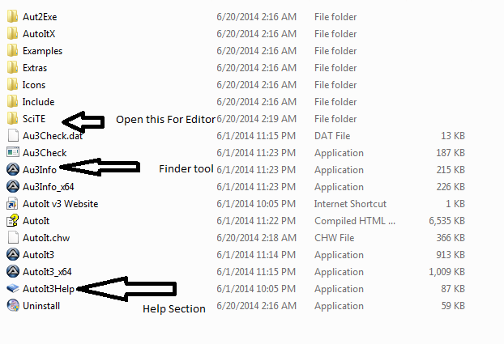](https://i1.wp.com/learn-automation.com/wp-content/uploads/2015/03/4400.png)

**Step5**– Open SCiTE folder and  Click on SciTE this will open AutoIt Editor

[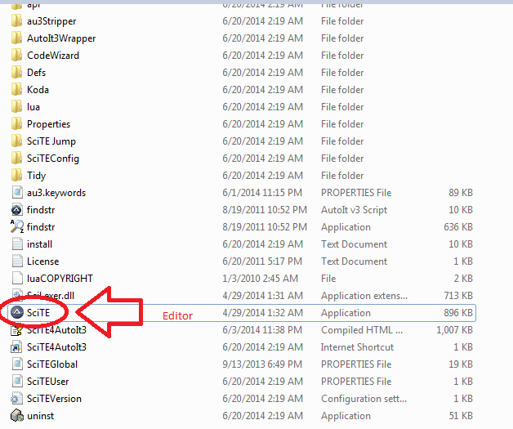](https://i2.wp.com/learn-automation.com/wp-content/uploads/2015/03/4401.png)  
Once all Installed Let’s see how we can write script

## Upload File in Selenium Webdriver using Autoit

To Upload File in Selenium Webdriver using Autoit we need to take care of some steps so let’s begin

To upload a file in Selenium Webdriver we will create AutoIT script, which will handle file-uploaded window, and then we will combine Selenium script with AutoIt scripts.

Click on Upload button you will get file uploader we will handle the same using AutoIt.

**Step 1- Open Editor and Finder Tool**

[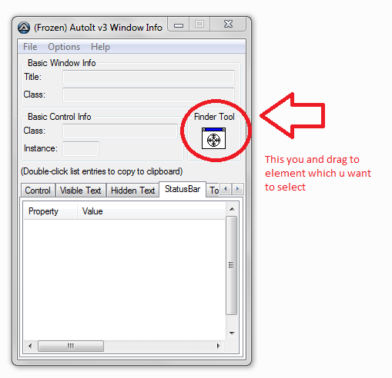](https://i1.wp.com/learn-automation.com/wp-content/uploads/2015/03/4402.png)

[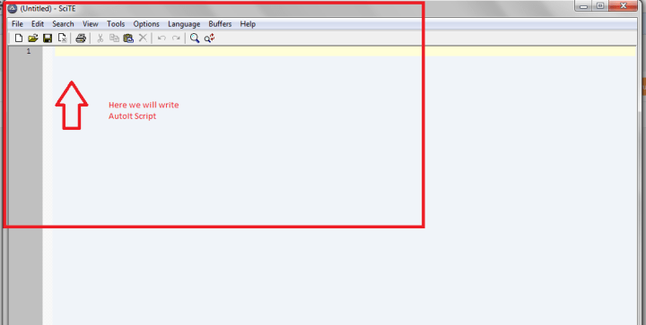](https://i2.wp.com/learn-automation.com/wp-content/uploads/2015/03/4403.png)

**Step 2**– We need to write script to upload file so we will use some method of AutoIt.  
Each method will have some own functionality  
**ControlFocus-This will give focus on the window**

**ControlSetText-This will set the file path**

**ControlClick-This will click on button**

**Step 1-**

Click on Browse button , a new window will open now open finder tool and Click on Finder tool and drag to the file name as I shown in below screenshot.

[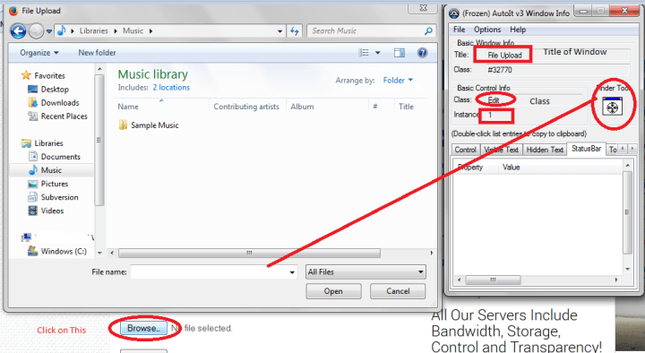](https://i0.wp.com/learn-automation.com/wp-content/uploads/2015/03/4404.png)

This will give all the detail about that window and file name section info; we will use only some attribute like window title, class, and instance.

Open AutoIt Editor and Write Script

[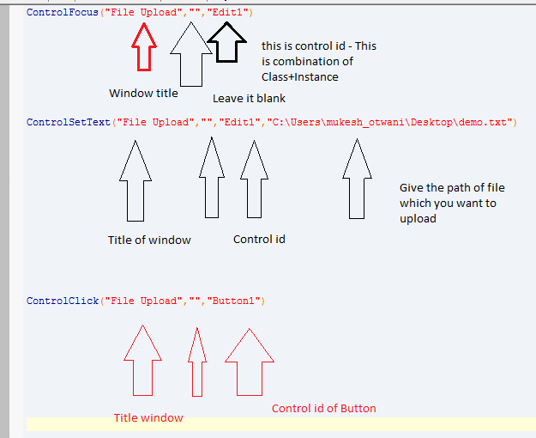](https://i1.wp.com/learn-automation.com/wp-content/uploads/2015/03/4405.png)

In ControlClick method we will give control id of open button

**Step 2-**

Save the script to a particular location with some unique name.

Note- By default script will be saved as .au3 extension

**Step 3**– Now Compile the script so for compiling right click on file and Select compile script this will generate a .exe file of the file.

[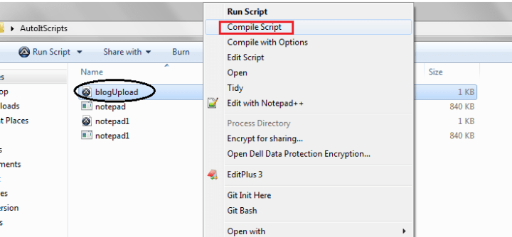](https://i0.wp.com/learn-automation.com/wp-content/uploads/2015/03/4406.png)  
**Step 4-** Now write Selenium program and add this .exe file and run your program

Here is the code

import org.openqa.selenium.By;

import org.openqa.selenium.WebDriver;

import org.openqa.selenium.firefox.FirefoxDriver;

public class DemoFileUpload {

public static void main(String[] args) throws Exception {

// This will open Firefox browser

WebDriver driver=new FirefoxDriver();

// This will maximize browser to full screen

driver.manage().window().maximize();

// This will open respective URL

driver.get("your application url");

// This will click on Upload button

driver.findElement(By.xpath("//*[@type='file']")).click();

// This will invoke AutoIT script here give the path of the script

//and this will throw IO exception so u can use throw or try catch

// In my case I am using throws

Runtime.getRuntime().exec("C:\\Users\\mukesh_otwani\\Desktop\\AutoItScripts\\blogUpload.exe");

// Once you will run this program AutoIt script will be invoked and respective f//ile will be attached

  }

}