### Basic concept of accounting

**Accounting :** It is an art of recording, classifying and summarizing in significant manner and in terms of money, transactions and events which are of financial character and interpreting the results thereof.

**Business Transaction :** A business transaction is “The movement of money and money’s worth form one person to another”. Or exchange of values between two parties is also known as “Business Transaction”.

**Purchase :** A purchase means goods purchased by a businessman from suppliers.

**Sales :** Sales is goods sold by a businessman to his customers.

**Purchase Return or Rejection in or Outward Invoice :** Purchase return means the return of the full or a part of goods purchased by the businessman to his suppliers.

**Sales Return or Rejection out or Inward Invoice :** Sales return means the return of the full or a part of the goods sold by the customer to the businessman.

**Assets :** Assets are the things and properties possessed by a businessman not for resale but for the use in the business.

**Liabilities :** All the amounts payable by a business concern to outsiders are called liabilities.

**Capital :** Capital is the amount invested for starting a business by a person.

**Debtors :** Debtor is the person who owes amounts to the businessman.

**Creditor :** Creditor is the person to whom amounts are owed by the businessman.

**Debit :** The receiving aspect of a transaction is called debit or Dr.

**Credit :** The giving aspect of a transaction is called credit or Cr.

**Drawings :** Drawings are the amounts withdrawn (taken back) by the businessman from his business for his personal, private and domestic purpose. Drawings may be made in the form cash, goods and assets of the business.

**Receipts :** It is a document issued by the receiver of cash to the giver of cash acknowledging the cash received voucher.

**Account :** Account is a summarized record of all the transactions relating to every person, every thing or property and every type of service.

**Ledger :** The book of final entry where accounts lie.

**Journal entries :** A daily record of transaction.

**Trail Balance :** It is a statement of all the ledger account balances prepared at the end of particular period to verify the accuracy of the entries made in books of accounts.

**Profit :** Excess of credit side over debit side.

**Profit and loss account :** It is prepared to ascertain actual profit or loss of the business.

**Balance Sheet :** To ascertain the financial position of the business. It is a statement of assets and liabilities.

**Types of accounts**

**Personal account:** Personal accounts are the accounts of persons, firms, concerns and institutions which the businessmen deal.

**Principles:** Debit the receiver Credit the giver

**Real Account:** These are the accounts of things, materials, assets & properties. It has physical existence which can be seen & touch.

Ex. Cash, Sale, Purchase, Furniture, Investment etc.

**Principles:** Debit what comes in Credit what goes out

**Nominal account:** Nominal account is the account of services received (expenses and Losses) and services given (income and gain)

Ex. Salary, Rent, Wages, Stationery etc.

**Principles:** Debit all expense/losses Credit all income/ gains

Tally is a complete business solution for any kind of Business Enterprise. It is a full fledged accounting software.

Procedure for creating company in Tally

Double click on Tally icon on desktop. **Alt+F3 Company info**-Create company.

**Accounts Only :** To maintain only the financial accounts of the company. Inventory (stock) management is not involved in it.

**Account with Inventory :** This is the default option, which allows maintaining both the financial account of the company as well as the inventory of the company.

**Select Company :** We can choose the company which is already created. Shortcut key - F1.

**Shut Company :** It is used to close the company which is opened. Shortcut key - Alt+F1. **Alter :** It is used to make alterations in the company creation like name, date, maintain etc. **Quit :** Exits from Tally. 1. Click on quit button.

1. Esc, Esc, Esc and enter.
2. Ctrl+Q

### Short cut keys

Alt+F3 Company information menu

Enter To accept information typed into a field.

To accept a voucher or master.

To get a report with further details of an item in a report.

Esc To remove what has been typed into a field.

To exit a screen.

To indicate you do not want to accept a voucher or master.

Ctrl+A To accept a form wherever you use the key combination the screen or report will be accepted as it is on this screen.

Ctrl+Q It quits the screen without making any changed to it. Alt+C To create a master at a voucher screen.

When working within an amount field presses Alt+C to act as a calculator.

Alt+D To delete a voucher. To delete a master.

Ctrl+Enter To alter a master while making an entry or viewing report. F2 Date

Alt+F2 Change period

Alt+F1 To see detail

F11 Features company

F12 Configuration options are applicable to all the companies in a data directory. Ctrl+N Calculator screen.

Ctrl+V Voucher mode (Cr. Dr)

Invoice mode (name of item, rate, quantity, and amount)

### Gateway of tally-Accounts info-Group

Bank account Bank Od account Branch/division Capital account Cash in hand Current asset Current liability Deposit

Direct expenses

Direct income Indirect expense Indirect income Duties and tax Fixed asset Investment

Loans and advance Loan (liability) Miscellaneous expenses

Provisions Retained earning

Reserves and surplus Purchase account Sales account Secured loan

Stock in hand Sundry debtor’s Sundry creditors Suspense Unsecured account

### Meaning:

**Current asset :** It is converted into cash with in a year. Ex. Bills receivable

**Direct expenses :** These are the expenses which are directly related to manufacturing of goods. Ex. Wages, factory rent, heating, lighting etc

**Indirect expense :** These are the expenses which are indirectly related to manufacturing of goods. Ex. Salary, rent, stationery, advertisement, printing

**Depreciation :** Decrease the value of the asset.

**Sundry debtors :** The person who is the receiver or customer

**Sundry creditors :** The person who gives or supplier.

**Expenses Outstanding or Unpaid expenses or Expenses due :** Expenditure incurred during current year but the amount on which is not yet paid. (Added to the expenditure on the debit side and entered on the liability side.)

##### Income received in advance or Income received but not earned

Income received during the current year but not earned or a part of which relates to the next year. (Deducted form the concerned income on the credit side and entered on the liability side)

##### Prepaid advance or Expenses or Prepaid expenses

Expenditure paid during current year but not incurred or a part of which relates to the next year is called expenditure prepaid. (Deducted form the concerned expenditure on the debit side and entered on the assets side)

##### Income outstanding or income earned but not received or Income accrued

Income outstanding means income earned during the current year but the amount on which is not yet received (added to the concerned income on the credit side and entered on the asset side)

Gateway of Tally-Accounts info-ledger-create

|  |  |
| --- | --- |
| **Ledger** | **Group** |
| Opening stock | Stock in hand |
| Purchase | Purchase account |
| Purchase return | Purchase account |

|  |  |
| --- | --- |
| Fright charges | Direct expenses |
| Carriage inwards or Purchases | Direct expenses |
| Cartage and coolie | Direct expenses |
| Octroi | Direct expenses |

|  |  |
| --- | --- |
| Manufacturing wages | Direct expenses |
| Coal, gas, water | Direct expenses |
| Oil and fuel | Direct expenses |
| Factory rent, insurance, electricity, lighting and heating | Direct expenses |
| Sales | Sales account |
| Salary | Indirect expenses |
| Postage and telegrams | Indirect expenses |
| Telephone charges | Indirect expenses |
| Rent paid | Indirect expenses |
| Rates and taxes | Indirect expenses |
| Insurance | Indirect expenses |
| Audit fees | Indirect expenses |
| Interest on bank loan | Indirect expenses |
| Interest on loans paid | Indirect expenses |
| Bank charges | Indirect expenses |
| Legal charges | Indirect expenses |
| Printing and stationery | Indirect expenses |
| General expenses | Indirect expenses |

|  |  |
| --- | --- |
| Sundry expenses | Indirect expenses |
| Discount allowed | Indirect expenses |
| Carriage outwards or sales | Indirect expenses |
| Traveling expenses | Indirect expenses |
| Advertisement | Indirect expenses |
| Bad debts | Indirect expenses |
| Repair renewals | Indirect expenses |
| Motor expenses | Indirect expenses |
| Depreciation on assets | Indirect expenses |
| Interest on investment received | Indirect income |
| Interest on deposit received | Indirect income |
| Interest on loans received | Indirect income |
| Commission received | Indirect income |
| Discount received | Indirect income |
| Rent received | Indirect income |
| Dividend received | Indirect income |
| Bad debts recovered | Indirect income |
| Profit by sale of assets | Indirect income |
| Sundry income | Indirect income |

|  |  |
| --- | --- |
| Loan from others | Loan Liabilities |
| Bank loan | Loan Liabilities |
| Bank overdraft | Bank OD |
| Bills payable | Current Liabilities |
| Sundry creditors | Sundry creditors |
| Mortgage loans | Secured loans |
| Expense outstanding | Current Liabilities |
| Income received in advance | Current Liabilities |
| Other liabilities | Current Liabilities |
| Capital | Capital account |
| Drawings | Capital account |
| Cash in hand | Cash in hand |
| Cash at bank | Bank account |
| Fixed deposit at bank | Deposit |
| Investments | Investments |
| Bills receivable | Current asset |
| Sundry debtors | Sundry debtors |
| Closing stock | Stock in hand |
| Stock of stationery | Current asset |
| Loose tools | Fixed asset |
| Fixtures and fittings | Fixed asset |
| Furniture | Fixed asset |
| Motor vehicles | Fixed asset |
| Plant and machinery | Fixed asset |

|  |  |
| --- | --- |
| Land and building | Fixed asset |
| Leasehold property | Fixed asset |
| Patents | Fixed asset |
| Goodwill | Fixed asset |
| Prepaid expenses | Current asset |
| Income outstanding | Current assset |

**Trading account** : Buying and selling of goods.

Dr. Receiving aspect Giving aspect Cr.

|  |  |  |  |  |  |
| --- | --- | --- | --- | --- | --- |
| **Direct expenses** | | **Amount** | **Direct Income** | | **Amount** |
| To | Opening stock | xxx | By | Sales | xxx |
| To | Purchases | xxx | By | (-)Sales return | xxx |
| To | (-)purchase return | xxx | By | Closing stock | xxx |
| To | Freight charges | xxx |  |  |  |
| To | Cartage and coolie | xxx |  |  |  |
| To | Lorry hire | xxx |  |  |  |
| To | Manufacturing expenses | xxx |  |  |  |
| To | Wages | xxx |  |  |  |
| To | Factory rent, fuel power | xxx |  |  |  |
| To | Gross profit (transfer to profit and loss account) | xxx |  |  |  |

**To Profit and loss account :** Actual profit and loss of the business

|  |  |  |  |  |  |
| --- | --- | --- | --- | --- | --- |
| **Indirect expenses or payments** | | **Amount** |  | **Indirect income or receipts** | **Amount** |
| To | Salary | xxx | By | Gross profit | xxx |
| To | Postage and Telegram | xxx | By | Interest on investment received | xxx |
| To | Telephone charges | xxx | By | Interest on deposit received | xxx |
| To | Rent paid | xxx | By | Interest on loans received | xxx |
| To | Rate and taxes | xxx | By | Discount received | xxx |
| To | Insurance paid | xxx | By | Discount received | xxx |
| To | Interest on bank loan | xxx | By | Rent received | xxx |
| To | Bank charges | xxx | By | Bad debts received | xxx |
| To | Printing and stationery | xxx | By | Net loss | xxx |
| To | Discount allowed | xxx |  |  |  |
| To | Advertisement |  |  |  |  |

|  |  |  |  |  |  |
| --- | --- | --- | --- | --- | --- |
| To | Carriage outward (sales) |  |  |  |  |
| To | Depreciation on assets |  |  |  |  |
| To | General expenses |  |  |  |  |
| To | Traveling |  |  |  |  |
| To | Bad debts |  |  |  |  |
| To | Net profit |  |  |  |  |

**Balance sheet:** Actual financial position

|  |  |  |  |
| --- | --- | --- | --- |
| Liabilities | Amount | Assets | Amount |
| Bank loan | xxx | Cash in hand | xxx |
| Bank overdraft | xxx | Cash at bank | xxx |
| Bills payable | xxx | Fixed deposit at bank | xxx |
| Sundry creditors | xxx | Investments | xxx |
| Expenses outstanding | xxx | Bills receivable | xxx |
| Capital | xxx | Sundry debtors | xxx |
| (-)drawings | xxx | Closing stock | xxx |
| Net profit | xxx | Stock of stationery | xxx |
|  |  | Furniture | xxx |
|  |  | Plant machinery | xxx |
|  |  | Land and building | xxx |
|  |  | Motor vehicles | xxx |
|  |  | Prepaid expenses | xxx |
|  |  | Income outstanding | xxx |

F4 Contra: Records funds transfer between cash and bank accounts. Deposit into bank or Opened bank account Cr. Cash

Dr. Bank

Withdraw form bank Cr. Bank

Dr. Cash

F5 Payment: Record all bank and cash payments.

Paid or Give Dr.

Cr. Cash/bank (in case cheque)

F6 Receipt: Records all receipts into bank or cash accounts.

Received or Borrow or Take Cr.

Dr. Cash/bank (in case cheque)

F7 Journal: Records adjustments between ledger accounts.

F8 Sales: Records all sales.

Dr. Cash/party (incase of credit-party) Cr. Sales

F9 Purchase: Records all purchase.

Cr. Cash/party (incase of credit-party) Dr. Purchase

# 0BClass Room Assignment No.1:-

Create a company Milan Trade for the year 2009-10, and pass necessary Journal Entries

##### Journalize the following transactions

1. Commenced business with cash Rs.10, 000.
2. Deposit into bank Rs. 15,000
3. Bought office furniture Rs.3,000
4. Soled goods for cash Rs.2,500
5. Purchased goods form Mr X on credit Rs.2,000
6. Soled goods to Mr Y on credit Rs.3,000
7. Received cash form Mr. Y on account Rs.2,000
8. Paid cash to Mr X Rs. 1,000
9. Received commission Rs. 50
10. Received interest on bank deposit Rs. 100
11. Paid into bank Rs. 1,000
12. Paid for advertisement Rs.500
13. Purchased goods for cash Rs. 800
14. Sold goods for cash Rs. 1,500
15. Paid salary Rs. 500

##### Gateway of tally-Account info-Ledger-Create Gateway of tally – Accounting voucher

|  |  |  |  |  |  |  |  |
| --- | --- | --- | --- | --- | --- | --- | --- |
| **Sl. No** | **Key** | **Voucher** | **Ledger** | **Group** | **Type of account** | **Principles** | **Amount** |
| 1 | F6 | Receipt | Cr. Capital | Capital account | Personal | Giver | 10,000 |
| Dr. Cash | Cash in hand | Real | Comes in | 10,000 |
| 2 | F4 | Contra | Cr. Cash | Cash in hand | Real | Goes out | 15,000 |
| Dr. Bank | Bank account | Real | Comes in | 15,000 |
| 3 | F5 | Payment | Dr. Office  furniture | Fixed asset | Real | Comes in | 3,000 |
| Cr. Cash | Cash in hand | Real | Goes out | 3,000 |
| 4 | F8 | Sales | Dr. Cash | Cash in hand | Real | Comes in | 2,500 |
| Cr. Sales | Sales account | Real | Goes out | 2,500 |
| 5 | F9 | Purchase | Cr. X | Sundry creditor | Personal | Giver | 2,000 |
| Dr. purchase | Purchase  account | Real | Comes in | 2,000 |
| 6 | F8 | Sales | Dr. Y | Sundry debtors | Personal | Receiver | 3,000 |
| Cr. Sales | Sales account | Real | Goes out | 3,000 |
| 7 | F6 | Receipt | Cr. Y |  |  | Giver | 2,000 |
| Dr. cash | Cash in hand | Real | Comes in | 2,000 |
| 8 | F5 | Payment | Dr. X |  |  | Receiver | 1,000 |
| Cr. Cash | Cash in hand | Real | Goes out | 1,000 |

|  |  |  |  |  |  |  |  |
| --- | --- | --- | --- | --- | --- | --- | --- |
| 9 | F6 | Receipt | Cr. Commission | Indirect income | Nominal | Credit all  income | 50 |
| Dr. cash | Cash in hand | Real | Comes in | 50 |
| 10 | F6 | Receipt | Cr. Interest on  bank deposit | Indirect income | Nominal | Credit all  income | 100 |
| Dr. Bank | Bank account | Real | Comes in | 100 |
| 11 | F4 | Contra | Cr. Cash | Cash in hand | Real | Goes out | 1,000 |
| Dr. Bank | Bank account | Real | Comes in | 1,000 |
| 12 | F5 | Payment | Dr.  Advertisement | Indirect  expenses | Nominal | Debit all  expenses | 500 |
| Cr. Cash | Cash in hand | Real | Goes out | 500 |
| 13 | F9 | Purchase | Cr. Cash | Cash in hand | Real | Goes out | 800 |
| Dr. purchase  Cr cash | Purchase  account | Real | Comes in | 800 |
| 14 | F8 | Sales | Dr. cash | Cash in hand | Real | Comes in | 1,500 |
| Cr. Sales | Sales account | Real | Goes out | 1,500 |
| 15 | F5 | Payment | Dr. salary | Indirect expense | Nominal | Debit all  expenses | 500 |
| Cr. Cash | Cash in hand | Real | Goes out | 500 |

1B**Lab Assignment No.1.1:-**

Create a company ‘InfoSoft Pvt. Ltd.’ On 1-4-2006. Pass the Journal Entry for the following transactions:-

* 1. Commenced business with Rs. 15000, goods of Rs. 3000 & Building Rs. 12000.
  2. Purchase goods for Rs. 1000.
  3. Sold goods to Pallavi for Rs. 15000.
  4. Sold goods for Rs. 2000.
  5. Paid office rent Rs. 200.
  6. Paid cash to Dhanashi Rs. 500.
  7. Received Commission Rs. 100.
  8. Returned goods by Pallavi of Rs. 150.
  9. Withdrawn Rs. 2000 for personal use.
  10. Purchase Furniture for Rs. 10000.
  11. Borrowed from Bank Rs. 8000.
  12. Paid carriage on behalf of Sudesh Rs. 30.
  13. Sold Building of Rs. 8000 for Rs. 7500.
  14. Depreciation charged on all the assets @ 5% p.a.
  15. Repaid loan to bank Rs. 3400.
  16. Goods purchase from Kanji worth Rs. 1500.
  17. Purchase Motor Car worth Rs. 8000 in exchange of Furniture worth Rs. 10000.
  18. Sold half of the goods purchase from Kanji to Kalidas, getting profit of Rs. 15 on each Rs. 100.

# 2BClass Room Assignment No.2:-

Create a company ‘M/S Albert & Brothers’ for the year 01.04.2006 and books beginning from 01.05.2006 and pass the transactions considering the following

2006

May 1 Albert starts business with Rs. 50,000. He opens a bank account and deposits Rs. 20,000.

May 1 Bought furniture for Rs. 5,000, machinery for Rs. 10,000. May 2 Purchased goods for Rs. 14,000.

May 31 Sold goods for Rs. 8,000.

May 31 Purchased goods from Malhotra & Co. Rs. 11,000. June 1 Paid telephone rent for the year by cheque Rs. 500.

June 1 Bought one typewriter for Rs. 2,100 from ‘Universal Typewriter Co.’ on credit. June 2 Sold goods to Keshav Ram for Rs. 12,000.

July 1 Sold goods to Rajesh Kumar for Rs. 2,000 cash.

July 1 Amount withdrawn from bank for personal use Rs. 1,500.

July 2 Received cash from Keshav Ram Rs. 11,900 and discount allowed Rs. 100. July 31 Paid into bank Rs. 5,800.

July 31 Bought 50 shares in X Y & Co. Ltd. At Rs. 60 per share, brokerage paid Rs. 20.

Aug 1 Goods worth Rs. 1,000 found defective were returned to Malhotra & Co. and balance of the amount due to them settled by issuing a cheque in their favour.

Aug 1 Sold 20 shares of X Y & Co. Ltd. at Rs. 65 per share, brokerage paid Rs. 20.

Aug 2 Bought goods worth Rs. 2,100 from Ramesh and supplied them to Suresh at Rs. 3,000. Aug 2 Suresh returned goods worth Rs. 100, which in turn were sent to Ramesh.

Aug 31 Issued a cheque for Rs. 1,000 in favour of landlord for rent .

Aug 31 Paid salaries to staff Rs. 1,500 & received from travelling salesman Rs. 2,000 for goods sold by him, travelling expenses Rs. 100.

# 3BLab Assignment No. 2.1:-

Create a Company by name “Khanna Sons” for the year 2007-08, prepare following ledgers and pass necessary entries

1. Commenced business with cash Rs.10, 000, as on 1/4/2007
2. Deposit into bank Rs. 15,000 on 2/4/2007
3. Bought office furniture Rs.3,000 on 2/4/2007
4. Sold goods for cash Rs.2,500 on 1/5/2007
5. Purchased goods form Mr X on credit Rs.2,000 on 2/5/2007
6. Sold goods to Mr Y on credit Rs.3,000 on 31/5/2007
7. Received cash form Mr. Y on account Rs.2,000 on 1/6/2007
8. Paid cash to Mr X Rs. 1,000 on 2/6/2007
9. Received commission Rs. 50 on 2/6/2007
10. Received interest on bank deposit Rs. 100 on 1/7/2007
11. Paid into bank Rs. 1,000 on 2/7/2007
12. Paid for advertisement Rs.500 on 31/7/2007
13. Purchased goods for cash Rs. 800 on 1/8/2007
14. Sold goods for cash Rs. 1,500 on 2/8/2007
15. Paid salary Rs. 500 on 31/8/2007

# 4BLab Assignment No.2.2:-

Create a company in the name of Raj Traders for the year ended 01.04.1998 and books beginning from 01.07.1998 and pass the transactions considering the following:-

Ledgers to be created:- 1) Purchase Account 2) Sales Account 3) Bank Account & Respective parties Accounts, pass the entry in Voucher mode.

1. On 01.07.1998 purchased goods worth Rs. 1,00,000/- from **Mafatlal Industries Ltd.**
2. On 02.07.1998 sold goods worth Rs. 40,000/- to **Rakesh Mills.**
3. On 31.07.1998 received Rs. 25,000/- from Rakesh Mills.
4. Sold goods worth Rs. 50,000/- to **Anil Textiles** on 02.08.1998.
5. Received Rs. 40,000/- from Anil Textiles on 31.08.1998.
6. On 01.09.1998 paid Rs. 50,000/- to Mafatlal Industries Ltd.
7. Purchased goods worth Rs. 80,000/- each from **Arvind Mills** and **Vimal** on 02.08.1998.
8. On the same day sold goods worth Rs. 40,000/- each to **Vikas Sales Agency** and Rakesh Mills.
9. Received Rs. 30,000/- each from Rakesh Mills and Vikas Sales Agency.
10. On 31.08.1998 paid Rs. 25,000/- each to Arvind Mills and Vimal.

# B5Class Room Assignment No. 3:-

##### Accounts with Inventory

Create a company in the name of Asian Car Arcade for the year ending 2001.

Prepare the required ledgers, stock group, category, items, godown and pass the transactions taking the following into consideration, entry to be done in invoice mode.

##### F11 Features to be activated:-

Under Maruti Maruti 800, Zen, Esteem, Baleno.

Under Hyundai Ascent, Hyundai Deluxe, Hyundai Regular. Under Premiere Fiat, Uno, Siena.

Under Tata Indica, Sumo, Estate, Sierra.

Under Hindustan Ambassador, Contessa.

Transaction

* Purchased the following on 01.06.2000, discount 2%

|  |  |  |  |
| --- | --- | --- | --- |
| Quantity | Name | Rate | Godown |
| 3 | Zen | 400000 | Mumbai |
| 2 | Ascent | 550000 | Mumbai |
| 2 | Uno | 375000 | Pune |
| 4 | Siena | 575000 | Pune |
| 2 | Sumo | 500000 | Mumbai |
| 5 | Indica | 400000 | Mumbai |

* On 02.06.2000 sold following cars to Patel Motors, discount 2%

|  |  |  |
| --- | --- | --- |
| Quantity | Name | Rate |
| 1 | Zen | 475000 |
| 1 | Siena | 610000 |
| 1 | Indica | 450000 |

* On 01.07.2000 sold following cars to Dhruv Motors, discount 2%

|  |  |  |
| --- | --- | --- |
| Quantity | Name | Rate |
| 1 | Ascent | 580000 |
| 1 | Indica | 430000 |

* On 02.07.2000 sold following cars to Gupta Car Arcade, discount 2%

|  |  |  |
| --- | --- | --- |
| Quantity | Name | Rate |
| 1 | Zen | 460000 |
| 1 | Siena | 600000 |

* On 31.07.2000 sold following cars to Continental Motors, discount 2%

|  |  |  |
| --- | --- | --- |
| Quantity | Name | Rate |
| 1 | Sumo | 550000 |
| 1 | Zen | 450000 |
| 1 | Siena | 600000 |

* Received on 01.08.2000 Rs. 1125000/- from continental Motors after deducting discount on total bill amount.
* Paid 50% bill amount from which 7.5% discount on bill amount has been paid for Hyundai motors on 02.08.2000.
* On 31.08.2000 received 75% bill amount after deducting 11.25% on net bill from Dhruv Motors.
* Paid full amount after deducting 15% discount to Premeiere 01.09.2000.
* Sold 1 Indica @ Rs. 450000 to Ramesh Motors (add 4% sales tax) on 02.09.2000.
* Sold 1 Siena @ Rs. 600000 and 1 Uno @ Rs. 400000 to Trilok Motors (add 4.8% sales tax) on 31.09.2000.

# B6Lab Assignment No. 3.1:-

##### Create a Company Raman Shop, as on 2006-07

On 1-4-06 Raman commenced business with cash of Rs. 25,00,000. He further introduced Land and Building costing Rs. 30,000, Plant and Machinery costing Rs. 25,000 and furniture and fixture costing Rs. 36,000.

1. On 2-4-06 Purchased Vehicle and Patents Rs. 20,000 and Rs. 15,000.
2. On1-5-06 He deposited Rs. 1,00,000 into Canara Bank.
3. On 2-5-06 Purchased from Cadbury Company, discount 1%

|  |  |  |  |
| --- | --- | --- | --- |
| 500 | 5 Stars @ Rs. 5 | 1000 | Munch @ Rs. 5 |
| 100 | Kit kat @ Rs. 4 | 200 | Dairy milk @ Rs. 7 |

1. On 31-5-06 Purchased from Paras, discount 2%

500 Moov @ Rs. 20

500 D’Clod @ Rs. 12

1. On 1-6-06 Purchased from Amber, discount 2%

|  |  |
| --- | --- |
| 450 | Adhensive tape roll @ Rs. 14.50 |
| 200 | Band Aid box @ Rs. 240 |
| 300 | Boric Acid powder @ Rs. 13 |

1. On 1-6-06 Sold to Pankaj, discount 2%

|  |  |
| --- | --- |
| 200 | Moov @ Rs. 20.50 |
| 100 | D’Clod @ Rs. 12.25 |
| 200 | Adhensive tape roll @ Rs. 15.25 |
| 100 | Band Aid box @ Rs. 252 |
| 200 | Boric Acid powder @ Rs.14 |

1. On 2-6-06 Sold to Akbar, discount 2%

500 Munch @ Rs. 6

200 5 Star @ Rs.5.25

50 Kit Kat @ Rs. 6

1. On 1-7-06 Paid to Cadbury company Rs. 7500/- in cash.
2. On 2-7-06 Received from Pankaj Rs. 30000/- by cheque
3. On 31-7-06 Paid to Paras Rs. 12000/- by cheque
4. On 2-8-06 Received from Akbar Rs. 3500/- in cash
5. On 2-8-06 Purchase from Well Cloth

T-Shirts Lee 25Pc @ Rs.200 Nike 30Pc @ Rs.300

Formal Shirts Pan America 35Pc @ Rs. 400

Peter England 30Pc @ Rs. 450

|  |  |  |
| --- | --- | --- |
| Jeans Pants | Tiger | 20Pc @ Rs. 500 |
|  | Ruff and Tuff | 30Pc @ Rs. 350 |
| Cotton Pants | Arrow | 40Pc @ Rs. 200 |
|  | Ex-Calibar | 20Pc @ Rs. 250 |

1. Paid Postage Rs. 500 by cheque
2. Received commission Rs. 15,000
3. Paid wages Rs. 2,500

##### Procedure for Inventory Problem

Gateway of Tally-Inventory Info-Unit of Measure-Create-

|  |  |  |
| --- | --- | --- |
| Symbol- | Nos. | Pcs |
| Formal Name- | Number | Pieces |

Gateway of Tally-Inventory Info-Stock Group-Create

Chocolate, Medicines, Cotton Pants, Jeans Pants, Formal Shirts, T-Shirts Gateway of Tally-Inventory Info-Stock Item-Create

5 Stars

Kitkat Chocolate

Munch Dairy milk

Moov D’Clod

Adhensive tape rolls Medicines Band Aid box

Boric Acid powder

Lee T-Shirts

Nike

Pan America Formal Shirts

Peter England

Tiger Jeans Pants

Ruff and Tuff

Arrow

Ex-Calibar Cotton Pants

# 7BClass Room Assignment No. 4:-

Given below is the trial balance of M/s. Sameer and Reena on 31st Dec. 1988. They divide profits and losses as 3:2 respectively. From the following trial balance you are required to prepare Trading and Profit and loss account for the year ended 31st December 1988 and the Balance Sheet as on that date.

Create Groups for Ledgers, F11 features Interest Calculation, Currency (€ Euro (**use Alt 0128** to insert symbol)):-

##### Trial balance as on 31st December 1988

|  |  |  |  |
| --- | --- | --- | --- |
| **Particulars** | **Debit Rs.** | **Particulars** | **Credit Rs.** |
| Stock (1-1-88) | 60,000 | Sales | 1,01,250 |
| Purchases | 1,20,000 | Purchases Returns | 1,000 |
| Sales Returns | 1,500 | Capital account Sameer | 80,000 |
| Drawings Sameer | 9,000 | Capital account Reena | 60,000 |
| Drawings Reena | 7,000 | Current A/c. Reena | 2,000 |
| Current A/c. Sameer | 3,000 | Bank Overdraft 4% p.a. | 17,000 |
| Sundry Expenses | 1,750 | Discount Received | 600 |
| Wages | 15,000 | Dividend Received | 2,400 |
| Salaries | 16,400 | Sundry Creditors | 10,000 |
| Travelling Expenses | 1,600 | Bills Payable | 25,000 |
| Advertisement | 6,000 | Outstanding Wages | 2,000 |
| Rent, Rates and Taxes | 12,500 | Loan from Dena bank @ 12% | 5,50000 |
| Bad Debts | 13,000 |  |  |
| Discount | 1,400 |  |  |
| Commission | 1,500 |  |  |
| Buildings | 1,80,000 |  |  |
| Machinery | 1,20,000 |  |  |
| Furniture | 75,000 |  |  |
| Sundry Debtors | 30,000 |  |  |

|  |  |  |  |
| --- | --- | --- | --- |
| Cash in Hand | 25,000 |  |  |
| Cash at Bank 2.5% interest p.m | 1,22,000 |  |  |
| Bills Receivable | 27,000 |  |  |
| Prepaid Insurance | 2600 |  |  |
|  | **8,51,250** |  | **8,51,250** |

**Additional Information at the end of the year.**

* Closing Stock as on 31-12-1988 Rs. 57600/-
* Outstanding Rent Rs. 400/- Salaries Rs. 600/-
* Provide depreciation on Building 10% Machinery 20% and Furniture 15%.
* Provide 10% interest on partner’s capital. Sameer is entitled to get Rs. 1,500/- as salary per month for his extra work for 3 Months.
* Partnership firm charges 5% interest on drawings.
* Share profit/loss in the ratio given

Display Balance sheet, Profit & Loss, Trial Balance in the the currency create (€ euro) Transfer the company data to new blank company using Import/Export option.

Merge both the company and create a Group company, showing individual balance sheet, profit / loss account, and also group wise details for the same.

**L**B8 **ab Assignment No. 4.1 :-**

Ramesh and Mahesh are partners sharing profits and losses 2:1. Following is the trial balance as on 31/12/1985.

|  |  |  |
| --- | --- | --- |
| **Particulars** | **Debit Rs.** | **Credit Rs.** |
| Land and Buildings | 55,000 |  |
| Machinery | 40,000 |  |
| Salary and Wages | 21,000 |  |
| Cash at bank | 40,000 |  |
| Cash in hand | 1,100 |  |
| Motor Vans | 20,000 |  |
| Office Expenses | 1,000 |  |
| Ramesh Capital |  | 1,16,000 |

|  |  |  |
| --- | --- | --- |
| Mahesh Capital |  | 62,000 |
| Carriage | 5,000 |  |
| Purchase and Sales | 2,20,000 | 2,80,000 |
| Returns | 2,000 | 5,500 |
| Bad Debts | 1,000 |  |
| Debtors and Creditors | 32,800 | 20,000 |
| Rent | 1,100 |  |
| Bills Payable |  | 35,000 |
| Printing and Stationary | 1,500 |  |
| Travelling Expenses | 5,500 |  |
| Stock (1/1/1985) | 30,000 |  |
| Insurance | 1,500 |  |
| Discount | 8,000 |  |
| Advertisement | 12,000 |  |
| Furniture | 20,000 |  |
|  | **5,18,500** | **5,18,500** |

##### Adjustments:-

* Goods worth Rs. 5,000 taken over by Ramesh for personal use were not entered in the books of accounts.
* For goods worth Rs. 5,000 were destroyed by fire and Insurance Company agreed to pay Rs. 4,000 in full settlement of the claim.
* Outstanding expenses, Rent Rs. 100/- and Salary Rs. 500/-
* Provide depreciation at 10% on machinery and 5% on furniture.

# B9Lab Assignment No. 4.2:-

Following is the trail balance of Sri Arora company for the year ended 31-3-01

|  |  |  |
| --- | --- | --- |
| **Particulars** | **Debit** | **Credit** |
| Capital account | - | 10,000 |
| Drawings account | 2,000 | - |

|  |  |  |
| --- | --- | --- |
| Purchases | 20,800 | - |
| Opening stock | 6,900 | - |
| Sales | - | 27,500 |
| Creditors | - | 8,100 |
| Rent | 1,000 | - |
| Discount Received | - | 270 |
| Furniture & Fixture | 900 | - |
| Machinery | 5,000 | - |
| Traveling expencess | 650 | - |
| Bad debts | 120 | - |
| Debtor | 7,500 | - |
| Sales Return | 300 | - |
| Purchase Return | - | 580 |
| Carriage Inward | 400 | - |
| Wages | 325 | - |
| Salaries | 900 | - |
| Interest | 480 | - |
| Carriage Outward | 700 | - |
| Insurance | 900 | - |
| Bank Loan | - | 3000 |
| Cash in hand | 575 | - |
| Total | **49,450** | **49,450** |

##### Additional information:

1. Closing stock was values at Rs. 8900.
2. Insurance prepaid Rs.250.
3. Interest on bank loan outstanding Rs.150.
4. Depreciate machinery and furniture at 10%.
5. Provide for doubtful debts at 5% on debtors.
6. O/S rent Rs 200 O/S salary Rs 100

# 01BClass Room Assignment No. 5 (VAT 4%):-

|  |  |  |  |  |  |
| --- | --- | --- | --- | --- | --- |
| **M/S SAI TECHNOLOGIES** | | | | | |
| **BALANCE SHEET AS ON 31-3-1998** | | | | | |
| **Liabilities** | **Amount** | **Total** | **Assets** | **Amount** | **Total** |
| **Capital Account** |  | **150000** | **Fixed Assets** |  | **72000** |
| Kapil | 75000 |  | Office equipment | 32000 |  |
| Mayur | 75000 |  | Furniture & Fixture | 40000 |  |
| **Loan Liabilities** |  | **100000** | **Investment** |  | **28000** |
| City Bank | 50000 |  | Shares in ICICI | 14000 |  |
| (Term loan) |  |  | Shares in HDFC | 14000 |  |
| Mohan Bansi | 50000 |  |  |  |  |
|  |  |  |  |  |  |
| **Current Liabilities** |  | **113310** | **Current Assets** |  | **263310** |
| Sundry Creditors A | 101340 |  | Stock | 134424 |  |
| Unpaid Expenses B | 11974 |  | Sundry Debtors C | 88850 |  |
|  |  |  | Cash in Hand | 8528 |  |
|  |  |  | Bank Accounts D | 31512 |  |
|  | **Total** | **363314** |  | **Total** | **363314** |

##### Schedule A:

|  |  |  |  |  |
| --- | --- | --- | --- | --- |
| **Sundry Creditors** | **Bill No.** | **Date** | **Amount** | **Total** |
| Sachin Trader | 1398 | 31/12/97 | 2070 |  |
|  | 1421 | 1/1/98 | 3073 |  |
|  | 1434 | 2/1/98 | 11020 |  |
|  | 1636 | 1/2/98 | 3079 |  |
|  | 1842 | 1/3/98 | 14011 | **33253** |
| Navjot Enterprises | 4120 | 1/2/98 | 8092 |  |

|  |  |  |  |  |
| --- | --- | --- | --- | --- |
|  | 4121 | 1/3/98 | 4293 | **12385** |
| Ganguly Tech | 3268 | 2/2/98 | 6028 |  |
|  | 4198 | 1/3/98 | 9011 | **15039** |
| Azhar Softech | 12941 | 1/3/98 | 4219 |  |
|  | 12983 | 2/3/98 | 3024 |  |
|  | 13492 | 31/3/98 | 5360 |  |
|  | 13780 | 31/3/98 | 28060 | **40663** |

**Schedule B:**

|  |  |  |
| --- | --- | --- |
| **Unpaid Expenses** | | |
| Telephone Expenses Payable | 8370 |  |
| Electricity Expenses Payable | 3604 |  |
|  | **Total** | **11974** |

**Schedule C:**

|  |  |  |  |
| --- | --- | --- | --- |
| **Sundry Debtors** | | | |
| **Amitabh Corporation** |  |  | **31621** |
| 1020/97-98 | 1/2/98 | 3430 |  |
| 1029/97-98 | 1/2/98 | 6918 |  |
| 1019/97-98 | 2/2/98 | 7024 |  |
| 1068/97-98 | 1/3/98 | 4120 |  |
| 1076/97-98 | 2/3/98 | 6148 |  |
| 1092/97-98 | 31/3/98 | 3981 |  |
| **Dev Enterprises** |  |  | **20601** |
| 1024/97-98 | 1/2/98 | 13210 |  |
| 1071/97-98 | 1/3/98 | 7391 |  |
| **Khanna Brothers** |  |  | **36628** |
| 1048/97-98 | 1/2/98 | 14216 |  |

|  |  |  |  |
| --- | --- | --- | --- |
| 1064/97-98 | 1/3/98 | 8929 |  |
| 1096/97-98 | 31/3/98 | 13483 |  |

**Schedule D:**

|  |  |  |
| --- | --- | --- |
| **Bank Accounts** | | |
| State Bank of India A/c 34292 | 9828 |  |
| Mandavi A/c 21767 | 21684 | **31512** |

**Enter the opening stock in M/s SAI Technologies:**

|  |  |  |  |  |
| --- | --- | --- | --- | --- |
| **Particulars Brand Name & Item** | **Qty. Nos.** | **Rate Per Nos.** | **Amount** | **Total** |
| **Floppy Disk** |  |  |  | **15123** |
| Sony |  |  |  |  |
| 1.44 MB | 15 | 210 | 3150 |  |
| 1.2 MB | 8 | 185 | 1480 |  |
| Maxell |  |  |  |  |
| 1.44 MB | 14 | 212 | 2968 |  |
| 1.2 MB | 6 | 191 | 1146 |  |
| Verbatim |  |  |  |  |
| 1.44 MB | 18 | 215 | 3870 |  |
| 1.2 MB | 13 | 193 | 2509 |  |
| **Compact Disc CD’s** |  |  |  | **3640** |
| Sony Writable | 6 | 175 | 1050 |  |
| HP Writable | 14 | 185 | 2590 |  |
| **Mouse** |  |  |  | **14950** |
| Logitech | 20 | 590 | 11800 |  |
| Genious | 15 | 210 | 3150 |  |
| **Monitor** |  |  |  | **54082** |
| Microtech | 4 | 9025 | 36100 |  |

|  |  |  |  |  |
| --- | --- | --- | --- | --- |
| Samtron | 1 | 8981 | 8982 |  |
| LG | 1 | 9000 | 9000 |  |
| **Keyboard** |  |  |  | **9630** |
| Chiconi | 15 | 642 | 9630 |  |
| **Central Processing Unit** |  |  |  | **37000** |
| Pentium II | 2 | 18500 | 37000 |  |

**Enter the following Purchase Transactions into M/s SAI Technologies: 4% Vat Applicable**

|  |  |
| --- | --- |
| **Date** | **Particulars** |
| 1-Apr-98 | Purchased 20 Boxes of 1.44 MB Sony Floppies @ Rs. 215 each from M/s. Navjot Enterprises Vide Bill No. 4304 amounting to Rs. 4300/- |
| 1-Apr-98 | Purchased 3 Pentium @ 18000/- each from M/s. Jadeja @ Co. vide Bill No. 24920 amounting to Rs. 54000/- |
| 2-Apr-98 | 50 CD’s of HP purchased from M/s. Nayab Trade Links @ Rs. 175 per C.D. as per Bill No. 18719 amounting to Rs. 8750/- |
| 2-Apr-98 | Purchased from M/s. Azhar Softechs Pvt. Ltd. As per Bill No. 13628 amounting to Rs. 5340/-. The items included ware 15 Boxes of Maxell 1.44 MB floppies @ 212/- & 10 Boxes Verbatim 1.44 MB Floppies Rs. 216/- per Box. |

**Enter the following Sales Transactions into M/s. SAI Technologies: 4% Vat Applicable**

|  |  |  |  |  |  |  |
| --- | --- | --- | --- | --- | --- | --- |
| **Date** | **Bill No.** | **Party & Items Details** | **Qty** | **Rate** | **Amount** | **Total** |
| 1-May-98 | 1101 | Khanna Brothers Logitech Mouse | 15 | 650 | 9750 | 9750 |
| 1-May-98 | 1102 | Kapoor Techno Pvt. Ltd. |  |  |  | 8275 |
|  |  | Sony 1.44 MB Floppies | 10 | 240 | 2400 |  |
|  |  | Sony 1.2 MB Floppies | 5 | 210 | 1050 |  |
|  |  | Verbatim 1.44 MB Floppies | 15 | 250 | 3750 |  |
|  |  | Verbatim 1.2 MB Floppies | 5 | 215 | 1075 |  |
| 2-May-98 | 1103 | Dev Enterprises Microtech Monitors | 2 | 10800 | 21600 | 21600 |
| 2-May-98 | 1104 | Shahrukh Impex Pentium II CPU | 2 | 15000 | 30000 | 30000 |

**Enter the following receipt Transactions into M/s. SAI Technologies:**

|  |  |
| --- | --- |
| **Date** | **Particulars** |
| 31-May-98 | Received Cash Rs. 13210/- from M/s. Dev Enterprises against Bill No. 1103/97-98 |
| 31-May-98 | Received a Cheque of Rs. 14468/- from M/s. Amitabh Corporation against Bill No. 1020, 1029, & 1068, the same was deposited into Mandvi Bank. |
| 1-June-98 | Deposited into State Bank of India a Cheque of Rs. 20000/- received from Khanna Brothers on account. |
| 1-June-98 | Received Cash from Kapoor Techno Pvt Ltd Rs. 3000/- against Bill No. 1102 of 1/5/98 |

**Enter the following payment transaction into M/s SAI Technologies:**

|  |  |
| --- | --- |
| **Date** | **Particulars** |
| 2-June-98 | Issued Cheque No. 2412218 of Rs. 19242/- from Mandavi bank in favour of M/s Sachin traders against Bill No. 1398, 1421, 1434 & 1636. |
| 2-June-98 | Paid Cash 257/- to Suresh Tea & Snacks for Staff. |
| 1-July-98 | Paid Rs. 15000/- in cash to Ganguly Technologies in settlement of their account. |
| 1-July-98 | Issued Cheque No. 2412219 of Rs. 20000/- from Mandavi bank in favour of M/s Kumble Traders advanced for the 10 Monitors. |

**Enter the following transaction into M/s. SAI Technologies:**

|  |  |
| --- | --- |
| **Date** | **Particulars** |
| 2-July-98 | Deposited Cash Rs. 5000/- into State Bank of India |
| 2-July-98 | Withdrawn Cash Rs. 1000/- from Mandavi Bank through Cheque no. 241220 |
| 31-July-98 | Transferred a sum of Rs. 30000/- from State Bank of India to Mandavi Bank vide Cheque no. 382101 |

**Enter the following Transaction into M/s. SAI Technologies:**

|  |  |
| --- | --- |
| **Date** | **Particulars** |
| 1-Aug-98 | Credit note no. cn/001 amounting to Rs. 480/- issued for 2 sony 1.44 MB floppy boxes returned by Kapoor Technologies Pvt. Ltd. Sold to Rs. 240/- each vide sales bill no. 1102/98-99 |
| 1-Aug-98 | Debit note no. dn/01/98-99 amounting to Rs. 430/- issued for return of boxes of 1.44 MB sony floppy boxes to Navjot enterprises which was purchase @ Rs. 215/- per box as per their bill no. 4304 on 1st April 98. |
| 2-Aug-98 | Commission note no. 108 dtd 30-4-98 issued by M/s Karan enterprises for Rs. 1250/- accepted by us payable after 30 days. |

**Adjustment Entries for VAT**

1. At the end of the month just Adjust your Output VAT Against the Input VAT & get the Vat Payable/Refundable adjusted to the corresponding accounts.
2. Take the Print of the VAT forms.

# 1BLab Assignment No. 5.1 (VAT 4%):-

Rupali & Dipali are partners sharing profits equally in M/s Delux Stationary, Nashik. From the following Traial Balance and the Additional information prepare Trading and Profit and Loss Account for the year ending 31st March, 1999 and balance sheet on the date.

##### Trail Balance (31st March 1999)

|  |  |  |  |
| --- | --- | --- | --- |
| **Particulars** | **Debit Amount** | **Particulars** | **Credit Amount** |
| Rupali Drawings | 2000 | Rupali Capital Account | 35000 |
| Dipali Drawings | 3500 | Dipali Capital Account | 25000 |
| Fixed Assets (A) | 64500 | Sales | 92500 |
| Salaries and Wages | 3700 | Return Outwards | 1300 |
| Trade Expenses | 1900 | General Reserve | 3800 |
| Carriage Inward | 400 | Creditors (C) | 15000 |
| Royalties | 1800 | Commission | 1500 |
| Purchase | 45300 | Bank loan taken on 1.1.1999 | 8000 |
| Return Inwards | 2500 |  |  |
| Debtors (B) | 24600 |  |  |
| Discount | 1000 |  |  |
| Insurance | 1200 |  |  |
| Stock (D) | 23800 |  |  |
| Advertisement | 3000 |  |  |
| ICICI Bank | 2900 |  |  |
|  | **182100** |  | **182100** |

|  |  |  |  |
| --- | --- | --- | --- |
| **Schedule A: (Fixed Assets)** |  | | |
| Machinery |  |  | 18000 |
| Land & Building |  |  | 36000 |
| Motor Car |  |  | 10500 |
|  | **Total** |  | **64500** |
| **Schedule B: (Debtors)** |  |  |  |
| Amol Shetty |  |  | 14000 |
| Amit Kumar |  |  | 5600 |
| Anjali Sharma |  |  | 5000 |
|  |  | **Total** | **24600** |
| **Schedule C: (Creditors)** |  |  |  |
| Anupama Verma |  |  | 3900 |
| Aparna Rane |  |  | 4000 |
| Babita Jain |  |  | 4600 |
| Anand Raj |  |  | 2500 |
|  |  | **Total** | **15000** |
| **Schedule D: (Stock) 4% VAT** |  |  |  |
| Product Qty | Rs. | Total |  |
| CDs 100 | 40/- | 4000/- |  |
| Spring File 60 | 15/- | 900/- |  |
| Box Files 40 | 20/- | 800/- |  |
| Large book 300 | 15/- | 4500/- |  |
| Small book 200 | 10/- | 2000/- |  |
| Pen Box 1000 | 10/- | 10000/- |  |

Floppy Disk 100 16/- 1600/-

##### Total 23800/- Pass the Journal entries for the following:-

1. Goods worth Rs. 4000/- taken by Dipali for personal use were not entered in the books of accounts. (400 pen box)
2. Depreciate Land and Building by 10% Machinery by 12.5% and Motor Car by 10%
3. 5% interest is to be allowed on partner’s capital.
4. Provide for interest on bank loan at 10% p.a.
5. Sold CDs for Rs. 45 each & Floppy disk Rs. 15 each to Anjali Sharma & Kimi Agarwal respectively.
6. Outstanding Salary & Wages of Rs. 400/- & Rs. 300/- respectively.
7. Withdraw Rs. 1000/- from ICICI Bank.
8. Purchase 10 Box files of Rs. 15 each from Ketan Verma.
9. Return goods of Rs. 250/- from Anjali Sharma.
10. Received cash of Rs. 9500/- from Amol Shetty.

# 12BClass Room Assignment No. 6:- (Vat Assignment) Multiple VAT percentage.

**Purchase Entries**

* 1. Purchased from Maganbhai & Co. 500 ITEM-1 @ Rs.20/- each on a credit of 30 days.
  2. Purchased from Chandulal & Co. 250 ITEM-2 @ Rs.25/- each.
  3. Purchased from Chandulal & Co. the following

|  |  |  |
| --- | --- | --- |
| ITEM-1 | 100 | 20 |
| ITEM-2 | 250 | 40 |
| ITEM-4 | 400 | 100 |

* 1. Purchased from Sanghavi Traders-M.P 1000 ITEM-1 @ Rs.12/- (Inter-State)
  2. Purchased from Chunilal & Co. ITEM-5 500 qty @ Rs.125/-
  3. Maganbhai & Co Returned ITEM-1 50 qty as they were damaged.
  4. Good Returned to Chandulal & Co.

|  |  |
| --- | --- |
| ITEM-1 | 25 |
| ITEM-2 | 100 |
| ITEM-4 | 200 |

* 1. Purchased from Manishbhai Sons 1000 ITEM-3 from Jammu @ 89/- (Inter-State)

**Sales Entries**

1. Sold Goods as per details give below to Rakesh Sharma & co.

|  |  |  |
| --- | --- | --- |
| ITEM-1 | 500 | 55 |
| ITEM-2 | 200 | 90 |
| ITEM-3 | 350 | 145 |
| ITEM-4 | 50 | 180 |
| ITEM-5 | 100 | 225 |

1. Sold goods to Chota Shakeel 750 ITEM-1 @ Rs. 75/-
2. Sold goods to Apple & Co. of Delhi as follows :- [Interstate Vat @4%]

|  |  |  |
| --- | --- | --- |
| ITEM-1 | 200 | 150 |
| ITEM-2 | 100 | 125 |
| ITEM-3 | 300 | 195 |
| ITEM-4 | 50 | 300 |
| ITEM-5 | 200 | 325 |

1. Apple & Co. Returned the following Goods Back

|  |  |  |
| --- | --- | --- |
| ITEM-1 | 20 | 150 |
| ITEM-2 | 20 | 125 |
| ITEM-3 | 20 | 195 |
| ITEM-4 | 20 | 300 |

ITEM-5 20 325

1. Chota Shakeel Returned 250 ITEM-1 Adjustment Entries for VAT
2. At the end of the month just Adjust you Output Against the input VAT & get the Vat Payable/Refundable adjusted to the corresponding accounts.
3. Take the Print of the VAT forms. Create Items under following rate of Vat :- ITEM-1 @4%

ITEM-2 @12.5% ITEM-3 @1% ITEM-4 @4% ITEM-5 @0%

# 13BLab Assignment No. 6.1:- (Vat Assignment) Multiple VAT percentage.

##### Account With Inventory

Create a Co. (Accounts with Inventory) F11 (Features) F3(Statutory)]

Enable Vat Yes

Set Alter Vat Details Yes Display-> Statutory Info Display-> Statutory Report GOT

Account Info->Ledger->Create Ledgers

##### Purchase Accounts

1. Purchase @ 1%
2. Purchase @ 12.5%
3. Purchase @ 20%
4. Purchase @ 4%
5. Purchase @ 0%
6. Purchase @ Inter-State

##### Sales Accounts

1) Sales @ 1%

2) Sales @ 12.5%

1. Sales @ 4%
2. Sales @ 20%
3. Sales @ 0%
4. Sales @ Inter-State **Duties and Taxes Vat Class**
5. Input Vat @ 1%
6. Input Vat @ 4%
7. Input Vat @ 12.5%
8. Input Vat @ 20%
9. Output Vat @ 1%
10. Output Vat @ 4%
11. Output Vat @ 12.5%
12. Output Vat @ 20%

##### CST Class

1. Input Vat @ Inter-State
2. Output Vat @ Inter-State

##### Sundry Creditors

1) Priti Creditors Maharashtra

##### GOT

Inventory Info **Stock Items** Item No 1 @ 4%

Item No 2 @ 20%

Item No 3 @ 12.5%

Item No 4 @ 1%

Item No 5 @ 0%

Item No 6 @ 4%

##### Transactions:-

1. The following items purchased from Priti

|  |  |  |
| --- | --- | --- |
| Item No 1 | 100 Qty | 175/- each |
| Item No 6 | 135 Qty | 135/- each |

Bill No. 1012

1. The following items purchased from Vikram
2. Vikram Creditors Maharashtra
3. Rishi Creditors Goa
4. Sunil Creditors Delhi
5. Shivaji Creditors Maharashtra

##### Sundry Debtors

1. Ganesh Debtors Maharashtra
2. Mukesh Debtors Gujarat
3. Tushar Debtors Maharashtra

|  |  |  |
| --- | --- | --- |
| Item No 1 | 70 Qty | 165/- each |
| Item No 2 | 250 Qty | 75/- each |
| Item No 3 | 170 Qty | 110/- each |
| Item No 4 | 225 Qty | 170/- each |
| Item No 6 | 125 Qty | 150/- each |

Bill No. 1102

* 1. The following items purchased from Rishi (Inter-state) Vat 4% Item No 3 100 Qty 125/- each

Item No 1 50 Qty 135/- each Bill No. 2123

* 1. The following items purchased from Sunil (Inter-State) Vat 12.5% Item No 5 100 Qty 225/- each

Bill No. 4154

* 1. The following items purchased from Shivaji

|  |  |  |
| --- | --- | --- |
| Item No 1 | 50 Qty | 135/- each |
| Item No 5 | 80 Qty | 210/- each |
| Item No 6 | 75 Qty | 195/- each |

Bill No. 5324

* 1. The following items returned to Vikram

|  |  |  |
| --- | --- | --- |
| Item No 1 | 20 Qty | 165/- each |
| Item No 2 | 50 Qty | 75/- each |
| Item No 3 | 70 Qty | 110/- each |
| Item No 4 | 25 Qty | 170/- each |
| Item No 6 | 25 Qty | 150/- each |

Bill No. 1102 (Against Ref) Sales Transaction

1. The following items sold to Ganesh

|  |  |  |
| --- | --- | --- |
| Item No 1 | 150 Qty | 200/- each |
| Item No 2 | 125 Qty | 115/- each |
| Item No 3 | 110 Qty | 150/- each |
| Item No 4 | 135 Qty | 190/- each |
| Item No 5 | 120 Qty | 250/- each |
| Item No 6 | 190 Qty | 175/- each |

Bill No. 201

1. The following items sold to Mukesh (Inter-state) Vat 4%

|  |  |  |
| --- | --- | --- |
| Item No 5 | 50 Qty | 195/- each |
| Item No 6 | 40 Qty | 190/- each |

Bill No. 202

1. The following items returned by Ganesh

|  |  |  |
| --- | --- | --- |
| Item No 1 | 20 Qty | 200/- each |
| Item No 2 | 20 Qty | 115/- each |
| Item No 3 | 20 Qty | 150/- each |
| Item No 4 | 20 Qty | 190/- each |
| Item No 5 | 20 Qty | 250/- each |
| Item No 6 | 20 Qty | 175/- each |

Bill No. 201

1. The following items sold to Tushar

|  |  |  |
| --- | --- | --- |
| Item No 1 | 60 Qty | 195/- each |
| Item No 3 | 50 Qty | 200/- each |
| Item no 6 | 40 Qty | 180/- each |

Bill No. 203 Vat Report

Display->Statutory Report

Adjustment of Vat (Refundable or Payable)

# 14BClass Room Assignment No. 7:- TDS (Tax Deducted at Source), Cost Category & Cost Centre:-

* 1. Create a Company for the year 2004-2005
  2. Press F11 (Company Features) and set ‘Yes’ to the following options
     1. Maintain Cost Centres
     2. More than ONE Cost Category
  3. Prepare the following Cost Categories with Cost Centres:

|  |  |  |
| --- | --- | --- |
| **Branch** | **Deptt.** | **Agent** |
| a) Mumbai | a) Purchase | a) Zahir |
| b) Delhi | b) Sales | 1. Amir 2. Lalit |

* 1. Pass the following entries:

1. Rs. 1500/- paid towards Printing & Stationery A/c from Petty Cash for Mumbai Branch, Sales Deptt on 01/04/2004
2. Rs. 1900/- withdrawn from HDFC Bank (Chq no: 234791) for office use on 01/04/2004.
3. Salary of Rs. 1500/- paid to Mumbai Branch, Purchase Deptt. Through cheque of HDFC (Chq no: 234792) on 01/04/2004.
4. Commission paid in Cash to the following Sales Agents on 01/04/2004. Zahir: Rs 500/-, Amir: Rs 300/- and Lalit: Rs 200/-
5. Transferred Rs. 1000/- from Main Cash to Petty Cash on 01/04/2004 to meet the daily expenses.
6. Office Rent paid in Cash Rs 5000/- for Delhi Branch, Sales Deptt on 01/04/2004.
7. Cash Rs 3000/- paid to Mr. Khemka on 01/04/2004 as advanced salary, which will be adjusted from his future salary.
8. Outstanding amount of Rs. 500/- paid for Telephone Bill through cheque of HDFC bank (chq no: 234793) on 01/04/2004.

## Tax Deducted at Source

* 1. Press F11 (Company Features), set ‘Yes’ to the following options

a) Enable TDS b) Set/Modify other Company Features

**Enter TDS Deductor details** (supply the following sample data)

WBTG00121A WBTDS – 100

Others Gautam Sinha

Account Manager

**:**

**:**

**:**

**:**

**:**

**Tax Assessment number Income Tax Circle/Ward (TDS) Deductor Type**

**Name of Person responsible**

**Designation**

* 1. Press F12 (Configuration)€Voucher Entry; turn on the option Allow Alteration of TDS and Values.
  2. Prepare the following ledgers for TDS:

1. TDS on Technical Services
   1. Under : Duties & Taxes
   2. Type of Duty/Tax : TDS
   3. Nature of payment : Fees for Professional or Technical Sevices
   4. Ignore TDS Exemption Limit : No
2. TDS
   1. Under : Duties & Taxes
   2. Type of Duty/Tax : TDS
   3. Nature of payment : Any
   4. Ignore TDS Exemption Limit : No

**NOTE:** - In Tally ERP version, while creating TDS (Duties & Taxes), its not compulsory to select **Nature of payment,** the option of **Any** is given in new version

* 1. Prepare the following party ledgers to make payments:

1. Roy Services
   1. Under : Sundry Creditors
   2. Is TDS Applicable : Yes
   3. Deductee Type : Individual/HUF – Resident
   4. Ignore Surcharge Exemption : No Limit
2. Vikash Agarwal
   1. Under : Sundry Creditors
   2. Is TDS Applicable : Yes
   3. Deductee Type : Individual/HUF – Resident
   4. Ignore Surcharge Exemption : No Limit
3. Banik Publishing Ltd
   1. Under : Sundry Creditors
   2. Is TDS Applicable : Yes
   3. Deductee Type : Local Authority
   4. Do the following as per given instructions:
4. Roy Services charged Rs. 35000/- as Fees for Technical Service on 01/04/2004 {Ref no: Tech/tds/001}.

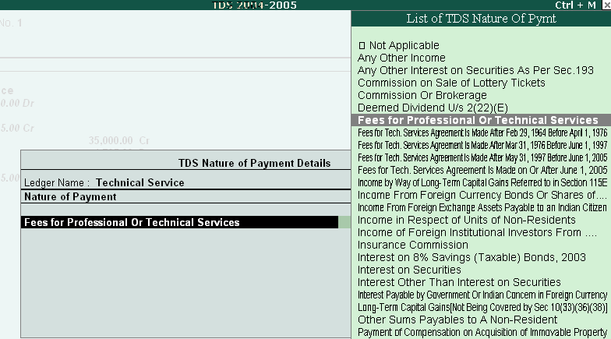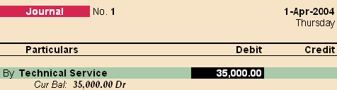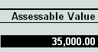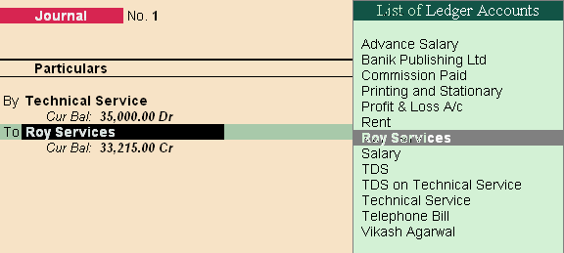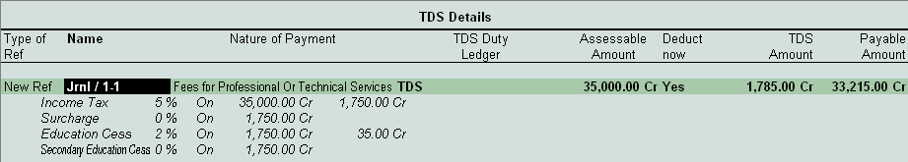

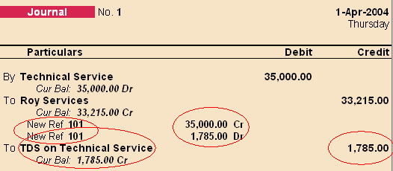

##### NOTE:-

In Above Entry the TDS is getting calculated at the time of Passing Expense Entry, so no separate entry needs to be done

Also in previous version, The TDS calculated was displayed under Display€Statement of Accounts€TDS outstanding, but now the entire TDS related reports are displayed under Statutory Report.

1. Paid annual Rent for Land and Building on 01/04/2004 Of Rs. 150000/- to Vikash Agarwal after deducting TDS @ 15% and Education Cess @ 2% on the amount and rest paid to Vikash Agarwal through HDFC (Chq no: 234797) {Ref no: Rent/tds/002}

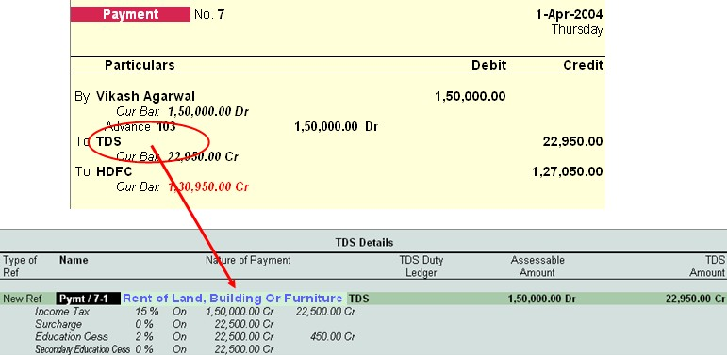

1. An Advertising Contract for Six years made on 01/04/2004 with Banik Publishing Ltd. (Advertising Contractors) for Rs. 300000/- (which will be paid through six equal installments) and Rs. 50000/- paid as first installment amount through cheque of HDFC (Chq no: 234798) on 01/04/2004 after deducting TDS @ 1%, Surcharge @ 2.5% and Education Cess @ 2% on entire amount (Rs. 300000) {Ref no: Advt/tds/003)

Step 1:- Pass the Advertising Contract entry in Journal, for Expenses incurred

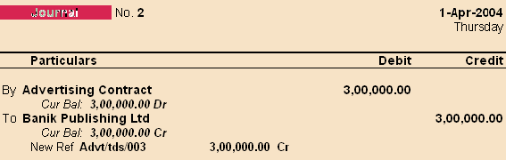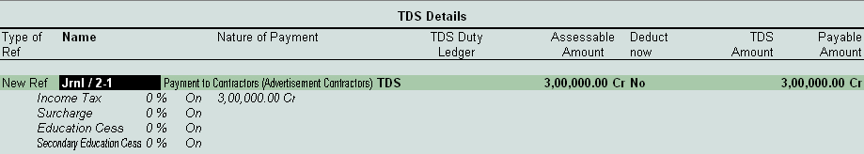

Step 2:- Deduct the TDS from the expenses booked i.e Advertising Contract F7 (Journal Entry) Press Alt + S for TDS deduction

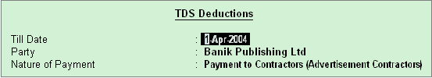

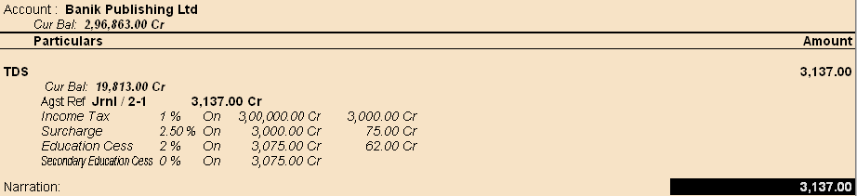

NOTE:- The bill selection details should be against reference, this will deduct 3137/- amount from Banik Publishing Ltd.

1. Check TDS payable report through GOT€Display€Statutory Reports€TDS Reports€Outstandings€TDS Payable. {It will display pending amount = Rs. 27872/-}
2. Paid entire TDS payable amount for the month of April on 02/04/2004 through (Chq no: 234799).

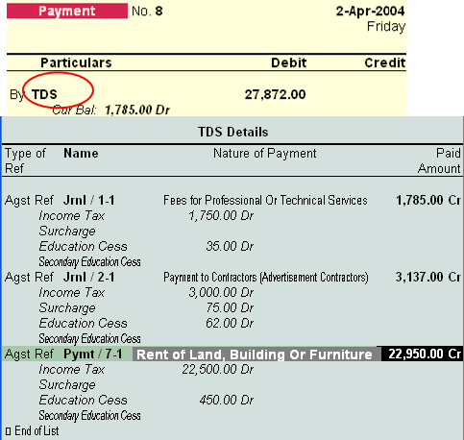

The Entry needs to be passed in payment voucher, and from the LIST select TDS only, and automatically it will be displaying the TDS Details, and to be paid part.

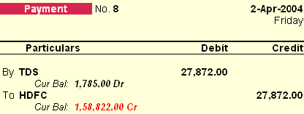

NOTE: - Also the cheque details can be inserted, while passing entry, so these details will be there in challan printing option.

Hint: - Use Print Preview of Cheque Printing and check TDS challan. Press Alt + Z to Zoom/enlarge the report.

In Tally erp Statutory Report generate all the details regarding the forms and all other reports.

# 15BLab Assignment No. 6:- (TDS)

##### Create a Company, for year 2009-2010 Enabling TDS features from F11 Example 1:-

The expense of Rs. 25000/- is booked for Professional Services, and payment is made to the party “Computronics Pvt. Ltd.”, **(Deductee type:- Individual/HUF – Resident)** deducting TDS.

##### Solution:-

**Step 1:-** Pass the Expense entry in F7 (Journal) Deducting TDS at the time of booking Expense *Note:- Create Professional Service under Indirect Expense (Mark Default payment Fees for Professional Or Technical Services)*

##### Example 2:-

The advance payment done to party Raghav & Co. **(Deductee type:- Association of Persons)** of Rs. 23000/- for Advertisement Contract, TDS deducted on the Same

##### Solution:-

**Step 1:-** Pass the entry in payment voucher (F5) deducting TDS at the time of payment.

*Note:- Advertisement in Indirect Expenses Nature of Payement:- Payment to Contractors (Advt. Contrct)*

##### Example 3:-

Expense of Rs. 122000/- incurred for Rent on Land & Building, to be paid to Mr. “Bhateja Consultants”

**(Deductee type:- Body of Individual)**, deducting TDS

##### Solution:-

**Step 1:-** Pass the Expense entry in F7 (Journal) making **TDS Deduct Now** option as a **NO** while selection.

**Step 2:-** Deduct TDS by using **Alt + S** option in Journal Voucher

##### TDS Payment:- (Total TDS to be paid :- 27944/-)

Check the TDS amount to be paid from Statutory Report, and make the payment for TDS

# 16BAssignment No. 8:- TCS (Tax Collected at Source) & Service Tax

Tax has to be collected at source by the seller, while debiting the amount payable by the buyer to buyer’s account (or) at the time of receipt of such amount from the buyer in cash or by issue of cheque / draft or by any other mode, whichever is earlier. The rate of tax should be applied as a percentage on the purchase price. Within 10 days from the date of debit or receipt of the amount, the person collecting tax should issue a certificate of tax collected. The Certificate shall be in Form No.27D.

1. Open Previous TDS Company Created (Alter to Account with Inventory) **(Change the period to 2005-2006 at gateway of tally)**
2. Press F11€F3 € Enable TCS (Yes)

€ Set/Alter TCS details (Yes)

##### Creation of TCS Ledger A/c

For TCS you create the TCS Ledger A/c on which the tax has been collected. At TCS Ledger creation screen enter the following details :

* 1. Name : TCS on Scrap Sale
  2. Under : Duties & Taxes
  3. Type of Duty/Tax : TCS
  4. Nature of Goods… : Scrap
  5. Inventory Values… : No

##### Creation of Party Ledger A/c

You must create the Party Ledger from whom TCS is collected. At the Party Ledger creation screen enter the following details :

1. Name : Roy Enterprises
2. Under : Sundry Debtors
3. Maintain balance… : Yes
4. Inventory Values… : No
5. Is TCS Applicable : Yes

Buyer/Lessee : Body of Individuals Is Lower /No Collection Applicable ? No

Ignore Surcharge Exemption Limit ? Yes

(Note:- (1) Select the Buyer / Lessee Type from the list. (2) Is Lower /No Collection Applicable : If this field is set to Yes then the exemption is applicable.)

##### Creation of Sales Ledger

1. Name : Scrap Sales
2. Under : Sales Account
3. Inventory Values… : Yes

##### Creation of Stock Item

1. Name : Scrap
2. TCS Nature of Goods : Scrap
3. Under : Primary
4. Units : Ton Pass the following entries for TCS
5. Sold scrap 10 tons at 1200/- to Roy Enterprises on 2/4/05

##### Entry to be passed in Sales invoice mode.

1. Received total amount from Roy Enterprises on 1/5/2005, after deducting 3.5% discount by cheque.
2. Paid TCS by cheque on 2/5/05

(Note:- Use TCS helper for calculating TCS amount)

##### TCS Report

Display > Statutory Report > TCS Report

There are three types of Statutory Reports 1) Print Form 27D. 2) Print Form 27B. 3) ETCS Forms.

**Service Tax (for the year 2009-10) (Change the period for the company)**

As Sales Tax is an indirect Tax on goods sold, Service Tax is indirect Tax on Services provided. Service Tax is paid by buyer of service to seller of service, who in turn, deposits the tax with government.

Activation of Service Tax in a Company

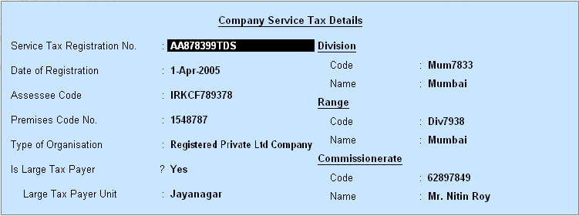Click F11: button & set **YES** at “Enable Service Tax”, also set **YES** at “Set / Alter Service Tax Details” under Statutory & Taxation Features.

##### Creation of Ledgers for Service Tax

* 1. **M/s Roy Trading**
     1. Under : Sundry Debtors
     2. Maintain Balance …. : Yes
     3. Is Service Tax applicable : Yes

Type of Classification : Not Applicable

##### M/s Biswas Bros.

* + 1. Under : Sundry Creditors
    2. Maintain Balance… : Yes
    3. Is Service Tax Applicable : Yes

Type of Classification : Not Applicable

##### Service Category Profile

Gateway of Tally > Display > Statutory Info > Service Categories > Bussiness Auxiliary. Ledgers Creation

##### Service Income

1. Under : Sales Account
2. Is Service Tax Applicable : Yes

Category Name : Business Auxiliary

##### Service Charge

* 1. Under : Purchase Account
  2. Is Service Tax Applicable : Yes

Category Name : Business Auxiliary

##### Service Tax (Purchase)

* 1. Under : Duties & Taxes
  2. Type of Duty/Tax : Service Tax Category Name : Bussiness Auxiliary

##### Service Tax (Sales)

* 1. Under : Duties & Taxes
  2. Type of Duty/Tax : Service Tax Category Name : Bussiness Auxiliary

##### Pass necessary Voucher entries:- (Purchase & Sales entry pass in Account invoice mode)

1. Service given to M/s Roy Trading, on which the service tax is levied, the amount is Rs. 1500/-
2. Received Rs. 1000/- from M/s Roy Trading, in form of Cheque.
3. Service taken from M/s Biswas Bros. of Rs. 1000/- (Entry in purchase Voucher)
4. Paid Rs. 800/- to Biswas Bros in form of Cheque.

##### Input Service Tax

We have discussed Service Tax in sales voucher for services provided and deposit of proportionate tax on receipt of payment against service bills.

Some organization also buys services paying service tax . If the service is bought to render the service sold , then the service tax paid on services purchased (called Input Credit) may be adjusted from the service rendered .

To see the amount of Input Credit available which can be adjust , follow this steps Gateway of Tally > Display > Statutory Reports > Service Tax Reports > Input Credit form . Adjustment of Input Credit and Payment of Balance Service Tax

Gateway of Tally > Accounting Voucher > F5 (Payment) on **1-5-2009**

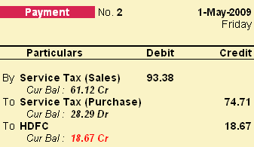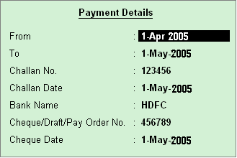

Challan For Balance Tax Deposit After adjustment of Input Tax , print the TR – 6 Challan to deposit the Tax with the authority . Gateway of Tally > Display > Statutory Reports > Service Tax Reports > TR-6 Challan

# 17BLab Assignment No. 8.1:- (TCS & Service Tax)

##### Tax Collected at Source

**Gateway of Tally**€**Click on the F11: F3 Set Enable TCS to Yes**

**Set/Alter Details Yes**

BLRM00123A

Wards Others Mr. Nair

Account Manager

**:**

**:**

**:**

**:**

**:**

**Tax Assessment Number Income Tax Circle/Ward (TCS) Deductor Type**

**Name of person responsible**

**Designation**

**Gate of Tally**€**Accounts Infor**€**Ledgers**€**Create Ledger 1**

**Ledger 2**

**Name :** TCS on Timber Leaves

**Under :** Duties & Taxes

##### Type of Duty/Tax : TCS

**Nature of Payment ;** Timber obtained under forest lease

**Name :** Agarwal Timber Plant

**Under :** Sundry Debtors

##### Maintain balance bill… ? Yes

**Is TCS Applicable ;** Yes

**Deductee Type :** Individula/HUF – Non Resident

##### Ignore surcharge Exemp… : Yes

**Gateway of Tally:-**

**Pass the necessary entries for TCS**

* 1. Sold Timber leaves to Agarwal Timber Plant at Rs. 5,00,000/-, Charged the TCS on same.
  2. Agarwal Timber paid the amount of 5,00,000/- plus TCS.
  3. Payment done through bank for TCS collected from Agarwal Timber Plant

**Service Tax**

##### Gateway of Tally€F11€F3 Enable Service Tax Yes Set/Alter Service Tax Details Yes

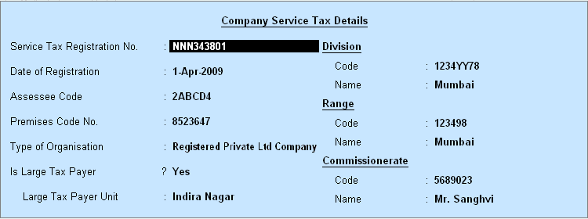

**Gateway of Tally Ledger Creations Ledger 1**

|  |  |  |
| --- | --- | --- |
| **Name** | **:** | Management Consultant |
| **Under** | **:** | Sales Accounts |
| **Inventory Values are affected** | **?** | Yes |
| **Is Service Tax Applicable** | **;** | Yes |
| **Category Name** | **:** | Management Consultant |
| **Name** | **:** | Purchase Mngmnt Consultant |
| **Under** | **:** | Purchase Accounts |
| **Inventory Values are affected** | **?** | Yes |
| **Is Service Tax Applicable** | **;** | Yes |
| **Category Name** | **:** | Management Consultant |
| **Name** | **:** | Bhateja Consultant |
| **Under** | **:** | Sundry Creditors |
| **Maintain Balance Bill by** | **?** | Yes |
| **Is Service Tax Applicable** | **;** | Yes |

**Ledger 2**

**Ledger 3**

**Exemption Details**€**Type of Classification**€Not Applicable

##### Ledger 4

**Name :** Kalka Traders

**Under :** Sundry Debtors

##### Maintain Balance Bill by ? Yes

**Is Service Tax Applicable ;** Yes

**Exemption Details**€**Type of Classification**€Not Applicable

|  |  |  |  |
| --- | --- | --- | --- |
| **Ledger 5** |  | | |
|  | **Name** | **:** | Input Serv Tax Mngmt Consultant |
|  | **Under** | **:** | Duties & Taxes |
|  | **Type of Duty/Tax** | **?** | Service Tax |
|  | **Category Name** | **;** | Management Consultant |
| **Ledger 6** |  |  |  |
|  | **Name** | **:** | Output Serv Tax Mngmt Consultant |
|  | **Under** | **:** | Duties & Taxes |
|  | **Type of Duty/Tax** | **?** | Service Tax |
|  | **Category Name** | **;** | Management Consultant |

##### Gateway of Tally

**Pass the necessary voucher entry for Service Tax**

1. Purchase services from Bhateja Consultant (Sundry Creditor) worth Rs. 80000/- on 31/7/2009. Pass the entry in purchase voucher with input service tax charged
2. Sold on 2/8/2009 service worth Rs. 200000/- to Kalka Traders, pass the entry in sales voucher with Output Vat.
3. Received from Kalka the total amount of services sold with service tax on 31/8/2009 through Cheque.

Check the details for Service Tax to be paid in

Gateway of Tally€Display€Statutory report€Service Tax report€Service Tax Payable

1. The total service tax paid on 1/9/2009,

**Print the service tax challan**

18B**Class Room Assignment No. 9:- (Create User & Security Control, Budget)**

Create a company by name Roa and company, Use security control option, and tally vault password, Budget Control, Cheque Printing option, Bank reconcilation statement

Using administrative user create following ledgers:-

|  |  |  |
| --- | --- | --- |
| **Ledger** | **Group** | **Budget** |
| Capital | Capital account | 1000 |
| Purchase | Purchase account | 2500 |
| Postage | Indirect expenses | 50 |
| Rajkamal | Sundry Creditor | 2000 |
| Sales | Sales account | 3000 |
| Rahim | Sundry Creditor | 300 |
| Suresh | Sundry Debtor | 400 |
| Nayak | Sundry Debtor | 250 |
| Purchase returns | Purchase account | 400 |

|  |  |  |
| --- | --- | --- |
| Salary | Indirect expenses | 250 |
| Drawings | Capital account | 1000 |
| Stationary | Indirect expenses | 200 |
| Rent | Indirect expenses | 150 |
| Commission | Indirect income | 250 |
| Bank of India | Bank Account | 125 |
| Office Furniture | Fixed Assets | 450 |
| Sales Return | Sales Account | 25 |

##### Pass the below mention entry in data entry user:-

|  |  |
| --- | --- |
| **Particulars**  1. Roa brought cash as investment in business 1-4-2009 | **Rs.**  5000 |
| 2. Bought goods for cash on 1-4-2009 | 2,500 |
| 3. Paid for postage as on 1-4-2009 | 10 |
| 4. Sold goods, amount received by cheque 1-4-2009 | 150 (Chq No. 694521) |
| 5. Received commission by cheque 1-4-2009 | 225 (Chq No. 754213) |
| 6. Bought office furniture for cash 2-4-2009 | 500 |
| 7. Purchased goods from Rajkamal 1-5-2009 | 2,000 |
| 8. Bought goods from Rahim 1-5-2009 | 400 |
| 9. Returned goods to Ralkamal 1-5-2009 | 200 |
| 10. Sold goods to Suresh 2-5-2009 | 400 |
| 11. Sold goods to Nayak 31-5-2009 | 250 |
| 12. Purchased goods for cash 31-5-2009 | 400 |
| 13. Recevied cash from Nayak 31-5-2009 | 200 |
| 14. Paid cash to Rahim 31-5-2009 | 50 |
| 15. Suresh returned goods 31-5-2009 | 50 |
| 16. Cash Deposited into bank 31-5-2009 | 500 |

1. Paid salary by cheque 31-5-2009 150 (Cheque No. 242560)
2. Sold goods for cash 31-5-2009 500
3. Rao withdraw cash for his personel use 31-5-2009 800
4. Paid rent by cheque 31-5-2009 50 (Cheque No. 242561)
5. Paid for stationery 1-6-2009 100

Use Tally audit feature for checking the ledgers and voucher entries

#### Bank Reconcilation Statement

1. Cheque deposited on 01/4/2009, Cheque No. 694521 got cleared on 1-5-2009
2. Commission received cheque deposited on 01/4/2009, Cheque no. 754213 got cleared on 2-5- 2009.
3. Rent paid on 31/5/2009 cheque no. 242561 got cleared on 1/6/2009
4. Salary paid on 31/5/2009 cheque no. 242560 got cleared on 2/6/2009

##### Please calculate balance as per Bank Amount Rs. 725/- for the month of May 2009.

9B**L**1 **ab Assignment No. 9.1:- (Create User & Security Contorl,**

# Budget, Separate Discount)

##### Haridas and company

1.Started business with cash Rs.10,000,furniture Rs.4,000 and machinery Rs.5,000. 2.Bought goods from Anil on credit Rs. 4,000 and for cash Rs.5,000.

1. Sold goods to Rajesh on credit Rs.5,000 and for cash Rs.3,000.
2. Bought goods from Arun Subject to trade discount of 2% of Rs.2,000.
3. Sold goods to Ramesh subject to trade discount of 5% of Rs.4,000.
4. Paid salary Rs.1,000, printing Rs.150 and wages rs.100. 7.Received rent Rs.500, commission Rs.400.

9. Sold goods to Ganesh Rs. 1200.

1. Received a cheque from Ganesh Rs.1,000.

|  |  |  |
| --- | --- | --- |
| **Ledger** | **Group** | **Budget** |
| Capital | Capital account | 8000 |
| Furniture | Fixed asset | 3500 |
| Machinery | Fixed asset | 4000 |
| Purchase | Purchase account | 12000 |

|  |  |  |
| --- | --- | --- |
| Anil | Sundry Creditor | 3500 |
| Sales | Sales account | 15000 |
| Rajesh | Sundry debtor | 6000 |
| Arun | Sundry creditor | 1750 |
| Ramesh | Sundry debtor | 3600 |
| Salary | Indirect expenses | 1200 |
| Printing | Indirect expenses | 250 |
| Wages | Direct expenses | 200 |
| Rent | Indirect expenses | 800 |
| Commission | Indirect expenses | 1000 |
| Ganesh | Sundry creditor | 600 |
| Trade discount | Indirect expenses | 300 |

# 0BC2 lass Room Assignment No. 10:-

##### Account With Inventory

Create a Company by name Maganbhai Stationary traders, create a godown Mumbai & Pune. Create Inventory Items under Stationary Using Standard Rates for stock Items

Inventory Info€Stock Items€***F12 (Allow Std. Rates for Stock Items) Yes***

|  |  |  |  |  |
| --- | --- | --- | --- | --- |
| **Stock Items Under** | **Units** | **Std. Rate** | **Standard Cost** | **Selling Price** |
| Natraj Pencil Stationary | Bx. | Yes | 30.00 | 32.00 |
| Natraj Eraser Stationary | Bx. | Yes | 25.00 | 33.00 |
| Natraj SharpnerStationary | Bx. | Yes | 35.00 | 37.00 |

* 1. Purchase order given for the following stationary items to Natraj company (Purchase Order (Alt+F4)), Godown **Mumbai** Order No. **1012**
     1. Natraj Pencil 5000 Bx.
     2. Natraj Eraser 4500 Bx.
     3. Natraj Sharpner 3000 Bx.

GOT€Display Menu€Statement of Inventory€Purchase Order Summary€Order (Outstanding)

The above entry been done, i.e its been passed as an order given to the Natraj Company for the stationary items.

* 1. Natraj company delivered the following stationary items (Receipt Note (Alt + F9)),

Godown **Mumbai** Order No. **1012** Tracking No. **B01245**

* + 1. Natraj Pencil 5000 Bx.
    2. Natraj Eraser 4500 Bx.
    3. Natraj Sharpner 3000 Bx.

GOT€Display Menu€Statement of Inventory€Purchase Bills Pending

The above entry been done, where the goods are delivered to godown, but bill is not given i.e pending

GOT€Profit and Loss€Purchase

* 1. Following stationary items distributed as a free sample to St. Xaviers School Tracking No.

##### B01246

* + 1. Natraj Sharpner 1000 Bx.
    2. Natraj Pencil 1500 Bx.
    3. Natraj Eraser 2000 Bx.
  1. Stationary Items sold to Sonal Depot, Tracking No. **B01247**

|  |  |  |
| --- | --- | --- |
|  | Actual | Billed |
| i. Natraj Sharpner | 250 Bx. | 200 Bx. |
| ii. Natraj Pencil | 150 Bx. | 100 Bx. |
| iii. Natraj Eraser | 100 Bx. | 75 Bx. |

* 1. The stationary items returned to Natraj Company (Rej Out Alt + F6) Tracking No. **B01245**

Order No. **1012**

* + 1. Natraj Pencil 150 Bx.
    2. Natraj Eraser 100 Bx.
  1. Following stationary transferred from Mumbai godown to pune godown
     1. Natraj Pencil 500 Bx.
     2. Natraj Eraser 450 Bx.
     3. Natraj Sharpner 300 Bx.

# BC21 lass Room Assignment No. 11:-

Manufacturing Journal Entry

GOT€Account Info€Voucher type€Create

**Name :** Manufacturing Journal

**Type of Voucher :** Stock Journal

##### Use as a Manufacturing Journal : Yes

**Create Units of measurement**

No (Number), Mtr (Meters) **Create Stock Group:- Material Stock Items:-**

(1) Cotton piece (Mtr), (2) Buttons (No.),(3) Thread (No.),(4) Niddles (No.),

##### Create Stock Group:- Garments Stock Items:-

1. Shirts (No.) (**Note:-** Use Bill of Material (F12) for creating Shirts requirement)

##### (Make Alter Components (BoM) ? Yes)

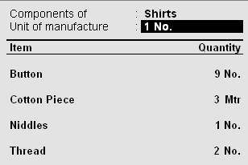

**Pass the necessary entries**

* 1. Purchased cotton piece from Raymond shop (F9€Purchase) **Invoice No**. 10456 Cotton piece 5000 mtr 15/- per meter
  2. Following material purchased from Vandana shop (F9€Purchase) **Invoice No.** 10678 Buttons 1000 No. 0.75/- each

Thread 1000 No. 2.50/- each

Niddles 250 No. 2.50/- each

* 1. Produced 100 No. shirts, (Alt+F7€Manufacturing Journal) Also additional cost incurred for producing shirts

Wages Rs. 5000/-, Electricity Rs. 500/- and Packaging Rs. 2000/- F11€F2€Use Multiple Price Levels

Company Price Levels : 1) Price costing GOT€Inventory Info€Price List

Price Level for Shirt **(Garments)**

|  |  |  |
| --- | --- | --- |
|  | **<25** | **190/- per shirt** |
| **>25** | **<50** | **187/- per shirt** |
| **>50** | **<75** | **175/- per shirt** |
| **>75** | **<100** | **160/- per shirt** |
| **>100** |  | **155/- per shirt** |

**Sales Entries**

* 1. 45 shirts sold to Geeta designer.
  2. 50 shirts sold to Hamid Garments.

# 2BClass Room Assignment No. 12 (Fringe Benefit Tax, ODBC)

### Fringe Benefit Tax

Press F11 (Features)€F3(Statutory)€ Enable Fringe Benefit Tax (FBT) (Yes)

Set/Alter FBT Details (Yes)

|  |  |  |
| --- | --- | --- |
| **Company FBT Assesse Details** | | |
| PAN/Income –Tax Number | : | JRS 12535 |
| Assesse Type | : | Associations of Persons |
| Is Surcharge Applicable | ? | Yes |
| Assesse Category | : | Hotel |

FBT Assesse Type

Gateway of Tally€Display€Statutory Info€FBT Assesse Type FBT Categories

Gateway of Tally€Display€Statutory Info€FBT Category

##### Creation of Ledgers for FBT

|  |  |  |
| --- | --- | --- |
| **1.** FBT |  | |
| a) Under | : | Duties and Taxes |
| b) Type of Duty/Tax | : | FBT |
| c) Inventory Value…. | ? | No |
| **2.** Supplier |  |  |
| a) Under | : | Sundry Creditors |
| b) Maintain balance…. | ? | Yes |
| c) Inventory Value… | ? | No |
| **3.** Entertainment |  |  |
| a) Under | : | Indirect Expenses |
| b) Is FBT Applicable | ? | Yes |

* + 1. FBT Category : Entertainment

##### Pass Necessary Voucher Entries

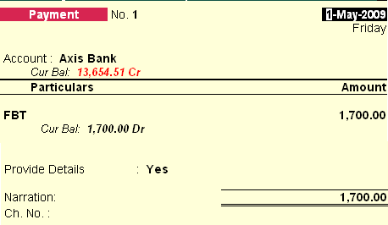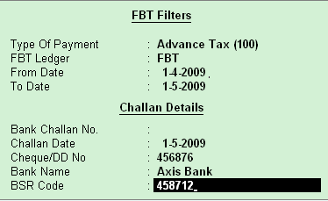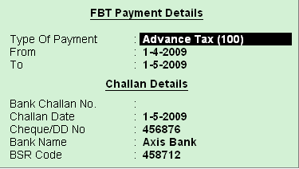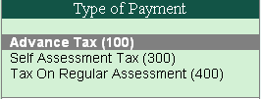

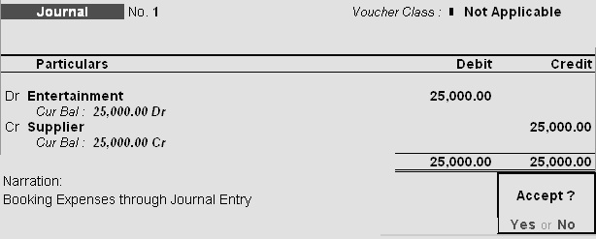 1) Entertainment Expense Rs. 25000/-

##### Payment of FBT for Expenses booked (Use single payment mode, and FBT Helper for calculating Tax)

**Alt + F (FBT Helper)**

1. **Print FBT Challan**€**Press Print Command after Payment entry of FBT done**

**ODBC in Tally**

1) Create Debtors & Creditors by following names:-

|  |  |  |  |  |  |  |  |  |
| --- | --- | --- | --- | --- | --- | --- | --- | --- |
| **Name** | **Under** | **Addres s 1** | **Addre ss 2** | **Addre ss 3** | **Pinco de** | **State** | **Contact No.** | **Email ID** |
| Lalit Jain | Sundr y Credit  ors | 206,  Royal Palace | Shiv Datta Societ  y | Kurla West | 40007  0 | Maharashtra sthra | 9867245  124 | lH [alit_k@gmail.comH](mailto:alit_k@gmail.comH) |
| Umes h Mishr a | Sundr y Debtor s | 202,  Sai Shradd ha Apartm  ent | Near Pipelin e Road, | Kalyan East | 42130  6 | Maharashtra sthra | 9868542  361 | uH [mesh@hotmail.co](mailto:mesh@hotmail.co) mH |
| Same er Zajam | Sundr y  Credit ors | Plot No. 27, | Sector No. 16 | Nerul | 40070  7 | Maharashtra sthra | 2525646  4 | Hsameer.256@yaho  o.co.inH |
| Imran Khush al | Sundr y Credit  ors | 856,  Rachna Garden | Shri Ridhi Sidhi  Sankul | Malad | 40006  4 | Maharashtra shtra | 9856425  241 | iH [mran@rediffmail.c](mailto:mran@rediffmail.c) omH |
| Aarti Kasbe | Sundr y Debtor  s | 256,  Ram Baug | Krishn a Height  s | Andhe ri | 40004  7 | Maharashtra | 6545857  4 | [Haarti_008@zapak.c](mailto:Haarti_008@zapak.c)  omH |
| Tajud din Patha  n | Sundr y Debtor  s | 456,  Rukma ni Villa | Sagar Palace | Grant Road | 40000  7 | Maharashtra | 2425367  4 | [Htaj@gmail.comH](mailto:Htaj@gmail.comH) |
| Jasm eet Naran  g | Sundr y Debtor  s | Gurukri pa CHS,  27 | Sukh Sagar Compl  ex | Sahar | 40009  9 | Maharashtra | 9874562  341 | jH [as_meet@indya.c](mailto:as_meet@indya.c) omH |

**Using the Data of Tally, create a letter for new product launch by the company and inviting the people for seminar kept by the company using Mail Merge in Ms-Word.**

Page **54** of **9**

# Class Room Assignment No. 13 (Payroll)

To enable payroll in Tally

###### *Go to Gateway of Tally*€*F11: Features*€*Accounting Features*

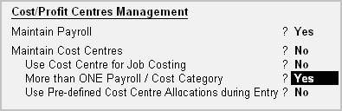

* Set **Maintain Payroll** to **Yes**
* You can set **More than ONE Payroll / Cost Category** to **Yes** if you wish to process payroll for multi group of Employees.

The Payroll Configuration can be enabled as shown below:

###### *Gateway of Tally > F12: Configure > Payroll Configuration*

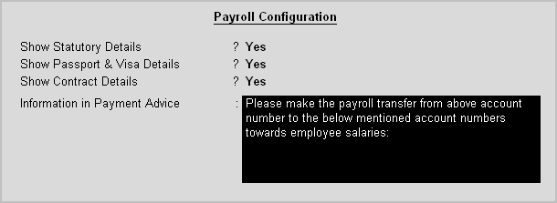

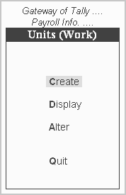A **Unit** in Tally Payroll is similar to the **Unit of Measure** in Tally’s Inventory module. In Payroll, Units are used to facilitate calculation of a Pay Head value based on **Production**, which in turn would be linked to **Units** such as **Time, Work** or **Quantity.**

###### Go to *Gateway of Tally > Payroll Info. > Unit (Work)*

In the Units Creation screen, select the **Type of unit** from the list. Select the **Symbol** from the list.

A Simple Unit in Tally is a single independent unit and has no relationship with other units, while a Compound Unit refers to two Simple Units having an arithmetical relationship and is not a distinct unit.

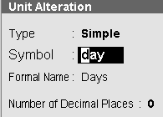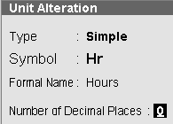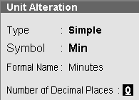

In the case of Overtime, whose value is computed based on Overtime Hours put in by an employee, you would need to define Hr – Hours and Min – Minutes as Simple Units and Hr of 60 Min as a Compound Unit and set this unit in Overtime Pay Head.

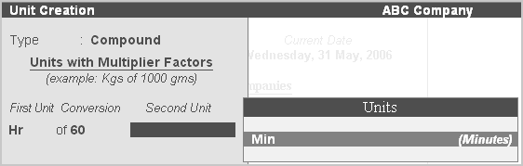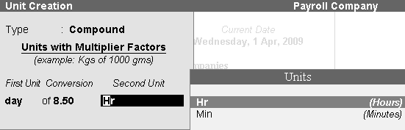

The Attendance / Production type is used to record the attendance and production data. Based on the component (Pay head) structure, you can define multiple attendance / production types.

Examples for attendance / production types are No. of days present or conversely, No. of days Absent and production based such as Hours worked, Number of Pieces produced.

**Attendance/Production Type** is associated with the Pay Head in employee’s Pay structure. The variable data is entered in the Attendance voucher for the payroll period.

**Attendance/Production Types** may also be defined in hierarchical groups whereby Types having a common Unit are combined under logical groups.

The **Attendance/Production Type** may be Attendance/leave with pay, Leave without Pay (if salary is to be paid based on number of days attended) **Paid Leave**, **Unpaid Leave**, **Absent** and **Production type** which can be based on **Piece Production**, **Overtime Hours**, and so on.

###### Go to *Gateway of Tally > Payroll Info. > Attendance/Production Types > Create*

Tally allows you to set up default (common) information for employees. An Employee Group allows you to group employees in a logical manner.

The Salary structure can be defined at the Employee Group level. Referring to this Group as a template and changing accordingly will ease building all your employee records on it.

For example, by department or function such as Production, Sales, Administration and so on, or by designation such as Managers, Supervisors, Workers and so on.

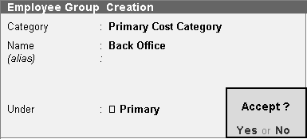To create **Sales** as an **Employee Group**,

###### Go to *Gateway of Tally> Payroll Info.>* Employee Groups> Create (Single Group)

**Creating Multiple Employee Groups**

You can create multiple Employee Groups in this mode.

Go to **Gateway of Tally> Payroll Info.> Employees> Create** (under Multiple Groups)

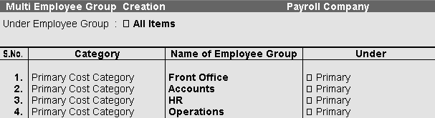The **Multi Employee Group Creation screen** displays.

The Employee Creation screen allows you to enter basic setup information that applies to the employees. Enter General Information, Payment Details and Passport & Visa Details.

**Creating Single Employee**

To create an **Employee** under the Employee group, Back Office:

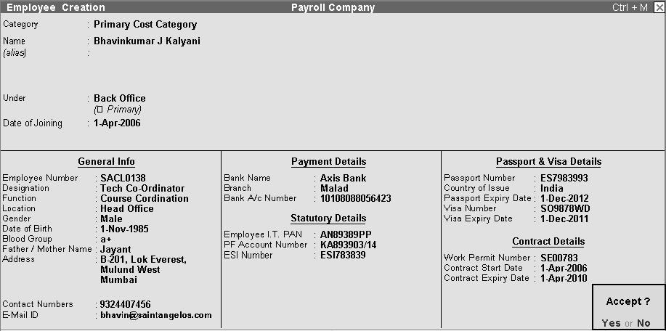

Similarly create employees under different employee groups:-

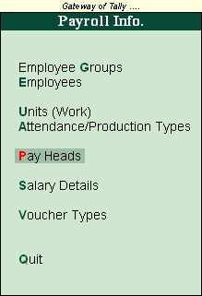The Payroll Info. allows you to set up the employee defaults and standard payroll information with common payroll fields used for calculating earning and deductions.

###### Go to *Gateway of Tally > Payroll Info.*

To create an Earning Pay Head, **Basic Salary**, under **Indirect Expenses**:

###### Go to *Gateway of Tally> Payroll Info. > Pay Heads> Create*

1. **Basic Salary**

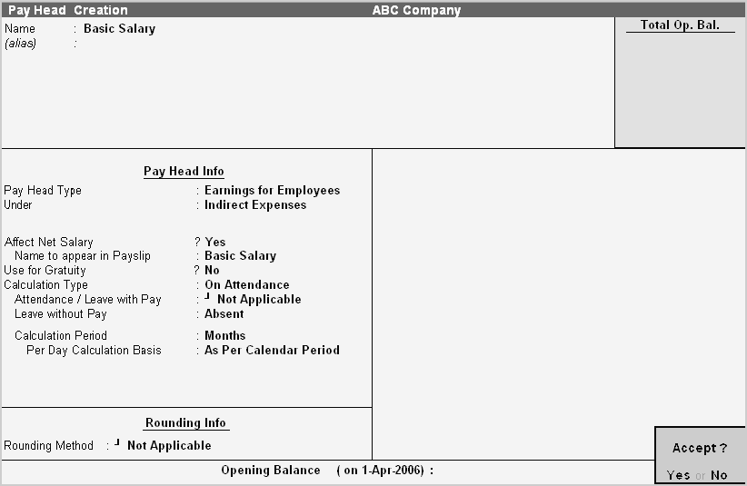

**Similarly create other pay heads:-**

1. **House Rent Allowance:-**

|  |  |  |
| --- | --- | --- |
| Pay Head Type | : | Earnings for Employees |
| Under | : | Indirect Expenses |
| Affect Net Salary | ? | Yes |
| Name to appear in pay slip | : | House Rent Allowance |
| Use for Gratuity | ? | No |
| Calculation Type | : | As Computed Value |
| Calculation Period | : | Months |

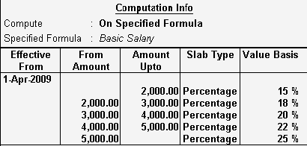**Computation Info**

##### Dearness Allowance:-

|  |  |  |
| --- | --- | --- |
| Pay Head Type | : | Earnings for Employees |
| Under | : | Indirect Expenses |
| Affect Net Salary | ? | Yes |
| Name to appear in pay slip | : | Dearness Allowance |
| Use for Gratuity | ? | No |
| Calculation Type | : | As Computed Value |
| Calculation Period | : | Months |

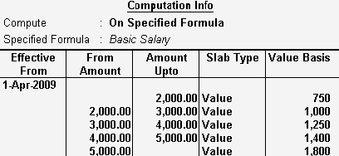Computation Info :

##### Conveyance:-

|  |  |  |
| --- | --- | --- |
| Pay Head Type | : | Earnings for Employees |
| Under | : | Indirect Expenses |
| Affect Net Salary | ? | Yes |
| Name to appear in pay slip | : | Conveyance |
| Use for Gratuity | ? | No |

Calculation Type : On Attendance Attendance/Leave with Pay : Not Applicable Leave without Pay : Absent

Calculation Period : Months

Per Day Calculation Basis : As per Calendar Period

##### Medical Allowance:-

|  |  |  |
| --- | --- | --- |
| Pay Head Type | : | Earnings for Employees |
| Under | : | Indirect Expenses |
| Affect Net Salary | ? | Yes |
| Name to appear in pay slip | : | Medical Allowance |
| Use for Gratuity | ? | No |
| Calculation Type | : | On Attendance |
| Attendance/Leave with Pay | : | Not Applicable |
| Leave without Pay | : | Absent |
| Calculation Period | : | Months |
| Per Day Calculation Basis | : | As per Calendar Period |

1. **Employee PF:-**

|  |  |  |
| --- | --- | --- |
| Pay Head Type | : | Deductions from Employees |
| Under | : | Current Liabilities |
| Affect Net Salary | ? | Yes |
| Name to appear in pay slip | : | Employee PF |
| Calculation Type | : | As Computed Value |
| Calculation Period | : | Months |

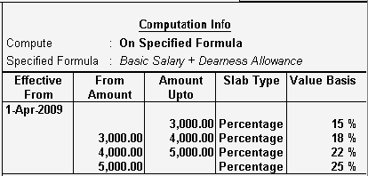Computation Info :

##### Other Allowance:-

|  |  |  |
| --- | --- | --- |
| Pay Head Type | : | Earnings for Employees |
| Under | : | Indirect Expenses |
| Affect Net Salary | ? | Yes |
| Name to appear in pay slip | : | Other Allowance |
| Use for Gratuity | ? | No |
| Calculation Type | : | Flat Rate |
| Calculation Period | : | Months |

1. **Professional Tax:-**

|  |  |  |
| --- | --- | --- |
| Pay Head Type | : | Employee’s Statutory Deductions |
| Under | : | Current Liabilities |
| Affect Net Salary | ? | Yes |
| Name to appear in pay slip | : | Professional Tax |
| Calculation Type | : | As Computed Value |
| Calculation Period | : | Months |

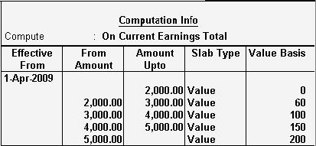Computation Info:-

Salary Details is used to define a Pay Structure to an Employee or to an Employee Group to speed up the entry of Individual Employee’s Pay Structure.

Select the basic Pay Heads that applies most for your employees and create as an Employee Group. However, it is not compulsory for all employees to have the same compensation structures as of the Employee Group. If required, a Pay Head element or its value may be added, deleted or altered at Individual Employee level.

**Note** : If the sla b r a te is no t de fined in the Pa yHead then you will ge t the full v a lue

To create **Salary Details for an Employee Group**, for example:

###### Go to *Gateway of Tally> Payroll Info.> Salary Details> Create> Select Back Office from the List* of Employees/Group

Copy the Salary Details created for Back office to Individual Employee

###### Go to *Gateway of Tally> Payroll Info.> Salary Details> Create> Select Employee from the List of* Employees/Group

Page **62**

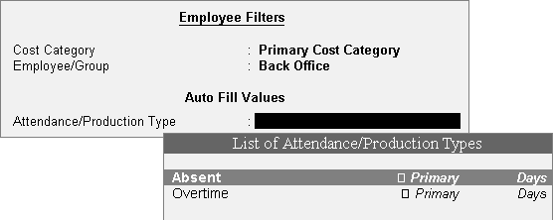

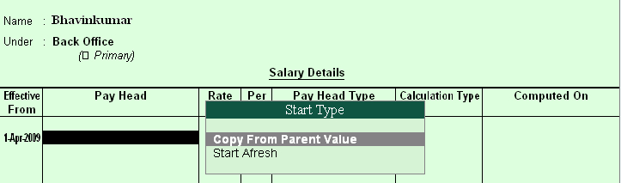

The Similar Salary details will be copied to the Employee from the list.

##### Salary Details Configuration

###### Go to *Gateway of Tally> Payroll Info.> Salary Details> Alter > Select Employee/ Employee* Group from the List of Employees/Group > F12: Configure

**Allow to Override Slab Percentage**

Set **Allow to Override Slab Percentage** to **No** to prevent changes made to Slab Percentages. If you set it to **Yes**, you can override the percentages already defined.

E.g. If you have defined Slab Rate for HRA as 40% in the Pay Head level, and if you wish to change the Slab Rate percentage in the Salary details screen. Set **Allow to Override Slab Percentage** to **Yes** in Salary details configuration screen and Tally will allow you to Overridde the percentage e.g. to 50% and so on... (Metro Cities & Non Metro Cities).

##### Passing the payroll entries in Tally

###### *Gateway of Tally*€*Payroll Voucher*

**Auto Fill Entries**

**1) Entry of no. of days staff absent in may month**

Date:- 31st May

Ctrl + F5:- Attendance (F5)€ Attd Auto Fill (A)

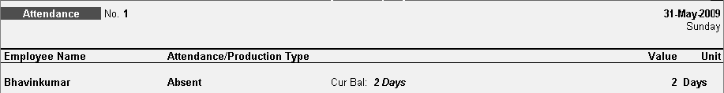

**2) Entry of payroll for may month**

Date:- 31st May

Ctrl + F4:- Attendance (F4)€ Attd Auto Fill (A)

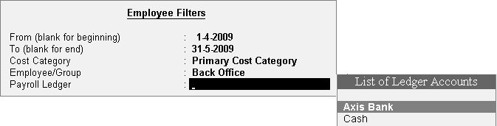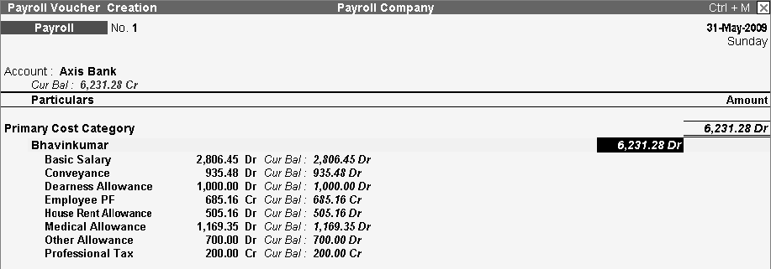

Similarly the entry can be done by manually, so report won’t get generated automatically, the data needs to be feed manually.

**Payslip can be seen**

***Gateway of Tally>Display Menu>Payroll Report>Statement of Payroll>Pay slip***

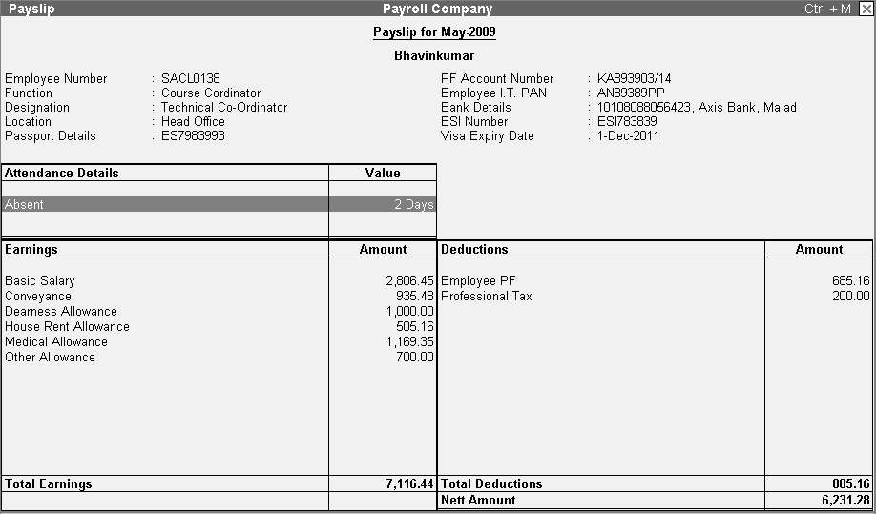

**Class Room Assignment No. 14 (Excise for Manufacturer)**

**Excise Duty**

* Excise Duty or Duty on Excise is a tax on goods manufactured or produced in India and intended for domestic consumption i.e. sale in India.
* The Excise Duty is payable at the time of production or manufacture, however, for administrative convenience duty is paid at the time of removal of goods.
* Excise Duty is an indirect tax.
* The liability of payment of Excise Duty is of manufacturers or producers (which is passed on to the ultimate consumer).
* The levy and collection of duty of Excise is provided under authority of the Central Excise Act, 1944 at the rates specified Central Excise Tariff Act, 1985.

##### Scope and Applicability

###### *Excise Duty can be levied, only on the fulfilment of the below mentioned conditions…*

* The Duty is on Goods.
* The Goods must be excisable.
* The goods must be manufactured or produced.
* Manufacture and Production must be in India.

##### Manufacturer

Manufacturer is a person who actually manufactures or produces excisable goods, i.e. one that actually brings into existence new and identifiable product.

##### Excisable Goods

* Excisable Goods means goods specified in the schedule to the Central Excise Tariff Act, 1985 as being subject to a duty of Excise.

###### *The Basic requirements to be satisfied are* :

* Goods must be movable.
* Goods must be marketable i.e. the goods must be such that it is known in the market and is capable of being bought or sold.

##### Valuation Methods

* Value of the excisable goods has to be necessarily determined to levy the duty on the goods.
* Under the Central Excise Act, 1944, the following methods of valuation of goods are considered for the assessment of Duty…

##### Valuation Methods €1. Ad valorem/ Transaction Value:

* Transaction value means the value of goods which are sold at the time and place of removal and includes in addition to the amount charged as price, any amount that the buyer is liable to pay to, including any amount charged for, or to make provision for, advertising or publicity, marketing and selling, organization expenses, storage, outward handling, servicing, warranty, commission or any other matter.

##### Valuation Methods € 2. Ad Quantum:

* In case of Ad Quantum the duty is payable on the basis of certain unit Like Weight, Length, volume etc.
* For Example: Duty on cigarette is payable on the basis of length of the cigarette, duty on Sugar is based on per Kg.

##### Valuation Methods € 3. Value determined on the basis of M R P:

* Retail sale price means the maximum price at which the excisable goods in packaged form may be sold to the ultimate consumer and includes all taxes local or otherwise, freight, transport charges, commission payable to dealers, and all charges towards advertisement, delivery, packing, forwarding and the like, as the case may be, and the price is the sole consideration for such sale.

##### Salient Features of Excise in Tally.ERP

* Simple and user-friendly
* Quick and easy to set up and use
* Allows Multiple Excise Registration (Manufacturer & Dealer) in Single Company
* Create Tariff (HSN) / Commodity Code
* Flexibility to have separate Unit of Measures for recording transactions and excise reporting
* Item wise Valuation Methods (Valorem, Quantum, MRP)
* Maintain Rule 11 Excise Invoice
* Can apportion Expense / Income ledger value to calculate Assessable Value
* Item wise Duty calculation for different Valuation Methods in single invoice
* Generate Rule 11 invoice for Purchase Returns
* Record Exempt, Export & Special Rate transactions
* Avail Full / Partial CENVAT Credit on Inputs and Capital Goods/ Service Tax towards Duty payable
* Reversal of CENVAT Credit
* Print G.A.R. -7 Challan
* Maintain Invoice Register
* Maintain RG -1 register
* Generate CENVAT Credit Register
* Generate ER-1 & ER-3 returns
* Maintain PLA Register
* Excise Computation Report

##### Excise Process in Tally.ERP

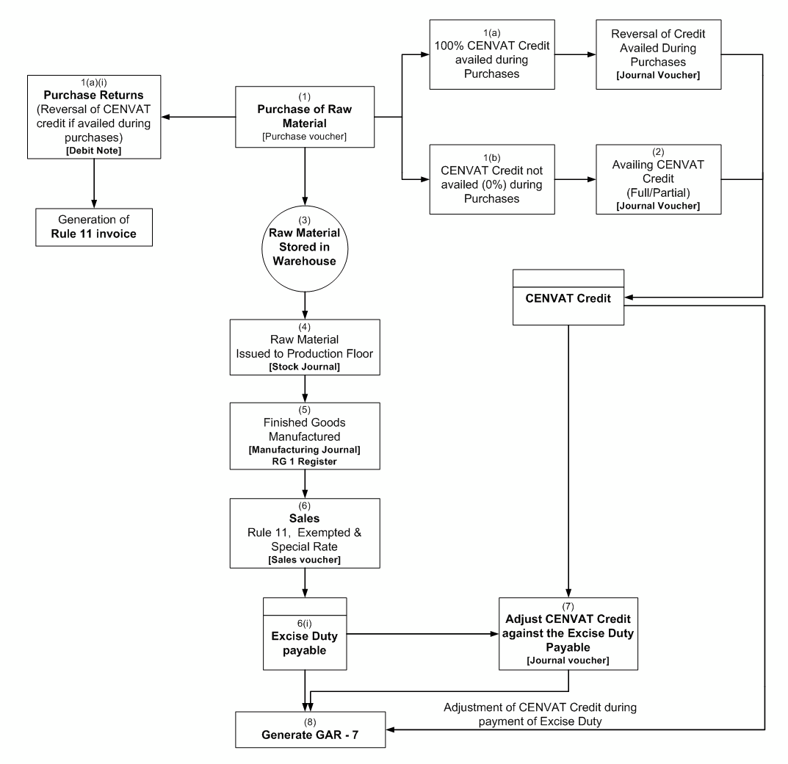

**Create a Company for the year 2009,**

Enabling Excise in Tally.ERP

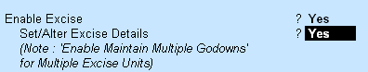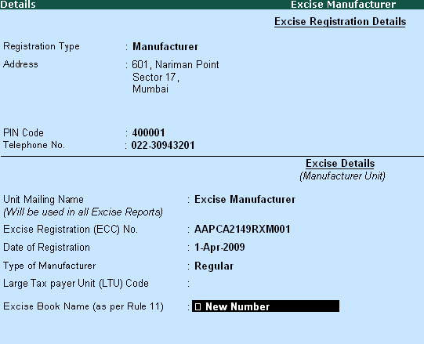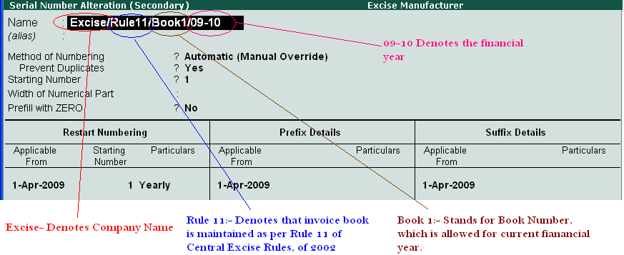

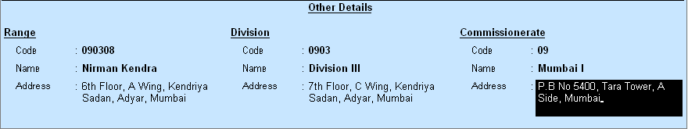

##### Also Enable the VAT details from F11 Statutory & Taxation

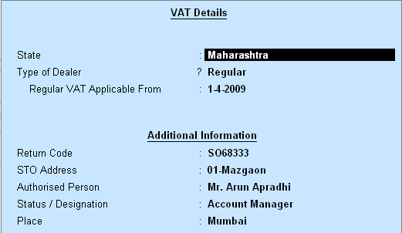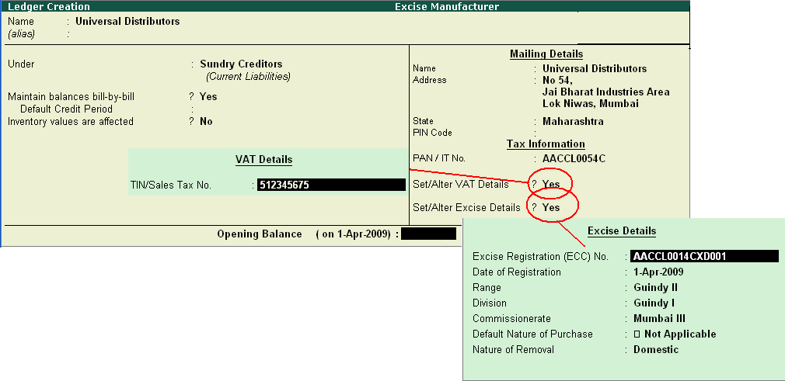

**Gateway of Tally:-**

**The Ledger Created is an Customer Ledger**

**Ledger Creation *(****Gateway of Tally€Acc ount Info€Ledg er€Create****)***

* + 1. Supplier Ledger

Name : Swastik Water Supplier

Under : Sundry Creditors

Maintain balance…. ? Yes Mailing Details

Name : Swastik Water Supplier

Address : No. 34 Anna Nagar Mumbai

State : Maharashtra Tax Information

PAN/IT No. : AEW45TGFDF

Set/Alter VAT Details ? Yes

TIN/Sales Tax No. : 44335543678

Set/Alter Excise Details ? Yes

Excise Registration (ECC) No. AESDE3210NXM001 Date of Registration 1-Apr-2009

Range National Park

Division Mumbai I

Commissionerate Mumbai II Default Nature of Purchase Not Applicable Nature of Removal Domestic

|  |  |  |
| --- | --- | --- |
| **3.** Sales Ledger  Name | : | Sales @ 12.5% |
| Under | : | Sales Accounts |
| Inventory Value….. | ? | Yes |
| Used in VAT Returns VAT/Tax Class  Use for Assessable Calc.. | ?  ? | Yes  Sales @ 12.5% Yes |
| Apportion for | ? | Yes |
| Method of Apportion | : | Based on Value |
| **4.** Purchase Ledger  Name | : | Purchase of Raw Material |
| Under | : | Purchase Accounts |
| Inventory Value….. | ? | Yes |
| Used in VAT Returns VAT/Tax Class  Use for Assessable Calc.. | ?  ? | Yes  Purchase @ 12.5% Yes |
| Apportion for | ? | Yes |
| Method of Apportion | : | Based on Value |

1. Input VAT Ledger

Name : Input Vat @ 4%

Under : Duties & Taxes

Type of Duty/Tax : VAT

VAT/Tax Class : Input Vat @ 4% Percentage of Calc… ? 4%

Method of Calc… : On VAT Rate Rounding Method : Normal Rounding

Rounding Limit : 0

1. Output VAT Ledger

Name : Output Vat @ 12.5%

Under : Duties & Taxes

Type of Duty/Tax : VAT

VAT/Tax Class : Output Vat @ 12.5% Percentage of Calc… ? 12.5%

Method of Calc… : On VAT Rate Rounding Method : Not Applicable

1. Basic Excise Duty Ledger

Name : Basic Excise Duty @ 10%

Under : Duties & Taxes

Type of Duty/Tax : Excise Excise Accountg Code :

Duty Head : Basic Excise Duty Percentage of Calc… ? 10%

Method of Calc… : On Assessable Value Rounding Method : Not Applicable

1. Education Cess Ledger

Name : Education Cess @ 2%

Under : Duties & Taxes

Type of Duty/Tax : Excise Excise Accountg Code :

Duty Head : Education Cess Percentage of Calc… ? 2%

Method of Calc… : On Total Excise Duty Rounding Method : Not Applicable

1. Seconday & Higher Education Cess Ledger

Name : Secondary & Higher Education (SHE) Cess

Under : Duties & Taxes

Type of Duty/Tax : Excise Excise Accountg Code :

Duty Head : Secondary Education Cess Percentage of Calc… ? 1%

Method of Calc… : On Total Excise Duty Rounding Method : Not Applicable

1. Basic Excise Duty CENVAT Ledger

Name : Basic Excise Duty-CENVAT @10%

Under : Duties & Taxes

Type of Duty/Tax : CENVAT Excise Accountg Code :

Duty Head : Basic Excise Duty Percentage of Calc… ? 10%

Method of Calc… : On Assessable Value Rounding Method : Not Applicable

1. Education Cess CENVAT Ledger

Name : Education Cess-CENVAT @ 2%

Under : Duties & Taxes

Type of Duty/Tax : CENVAT

Excise Accountg Code :

Duty Head : Education Cess Percentage of Calc… ? 2%

Method of Calc… : On Total Excise Duty Rounding Method : Not Applicable

1. Secondary & Higher Education Cess CENVAT Ledger

Name : Secondary & Higher Education (SHE)-CENVAT

Under : Duties & Taxes

Type of Duty/Tax : CENVAT Excise Accountg Code :

Duty Head : Secondary Education Cess Percentage of Calc… ? 1%

Method of Calc… : On Total Excise Duty Rounding Method : Not Applicable

|  |  |  |
| --- | --- | --- |
| **13.** Expense Ledger |  | |
| Name | : | Packing Charge |
| Under | : | Indirect Expenses |
| Use for Assessable Val…. | ? | Yes |
| Apportion for | ? | Excise & VAT |
| Method of Apportion | : | Based on Value |

**Gateway of Tally**€**Account Info**€**Voucher Types Creating Excise Voucher Types**

1. Excise Purchase Voucher Type

Name : Excise - Purchase

Type of Voucher : Purchase

*Rest all as it is*

Yes

Excise Manufacturer

?

:

Use for Excise Default Excise Unit

1. Sales Voucher Type

Name : Excise - Sales

Type of Voucher : Sales

*Rest all as it is*

Yes

Excise Manufacturer

?

:

Use for Excise Default Excise Unit

1. Debit Note Voucher Type

Name : Excise – Debit Note

Type of Voucher : Debit Note

*Rest all as it is*

Yes

Excise Manufacturer

?

:

Use for Excise Default Excise Unit

1. Manufacturing Journal Voucher:- *Manufacturing Journal is used to account…*

€ the issue of raw materials to production floor and

€ for the receipt of finished goods.

Name : Manufacturing Journal

Type of Voucher : Stock Journal

*Rest all as it is*

Use as a Manufacturing Journal ? Yes

##### Creating Tariff Classification …

* Each and every goods manufactured or produced have to be classified for finding out the rate of duty applicable. Accordingly, Central Excise Tariff Act 1985 classifies all the goods under 91 chapters and specific code is assigned to each item.
* This code is called **Tariff Classification code**, which consists of 8 digits.
* *First 4 digits represent Chapter and heading a*
* *Next 2 digit represents sub-heading and*
* *The last 2 digit represents sub-sub heading.*

##### HSN CODE

* *The* ***Harmonized Commodity Description and Coding System*** *(HS) of tariff nomenclature popularly known as* ***Harmonised System of Nomenclature (HSN)****,*
* *is an internationally standardized system of names and*
* *numbers for classifying traded products developed and maintained by the World Customs Organization.*

Gateway of Tally:: Inventory Info€Tariff/VAT Commodity

1. Plastic Bottles

Name : Plastic Bottles

Used for : Excise

HSN Code : 39233010

1. Plastic Bottle Caps

Name : Plastic Bottle Caps

Used for : Excise

HSN Code : 39235010

1. Water

Name : Water

Used for : Excise

HSN Code : 22011010

1. Linear Low Density Polyethylene (LLDPE)

Name : Linear Low Density Polyethylene (LLDPE)

Used for : Excise

HSN Code : 39110010

Gateway of Tally:: Inventory Info€Stock Items

Important Note:- Press F12 (Configuration) In Stock Items Mode and Enable the feature Use **Alternate Units** for Stock Items **YES**

1. Pet Bottles – 1 Ltr

Name : Pet Bottles – 1 Ltr

Under : Primary

Units : **U**

Alternate Units : **Kg**

Where : **1 Kg = 100 U**

Tariff Classification : Plastic Bottles Set/Alter Excise Details ? Yes

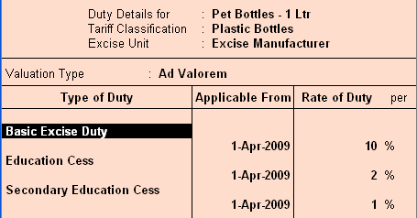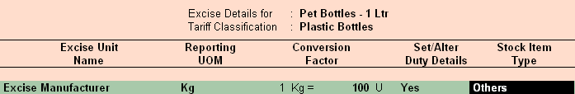

**VAT Details**

Commodity : Not Applicable

Rate of VAT (%) : 4

1. Water Container 20 Ltrs

Name : Water Container 20 Ltrs

Under : Primary

Units : **U**

Alternate Units : **Kg**

Where : **1 Kg = 20 U**

Tariff Classification : Plastic Bottles Set/Alter Excise Details ? Yes

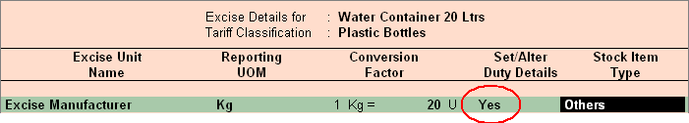

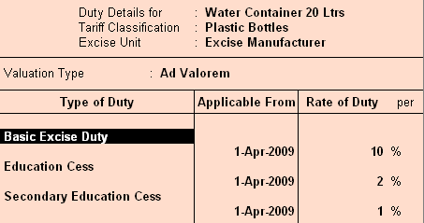

**VAT Details**

Commodity : Not Applicable

Rate of VAT (%) : 4

1. Bottle Caps

Name : Bottle Caps

Under : Primary

Units : **U**

Alternate Units : **Kg**

Where : **1 Kg = 500 U**

Tariff Classification : Plastic Bottle Caps Set/Alter Excise Details ? Yes

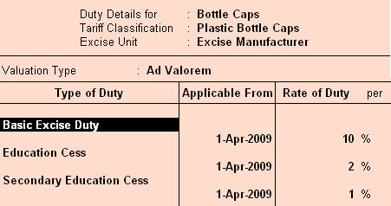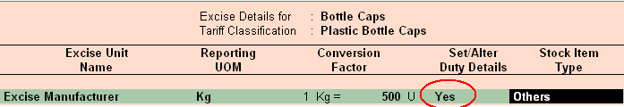

**VAT Details**

Commodity : Not Applicable

Rate of VAT (%) : 4

1. Low Density Polyethylene

Name : Low Density Polyethylene

Under : Primary

Units : **U**

Alternate Units : **Kg**

Where : **1 Kg = 1000 U**

Tariff Classification : Linear Low Density Polyethylene (LLDPE) Set/Alter Excise Details ? Yes

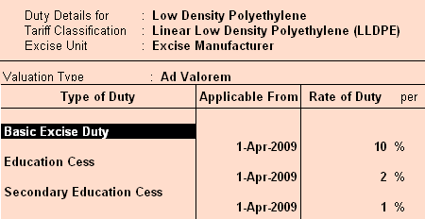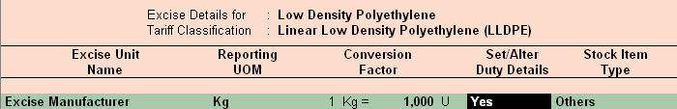

**VAT Details**

Commodity : Not Applicable

Rate of VAT (%) : 4

|  |  |  |
| --- | --- | --- |
| **5.** Natural Water  Name | : | Natural Water |
| Under | : | Primary |
| Units | : | **L** |
| Alternate Units | : | Not Applicable |
| Tariff Classification | : | Water |
| Set/Alter Excise Details | ? | Yes |

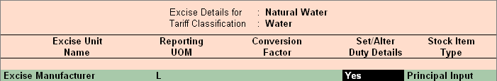

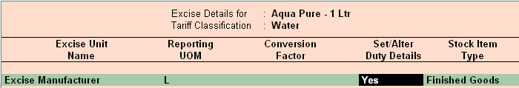

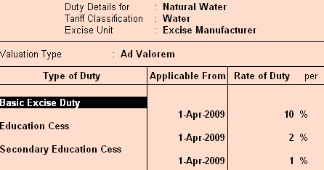

NOTE:- Stock Item Type **Principal Input**

**VAT Details**

Commodity : Not Applicable

Rate of VAT (%) : 0

##### Creating Stock Item - Finished Goods

Important Note:- Press F12 (Configuration) In Stock Items Mode and Enable the feature

**Allow Component list details (Bill of Material) YES**

1. Aqua Pure – 1 Ltr

Name : Aqua Pure – 1 Ltr

Under : Primary

Units : **L**

Alternate Units : **Box**

Where : **1 Box = 24 L**

Alter Components (BoM) ? Yes

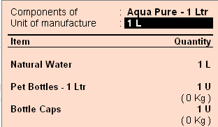

|  |  |  |
| --- | --- | --- |
| Tariff Classification | : | Water |
| Set/Alter Excise Details | ? | Yes |

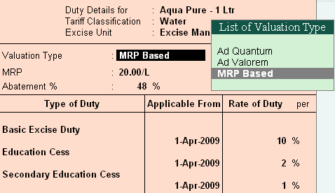

NOTE:- Stock Item Type **Finished Goods**

**VAT Details**

Commodity : Not Applicable

Rate of VAT (%) : 12.5%

1. Aqua Mini – 200 ml

Name : Aqua Mini – 200 ml

Under : Primary

Units : **U**

Alternate Units : **L**

Where : **1 L = 5 U**

Alter Components (BoM) ? Yes

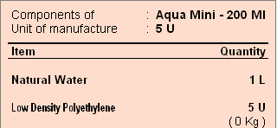

|  |  |  |
| --- | --- | --- |
| Tariff Classification | : | Linear Low Density Polyethylene (LLDPE) |
| Set/Alter Excise Details | ? | Yes |

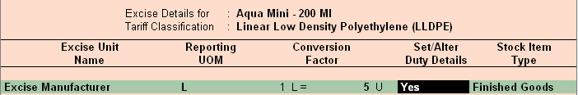

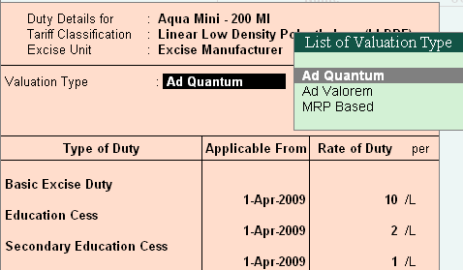

NOTE:- Stock Item Type **Finished Goods**

**VAT Details**

Commodity : Not Applicable

Rate of VAT (%) : 12.5%

1. Aqua King – 20 Ltr

Name : Aqua King – 20 Ltr

Under : Primary

Units : **U**

Alternate Units : **L**

Where : **20 L = 1 U**

Alter Components (BoM) ? Yes

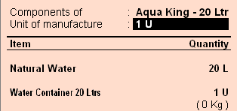

|  |  |  |
| --- | --- | --- |
| Tariff Classification | : | Water |
| Set/Alter Excise Details | ? | Yes |

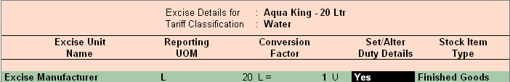

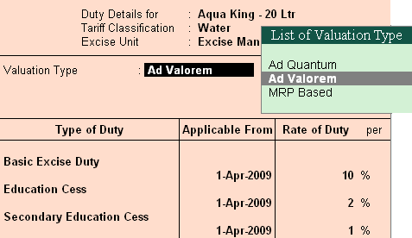

NOTE:- Stock Item Type **Finished Goods**

**VAT Details**

Commodity : Not Applicable

Rate of VAT (%) : 12.5%

1. Aqua Ease – 20 Ltr

Name : Aqua Ease – 20 Ltr

Under : Primary

Units : **U**

Alternate Units : **L**

Where : **1 L = 10 U**

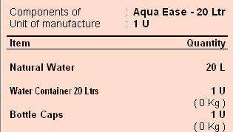Alter Components (BoM) ? Yes

|  |  |  |
| --- | --- | --- |
| Tariff Classification | : | Water |
| Set/Alter Excise Details | ? | Yes |

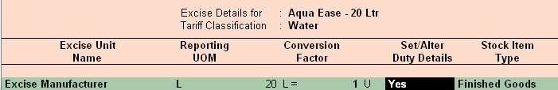

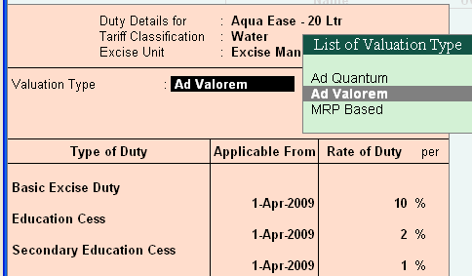

NOTE:- Stock Item Type **Finished Goods**

**VAT Details**

Commodity : Not Applicable

Rate of VAT (%) : 12.5%

**Transactions**

**Creating a Excise Purchase Voucher *Not Availing CENVAT Credit***

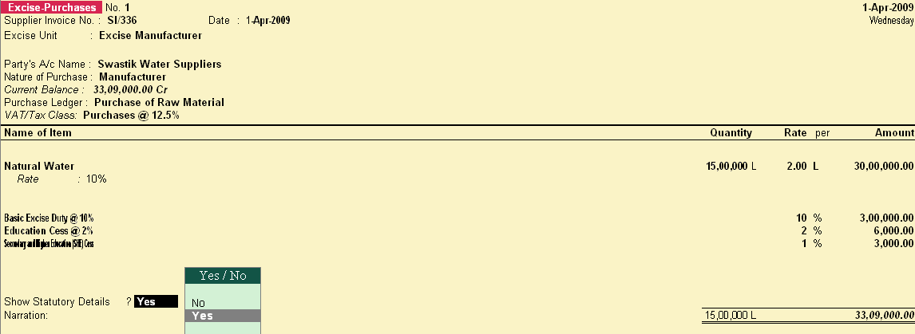

###### *When the CENVAT Credit is not availed*

* The Duty Legers selected won't display the ledger balance and ***duty amount*** *will be apportioned to the Stock Item cost.*

**Gateway of Tally** € **Stock Summary**

Gateway of Tally € Display € Account Books € Ledger

* Basic Excise Duty @ 10%
* Education Cess @ 2%
* Secondary and Higher Education (SHE) Cess All the above ledger, the details will be blank.

##### Creating a Excise Purchase Voucher Availing CENVAT Credit

###### *When the CENVAT Credit is availed…*

* 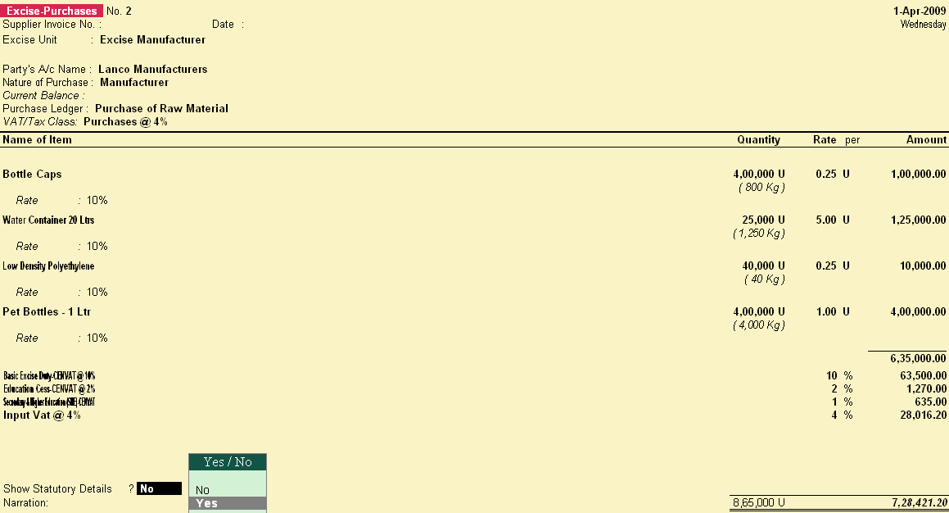The **Duty Ledgers** selected will display the ledger balance and duty amount will not be apportioned to the Stock Item Rate.

###### *When the CENVAT Credit is availed…*

* In Stock Vouchers report stock item rate is displayed as the actual purchase rate.
* In this case the duty amount is **not apportioned** to the Stock item.

Check the Stock in Stock summary the Rate will be same as the amount product Purchased.

##### Creating a Manufacturing Voucher

* Manufacturing of Packed Drinking Water being a Process Industry, Manufacturing Journal is used to account the issue of raw materials to production floor and for the receipt of finished goods.
* *In case of discrete industries, Stock Journal can be used to account the issue of Raw materials to production floor and for the receipt of finished goods*
* To Manufacture > **AquaPure - 1Ltr** using Manufacturing Journal

##### AquaPure – 1 Ltr of 2,00,000 L

* To Manufacture **10,000 U** > **AquaMini - 200 ml** using Manufacturing Journal

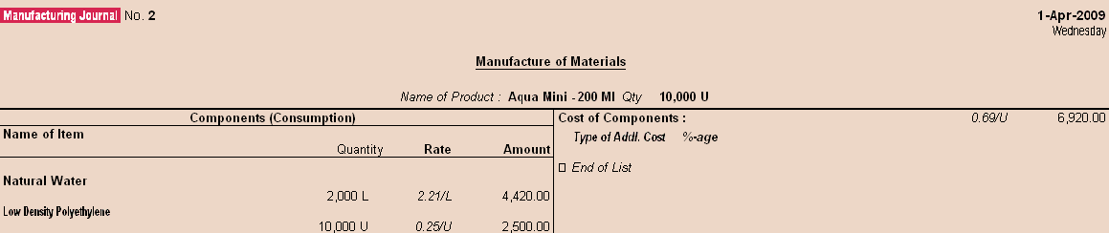

* To Manufacture **10,000 U** > **AquaKing – 20 Ltr** using Manufacturing Journal

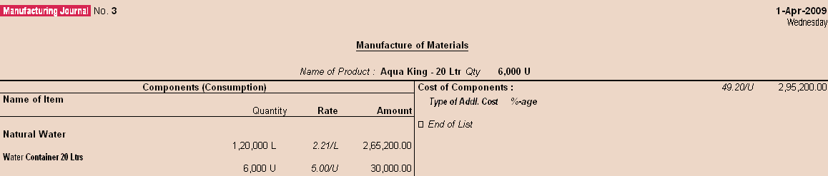

* To Manufacture **1000 U** > **AquaEase - 20Ltr** using Manufacturing Journal

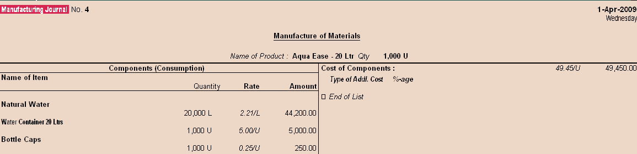

##### Creating a Excise Sales Voucher_ Rule 11 Invoice

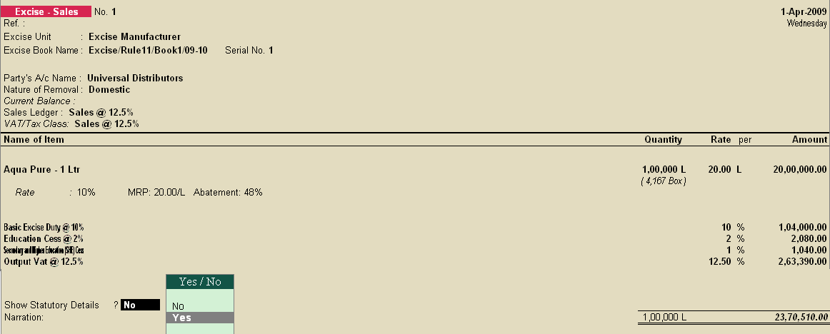

Note:- Give the print command to the sales entry, and enable the print preview option, so Excise Invoice will be printed (Changes to be done in print configuration)

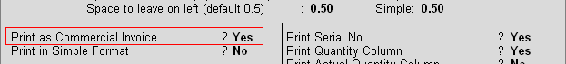

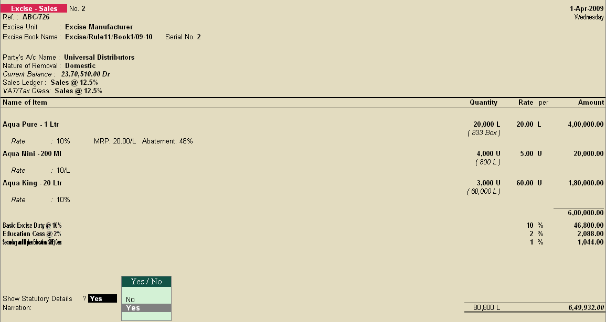**Rule 11 Invoice for *Stock Items Falling Under Different Valuation Type***

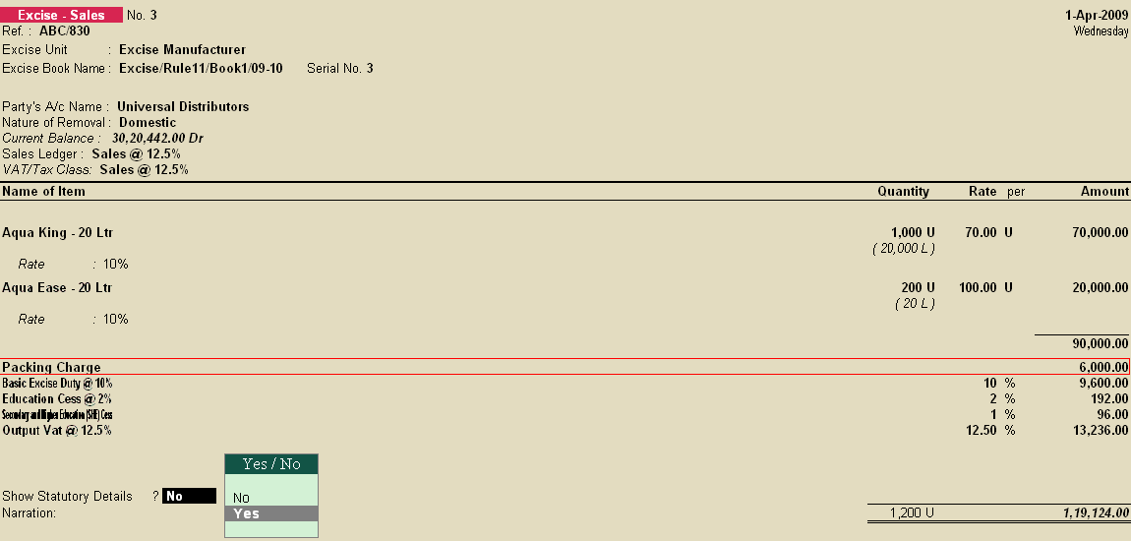**Rule 11 Invoice *for Stock Items with Expenses***

##### Creating a Debit Note (Purchase Returns) _ Rule 11 invoice

* As per Rule 11 of the Central Excise (No.2) Rules, 2001 provides that no excisable goods shall be removed from a factory or a warehouse except under an invoice signed by the owner of the factory or his authorised agent.
* The invoice shall be serially numbered and shall contain the registration number, description, classification, time and date of removal, rate of duty, quantity and value, of goods and the duty payable thereon.
* Invoicing under Rule 11 of the Central Excise (No.2) Rules, 2001 is applicable even for Purchase Returns.
* In case of purchase returns goods are removed from factory or warehouse to return the goods to the supplier.

##### F11€ Features (Enabling following features)

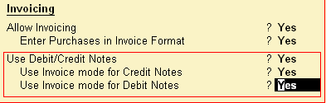

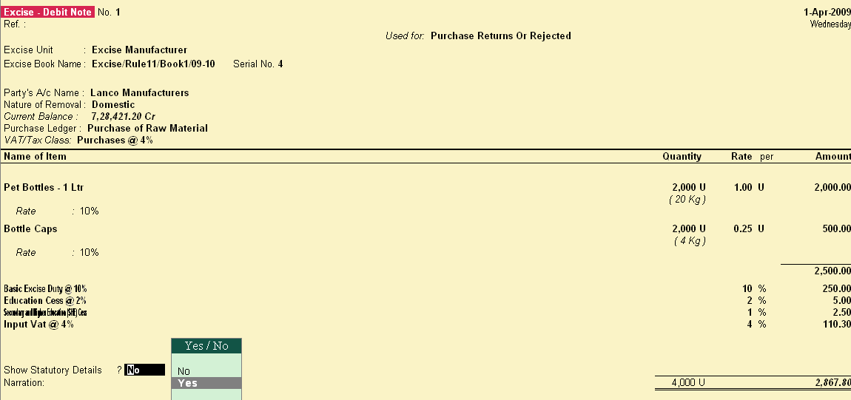

**Creating a Journal Voucher_CENVAT Credit Adjustment**

* CENVAT Credit available to a Unit will be adjusted towards the Duty Payable to arrive at the Net Duty Payable to the Government.
* In Tally.ERP to record the adjustment, CENVAT Duty and Excise Duty accounts are Credited and Debited, respectively to nullify their balances and the net balance in the Excise Duty ledgers will be paid to the Government.
* CENVAT Credit Adjustment entry is recorded at the end of Every month or Quarter depending on the type of Manufacturer.

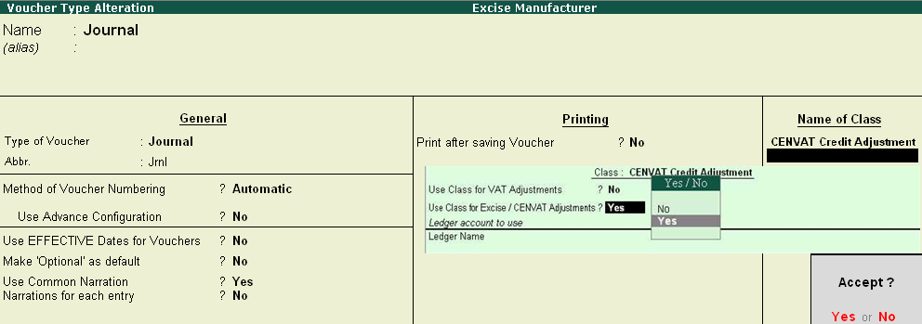

Gateway of Tally€Accounting Vouchers € F7 (Journal)

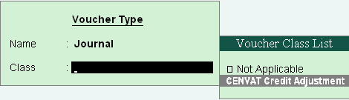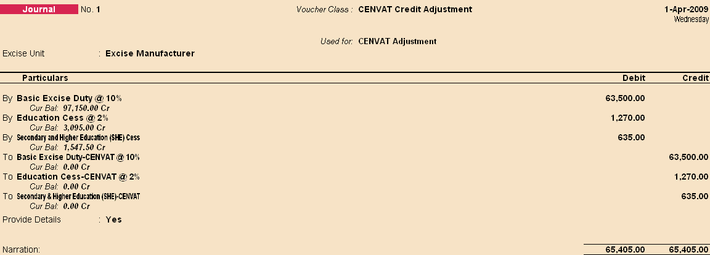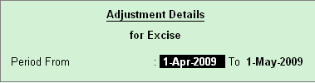

##### Creating a Payment Voucher_GAR 7 Payment

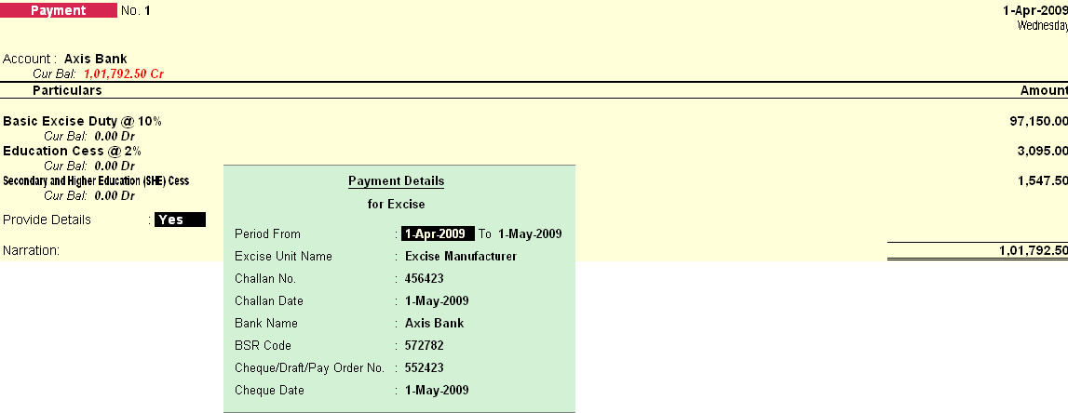

**Printing G.A.R.–7 Challan**

Note:- Give the print command to the Payment Voucher of Duties

**Reports**

* Excise Computation
* Daily Stock Register
* PLA Register
* Form ER 1
* Form ER 2
* CENVAT Credit Register

**Other Reports**

**Gateway of Tally** €**Display** € **Statutory Report** €**Excise Report**

**Daily Stock Register**

* Daily Stock Register is a record of stock maintained on daily basis.
* A daily stock has to be maintained by every assessee.
* This report contains details about Description of goods manufactured/produced, opening balance, Quantity manufactured or produced, Total quantity, Quantity removed, Assessable value, Amount of duty payable and details regarding amount of Duty actually paid.

##### PLA Register

* Personal Ledger Account (PLA) is an current account through which Assessee pays the Duty to the Government.
* The PLA register is credited when the duty is liable to pay and when the Duty is discharged (by CENVAT Credit /Payment) the PLA register will be debited.
* The Duty Payable if any will be displayed as Balance. PLA and CENVAT Credit should be used only for payment of excise duty and not for any other payments like rent, fines, penalties etc.
* Personal Ledger Account (PLA) is an current account through which Assessee pays the Duty to the Government.
* The PLA register is credited when the duty is liable to pay and when the Duty is discharged (by CENVAT Credit /Payment) the PLA register will be debited.
* The Duty Payable if any will be displayed as Balance. PLA and CENVAT Credit should be used only for payment of excise duty and not for any other payments like rent, fines, penalties etc.

##### Form ER 1

Form ER 1 is a monthly return for production, removal of Goods, other relevant particulars and CENVAT Credit.

* All the Excise Manufacturing (Regular/Large Tax payer) Units should file returns in Form ER 1.

##### CENVAT Credit Availed

CENVAT Credit Availed report displays…

€ the details of CENVAT credit availed of Principal Input or Capital Goods.