# Universal Search

Prepared By:

Sourav Kumar

(20-03-2020)

TABLE OF CONTENTS

1. Introduction
2. Objectives
3. Questions
4. Assumptions
5. Mock-ups
6. Estimation

Introduction

The system is already developed and functional. One of the major issues our users face is to search across the information available on the platform. So for a solution which allows our user to go through all the details in our system in a very easy to use manner, we developed a universal search component for our application.

Objectives

When our user search any details with keyword then all the necessary and related details of keyword should appear on user interface in well and readable manner.

Questions

1. What are the user prerequisites before using the searching features?
2. How the data are displayed to the user?
3. What is expected time for the search?
4. What happen if data is not found?

Assumptions

1. We assumed that there are 7 types of data to be searched.
2. Database is updated at regular interval.
3. Systems can handle the lots of data.

Mock-ups

User Interface:

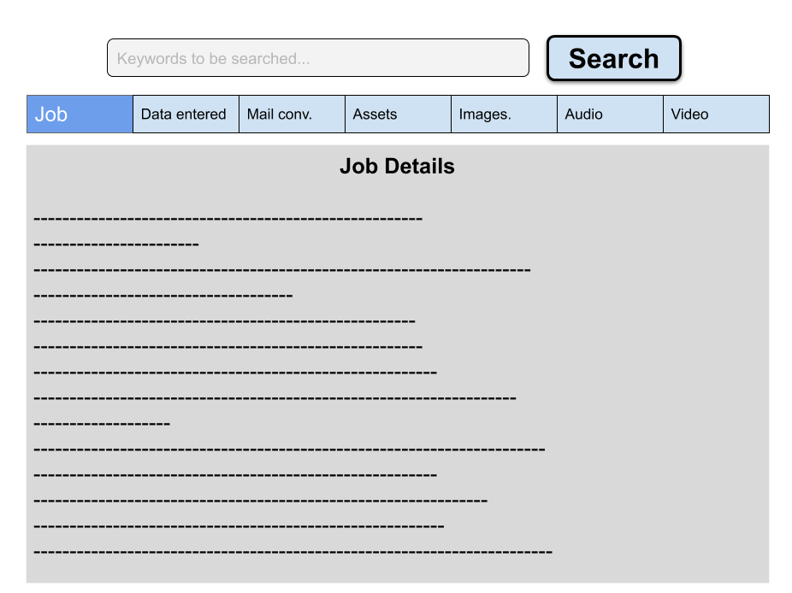

Backend process:

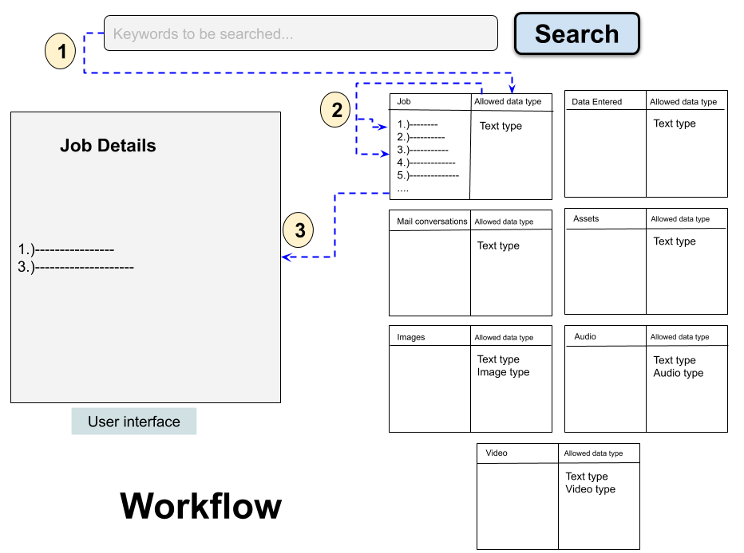

1. In Main page, there will be 7 sections.
2. If user enter any keyword and select the search button. Then the keyword goes to each table (i.e here 7 tables for each type of data) for type matching.
3. According to each match the data will passed to the respective section at main page and if the type is not matched with entered keyword then that section display message that “There is no related data.”.

Estimation

Time:

1. For Best Case: As per my knowledge, total man-hours to complete the task are 40.
2. For Average Case: Means if there is some short of problems occur then the time may extend to 60 man-hours.
3. For Worst Case: Unexpected problem arises, and then the time may extend to 100 man-hours.

Cost:

1. As per time estimation and resources, we can take the worst case of time estimation. Accordingly, if $50 per man-hours will be taken then total cost will be $5000.