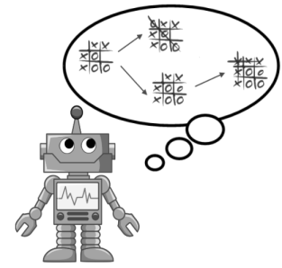

Project 2

Artificial Intelligence
Submitted by: Vimmi Taneja | Artificial Intelligence: CS5346 (Fall 2016) | 11/21/2016

Table of Contents
1. Introduction 3
1.1. Problem Statement 3
1.2 Solution 3
2. Contributions 3
3. Methodology 3
4. Explanation of Program 4
Main.cpp 4
Helper.cpp 5
ABSearch.cpp 7
MinMaxAB.cpp 11
Evaluator.cpp 14
5. Description of Evaluation Functions: 15
1. Standard evaluation function 15
2. Simple score evaluation function 18
3. Evaluate Position 19
4. Linear evaluation function 21
Sample Run of application 22
Sample Run with intermediate results 28
Analysis of results 29
Comparing algorithms 29
Comparing Evaluation Functions 31
Conclusion 33
Source Code 34
Main.cpp 34
Helper.cpp 43
Evaluator.cpp 46
MinMaxAB.cpp 58
AB_Search.cpp 63

Introduction
Tic-tac-toe (also known as Xs and Os) is a paper-and-pencil game for two players, X and O, who take turns marking the spaces in a 3×3 grid. The player who succeeds in placing three of their marks in a horizontal, vertical, or diagonal row wins the game. Despite its apparent simplicity, Tic-tac-toe requires detailed analysis to determine even some elementary combinatory facts, the most interesting of which are the number of possible games and the number of possible positions. A position is merely a state of the board, while a game usually refers to the way a terminal position is obtained.
The current state of the game is the root of the tree (drawn at the top). In general this node has several children, representing all of the possible moves that we could make. Each of those nodes has children representing the game state after each of the opponent's moves. These nodes have children corresponding to the possible second moves of the current player, and so on. The leaves of the tree are final states of the game: states where no further move can be made because one player has won or cutoff depth has reached.

Problem Statement
To evaluate and compare two algorithms – MinMaxAB from Rich and Knight book and Alpha Beta Search from textbook by Russel and Norvig and compare 4 different evaluation functions for tic tac toe and compare results of algorithm’s performance in terms of length of game path, winning/losing result, number of nodes generated. These 2 algorithms are for 2 player games played without dice. For example Tic Tac Toe. Game will be played between computer and computer using different algorithms with depth 2 and 4 and different evaluations functions. Problem is to implement the given algorithms in C++ and develop three evaluation functions for tic tac toe.

Solution
Solution to above problem is to implement the two algorithms – MinMaxAB given in Rich and Knight book and Alpha beta search in C++. Then write 3 evaluation functions for tic tac toe. Play game between computer and computer using different algorithms and evaluation functions. Analyze the results of the 2 algorithms in terms of number of nodes generated for each player, length of game path and winning/losing result.

Contributions

  - Team Members: Vimmi Taneja
- Implemented the 2 algorithms in C++
- Devised Deep Enough and MoveGen functions
- Wrote 3 evaluation functions
- Compared the performance of the algorithms and evaluation functions.
- Developed all source files and header files.

Methodology
The 2 algorithms are implemented as 2 different functions. Algorithm minimaxAB is implemented by a function in a class and algorithm Alpha beta search is implemented by a set of functions in a class since it is composed of 3 functions. The functions Deep enough and move gen are implemented in another file called helper.cpp since they are used in both algorithms. Deep enough checks the depth of the algorithm and compares it to cutoff depth given by user. If that depth has reached or some player is winning in that state, then deep enough returns true.

Regarding evaluation functions, we take one from Luger book and call it Standard evaluation function. Other 3 are developed manually. All evaluation functions are implemented in one file called evaluator.cpp.

For comparing algorithms, both players will use different algorithms and same evaluation function and play game. For comparing evaluation functions, both players will use same algorithm but different evaluation function and play game. The results will be compared based on length of game path, number of nodes generated and winning/losing result.

Implementation of tic tac board in c++
There are 9 positions in Tic Tac Toe board which are marked 1 to 9. In C++ implementation, we have taken an array of 10 positions. 1st position tells about position that is marked in that move and rest 9 are marked as: if the position is taken by player 1 then that position in array is marked 1. If that position on board is taken by player 2 then that is marked 2 in array at that position, rest are marked 0. These 9 positions are filled with player 1 or 2 telling about player’s moves or 0 if square is blank.
1 | X | 3
O | 5 | 6
7 | 8 | 9
For example, if above is the root node, and next node to be generated or next move is of X, then one of its successor nodes will put mark on 5, then the array will look like:
5 0 1 0 2 1 0 0 0 0
where player X is 1 and player O is 2 and first number “5” tells that 1 was put on 5. In this way, all legal moves or possible moves are generated by filling up each vacant position. This array of arrays is implemented as vector of vector of integers.

User Interface
User will be given 2 choices:
1. Compare algorithms
2. Compare evaluation functions.

If user chooses 1, Player 1 will be using Minimax-AB and Player 2 will be using Alpha Beta search. For comparing algorithms, this is fixed. But to give flexibility, user is given a choice to select turn. Either player can go first.

Then, user is asked to choose heuristic function from:
- Standard evaluation function
- Simple Score
- Evaluate Position
- Linear evaluation function

User must enter a number. Then user is asked to choose depth out of 2 and 4. Then user must choose player for first move or first turn. Then in a loop of 9 turns, functions are called to execute algorithms for the corresponding player and tic tac toe board is displayed for each turn. This loop goes on until somebody wins or game is a tie. In each turn, total nodes generated and visited are displayed.

4. Explanation of Program
Implementation:

There are 5 Source files –
- ABSearch.cpp – implements alpha beta search algorithm.
- MinmaxAB.cpp – implements minimaxAB algorithm.
- Helper.cpp – helper functions such as deep enough and moveGen.
- Evaluator.cpp – Contains evaluation functions.
- main.cpp. – code for screen display of choices and outputs to user. It calls functions in minmaxAB and ABSearch files to execute algorithms.
4 Header files – Contain declarations of functions and classes implemented in their respective source files.
- AB_search.h
- MinmaxAB.h
- Helper.h
- Evaluator.h.

Main.cpp
This file has functions to show user interface to user. It displays the choices to user and calls appropriate functions according to choices and displays tic tac toe board at each turn until somebody wins or game is a tie.
It has following functions:
- Show Tile – Shows ‘X’ or ‘O’ based on user number.
- Display Board – Displays tic tac toe board with marks given the array of positions.
- Opposite – Returns opposite player
- Display Heuristics – Displays the choices for evaluation functions to user.
- Play Tic tac toe – gets choices from user and calls respective functions and displays the results.
- Main – Calls ‘play tic tac toe’ function until the user enters no.

Helper.cpp
Helper.cpp defines structure for result to be returned by both algorithms.
C++ code:
struct result {
int score;
stack<int> path;
int bestDepth;
int num_of_nodes;
};
Result contains score evaluated by evaluation function, stack to implement best path taken by algorithm, integer value for best depth – depth of best path and integer variable to store number of nodes visited.

It defines following functions:
- MoveGen – to generate successors of a node.
- HasWinner – to find if current board has any winner.
- DeepEnough

- Deep enough checks the depth against the depth cutoff. If depth is same as maxDepth, it returns true. If depth is still less than maxDepth, then it finds if somebody has won at that point in game. If somebody wins, then it returns true. It means that though the depth has not reached yet, but if somebody is winning, it will not generate any more successors.

Deep Enough code:
bool deepEnough (vector<int> position, int depth, int maxDepth) {
if (depth == maxDepth) return true;
if (hasWinner(position)) return true;
return false;
}

- MoveGen: Another function is MoveGen to generate successors of a node. It returns array of nodes which is vector of vector of integers. It takes position – current board, player number, and changes node count by adding more new nodes to it. It makes a copy of current board, finds a vacant position in board, puts player mark in that position, adds that copy of board which is new node to array of nodes. In this way, all vacant positions are filled in each node. For every blank square, new potential move is added to array of moves or nodes.

vector<vector <int> > moveGen(vector<int> position, int player, int& nodeCount) {
//Scan through the current position. For every blank square, add that potential move to the results
for (int i = 1; (int) i < 10; i++) {
if (position[i] == 0) {
//Make a copy of the board, set the move and add to the array to be returned.
vector<int> boardCopy = position;
boardCopy[0] = i;
boardCopy[i] = player;
results.push_back(boardCopy);
nodeCount++;
}
}

- HasWinner: It checks all 8 possible winning rows, columns, diagonal to see if all 3 positions in a row, column or diagonal are occupied by a player or opponent.
board[1] == 1 && board[2] == 1 && board[3] == 1 is checking for player 1 in the first row – positions 1, 2, 3. If player 1 has occupied first row, he has a win. Similarly, it checks in positions – 4,5,6 – second row; 7,8,9 – third row and so on.

int hasWon(vector<int> board) {
//Test all player 1 wins
if ((board[1] == 1 && board[2] == 1 && board[3] == 1) ||
(board[4] == 1 && board[5] == 1 && board[6] == 1) ||
(board[7] == 1 && board[8] == 1 && board[9] == 1) ||
(board[1] == 1 && board[5] == 1 && board[9] == 1) ||
(board[3] == 1 && board[5] == 1 && board[7] == 1) ||
(board[1] == 1 && board[4] == 1 && board[7] == 1) ||
(board[2] == 1 && board[5] == 1 && board[8] == 1) ||
(board[3] == 1 && board[6] == 1 && board[9] == 1)
) return 1;

//Test all player 2 wins
else if ( (board[1] == 2 && board[2] == 2 && board[3] == 2) ||
(board[4] == 2 && board[5] == 2 && board[6] == 2) ||
(board[7] == 2 && board[8] == 2 && board[9] == 2) ||
(board[1] == 2 && board[5] == 2 && board[9] == 2) ||
(board[3] == 2 && board[5] == 2 && board[7] == 2) ||
(board[1] == 2 && board[4] == 2 && board[7] == 2) ||
(board[2] == 2 && board[5] == 2 && board[8] == 2) ||
(board[3] == 2 && board[6] == 2 && board[9] == 2)
) return 2;
return 0;
}

HasWinner calls hasWon and returns true if either player or opponent is winning.
bool hasWinner(vector<int> board) {
int winner = hasWon(board);
if (winner == 0)
return false;

else if (winner == 1 || winner == 2)
return true;
}

ABSearch.cpp
ABSearch.cpp is the implementation of alpha beta search algorithm.
In main.cpp, we do following to call and execute alpha beta search algorithm.
We have a class ABSearch. We create object of this class and pass initial values in constructor. Its constructor initializes the values passed by user.
AB_search abSearch(board, player, evalPlayer1, maxDepth);
Board is an array of 10 integers:
vector<int> board (10,0); //Board

Then method “evaluate” is called which calls “max_value” function which is the main function for alpha beta search algorithm.
result absearchresult = abSearch.evaluate(nodeCount);

Implementation of Alpha beta search algorithm:
This algorithm is from book by Stuart Russell and Peter Norvig. It is as follows:
function ALPHA-BETA-SEARCH(state) returns an action
v ←MAX-VALUE(state,−∞,+∞)
return the action in ACTIONS(state) with value v

The above function is implemented as “evaluate”.
result AB_search::evaluate(int& nodeCount)
{
result tmp;
tmp = max_value(board, -999, 999, heuristic_number, 0, nodeCount);
tmp.num_of_nodes = num_of_nodes;
return tmp;
}
The first call to max_value is made in evaluate function. We pass current tic tac toe board, alpha as -999, beta as 999, evaluation function number, depth and node count as 0. We return the result structure returned by max_value with path and number of nodes visited.

Algo from book:
function MAX-VALUE(state,α, β) returns a utility value
if TERMINAL-TEST(state) then return UTILITY(state)
v ←−∞
for each a in ACTIONS(state) do
v ←MAX(v, MIN-VALUE(RESULT(s,a),α, β))
if v ≥ β then return v
α←MAX(α, v)
return v
Implementation:
The above max-value function is implemented as shown below. Max_value takes parameters – current state, alpha, beta, evaluation function number, depth, node count. Alpha is passed as -999 and beta is passed as 999. Node count and depth are 0 initially.
We create an empty result structure to store the evaluation or utility score of terminal nodes, best path, depth and number of nodes visited. For every call to max_value and min_value we increment number of nodes visited. As mentioned in algorithm from book, if deep enough is true, we evaluate terminal node and return result.
result AB_search::max_value(vector<int> state, int _alpha, int _beta, int heuristic_num, int depth, int& nodeCount)
{
result res;
//captures number of nodes generated based on the amount of function calls
num_of_nodes++;

if(deepEnough(state, depth, maxDepth)) {
res.score = Evaluator::evaluate(state, player, heuristic_num);
res.path.push(state[0]);
if (depth <= maxDepth) res.bestDepth = depth;
else res.bestDepth = maxDepth;
return res;
}
Then we initialize value to worst value – 999.
res.score = -999;
value = -999;
Then we create successors of current node by calling moveGen function and iterate through each of them.
possible_actions = moveGen(state, player, nodeCount);

Then we loop through all legal moves one by one. For each move, we call min_value function and get value returned by it. We compare this value with previous score which is -999 in first case – visiting first successor. Then this node is pushed to the path. If score is greater than or equal to beta, we stop iterating through rest of successors and return.
//loop through all legal moves
for (vector<vector <int> >::iterator it = possible_actions.begin(); it != possible_actions.end(); ++it) {

//select min value
value = min_value(*it, _alpha, _beta, heuristic_num, depth+1,nodeCount).score;
if (res.score < value) {
res.score = value;
res.path.push(it->at(0));
res.bestDepth = depth+1;
}
else
if(res.path.empty())
res.path.push(it->at(0));

if(res.score >= _beta){
return res;
}
_alpha = max(_alpha, res.score);

}
return res;
}
Min-value from textbook:
function MIN-VALUE(state,α, β) returns a utility value
if TERMINAL-TEST(state) then return UTILITY(state)
v ←+∞
for each a in ACTIONS(state) do
v ←MIN(v, MAX-VALUE(RESULT(s,a) ,α, β))
if v ≤ α then return v
β←MIN(β, v)
return v

The above min-value is implemented as follows:
result AB_search::min_value(vector<int> state, int _alpha, int _beta, int heuristic_num, int depth, int& nodeCount)
{
int value;
result res;
vector<vector <int> > possible_actions;

//captures number of nodes generated based on the amount of function calls
num_of_nodes++;

if(deepEnough(state, depth, maxDepth)) {
res.score = Evaluator::evaluate(state, player, heuristic_num);
res.path.push(state[0]);
return res;
}
Min_value takes parameters as state, alpha, beta, evaluation function number, depth, node Count. State is current tic tac toe board which is a vector of integers. Alpha and beta are passed from max_value function. Depth is also passed from max_value function as depth + 1. Node count is the number of nodes generated till now starting from root node. This node count variable is passed by reference because we keep on adding more nodes to it in every call.
Then we initialize the score to 999 and call moveGen to generate successors of the current state.
//initialize
res.score = 999;
value = 999;
possible_actions = moveGen(state, oppositePlayer(), nodeCount);

Then we iterate through the successors. For each successor we call max_value function and compare the value returned by max_value function with the score. The minimum of score and value is stored in result structure. Let’s call this minimum as new value. If new value is less than or equal to alpha then stop iterating and return to max_value, otherwise change beta value to minimum of beta and new value and return result to max value.
Code:
//loop through all legal moves
for (vector<vector <int> >::iterator it = possible_actions.begin(); it != possible_actions.end(); ++it) {

//select max value
value = max_value(*it, _alpha, _beta, heuristic_num, depth+1, nodeCount).score;
if (value < res.score) {
res.score = value;
res.path.push(it->at(0));
res.bestDepth = depth+1;
}
else
if(res.path.empty())
res.path.push(it->at(0));

if(res.score <= _alpha)
{
return res;
}

_beta = min(_beta, res.score);

}
return res;
}

MinMaxAB.cpp
MinMaxAB.cpp is implementation of Minimax-A-B algorithm.
A class minMaxABAlg is made with one static method minMaxAB. This method implements the minimaxAB algorithm. It takes arguments as current position (current tic tac toe board), depth, player, use Thresh, pass Threshold, node Count, nodes Visited, evaluation Function, maximum Depth. In the initial call – first call to this method, we pass current position of board, depth as 0, player number whose turn it is, use Threshold as 999, pass threshold as -999, node count as 0, nodes visited as 0, number of evaluation function chosen by user, maximum depth chosen by user as 2 or 4.

Implementation of Algorithms:
- MinMaxAB – This algorithm is taken from Rich & Knight Chapter 12. It is as follows:
MINIMAX-A-B (Position, Depth, Player, Use-Thresh, Pass-Thresh )
1. If DEEP-ENOUGH(Position, Depth), then return the structure
VALUE = STATlC (Position, Player);
PATH = nil
C++ code for result structure :
struct result {
int score;
stack<int> path;
int bestDepth;
int num_of_nodes;
};

MinMaxAB takes parameters as current tic tac toe board, depth, player number, use Threshold, pass threshold, node count – initially 0, nodes visited, evaluation function number, maximum depth chosen by user – either 2 or 4. If deep enough is true, we calculate score for that node by calling evaluation function and push that node on the path and return the result structure.
result minMaxABAlg::minMaxAB(vector<int> position, int depth, int player, int useThresh, int passThresh, int& nodeCount, int& nodesVisited, int evalFunction = 1, int maxDepth = 2) {
if (deepEnough(position, depth, maxDepth)) {
res.score = Evaluator::evaluate(position, player, evalFunction);
res.path.push(position[0]);
if (depth <= maxDepth) res.bestDepth = depth;
else res.bestDepth = maxDepth;
return res;
}

- Otherwise, generate one more ply of the tree by calling the function MOVE- GEN(Position, Player) and setting SUCCESSORS to the list it returns.
Code:
vector<vector <int> > successors;
successors = moveGen(position, player, nodeCount);
We call moveGen to generate successors of the current position.

3.If SUCCESSORS is empty, there are no moves to be made; return the same structure that would have been returned if DEEP-ENOUGH had returned TRUE.
Code:
if ((int) successors.empty()) {
res.score = Evaluator::evaluate(position, player, evalFunction);
res.path.push(position[0]);
res.bestDepth = depth;
return res;
}
If there are no successors, we evaluate current node by calling evaluation function and put node in path and return the result.

- If SUCCESSORS is not empty, then go through it, examining each element and keeping track of the best one. This is done as follows.

For each clement SUCC of SUCCESSORS:
(a) Set RESULT-SUCC to
MINIMAX-A-B(SUCC, Depth + 1, OPPOSlTE (Player),
- Pass-Thresh, - Use-Thresh).
(b) Set NEW-VALUE to - VALUE(RESULT-SUCC).
(c) If NEW-VALUE> Pass-Thresh, then we have found a successor that is better than any that have
been examined so far. Record this by doing the following.
(i) Set Pass-Thresh to NEW-VALUE.
(ii) The best-known path is now from CURRENT to SUCC and then on to the appropriate path
from SUCC as determined by the recursive call to MINIMAX-A-B. So set BEST-PATH to
the result of attaching SUCC to the front of PATH(RESULT-SUCC).

for (vector<vector <int> >::iterator it = successors.begin(); it != successors.end(); ++it) {

result resultSucc = minMaxAB(*it, depth+1, oppositePlayer(player), passThresh*-1, useThresh*-1, nodeCount, nodesVisited, evalFunction, maxDepth);

//(b) Set NEW-VALUE to - VALUE(RESULT-SUCC).
int newValue = resultSucc.score * -1;

//(c) If NEW-VALUE> Pass-Thresh, then we have found a successor that is better than any that have
// been examined so far. Record this by doing the following.
if (newValue > passThresh) {

//(i) Set Pass-Thresh to NEW-VALUE.
passThresh = newValue;

/*(ii) The best known path is now from CURRENT to SUCC and then on to the appropriate path
from SUCC as determined by the recursive call to MINIMAX-A-B. So set BEST-PATH to
the result of attaching SUCC to the front of PATH(RESULT-SUCC).
*/
bestPath = resultSucc.path;
bestPath.push(it->at(0));
res.bestDepth = resultSucc.bestDepth;
}

(d) If Pass-Thresh (reflecting the current best value) is not better than Use-Thresh, then we should
stop examining this branch. But both thresholds and values have been inverted. So if Pass-Thresh
>= Use-Thresh, then return immediately with the value
VALUE = Pass-Thresh
PATH = BEST-PATH
if (passThresh >= useThresh) {

nodesNotVisited = nodesNotVisited + successors.size() - ((it - successors.begin()) + 1);
totalNodesVisited = nodeCount - nodesNotVisited;
nodesVisited = totalNodesVisited;

res.score = passThresh;
res.path = bestPath;
res.path.push(it->at(0));
res.bestDepth = depth;
return res;
}
We calculate nodes not visited here by subtracting current node position from whole array of nodes generated or subtracting index of array from where we are returning from size of array.
5. Return the structure
VALUE = Pass-Thresh
PATH = BEST-PATH
res.score = passThresh;
res.path = bestPath;

return res;

Evaluator.cpp
This file has a class evaluator and following functions:
- Evaluate – implements all 4 evaluation functions.
- InitWinningRows – initializes 8 winning rows or combinations.
- OppositePlayer – to find opponent player number.
- EvaluatePosition – function for second evaluation function.
- EvaluateLinear – function for third evaluation function.

It also implements following:
- Structure winning row – collection of 3 positions such as a row.

struct winningRow {
int a,b,c; // 3 elements for 3 positions in a row/column/diagonal of tic tac toe game.
};
- Two dimensional arrays – Three in a row and heuristic array.
const int Three_in_a_Row[Possible_Wins][3] = {
{ 0, 1, 2 },
{ 3, 4, 5 },
{ 6, 7, 8 },
{ 0, 3, 6 },
{ 1, 4, 7 },
{ 2, 5, 8 },
{ 0, 4, 8 },
{ 2, 4, 6 }
};
const int Heuristic_Array[4][4] = {

{ 0, -10, -100, -1000 },
{ 10, 0, 0, 0 },
{ 100, 0, 0, 0 },
{ 1000, 0, 0, 0 }

};

Description of Evaluation Functions:

- Standard evaluation function – This function is taken from Luger’s book. This function calculates winning lines for player and opponent. Then it subtracts winning lines of opponent from winning lines of player to get the score.
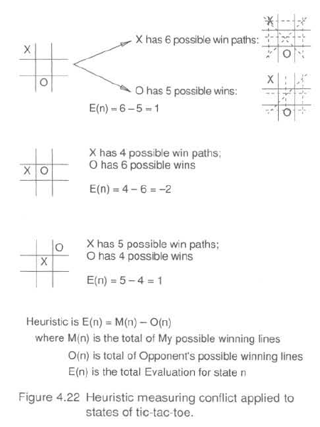
Implementation:
a Vector of winning rows is taken. A winning row is structure of 3 positions in row, column or diagonal.
struct winningRow {
int a,b,c; // 3 elements for 3 positions in a row/column/diagonal of tic tac toe game.
};

Vector of winning rows is initialized.
void initWinningRows(vector<winningRow> &winningRows) {
winningRow tmp;

//1 row 1
tmp.a = 1;
tmp.b = 2;
tmp.c = 3;
winningRows.push_back(tmp);

//2 row 2
tmp.a = 4;
tmp.b = 5;
tmp.c = 6;
winningRows.push_back(tmp);

//3 row 3
tmp.a = 7;
tmp.b = 8;
tmp.c = 9;
winningRows.push_back(tmp);

//4 Diagonal 1
tmp.a = 3;
tmp.b = 5;
tmp.c = 7;
winningRows.push_back(tmp);

//5 Diagonal 2
tmp.a = 1;
tmp.b = 5;
tmp.c = 9;
winningRows.push_back(tmp);

// column 1
tmp.a = 1;
tmp.b = 4;
tmp.c = 7;
winningRows.push_back(tmp);

//7 column 2
tmp.a = 2;
tmp.b = 5;
tmp.c = 8;
winningRows.push_back(tmp);

//8 column 3
tmp.a = 3;
tmp.b = 6;
tmp.c = 9;
winningRows.push_back(tmp);
}
Then we iterate through the given board. For each position of opponent in tic tac toe board, we iterate through all 8 winning rows and erase those rows from the vector which have mark of opponent. The remaining rows are the player’s winning rows.
Similarly, we find opponent’s winning rows. We iterate through all 9 board positions and for each position, we iterate through all 8 winning rows and erase the rows in the vector which have player’s mark.
We get score by subtracting opponent’s rows from player’s rows.
for (int i = 1; i < 10; i++) {
if (board[i] == min) {
vector<winningRow>::iterator it;
for (it = winningRows.begin(); it != winningRows.end(); it++) {
if (it->a == i || it->b == i || it->c == i) {
if (it == winningRows.begin())
{
//handles case where it is pointing to first element
winningRows.erase(it);
it = winningRows.begin();
if (winningRows.size() == 1|| it != winningRows.end())
{
if (it->a == i || it->b == i || it->c == i) {
winningRows.erase(it);
}
}
}
else
{
it--;
winningRows.erase(it+1);
}
Calculation of max score and min score and final score:
maxScore = (int) winningRows.size();
minScore = (int) winningRows.size();
score = maxScore - minScore;

- Simple score evaluation function – It gives different weightage or points to different positions. For example, it gives 3 points to corners, 4 points to center and 2 points to rest of the positions in Tic Tac Toe game board.

// 3 points for corners – 1, 3, 7, 9
if ((i==1) || (i==3) || (i==7) || (i==9)) {
if (board[i] == max) maxScore += 3;
if (board[i] == min) minScore += 3;
} else if (i==5)
{//4 points for center
if (board[i] == max) maxScore += 4;
if (board[i] == min) minScore += 4;
} else {//2 points for rest
if (board[i] == max) maxScore += 2;
if (board[i] == min) minScore += 2;
}
score = maxScore - minScore;

Here max is the player and min is the opponent.
Min is calculated using following function
int oppositePlayer2(int player) {
//If player 1, return player 2.
if (player == 1) return 2;
//Otherwise, return player 1
else return 1;
}

If a player has won, maximum score is assigned to the player.
Code:
if (checkWinResult > 0) {
//If Max has won
if (checkWinResult == max) score = 999;
//else Min has won
else score = -999;
}
Score is calculated by subtracting opponent score from player score.

- Evaluate Position evaluation function: In this, an array of arrays of possible wins is created. There are 8 possible wins in tic tac toe game – 3 rows, 2 diagonals, 3 columns.
Following is the code for that:
#define Possible_Wins 8
const int Three_in_a_Row[Possible_Wins][3] = {
{ 0, 1, 2 },
{ 3, 4, 5 },
{ 6, 7, 8 },
{ 0, 3, 6 },
{ 1, 4, 7 },
{ 2, 5, 8 },
{ 0, 4, 8 },
{ 2, 4, 6 }
};
Then a heuristic array is created.
Suppose there are 2 players – player X and Player O.
In some row, column or diagonal, count of X’s is numX and that of O’s is numO.
There are following four cases:
numX == numO: No player has an advantage. Utility = 0. This fills the main diagonal in the heuristic array.
numX > numO and numO == 0: Player 1 some X’s while other has none in some row, column or diagonal i.e., player 1 has a possibility of winning so he gets a positive utility depending on the number of X’s. The greater the number of X’s, the greater is his utility from the position. This fills the first column in the heuristic array.

numX < numO and numX == 0: Since the game is symmetric, this is completely analogous to the previous case except that now player 1’s utility is negative and the position is advantageous for player 2. This fills the first row in the heuristics array.

Otherwise: In all other cases, no player has a chance of making 3-in-a-row because another player has at least one of their marker there. Since the game is won by having 3-in-a-row and not just more markers there, the position offers no advantage to any player and thus should have a utility of 0. This fills the remaining entries in the heuristics array.

Heuristic array
const int Heuristic_Array[4][4] = {

{ 0, -10, -100, -1000 },

{ 10, 0, 0, 0 },

{ 100, 0, 0, 0 },

{ 1000, 0, 0, 0 }

};
To find score, we traverse through the board and through all possible wining rows, columns and diagonals and find number of player’s marks and number of opponent’s marks in each possible winning situation. Let number of player’s marks in a given row is numP and number of O’s in the same row is numO. Then in heuristic array, we look for value [numP][numO]. We add up the values for each of the 8 possible winning situations to get final score. For example, there are 2 X’s and zero O’s in first row, so we will look for [2][0] in heuristic array which is 100. In this way we find all 8 scores and add them up to get final score.
for (i = 0; i < 8; i++) {
players = others = 0;
for (j = 0; j < 3; j++) {
piece = board[(Three_in_a_Row[i][j]) + 1];
if (piece == player)
players++;
else if (piece == opponent)
others++;
}
t += Heuristic_Array[players][others];
}
t is the score.

- Linear evaluation function: We define Xn as the number of rows, columns, or diagonals
with exactly n X’s and no O’s. Similarly, On is the number of rows, columns, or diagonals
with just n O’s. The utility function assigns +1 to any position with X3 = 1 and −1 to any
position with O3 = 1. For all other terminal positions,
we use a linear evaluation function defined as Eval (s) = 3X2(s)+X1(s)−(3O2(s)+O1(s)).
int evaluatePosition2(vector<int> board, int player) {

int opponent = oppositePlayer2(player);
int players, others, t = 0, i, j, piece;

int p1, p2, o1, o2, p3, o3; // P1 = number of rows, columns, diagnols which have 1 player move and no opponent's moves.
p1 = p2 = o1 = o2 = p3 = o3 = 0;
for (i = 0; i < 8; i++) {

players = others = 0;

for (j = 0; j < 3; j++) {
piece = board[(Three_in_a_Row[i][j]) + 1];
if (piece == player)
players++;
else if (piece == opponent)
others++;
}
if (players == 3 && others == 0)
{
return 999;
}
if (players == 1 && others == 0)
{
p1++;
}
else if(players == 2 && others == 0)
{
p2++;
}
else if (others == 1 && players == 0)
{
o1++;
}
else if (others == 2 && players == 0)
{
o2++;
}
if(others == 3 && players == 0)
{
return -999;
}

}

t = 3*p2 + p1 - (3*o2 + o1);
return t;
}
This function also iterates through all possible winning lines and calculates O1, O2, P1, P2 where O1 is number of rows, columns or diagonals with 1 O and no X. P1 is number of row, columns, diagonals with 1 X and no O, if player is X and opponent is O. Then calculates score by formula 3*p2 + p1 - (3*o2 + o1). If player 1 has 3 in a row, it returns 999 as score else if opponent has 3 in a row, it returns -999;

Sample Run of application
Screen display:
User is given 2 choices:
- Compare algorithms
- Compare evaluation functions
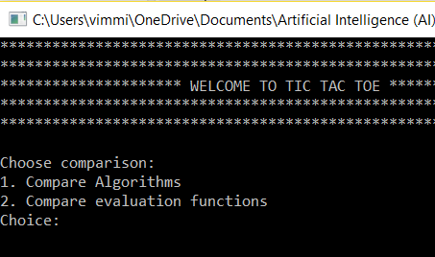

If he selects to compare algorithms, then
He is asked to choose evaluation function out of 4 evaluation functions:
- Standard evaluation function from Luger
- Simple Score
- Evaluate position
- Linear evaluation function

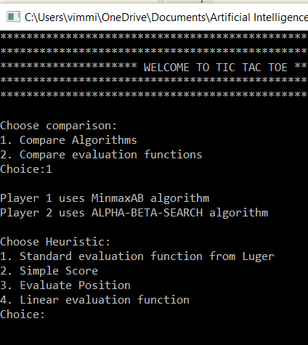
It has been kept fixed that player 1 uses MinmaxAB algorithm and player 2 uses Alpha beta search algorithm. Turn of each player can be changed. Each algorithm gets to go first.
After choosing evaluation function, he is asked to choose depth 2 or 4.
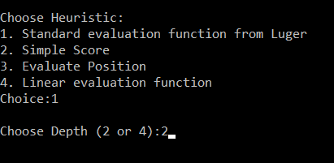
Then he is asked to choose turn – player 1 or 2.
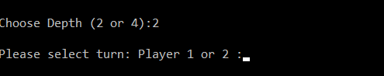

If he selects to compare evaluation functions, then
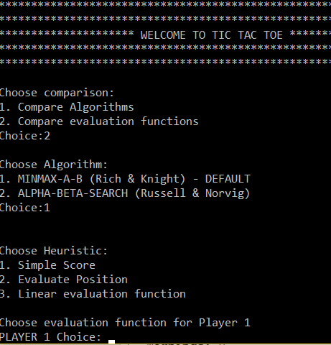
User can choose algorithm and choose evaluation function for player 1 and player 2.
Then user is asked to choose depth and Player who wants to go first.
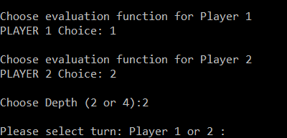
After selecting the turn, game is played. Following are the screenshots of a game.
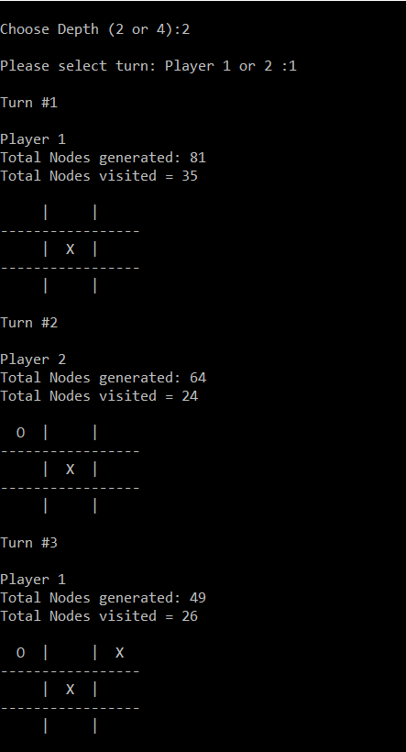
In above picture, player 1 goes first and total nodes generated are the successors of the root node. Total nodes visited are the nodes which are visited by the algorithm and others are pruned or not visited due to pruning by the algorithm.
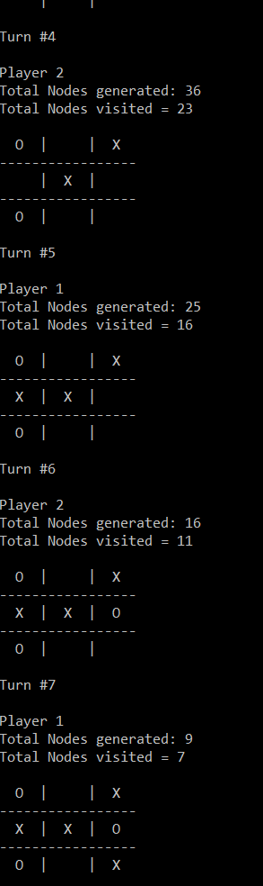
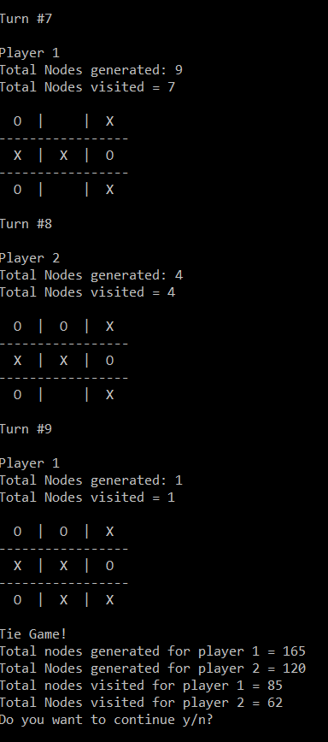
After game is over, user interface displays total nodes generated and visited for each player and asks if the user wants to continue. If he enters y, then again choices will be displayed and another game can be played.

Sample Run with intermediate results
Following is the sample run for comparing algorithms with Standard evaluation function using depth 2. Game was a tie and had 9 turns. It shows only turn 5. Result of turn #4 is shown in picture. The possible positions for player 1 in Turn 5 are 2, 4, 6, 8, 9.
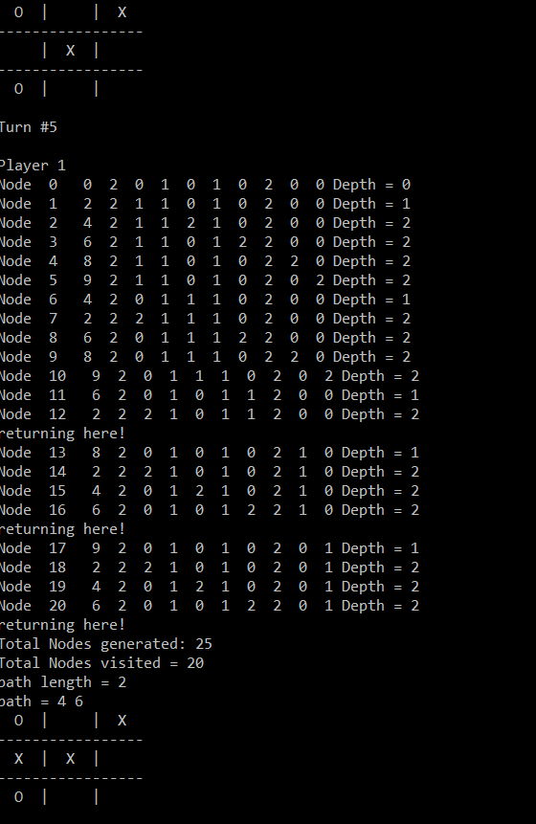

Total legal moves are 25. Since 2, 4, 6, 8, 9 are immediate successors of root node and each of these will have 4 successors so 4 * 5 = 20 nodes at depth 2 and 5 nodes at depth 1 so total 25 nodes are generated. Nodes shown in the picture are nodes visited by the algorithm in the order they are visited. Node 0 is the root node.
Node 1 = 2 2 11 0 1 0 2 0 0
The first number - 2 tells the position of putting the next mark. So “1” is put at position 2. “1” is for player 1. This node is at depth 1.
At depth 2, 4 nodes are visited – 4 moves at positions 4, 6, 8, 9.
Node 2 = 4 211210200
At 4th position, which was vacant, player 2 puts his mark so we get 211210200.
After visiting all 4 nodes at depth 2, algorithm goes back to depth 1 and visit node 4. Then it generates it’s successors – 2, 6, 8, 9. After visiting them, algorithm goes back to node 6 at depth 1 and generates its 4 successors but visits only 1 and prunes the rest of them based on the comparison it did. The picture shows “returning here”. Similarly, rest of the nodes are visited. In total, 20 nodes are visited out of 25 generated.
Best Path followed by algorithm is node 4 and node 6.

Analysis of results
Following are the 4 evaluation functions used:
F1 - Standard evaluation function
F2- Simple Score
F3 – Evaluate Position
F4 – Linear evaluation function

Comparing algorithms
Player 1 uses MiniMaxAB algorithm.
Player 2 uses Alpha beta search algorithm.
Results
S.No. | Eval Function | 1st move (turn) | Depth | Length of game path for player 1 | Length of game path for player 2 | Nodes visited/Nodes generated for player 1 | Nodes visited/Nodes generated for player 2 | Winning/Losing result
 | F1 | 1 | 2 | 5 | 4 | 90/165 | 66/120 | Game Tie
 | F1 | 2 | 2 | 4 | 5 | 66/120 | 90/165 | Tie
 | F2 | 1 | 2 | 5 | 4 | 85/165 | 63/120 | Tie
 | F2 | 2 | 2 | 4 | 5 | 63/120 | 87/165 | Tie
 | F3 | 1 | 2 | 5 | 4 | 89/165 | 68/120 | Tie
 | F3 | 2 | 2 | 4 | 5 | 68/120 | 89/165 | Tie
 | F4 | 1 | 2 | 5 | 4 | 89/165 | 65/120 | Tie
 | F4 | 2 | 2 | 4 | 5 | 65/120 | 89/165 | Tie
 | F1 | 1 | 4 | 3 | 2 | 789/1604 | 340/638 | Player1 wins
 | F1 | 2 | 4 | 2 | 3 | 340/638 | 789/1604 | Player 2 wins
 | F2 | 1 | 4 | 5 | 4 | 801/1634 | 359/677 | Tie
 | F2 | 2 | 4 | 4 | 5 | 359/677 | 795/1628 | Tie
 | F3 | 1 | 4 | 5 | 4 | 992/1764 | 562/933 | Tie
 | F3 | 2 | 4 | 4 | 5 | 562/933 | 986/1758 | Tie
 | F4 | 1 | 4 | 5 | 4 | 903/1671 | 478/849 | Tie
- 16 | F4 | 2 | 4 | 4 | 5 | 478/849 | 897/1665 | Tie

Analysis
In terms of winning, game is tie most of the times except in case of F1. In that case also, player who goes first wins after same number of turns and they generate and visit same number of nodes. So both algorithms look same in performance.
In terms of length of game path, both have same length depending upon the turn of player. If player 1 goes first he goes 5 turns and player 2 goes 4 turns in case game is tie. In case of F1 and depth 4, player 1 went 3 moves and plyer 2 went 2 moves. But if player 2 got to play first then he played 3 moves and other got 2 moves. So according to length of game path, both algorithms are equally good.
In terms of number of nodes generated and visited, both have almost same number in most of the cases. There is minor difference of 6 nodes in number of nodes generated using evaluation function F2, F3, F4 and depth 4. With F1 and depth 4, nodes generated and visited are same.
Let’s take case of F1 and depth 2. If player 1 goes first:
 | Nodes generated | Nodes visited
Player 1 | 165 | 90
Player 2 | 120 | 66
If player 2 goes first:
 | Nodes generated | Nodes visited
Player 1 | 120 | 66
Player 2 | 165 | 90
Even with depth 4 and F1, both players generate and visit same number of nodes.
Conclusion is both algorithms are equally good.

Comparing Evaluation Functions
- Using Minimax-AB algorithm
Results
LGP – Length of game path
S.No. | Evaluation Function 1 | Evaluation Function 2 | Depth | LGP for player 1 | LGP for player 2 | Turn of player | Total number of nodes visited for player 1 / Nodes generated | Total Number of nodes visited for player 2/ Nodes generated | Winning/Losing result
1 | F1 | F2 | 2 | 5 | 4 | 1 | 85/165 | 62/120 | Tie
 | F1 | F2 | 2 | 4 | 5 | 2 | 68/120 | 89/165
2 | F1 | F3 | 2 | 5 | 4 | 1 | 85/165 | 62/120 | Tie
 | F1 | F3 | 2 | 4 | 5 | 2 | 68/120 | 89/165
3 | F2 | F3 | 2 | 5 | 4 | 1 | 89/165 | 66/120 | Tie
 | F2 | F3 | 2 | 4 | 5 | 2 | 66/120 | 89/165
4 | F1 | F2 | 4 | 5 | 4 | 1 | 801/1634 | 548/921 | Tie
 | F1 | F2 | 4 | 4 | 5 | 2 | 367/683 | 992/1764
5 | F1 | F3 | 4 | 5 | 4 | 1 | 801/1634 | 470/843 | Tie
 | F1 | F3 | 4 | 4 | 5 | 2 | 367/683 | 903/1671
6 | F2 | F3 | 4 | 5 | 4 | 1 | 992/1764 | 478/849 | Tie
 | F2 | F3 | 4 | 4 | 5 | 2 | 562/933 | 903/1671

Analysis
F1 is best evaluation function to be used with MinimaxAB algorithm since it generates less number of nodes and less number of nodes need to be visited.
Following is the case when player makes the first move:
Eval Function | Nodes visited | Nodes generated
F1 | 801 | 1634
F2 | 992 | 1764
F3 | 903 | 1671
Player using F1 generates smallest number of nodes (1634) and visits less number of nodes (801) than F2 and F3.
Following is the case when player makes second move:
Eval Function | Nodes visited | Nodes generated
F1 | 367 | 683
F2 | 548 to 562 | 921 to 933
F3 | 470 to 478 | 843 to 849
The player who is using F1 and makes second move in response to other evaluation functions generates and visits less nodes than other evaluation functions. Therefore, F1 is the best evaluation function out of all 3 functions.

Comparing Evaluation Functions with Alpha Beta Search Algorithm
Results
S.No. | Evaluation Function for Player 1 | Evaluation Function for Player 2 | Depth | Turn of player | Length of Game Path for Player 1 | Length of game path for Player 2 | Total number of nodes visited or expanded for Player 1 | Total number of nodes visited or expanded for Player 2 | Winning/Losing result
1 | F1 | F2 | 2 | 1 | 5 | 4 | 87/165 | 62/120 | Tie
 | F1 | F2 | 2 | 2 | 4 | 5 | 68/120 | 89/165 | Tie
- 3 | F1 | F3 | 2 | 1 | 5 | 4 | 87/165 | 62/120 | Tie
 | F1 | F3 | 2 | 2 | 4 | 5 | 68/120 | 89/165 | Tie
- 5 | F2 | F3 | 2 | 1 | 5 | 4 | 89/165 | 66/120 | Tie
 | F2 | F3 | 2 | 2 | 4 | 5 | 68/120 | 89/165 | Tie
- 7 | F1 | F2 | 4 | 1 | 5 | 4 | 795/1628 | 548/921 | Tie
 | F1 | F2 | 4 | 2 | 4 | 5 | 367/683 | 986/1758 | Tie
- 8 | F1 | F3 | 4 | 1 | 5 | 4 | 795/1628 | 470/843 | Tie
 | F1 | F3 | 4 | 2 | 4 | 5 | 367/683 | 897/1665 | Tie
- 9 | F2 | F3 | 4 | 1 | 5 | 4 | 986/1758 | 478/849 | Tie
 | F2 | F3 | 4 | 2 | 4 | 5 | 562/933 | 897/1665 | Tie

Analysis
F1 is the best evaluation function out of all three evaluation functions with Alpha beta search algorithm because less number of nodes are generated and less number of nodes need to be visited if we use F1. So it saves memory space and time taken to evaluate nodes.
If F1 is used, with Depth 4:
Nodes visited = 795, Nodes generated = 1628 initially – when the player making the first move uses F1.
Also, with depth 2, F1 visits minimum number of nodes - 87

Following is the case where player making the first move is using following eval functions:
Eval Function | Nodes visited | Nodes generated
F1 | 795 | 1628
F2 | 986 | 1758
F3 | 897 | 1665

With F1, number of nodes generated in response to first move generated by other evaluation functions is also minimum (367)
Eval Function | Nodes visited | Nodes generated
F1 | 367 | 683
F2 | 548 to 562 | 921 to 933
F3 | 470 to 478 | 843 to 849
Therefore, F1 is the best evaluation function with Alpha beta search algorithm in terms of performance – space and time since it generates less nodes and saves memory space and time to visit the nodes.

Conclusion
Based on above analysis, both algorithms have almost same performance in terms of number of nodes generated and visited and winning result and length of game path.
Applying both algorithms to each of the players in game of tic tac toe helped in understanding them better. Both algorithms did pruning of branches. Minimax-AB does all the procedure in one function whereas Alpha beta search does that in two different functions one for each player.
Since all the games were tie except one so winning/losing result and length of game path shows that both algorithms have same performance. The number of nodes visited is also almost same for both algorithms. It only varies with change in evaluation function. So number of nodes generated and visited also show similar performance in terms of space and time complexity. We gave both players first player advantage, still they both were generating same number of nodes with depth 2.
An evaluation function returns an estimate of the expected utility of the game from a given position. F1 is the best evaluation function out of all three evaluation functions with both algorithms because less number of nodes are generated and less number of nodes need to be visited if we use F1. So it saves memory space and time taken to evaluate nodes.
To compare them more, we can increase the depth or change the game.

