1. **What are three conclusions we can make about Kickstarter campaigns given the provided data?**

Based on the information brought by Kickstart, the 53% of the projects are successful, 34% are failed and only the 7% are canceled.

The most successful categories are music (77%) and theater (60%) and the worst are games (36%), publishing (33%) and technology (34%). Another important finding is the important quantity of canceled projects related with technology; they represent the 51% of the total canceled projects of the crown founding.

Most of the projects belong to the theater category and this sector represents the majority of successful (38%) and failed (32%) projects of the total of Kickstart.

Finally the 100% of the Journalism projects were canceled.

The first notable information is that subcategory “Plays” represents the 26% of the total projects of Kickstart.

As we mentioned in the first section the most popular categories were theater and music, thus the most notable subcategories are “Play” which represents the 26% of the total success projects of Kickstart and “Rock” with the 12%.

In the previous graph we saw the special case of the category Journalism, but in this case we see 12 cases where the rate of success is 100% like classical music, documentary, electronic music, etc. The 41% of them belong to the category Music.

By the other side, we have 11 subcategories where the rate of success is 0, for example animation, children´s book, drama, gadgets, etc.

Based on the information from 2009 to 2017, the number of canceled projects maintains a linear behavior, with an average of 29 per year.

In May the difference between the rate of successful and failed projects is the most significant with the 60% against the 33% respectively, but that moment is the start of a decreasing of the rate of success which ends on December when the rate of failed is superior. This negative behavior started on the year 2014 and continued

Finally, using Python(we didn´t omit the outliers), we can see the pledged amount obtained for successful projects is 10 times the amount of the failed and the goal is 8 times lower respectively.

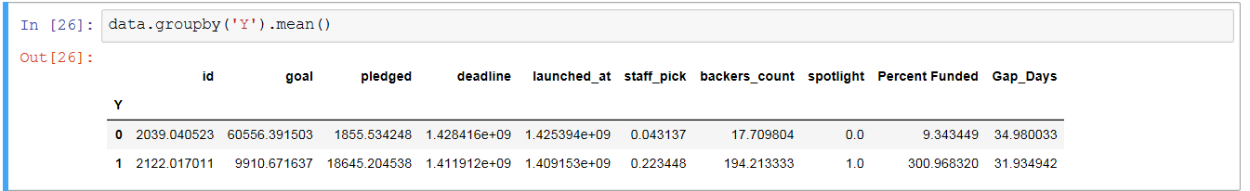

1. What are some of the limitations of this dataset?

The size of the sampling is small, as we could confirm in the subcategory section where we saw quantities less than 10.

We can´t assume the same behavior will be presented by another crown founding, because some of them operate in a different way. For example, in some of them, the risk to invest in a failed project is not avoided as it is done in Kickstart, which will modify the trust of the backers and the statistics.

It will be good to have the data from more crown founding associations; putting all together we could generate a better general idea in case the sample is representative of the population.

1. What are some other possible tables/graphs that we could create?

The 73% of the projects are from the United States, so in case that we have the specific state we could see the tendency for each one.

There are two possible factors that we can analyze, one is the duration of the project, because there is an interesting tendency obtained by the same kickstart foundation described in this article <https://www.kickstarter.com/blog/trends-in-pricing-and-duration>.

Similarly we could analyze the reviews and comments and see the relation with the success or fail of the projects.

Finally we can try to obtain the model; in our case I consider the logistic regression could be a good option.