**Unit 2 | Assignment - The VBA of Wall Street**

**RESUME**

Trying to simulate an original situation, I assumed the records were not ordered by ticker or date. I used the collections implemented by Excel and a custom class which helped me to implement all the logic needed to obtain a resume with the required information.

As it was required it moves into each sheet and create the consolidated table with the information.

**SCREENSHOTS**

**Year 2014**

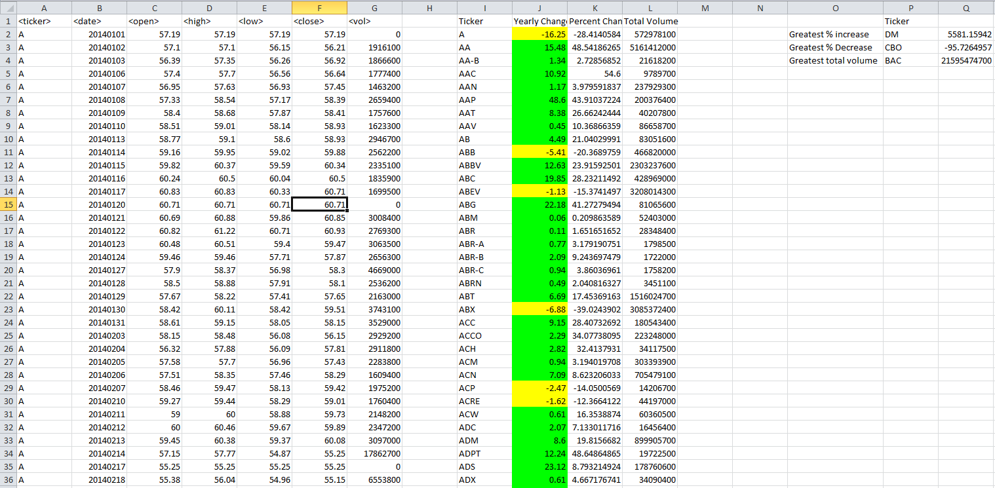

**Year 2015**

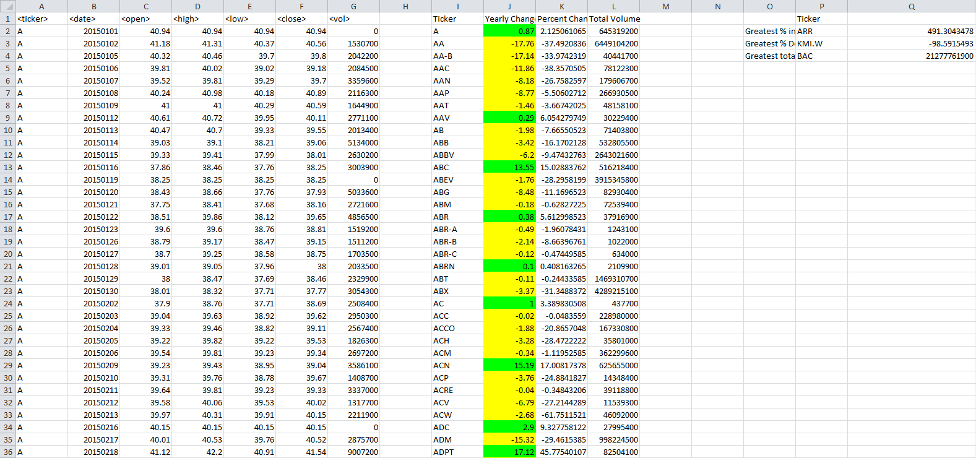

**Year 2016**

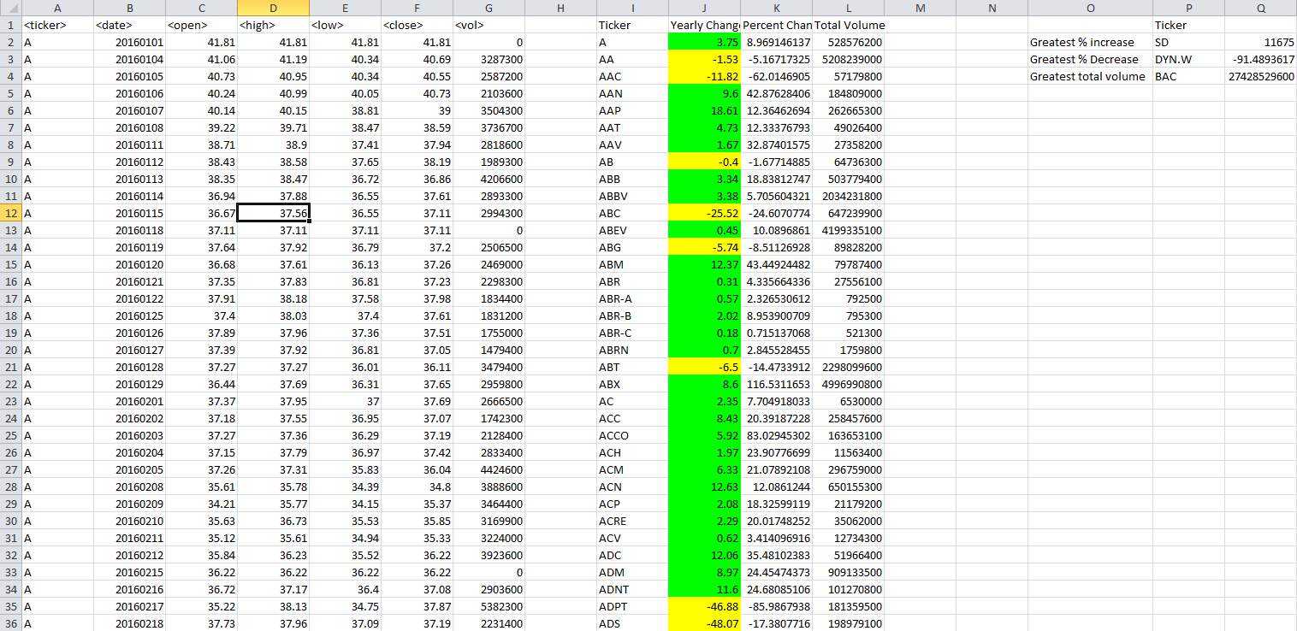

**SOURCE CODE**

**Code of Module**

Dim tabla_final As New Collection

Dim element As cl_final

Sub get_total_volume()

Dim sh As Worksheet

Dim rw As Range

Dim element2 As cl_final

Dim TotalRange As Range

Set tabla_final = New Collection

Dim min_change As Double

Dim max_change As Double

Dim max_total As Double

Dim ticker_min_change As String

Dim ticker_max_change As String

Dim ticker_max_total As String

Dim indexRow As Integer

For Each sh In ThisWorkbook.Worksheets

sh.Activate

Set TotalRange = sh.UsedRange

Set TotalRange = TotalRange.Offset(1, 0).Resize(TotalRange.Rows.Count - 1, TotalRange.Columns.Count)

For Each rw In TotalRange.Rows

Set element2 = searchInFinal(Cells(rw.Row, 1).Value)

If Not element2 Is Nothing Then

element2.Total_Volume = Cells(rw.Row, 7).Value + element2.Total_Volume

If Cells(rw.Row, 2).Value > element2.Date_Close Then

element2.Close_Stock = Cells(rw.Row, 6).Value

element2.Date_Close = Cells(rw.Row, 2).Value

End If

If Cells(rw.Row, 2).Value < element2.Date_Open Then

element2.Date_Open = Cells(rw.Row, 2).Value

element2.Open_Stock = Cells(rw.Row, 3).Value

End If

element2.Yearly_Change = element2.Close_Stock - element2.Open_Stock

If element2.Open_Stock <> 0 Then

element2.Percent_Change = (element2.Yearly_Change * 100) / element2.Open_Stock

Else

element2.Percent_Change = 0

End If

Else

Set element2 = New cl_final

element2.Ticker = Cells(rw.Row, 1).Value

element2.Total_Volume = Cells(rw.Row, 7).Value

element2.Date_Open = Cells(rw.Row, 2).Value

element2.Date_Close = Cells(rw.Row, 2).Value

element2.Open_Stock = Cells(rw.Row, 3).Value

element2.Close_Stock = Cells(rw.Row, 6).Value

element2.Yearly_Change = element2.Close_Stock - element2.Open_Stock

If element2.Open_Stock <> 0 Then

element2.Percent_Change = (element2.Yearly_Change * 100) / element2.Open_Stock

Else

element2.Percent_Change = 0

End If

tabla_final.Add element2

Set element2 = Nothing

End If

Next rw

Cells(1, "I").Value = "Ticker"

Cells(1, "J").Value = "Yearly Change"

Cells(1, "K").Value = "Percent Change"

Cells(1, "L").Value = "Total Volume"

Cells(2, "O").Value = "Greatest % increase"

Cells(3, "O").Value = "Greatest % Decrease"

Cells(4, "O").Value = "Greatest total volume"

Cells(1, "P").Value = "Ticker"

indexRow = 2

min_change = 0

max_change = 0

max_volume = 0

Set element = Nothing

For Each element In tabla_final

Cells(indexRow, "I").Value = element.Ticker

Cells(indexRow, "J").Value = element.Yearly_Change

If element.Yearly_Change > 0 Then

Cells(indexRow, "J").Interior.ColorIndex = 4

Else

Cells(indexRow, "J").Interior.ColorIndex = 6

End If

Cells(indexRow, "K").Value = element.Percent_Change

Cells(indexRow, "L").Value = element.Total_Volume

indexRow = indexRow + 1

If element.Percent_Change < min_change Then

ticker_min_change = element.Ticker

min_change = element.Percent_Change

End If

If element.Percent_Change > max_change Then

ticker_max_change = element.Ticker

max_change = element.Percent_Change

End If

If element.Total_Volume > max_volume Then

ticker_max_volume = element.Ticker

max_volume = element.Total_Volume

End If

Next element

Cells(2, "P").Value = ticker_max_change

Cells(3, "P").Value = ticker_min_change

Cells(4, "P").Value = ticker_max_volume

Cells(2, "Q").Value = max_change

Cells(3, "Q").Value = min_change

Cells(4, "Q").Value = max_volume

Set tabla_final = Nothing

Next sh

End Sub

Function searchInFinal(ByVal pTicker As String) As cl_final

Dim element As cl_final

For Each element In tabla_final

If (element.Ticker = pTicker) Then

Set searchInFinal = element

Exit For

End If

Next element

End Function

Function setVolume(ByRef pVoloume As Long)

Dim element As typeConsolidated

For Each element In table_final

If (element.Ticker = pElement.Ticker) Then

element.Total_Volume = pvolume

Exit For

End If

Next element

End Function

**Class**

Private aTicker As String

Private aYearly_Change As Double

Private aPercent_Change As Double

Private aTotal_Volume As Double

Private aDate_Open As Long

Private aDate_Close As Long

Private aOpen_Stock As Double

Private aClose_Stock As Double

' Properties

Property Get Ticker() As String

Ticker = aTicker

End Property

Property Let Ticker(dTicker As String)

aTicker = dTicker

End Property

Property Get Yearly_Change() As Double

Yearly_Change = aYearly_Change

End Property

Property Let Yearly_Change(dYearly_Change As Double)

aYearly_Change = dYearly_Change

End Property

Property Get Percent_Change() As Double

Percent_Change = aPercent_Change

End Property

Property Let Percent_Change(dPercent_Change As Double)

aPercent_Change = dPercent_Change

End Property

Property Get Total_Volume() As Double

Total_Volume = aTotal_Volume

End Property

Property Let Total_Volume(dTotal_Volume As Double)

aTotal_Volume = dTotal_Volume

End Property

Property Get Date_Open() As Long

Date_Open = aDate_Open

End Property

Property Let Date_Open(dDate_Open As Long)

aDate_Open = dDate_Open

End Property

Property Get Date_Close() As Long

Date_Close = aDate_Close

End Property

Property Let Date_Close(dDate_Close As Long)

aDate_Close = dDate_Close

End Property

Property Get Open_Stock() As Double

Open_Stock = aOpen_Stock

End Property

Property Let Open_Stock(dOpen_Stock As Double)

aOpen_Stock = dOpen_Stock

End Property

Property Get Close_Stock() As Double

Close_Stock = aClose_Stock

End Property

Property Let Close_Stock(dClose_Stock As Double)

aClose_Stock = dClose_Stock

End Property

' Event - triggered when class created

' Methods

'