Requirements to install RDM.............................................................................................

How to install RDM...........................................................................................................

Requirements to install EDMS...........................................................................................

How to install EDMS.........................................................................................................

1 Requirements to install RDM

Database : Mysql

Programming language: php v7.0.4

Php ext : Memcache

Php ext : Mosquitto library for php
You can find help on the web,
example ( http://wingsquare.com/blog/setting-up-mqtt-mosquitto-broker-in-ubuntu-linux/ )

Development took place on ubuntu.

1.1 How to install RDM

Step 1) Create an empty database, name it : VimsentPlatform

(command on mysql shell: create database VimsentPlatform )

Step 2) install to mysql the following sql script VimsenPlatform.sql

( mysql -u <username> -p <database name> < <dump file path> )

Step 3) Unzip the contents of the folder RDM_SOFTWARE and place it to your desire path on your web server.

Step 3.1) YourBaseFolder/Codelgniter/application/config/config.php

search and find variable $config['base_url']='' add your server bath URL

Once you have place it to your favorite folder on your web server,
navigate throw your web browser, to the below url to make sure everything is correctly.

http://127.0.0.1/yourfolder/CodeIgniter/index.php/login

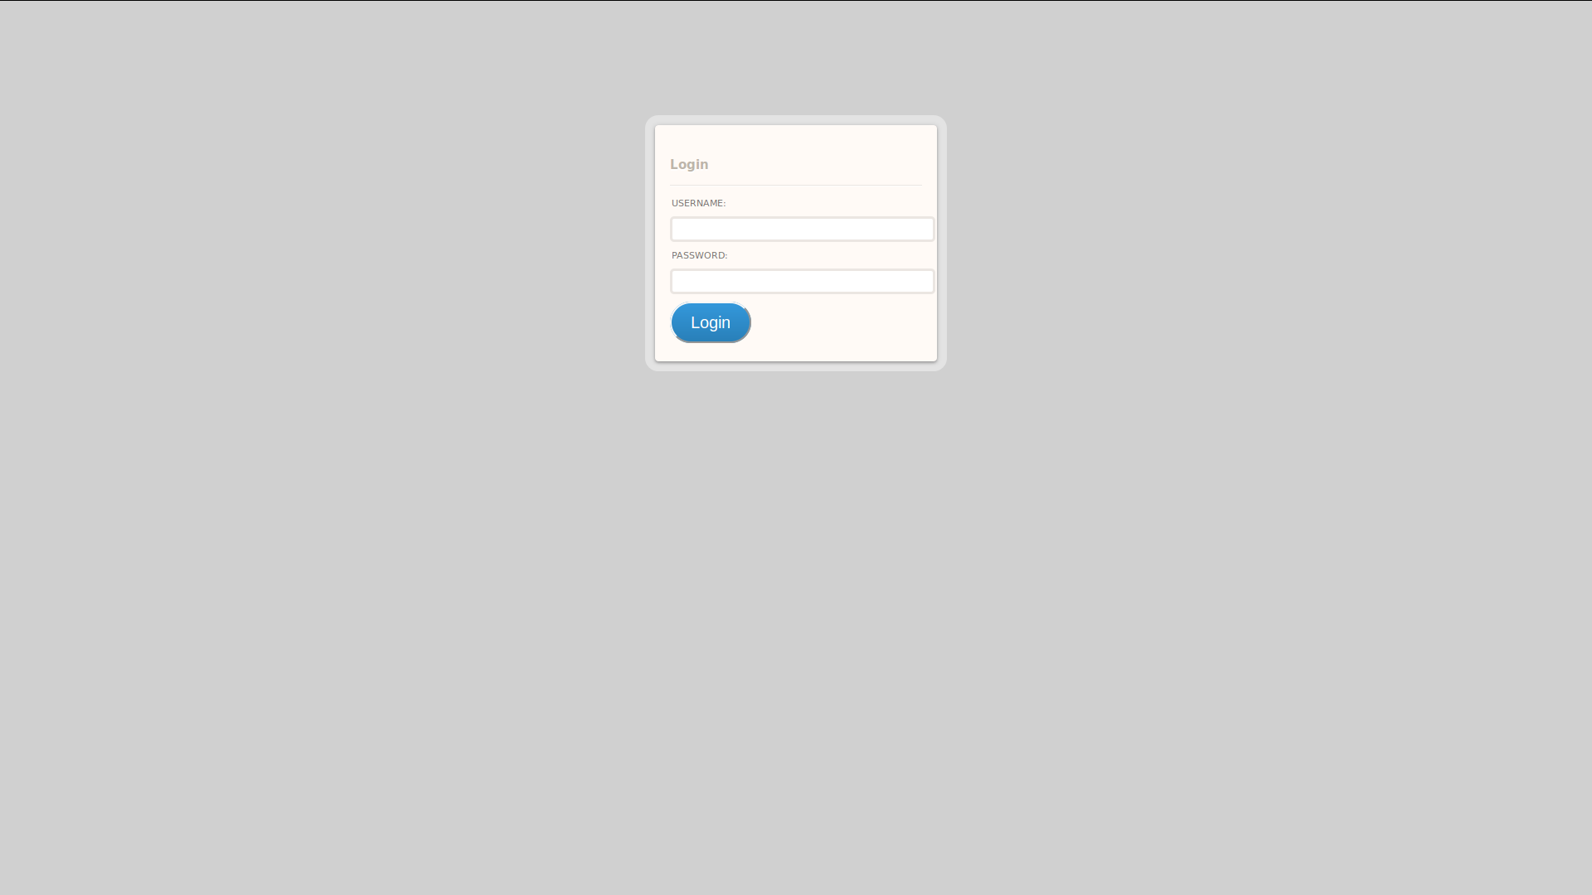

If you see the above screen then your setup is successful, otherwise make sure either you haven't typed the correct URL, it must correspond to the one you have placed inside your web server, or you have place RDM on a folder where your web server can not serve / access.

Step 4) Inside folder RDM search and find Codelgniter/application/config/database.php

add your local database details.

$db['default']['hostname'] = 'localhost';
$db['default']['username'] = 'username_of_your_database';
$db['default']['password'] = 'password_of_your_database';
$db['default']['database'] = 'database_name';

Step 5) Return to your web browser and try to login

username: bob
password: supersecret

Step 6) Click on the left menu the first option 'Add New meter'
Gateway Name: add your display name
Gateway Mac Address: add the actual root (2 second) path name of the topic you want to follow.

e.g:
telint/b827ebf9b703/VGW/

you will add : b827ebf9b703, don't forget to press save.

Step 7) On the left menu click the second option 'View Meters'

Click 'Add Devices for this Gateway'

select a number from the DropDown menu,

add the names of the devices you want to follow.

On the broker the path is the bellow:

Glimperop/yourname/state/theNameYouWantToFollow/state

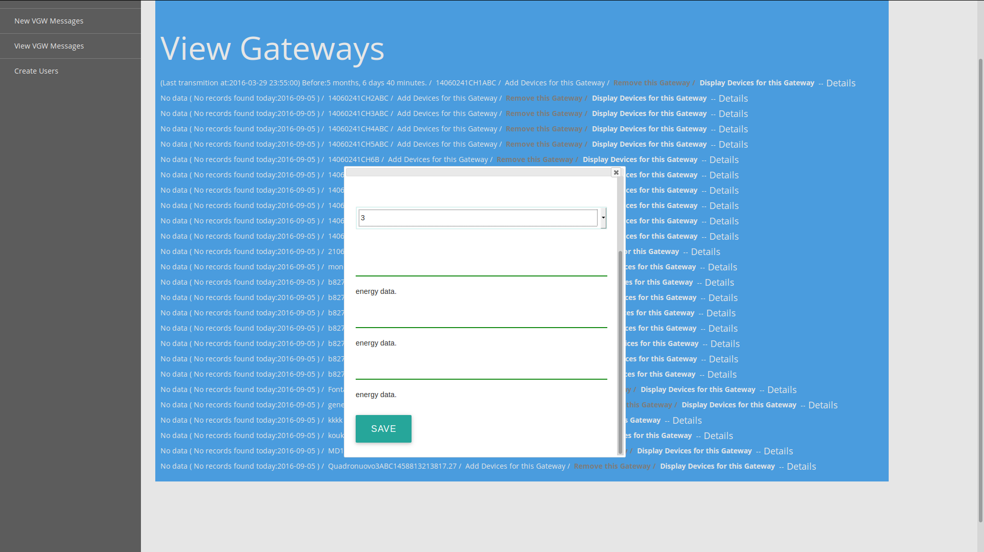

Before you add 'Devices', to follow, make sure your broker broadcast the names you want to store, in the above path.
after you typed the names you want to follow, press save,
without doing any further move, the script will listen (run3.php) the new Gateway and their devices you have added, it will start collecting data automatically.

(in case it didn't happen just restart 'run3.php')

If you want to stop collecting data either remove the new Meter, (from the first option on the left menu)
'Remove this Gateway',

or click Display Devices for this Gateway

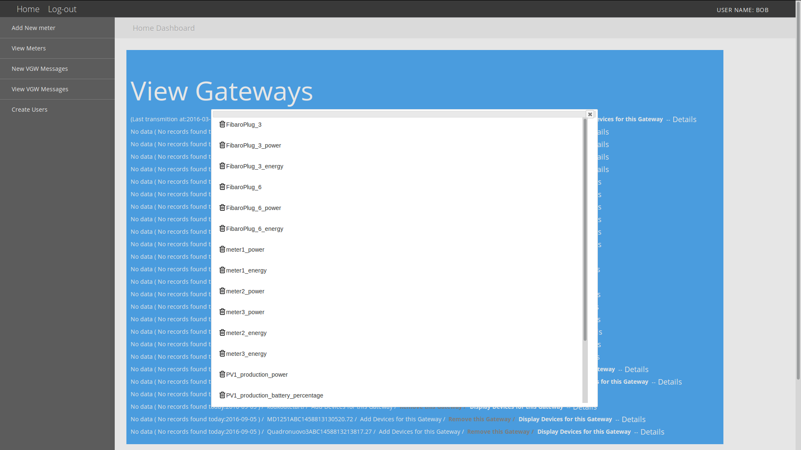

click on the bin next to the name you want to remove.

2 Requirements to install EDMS

Database : Mysql

Programming language: php v7.0.4

Development took place on ubuntu.

2.1 How to install EDMS

Step 1) Unzip the FOLDER EDMS_SOFTWARE
and place it to your desire path on your web server.

Step 2) open the following file application / config / database.php

Step 3) Now that we have successful setup database along with EDMS software, the next step is to initiate process to start receiving data,
How we do that?

Navigate your self to following path:
'install_folder'/EDMS_SOFTWARE/cronjobs
here exists a file by name run3.php.

1) Search for a line with starts $db = new PDO, add your database credentials, and save the file.

$db = new PDO('mysql:host=localhost;dbname=YourDatabaseName;charset=utf8', 'MysqlUserName', 'MysqlUserPassword');

2) Search for a line $mqtt->connect('94.70.239.217') add your broker address. This address is being used by the script to connect and listen from the broker. Once you change the file don't forget to save the file again.

Step 4) From your command line navigate to 'install_folder'/EDMS_SOFTWARE/cronjobs/ execute this file:
php run3.php
if you do this, you will see that the command line hangs, it does not return cursor to your command line,

if you want to avoid this just add & to the end of the command.
php run3.php &
the purpose of this script is to run 24/7 and listen everything publish to the broker.

Step 5) assuming you are still at 'install_folder'/EDMS_SOFTWARE/cronjobs/ path
open file 'produceLastDayaggregateValues.php'
search and locate line:

$con = mysqli_connect("localhost", "MysqlUserNAME", "MysqlPassword", "VimsentPlatform");

add your credentials,

add this script as a cron job to you system 30 min after midnight every day-ahead
( 00:30:00 midnight)

the purpose of this script is to gather all data of previous day, only previous day,
aggregate them and insert them, ready to be retrieved with out any processing at retrieving time.
(API CALL)

Since everything took place correct, to start and print in JSON format data,

open a browser and https://YourServerName/EDMS_SOFTWARE/index.php/intelen5/getdataVGW?startdate=2016-02-07T00%3A00%3A00%2B00%3A00&enddate=2016-2-31T23%3A00%3A00%2B00%3A00&interval=3600&prosumers=HP_0160&pointer=2&consumptionFlag=1

or

https://beta.intelen.com/vimsenapi/EDMS_DEMO/index.php/intelen5/getdataVGW?prosumers=b827eb4c14af&startdate=2016-03-22T06:30:00.000+02:00&enddate=2016-03-22T07:15:00.000+02:00&interval=900&pointer=2

required URL arguments

1) startdate

2) enddate

3) prosumers

4) interval

5) pointer = 2 (always set to 2)

the values to the variables will be corresponding to the actual data you have received.

Every broadcast of each device must contains some fixed topics in order for EDMS to pick them and produce results.

PV1_production_battery_percentage

PV1_production_power

total_energy_consumption_300

total_power

meter1_power

the format of the transited data must be

b827eb4c14af/Device_Name/VGW/PV1_production_power/state

