Name : Vimukthi Wijeratne

Date : 2022/07/27

Technology Training at Winhe SEA Exercise – 1

1. What is the major problem being solved?

* (Convenience) Users can book doctor appointments anytime anywhere they want. This is very convenient.

1. What are the other problems being solved?

* The users can see the rough estimate of the time their appointment will be

1. Who are the users of the system?

* The users will be patients who wants to book a appointment with their desired doctor or Hospital for medical /health reasons

1. What benefits the each user gets

* This will save a lot of time as they can book from home
* User can see the different locations and hospitals the doctor visits and the user can choose the best location depending on convinces
* User can check the number of patients who has already booked to get a idea of the waiting time
* User can also transfer money online which will eliminate the use of physical money

1. What are the other alternative similar systems available and do a comparison

Another alternative to E-channeling would be doc.lk. When comparing these two systems doc.lk only has 4 filters for search

* Doctor name
* Hospital name
* Specification
* Date

echanneling.com has more search filters like

* Hospital type (private or public, ayurvedic hospital)
* Setting a price range
* Setting the Gender
* Can select a hospital depending on location
* etc

6) Understand the process of channeling a doctor and briefly describe in words and

in a graphical way.

1. The online user picks a date, time, doctor and a hospital depending on availability.
2. The user is shown the receipt with all the details and the amount.
3. The user picks a payment method and makes the payment and the booking gets confirmed
4. When booking is confirmed the number of patients is updated and if it was the final slot available the bookings are closed (Fully Booked).
5. A message (receipt) is sent to the user’s mobile phone and email, which the user can decide to print or show the phone at the hospital on that day.
6. The hospital gets alerted of this booking so they can add it to their records

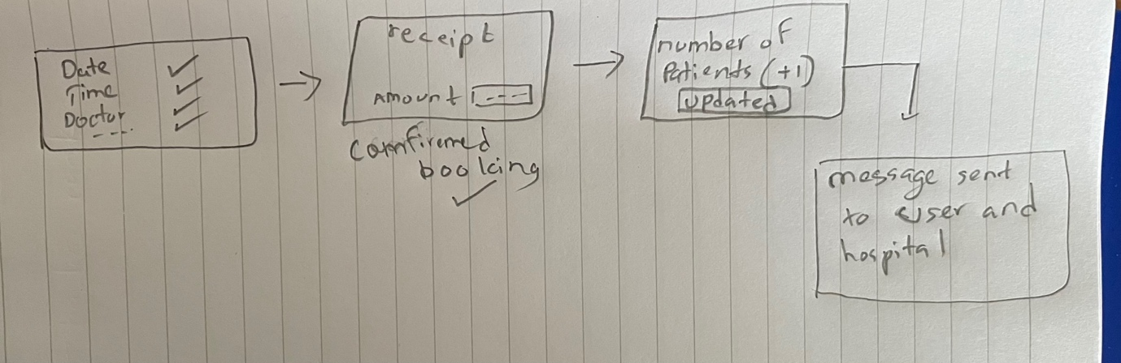

7) Describe each user interface used in the process (workflow) of channeling the

doctor (Hint: Use screen clipping feature in MS Word)

The is many places for inputs in the search section (Advanced search) .The dropdown boxes make it easier for us to select the one we want with out us typing.

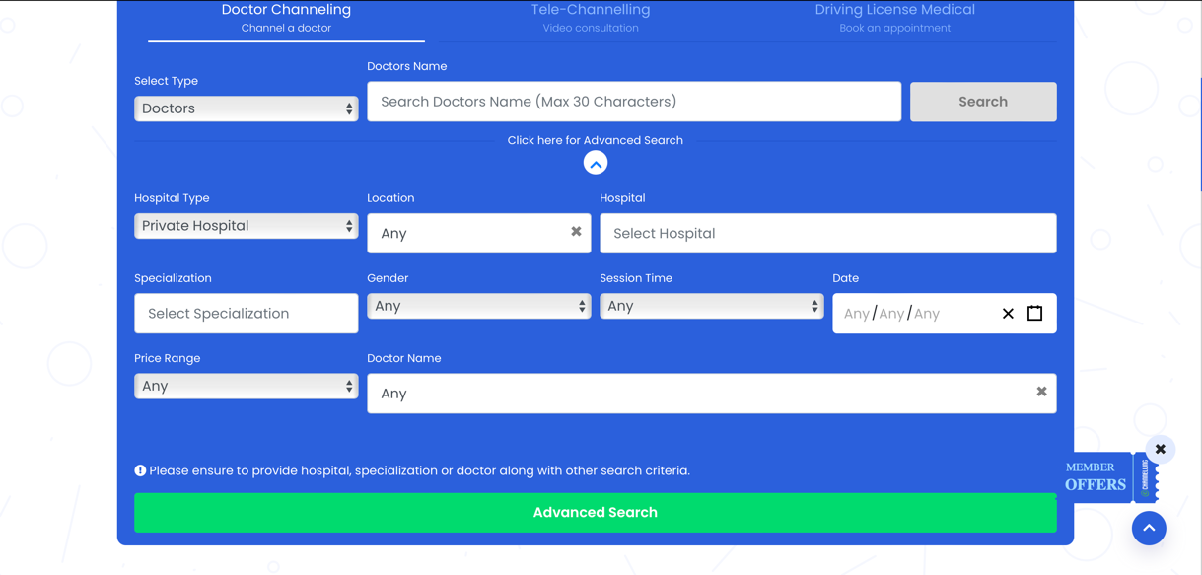

When selecting the date a calendar is shown which is very user friendly and easy to understand

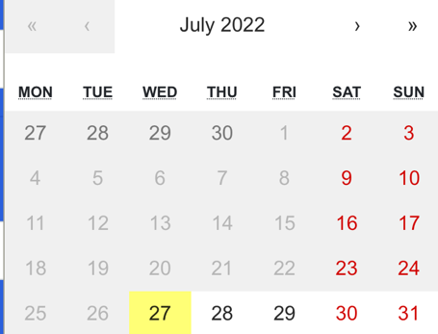

If we say we want any chest specialist, it’s going to take us to another screen and show us all the doctors who are chest specialists and all the Hospitals they visit

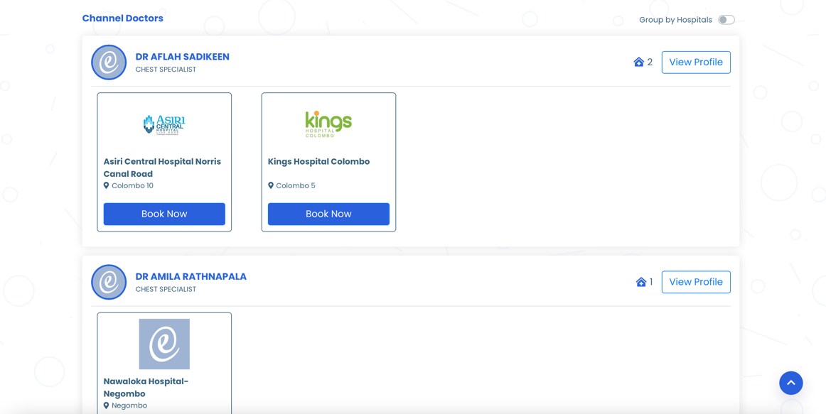

If we choose the doctor and the hospital that is best for us and click “Book Now”. Its going to take us to the next screen showing us the times the doctor is available and the number of patients active

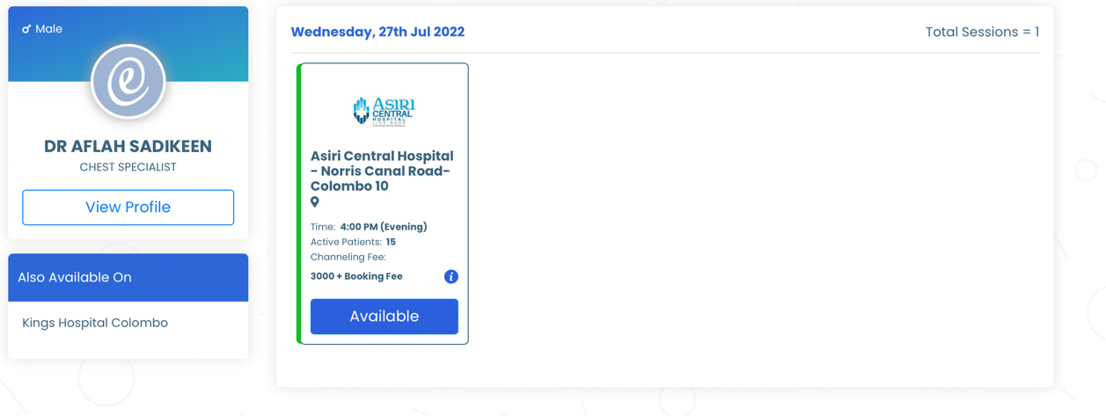

When we click the “Available” button on the slot we want its takes us to the page to fill the users details (patient details). It also shows the amount to pay.

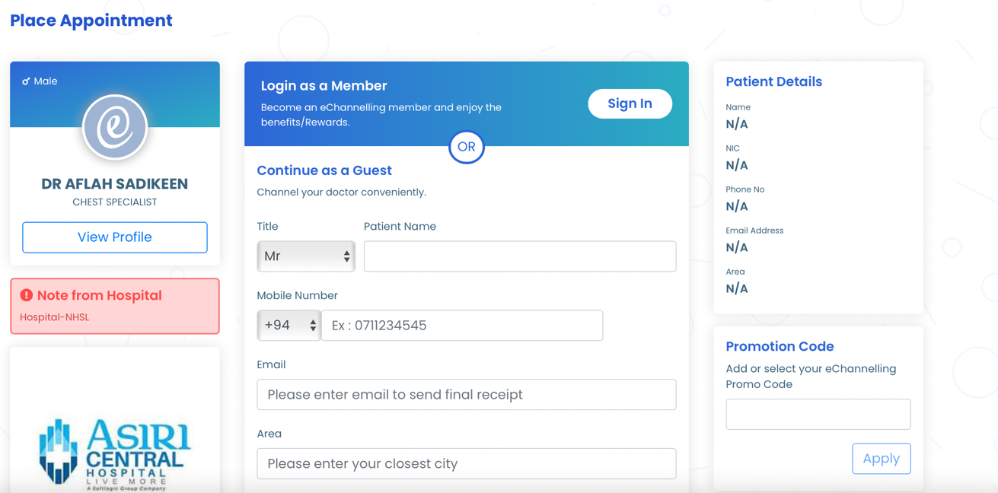

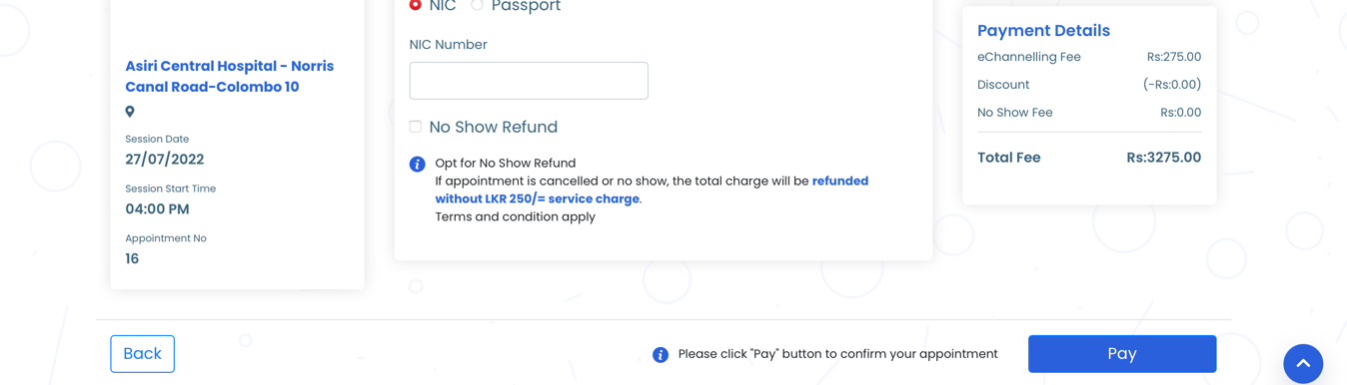

After clicking “Pay”, it shows the payment methods and after the payment it finally shows the receipt which we can print if the user wants (the receipts is sent to the email and mobile phone as well).

1. What is the type of software solution (desktop, client-server, web)

Client-server (software solution)

9) What should be the data stored in the database

Data that gets stored in the database should be:

* all the patent details that they fill with their information
* The payment method and amount
* The booked doctor and hospital details
* The booked time slot
* And as primary key a patient reference number

10) Try to draw a technical diagram to illustrate the communication from browser- network-server-database.

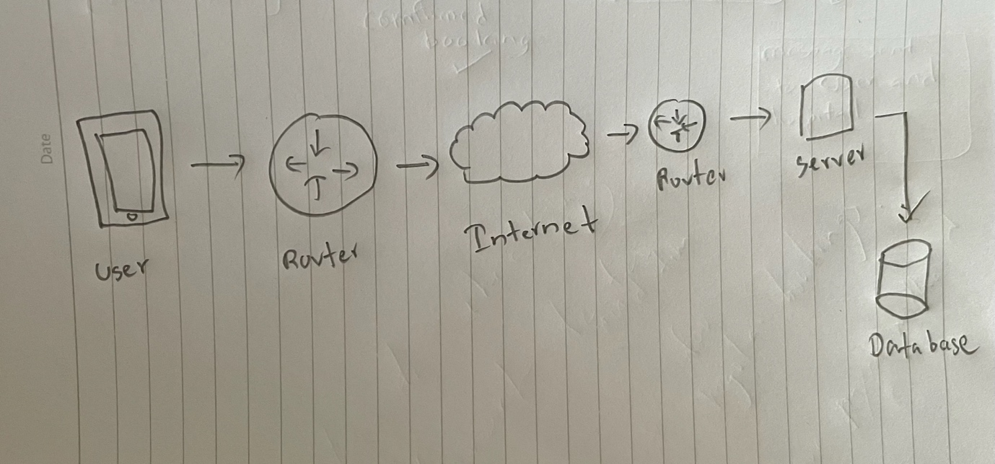

11) Do you think that the system has an administrative user? If so mention 3 tasks.

* Administrative user can edit, change and delete the details.

12) Considering total scenario, what are the processes and activities you cannot

achieve through the system (that user should do manually)

* The user has to pick the date, time, location manually but if there was a advanced way of the system automatically checking the free slots in your device calendar and checking your location and getting the best slots shown to you.
* If a patient has regular appointments (for certain medical conditions) they can set and save their doctor, location and preferred time and payment methods. (For weekly appointments) the whole proses will be automated

13) Suggest some ways of automating the activities that you mention in no. 12

Saving your favorite details (doctor, location, payment method) after you signed in. which will be only in your account and saved. This will automate the suggested way