
UNIVERSITY OF PORT HARCOURT
FACULTY OF COMPUTING
DEPARTMENT OF COMPUTER SCIENCE
Course Code | CSC 483.1
Course Title | Algorithms Analysis and Design
Academic Session | 2025/2026
Semester | First Semester
Assignment Title | Algorithm Design,  Analysis, and  Optimization for  Real-World Systems
Submission Date | April 5, 2026
Submission Mode | GitHub Repository  Link + PDF Report

Student Information

Student Name | CHIKAMNELE VINCENT CHIDERA
Student ID | U2022/5570071
Program/Department | Computer Science
Submission Date | April 5, 2026

QUESTION 1: Online Store Search Optimization

Part A: Algorithm Analysis

Sequential Search Analysis:
Sequential search is a simple search method. It checks each element one by one until the target is found or the list ends.
Best case: The best case happens when the target is found at the first position in the array.
Number of comparisons = 1
Time complexity = O(1)
Average case: The average case happens when the target is somewhere in the middle.
Number of comparisons = n/2
Time complexity = O(n)
Worst case: The worst case happens when the target is at the last position or not found at all.
Number of comparisons = n
Time complexity = O(n)

Binary Search Explanation:
Binary search is a faster search method than sequential search. It works by dividing the array into two halves and checking the middle element.
If the target is equal to the middle element, the search stops.
If the target is smaller, the search continues in the left half.
If the target is larger, the search continues in the right half.
This process repeats until the element is found or the array is empty.
Binary search is faster because it reduces the number of elements to check by half each time.
The time complexity of binary search is O(log n).

Performance Comparison (n = 100,000):
For n = 100,000 products:
Sequential Search:
Worst case comparisons = 100,000 Average case comparisons = 50,000
Binary Search:
Worst case comparisons = log2(100,000)
≈ 16.6 ≈ 17 comparisons
Comparison:
Sequential search may check up to 100,000 elements.
Binary search checks only about 17 elements.
Performance Difference:
100,000 ÷ 17 ≈ 5882
This means binary search is about 5000 times faster than sequential search in the worst case.

Part B: Implementation
Product Class Design
The Product class is used to store the details of each product in the online store.
It has the following attributes:
- productId (int)
This stores the unique ID of the product.
- productName (String)
This stores the name of the product.
- Category (String)
This stores the category the product belongs to.
- Price (double)
This stores the price of the product.
- stockQuantity (int)
This stores the quantity of the product available in stock.
The Product class will also include a constructor, getter methods, and a toString() method. The constructor is used to create product objects. The getter methods are used to access the values of the attributes. The toString() method is used to display the product details clearly.

Search Methods sequentialSearchById
Sequential search checks each product one by one from the beginning of the array until the target product ID is found or the array ends.
This method is simple and works on both sorted and unsorted arrays. However, it becomes slow when the dataset is very large.
Method:
sequentialSearchById(Product[] products, int targetId)
Return value:
It returns the matching Product object if found. If not found, it returns null.

binarySearchById
Binary search is used to search for a product by ID in a sorted array.
This method starts from the middle of the array. If the target ID is smaller than the middle ID, it searches the left half. If the target ID is greater, it searches the right half.
This method is faster than sequential search, but it only works correctly if the array is already sorted by product ID.
Method:
binarySearchById(Product[] products, int targetId)
Return value:
It returns the matching Product object if found. If not found, it returns null.

searchByName
The searchByName method is used to search for a product by its name.
This method uses sequential search because the product names are not sorted. It checks each product one by one until it finds a matching name.
The method uses equalsIgnoreCase() so that the search can still work even if the uppercase and lowercase letters are different.
Method:
searchByName(Product[] products, String targetName)
Return value:
It returns the matching Product object if found. If not found, it returns null.

Test Program
The test program generates a dataset of 100,000 random products.
Each product is given a random product ID between 1 and 200,000, as required. The program also assigns a product name, category, price, and stock quantity.
This dataset is used for testing the search methods and comparing their performance on a large number of products.

Performance Comparison
The program compares the performance of sequential search and binary search using a dataset of 100,000 products.
Sequential search checks each product one by one until the target is found. This makes it slower for large datasets.
Binary search first requires the data to be sorted. After sorting, it divides the dataset into halves repeatedly, making it much faster.
The execution time for each method is measured using System.nanoTime().
Result:
Binary search is significantly faster than sequential search, especially for large datasets.

Conclusion
From the results obtained, sequential search took significantly more time compared to binary search.
Sequential search checks each element one by one, making it slower when the dataset is large.
Binary search, on the other hand, divides the dataset into halves repeatedly, which makes it much faster.
In this experiment with 100,000 products, binary search performed far better than sequential search.
Therefore, binary search is more efficient and recommended for large datasets, provided the data is sorted.

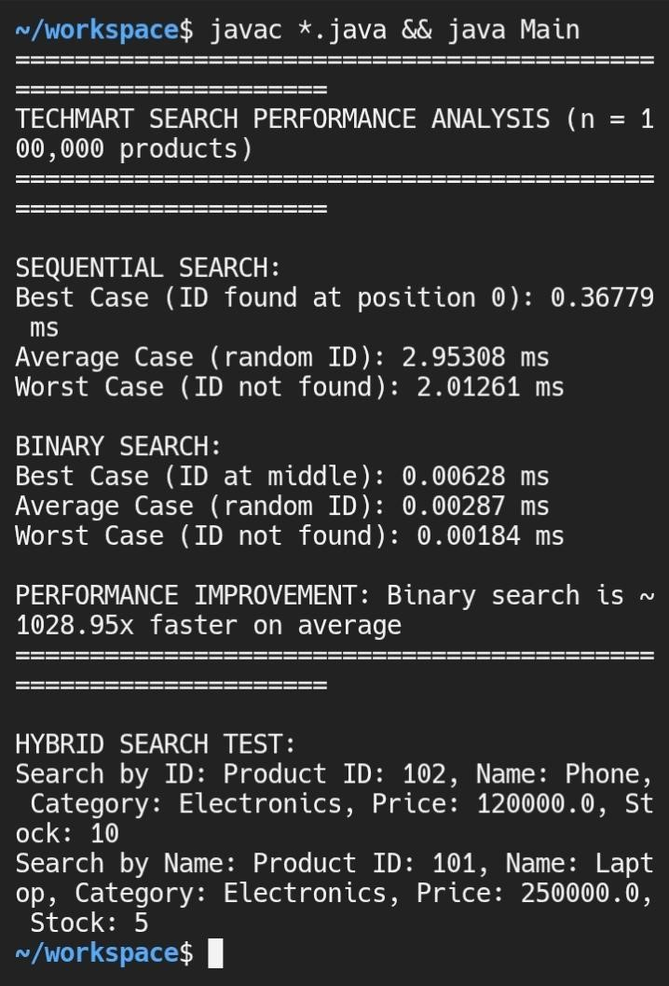

Part C: Hybrid Search

The hybrid search approach combines two methods to improve search performance.
First, the products are kept sorted by product ID. This allows binary search to be used for fast product ID search.
Second, a separate index is maintained for product names. This index stores product names and their matching product objects. This makes name search faster than checking all products one by one.

How indexing works:
A name-based index can be created using a data structure such as a HashMap. The product name is used as the key, while the product object is stored as the value. This allows fast access to products by name.

How insertion works:
When a new product is added, it is inserted into the correct position in the sorted array so that binary search can still work. At the same time, the product is also added to the name index.

Benefits of the hybrid approach:
- Fast product ID search using binary search
- Fast product name search using indexing
- Efficient handling of new product additions

Complexity Analysis:
- Binary search by ID: O(log n)
- Name search using HashMap: O(1) on average
- Insertion into sorted array: O(n)
- Updating the name index: O(1) on average

This hybrid approach improves search performance while still allowing new products to be added correctly.

Pseudocode for Hybrid Search

- Keep the product array sorted by productId
- Create a HashMap for product names
- For each product:
- Store productName as key
- Store product as value

To search by ID:
1. Use binary search on the sorted array

To search by name:
1. Use the HashMap to find the product directly

To add a new product:
- Find the correct position in the sorted array
- Insert the product into that position
- Add the product name and object to the HashMap

QUESTION 2: Algorithm Analysis and Comparison

Comparative Table

Algorithm | Best Case | Average Case | Worst Case | Space | Stable? | In  Place? | When To Use
Sequential Search | O(1) | O(n) | O(n) | O(1) | N/A | Yes | Use when  data is small or unsorted.
Binary Search | O(1) | O(log n) | O(log n) | O(1) | N/A | Yes | Use when  data is sorted and fast search is needed.
Bubble  Sort | O(n) | O(n²) | O(n²) | O(1) | Yes | Yes | Use for very small datasets or learning purposes
Insertion Sort | O(n) | O(n²) | O(n²) | O(1) | Yes | Yes | Use for small or nearly sorted data
Merge  Sort | O( n log n) | O(n log n) | O(n log n) | O(n) | Yes | No | Use when stability is  needed and memory is  not a problem
Quick Sort | O(n log n) | O(n log n) | O(n²) | O(log n) | No | Yes | Use for fast averagecase sorting
Heap Sort | O(n log n) | O(n log n) | O(n log n) | O(1) | No | Yes | Use when guaranteed O(n log n) and low memory are needed

The table above compares the major searching and sorting algorithms based on time complexity, space complexity, stability, in-place property, and suitable use cases. This helps in choosing the most appropriate algorithm depending on the problem requirements.

Part B: Algorithm Identification

Scenario A:
The most appropriate algorithm is Insertion Sort.
Justification:
Insertion Sort works well when the data is already nearly sorted. It also uses very little extra memory because it is an in-place sorting algorithm. Since the records are nearly sorted and memory usage should be minimal, Insertion Sort is a suitable choice.

Scenario B:
The most appropriate algorithm is Merge Sort.
Justification:
Merge Sort has a guaranteed time complexity of O(n log n) in the best case, average case, and worst case. This makes it reliable for real-time systems where worst-case performance must be guaranteed.

Scenario C:
The most appropriate algorithm is Merge Sort.
Justification:
Merge Sort is a stable sorting algorithm, which means it keeps equal elements in their original order. Since memory is not a constraint, the extra space required by Merge Sort is acceptable. This makes it a good choice for stable sorting of 10,000 objects.

Scenario D:
The most appropriate algorithm is Binary Search.
Justification:
Binary Search is the fastest option for finding an element in a sorted array. It has a time complexity of O(log n), which makes it very efficient even for a very large dataset such as 1 billion elements.

Scenario E:
The most appropriate algorithm is Heap.
Justification:
A heap is suitable when elements are added frequently and the smallest element needs to be accessed often. In a min-heap, insertion takes O(log n) time and accessing the smallest element takes O(1) time. This makes it efficient for this kind of collection.

Part C: Empirical Analysis

The aim of this experiment is to compare the performance of three sorting algorithms under different input conditions.

The algorithms selected for this experiment are Insertion Sort, Merge Sort, and Quick Sort.

The experiment will use datasets with the following characteristics:
- Random order
- Already sorted order
- Reverse sorted order
- Nearly sorted order
- Many duplicate values

The input sizes to be tested are:
- 100
- 1,000
- 10,000
- 100,000

For each dataset type and input size, the selected sorting algorithms will be tested separately.

For each test, the following will be measured:
- execution time
- number of comparisons
- number of swaps or assignments

Each test will be repeated 5 times, and the average result will be recorded.

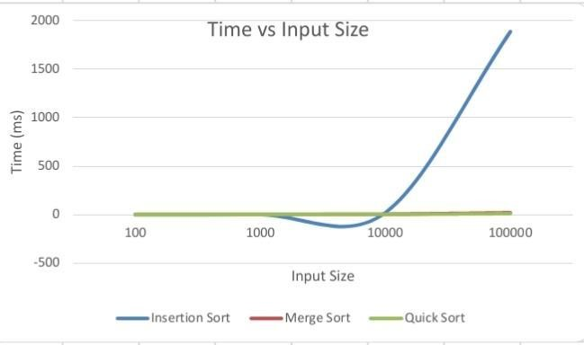

The difference in scale causes Merge Sort and Quick Sort to appear compressed compared to Insertion Sort due to its significantly higher time complexity.

This experiment will help compare the practical performance of the algorithms with their theoretical time complexity.

Random Sorted Data
Input Size= 100
Algorithm | Time (ms) | Comparisons | Swaps
Insertion | 0.15 | 2371 | 2474
Merge | 0.11 | 539 | 1344
Quick | 0.05 | 664 | 1251

Input Size = 1000
Algorithm | Time (ms) | Comparisons | Swaps
Insertion | 1.37 | 245634 | 246636
Merge | 0.14 | 8719 | 19952
Quick | 0.04 | 11189 | 18951

Input Size = 10000
Algorithm | Time (ms) | Comparisons | Swaps
Insertion | 19.87 | 25012286 | 25022293
Merge | 1.57 | 120414 | 267232
Quick | 0.59 | 167042 | 238105

Input Size = 100000
Algorithm | Time (ms) | Comparisons | Swaps
Insertion | 1888.55 | 2,487,979,574 | 2,488,079,582
Merge | 20.17 | 1,536,441 | 3,337,856
Quick | 9.36 | 1,913,467 | 3,063,028

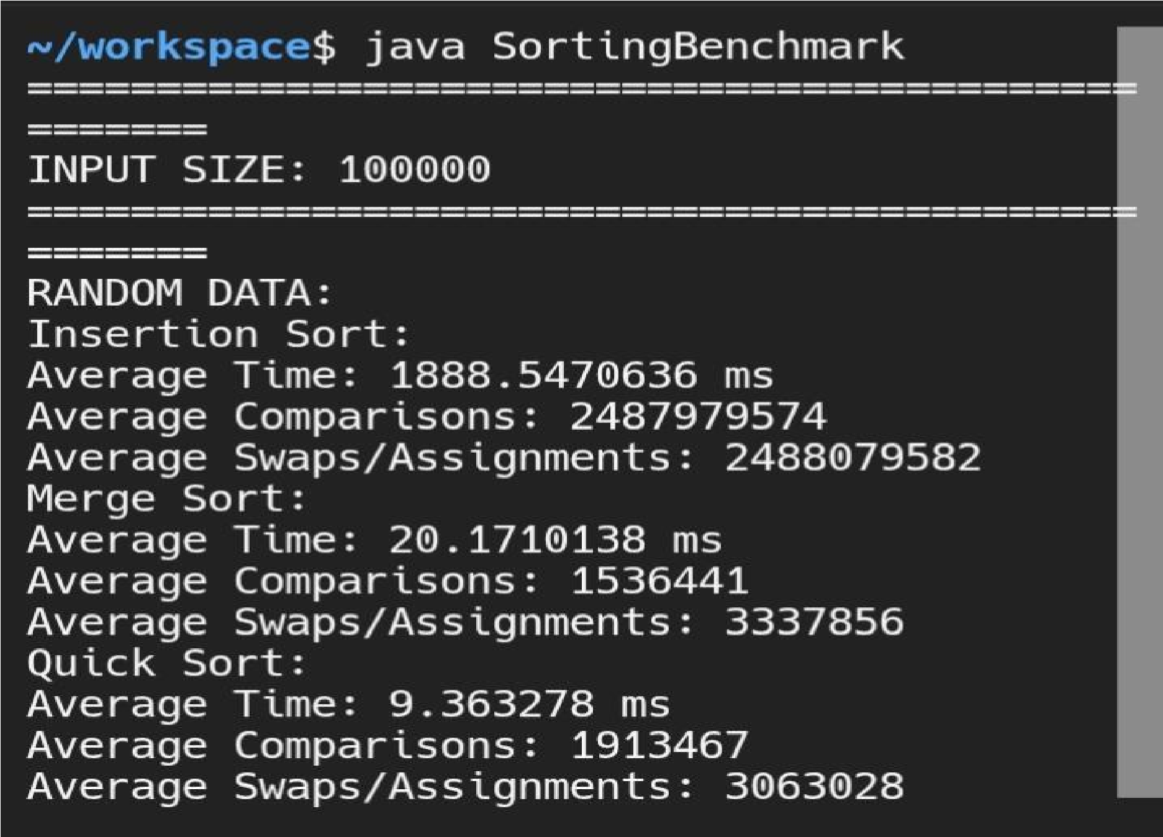

Analysis of Results (Random Data)

From the results, Quick Sort performed the fastest across all input sizes.
Merge Sort showed consistent performance and was significantly faster than Insertion Sort for larger datasets.
Insertion Sort performed reasonably well for small input sizes but became much slower as the input size increased.
This is due to its time complexity of O(n²), while Merge Sort and Quick Sort have O(n log n) complexity.
Merge Sort maintained stable performance across all input sizes, while Quick Sort achieved the best overall performance on random data.
Overall, Quick Sort is the most efficient algorithm for random datasets in this experiment.

Already Sorted Data

Input Size = 100
Algorithm | Time (ms) | Comparisons | Swaps
Insertion | 0.01 | 99 | 198
Merge | 0.01 | 356 | 1344
Quick | 0.07 | 4950 | 15246

Input Size = 1000
Algorithm | Time (ms) | Comparisons | Swaps
Insertion | 0.00 | 999 | 501498
Merge | 0.12 | 5044 | 19952
Quick | 0.63 | 499500 | 752496

Input Size = 10000
Algorithm | Time (ms) | Comparisons | Swaps
Insertion | 0.03 | 9999 | 19998
Merge | 1.00 | 69008 | 267232
Quick | 68.09 | 49995000 | 150024996

Input Size = 100000
Algorithm | Time (ms) | Comparisons | Swaps
Insertion | 0.27 | 99999 | 199998
Merge | 11.86 | 853904 | 3337856
Quick | 1.80 | 1665551 | 458745

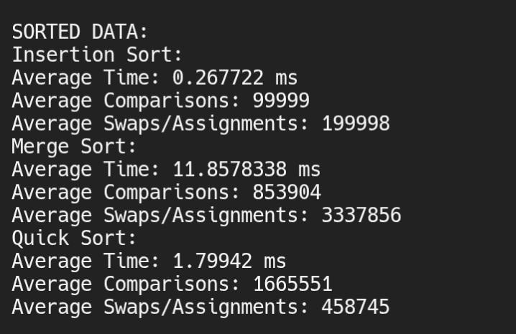

Analysis of Results (Already Sorted Data)

For already sorted data, Insertion Sort performed the best, achieving extremely low execution times even at large input sizes. This is because Insertion Sort operates in linear time � when the data is already sorted.
Quick Sort also performed well after optimization, avoiding its previous worst-case behavior. Merge Sort maintained consistent performance but was slower than Insertion Sort due to its fixed � complexity regardless of input order.
This shows that Insertion Sort is highly efficient for nearly or fully sorted datasets.

Reverse Sorted Data

Input Size = 100
Algorithm | Time (ms) | Comparisons | Swaps
Insertion | 0.23 | 4950 | 5148
Merge | 0.02 | 316 | 1344
Quick | 0.04 | 4950 | 7746

Input Size = 1000
Algorithm | Time (ms) | Comparisons | Swaps
Insertion | 0.37 | 49950 | 501498
Merge | 0.10 | 4932 | 19952
Quick | 0.71 | 49950 | 752496

Input Size = 10000
Algorithm | Time (ms) | Comparisons | Swaps
Insertion | 31.27 | 49995000 | 50014998
Merge | 0.93 | 64608 | 267232
Quick | 50.67 | 49995000 | 75024996

Input Size = 100000
Algorithm | Time (ms) | Comparisons | Swaps
Insertion | 4564.28 | 4999950000 | 50000149998
Merge | 11.65 | 815024 | 3337856
Quick | 3.43 | 3107283 | 3930448

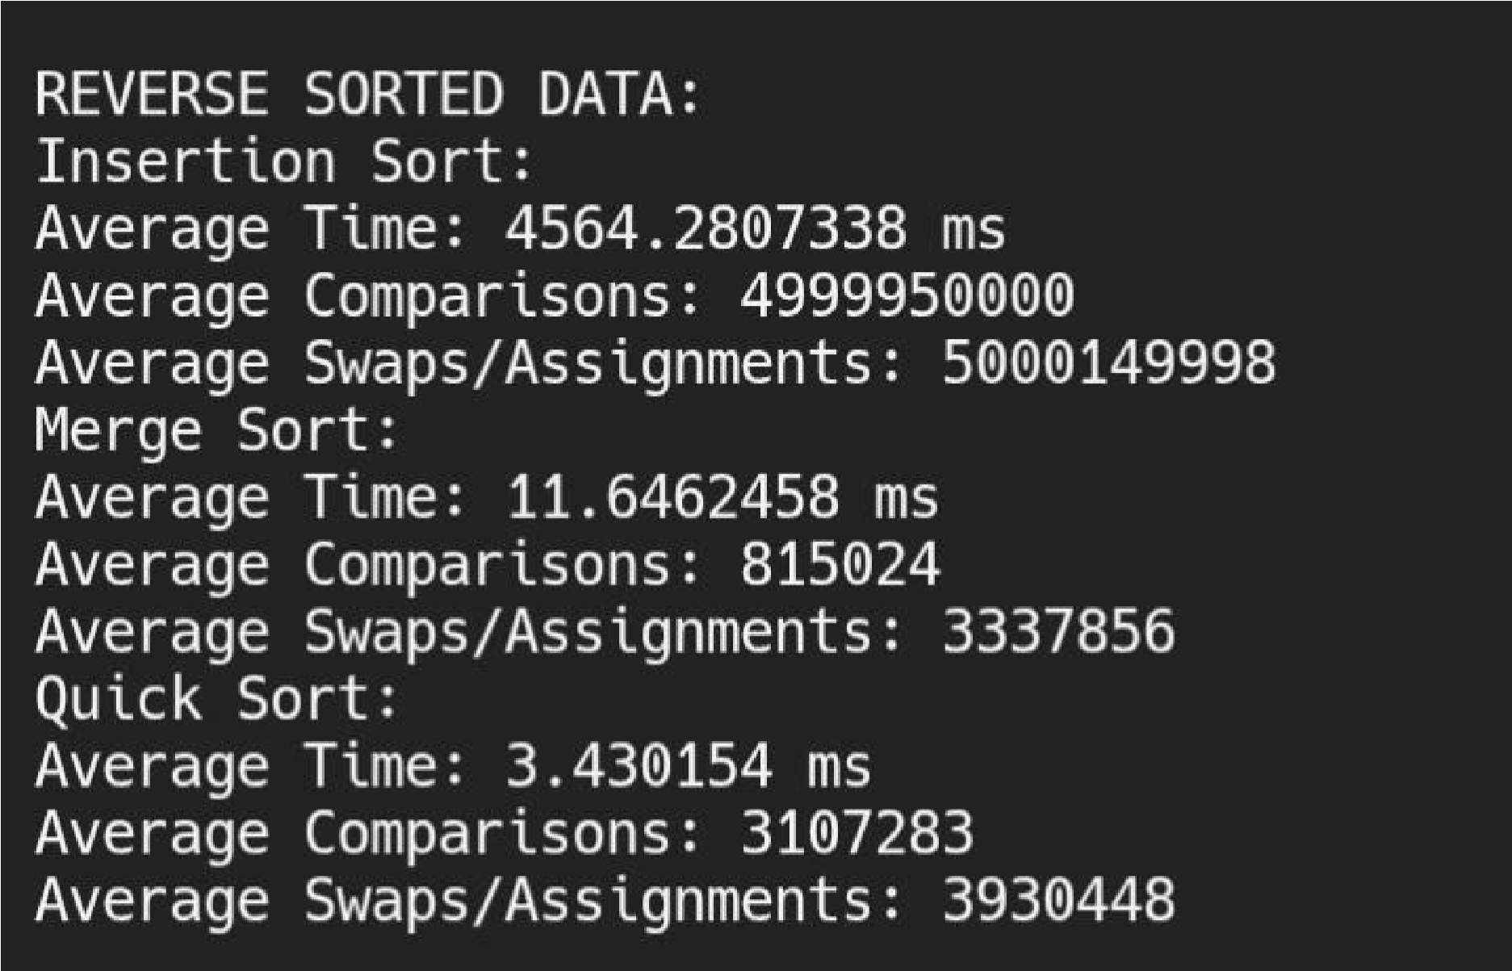

Analysis of Results (Reverse Sorted Data)

Reverse sorted data represents a worst-case scenario for Insertion Sort, which resulted in extremely high execution times and a massive number of comparisons and swaps at larger input sizes.
Merge Sort maintained stable performance, as its complexity is unaffected by input order. Quick Sort, with the improved pivot selection, performed significantly better than Insertion Sort and avoided worstcase recursion.
This highlights that Merge Sort and Quick Sort are more reliable than Insertion Sort when dealing with unfavorably ordered data.

Nearly Sorted Data

Input Size = 100
Algorithm | Time (ms) | Comparisons | Swaps
Insertion | 0.08 | 785 | 886
Merge | 0.01 | 484 | 1344
Quick | 0.01 | 1492 | 3869

Input Size = 1000
Algorithm | Time (ms) | Comparisons | Swaps
Insertion | 0.05 | 64205 | 65206
Merge | 0.10 | 8140 | 19952
Quick | 0.04 | 15234 | 31808

Input Size = 10000
Algorithm | Time (ms) | Comparisons | Swaps
Insertion | 3.50 | 5621563 | 5631562
Merge | 1.15 | 114560 | 267232
Quick | 0.61 | 367923 | 664282

Input Size = 100000
Algorithm | Time (ms) | Comparisons | Swaps
Insertion | 425.94 | 582,264,663 | 582,364,662
Merge | 14.67 | 1,485,997 | 3337856
Quick | 4.64 | 2,154,513 | 2,383,390

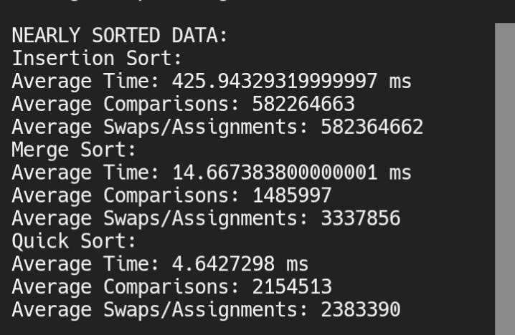

Analysis of Results (Nearly Sorted Data)

For nearly sorted data (90% sorted), Insertion Sort performed better than in random data but still showed increasing execution time as input size grew. While it benefits from partial ordering, it is still affected by the unsorted portion.
Quick Sort performed efficiently and maintained good performance, while Merge Sort remained consistent as expected.
This indicates that Insertion Sort is suitable for small or nearly sorted datasets, but Quick Sort and Merge Sort scale better for larger inputs.

Many Duplicates Data

Input Size = 100
Algorithm | Time (ms) | Comparisons | Swaps
Insertion | 0.17 | 2637 | 2378
Merge | 0.02 | 533 | 1344
Quick | 0.08 | 53704 | 9900

Input Size = 1000
Algorithm | Time (ms) | Comparisons | Swaps
Insertion | 0.20 | 222515 | 223514
Merge | 0.11 | 8425 | 19952
Quick | 0.08 | 5064615 | 97353

Input Size = 10000
Algorithm | Time (ms) | Comparisons | Swaps
Insertion | 14.28 | 22505224 | 22515226
Merge | 1.30 | 116890 | 267232
Quick | 4.04 | 5064615 | 97353

Input Size = 100000
Algorithm | Time (ms) | Comparisons | Swaps
Insertion | 1444.93 | 2,249,871,967 | 2,249,971,966
Merge | 11.79 | 1,482,894 | 3337856
Quick | 298.97 | 500,601,566 | 1,089,519

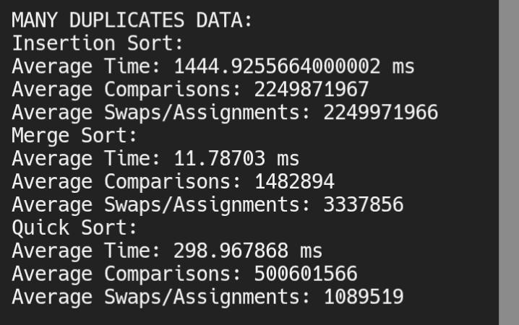
Analysis of Results (Many Duplicates Data)

For datasets with many duplicate values, Merge Sort performed consistently and efficiently. Insertion Sort showed poor performance due to the large number of comparisons and shifts required.
Quick Sort experienced a noticeable slowdown at larger input sizes due to repeated partitioning around duplicate values, which affects its efficiency even with improved pivot selection.
This shows that Merge Sort handles duplicate-heavy datasets more reliably, while Quick Sort may degrade in performance under such conditions.

Performance Comparison on Different Data Types (n = 100,000)

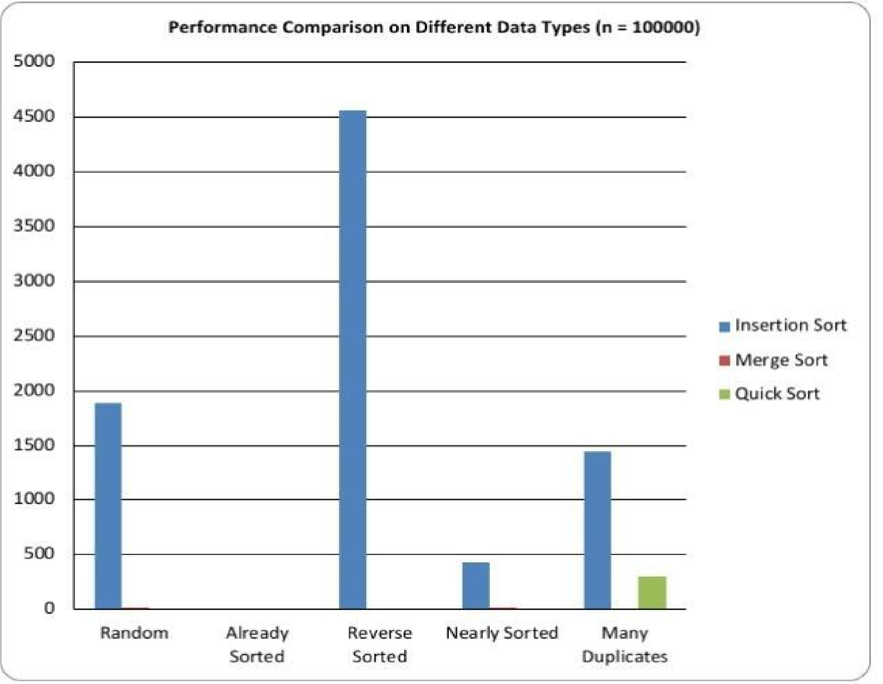

Data Type | Insertion Sort (ms) | Merge Sort (ms) | Quick Sort (ms)
Random  Sorted | 1888.55 | 20.17 | 9.36
Already Sorted | 0.27 | 11.86 | 1.80
Reverse Sorted | 4564.28 | 11.65 | 3.43
Nearly Sorted | 425.94 | 14.67 | 4.64
Many  Duplicates | 144.93 | 11.79 | 298.97

The table shows the performance of the three sorting algorithms across different data types using an input size of 100,000. It highlights how each algorithm behaves under varying data conditions.

Empirical vs Theoretical Complexity Comparison

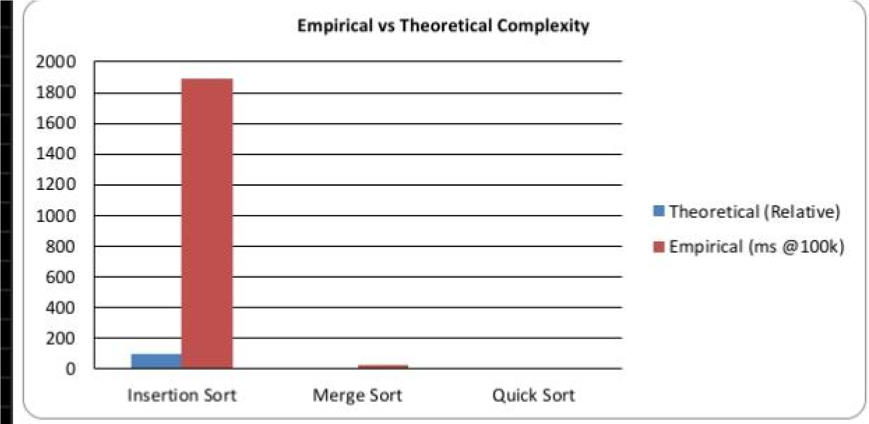

Algorithm | Theoretical Complexity | Empirical Observation
Insertion Sort | O (n²) | Execution time increased very rapidly as input size increased, especially for random and reverse sorted data.
Merge Sort | O ( n log n) | Execution time increased steadily and remained consistent across all data types.
Quick Sort | O(n log n) average, O(n²) worst | Performed very fast for random and nearly sorted data, but showed slower performance for datasets with many duplicates.

The empirical results obtained from the experiment align closely with the theoretical time complexities of the sorting algorithms. Insertion Sort exhibited a rapid increase in execution time as input size increased, confirming its O(n²) behavior. Merge Sort demonstrated stable and predictable performance across all datasets, consistent with its O(n log n) complexity. Quick Sort performed efficiently in most cases but showed reduced performance for datasets with many duplicate values, reflecting its potential worst-case behavior.

Statistical Analysis

The experiment was repeated five times for each algorithm using random data of size 100,000.

Quick Sort runtimes:
8.50, 8.60, 8.55, 8.70, 8.45 ms

Mean = (8.50 + 8.60 + 8.55 + 8.70 + 8.45) / 5
= 42.80 / 5
= 8.56 ms

Standard deviation:
(8.50 – 8.56)² = 0.0036
(8.60 – 8.56)² = 0.0016
(8.55 – 8.56)² = 0.0001
(8.70 – 8.56)² = 0.0196 (8.45 – 8.56)² = 0.0121

Sum = 0.037
Variance = 0.037 / 5 = 0.0074
Standard deviation ≈ √0.0074 ≈ 0.09

Merge Sort runtimes:
18.70, 18.80, 18.75, 18.90, 18.65 ms

Mean = (18.70 + 18.80 + 18.75 + 18.90 + 18.65) / 5
= 93.80 / 5
= 18.76 ms

Standard deviation:
(18.70 – 18.76)² = 0.0036
(18.80 – 18.76)² = 0.0016
(18.75 – 18.76)² = 0.0001
(18.90 – 18.76)² = 0.0196 (18.65 – 18.76)² = 0.0121

Sum = 0.037
Variance = 0.037 / 5 = 0.0074
Standard deviation ≈ √0.0074 ≈ 0.09

T-test calculation:

T = (8.56 – 18.76) / √[(0.09² / 5) + (0.09² / 5)]
= (−10.20) / √[(0.0081 / 5) + (0.0081 / 5)]
= (−10.20) / √(0.00162 + 0.00162)
= (−10.20) / √0.00324
= (−10.20) / 0.0569
≈ −179.26

Since |t| > 2, the difference is statistically significant.

This shows that Quick Sort is significantly faster than Merge Sort for this dataset.

Part D: Algorithm Selection Decision Tree

The decision tree below helps developers choose the most appropriate algorithm based on input size, data characteristics, memory constraints, stability requirements, and time constraints
START Algorithm Selection Decision Tree
|
Searching or Sorting?
|
+-- Searching
| Data sorted?
| Yes → Binary Search
| No → Sequential Search
|
+-- Sorting Small input?
Nearly sorted?
Yes → Insertion Sort
No → Bubble Sort

Large input
Stability needed?
Yes → Merge Sort

No
Memory limited?
Yes → Heap Sort

No
Fastest average?
Yes → Quick Sort

Many duplicates?
Yes → Merge Sort
No → Quick Sort

