Predictive Analytics & AI Model Deployment
Customer Churn Prediction Project Report
Vinay Petkar | Cognevance Technologies – Internship Task 3
GitHub: https://github.com/vina-gif/churn-prediction-ai

1. Introduction
Customer churn is a major problem for subscription businesses. This project builds an end-to-end machine learning solution that predicts whether a telecom customer will leave, deploys the model as a REST API and exposes it through an interactive dashboard.

2. Objectives
- Explore and preprocess the Telco Customer Churn dataset
- Train and compare multiple ML models
- Select and persist the best model
- Deploy the model via a Flask REST API
- Build a Streamlit dashboard for insights and live predictions
- Document the work and publish code on GitHub

3. Dataset
Telco Customer Churn dataset: 7,043 customers and 21 columns; 1,869 customers churned (26.5%), so the target is imbalanced. Features include tenure, contract type, monthly and total charges, internet service, payment method and add-on services.

4. Architecture & Workflow
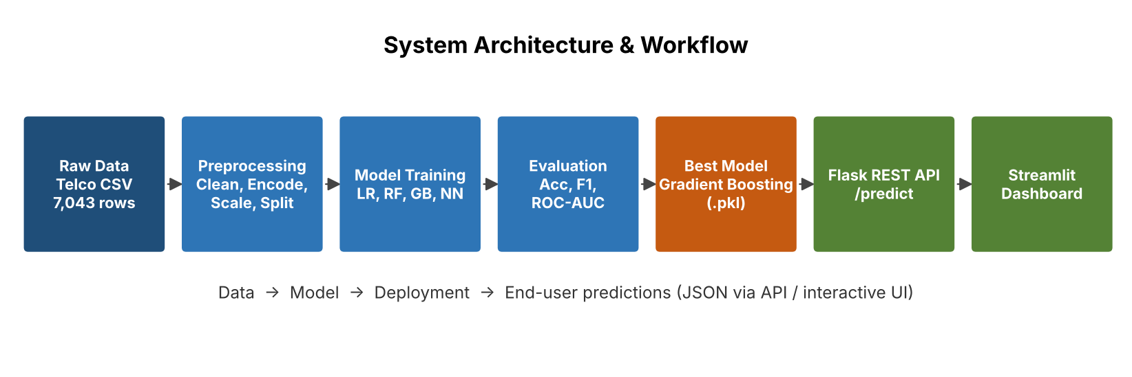
- Raw data (CSV) is cleaned and transformed by preprocess.py
- train_models.py and train_neural_network.py train four models
- evaluate_models.py compares them and saves results
- The best model (Gradient Boosting) is saved with joblib
- app.py serves it through Flask; dashboard.py (Streamlit) calls the API

5. Data Preprocessing
- TotalCharges converted to numeric; 11 rows with missing values dropped (7,032 rows)
- customerID dropped; Churn mapped to 0/1
- Engineered features: AvgChargesPerMonth, TenureGroup, TotalServices
- One-hot encoding of categorical variables (35 features in total)
- StandardScaler applied to numeric columns (scaler.pkl, num_cols.pkl, columns.pkl saved)
- Stratified 80/20 train-test split: 5,625 train / 1,407 test

6. Models
- Logistic Regression – linear baseline
- Random Forest – ensemble of decision trees
- Gradient Boosting – sequential boosted trees (selected)
- Neural Network (Keras) – 64-32-1 layers with dropout and EarlyStopping

7. Results
Model | Accuracy | Precision | Recall | F1 | ROC-AUC
Gradient Boosting | 0.7996 | 0.6494 | 0.5348 | 0.5865 | 0.8420
Logistic Regression | 0.7953 | 0.6387 | 0.5294 | 0.5789 | 0.8378
Neural Network | 0.7889 | 0.6351 | 0.4840 | 0.5493 | 0.8339
Random Forest | 0.7889 | 0.6296 | 0.5000 | 0.5574 | 0.8190

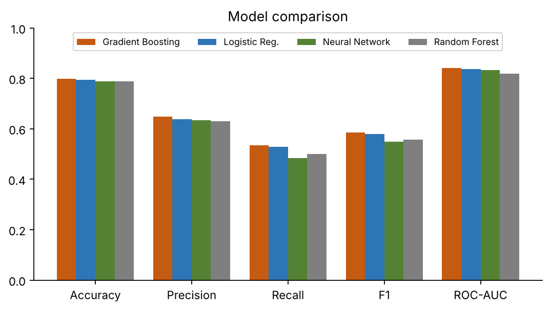
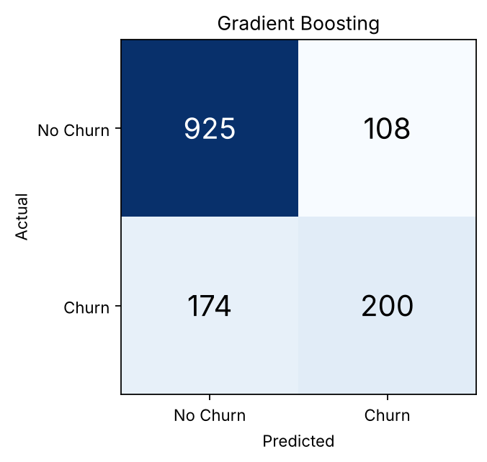
Gradient Boosting confusion matrix: TN 925, FP 108, FN 174, TP 200. Gradient Boosting achieved the highest ROC-AUC (0.842) and was chosen for deployment.

8. Deployment – Flask REST API
- GET / – health check
- POST /predict – accepts raw customer JSON, rebuilds engineered features, one-hot encodes, scales and returns the churn prediction with probability
- Test: new month-to-month customer → 0.7741 churn probability; loyal two-year customer → 0.0273

9. Dashboard (Streamlit + Plotly)
Three tabs: Data Insights, Model Comparison and Predict Churn.
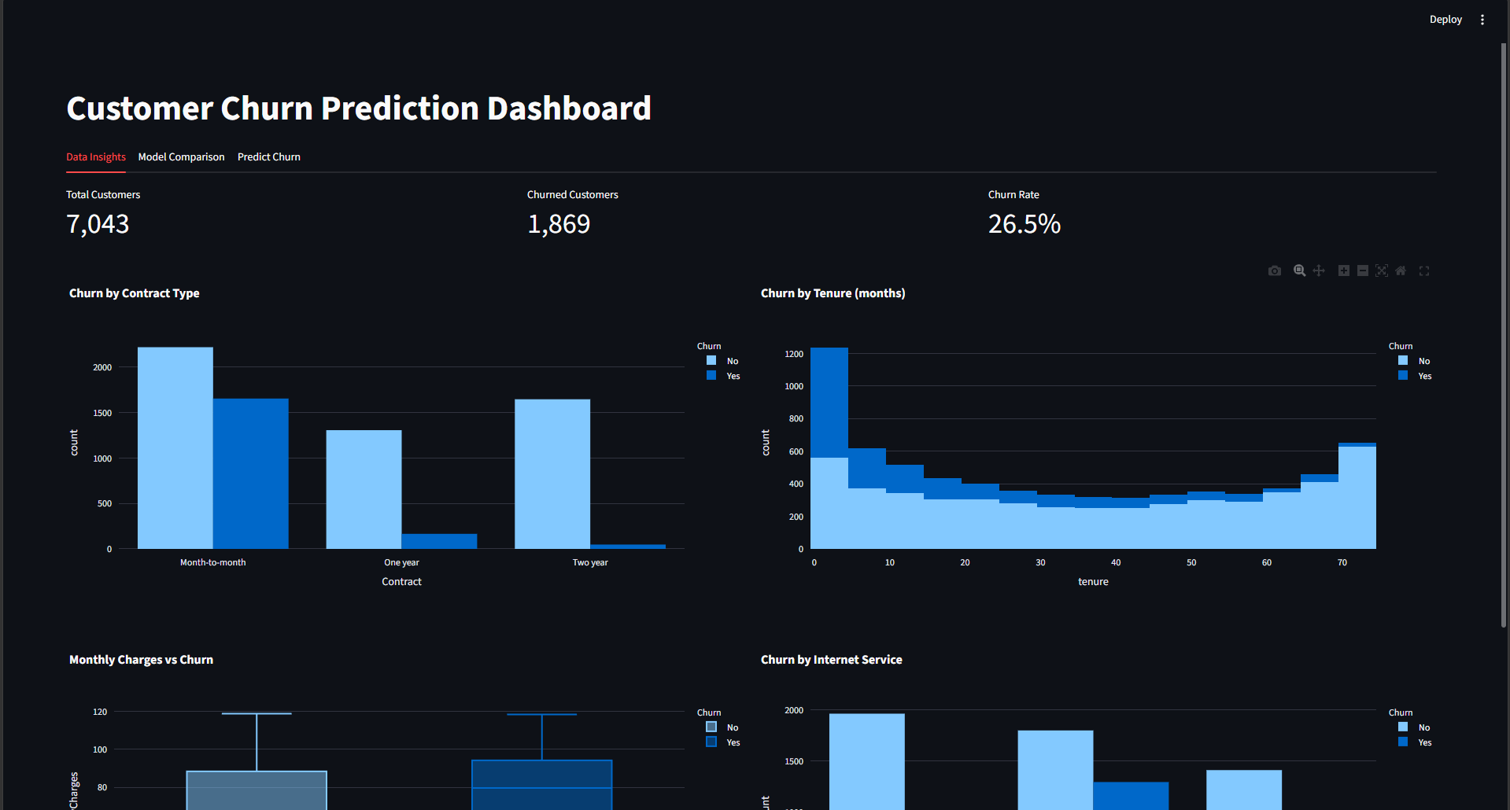
Data Insights tab
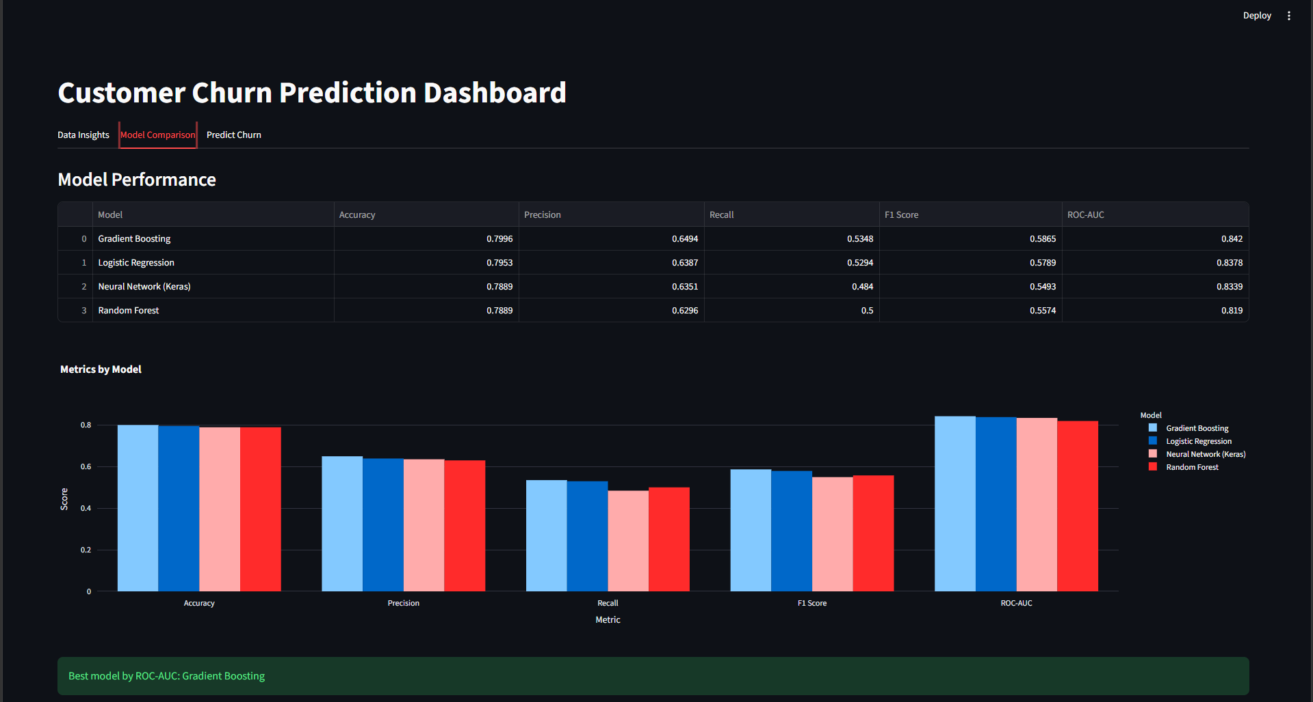
Model Comparison tab
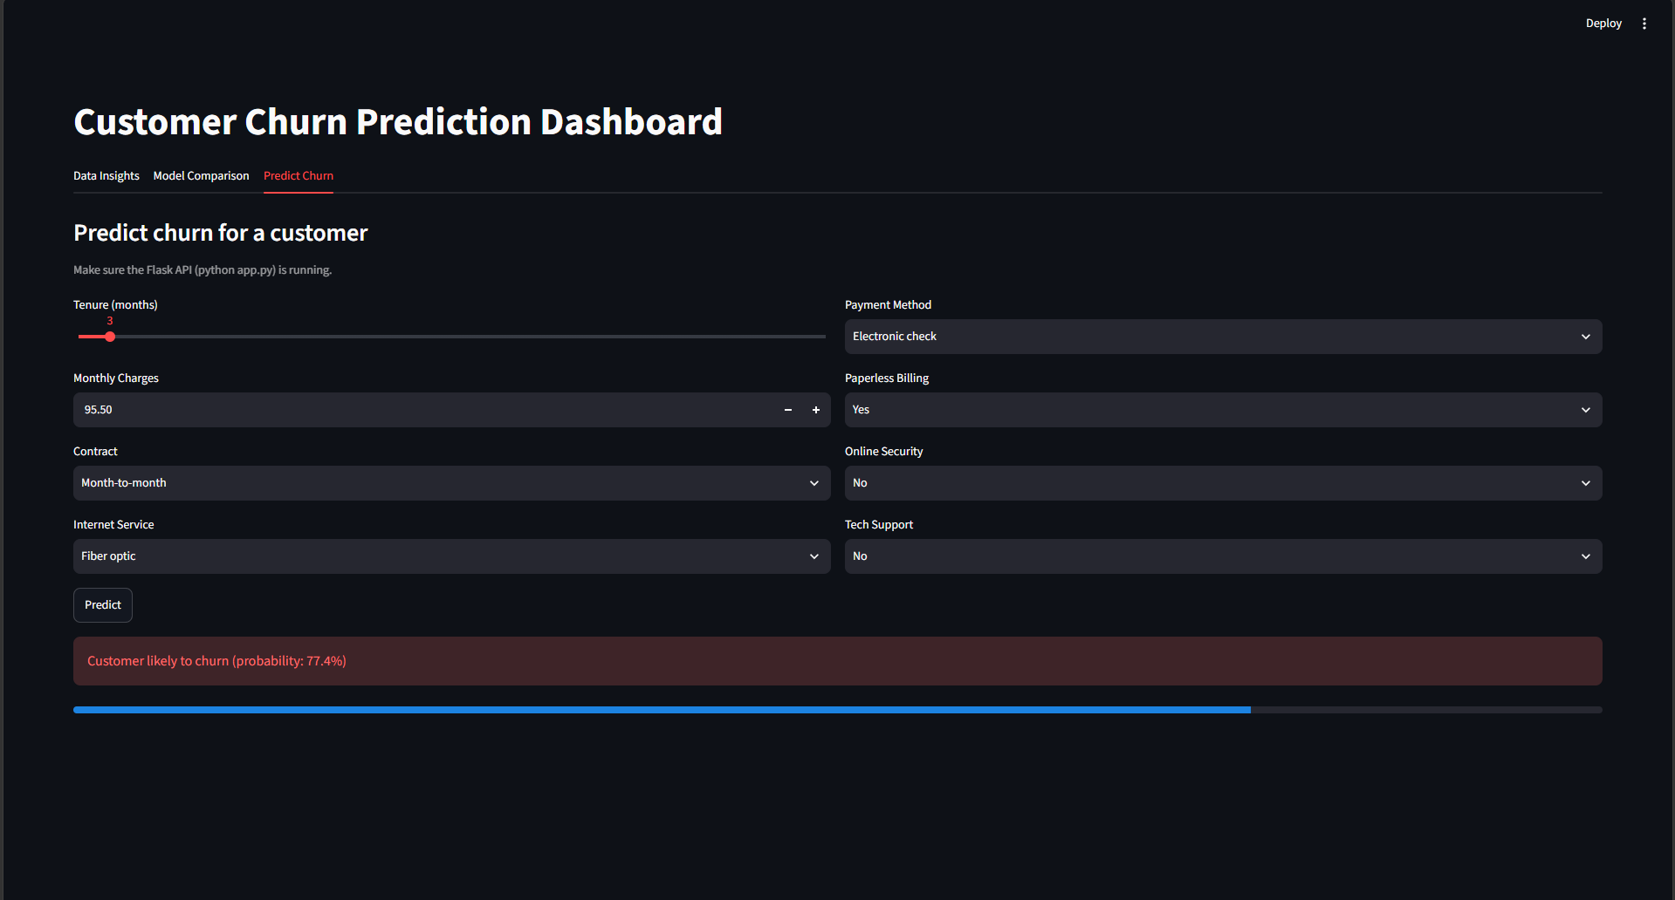
Prediction – high-risk customer
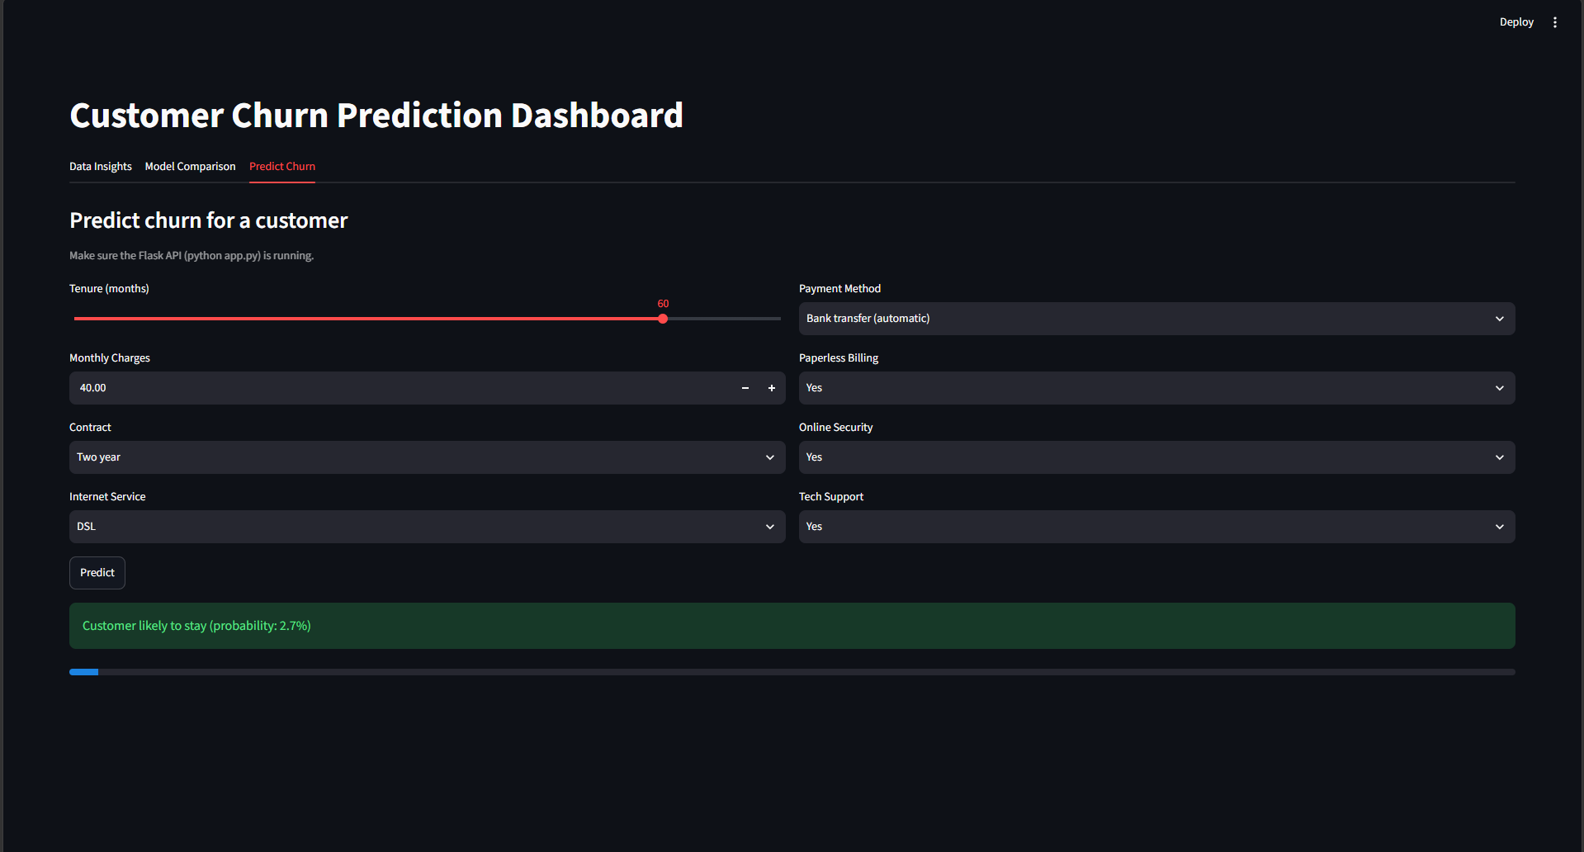
Prediction – low-risk customer

10. How to Run
pip install -r requirements.txt
python preprocess.py
python train_models.py
python app.py # starts API
streamlit run dashboard.py

11. Conclusion & Future Work
The project delivers a complete, working churn-prediction pipeline from raw data to deployed API and dashboard. Future improvements: hyperparameter tuning, handling class imbalance (SMOTE / class weights), Docker and cloud deployment, and monitoring for model drift.

