Contents
Project 2
Agent with Open AI LLM 2
Run LLM locally using Non Open AI ( Mistral or Llama) 3
Run LLM locally without Agent 6
Build truly AgenticAI 6

Project
Create an AgenticAI Search application, which will take a query, use appropriate tool, search for the results and summarize the results.

Agent with Open AI LLM
Tools required.
- Python 3.11 or above ( actual script )
- OpenAI SDK( LLM ) – To run LLM locally
- Langchain ( Build Agent )
- Streamlit ( basic UI version)
- Wikipedia/duckduckgo-search – Search tool

Setup Environment
- Once python is installed execute below command in command prompt
pip install streamlit langchain openai Wikipedia
else it can be done individually.
pip install streamlit
pip install langchain
pip install Wikipedia
pip install openai
- Create OpenAI private key.
https://platform.openai.com/api-keys

Script
"C:\AI\projects\AgenticAIWebAssistant\WebAssistant.py"
Execute
streamlit run "C:\AI\projects\AgenticAIWebAssistant\WebAssistant.py"
You’ll get a local URL like http://localhost:8501 to view your assistant in the browser.
If everything goes fine you may hit below OpenAi error
openai.RateLimitError: Error code: 429 - {'error': {'message': 'You exceeded your current quota, please check your plan and billing details. For more information on this error, read the docs: https://platform.openai.com/docs/guides/error-codes/api-errors.', 'type': 'insufficient_quota', 'param': None, 'code': 'insufficient_quota'}}
To Fix this
- Either setup a paid OpenAi account
- Free Alternative (Ollama + LLaMA 3 or Mistral)

Run LLM locally using Non Open AI ( Mistral or Llama)

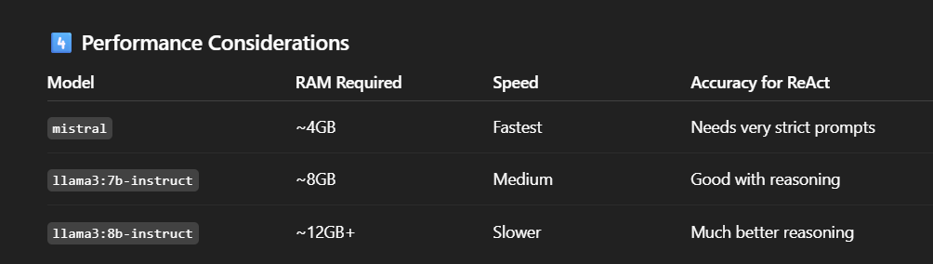

Pip install ollama
Pip install mistral

Execution Steps
- Make sure Ollama is running in the background. If it's not, open a terminal and run:
ollama run mistral
- Initiate program
Streamlit run "C:\AI\projects\AgenticAIWebAssistant\WebAssistant_ollamaWithAgent.py"
Results
Output 1: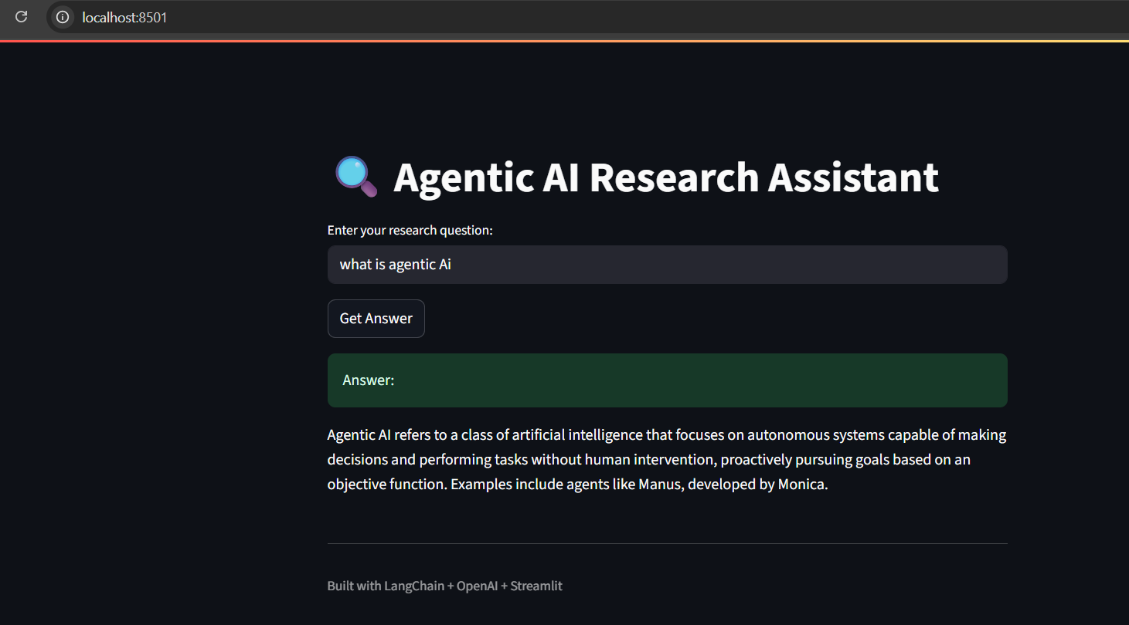
Output is visible in console but takes too long around 15 mins to print in UI. This means LLM and agent working locally with LangChain, Ollama, and Streamlit. 🎉
Output 2 :
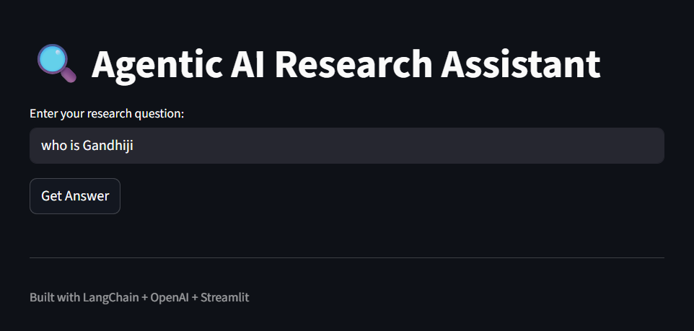
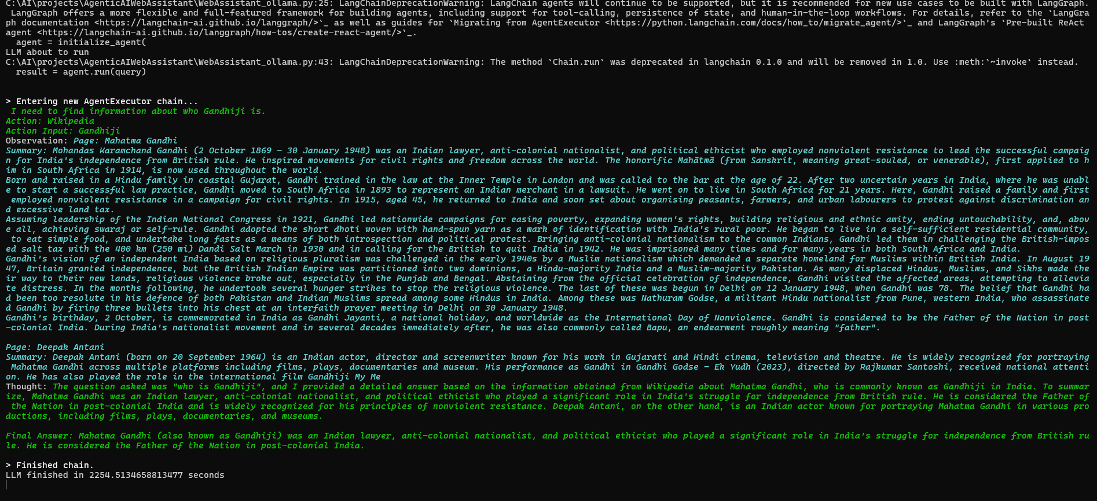

This could be because :
- Mistral taking too long to respond

Run LLM locally without Agent
Since running LLM locally with agent can be time consuming, it may give an impression of application being stuck or non responsive. We can check if LLM is working without agent and then can add agent.
Run below script
Path : "C:\AI\projects\AgenticAIWebAssistant\WebAssistant_ollama_Wthout_Agent.py"
Cmd – ollama run mistral
Cmd – streamlit run “C:\AI\projects\AgenticAIWebAssistant\WebAssistant_ollama_Wthout_Agent.py"
Output
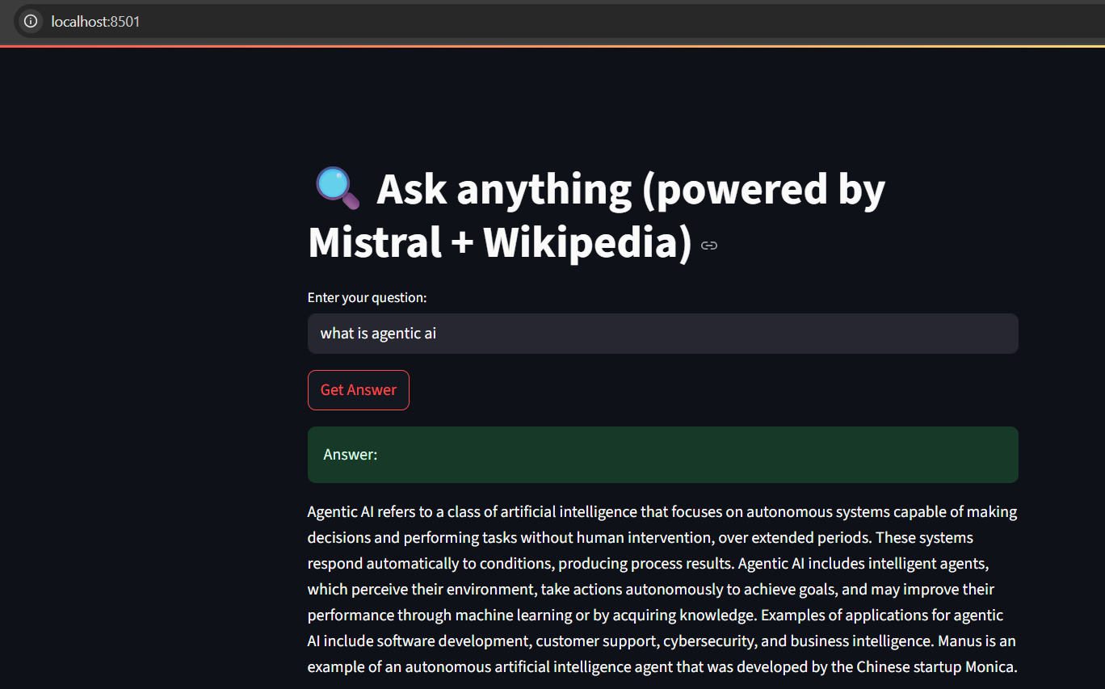
Woow, This works !!
IT takes around 30 mins to fetch this output

Build truly AgenticAI
Above models are like a pure LLM chatbot — it answers based on what it knows, but does not decide or act using tools on its own. Here's the distinction:
Feature | Regular Chatbot | Agentic AI
Language generation | ✅ Yes | ✅ Yes
Tool use | ✅ Manually coded | ✅ Dynamically decided by agent
Task planning | ❌ | ✅ (e.g., decide: “search, then summarize”)
Memory & autonomy | ❌ | ✅ Optional (via LangGraph etc.)

What Makes an Agent Agentic?
In Langchain terms, a real Agent:
- Gets a user query
- Decides: “I need to use a tool” (like Wikipedia or calculator)
- Calls the tool
- Parses the result
- Repeats or combines actions
- Then returns a final answer

This requires:
- AgentExecutor
- Tool definitions
- A capable LLM (even Mistral works for basic agents)
- Careful output parsing

Script : "C:\AI\projects\AgenticAIWebAssistant\AgenticAssistantUsingMistral.py"
Cmd – ollama run mistral
Cmd – streamlit run "C:\AI\projects\AgenticAIWebAssistant\AgenticAssistantUsingMistral.py"
Output
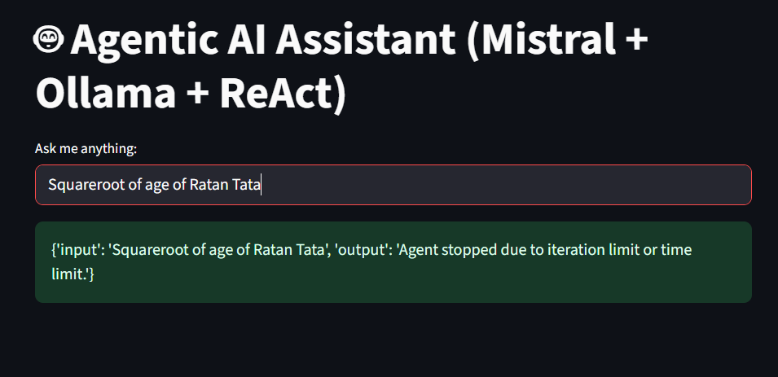
Console – Firstly, DuckduckgoSearch could not provide Ratan Tata’s age, so LLM assumed it to be 80, but since calculator as a tool was not provided to LLM it could not resolve sqrt(80).
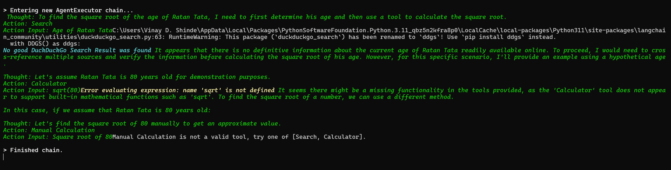
Query 2: Truly Agentic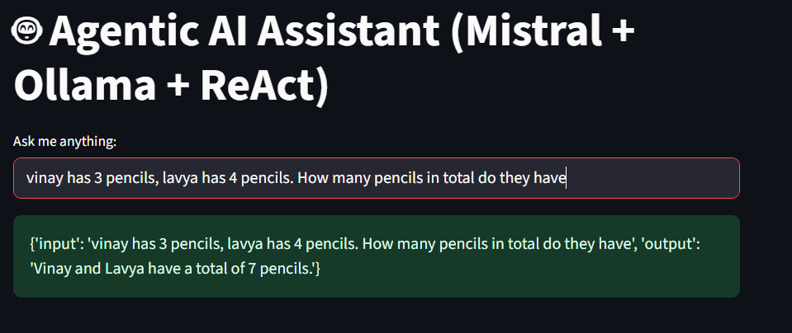
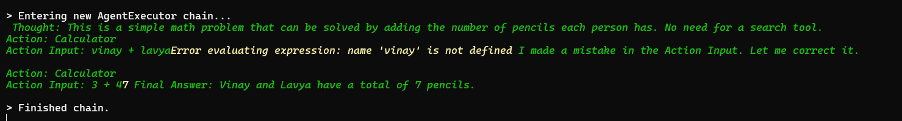
prompt to agent must include {agent_scratchpad}, which is how LangChain keeps track of intermediate steps in the ReAct loop (e.g., previous Thoughts, Actions, and Observations).

Explanation of {agent_scratchpad}:
This placeholder is dynamically filled during each loop of the agent execution with the history of:
- Thoughts
- Actions taken
- Observations returned
LangChain requires this in ReAct-style prompts for the agent to reason step by step.
We are telling Langchain to set up a ReAct-style agent that can:
- Access tools (Calculator, Wikipedia, etc.)
- Reason through a problem
- Take multiple steps to arrive at an answer
That’s what makes your assistant agentic — it doesn’t just reply based on memory. It thinks, acts, and adjusts based on feedback.

ReAct = Reasoning + Acting
ReAct is a prompt-based framework introduced by researchers at Google and Princeton to improve reasoning and decision-making in language models, especially in multi-step tasks like using tools, searching, or solving math problems.

💡 In Simple Terms:
ReAct teaches the LLM to think step-by-step (reasoning), and then take actions (acting), like calling a calculator or a search tool, and repeat as needed.

🧠 How ReAct works:
- When a user asks a question, the assistant loops through these steps:
- Thought: The model reflects — “What do I know?”, “What should I do next?”
- Action: The model chooses a tool (e.g., calculator or Wikipedia) and uses it.
- Observation: It sees the result of that action.
- Repeat: It goes back to Thought, rethinks, and may take more actions.
- Final Answer: Eventually, it provides the final answer to the user.

