1. Install and Start Prometheus
- Download the Windows amd64 zip file from the Prometheus official site.
https://github.com/prometheus/prometheus/releases/download/v3.15.0-rc.0/prometheus-3.15.0-rc.0.windows-amd64.zip
Extract the zip file and move the folder to C:\Prometheus
Double click on the C:\Prometheus\prometheus.exe
Open your browser and go to http://localhost:9090 after running prometheus.exe from the command line or setting it up as a Windows service.
Verify that metrics appear on the page
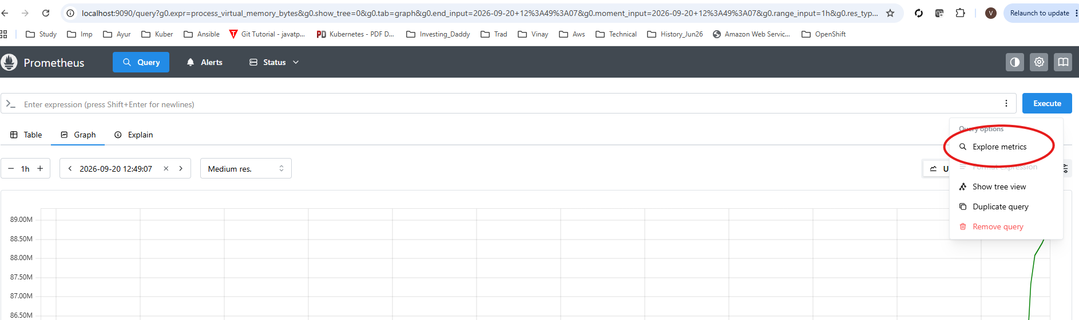

Now click on below link and download and Install below windows exporter.
https://github.com/prometheus-community/windows_exporter/releases/download/v0.31.8/windows_exporter-0.31.8-amd64.msi
Double click on installer (downloaded) file and follow below steps.
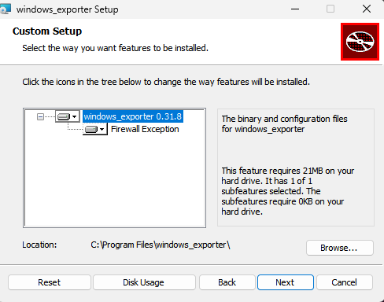

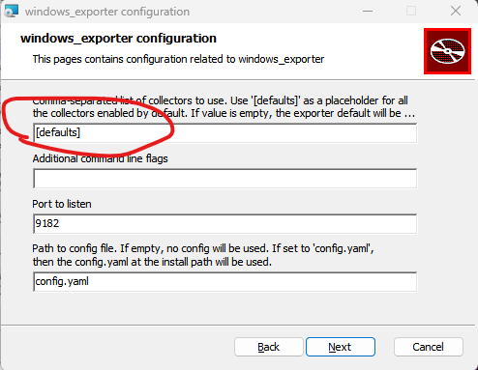
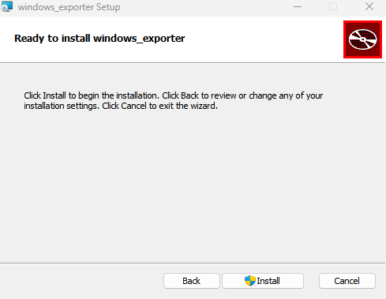
Click On Install.

http://localhost:9182/metrics
You will get all metrics as below.
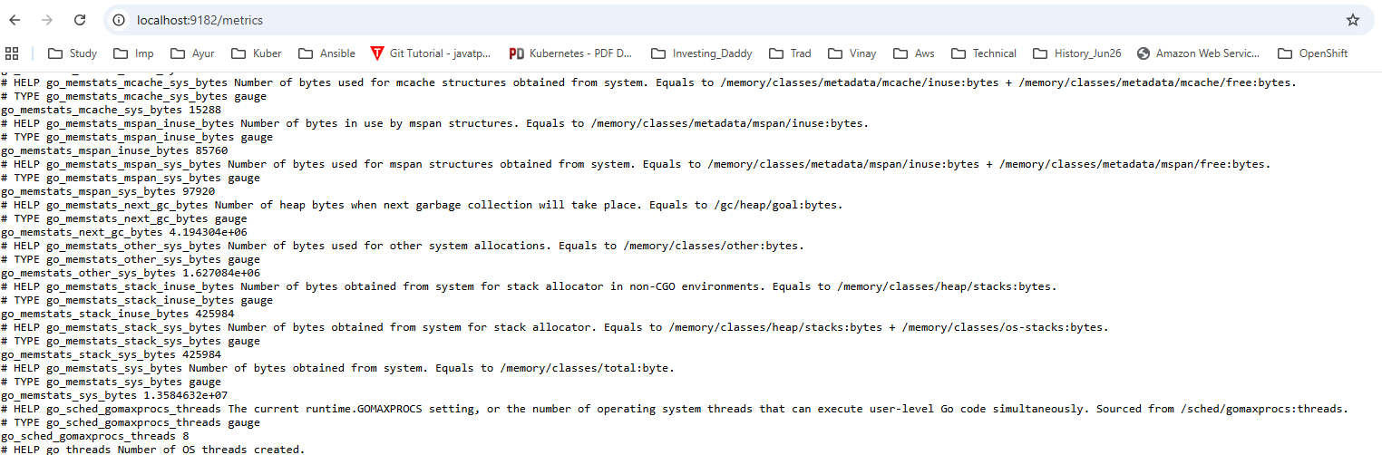

Now follow below steps.
2. Install and Start Grafana
Go to the Grafana Download Page and download the Windows installer (.msi)
Run the installer (double click on downloaded msi file) and complete the setup wizard using the default settings.
Open your browser and navigate to http://localhost:3000 (the default login is username - admin / password - admin). Once logged in grafana webpage will ask to set new password.

3. Connect Prometheus to Grafana
- In Grafana, click the menu icon, go to Data Sources, and click Add data source.
- Select Prometheus.
- Set the connection URL to http://localhost:9090 and click Save & test.
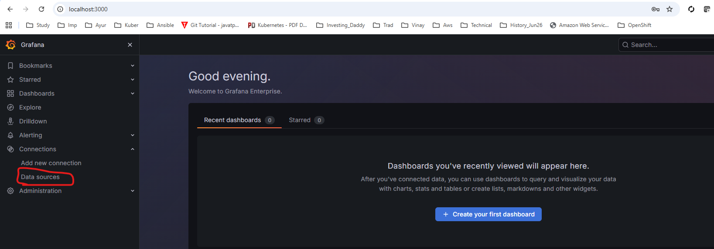

Click on data sources. And select Prometheus and set the connection as above.

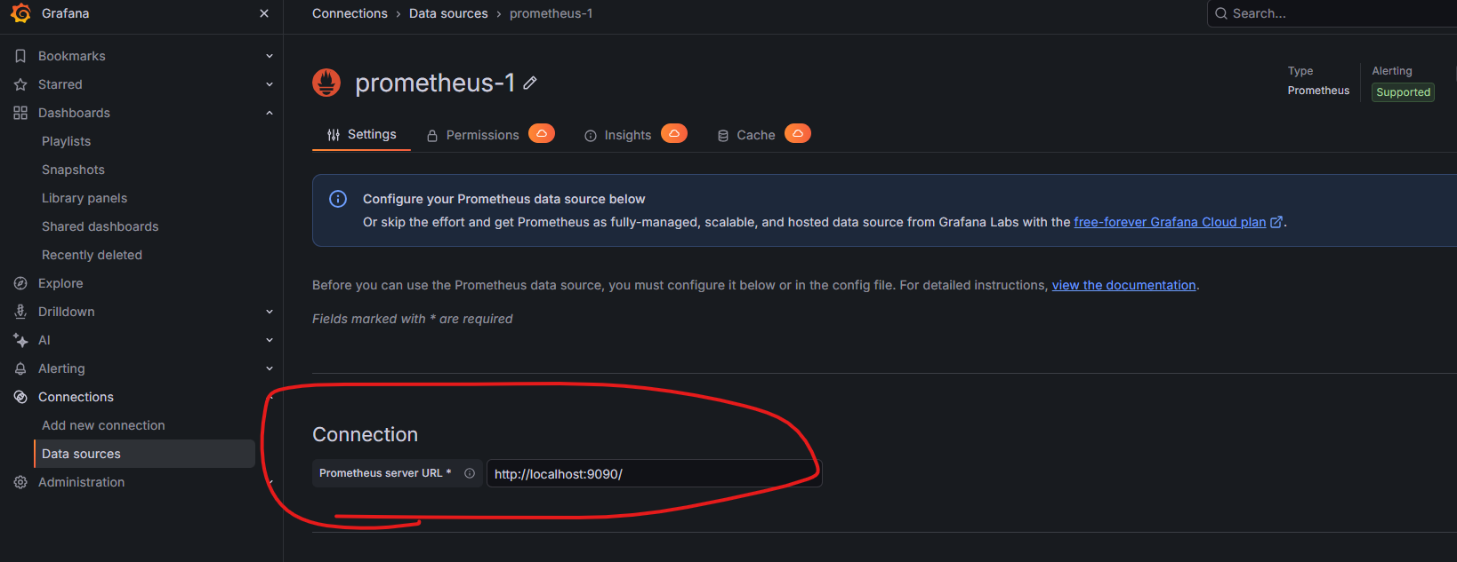
Enter prometheus url link.
And scroll down and click on Save and Test Icon.
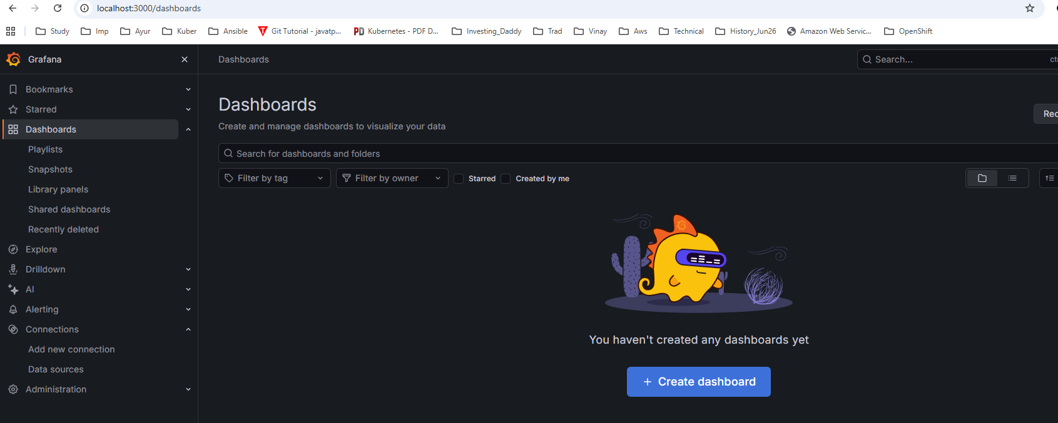
Now click on Dashboards and click on create dashboard.
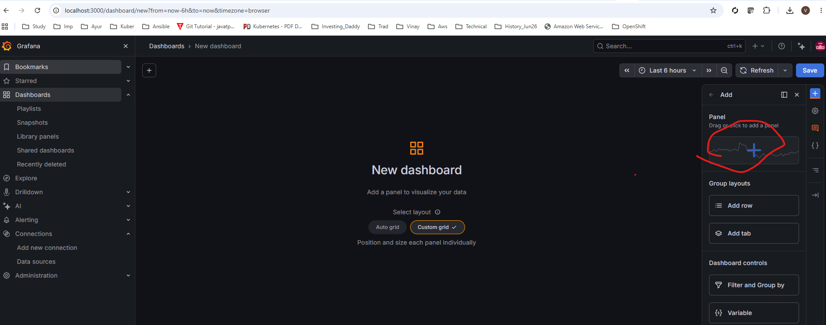
Now click on + sign on right hand side corner.
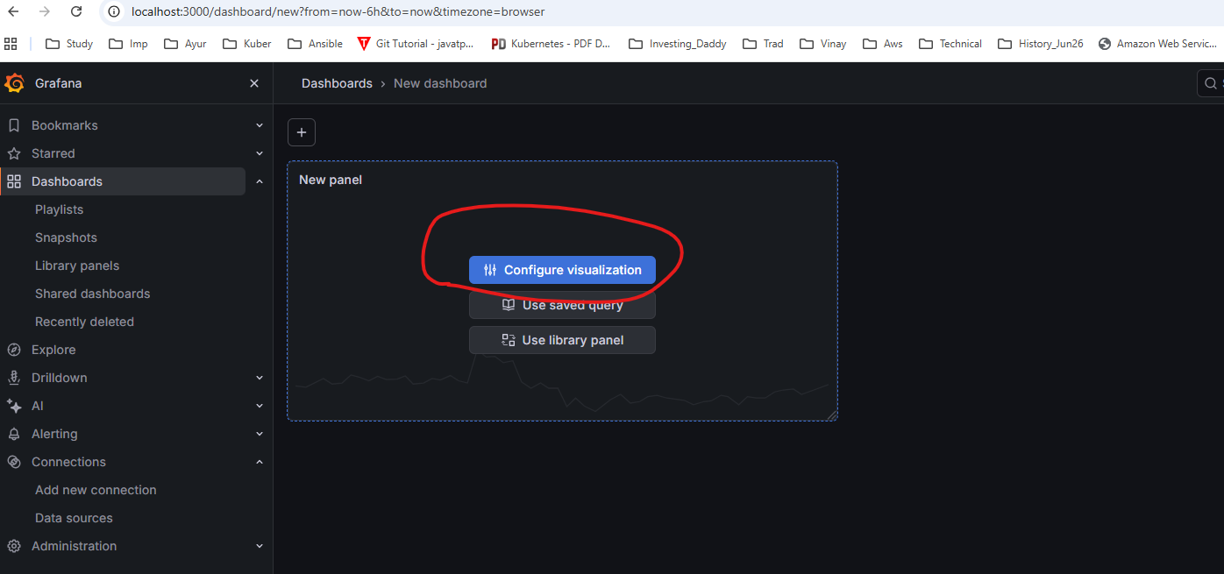
Now click on Configuration visualization.

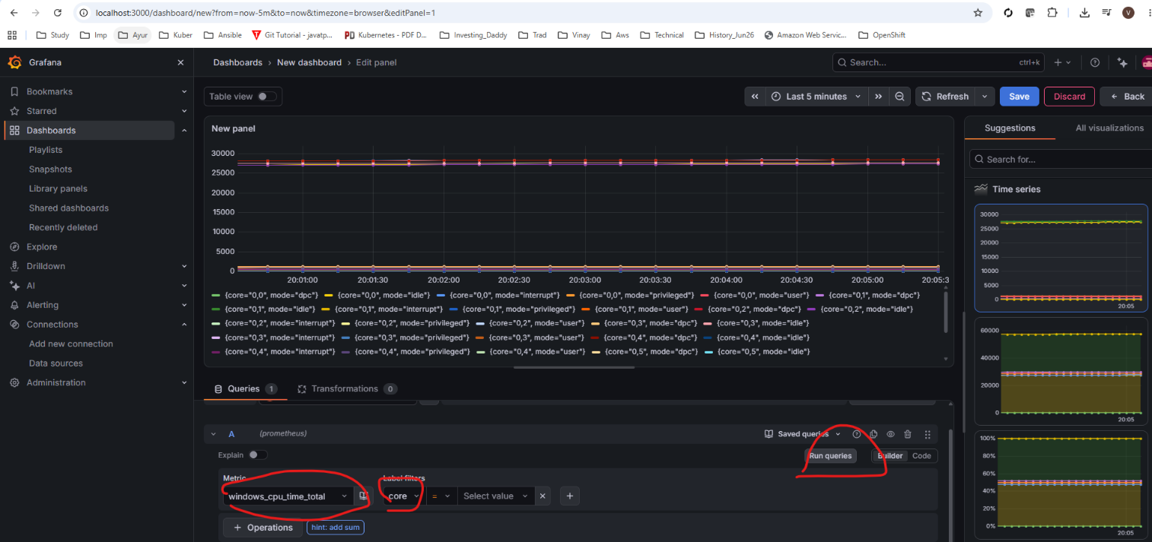
Slect the metric , core and run query.
Click on save on top right hand side corner and create a dashboard.

