Software Engineering-process framework
A Software Engineering Process Framework is a structured template that defines the phases, tasks, and activities of the software development life cycle (SDLC). It ensures consistency, quality, and efficiency by guiding teams through inception, elaboration, construction, and deployment, supported by umbrella activities like risk management and quality assurance.

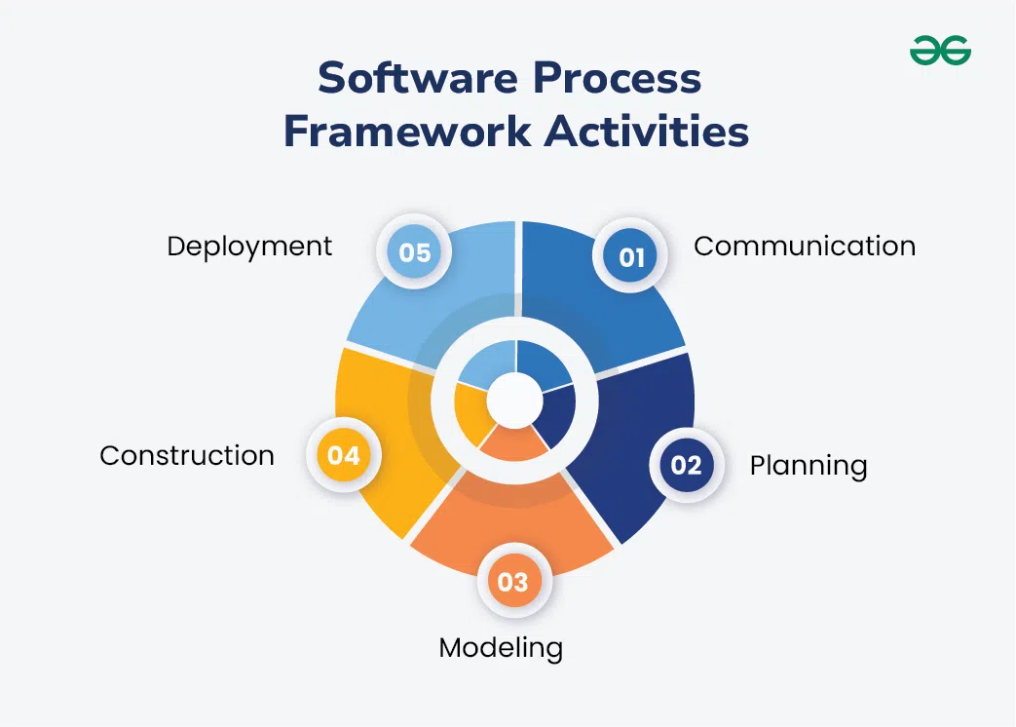

🔑 Core Framework Activities
- Inception → Define goals, scope, feasibility, and initial planning.
- Elaboration → Analyze requirements, design architecture, refine risks.
- Construction → Code, perform unit testing, and integrate components.
- Deployment → Release software, monitor performance, and provide support.
🛠️ Umbrella Activities
These run across all phases to ensure control and quality:
- Project tracking and control
- Risk management
- Quality assurance
- Configuration management
- Communication & training

📊 Popular Process Models Built on Framework
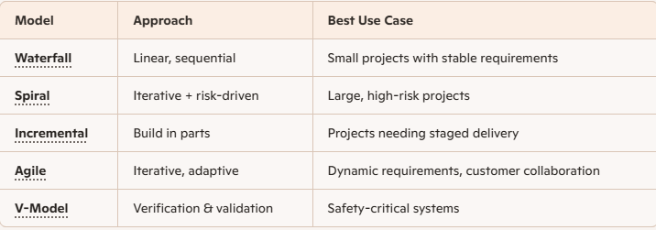

⚠️ Risks & Considerations
- Rigid models (Waterfall) → Fail if requirements change mid-project.
- Agile → Needs strong communication; chaos if poorly managed.
- Spiral → Powerful but resource-intensive.
- Framework choice must match project context (size, risk, domain).

The Software Development Life Cycle (SDLC) is a structured process that guides teams through planning, building, testing, deploying, and maintaining software. It ensures high-quality delivery, reduces risks, and aligns projects with business goals.
🔑 Phases of SDLC
- Planning
  - Define scope, goals, feasibility, cost, and schedule.
  - Deliverable: Project plan, feasibility report.
- Requirement Analysis
  - Gather functional and non-functional requirements.
  - Deliverable: Software Requirement Specification (SRS).
- Design
  - High-Level Design (architecture, tech stack).
  - Low-Level Design (APIs, workflows, data structures).
  - Deliverable: Design Document Specification (DDS).
- Development (Coding)
  - Write source code, perform unit testing, manage versions.
  - Deliverable: Executable application.
- Testing
  - Unit, integration, system, and user acceptance testing.
  - Deliverable: Test cases, defect reports, quality metrics.
- Deployment
  - Release software to production.
  - Modern approach: CI/CD pipelines for faster rollout.
  - Deliverable: Live application.
- Maintenance
  - Bug fixes, updates, performance tuning, feature enhancements.
  - Deliverable: Patches, new versions.

✅ Benefits of SDLC
- Improved risk management and cost estimation.
- Early defect detection, reducing overall cost.
- Clear documentation and transparency for stakeholders.
- Alignment with business goals and customer expectations.

🔑 Major SDLC Process Models
- Waterfall Model
  - Linear, sequential phases (requirements → design → coding → testing → deployment → maintenance).
  - Best for projects with stable requirements.
  - Pros: Simple, predictable timelines.
  - Cons: Rigid, poor fit for changing needs.
- Agile Model
  - Iterative and incremental, with short sprints (2–4 weeks).
  - Focus on customer collaboration and adaptability.
  - Pros: Flexible, fast feedback, continuous delivery.
  - Cons: Requires strong communication and discipline.
- Spiral Model
  - Combines iterative development with risk analysis at each cycle.
  - Best for large, high-risk projects.
  - Pros: Strong risk management.
  - Cons: Complex, resource-intensive.
- V-Model
  - Extension of Waterfall with verification and validation at each stage.
  - Best for safety-critical systems (e.g., medical, aerospace).
  - Pros: Strong testing discipline.
  - Cons: Rigid, costly if requirements change.
- Incremental Model
  - Software delivered in small functional increments.
  - Best for projects needing phased rollout.
  - Pros: Early delivery of working software.
  - Cons: Integration challenges if increments aren’t well-planned.

The LinearSequential Model (WaterFall Model)
The Linear Sequential Model in SDLC, also known as the Waterfall Model, is a traditional software development approach where each phase flows into the next in a strict order—requirements → design → implementation → testing → deployment → maintenance—with no overlap or backtracking. It is best suited for projects with stable, well-defined requirements.
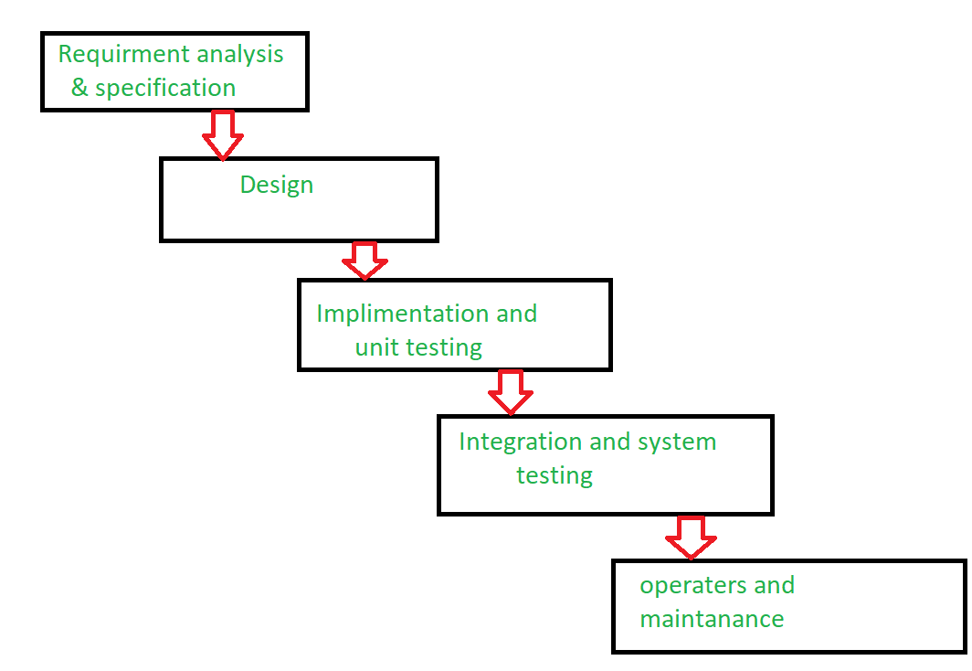

🔑 Key Characteristics
- Sequential flow: Each phase must be completed before the next begins.
- No overlap: Work does not proceed in parallel; strict discipline is required.
- Heavy documentation: Detailed specifications and design documents are essential.
- Formal change management: Changes are costly and difficult once requirements are locked.

📊 Phases of the Linear Sequential Model
- Requirements Analysis → Gather and document all functional/non-functional requirements (SRS).
- System Design → Create architecture diagrams, data models, and interface specifications.
- Implementation → Developers write code based on design documents.
- Testing → Verify functionality, integration, and performance against requirements.
- Deployment → Release the software to production.
- Maintenance → Apply patches, updates, and enhancements.

✅ Advantages
- Clear structure: Easy to understand and manage.
- Predictable timelines: Milestones are well-defined.
- Strong documentation: Useful for regulated industries.

⚠️ Disadvantages
- Rigid: Poor fit for projects with evolving requirements.
- Late testing: Defects discovered only after full implementation.
- Costly changes: Revisiting earlier phases is expensive.

🎯 Practical Use Cases
- Government projects with fixed scope.
- Banking systems requiring strict compliance.
- Infrastructure software where requirements rarely chang

The Prototyping Model
The Prototyping Model in SDLC is an iterative approach where developers build a simplified working version of the software early, gather user feedback, refine it repeatedly, and then evolve it into the final product. It is especially useful when requirements are unclear or user experience is critical.
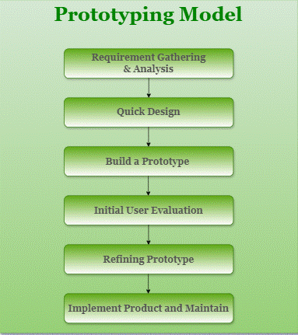

🔑 Key Phases of the Prototyping Model
- Requirements Gathering → Interview users, collect initial needs (not exhaustive).
- Quick Design → Sketch preliminary design (screens, workflows, data flow).
- Build Prototype → Create a low-fidelity working model with basic functionality.
- User Evaluation → Stakeholders interact with the prototype, identify gaps and issues.
- Refinement → Developers improve the prototype based on feedback.
- Final Development → Once approved, build the full production system.
📊 Types of Prototyping
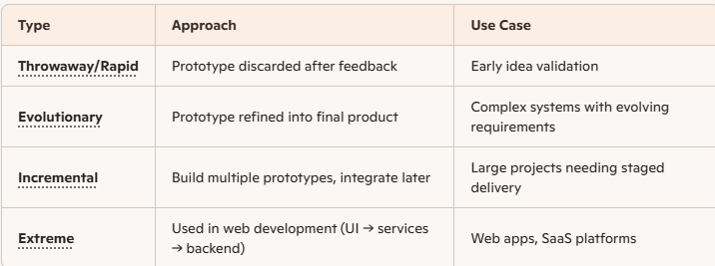

✅ Advantages
- Early user involvement → Reduces misunderstandings.
- Faster validation → Feedback loops shorten to weeks instead of months.
- Reduced rework → Catch usability issues early, saving 30–60% downstream effort.
- Better alignment → Stakeholders see tangible progress.
⚠️ Disadvantages
- Scope creep → Users may keep requesting changes.
- Resource intensive → Multiple iterations can be costly.
- Not ideal for regulated domains → Safety-critical projects (medical, aerospace) need strict documentation.
🎯 Best Use Cases
- User-centric applications → Dashboards, portals, consumer apps.
- Enterprise interfaces → Workflows where usability drives adoption.
- Innovation projects → When requirements are uncertain or exploratory.

The RAD Model
The Rapid Application Development (RAD) Model is an SDLC approach that emphasizes quick prototyping and iterative delivery over long planning cycles. It’s designed to speed up software development by involving users early and continuously, making it ideal for projects where requirements evolve rapidly.
🔑 Key Phases of the RAD Model
- Business Modeling
  - Understand business processes and information flow.
  - Define what data drives the business and how it’s used.
- Data Modeling
  - Identify and structure data objects.
  - Define relationships between them.
- Process Modeling
  - Map out how data flows through the system.
  - Define transformations and business logic.
- Application Generation
  - Use automated tools (CASE tools, code generators) to quickly build prototypes.
  - Iteratively refine based on user feedback.
- Testing & Turnover
  - Continuous testing of prototypes.
  - Finalize system after multiple refinements.
📊 Advantages
- Fast delivery → Shortens development cycle.
- User involvement → Ensures product meets expectations.
- Flexibility → Adapts to changing requirements.
- Reduced risk → Issues caught early in prototypes.
⚠️ Disadvantages
- Resource intensive → Needs skilled developers and powerful tools.
- Not ideal for large, complex systems → Works best for modular applications.
- Dependency on user availability → Continuous feedback is critical.
🎯 Best Use Cases
- UI/UX-heavy applications → Dashboards, portals, consumer apps.
- Time-sensitive projects → When speed is more important than perfection.
- Proof-of-concept systems → Early validation of ideas before full investment.

Evolutionary Process Models
Evolutionary Process Models in SDLC combine iterative and incremental approaches, allowing software to evolve through multiple cycles of development and user feedback. They reduce risk, improve quality, and ensure closer alignment with user needs compared to rigid models like Waterfall.
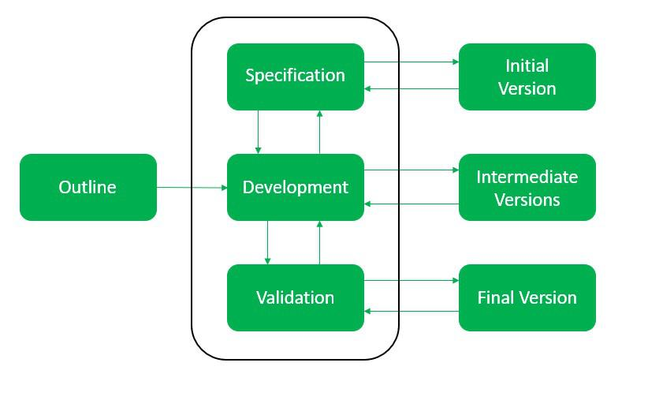
🔑 Core Idea
- Build an initial version of the product.
- Refine it through multiple iterations with continuous feedback.
- Final product emerges after successive improvements.
- Emphasis on customer involvement and error reduction.

📊 Types of Evolutionary Process Models
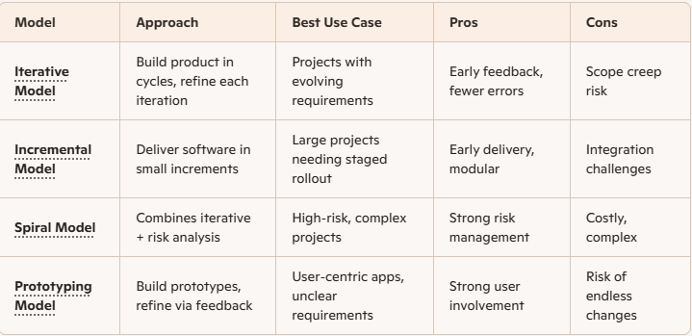
✅ Advantages
- Customer involvement ensures product matches expectations.
- Reduced errors due to multiple iterations.
- Flexibility to adapt to changing requirements.
- Improved reliability and efficiency compared to linear models.
⚠️ Disadvantages
- Resource intensive → Requires skilled teams and time.
- Scope creep → Frequent changes can delay delivery.
- Complex management → Multiple iterations need strong coordination.
🎯 Best Use Cases
- Large projects with uncertain requirements.
- Risk-heavy systems where failure costs are high.
- User-centric applications needing continuous feedback.

Agile Process Model
The Agile Process Model is an SDLC approach that emphasizes iterative development, customer collaboration, and adaptability. Instead of delivering software in one big release (like Waterfall), Agile delivers it in small, functional increments (sprints), allowing continuous feedback and improvement.
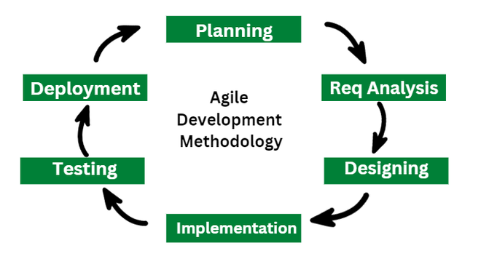
🔑 Core Principles of Agile
- Iterative development → Build software in short cycles (2–4 weeks).
- Customer collaboration → Users are involved throughout the process.
- Flexibility → Requirements can evolve during development.
- Working software → Deliver usable features early and often.
- Team empowerment → Self-organizing teams make decisions quickly.
📊 Agile Process Flow
- Requirement Gathering → Collect high-level user stories.
- Planning → Break down work into sprints.
- Design & Development → Build features iteratively.
- Testing → Continuous integration and testing during each sprint.
- Review → Sprint review with stakeholders.
- Deployment → Release working increments.
- Feedback & Retrospective → Adjust process and product for next sprint.
✅ Advantages
- Faster delivery of usable software.
- Strong alignment with customer needs.
- Early detection of issues.
- High adaptability to change.
⚠️ Disadvantages
- Requires continuous user involvement.
- Can lead to scope creep if not managed.
- Needs disciplined, skilled teams.
- Documentation may be lighter than traditional models.
🎯 Best Use Cases
- Dynamic projects → Startups, SaaS, evolving requirements.
- Customer-centric apps → Portals, dashboards, mobile apps.
- Enterprise IT → Cloud migrations, DevOps pipelines.

Component-Based Development
Component-Based Development (CBD) is a software engineering approach where systems are built by assembling pre-existing, reusable components rather than coding everything from scratch. It emphasizes modularity, reusability, and faster delivery.
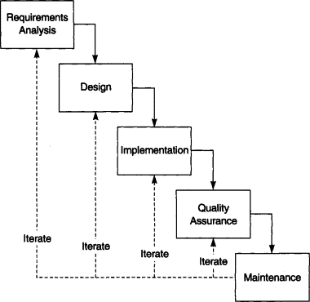
🔑 Core Principles
- Modularity → Break software into independent, self-contained components.
- Reusability → Components can be reused across multiple projects.
- Encapsulation → Each component hides its internal logic, exposing only interfaces.
- Interoperability → Components must work together seamlessly.
- Maintainability → Easier updates since changes are localized to components.
📊 CBD Process Model Phases
- Requirement Analysis → Identify system needs and map them to reusable components.
- Design → Define architecture, component interfaces, and integration strategy.
- Component Search & Evaluation → Look for existing components in repositories or libraries.
- Adaptation & Integration → Customize components and integrate them into the system.
- Testing → Verify both individual components and system integration.
- Deployment & Maintenance → Release system, update components as needed.
✅ Advantages
- Faster development cycles.
- Reduced cost by reusing existing modules.
- Higher reliability (well-tested components).
- Easier maintenance and scalability.
⚠️ Disadvantages
- Dependency on availability of suitable components.
- Integration challenges if components are incompatible.
- Customization may be limited.
- Requires strong governance of component repositories.
🎯 Best Use Cases
- Enterprise applications → ERP, CRM systems.
- Web development → Modular UI frameworks (React, Angular).
- Cloud services → Microservices and containerized applications.
- Embedded systems → Reusable hardware/software modules.

Need of Agile software development
The need for Agile software development arises from the limitations of traditional models like Waterfall, which are rigid and slow to adapt to change. Agile was designed to handle dynamic requirements, deliver value faster, and involve customers throughout the process.
🔑 Why Agile is Needed
- Changing requirements → In modern projects, requirements evolve quickly; Agile accommodates this.
- Faster delivery → Working software is delivered in short sprints (2–4 weeks).
- Customer involvement → Continuous feedback ensures the product meets real needs.
- Risk reduction → Early testing and iterations catch issues sooner.
- Team collaboration → Self-organizing teams improve productivity and morale.
- Flexibility → Agile adapts to scope changes without derailing the project.

📊 Benefits of Agile vs Traditional Models
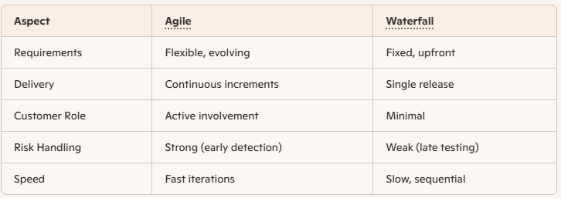

🎯 Situations Where Agile is Essential
- Startups → Rapid pivots and evolving business models.
- Enterprise IT → Cloud migrations, DevOps pipelines, digital transformation.
- Customer-centric apps → Portals, dashboards, mobile apps needing usability feedback.
- Innovation projects → When requirements are uncertain or exploratory.
⚠️ Without Agile
- Projects risk delays due to rigid planning.
- Customer dissatisfaction if delivered product doesn’t match evolving needs.
- Higher costs from late defect detection.
- Team frustration due to lack of flexibility.

Agile Manifesto and Principles
The Agile Manifesto (2001) defines the foundation of Agile software development, built on four core values and twelve guiding principles. It emphasizes collaboration, adaptability, and delivering working software quickly to meet customer needs.
🔑 The Four Core Values of the Agile Manifesto
- Individuals and interactions over processes and tools
- Working software over comprehensive documentation
- Customer collaboration over contract negotiation
- Responding to change over following a plan
📊 The 12 Principles of Agile
- Customer satisfaction through early and continuous delivery.
- Welcome changing requirements, even late in development.
- Deliver working software frequently (weeks rather than months).
- Business and developers collaborate daily.
- Build projects around motivated individuals, trust them to deliver.
- Face-to-face communication is the most effective.
- Working software is the primary measure of progress.
- Sustainable development with consistent pace.
- Continuous attention to technical excellence and good design.
- Simplicity—maximize work not done.
- Self-organizing teams produce the best results.
- Regular reflection to improve effectiveness
✅ Why These Values & Principles Matter
- Flexibility → Agile thrives in environments where requirements change rapidly.
- Customer focus → Ensures the product solves real problems.
- Speed → Frequent delivery reduces time-to-market.
- Quality → Continuous testing and technical excellence improve reliability.
- Team empowerment → Motivated, self-organizing teams innovate faster.

Stakeholders and Challenges
Stakeholders in Software Development are individuals or groups who have an interest in the success, outcome, or impact of a project. Each stakeholder brings unique expectations, and managing them effectively is critical to project success.
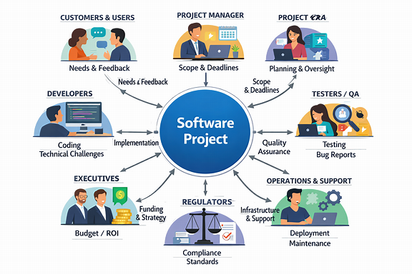
🔑 Key Stakeholders
- Customers → End-users who will use the product.
- Project Managers → Responsible for planning, execution, and delivery.
- Developers → Build and maintain the software.
- Testers/QA → Ensure product quality and reliability.
- Business Analysts → Translate business needs into technical requirements.
- Investors/Executives → Provide funding and strategic direction.
- Operations/Support Teams → Handle deployment, monitoring, and customer support.
- Regulators → Ensure compliance with laws and standards.

⚠️ Challenges in Managing Stakeholders
- Conflicting interests → Different stakeholders may have opposing priorities.
- Changing requirements → Customers often refine needs mid-project.
- Communication gaps → Misunderstandings between technical and non-technical teams.
- Resource constraints → Limited time, budget, or skilled workforce.
- Resistance to change → Stakeholders may prefer old systems or processes.
- Quality vs speed → Pressure to deliver quickly can compromise quality.
- Compliance issues → Regulatory bodies may impose strict standards.
📊 Stakeholder vs Challenge Matrix
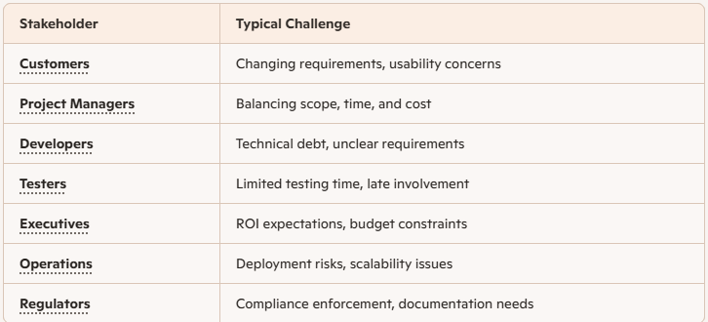

🎯 Best Practices to Handle Challenges
- Early stakeholder engagement → Involve all parties from the start.
- Clear communication → Use simple language, regular updates, and visual aids.
- Agile practices → Iterative delivery helps manage changing requirements.
- Prioritization frameworks → Balance conflicting interests using MoSCoW or Kano models.
- Risk management → Identify and mitigate risks early.

Historyof Agile Software Development
Agile software development emerged as a response to the failures of rigid, document-heavy methods like Waterfall. It was formally defined in 2001 with the Agile Manifesto, but its roots go back decades to iterative practices in NASA, IBM, Toyota, and early methodologies like RAD and Spiral. Today, Agile has evolved into enterprise-level frameworks, scaling adaptability across organizations.
📜 Early Roots (1950s–1990s)
- 1950s–1960s → IBM and NASA used incremental and iterative development (e.g., Project Mercury software built in half-day iterations).
- 1980s → Barry Boehm introduced the Spiral Model, combining iterative cycles with risk management.
- Toyota Production System → Lean principles like eliminating waste and empowering workers influenced Agile thinking.
- 1990s → James Martin’s Rapid Application Development (RAD) emphasized short cycles and customer involvement.
🏔️ The Agile Manifesto (2001)
- In February 2001, 17 software practitioners met at Snowbird, Utah.
- They published the Agile Manifesto with 4 values and 12 principles:
  - Individuals & interactions over processes & tools.
  - Working software over documentation.
  - Customer collaboration over contract negotiation.
  - Responding to change over following a plan.
- This became the foundation of Agile methodologies like Scrum, XP, Crystal, and DSDM.

Traditional Model vs Agile Model
📊 Traditional Model (Waterfall)
- Sequential process → Each phase (requirements → design → implementation → testing → deployment) must be completed before moving to the next.
- Rigid structure → Changes are difficult once development starts.
- Documentation heavy → Detailed upfront requirements and design documents.
- Customer involvement → Minimal, usually only at the beginning and end.
- Delivery → Final product delivered at the end of the cycle.
🌀 Agile Model
- Iterative development → Work is divided into short sprints (2–4 weeks).
- Flexibility → Requirements can evolve during development.
- Customer collaboration → Continuous involvement and feedback.
- Working software → Delivered frequently in increments.
- Team empowerment → Self-organizing teams adapt quickly.
🎯 Key Takeaway
- Traditional Model works best when requirements are fixed and well-understood (e.g., government contracts, regulated industries).
- Agile Model is ideal for projects with evolving requirements, customer-centric apps, and innovation projects.

Classification of Agile Methods
Agile methods are classified into several frameworks and approaches, each emphasizing iterative delivery, customer collaboration, and adaptability. While they share the Agile Manifesto’s values and principles, they differ in structure, practices, and focus.
📊 Classification of Agile Methods
1. Scrum
- Framework based on sprints (2–4 weeks).
- Roles: Product Owner, Scrum Master, Development Team.
- Artifacts: Product Backlog, Sprint Backlog, Increment.
- Events: Daily Scrum, Sprint Review, Retrospective.
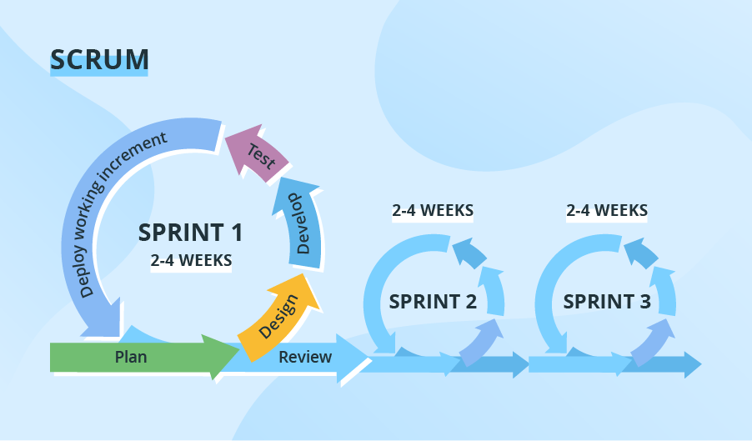
2. Extreme Programming (XP)
- Focuses on engineering practices.
- Practices: Pair programming, Test-Driven Development (TDD), Continuous Integration.
- Strong emphasis on code quality and customer involvement.
3. Dynamic Systems Development Method (DSDM)
- Originated in the UK.
- Emphasizes timeboxing, prototyping, and active user involvement.
- Often used in enterprise projects with strict deadlines.
4. Crystal Method
- Family of methods (Crystal Clear, Crystal Orange, etc.).
- Tailored based on team size and project criticality.
- Focuses on simplicity, communication, and frequent delivery.
5. Feature-Driven Development (FDD)
- Model-driven, short iterations.
- Builds software by designing and developing features.
- Best for large projects requiring structured planning.
6. Lean Software Development
- Inspired by Toyota Production System.
- Principles: Eliminate waste, amplify learning, deliver fast.
- Strong focus on efficiency and value delivery.
7. Kanban
- Visual workflow management using boards.
- Continuous delivery, no fixed iterations.
- Focus on limiting Work in Progress (WIP) and improving flow.
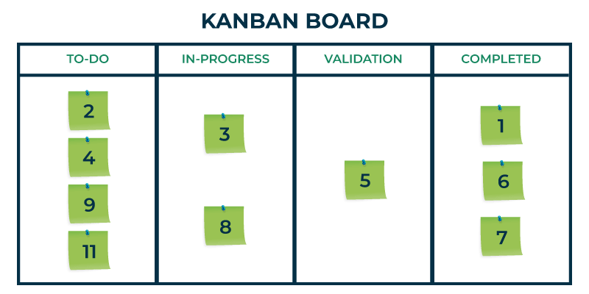

Agile Teams
Agile Teams are the backbone of Agile software development. They are designed to be cross-functional, self-organizing, and collaborative, ensuring rapid delivery of working software and continuous improvement.
🔑 Characteristics of Agile Teams
- Cross-functional → Include developers, testers, designers, and business analysts.
- Self-organizing → Teams decide how best to accomplish work without heavy management.
- Collaborative → Daily communication, pair programming, and shared responsibility.
- Customer-focused → Work closely with Product Owners and stakeholders.
- Adaptable → Adjust quickly to changing requirements.
🧩 Roles in Agile Teams
- Product Owner → Defines vision, prioritizes backlog, represents customer.
- Scrum Master → Facilitates process, removes impediments, coaches team.
- Development Team → Builds, tests, and delivers increments of working software.
- Stakeholders → Provide feedback, validate outcomes, and align business goals.
📊 Agile Team Practices
- Daily Stand-ups → Short meetings to track progress and blockers.
- Sprint Planning → Define goals and tasks for each iteration.
- Retrospectives → Reflect on what worked and what can improve.
- Pair Programming → Two developers collaborate on the same code.
- Continuous Integration → Frequent code merges and automated testing.
✅ Benefits of Agile Teams
- Faster delivery of usable features.
- Higher quality through continuous testing.
- Stronger alignment with customer needs.
- Increased team morale and ownership.
- Better adaptability to change.
⚠️ Challenges Agile Teams Face
- Distributed teams → Communication gaps across geographies.
- Scaling Agile → Coordinating multiple teams in large enterprises.
- Role confusion → Overlap between Scrum Master and Project Manager.
- Resistance to change → Traditional organizations may struggle with Agile culture.

Team Meetings and Ceremonies
Agile Team Meetings and Ceremonies are structured events designed to keep teams aligned, ensure transparency, and drive continuous improvement. They are central to frameworks like Scrum, but also widely used across other Agile practices.
🌀 Core Agile Ceremonies
- Sprint Planning
  - Held at the start of each sprint.
  - Team and Product Owner decide what backlog items will be delivered.
  - Defines sprint goals and tasks.
- Daily Stand-up (Daily Scrum)
  - Short (15-minute) meeting every day.
  - Each member shares: What I did yesterday, what I’ll do today, blockers.
  - Keeps the team synchronized.
- Sprint Review
  - Held at the end of the sprint.
  - Team demonstrates completed work to stakeholders.
  - Feedback is gathered for future iterations.
- Sprint Retrospective
  - Immediately after the sprint review.
  - Team reflects on what went well, what didn’t, and how to improve.
  - Drives continuous improvement.
📊 Supporting Agile Meetings
- Backlog Refinement
  - Ongoing meeting to clarify, estimate, and prioritize backlog items.
  - Ensures the backlog is ready for sprint planning.
- Release Planning
  - Higher-level planning across multiple sprints.
  - Aligns product roadmap with business goals.
- Cross-team Syncs
  - Used in scaled Agile frameworks (SAFe, LeSS).
  - Coordinates dependencies across multiple teams.
✅ Benefits of Agile Ceremonies
- Transparency across the team and stakeholders.
- Early detection of risks and blockers.
- Continuous feedback loop.
- Stronger collaboration and accountability.
- Improved adaptability to change.
Agile Drivers
Agile Drivers are the key forces and motivations that led to the rise and adoption of Agile software development. They explain why organizations shifted from traditional, rigid models to Agile practices.
🚀 Main Drivers of Agile
- Changing requirements Projects often face evolving customer needs; Agile embraces change rather than resisting it.
- Customer satisfaction Delivering working software early and frequently ensures customers see value sooner.
- Faster time-to-market Agile shortens delivery cycles, helping businesses stay competitive.
- Collaboration & communication Agile emphasizes teamwork, daily stand-ups, and stakeholder involvement.
- Risk reduction Iterative delivery and early testing catch issues before they escalate.
- Quality improvement Practices like continuous integration, test-driven development, and retrospectives enhance product quality.
- Employee empowerment Self-organizing teams take ownership, boosting morale and innovation.
Capabilities and Values.
Capabilities and Values in Agile are the foundation of why Agile works — they define both the skills teams need and the principles they uphold.
⚙️ Capabilities of Agile Teams
- Iterative delivery → Ability to release working software in short cycles.
- Adaptability → Respond quickly to changing requirements.
- Collaboration → Seamless teamwork across roles and functions.
- Technical excellence → Practices like TDD, CI/CD, and refactoring.
- Transparency → Clear visibility of progress, blockers, and priorities.
- Customer focus → Continuous feedback ensures relevance and value.
- Self-organization → Teams manage their own work without heavy oversight.
🌟 Values of Agile (from the Agile Manifesto)
- Individuals and interactions over processes and tools.
- Working software over comprehensive documentation.
- Customer collaboration over contract negotiation.
- Responding to change over following a plan.
🎯 Key Takeaway
- Capabilities are the practical skills Agile teams develop to deliver effectively.
- Values are the guiding principles that shape team culture and decision-making. Together, they ensure Agile is not just a methodology, but a mindset and practice that drives innovation and customer satisfaction.

Agile Processes
Agile Development Models:
Scrum: is one of the most widely used Agile development models, designed to help teams deliver complex projects through short, iterative cycles called sprints. It emphasizes collaboration, transparency, and adaptability.
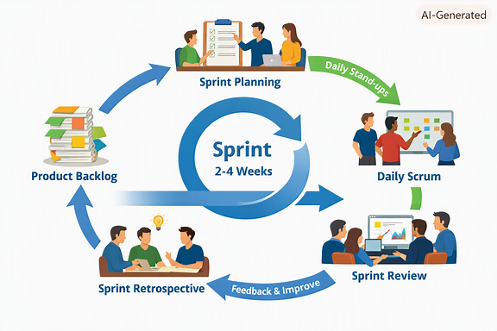
it visually maps out the flow from Product Backlog → Sprint Planning → Daily Scrum → Sprint Review → Sprint Retrospective, looping back into the next sprint.

🌀 Core Elements of Scrum
- Roles
  - Product Owner → Defines vision, manages backlog, prioritizes features.
  - Scrum Master → Facilitates process, removes impediments, coaches the team.
  - Development Team → Cross-functional group that builds and delivers increments.
- Artifacts
  - Product Backlog → Ordered list of features, fixes, and tasks.
  - Sprint Backlog → Selected items for the current sprint.
  - Increment → Working software delivered at the end of each sprint.
- Events
  - Sprint Planning → Decide what to deliver in the sprint.
  - Daily Scrum (Stand-up) → 15-minute sync on progress and blockers.
  - Sprint Review → Demonstrate completed work to stakeholders.
  - Sprint Retrospective → Reflect and improve team practices.
📊 Scrum Workflow
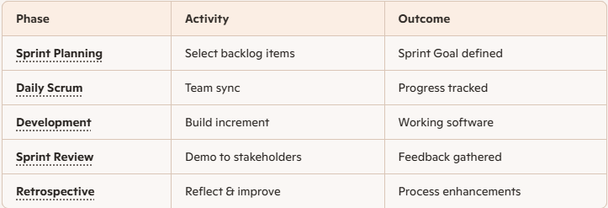

Extreme Programming: is an Agile software development model that focuses on engineering excellence, customer satisfaction, and adaptability. It’s ideal for projects with rapidly changing requirements and emphasizes high-quality code through disciplined technical practices.
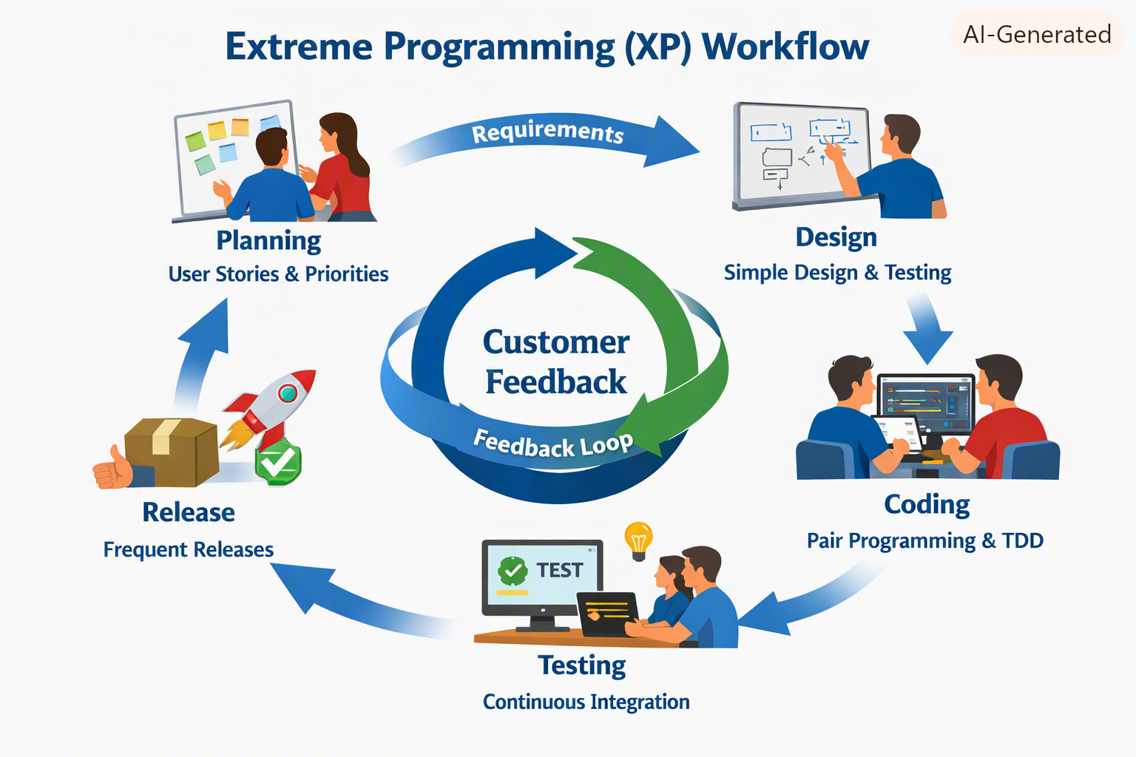
Extreme Programming (XP) workflow diagram — it visually captures the continuous loop of Planning → Design → Coding → Testing → Release, all centered around Customer Feedback.
⚙️ Core Principles of XP
- Communication → Frequent collaboration between developers and customers.
- Simplicity → Build only what’s needed; avoid over-engineering.
- Feedback → Continuous testing and customer input guide improvements.
- Courage → Encourage refactoring and honest communication.
- Respect → Foster trust and teamwork across all roles.
🔧 Key Practices in XP
- Pair Programming → Two developers work together at one workstation to improve code quality.
- Test-Driven Development (TDD) → Write tests before writing code to ensure correctness.
- Continuous Integration → Integrate and test code frequently to catch issues early.
- Refactoring → Regularly improve code structure without changing behavior.
- Small Releases → Deliver working software frequently for quick feedback.
- Collective Code Ownership → Any developer can improve any part of the codebase.
- Sustainable Pace → Avoid burnout by maintaining consistent, manageable workloads.
📊 XP Workflow Overview
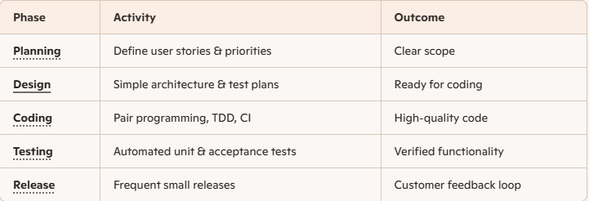

Extreme Programming pushes Agile principles to the technical extreme — prioritizing code quality, collaboration, and continuous feedback. It’s best suited for environments where requirements evolve quickly and reliability is critical.

Feature Driven Development: is an agile iterative and incremental model that focuses on progressing the features of the developing software. The main motive of feature-driven development is to provide timely updated and working software to the client. In FDD, reporting and progress tracking is necessary at all levels. In this article we will see Feature-Driven Development in detail.
History of FDD
FDD was first applied in the year 1997 on a real-world application by Jeff De Luca for large software development with specific needs of 15-month and 50 persons and published as a discussion in book Java Modeling in Color with UML in the year 1999.
FDD Lifecycle
- Build overall model
- Build feature list
- Plan by feature
- Design by feature
- Build by feature
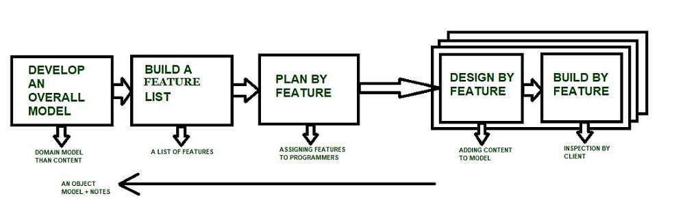
Characteristics of FDD
- Short iterative: FDD lifecycle works in simple and short iterations to efficiently finish the work on time and gives good pace for large projects.
- Customer focused: This agile practice is totally based on inspection of each feature by client and then pushed to main build code.
- Structured and feature focused: Initial activities in lifecycle builds the domain model and features list in the beginning of timeline and more than 70% of efforts are given to last 2 activities.
- Frequent releases: Feature-driven development provides continuous releases of features in the software and retaining continuous success of the project.
Advantages of FDD
- Reporting at all levels leads to easier progress tracking.
- FDD provides continuous success for larger size of teams and projects.
- Reduction in risks is observed as whole model and design is build in smaller segments.
- FDD provides greater accuracy in cost estimation of the project due to feature segmentation.
Disadvantages of FDD
- This agile practice is not good for smaller projects.
- There is high dependency on lead programmers, designers and mentors.
- There is lack of documentation which can create an issue afterwards.
Conclusion
So FDD or Feature-Driven Development is an agile iterative and incremental model which mainly focuses on progressing the features of the developing software.

Crystal: methods are flexible approaches used in Agile software development to manage projects effectively. They adapt to the needs of the team and the project, promoting collaboration, communication, and adaptability for successful outcomes.
The crystal method is an agile framework that is considered a lightweight or agile methodology that focuses on individuals and their interactions. The methods are color-coded to significant risk to human life. It is mainly for short-term projects by a team of developers working out of a single workspace. Among a few Agile Software Development Life Cycle (SDLC) models crystal is considered as one of the Agile SDLC models.
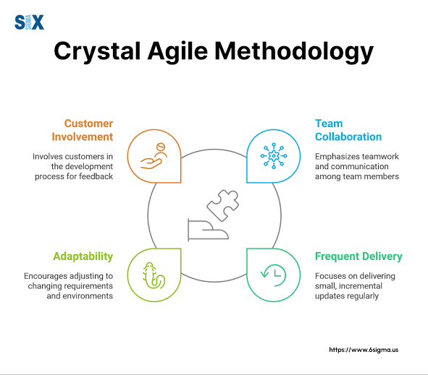
Two core beliefs of the Crystal method:
- Find your own way and methods to optimize workflow.
- Make use of unique methods to make the project unique and dynamic.

History of the Crystal Method
The crystal method was developed by an American scientist named Alistair Cockburn who worked at IBM. He decided not to focus on step-by-step developmental strategies, but to develop team collaboration and communication.
Properties of Crystal Agile Framework
- Frequent Delivery: It allows you regularly deliver the products and test code to real users. Without this, you might build a product that nobody needs.
- Reflective Improvement: No matter how good you have done or how bad you have done. Since there are always areas where the product can be improved, so the teams can implement to improve their future practices.
- Osmotic Communication: Alistair stated that having the teams in the same physical phase is very much important as it allows information to flow in between members of a team as in osmosis.
- Personal Safety: There are no bad suggestions in a crystal team, team members should feel safe to discuss ideas openly without any fear.
- Focus: Each member of the team knows exactly what to do, which enables them to focus their attention. This boosts team interaction and works towards the same goal.
- Easy access to expert users: It enhances team communication with users and gets regular feedback from real users.
- Technical tooling: It contains very specific technical tools which to be used by the software development team during testing, management, and configuration. These tools make it enable the team to identify any error within less time.
- Continuous learning: The framework emphasizes on continuous learning, enabling team members to acquire new skills and knowledge, and apply them in their work.
- Teamwork: The framework stresses on the importance of teamwork, promoting collaboration, and mutual support among team members.
- Timeboxing: The framework adopts timeboxing to manage project deadlines, ensuring that the team delivers within set timelines.
- Incremental development: The framework promotes incremental development, enabling the team to deliver working software frequently, and adapt to changes as they arise.
- Automated testing: The framework emphasizes on automated testing, enabling the team to detect and fix bugs early, reducing the cost of fixing errors at later stages.
- Customer involvement: The framework emphasizes on involving customers in the development process, promoting customer satisfaction, and delivering products that meet their needs.
- Leadership: The framework encourages leadership, enabling team members to take ownership of their work and make decisions that contribute to the success of the project.
How does Crystal Methodology Operates?
Till now, we got to know that crystal is a family of various developmental approaches, and it is not a group of prescribed developmental tools and methods. In the beginning, the approach is set by considering the business requirements and the needs of the project. Various methodologies in the Crystal family also known as weights of the Crystal approach are represented by different colors of the spectrum.
Crystal family consists of many variants like Crystal Clear, Crystal Yellow, Crystal Red, Crystal Sapphire, Crystal Red, Crystal Orange Web, and Crystal Diamond.
- Crystal Clear- The team consists of only 1-6 members that is suitable for short-term projects where members work out in a single workspace.
- Crystal Yellow- It has a small team size of 7-20 members, where feedback is taken from Real Users. This variant involves automated testing which resolves bugs faster and reduces the use of too much documentation.
- Crystal Orange- It has a team size of 21-40 members, where the team is split according to their functional skills. Here the project generally lasts for 1-2 years and the release is required every 3 to 4 months.
- Crystal Orange Web- It has also a team size of 21-40 members were the projects that have a continually evolving code base that is being used by the public. It is also similar to Crystal Orange but here they do not deal with a single project but a series of initiatives that required programming.
- Crystal Red- The software development is led by 40-80 members where the teams can be formed and divided according to requirements.
- Crystal Maroon- It involves large-sized projects where the team size is 80-200 members and where methods are different and as per the requirement of the software.
- Crystal Diamond & Sapphire- This variant is used in large projects where there is a potential risk to human life.
Benefits of using the Crystal Agile Framework
Following are the benefits of using Crystal Agile Framework:
- Collaboration: Facilitate and enhance team communication and accountability.
- Adaptability: The adaptive approach lets the team respond well to the demanding requirements.
- Empowerment: Allows team to work with the one they see as the most effective.
- Efficiency: Teams talk directly with each other, which reduces management overhead.
- Faster delivery: The framework enables the team to deliver working software faster, which can help gain a competitive advantage in the market.
- Higher quality: The framework emphasizes on quality, enabling the team to detect and fix defects early in the development process, resulting in a higher quality product.
- Improved customer satisfaction: The framework promotes customer involvement, enabling the team to deliver products that meet customer needs, resulting in higher customer satisfaction.
- Increased productivity: The framework enables the team to focus on delivering the highest value features, which can increase productivity and reduce waste.
- Flexibility: The framework is highly adaptable, enabling the team to adjust to changing requirements, and make decisions based on real-time feedback.
- Autonomy: The framework promotes empowerment, enabling team members to take ownership of their work, and make decisions that contribute to the success of the project.
- Reduced risk: The framework promotes risk management, enabling the team to identify and mitigate potential risks early in the development process, reducing the likelihood of project failure.
Drawbacks of using the Crystal Agile Framework
Following are the drawbacks of using the Crystal Agile Framework:
- Ambiguity: A lack of pre-defined plans may lead to confusion and loss of focus.
- Disorganization: Lack of structure may slow down inexperienced teams.
- Uncertainty: Not clear on how a remote team can share knowledge informally.
- Lack of predictability: The framework's emphasis on adaptability and flexibility may result in a lack of predictability, making it difficult to plan and estimate project timelines and budgets.
- Lack of documentation: The framework's emphasis on communication and collaboration may result in a lack of documentation, making it difficult to track progress and maintain a record of decisions.
- Limited scalability: The framework may not be suitable for large or complex projects, as the lack of structure and predefined plans may make it difficult to manage teams at scale.
- Dependence on team expertise: The framework relies heavily on the expertise and skills of the development team, which may not be suitable for teams with limited experience or knowledge.
- Lack of clarity on roles and responsibilities: The framework's emphasis on self-organizing teams may result in a lack of clarity on roles and responsibilities, leading to confusion and a loss of focus.
- Inability to handle regulatory requirements: The framework may not be suitable for projects with strict regulatory requirements, as the lack of documentation and structure may not meet compliance standards.
- Potential for informal knowledge sharing: The framework's emphasis on osmotic communication may result in informal knowledge sharing, which may be difficult to track and monitor for accuracy and completeness.

Kanban: method is an approach to evolutionary and incremental systems and process change for organizations. A work-in-progress limited pull system is the central mechanism to uncover system operation (or process) complications and encourage collaboration to continuously improve the system.
When Would The Kanban Approach Be Needed?
Kanban is best suited in the below scenarios:
- Dynamic/ frequent changing requirements which need to be delivered faster.
- In case of changing priorities, the team can pull the prioritized work as soon as the WIP limit drops.
- Frequent releases are there (Periodically).
- When incoming work is continuous.
- Where task priority needs to be decided dynamically based on task nature and type.
- The best suit is for Ticket or Production support projects.
- Kanban could be used by any function of an organization as well, for instance in Marketing, Sales, and HR.
However, Kanban might not be the right fit for projects where:
- Tasks could remain in the ‘wait’ state for long.
- Mainly research-oriented takes are there.
- For enhancements where requirements are evolving/ unclear.
- No prior scope is not defined and tasks keep on evolving.
- Too much dependency is there between tasks.
- If all the items across work stages need to be collated, then only deployed.
Kanban Board/Card
It is critical to understand the visualization of workflow stages in the task execution pipeline. Kanban board provides a simple way to understand the process. It can be explained as follows:
- Every request received is put on the Kanban board.
- A column on the board represents a stage (these stages are termed as the Work stage) during the lifecycle of bugs/ tickets. For instance, the Kanban board can have 4 stages- Received/ Acknowledged, In-progress, UAT & Done.
- The received stage could be called a “Backlog” also.
- The team could decide the names for the phases based on the terminology used by their respective teams.
- Kanban board could be a simple whiteboard on which sticky notes could be used with ticket details or an electronic Kanban board could be used.
- ALM tools like Rally/ Jira could be configured to use the Kanban board.
- The board can give a signal in case the bugs/ tickets are stuck in one stage for a long.
- For electronic boards, one can configure the Kanban board in a way that tickets/ user stories along with the time stamp are visible.
- For whiteboards that are maintained manually, the team can enter the date/ time.

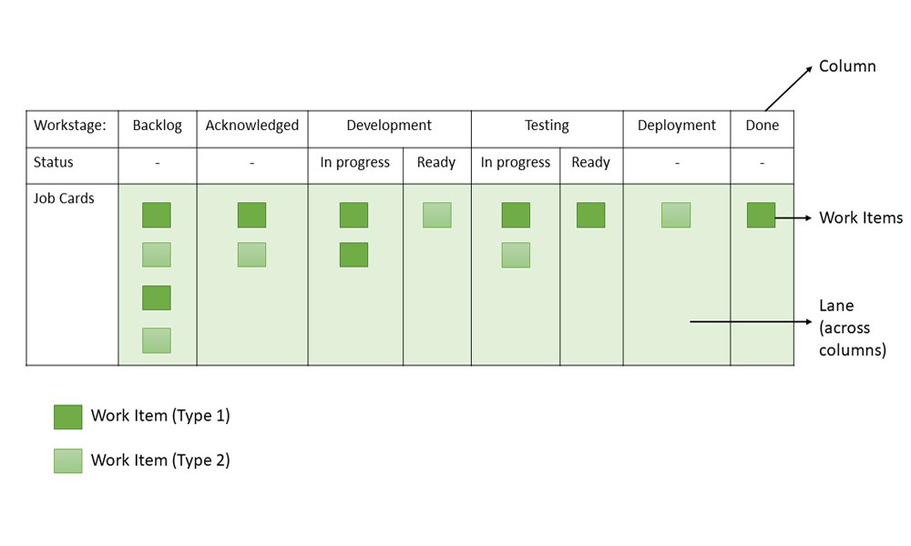

From the sample board above, these can be inferred about Kanban Boards or Cards:
- Workflow: Backlog -> Acknowledged -> Development -> Testing -> Deployment/UAT -> Done
- Work stages: Acknowledged, Development (In Progress), Development (Ready), Testing (In Progress), Testing (Ready), Deployment/UAT, Backlog (Arrival Queue), Done (Finished Stage)
- Work Items: Two types of tasks (Type 1 and Type 2) are represented by work items
Principles of Kanban
Kanban is based on four key principles which are mentioned below:
- Start with the existing process: It is a change management method that starts with the existing process. Changes are done in the system in incremental and evolutionary ways , there's no specific process or roles defined in Kanban.
- Agree to continue evolutionary and incremental changes: After starting with the existing process, the team must agree on continuous, incremental, and evolutionary changes. The changes should be small and incremental. Rapid and substantial changes may be effective but they will be subjected to larger resistance as well by the Team.
- Admire current roles, processes, responsibilities & titles: Though Kanban suggests continuous incremental changes in the process, it respects current roles, responsibilities, and job titles. This helps the team to gain confidence as they get started with Kanban.
- Leadership at all levels: Kanban does not expect leadership from a specific set, rather the actions of leadership at all levels in the organization, are very much encouraged.
Kanban Practices
The following are the six core Kanban practices:
- Limit WIP: Limiting Work-In-Process (WIP) implies that a pull system is executed on either parts or the whole workflow. It (PULL system) will act as one of the key stimuli for incremental, continuous, and evolutionary changes to the system. Limit WIP assigns explicit limits to the number of items that may be in progress at each workflow state.
- Visualize: Visualizing the workflow and making it visible is important so as to know how work proceeds. Without understanding the flow of work, incorporating the right changes is difficult. Usually, a card wall with columns and cards is used to visualize the flow of work. Different states or steps within the workflow are represented by the columns on the card wall.
- Manage flow: Flow of work through every state within the workflow should be observed, measured, and informed. By managing the flow vigorously, the incremental, continuous, and evolutionary modifications to the system can be assessed to have negative or positive effects on the system.
- Improve Collaboratively, Evolve Experimentally: Kanban encourages small incremental, continuous, and evolutionary changes. Whenever teams have a common understanding of concepts about work, process, workflow, and risk, they are more likely to be able to form a shared understanding of a problem and suggest enhancement actions that could achieve a consensus.
- Implement Feedback Loops: Early feedback from clients and the pull system are important in Kanban. If we get feedback from different stakeholders and processes, it will help to eliminate risk and optimize the delivery process.
- Make Policies Explicit: Until the mechanism of a process is not made clear, it is difficult to hold a debate and discuss ways to improve it. Without a clear understanding of how work is truly done and how things actually work, any conversation of complications tends to be anecdotal, emotional, and subjective. With a clear understanding, it is possible to hold a more rational, empirical, objective discussion of issues. It is more likely to facilitate consensus around improvement suggestions.
Kanban Workflow - How does Kanban Pull System Work?
Step 1. Visualize your Workflow
- Identify work stages and the work items.
- Work items: The max effort of 2 days to keep it short and moving.
  - Write work items on cards and stick them in columns, under corresponding work stages, based on system workflow - From left to right.
  - Workflow can be depicted physically or with a tool like Jira.
- Sample Work stages: Design, Development, Test, Production, Deployment, Done.
  - Each Stage can be split into- Ready and In Progress.
  - Initially, these two sub-stages may not be present.
  - Later they are introduced to check the waiting time in each stage.
Step 2. Establish a Pull System
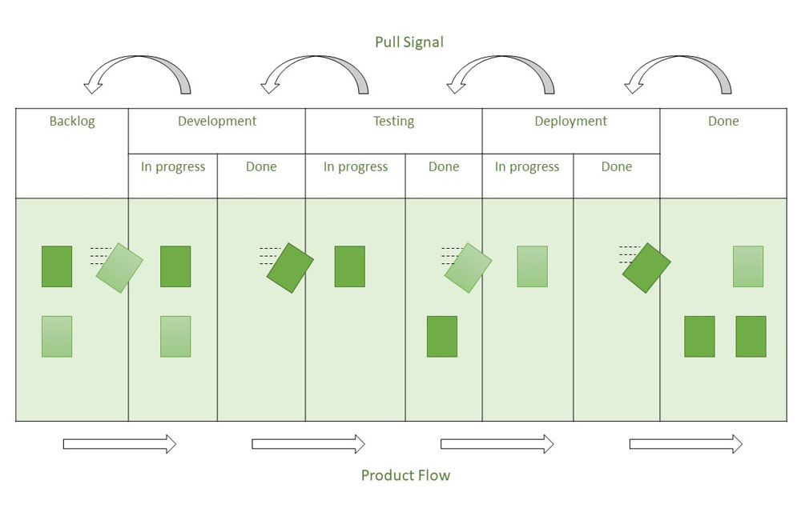
- Rather than pushing tasks into the process, teams pull work only when there is a need for it and they have the capacity to meet it. 'In progress (IP)' and 'Done' columns appear in every process state.
- For example, when a development task is finished, it is moved to the 'Development (Done)' column.
- Queue statuses are what 'Done' columns are referred to be. No one works on tasks in the queue states; hence these are passive.
- In our example, 'Development (Done)', is the queue from which testing teams pull tasks ready for testing once they have the capacity to handle new work.
- Teams can avoid multitasking by pulling work and focusing on the most important tasks.
- This results in higher throughput and shorter cycle times, which implies happy customers and higher profits.
Step 3. Limiting WIP
Create a Pull system upstream by setting WIP limits, and also ensure that the team "Stops beginning and Starts Finishing." After finishing a task in the current stage, team members can pull a task from the previous stage, thereby freeing up capacity in the preceding stage. This keeps going till the input of the bugs/ tickets.
- WIP limits could be set based on historical data and capacity planning.
- In case many tickets get piled up in one stage other team members help their team members so that tickets movement is smooth, thereby increasing collaboration.
- WIP limits defined could be observed for 3 to 4 weeks and updated based on the team’s experience.
The sample Kanban board with WIP limits introduced is given below:
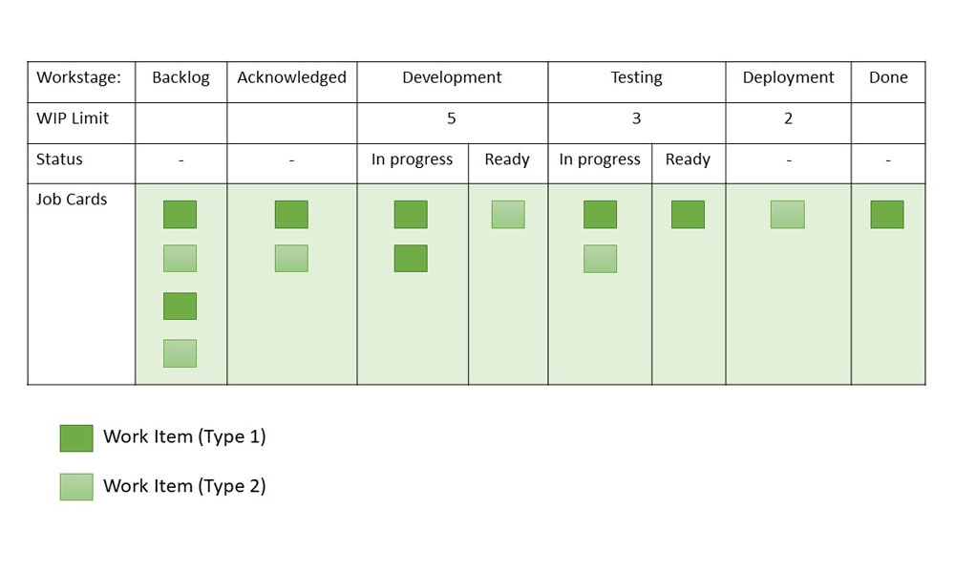

Step 4. Apply Pull Signals
The use of pull signals to indicate that fresh tasks are ready to be handled is an important part of a pull system. When the quantity of cards in a column falls below the specified limit in a Kanban pull system, a pull signal is generated. This tells the previous column that a new job is ready to move forward. No further tasks may be pulled once the work in progress limit has been reached unless an outstanding one has been completed first. This helps to avoid team burnout by ensuring that they only have as much work as they can handle. It also aids in the avoidance of jobs being overlooked.
Lead Time and Cycle Time
- Lead Time: The time span between the time a task enters the work system and the time it is completed is known as lead time. Lead time is the time it takes for an input to pass through all of the operations and arrive at the finish line. In Kanban terminology, the overall time it takes for a delegated task to reach the right-most column.
- Cycle Time: The cycle time displays how much time the team spends working on a prioritized task. Cycle time begins when any team member begins working on the task and transfers it to the 'in progress' column, and it continues until the task is completed.
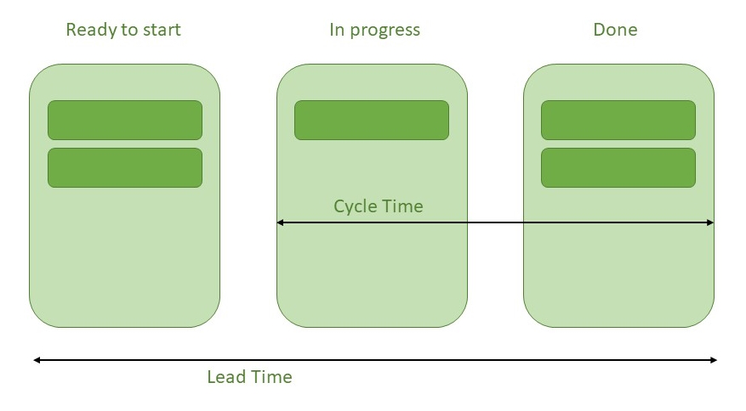

Steps of Kanban Approach
The Kanban approach involves three steps:
Step 1. Visualize: This step involves defining and visualizing the workflow.
- Understand the need for improvement.
- Define the process.
- Value stream entire process flow.
- Visualize process flow.
Step 2. Quantify: This step involves three activities:
- Startup:
  - Understand and/ or estimate WIP.
  - Create initial WIP limits.
- Adjust:
  - Study the feasibility of WIP limits.
  - Adjust the limits if required.
  - Develop statements on the limits and policies.
  - Train the team on a pilot basis.
- Measure:
  - Define current problems.
  - Convert them to measurements.
  - Derive metrics.
  - Establish a metrics collection system.
  - Define the tools used to analyze metrics and data.
Step 3. Optimize: This step involves the following three activities-
- Identify and Improve:
  - Analyze data.
  - Establish future value stream.
  - Identify improvement opportunities.
  - Prioritize.
  - Develop action plans.
  - Implement action plans.
  - Ensure improvement.
- Establish standards:
  - Revisit limits and policies.
  - Train the team.
  - Implement a new process.
- Envision for continuous improvement:
  - Set up the system to continuously monitor and improve processes.
  - Make the process, process-driven rather people-driven.
Benefits of using Kanban Framework
- Limiting Work in Progress and setting policies will result in a better focus on quality and, as a result, increased customer satisfaction.
- Use transparency to drive process improvement
- Minimized Waste
- Less process overhead
- A more precise and predictable pace guarantees that team members are never overburdened.
- Allows for quick reprioritization in order to adapt changes according to market demand.
- Better task flow
- The composition of the team can also be changed.
- Helps achieve improved productivity of teams
- Prioritization helps in streamlining processes and workflow.
- Enhanced quality of work
- Identification and elimination of bottlenecks
- Reduced queue time
- Reduction of wasted effort

Conclusion
Kanban is an Agile methodology focused on visualizing workflows, making work-in-progress in limits, and making continuous improvement. It will helps the teams manage the tasks more efficiently, reducing the waste, and learn quickly to changing priorities.

Adaptive Software Development (ASD): is a software development methodology that emphasizes adaptability to respond to changing requirements and environments. It focuses on continuous learning and is considered a part of agile software development.
- Iterative Development: ASD breaks down the project into small, manageable iterations, delivering incremental values.
- Risk Management: ASD involves identifying and addressing risks early in the development process.
- Continuous Testing: It integrates testing throughout the development process to ensure high-quality outcomes.
- Decentralized Control: It encourages decision-making at the team level instead of relying on top-down directives.
- Customer Satisfaction: It prioritizes customer satisfaction by delivering products that meet their needs and expectations.
Today, ASD remains relevant and useful as organizations increasingly face rapidly changing markets and technologies.
Characteristics of ASD Process
Here are the seven principles of ASD that distinguish it from more traditional, plan-driven methodologies:
- Adaptability: ASD focuses on high-level adaptive planning instead of detailed, fixed plans.
- Collaborative Environment: In ASD, a strong focus is on collaboration within the team, thus promoting a culture of open communication.
- Continuous Learning: It emphasizes learning from each iteration and using feedback to improve the process and the product.
- Iterative Development: In ASD, the development is broken into small, manageable increments. Each increment delivers a piece of functional software.
- Responsive to Change: It allows the project to quickly adapt to the changes in requirements, technology, and market conditions.
- Risk Management: Proactive identification and management of the risks with the flexibility to adapt as risks evolve.
- Emphasizes Quality: Testing is integrated throughout the development process to ensure high quality and early detection of issues. Regularly improve the code to maintain quality and adaptability.
- Empowerment and Ownership: It allows teams to make decisions and take ownership of their work. It also encourages decision-making at the team level to promote responsiveness and accountability.
Phases of ASD Process
ASD life cycle incorporates three phases namely:
- Speculation
- Collaboration
- Learning
These are explained below:
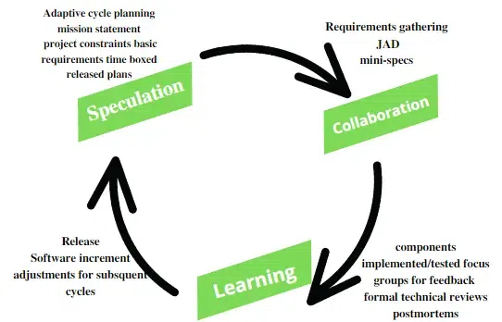
JAD – Joint Application Development
1. Speculation
During this phase project is initiated and planning is conducted. The project plan uses project initiation information like project requirements, user needs, customer mission statement, etc, to define a set of release cycles that the project wants.
2. Collaboration
It is the difficult part of ASD as it needs the workers to be motivated. It collaborates communication and teamwork but emphasizes individualism as individual creativity plays a major role in creative thinking. People working together must trust each other to
- Criticize without animosity,
- Assist without resentment,
- Work as hard as possible,
- Possession of skill set,
- Communicate problems to find effective solutions.
3. Learning
The workers may have an overestimate of their understanding of the technology which may not lead to the desired result. Learning helps the workers to increase their level of understanding of the project.
The learning process is in 3 ways:
- Focus groups
- Technical reviews
- Project postmortem
ASD’s overall emphasis on the dynamics of self-organizing teams, interpersonal collaboration, and individual and team learning yields software project teams that have a much higher likelihood of success.
Strengths of ASD
Here are some key strengths of Adaptive Software Development (ASD):
- Customer Focus: Regular and active involvement of customers to make sure that the product meets their needs and expectations.
- Continuous Delivery: Delivering functional software in small, manageable increments allows for early and continuous delivery of value.
- Early Problem Detection: Regular testing and releases help to identify and resolve issues early in the development process.
- Strong Teamwork: Emphasizes teamwork among the team members, thus fostering a supportive environment.
- Continuous Learning: Continuous learning from each iteration helps to improve processes and products.
- Empowered Teams: In ASD, teams are given the autonomy to make decisions, leading to higher motivation.
Weakness of ASD
Here are some key weaknesses of Adaptive Software Development (ASD):
- Requires High Level of Skill: Successful implementation of ASD requires a team with a high-level of skill, experience, and familiarity with the agile principles.
- Changing Requirements: The flexible nature of ASD may result in frequent changes of requirements, which might result in scope creep if it is not managed properly.
- Customer Availability: ASD relies heavily on active and continuous customer participation, which can be difficult to achieve in cases when the customer is not fully engaged or not available.
- Uncertain Project Outcomes: The iterative and adaptive nature of ASD makes it difficult to predict the outcome of the project.
- Cultural Shift: Organizations may face resistance to the cultural shift needed to fully utilize the principles of ASD.
- Requires Specific Tools: ASD may require specific tools and infrastructure for version control and automated testing, which might not be available in all organizations.
- Iteration Overhead: Managing frequent iterations can introduce overhead, which may hamper productivity if not managed effectively.

Test Driven Development: is a method in software development where the focus is on writing an Automation Tests before writing the actual code for any feature of an application or product. This approach uses short development cycles that repeat to verify the quality and correctness.
TDD simply means a method of coding in which you first write a test, and it fails, then write the code to pass the test of development, and clean up the code. This process is recycled for one new feature or change. In other methods in which you write either all the code or all the tests first, TDD will combine and write tests and code together into one.
Process of Test Driven Development (TDD)
It is the process in which Test Cases are written before the code that validates those cases. It depends on the repetition of a concise development cycle. Test-driven Development is a technique in which automated Unit tests are used to drive the design and free decoupling of dependencies.
The process of Test-Driven Development (TDD) follows a repetitive cycle called Red-Green-Refactor
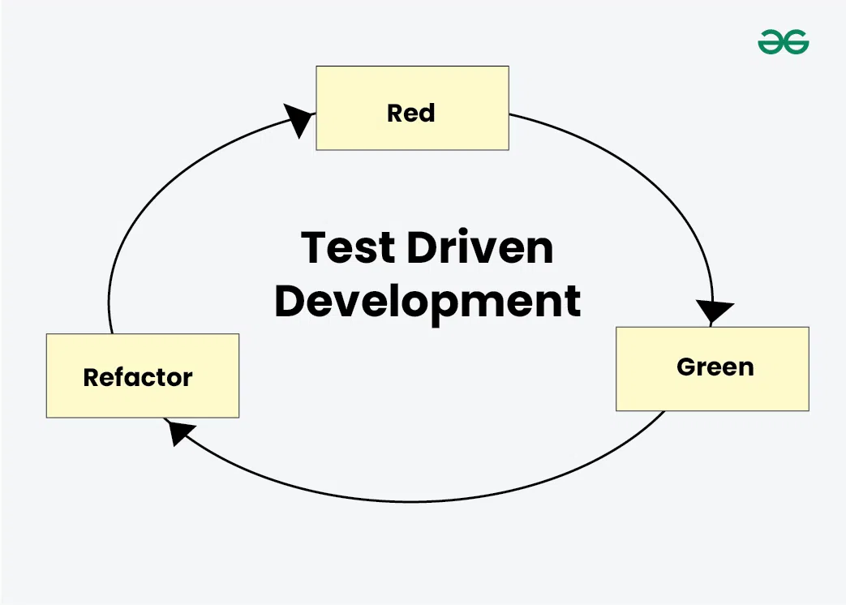
Run all the test cases and make sure that the new test case fails.
- Red - Create a test case and make it fail, Run the test cases
- Green - Make the test case pass by any means.
- Refactor - Change the code to remove duplicate/redundancy and Refactor code - This is done to remove duplication of code.
Once you completed through the Red-Green-Refactor cycle, you continue repeating the process for the next piece of functionality or unit of code. Every time you write a new test, your code gets better and more reliable, making the overall software stronger.
Approaches of Test Driven Development (TDD)
There are two main approaches to TDD: Inside Out and Outside In.
1. Inside Out:
In Test-Driven Development (TDD), you begin by testing the smallest units of code, such as individual functions or methods. Inside Out approach is also known as the Detroit School of TDD or Classicist.
- Focuses on testing the smallest units first and building up from there.
- The architecture of the software emerges naturally as tests are written.
- Design and architecture are refined during the refactor stage, which can sometimes lead to significant changes.
- Easier to learn for beginners.
- Minimizes the use of mocks.
- Helps prevent over-engineering.
2. Outside In:
Outside In approach known as the London School of TDD or Mockist. It will focuses on testing user behavior and interactions.
- Testing starts at the outermost level, such as the user interface, and works inward to the details.
- Relies heavily on mocks and stubs to simulate external dependencies.
- Harder to learn but ensures the code meets overall business needs.
- Design is considered during the red stage, aligning tests with business requirements from the start.
Test-driven work in Test Driven Development (TDD)
TDD, or Test-Driven Development, is not just for software only. It is also used to create product and service teams as test-driven work. To make testing successful, it needs to be created at both small and big levels in test-driven development.
This means testing every part of the work, like methods in a class, input data values, log messages, and error codes. Other side of software, teams use Quality Control (QC) will check before starting work. These will be checks to help plan and check the outcomes of the tests. They follow a similar process to TDD, with some small changes which are as follows:
- "Add a check" instead of "Add a test"
- "Run all checks" instead of "Run all tests"
- "Do the work" instead of "Write some code"
- "Run all checks" instead of "Run tests"
- "Clean up the work" instead of "Refactor code"
- Repeat these steps
TDD Vs. Traditional Testing
- Approach: Test Driven Development (TDD) it is a way of making software in that tests are written first after that the code is written. In traditional testing it the other way, It will making the code first and then start testing in it.
- Testing Scope: TDD checks small parts of code one by one. Traditional testing checks the whole system, including how different parts work together.
- Iterative: TDD is works in small small steps. It will write a small code and tests, and then improve regularly to code until it passes all the tests which are required. Traditional testing tests the code one time and then fixing any problems which ate been find.
- Debugging: TDD will try to find mistakes early in the process of code, which makes it will easier to fix them. Traditional testing will find the mistakes for after, which can be when held then it will harder to fix in the future.
- Documentation: TDD will focuses on documentation of the tests and their results. Traditional testing might have been more clear information about how the testing made done and the system will tested.
Advantages of Test Driven Development (TDD)
- Unit test provides constant feedback about the functions.
- Quality of design increases which further helps in proper maintenance.
- Test driven development act as a safety net against the bugs.
- TDD ensures that your application actually meets requirements defined for it.
- TDD have very short development lifecycle.
Disadvantages of Test Driven Development (TDD)
- Increased Code Volume: Using TDD means writing extra code for tests cases , which can make the overall codebase larger and more Unstructured.
- False Security from Tests: Passing tests will make the developers think the code is safer only for assuming purpose.
- Maintenance Overheads: Keeping a lot of tests up-to-date can be difficult to maintain the information and its also time-consuming process.
- Time-Consuming Test Processes: Writing and maintaining the tests can take a long time.
- Testing Environment Set-Up: TDD needs to be a proper testing environment in which it will make effort to set up and maintain the codes and data.
Conclusion
Test-Driven Development (TDD) is a coding methodology where tests are written before the actual code. This process verify the code reliability, quality, and maintainability through its Red-Green-Refactor cycle.

LeanSoftwareDevelopment: is an approach derived from lean manufacturing principles aimed at optimizing efficiency and minimizing waste in the software development process.
- Prevent Defects: It integrates quality assurance throughout the development process to prevent defects.
- Eliminate Waste: It focuses on activities that add value to the customer and eliminates those activities that do not add value.
- Fast Delivery: Reduces cycle time to deliver software quickly and respond to feedback and changing requirements rapidly.
- Delay Decisions: Delay decisions until they can be made based on facts.

