CI/CD and DevOps pipelines automate how software moves from a developer's computer to users. CI/CD handles building, testing, and releasing code, while DevOps covers the wider teamwork and system management. Together, they use tools like GitHub Actions or Jenkins to catch bugs fast and ship safe updates.
What is Continuous Integration (CI)?
- Frequent commits: Developers add small code changes to a shared system several times a day.
- Automated builds: The system puts the code pieces together and checks if it compiles correctly.
- Automated tests: Unit and integration tests run right away to find bugs early before they cause bigger issues.
What is Continuous Delivery and Deployment (CD)?
- Continuous Delivery: Code that passes all tests is always ready to go live, but a human must click a button to approve the final release.
- Continuous Deployment: The system skips manual approval and pushes valid code straight to production users automatically.
- Safe rollouts: Uses staging environments to preview updates and catch last-minute problems.

Steps to Install Jenkins On Windows.
Prerequisites
- Download and install Java (JDK 17 or 21) from a trusted provider like Oracle or Eclipse Temurin.
- Set up your JAVA_HOME system environment variable and add the bin path to your system path variables.
https://www.jenkins.io/download/
• Go to the official Jenkins website and download the Windows LTS (Long-Term Support) installer package.
• Double-click the downloaded .msi file to launch the Setup Wizard and click Next.
• Choose your destination folder (default is usually fine) and click Next.
• Select Run service as Local System (or provide local/domain user credentials if preferred) and click Next.
• Point the installer to your installed Java JDK directory (e.g., C:\Program Files\Java\jdk-21) when prompted, then click Next.
• Proceed through the custom setup options and click Install. Click Yes if Windows prompts you for permission.
• Click Finish when the installation completes
First-Time Unlock and Setup
- Open your web browser and go to http://localhost:8080.
- Retrieve your initial admin password by navigating to C:\Program Files\Jenkins\secrets\initialAdminPassword (or check the jenkins.err log file) using File Explorer or a text editor.
- Paste the password into the browser prompt to unlock Jenkins.
- Choose Install suggested plugins to complete the standard feature setup.
- Create your first administrative user account and save your Jenkins URL to start using the dashboard.
Jenkins First Job Creation.
Login Into Jenkins and click on New Item , Enter an Item Name and Select Freestyle Project and click on ok.
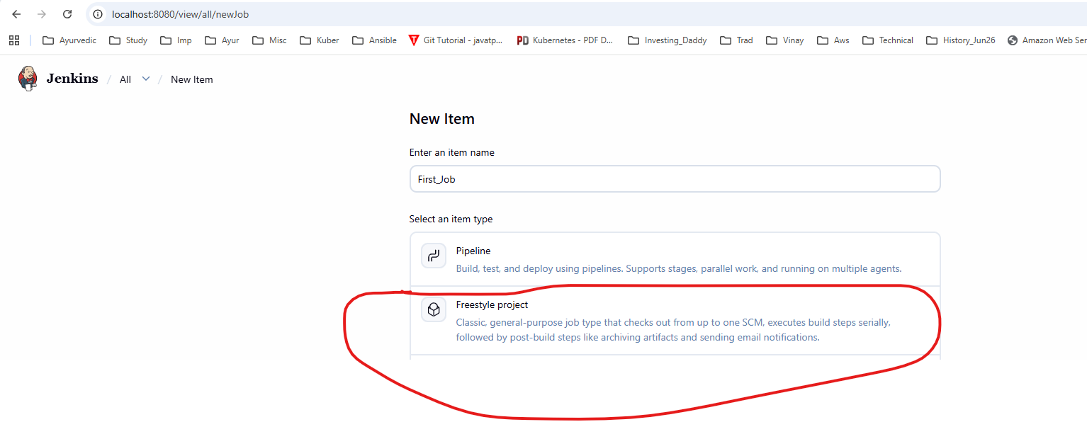
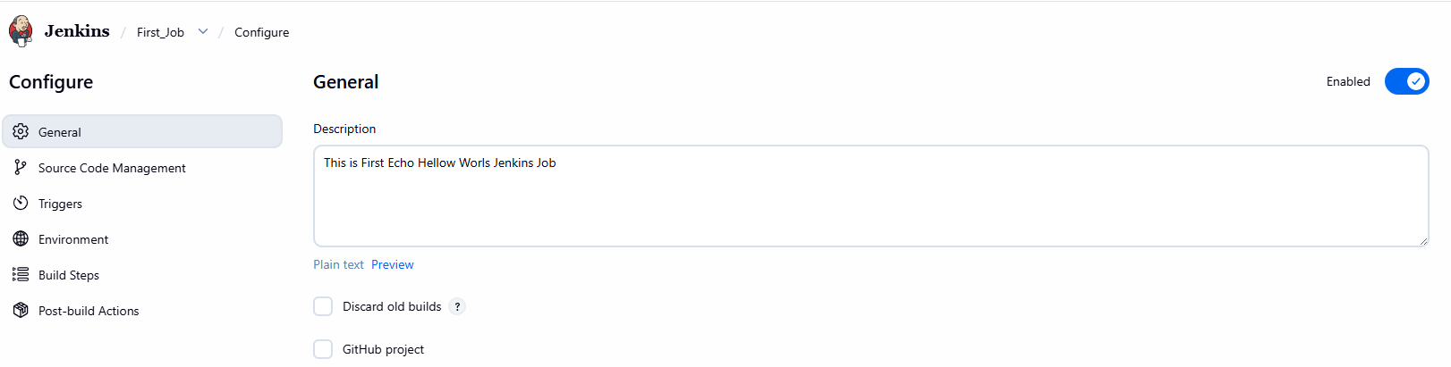
Give Some description and scroll down.
Select Build Steps and click on Add Build Step and Select “ Execute Windows batch command”
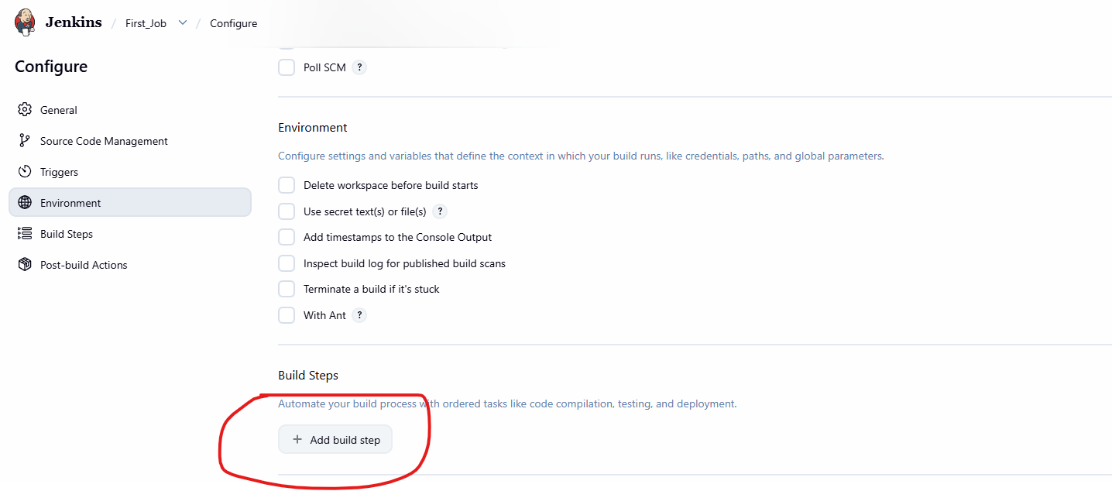
Enter windows command “echo Hello World” as shown below. And click on “Save”
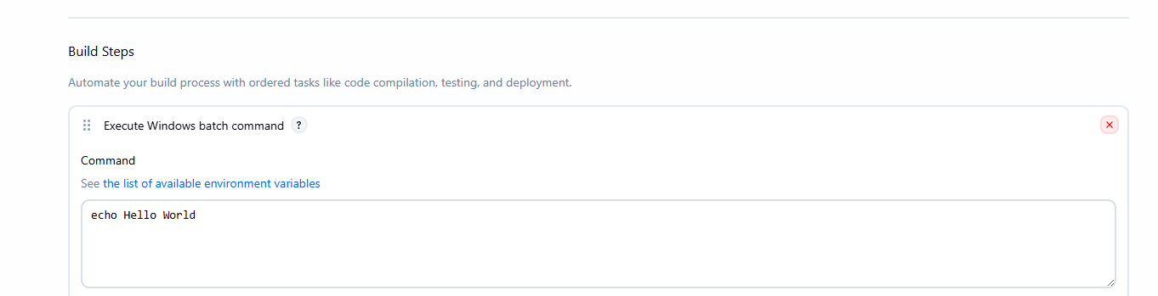
Once Done Click on “Build Now” and check status in Builds
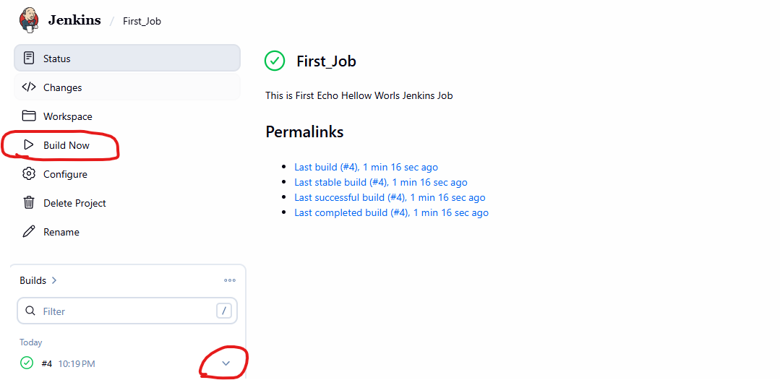
Click on Console Output.
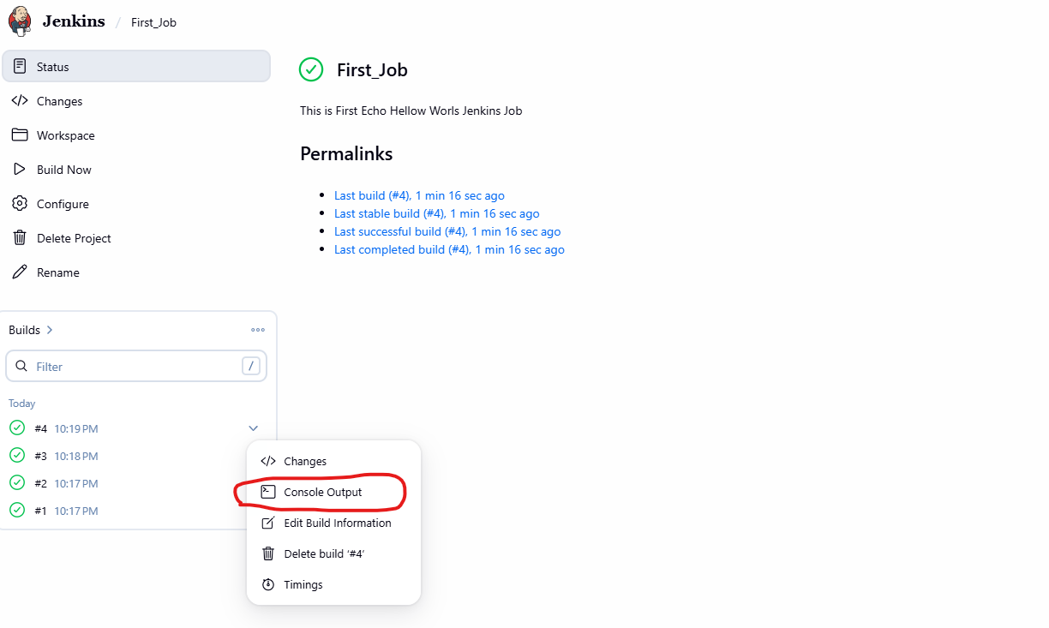
CI pipeline:
Login Into Jenkins and click on New Item , Enter an Item Name and Select Pipeline and click on ok.
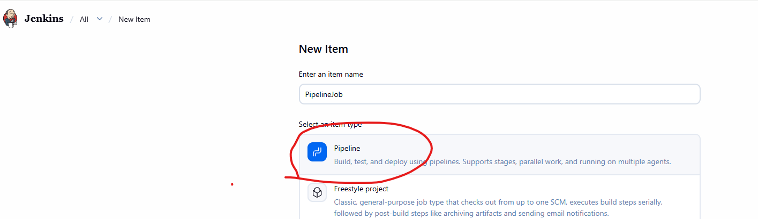

Give Some description and scroll down.
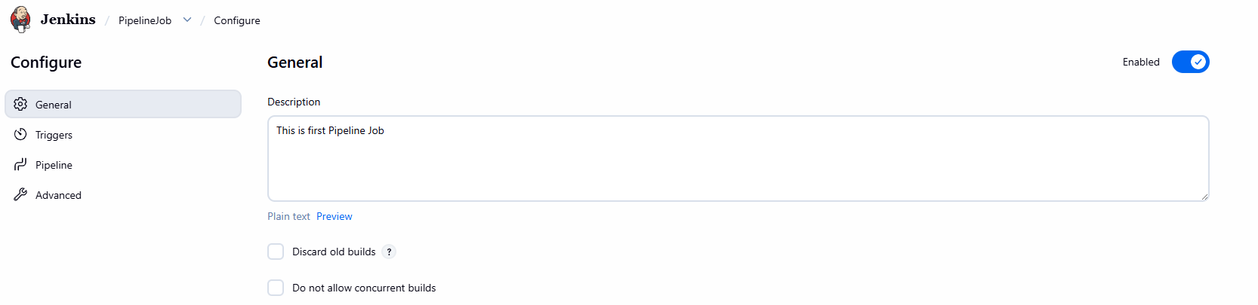
Select Hello World from the DropDown in Right Hand Side. And Click on Save.
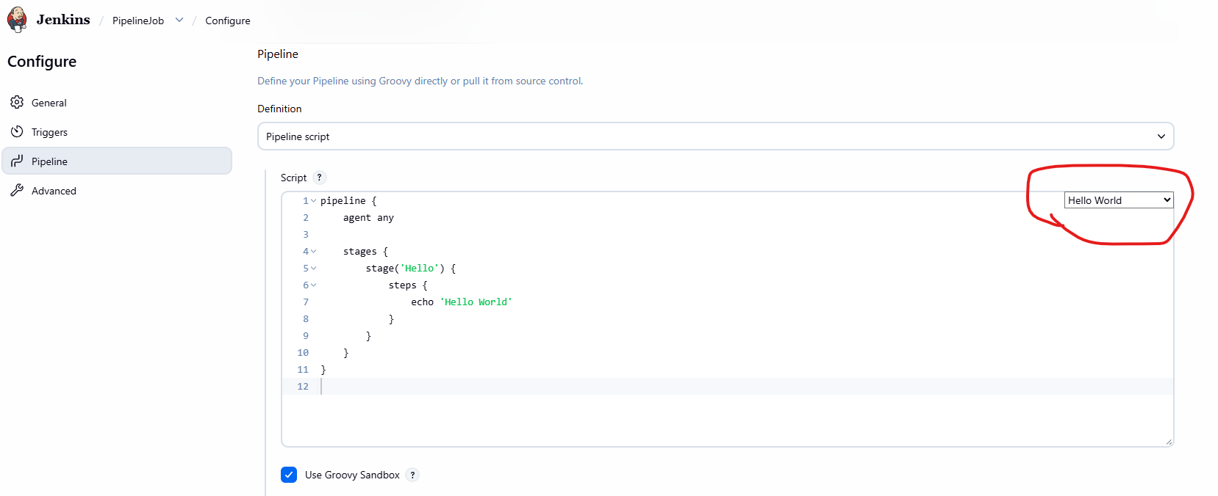
Once Done click on Build.
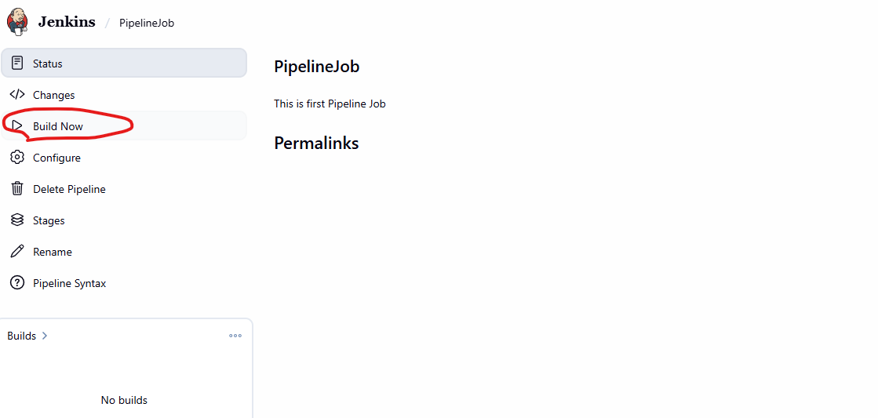
Now Click on Builds and select console output.
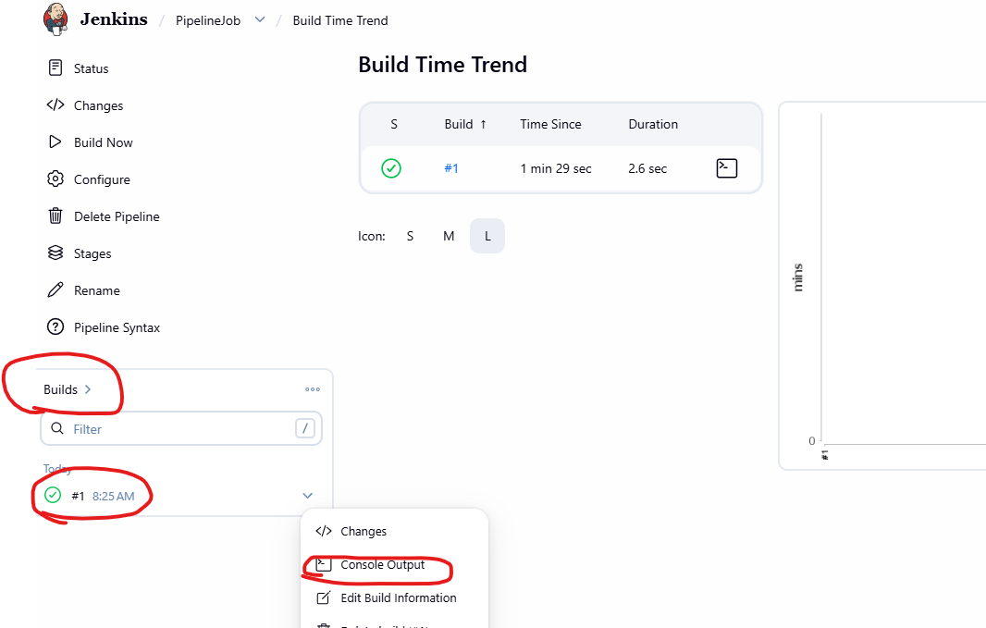
Here will be our output
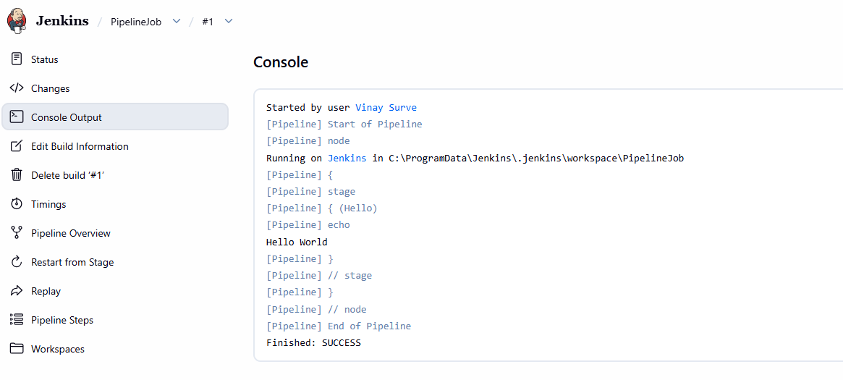

GitHub webhook integration.
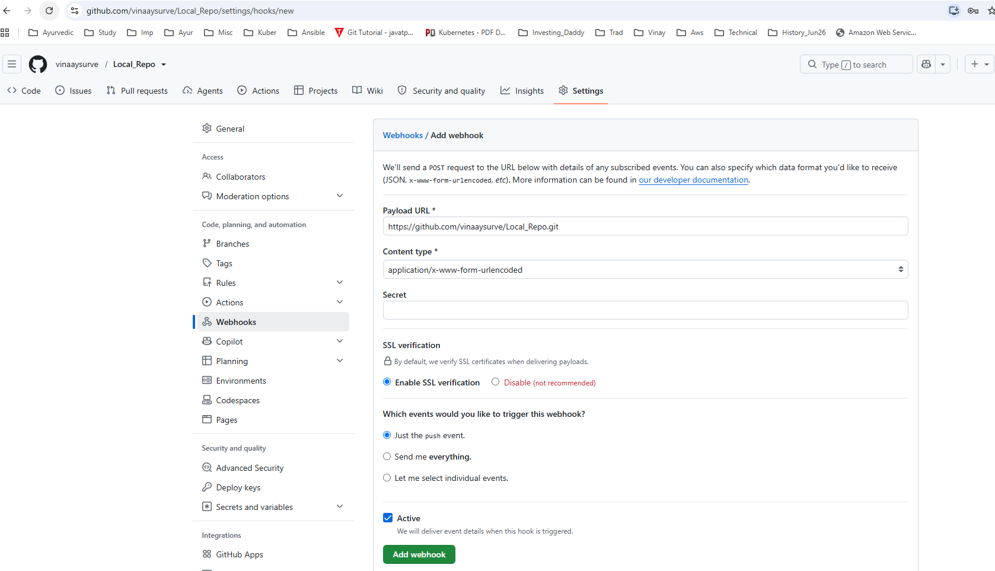

https://docs.docker.com/
Click on Get Started
wsl --version --- On Command Prompt
If Not getting output that mean wsl is not installed. Follow below steps to install wsl.
Option 1: Install or update WSL via the terminal
- Open PowerShell or Windows Command Prompt in administrator mode.
- Run either the install or update command. You may be prompted to restart your machine. For more information, refer to Install WSL.
wsl --install
wsl --update
Option 2: Install WSL via the MSI package
If Microsoft Store access is blocked due to security policies:
- Go to the official WSL GitHub Releases page.
- Download the .msi installer from the latest stable release (under the Assets drop-down).
- Run the downloaded installer and follow the setup instructions.
https://www.docker.com/products/docker-desktop/?at_exp=DO103.A

To install Docker on Windows Desktop.
https://docs.docker.com/desktop/setup/install/windows-install/
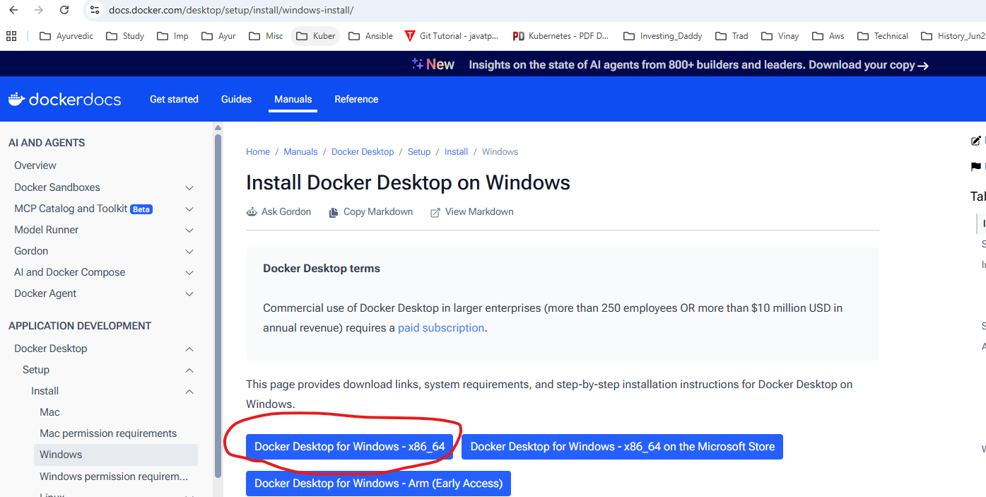
On command prompt check whether docker command is working or not.
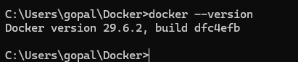
Restart windows system if docker command is not working.
-----------------------------------------------------
To install Docker on Fedora 44, add the official repository, install the Docker Engine packages, and start the service.
Installation Steps
- Add the official repository using Docker Engine for Fedora Docs:
sudo dnf config-manager addrepo --from-repofile https://download.docker.com/linux/fedora/docker-ce.repo
- Install Docker Engine and plugins:
sudo dnf install docker-ce docker-ce-cli containerd.io docker-buildx-plugin docker-compose-plugin
- Enable and start the service:
sudo systemctl enable --now docker
Post-Installation
- Run Docker without root privileges (optional):
sudo usermod -aG docker $USER and then newgrp docker
- Verify the installation:
docker run hello-world

To use Docker Compose on Fedora 44, you do not need a separate installation if you followed the previous steps. The modern docker-compose-plugin provides the functionality directly through the docker compose command (without the hyphen).

Docker is an open-source platform that automates the deployment of applications inside lightweight, portable software containers. Unlike traditional Virtual Machines (VMs) which virtualize entire hardware stacks and require a full guest operating system, Docker virtualizes the application layer. It shares the host machine's OS kernel, making containers exceptionally fast to start and highly resource-efficient.
Core Docker Concepts
Understanding the relationship between these four building blocks is essential for mastering Docker:
- Dockerfile: A text file containing sequential instructions used to build a Docker image.
- Docker Image: A read-only template that packages your application code, runtime, libraries, configurations, and environment variables.
- Docker Container: A running, executable instance of a Docker image. It provides a completely isolated sandbox environment.
- Docker Registry: A storage and distribution system for Docker images. Docker Hub is the largest default public registry.

Steps to create a Dockerfile
Open Notepad or Vi and copy below content and save it in a file called Dockerfile.
#
# Each instruction in this file generates a new layer that gets pushed to your local image cache
#
#
# Lines preceeded by # are regarded as comments and ignored
#
#
# The line below states we will base our new image on the Latest Official Ubuntu
FROM ubuntu:latest
#
# Identify the maintainer of an image
LABEL maintainer="myname@somecompany.com"
#
# Update the image to the latest packages
RUN apt-get update && apt-get upgrade -y
#
# Install NGINX to test.
RUN apt-get install nginx -y
#
# Expose port 80
EXPOSE 80
#
# Last is the actual command to start up NGINX within our Container
CMD ["nginx", "-g", "daemon off;"]

Dockerfile Commands
ADD — Defines files to copy from the Host file system onto the Container
- ADD ./local/config.file /etc/service/config.file
CMD — This is the command that will run when the Container starts
- CMD [“nginx”, “-g”, “daemon off;”]
ENTRYPOINT — Sets the default application used every time a Container is created from the Image. If used in conjunction with CMD, you can remove the application and just define the arguments there
- CMD Hello World!
- ENTRYPOINT echo
ENV — Set/modify the environment variables within Containers created from the Image.
- ENV VERSION 1.0
EXPOSE — Define which Container ports to expose
- EXPOSE 80
FROM — Select the base image to build the new image on top of
- FROM ubuntu:latest
LABEL maintainer — Optional field to let you identify yourself as the maintainer of this image. This is just a label (it used to be a dedicated Docker directive).
- LABEL maintainer=someone@xyz.xyz”
RUN — Specify commands to make changes to your Image and subsequently the Containers started from this Image. This includes updating packages, installing software, adding users, creating an initial database, setting up certificates, etc. These are the commands you would run at the command line to install and configure your application. This is one of the most important dockerfile directives.
- RUN apt-get update && apt-get upgrade -y && apt-get install -y nginx && rm -rf/var/lib/apt/lists/*
USER — Define the default User all commands will be run as within any Container created from your Image. It can be either a UID or username
- USER docker
VOLUME — Creates a mount point within the Container linking it back to file systems accessible by the Docker Host. New Volumes get populated with the pre-existing contents of the specified location in the image. It is specially relevant to mention is that defining Volumes in a Dockerfile can lead to issues. Volumes should be managed with docker-compose or “docker run” commands. Volumes are optional. If your application does not have any state (and most web applications work like this) then you don’t need to use volumes.
- VOLUME /var/log
WORKDIR — Define the default working directory for the command defined in the “ENTRYPOINT” or “CMD” instructions
- WORKDIR /home

Once Created run following commands.

C:\Users\gopal\Docker>docker build -t nginxnew .
C:\Users\gopal\Docker>docker images
nginxnew:latest 437ddfd48d89 271MB 82.4MB U
C:\Users\gopal\Docker> docker run -p 80:80 nginxnew:latest
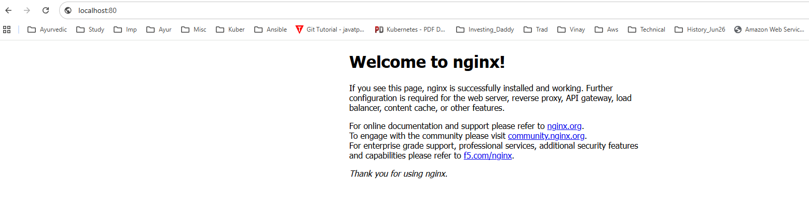
Verify the Installation
- Check your current Docker Compose version:
docker compose version

Create a Test Project
- Create a new directory for your project:
mkdir my-test-app && cd my-test-app
- Create a file named docker-compose.yml:
nano docker-compose.yml
- Paste this basic configuration for an Nginx web server:
Create a nginx.yaml file
services:
web:
image: nginx:latest
ports:
- "8080:80"
Manage the Container
- Start the container in the background:
docker compose up -d
- Check the running status of your stack:
docker compose ps
- Stop and remove the container:
docker compose down

