

Hotel Agency project
Software Requirement Specification

Project Code: Ho.1
Document Code: HoSR – v<1.0>

Ho Chi Minh, 08/11/2013

Record of change

*A - Added M - Modified D - Deleted
Effective Date | Changed Items | A*  M, D | Change Description | New Version
08/11/2013 | Initial | A | Add project over view
10/11/2013 | Add more info | A | Add funcional requirement

SIGNATURE PAGE

ORIGINATOR: Ho Xuan Tuyen 08/11/2013
Student

REVIEWERS: Lai Duc Hung 14/11/2013
Teacher

<Name, if it’s needed> <Date>
<Position>

APPROVAL: <Name> <Date>
<Position>
TABLE OF CONTENTS
1 Introduction 5
1.1 Purpose 5
1.2 Scope 5
1.3 Definitions, Acronyms, and Abbreviations 5
1.4 References 6
1.5 Overview 6
2 Overall Description 7
3 FUNCTIONAL Requirements 8
3.1 <Functional Requirement One> 8
3.2 <Functional Requirement Two> 8
3.3 … 8
4 NON-FUNCTIONAL Requirements 9
4.1 Usability 9
4.2 Reliability 9
4.3 Performance 10
4.4 Supportability 10
4.5 Design Constraints 11
4.6 On-line User Documentation and Help System Requirements 11
4.7 Purchased Components 11
4.8 Interfaces 11
4.9 Licensing Requirements 12
4.10 Legal, Copyright, and Other Notices 12
4.11 Applicable Standards 12
5 Supporting Information 13

Introduction
This section will give an over view of “Hotel Agency” system.

Purpose
The purpose of the SDS is to document the technical design of HA. This technical design specification aims to provide a formal technical design specification of the overall system architecture which includes components design, database design and user interface design.
The HA layout the set of standards govern the design and implementation of the system, which the development team will use as a basis for system implementation of HA.
When accepted, this document shall form the basis for implementation and development of the system.

Definitions, Acronyms, and Abbreviations
Terms | Descriptions
HA | Hotel Agency
Admin | Administrator
DB | Database

References
Document Number | Title
01 | EXT. Software Design Specification Guideline
02 | SU2010B2_Software_Requirment_Specification_Template
03 | Project_Description_Restaurant_Automation_2011_Summer_Block_1
04 | vulht_binhtdh60060_asm2_update

Overview
Section 2: gives an overall description of the system architecture.
Section 3: gives us a view to functional requirements.
Section 4: discribes non-functional requirements.
Section 5: discribes supporting information.

Overall Description
Application architectural will based on n tiers that system will be separated to many components. The application layer will include:
- Presentation layer: Users can use browser on PC to use system.
- Web server: admin run on the server side using the admin object and some securities to manage system such as: maintain, configuration. The JPS, HTML combined with JS are used to create the dynamic page.
- Middle ware: Provide function and application on application server. Provide flexibility in maintain and services will be available 24/7.
- Data layer: DBMS is used to manage the data and constraints to the application progress.
Architectural diagram:
Application is decomposed into several components corresponding to the multi-layer architectural and business functionality in the following diagram:
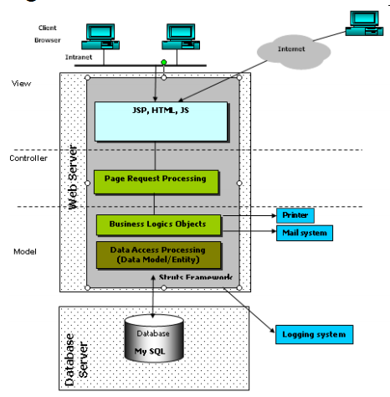
EXT. Software Design Specification Guideline (P.8)

System operation:
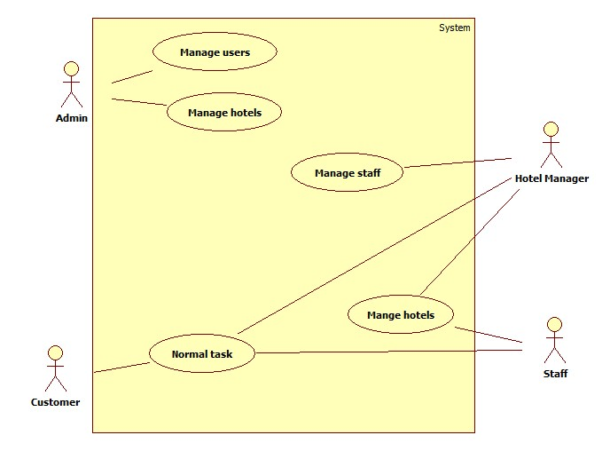

FUNCTIONAL Requirements
This section will discribe functions that HA System will have , and how the system executes these functions.

Admin function:
3.1.1 Manage users:
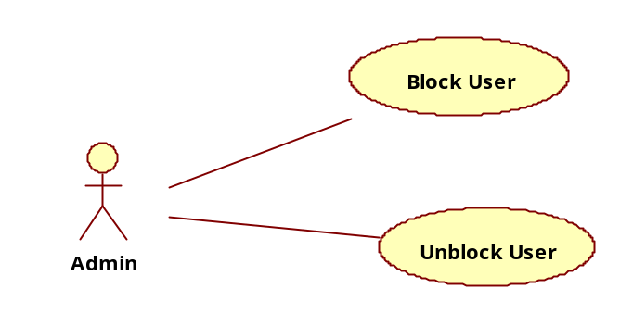
In this module, there are 2 small functions:
- Block user: This function helps admin to disable user account when that user violates system rules.
- Unblock user: This function helps admin to enable user account after blocked.

Use case name | Block user
Actors | Admin
Description | This section helps admin to disable user account
Requirements | User must login as admin before do this function
Pre-conditions | N/A
Post-conditions | Success: That account can not do any action in the system.  Fail: N/A
Basic flow | Actor action:  - Admin accesses into admin manage page.  - Admin finds user account that he wants to block by inserting account name and click “Search”  -  In result page, admin click on “Block” in user acount that admin want to block | System response:  - Admin manage page will be show.  - System searches and return result page to admin.  - User account color will change to red, and account status will be “blocked”.
Alternative Flow | N/A | N/A
Exception Flow | N/A | N/A

Use case name | Unblock user
Actors | Admin
Description | This section helps admin to enable user account after blocked
Requirements | User must login as admin before do this function
Pre-conditions | N/A
Post-conditions | Success: Account status return normal, that account can do any normal action on system.  Fail: N/A
Basic flow | Actor action:  - Admin accesses into admin manage page.  - Admin finds user account that he wants to unblock by inserting account name and click “Search”  -  In result page, admin click on “Unlock” in user acount that admin want to block | System response:  - Admin manage page will be show.  - System searches and return result page to admin.  - User account color will change to blue, and account status will be “normal”.
Alternative Flow | N/A | N/A
Exception Flow | N/A | N/A

3.1.2 Manage hotels:
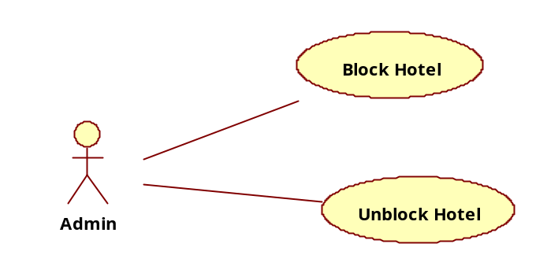
In this module, there are 2 small functions:
- Block hotel: This function helps admin to disable hotel when that hotel violates system rules.
- Unblock hotel: This function helps admin to enable hotel after blocked.

Use case name | Block hotel
Actors | Admin
Description | This function helps admin to disable hotel when that hotel violates system rules.
Requirements | User must login as admin before do this function
Pre-conditions | N/A
Post-conditions | Success: Customer cannot access that hotel on the system  Fail: N/A
Basic flow | Actor action:  - Admin accesses into admin manage page.  - Admin finds hotel that he wants to block by inserting hotel name and click “Search”  -  In result page, admin click on “Block” in hotel that admin want to block | System response:  - Admin manage page will be show.  - System searches and return result page to admin.  - User hotel color will change to red, and account status will be “blocked”.
Alternative Flow | N/A | N/A
Exception Flow | N/A | N/A

Use case name | Unblock user
Actors | Admin
Description | This section helps admin to enable hotel after blocked
Requirements | User must login as admin before do this function
Pre-conditions | N/A
Post-conditions | Success: Customer accesses that hotel on the system normally.  Fail: N/A
Basic flow | Actor action:  - Admin accesses into admin manage page.  - Admin finds hotel that he wants to unblock by inserting hotel name and click “Search”  -  In result page, admin click on “Unlock” in hotel that admin want to block | System response:  - Admin manage page will be show.  - System searches and return result page to admin.  - Hotel color will change to blue, and account status will be “normal”.
Alternative Flow | N/A | N/A
Exception Flow | N/A | N/A

Manager and staff function
Manager and staff have the same function that is manage hotel. This function divided into 7 small functions:
+ Update hotel information: This function helps manager and staff to update hotel information. Such as: Phone, address, etc.
+ Add room: This function helps manager and staff to add a room into hotel.
+ Remove room: This function helps manager and staff to remove a room in hotel.
+ Update room information: This function helps manager and staff to update room information. Such as: status (hired/blank), room name, room type, price, etc.
+ Add promotion: This function helps manager and staff to add a promotion to hotel.
+ Remove promotion: This function helps manager and staff to remove promotion inhotel.
+ Change promotion information: This function helps manager and staff to change promotion infomation

Otherwise, the manager also has manage staff function. This function also divided into 2 small functions:
+ Add staff: This function helps manager to add a staff into hotel.
+ Remove staff: This function helps manager to remove a staff.
Diagram:
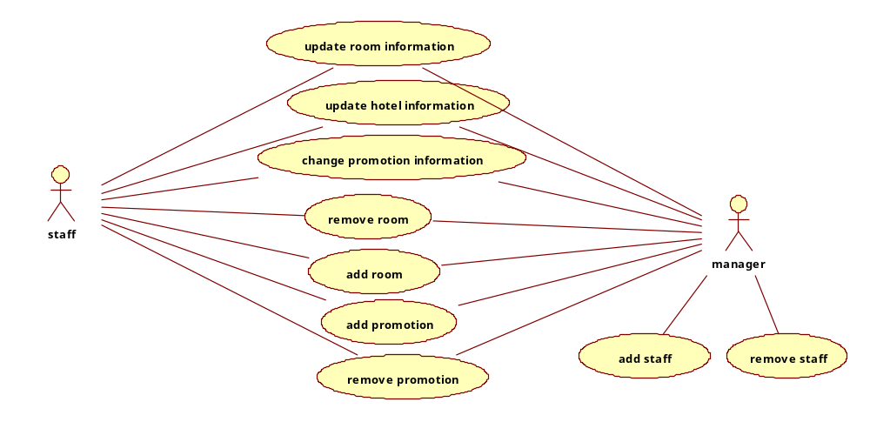

…

NON-FUNCTIONAL Requirements
[This section describes the non-functional requirements of the system. Some examples are listed as below]

Usability
[This section includes all those requirements that affect usability. For example,
specify the required training time for a normal users and a power user to become productive at particular operations
specify measurable task times for typical tasks or base the new system’s usability requirements on other systems that the users know and like
specify requirement to conform to common usability standards, such as IBM’s CUA standards Microsoft’s GUI standards]

<Usability Requirement One>
[The requirement description goes here.]

Reliability
[Requirements for reliability of the system should be specified here. Some suggestions follow:
Availability—specify the percentage of time available ( xx.xx%), hours of use, maintenance access, degraded mode operations, and so on.
Mean Time Between Failures (MTBF) — this is usually specified in hours, but it could also be specified in terms of days, months or years.
Mean Time To Repair (MTTR)—how long is the system allowed to be out of operation after it has failed?
Accuracy—specifies precision (resolution) and accuracy (by some known standard) that is required in the system’s output.
Maximum Bugs or Defect Rate—usually expressed in terms of bugs per thousand lines of code (bugs/KLOC) or bugs per function-point( bugs/function-point).
Bugs or Defect Rate—categorized in terms of minor, significant, and critical bugs: the requirement(s) must define what is meant by a “critical” bug; for example, complete loss of data or a complete inability to use certain parts of the system’s functionality.]

<Reliability Requirement One>
[The requirement description.]

Performance
[The system’s performance characteristics are outlined in this section. Include specific response times. Where applicable, reference related Use Cases by name.
Response time for a transaction (average, maximum)
Throughput, for example, transactions per second
Capacity, for example, the number of customers or transactions the system can accommodate
Degradation modes (what is the acceptable mode of operation when the system has been degraded in some manner)
Resource utilization, such as memory, disk, communications, and so forth.

<Performance Requirement One>
[The requirement description goes here.]
Interfaces

Supportability
[This section indicates any requirements that will enhance the supportability or maintainability of the system being built, including coding standards, naming conventions, class libraries, maintenance access, and maintenance utilities.]

<Supportability Requirement One>
[The requirement description goes here.]

Design Constraints
[This section indicates any design constraints on the system being built. Design constraints represent design decisions that have been mandated and must be adhered to. Examples include software languages, software process requirements, prescribed use of developmental tools, architectural and design constraints, purchased components, class libraries, and so on.]

<Design Constraint One>
[The requirement description goes here.]

On-line User Documentation and Help System Requirements
[Describes the requirements, if any, for o-line user documentation, help systems, help about notices, and so forth.]

Purchased Components
[This section describes any purchased components to be used with the system, any applicable licensing or usage restrictions, and any associated compatibility and interoperability or interface standards.]

Interfaces
[This section defines the interfaces that must be supported by the application. It should contain adequate specificity, protocols, ports and logical addresses, and the like, so that the software can be developed and verified against the interface requirements.]

User Interfaces
[Describe the user interfaces that are to be implemented by the software.]

Hardware Interfaces
[This section defines any hardware interfaces that are to be supported by the software, including logical structure, physical addresses, expected behavior, and so on.]

Software Interfaces
[This section describes software interfaces to other components of the software system. These may be purchased components, components reused from another application or components being developed for subsystems outside of the scope of this SRS but with which this software application must interact.]

Communications Interfaces
[Describe any communications interfaces to other systems or devices such as local area networks, remote serial devices, and so forth.]

Licensing Requirements
[Defines any licensing enforcement requirements or other usage restriction requirements that are to be exhibited by the software.]

Legal, Copyright, and Other Notices
[This section describes any necessary legal disclaimers, warranties, copyright notices, patent notices, wordmark, trademark, or logo compliance issues for the software.]

Applicable Standards
[This section describes by reference any applicable standard and the specific sections of any such standards which apply to the system being described. For example, this could include legal, quality and regulatory standards, industry standards for usability, interoperability, internationalization, operating system compliance, and so forth.]

Supporting Information
[The supporting information makes the SRS easier to use. It includes:
- Table of contents
- Index
- Appendices
These may include use-case storyboards or user-interface prototypes. When appendices are included, the SRS should explicitly state whether or not the appendices are to be considered part of the requirements.]

