**NAME:Vinal Bagaria Class: SE COMPS**

**UID: 2017130007**

**SEVA Activity Report**

ACTIVITY : Dana Pani Beach and Mithi River cleanup

Number of hours spent in this semester : **4**

Abstract (500 to 1000 words): (Please write about the activity you did):

As a part of a huge clean-up initiative in which SPIT collaborated with Afroz Shah, the founder of the world’s largest beach clean-up project, weekly sessions were organized at two locations; Dana Pani Beach and Mithi River. I attended 13 of these sessions, from January to March 2019.

Dana Pani Beach : It is a beach located north of Versova beach, near Malad. When we first arrived there on the first day, there was garbage, heaps of plastic bags and bottles strewn across. Our first task was to remove all the cloth materials, plastic bags wrapped around the plants there so that they could breathe. We were given gloves and containers to put all the collected waste in, which was then taken by the trucks at regular intervals. The volunteers themselves worked with us, instructing us about what can be considered as non biodegradable waste and be collected.

We were asked to help clean different parts of the beach every Saturday. We had to pick up loose plastic bags, bottles, dig up clothes buried deep inside the sand.

Many other school and college students had come as well. It was great to see the collective effort put in by the youth of this country, furthering the motivation inside all of us.

After we collected the waste we would empty our baskets inside the back of a mini truck which carried it off. Every session would end with an educative talk from one of the senior volunteers.

Mithi River : It is a river, located in Aarey colony. At a first glance, it was difficult to see the grand and the most important river in Mumbai reduced to a stinking, garbage clogged channel. It had barely any water and all the waste in large heaps across both the sides. Mithi River was more challenging, but the satisfaction of cleaning some part of it was great.

Another thing to be done at Mithi river was to go to the slums which were right beside the river and create awareness among the residents there about segregation of waste. It was a great initiative, as the people living there are the ones who have the ability to change the face of the river in their hands.

We had to go to each and every house there and tell people about the hazards of waste and tell them to keep biodegradable and non-biodegradable waste separate. The biodegradable waste would be collected everyday by the BMC and the non- biodegradable waste was collected every Sunday by us. Some of the locals were at first reluctant to adopt to this, and were not very accepting of this idea of us, but there were some others who were extremely friendly and helpful, making our work easier.

Did you face any challenges/problems; and if so how did you overcome them and what did you learn from it? :

Sometimes the plastic that we had to collect was very small and picking up such small pieces was very cumbersome. But it only made us reflect on how every little thing that we throw away is ending up on some beach somewhere and how we need to be mindful of how we are reducing our waste individually too.

The plastic and clothes at Dana Pani beach were sometimes very deeply buried, difficult to be removed by a single person alone. This is where teamwork came in and all of us together removed it.

Were there any memorable experiences?

Seeing people from all walks of life, from school to office employees, being united by a social cause was definitely a memorable experience.

The feeling of doing something for the nature, for the society was in itself a fulfilling experience. At the end of every session,we all would gather around in a circle and Afroz Shah or one of his volunteers would ask any one of us to talk about our experience. That according to me was a very good initiative to motivate us further.

Was there any learning from the program which you could possibly apply to other aspects of your life? :

Teamwork is one crucial thing I learnt in the course of all these sessions.

How does this support your development as a student and as a human being? :

This activity made me aware about the magnitude of the rising concern about the state of the earth. At the rate at which we are polluting the nature and using up its resources for our selfish needs, it would soon run out of resources, rivers would clog up if we continue with this careless disposal. This made me aware about my responsibility towards the society and myself.

It taught me no work is little and it is this small contribution that counts, which when combined can move mountains.

Any other feedback?

Transport to Daana Paani beach is very poor. So keeping the beach cleaning at times in the evening is a bit inconvenient as the transport time to and fro is very high due to traffic and it becomes more difficult to find a transport means at daana paani .

ACTIVITY : Abhudaya

Number of hours spent in this semester : **3**

Abstract (500 to 1000 words): (Please write about the activity you did):

Abhudaya is a non-profit programme started by SPJIMR for its students. It holds classes for the underprivileged kids every sunday. I volunteered there as a teacher’s assistant for the subjects Spoken English, Math and Science. These students are of 6th grade and very smart.

6th grade students were divided into 2 divisions, 6th A had all English Medium students and 6th B had all the other medium students. Due to which the language followed in the first class was English and the other was Hindi.

They are always excited, eager to learn and very friendly. Our job was to teach them if the teachers were absent or keep an eye on them, correct their mistakes and solve their doubts. Teaching them is always fun; they are very attentive and quickly grasp the concepts. Then we go and take a walk around the class and help those who are struggling.

It was a fun experience all in all, and the love we received from the students was amazing, always making us want to go for more.

Did you face any challenges/problems; and if so how did you overcome them and what did you learn from it? :

One of the problem was, while teaching the students, to be able to explain the concept in such a way that they understand. It had to be made as simple as possible. Especially to the other medium students like Urdu or Marathi.  To ensure this, we took constant feedback from the students, encouraging questions at any point of time. We also solved doubts individually if they felt shy asking in front of the class.

Were there any memorable experiences?

The love we received from the students was immensely fulfilling and satisfying. The happiness I got after they understood what I taught was truly memorable.

Was there any learning from the program which you could possibly apply to other aspects of your life? :

It helped me gain confidence in my teaching skills. It was great to see so many parents willing to send their children to schools, realizing the betterment of their children in it. The students as well being proactive, despite it being kept on a holiday. This is a clear indication that this generation is going to grow out from the age old traditions into a new world.

How does this support your development as a student and as a human being? :

Volunteering is a very satisfactory thing. Doing your bit for the society in which you live, dedicating your time for the betterment of it, makes you want to be a better person.  The support I got from the students just intensified the feeling. And I am truly grateful for it.

Any other feedback?

There is usually a lot of chaos when choosing who gets to volunteer for that weekend. I would like if the process was more streamlined and fair.

**Dana Pani Beach**

20/04/2019(2 hrs):

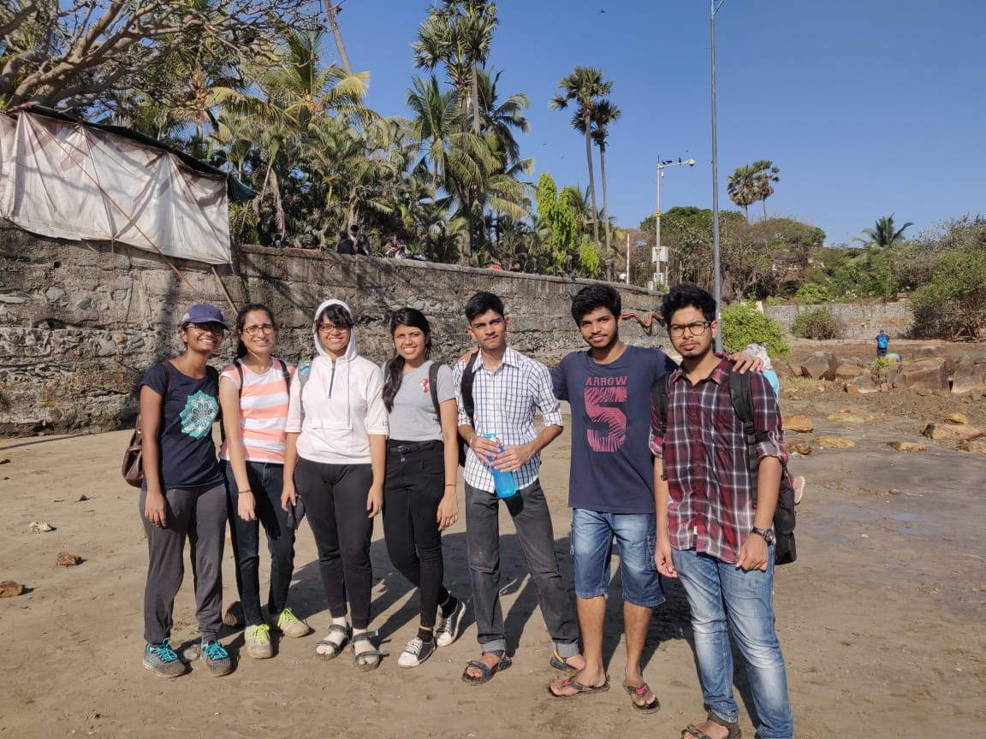

27/04/2019(2 hrs):

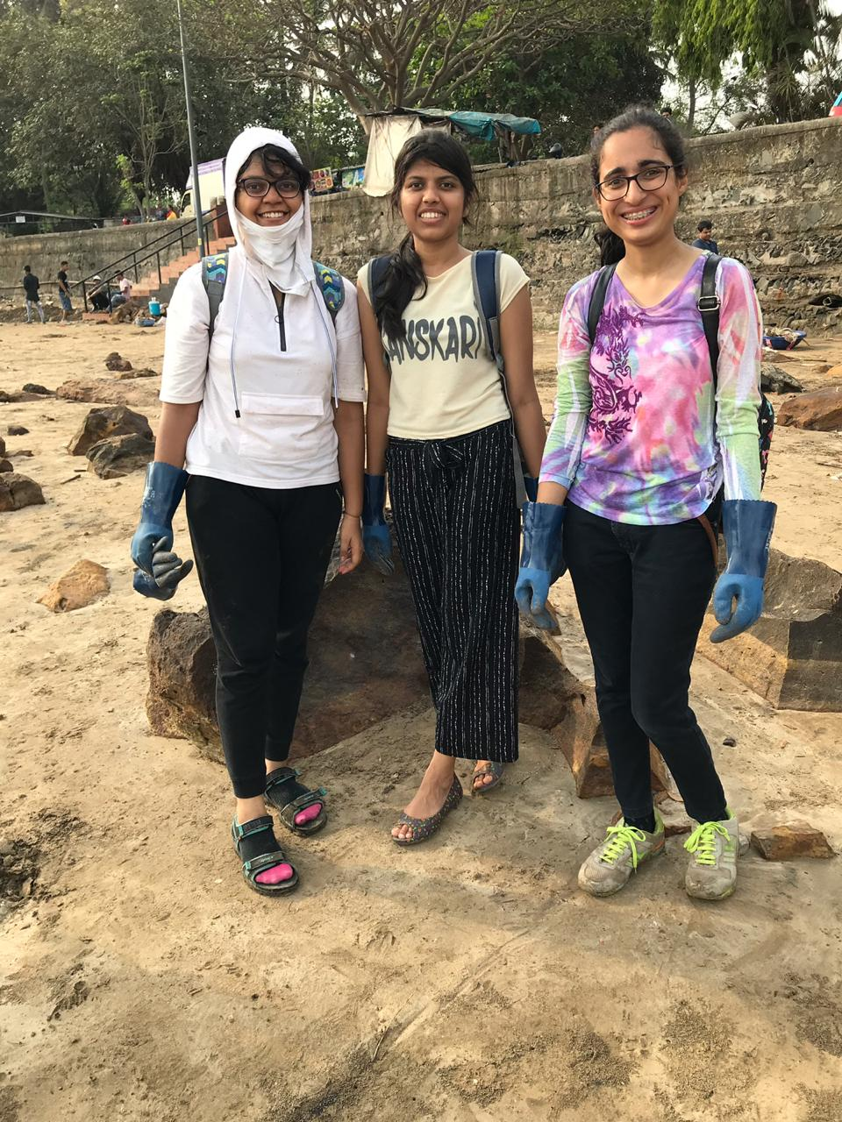

**ACTIVITY  : SPIT MARATHON**

No of hours spent this semester: **2**

**ABSTRACT :**

The SPIT Marathon was organized on the 17th of February, to run for a cause. The 6km run stretched from Juhu Beach to Bhavan’s Campus. It was organized in collaboration with the Plants and Animals Welfare Society (PAWS), to which the proceeds from the event went. Over 700 participants ran the course, and I’m proud to have been a part of this initiative.