Main Manuscript for
Sublimation of Isolated Toric Focal Conic Domain on Micro-Patterned Surfaces
Wantae Kim^{a,1}, Eduardo Vitral^{b,1}, Perry H. Leo^{c}, Jorge Viñals^{d,2}, Dae Seok Kim^{e,2}, Dong Ki Yoon^{a,2}

ªDepartment of Chemistry, Korea Advanced Institute of Science and Technology, Yuseong-gu, Daejeon 34141, Republic of Korea
^{b}Department of Mechanical Engineering, Rose-Hulman Institute of Technology, Terre Haute, IN 47803, USA
^{c}Department of Aerospace Engineering and Mechanics, University of Minnesota, 110 Union St. SE, Minneapolis, MN 55455, USA
^{d}School of Physics and Astronomy, University of Minnesota, 116 Church St. SE, Minneapolis, MN 55455, USA
^{e}Department of Polymer Engineering, Pukyong National University, Nam-gu, Busan 48513, Republic of Korea

¹W.K. and E.V. contributed equally to this work

²To whom correspondence may be addressed.
Email:
Jorge Viñals : vinals@umn.edu
Dae Seok Kim : daeseok@pknu.ac.kr
Dong Ki Yoon : nandk@kaist.ac.kr

Author Contributions:
W.K., E.V., P.L., J.V., D.S.K., D.K.Y. designed research. W.K., E.V. performed research. W.K., E.V., P.L., J.V., D.S.K., D.K.Y. wrote the paper.

Competing Interest Statement:
The authors declare no competing interest.

Classification:
Physical Sciences - Chemistry

Keywords: smectic liquid crystal, toric focal conic domain, sublimation, surface tension

This PDF file includes:
Main Text
Figures 1 to 5

Abstract
Toric Focal Conic Domains (TFCDs) in smectic liquid crystals exhibit distinct topological characteristics, featuring torus-shaped molecular alignment patterns with rotational symmetry around a central core. TFCDs have attracted much interest due to their unique topological structures and properties, enabling not only fundamental studies but also potential applications in liquid crystal (LC)-based devices. Here, we investigated the precise spatial control of TFCDs arrangement using micropatterns and sublimation of TFCDs to estimate the energy states of the torus-like structures. Through simulations, we observed that the arrangement of TFCDs strongly depends on the shape of the topographies of underlying substrates. To accurately estimate the energetic effects of non-zero eccentricity and evaluate their thermodynamic stability, we propose a geometric model. Our findings provide valuable insights into the behavior of smectic LCs, offering opportunities for developing novel LC-based devices with precise control over their topological properties.
Significance Statement
While molecular evaporation of a material in an isotropic phase is naturally observed, evaporation in an ordered state, i.e. sublimation, occurs in relatively few materials. Furthermore, molecular sublimation in the liquid crystal phase remains highly uncommon. Our research has uncovered a structural evolution of an independent toroidal structure made of the smectic liquid crystal during its thermal sublimation process. Additionally, we adopted a geometric model that comprehensively describes the process by calculating the energy effect at non-zero eccentricities. This research not only unveils the coexistence of smectic liquid crystal formation and sublimation within a single substance through controlled spatial manipulation but also offers a theoretical analysis to elucidate their curvature-dependent behavior.
Introduction
Self-assembled structures, defined as shaping and forming ordered patterns, represent a fundamental concern across natural sciences in general, and particularly within the field of soft matter physics.(1-5) Particularly notable instances of the intricate relationship between the molecular organization of soft material and resultant order and orientation are evident in various morphologies. Among complex structures of soft materials, the layered smectic structures featured by a pseudo-one-dimensional periodic arrangement of molecules are influenced by factors like layer spacing and the delicate balance between the elastic energy of soft materials and the interfacial affected of surroundings. Examples of such soft material systems include block copolymers,(6, 7) stacked membranes,(8-10) and various liquid crystals (LCs).(11-16) LC is a state of matter with intermediate properties between liquids and crystals.

Of particular interest is the smectic phase of LC, characterized by its layered molecular ordering, in which the molecules are arranged in layers that preserve their equidistance.(17-22) Structures in the smectic A phase are characterized by the ordered arrangement of molecules normal to a layer, with long-range positional order within the layers but only short-range positional order between the layers.(23-26)
One of the structural features in the smectic A phase is the dimple-like defects, so-called toric focal conic domains (TFCDs).(15, 26-29) Due to the high elastic energy at the line defects around the core part of TFCDs, it is preferred to release the energy by rearrangement of local directors near the line defects when the sample is perturbed. For example, when guest materials such as colloidal particles(13, 30) and reactive mesogens (31, 32) are introduced to TFCDs, they are trapped in the defect core. Furthermore, by manipulating the physically constrained space where TFCDs form, it is possible to control the hexagonal lattice arrangement of TFCDs and their density and arrangement to be balanced between the elastic energy and the surface anchoring energy at the boundaries.(27, 28, 33)
Recent studies show the intriguing results that sublimation of semi-fluorinated molecules in TFCDs at the smectic LC phase leads to the evolution of the layering morphologies at micro- and nano-scales through leaving and re-condensing of the molecules from the surface, which is quite different from the previous researches focused on manipulating the arrangement of TFCDs or utilizing the structure of TFCDs.(11, 15, 30, 34) Sublimation occurs from the LC surface structure while maintaining the internal layered structure, which is strongly influenced by the presence of semi-fluoroalkyl chains due to the specific charge balance.(35, 36) Despite the precise control achievable over the arrangements of TFCDs through the utilization of topographic patterns and applied electric fields,(37, 38) the investigation of TFCD sublimation has been limited to closely packed hexagonal arrays.(11, 15) In this study, we observe the sublimated smectic LC layers of the isolated TFCD to provide a better understanding the intricate interplay with elastic energy and surface anchoring. For this, various micro-patterned silicon substrates are utilized, including channels, circles, and ellipses, in which the diverse morphologies of TFCDs are investigated rather than the conventional hexagonal arrangement. Various shaped TFCDs exhibit distinct thermally evolved structures via the sublimation and re-condensation process, depending on the shape of the patterned substrates. The experimental results obtained from direct observations match to theoretical analysis in elucidating the morphogenesis of sublimated TFCDs across a wide range of topographical shapes. We believe the presented results can give a hint to realizing a new soft matter design concept that utilizes sublimation and condensation to deliberately deform and pattern unexplored structures.
Results
Sublimed morphologies of smectic TFCD
Fig. 1a illustrates the chemical structure and phase transition temperatures of Y002, a synthesized molecule with a perfluoroalkyl chain added to achieve its sublimation. Its unique properties have been studied in earlier researches.(11, 15, 34) Y002 becomes an isotropic liquid state at temperatures above approximately 190 °C, and a smectic A phase between 114 °C and 190 °C without passing through the nematic phase. In this phase, the molecules of a LC are arranged in layers or sheets that are parallel to one another. The layers are typically spaced apart by a distance that is roughly the same as the length of the LC molecule.(24, 39-41) Within the smectic A phase, a particular type of structure called the TFCD can arise. TFCDs are created in a smectic A phase when the LC molecules are placed between conflicting anchoring boundaries where one prefers planar anchoring and the other prefers homeotropic anchoring. As a result, the smectic layers seek to form a tangentially bent layer-stacking from one boundary to the other, forming a toroidal domain with a surface-frustrated singularity, in which director of LC molecules are unable to be defined in three dimensions. The toroidal domains are closely packed and all connected with layering and a local director field in each domain forms two types of topological defects, one is line defect at the core of TFCD and the other is a circular defect at the bottom, schematically represented in Fig. S2a.(42-44) The smectic layers are illustrated with pink color on the left side of the image in fig. 1c, with a noticeable indentation, called "dimple", located at the center of the TFCD domain (see also the hexagonal arrays of dimples in Fig. S2b, S2c). The arrangement of TFCDs is typically hexagonal when deposited on a flat substrate; however, TFCDs exhibit different arrangement depending on geometries of underlying substrates, such as channel and micro-posts.(28, 44-46) Arrays of TFCDs can be affected with a complex interplay between the elastic energy caused by the curvature of the LC layer and the surface energies of the air-LC and substrate-LC interfaces.
Interestingly, Y002 is a material that exhibits the property of sublimation, indicating the transition from the smectic A phase to a gas phase (typically, sublimation refers to the transition from a solid to a gas phase). This sublimation can be attributed to the presence of a perfluoroalkyl chain within the molecule (Fig. 1b). The strong electronegativity of fluorine in perfluoroalkyl chains causes symmetric arrangement of dipoles, hindering intermolecular interactions due to a strong electrical barrier and a lack of induced dipole formation, leading to minimal dispersion force influence.(15, 34, 45) This property is effective even in the crystalline state, where the molecules are tightly packed. Due to the low intermolecular forces, the molecules in the outermost layer tend to escape from the surface with thermal stimuli, leading to sublimation. When TFCDs made of Y002 are thermally annealed at 160 °C on a flat silicone substrate or circular micro-post, an intriguing concentric semi-toroidal pattern is revealed within an hour (Fig. 1c, Fig. S3). Once the concentric hemi-cylindrical patterns form, they remain stable more than 90 minutes during the subsequent annealing process. The concentric hemi-cylindrical patterns appear to be associated with the internal organization of the TFCD assembly and exhibit a longer-lasting stability compared to the dimple structures.

To analyze the distinctive structures formed from the sublimation process, it is essential to perform energy analysis of the changes occurring at the surface. The surface curvature of the TFCD consisting of Y002 plays an important role in describing the sublimation or evaporation rates. For this, with micro-pillars substrate, a single TFCD is isolated from the TFCDs film to observe a detail of curvature-evolution in the TFCD.

The sublimation processes of Y002 on the Si substrate with micro-pillars have been carefully studied in order to better understand the TFCDs and their stability. The sublimation of the TFCD array on the Si substrate with micro-pillars was carried out by precisely controlling the depth of pillars in range of from 2 to 3 µm (Fig. 2a). Initially, similar to previous literature,(28) the cores of TFCDs are all placed onto the centers of circular pillars and satellite TFCDs are positioned between neighboring groups of four pillars (Fig. 2d). Subsequently, through a thermal annealing at 160 ℃ for ~ 1 hour, concentric hemicylindrical patterns of Y002 were formed on the pillars (Fig. 2b). These patterns are similar to those formed on a flat Si substrate, but they are all isolated within the pillars. Despite the significant sublimation occurring around the pillar vicinity at depths exceeding 5 µm, it is noteworthy that the concentric patterns on top of the pillar largely remain intact. This result is similar to the previously observed retention of concentric patterns on the top of the square micro pillars pattern from TFCDs film over the substrate.(34) The thermal stability of the evolved layering structures implies a lesser degree of sublimation from the concentric residue. This intriguing outcome emphasizes the complex interplay between the sublimation dynamics and the inherent structural characteristics of the TFCDs. To gain a clearer understanding of the sublimation process, the evolved topographies of the smectic layering were investigated through SEM images (Fig. 3). Initially, the sublimation occurs gradually, commencing from the highest layers on the film. Annealing takes place within a straightforward TFCD setup connected to its surroundings (as depicted in Fig. 2a, ii). Following its detachment from the surroundings (as shown in Fig. 2c), it assumes the form of a spindle torus. Subsequently, the droplet assumes a circular shape that persists until it reaches the core. Finally, the process results in the formation and isolation of a circular residue onto the pillar, which occupies precisely half the diameter of its TFCD (Fig. 2b, c). As the sublimation process progresses, it passes through a horn torus and becomes a ring torus (donut) shape. The bottom of the torus with the core layers corresponds to the central axis of the torus and remains the longest.
When a simple solid crystal sublimates from the surface, the molecular orientations and arrangements remain fixed and are exposed. Factors such as the local stress and strain relationship cannot be applied. In contrast, when evaporation occurs on the surface of an isotropic liquid, the molecular orientations dynamically change due to the free-flowing nature of the fluid, resulting in the continuous relaxation of partial stresses in droplets.(47-50) As a result, the structural characteristics of the interface are spontaneously and continuously relieved. LCs possess both crystalline order and fluidic behavior. Therefore, physical properties such as surface tension and viscosity, which are characteristic of liquids, still apply. Ultimately, Y002 is a crystalline fluid in the smectic phase, where structural loss occurs from the surface down to the layer level. It clearly exhibits distinct characteristics from the sublimation of simple solid crystals or the evaporation of isotropic liquids. The real-time morphological changes due to the surface tension during the sublimation process can be explained by the Bond number (Bo) of the fluid,(51)
$$Bo=\frac{ρgL^{2}}{γ}$$
where $ρ$ is the density, gg is gravitational acceleration 9.8 m/s², $L$ is the characteristic length, like the radius of curvature for a droplet, and $γ$ is the surface tension. The Bond number is a dimensionless number that represents the importance of surface tension in a fluid system. When the Bond number is small (Bo << 1), surface tension dominates and has a pronounced effect on the surface morphology. On the other hand, when the Bond number is large (Bo >> 1), gravity becomes more significant, leading to different behaviors of the fluid. With a reference droplet size of 5.5 µm, Y002 demonstrates a Bond number in the range of 10⁻⁵, signifying that the influence of surface tension is sufficiently pronounced to remain largely unaltered by gravitational forces, thus directly manifesting in the surface morphology. However, it exhibits distinct characteristics compared to the evaporation of a simple isotropic liquid droplet.
Due to its high viscosity, Y002 experiences significantly limited flow within the system, resulting in restricted movement and deformation of the droplet. As a result, the stress induced by the droplet deformation remains prominent, and this is evident in the changes observed during the sublimation process. Meanwhile, since the outermost surface molecules are not firmly fixed, surface tension may affect the interface structure of droplets formed after sublimation. The Laplace number (La) is a dimensionless number that also represents the relative importance of viscous forces to surface tension forces in a fluid system. It provides a numerical measure of behavior differences between LC and isotropic liquids. It is defined as:
La=Re2We=ργLμ2=inertia∙/bulletsurface tensionviscous forces2
where$μ$ is the viscosity. Reynolds number (Re)Re is a dimensionless number that represents the relative importance of inertia and viscosity in a fluid flow, and it determines the flow characteristics of the fluid. Weber number (We) is a dimensionless number that quantifies the relative importance of inertial forces to surface tension forces in a fluid system, providing insights into the behavior of fluid flows and the deformation of fluid interfaces. A large Laplace number signifies a significant ratio between surface tension and momentum transport within a fluid. The maintenance of fine droplet structures under conditions such as atomization is primarily described by the Laplace number.(52-54) It indicates that the influence of surface tension forces is relatively strong compared to the fluid's momentum, affecting the behavior and dynamics of fluid interfaces.
In contrast, the experiment using a non-circular elliptical pillar pattern yielded significantly different results.(Fig. 3) When the TFCDs were positioned on an ellipse with an eccentricity of 0.573 (Fig. 3b, left), their depth on the Y002 surface was comparatively shallower than in the case of a circular pattern. During the sublimation, irregular concentric residues resembling the TFCD structure were temporarily formed. These residues sublimated and disappeared relatively quickly. (Fig. S6) On the other hand, for an elliptical pillar with a larger eccentricity of 0.807 (Fig. 4b, right), achieving precise positioning of the TFCDs at the center proved considerably challenging. The resulting residue exhibited an irregular shape and tended to sublime rapidly, eventually vanishing completely. This finding suggests that the highly deformed smectic A layer structure becomes notably unstable. The observed instability is attributed to the asymmetric deformation that occurs when the smectic A layer forms TFCDs. In particular, it is expected that significant splay deformation occurs at the point corresponding to the long axis of the ellipse.
The thermodynamic properties of fluids are highly sensitive to the geometric structure of interfaces. In particular, the influence of interface curvature on phase transitions is described by the Kelvin’s or Young-Laplace equation.(51, 55, 56) It describes the relationship between the change in equilibrium vapor pressure and the curvature of an interface. The Laplace pressure, the difference of vapor pressure between the inside and the outside, denoted as $∆p$, can be expressed as:
$$∆p=γ∇∙n$$where $γ$ is the surface tension. The unit normal vector, $n$, is perpendicular to a surface at a given point toward outside. The term $∇∙n$ which represents the divergence of the unit normal vector, can be rewritten in terms of curvature. It is equal to twice the mean curvature ($2H)$, which is the sum of the reciprocals of the principal radii of curvature $\left(\frac{1}{r_{1}}+\frac{1}{r_{2}}\right).$
This equation relates the vapor pressure at a curved surface to the vapor pressure at a flat surface, the surface tension, the densities of the vapor and liquid phases, and the curvature of the surface. It provides a mathematical description of how the vapor pressure changes with the curvature of the surface. When the curvature is large (corresponding to smaller radii of curvature), the vapor pressure equation indicates an enhancement in the process of sublimation or vaporization. This means that in regions with significant curvature, where the surface is highly curved or sharply curved, there is a stronger tendency for molecules to undergo a transition to the vapor phase. In the case of an elliptical droplet, the Kelvin equation shows that there will be differences in vapor pressure occur between the sharp edges and the wider parts. This imbalance leads to asymmetric phase transitions, disrupting the stable TFCD structure formed by the smectic A phase. As a result, the system becomes more unstable and transitions into a less stable configuration. This phenomenon can be attributed to splay deformation, which causes increased thermodynamic activity due to molecular instability. The splay deformation of molecules in the curved regions results in an increase in the intermolecular spacing, reducing the cohesive forces between the molecules. As a result, the molecules in the curved regions have higher thermal energy, leading to an increase in the vapor pressure of the droplet.

In the case of torus droplets arranged in a circular pattern, sublimation occurs more slowly in the inner region of the ring, which has a negative curvature component, as shown in Fig. 4. This corresponds to the presence of concentric circles remaining in the inner region of the ring at the half point formed during the actual sublimation process. Due to the appropriate fluidity of Y002 and its high surface tension, it reassembles into droplets and converges into a torus shape instead of a spherical shape. (Fig. S3) The residues formed near the dimples during the sublimation of TFCD arrays on a flat substrate are structurally and topologically equivalent to the concentric circular trace within the 1/2 ring of the circular pillar. (Fig. S5) If the droplet's crystallinity decreases and its ordering ability of molecules becomes low, the torus droplet described earlier may not be maintained during the sublimation process. After the initial formation of the TFCD array, if the smectic phase is maintained at a high temperature of 190 °C and rapid sublimation occurs, a spherical droplet typically forms at the centers of the TFCDs, which are the dimple positions. However, this spherical droplet exists only for a very short period of time and quickly sublimates and disappears.(15) This is attributed to the decrease in crystallinity and reduction in surface tension of Y002 at high temperatures, coupled with a more significant decrease in viscosity. As a result, the Laplace number increases, leading to the observed changes.

Although the Kelvin equation provides a quantitative relationship between vapor pressure and droplet curvature, it assumes isotropic liquid and does not consider the effects of molecular order in the droplet. For example, while it is commonly used to describe the evaporation behavior of isotropic droplets, this equation is inadequate for explaining the complete evaporation dynamics of non-isotropic droplets, including those with a crystalline structure. This equation, based on the assumption of spherical symmetry, fail to account for the intricate internal organization and surface properties exhibited by non-isotropic droplets, making them unsuitable for accurate characterization of their sublimation behavior. The surface energy of the droplet is strongly influenced by the molecular ordering, and this needs to be considered when modeling the evaporation of non-isotropic droplets. An important next step based on the previous discussion is to understand how the deformation energy of smectic phases can be estimated and used to accurately model their behavior.

Energy calculation and simulation
The residue patterns that emerge following the sublimation of TFCD droplets result from the sublimation of the smectic A liquid crystal (LC) phase. This non-uniform sublimation process preferentially directs the evaporation or sublimation along specific orientations, giving rise to distinct residue patterns on the surface. The sublimation rate significantly influences the formation of these residue patterns. The speed at which TFCD droplets undergo sublimation determines the time available for the remaining material to reorganize, and during this period, surface tension aids in facilitating this reorganization. Therefore, the ultimate residue patterns observed after TFCD droplet sublimation are determined by the interplay between the surface tension of the smectic A phase and the sublimation rate. These patterns offer valuable insights into the surface properties and dynamics of the LC system, contributing to a deeper understanding of the behavior of this complex material.

Fig. 4 depicts the simulation results of the sublimation process of TFCD droplets, limited to circular or elliptical patterns, which are based on a phase-field model for a smectic interfacing an isotropic phase of different density.(57-59) The differentiation of smectic layer stacks is represented by the red and blue laminae (sinusoidal order parameter ψ), and the isotropic phase is shown in green (ψ = 0). The top-view images display the layers on the substrate surface where the torus droplets are located, with thick blue lines indicating the center circle of the tori, and the side-views reveal a center cross-section of the tori. The first case presents an initial order parameter $ψ$ configuration of a half spindle torus, with a focal conic at its center, using a grid of $N={512}^{2}×256$. The focal conic radius is $a = 100$, and the starting number of $ψ$ layers is 32. By simulating a heating treatment at a control parameter value higher than the coexistence one, $ϵ=0.85>ϵ_{c}=0.675$, the smectic is destabilized and gradually sublimates into a small ring torus like configuration. The asymmetry in the interface evolution between the outer and inner part of the torus occurs because of the difference in mean curvature, particularly due to its change in sign close to the focal conic core.
The second set of simulation results in Fig. 4 mixes stretching and compression of layers with respect to the previous initial condition: the focal conic initial x-direction is stretched by 6.2/5.5 ($N_{x}=578$), and the y-direction compressed by 5.2/5.5 ($N_{y}=484$). For $ϵ=0.85$, besides the interface evolution taking place on top of the torus, we observe that layers close to the bottom slowly become unstable and disappear, so that a residual ring torus is not formed. The instability magnifies in the third case, where we stretch the initial layers by 7/5.5 in the x-direction ($N_{x}=652$) and compress by 3.4/5.5 in the y-direction ($N_{y}=316$).
The elastic deformation energy of a smectic LC is a crucial factor in understanding its behavior and predicting its properties, which connects experimental observations to simulation results. For a nematic LC, the deformation energy that arises from distortions of the director field is described by the well-known Oseen-Frank elastic free energy. This energy functional presents contributions from the splay, twist, and bend deformation modes, which describe the energy cost of deforming the director field in different ways.
The Oseen-Frank free energy is given by the expression:
$${∆F}_{Free}={∆F}_{0}+{∆F}_{d}$$The distortion term of Oseen-Frank free energy is given by the expression:
$$F_{d}=\frac{{\text{K}}_{\text{1}}}{2}{\left(∇∙\text{n}\right)}^{2}+\frac{{\text{K}}_{\text{2}}}{2}{\left(\text{n}∙∇×\text{n}\right)}^{2}+\frac{{\text{K}}_{\text{3}}}{2}{\left|\text{n}×∇×\text{n}\right|}^{2}$$
where $\text{n}$ is the director field and ${\text{K}}_{\text{1}}$, ${\text{K}}_{\text{2}}$, and ${\text{K}}_{\text{3}}$ are the splay, twist, and bend elastic constants, respectively.
For a smectic A, the twist and bend deformation modes of n are restricted, so that only the splay of molecules are allowed, which corresponds to bending of the smectic layers. Besides bending of layers, deviations from the equilibrium interlayer spacing also contribute to the smectic elastic energy, but we will not include them in this analysis. Since sublimation occurs at the outermost layers, there is no need to consider the interaction with the substrate. Therefore, the deformation energy density of the outermost layer of TFCD, considering the sublimation of torus-shaped droplets, can be abbreviated as follows:
$F_{d}=\frac{{\text{K}}_{\text{1}}}{2}{\left(∇∙\text{n}\right)}^{2}$,
here, $∇∙\text{n}$ is the same term that appears in the Laplace pressure, which is twice the mean curvature of the TFCD outermost layer. This energy penalization is also present in the phase-field model we adopt, where the elastic constant K1 can be related to the model parameters (see Supplementary Information).
In the case of an elliptical droplet, the asymmetric and pronounced sublimation at the pointed regions lead to an imbalance and structural deformation. Isotropic liquids, such as water or alcohol, which have relatively high fluidity, can easily alleviate this imbalance through the free flow of the fluid. However, in the case of smectic A phase and other viscous and anisotropic materials, this structural stress cannot be resolved and causes a discontinuous phase transition, making it very difficult to predict intermediate processes. Partial imbalances in the smectic A phase and other viscous and anisotropic materials can lead to the collapse of the structure, resulting in the formation of irregular and amorphous residues. (Fig. 3b and Fig. S5) This behavior highlights the intricate nature of the sublimation process in these materials, where the interplay between structural stress, phase transitions, and surface morphology becomes highly complex. These findings pave the way for advancements in the field of smectic liquid crystals and provide valuable insights for the development of novel applications and technologies.

Smectic residual 3D lithography
Lastly, we investigated the thermally sublimed patterns that occur when a TFCD array is formed over a microchannel, based on the mechanism forming the hemicylindrical circular residuals that survives relatively longer. When TFCDs are formed within confined channels, their size and arrangement can be varied according to the depth and width of the channels. For example, when the Y002 is filled in microchannels of width 5 and depth 5 μm, the arrays of TFCDs show a linear pattern (Fig. S8), in which each array is independent of the other. However, when the TFCD film is formed thicker than the height of the channel, the arrangement of TFCDs, formed through planar anchoring-based epitaxial self-assembly of SmA LC molecules along the channel's terrain, can exhibit its typical hexagonal array by connecting the smectic layers in TFCDs (Fig. 5a). In the microchannel, the centers of TFCDs are positioned along its main direction and arranged in a staggered manner with respect to adjacent channels, resulting in the formation of a hexagonal array over the channels. Interestingly, as shown in SEM images (Fig. 5b) and the corresponding schematic sketches (Fig. 5c), the annealed structures of the TFCDs in the channel are considerably different from that of TFCDs on a flat substrate (Fig. 1c and Fig. S3), in which the hemicylindrical patterns is seemingly elongated perpendicular to the channel while the concentric patterns of the hemicylinders are revealed on the flat substrate. Concentrating on a single TFCD in the channel, initially it shows concentric patterns of the hemicylinders, which is highly similar to the patterns on flat substrate. With further annealing, the hemicylinders are seemingly transformed into elongated patterns across the width of channel (Fig. 5d).
Simulation results clearly represent the corresponding topographical evolution of annealed TFCDs confined in the channel, as observed from the hemicylinders’ modulation evolution on the bottom of the channel (Fig. 5e). These simulations use a grid of N=256×128×256, and an initial order parameter configuration consisting of a TFCD similar to the ones in experiments (Fig. 5d), whose film depth is higher than the channel’s height. Both the channel walls and the substrate present a neighborhood favoring the smectic and planar anchoring, to connect with the surface treatment of the substrate in experiments. As in the previous section, we use ϵ=0.85>ϵc=0.675 in the numerical experiments to simulate the annealing, so that the outer smectic layers sublime while the bottom layers restructure.

The formation of a hemispherical cylinder structure in experiments is due to the partial rearrangement of Y002 molecules normal to the air interface, during the sublimation process of Y002 on the surface of TFCDs.(43) Therefore, it can be understood that the molecular alignment within the internal layers is always perpendicular to the long axis of the hemispherical cylinder. Based on this fact, by examining the intermediate structures that arise through the sublimation process in the layer-by-layer evaporation, the layered structure and molecular alignment within the initial TFCDs can be sequentially confirmed throughout its thickness. Thus, as observed with TFCDs' thermal annealing process on flat substrates and as inferred from the Maltese cross pattern of TFCDs observed through POM, it can be inferred that on flat substrates, molecular alignment at the bottom surface occurs radially with a defect-centered orientation. However, in the case of TFCDs on channel substrates, while POM images might not clearly distinguish them from those on flat substrates, SEM images of structures processed at 160 ℃ for 40 minutes reveal that the molecular alignment at the bottom of the channel is parallel to the long axis of channels (4th image in Fig. 5d), distinct from the radial orientation (Fig. S4). The above results introduce a new method for analyzing the internal structure of smectic LCs, which can complement the limitations of observation on layered LC structures using POM. Furthermore, it holds potential as a novel fabrication technique capable of hierarchically forming micro-nanostructures on the surface of three-dimensional structures.

Discussion
In conclusion, our study has demonstrated the precise spatial control achieved by depositing smectic LCs on patterned silicon substrates and isolating TFCD in a well-defined arrangement. Sublimation of the LCs was used to indirectly assess the energy properties of the TFCD structures, with the thickness of the LC layer and parameters of the substrate pattern enabling the production of isolated TFCDs. These findings provide us with a greater understanding of the behavior of torus-shape droplets, and how their arrangement is greatly influenced by the shape of the patterned substrate. Simulation results reveal that the arrangement of TFCDs is greatly impacted by the shape of the patterned silicon substrate, and a geometric model was proposed to accurately estimate the energetic effects of nonzero eccentricity and evaluate their thermodynamic stability. This model can help us better understand the stability of the TFCD structures, and the parameters of the silicon substrate can be manipulated to produce unique patterns. Sublimation can be considered as a measure of molecular arrangement stability, with the more unstable the state, the faster sublimation occurs. In the elliptical shape, TFCD has a more distorted and unstable structure, thus leading to faster sublimation. Our findings provide valuable insights into the behavior of smectic LCs, and open up new possibilities for the development of novel LC-based devices with precise control over their topological properties. By manipulating the parameters of the silicon substrate, it is possible to create TFCD arrangements that are thermodynamically stable, and therefore less likely to be affected by sublimation. This can enable the production of unique patterns that can be used to develop novel LC-based devices.
Materials and Methods
Materials
All solvents were procured from commercial suppliers at reagent grade or higher purity. If required, they were further purified to eliminate any residual moisture or oxygen. 3-Butenoic acid (97%), heptadecafluoro-n-octyl iodide (98%), tetrakis(triphenylphosphine)palladium (99%), lithium aluminium hydride (95%), ethyl 3-(4-hydroxyphenyl) benzoate (98%) were purchased from Sigma-Aldrich. Potassium carbonate (99%) was purchased from Alfa Aesar. Carbon tetrabromide (99%), triphenylphosphine(95%) were purchased from TCI Chemicals.

Synthesis of Ethyl 4’-[(5,5,6,6,7,7,8,8,9,9,10,10,11,11,12,12,12-heptadecaflourododecyl)oxy] [1,1’-biphenyl]-4-carboxylate (Y002)
5,5,6,6,7,7,8,8,9,9,10,10,11,11,12,12,12-heptadecafluoro-1-bromododecane reacted with ethyl 3-(4-hydroxyphenyl) benzoate, leading to the final synthesis of Ethyl 4′-[(5,5,6,6,7,7,8,8,9,9,10,10,11,11,12,12,12-heptadecafluorododecyl)oxy][1,1′-biphenyl]-4-carboxylate (Y002). The synthesized compound underwent purification through multiple extractions using water and dichloromethane, with detailed information available in the Supplementary Information (SI).

Sublimation procedure
The following detailed process was carried out to effectively interact with the Si substrate by adjusting the depth of the sample. The Si substrate was pretreated with 100 W UV irradiation to generate oxygen plasma, which resulted in a hydrophilic surface on the substrate. In the first step of the process, Y002 material is deposited on a Si substrate that has been heated to approximately 200 °C, which leads to an isotropic state. Upon cooling to around 190°C, TFCD forms randomly on the surface. The temperature is then maintained to allow for slow sublimation to adjust the thickness. When the TFCD on the surface is observed under an optical microscope to begin being influenced by the pattern of the Si substrate, the substrate is reheated to 200°C in order to achieve an isotropic state (Figure 3a, i). It is rapidly cooled at a rate of 5°C/min and reaches a temperature of approximately 190-195°C. The sample undergoes a transition to the smectic A phase, and the formation of a uniformly distributed TFCD begins. Under the given conditions, arranging TFCD hexagonally is unfavorable, and it is strongly influenced by the pattern of the underlying Si substrate. Afterward, the sample is rapidly cooled to 160°C (at a rate of 50°C/min) and annealed for approximately 40 minutes.

Observation
Scanning electron microscope (SEM) samples were prepared through the application of an osmium plasma coater to deposit a conductive osmium layer. Imaging procedures were carried out utilizing a Hitachi SU-8230.
Phase Field Model and Computational Methodology
This work introduces simulations based on a weakly compressible model for smectic-isotropic interfaces, building upon previous phase-field models. The model describes a smectic phase in contact with an isotropic fluid of different density. Numerical integration of the governing equations captures complex transitions, and offers insights into how the alignment of layers and hemicylinders affect the interface thermodynamics and curvature driven evolution, demonstrating relevance to experimental observations. The smectic is represented by a sinusoidal order parameter linked to molecular density variations. The energy of the system accounts for displacement from planar layer configurations, and also for deviations from equilibrium interlayer spacing and densities. The energy density is expressed in terms of the order parameter and its derivatives, with a control parameter that can set which phase is energetically favored or allow both to coexist.
The governing equations encompass mass and momentum balances, as well as the smectic order parameter equation. These equations are numerically integrated using a pseudo-spectral method, with specific boundary conditions reflecting planar anchoring. The simulations capture transitions from initial TFCD configurations to conical pyramids and concentric rings, mirroring experimental observations. The surface tension and splay modulus can be written in terms of model parameters, and are tied to each other through those.
The simulations consider parameter settings in line with experimental data, ensuring a sensible ratio between splay modulus and surface tension. The chosen density penalization parameter remains small to account for heating effects and allow for sublimation to occur. Viscosity constants and mobility are specified, along with equilibrium densities for both phases. Further details are provided in the supporting information.

Acknowledgments

This was supported by the KAIST Grand Challenge 30 Project (KC30) and the National Research Foundation (NRF) funded by the Korean Government (MIST) (RS-2023-00273025). This research was also supported by the Extreme Science and Engineering Discovery Environment (XSEDE), which is supported by the National Science Foundation under Grant No. ACI-1548562.

References
1. X. B. Zuo, Structural Studies on Soft Matter Self-Assembly with Small-Angle X-ray Scattering. Acta Crystallogr A 77, A204-A204 (2021).
2. S. I. Stupp, R. H. Zha, L. C. Palmer, H. Cui, R. Bitton, Self-assembly of biomolecular soft matter. Faraday Discuss 166, 9-30 (2013).
3. G. H. Sagar, M. A. Arunagirinathan, J. R. Bellare, Self-assembled surfactant nano-structures important in drug delivery: A review. Indian J Exp Biol 45, 133-159 (2007).
4. P. Viswanathan, D. Lee, S. Manivannan, T. Yim, K. Kim, Monolayer assembly of gold nanodots on polyelectrolyte support: A multifunctional electrocatalyst for reduction of oxygen and oxidation of sulfite and nitrite. B Korean Chem Soc 43, 396-401 (2022).
5. W. K. Zhu, W. R. Cai, Z. Z. Yin, M. J. Cheng, Y. Kong, Self-assembly of covalent porphyrin compound and its enhanced electrochemiluminescence performance. B Korean Chem Soc 43, 1373-1382 (2022).
6. A. D. Pezzutti, L. R. Gómez, D. A. Vega, Smectic block copolymer thin films on corrugated substrates. Soft Matter 11, 2866-2873 (2015).
7. J. Diaz, M. Pinna, A. V. Zvelindovsky, I. Pagonabarraga, Nematic Ordering of Anisotropic Nanoparticles in Block Copolymers. Adv Theor Simul 5 (2022).
8. P. A. Beales et al., Reversible Assembly of Stacked Membrane Nanodiscs with Reduced Dimensionality and Variable Periodicity. J Am Chem Soc 135, 3335-3338 (2013).
9. H. Noguchi, J. B. Fournier, Membrane structure formation induced by two types of banana-shaped proteins. Soft Matter 13, 4099-4111 (2017).
10. H. Lee, U. J. Choi, H. Kim, J. S. Lee, Binding Energy-dependent Growth Behaviors and Surface Characteristics of Sequentially Polymerized Zincone Films. B Korean Chem Soc 41, 54-59 (2020).
11. D. K. Yoon et al., Three-dimensional textures and defects of soft material layering revealed by thermal sublimation. P Natl Acad Sci USA 110, 19263-19267 (2013).
12. A. Hochbaum, Thermally Addressed Smectic Liquid-Crystal Displays. Opt Eng 23, 253-260 (1984).
13. A. Honglawan et al., Synergistic assembly of nanoparticles in smectic liquid crystals. Soft Matter 11, 7367-7375 (2015).
14. D. S. Kim, A. Suh, S. Yang, D. K. Yoon, Grooving of nanoparticles using sublimable liquid crystal for transparent omniphobic surface. J Colloid Interf Sci 513, 585-591 (2018).
15. D. S. Kim, Y. J. Cha, M. H. Kim, O. D. Lavrentovich, D. K. Yoon, Controlling Gaussian and mean curvatures at microscale by sublimation and condensation of smectic liquid crystals. Nat Commun 7 (2016).
16. S. M. Hare, B. Lunsford-Poe, M. Kim, F. Serra, Chiral Liquid Crystal Lenses Confined in Microchannels. Materials 13 (2020).
17. P. Barois, H. Gleeson, C. C. Huang, R. Pindak, Application of X-ray resonant diffraction to structural studies of liquid crystals. Eur Phys J-Spec Top 208, 333-350 (2012).
18. B. I. Ostrovskiĭ, X-ray diffraction study of nematic, smectic A and C liquid crystals, Soviet scientific reviews. Section A, physics reviews vol. 12, part 2 (Harwood Academic, Chur, 1989).
19. L. D. Hazelwood, Theories of defect structures found in smectic-A liquid crystals (Original typescript, 1998), pp. 165p.
20. O. A. Alsuhaimi, I. Stewart, G. Hornig, D. University of, Stability and instability of planar layers of smectic A liquid crystals (University of Dundee, Great Britain, 2021).
21. F. Stewart, S. University of, The mathematical modelling of dynamics in smectic A liquid crystals (University of Strathclyde, Glasgow, 2008).
22. H. Y. Chen, D. Jasnow, Layer dynamics of freely standing smectic-A films. Phys Rev E 61, 493-503 (2000).
23. E. S. Filimonova, A. V. Emel'yanenko, J. H. Liu, A Study of Polarization in Smectic Liquid Crystals via Statistical-Physics Methods. Mosc U Phys B+ 72, 369-375 (2017).
24. I. Sliwa, A. V. Zakharov, Structural, Optical and Dynamic Properties of Thin Smectic Films. Crystals 10 (2020).
25. P. Pieranski et al., Physics of Smectic Membranes. Physica A 194, 364-389 (1993).
26. J. P. Bramble, S. D. Evans, J. R. Henderson, T. J. Atherton, N. J. Smith, Observations of focal conic domains in smectic liquid crystals aligned on patterned self-assembled monolayers. Liq Cryst 34, 1137-1143 (2007).
27. Y. H. Kim et al., Confined Self-Assembly of Toric Focal Conic Domains (The Effects of Confined Geometry on the Feature Size of Toric Focal Conic Domains). Langmuir 25, 1685-1691 (2009).
28. A. Honglawan et al., Pillar-Assisted Epitaxial Assembly of Toric Focal Conic Domains of Smectic-A Liquid Crystals. Adv Mater 23, 5519-+ (2011).
29. S. Fujii, S. Komura, Y. Ishii, C. Y. D. Lu, Elasticity of smectic liquid crystals with focal conic domains. J Phys-Condens Mat 23 (2011).
30. D. K. Yoon et al., Internal structure visualization and lithographic use of periodic toroidal holes in liquid crystals. Nat Mater 6, 866-870 (2007).
31. V. K. Baliyan, S. H. Lee, S. W. Kang, Optically and spatially templated polymer architectures formed by photopolymerization of reactive mesogens in periodically deformed liquid crystals. Npg Asia Mater 9 (2017).
32. I. Gharbi, A. Missaoui, D. Demaille, E. Lacaze, C. Rosenblatt, Persistence of Smectic-A Oily Streaks into the Nematic Phase by UV Irradiation of Reactive Mesogens. Crystals 7 (2017).
33. A. Honglawan et al., Topographically induced hierarchical assembly and geometrical transformation of focal conic domain arrays in smectic liquid crystals. P Natl Acad Sci USA 110, 34-39 (2013).
34. D. S. Kim et al., Creation of a superhydrophobic surface from a sublimed smectic liquid crystal. Rsc Adv 4, 26946-26950 (2014).
35. M. Zhang, K. Yamada, S. Bourguet, J. Guelfo, E. M. Suuberg, Vapor pressure of nine perfluoroalkyl substances (PFASs) determined using the Knudsen Effusion Method. J Chem Eng Data 65, 2332-2342 (2020).
36. C. A. Barton, M. A. Botelho, M. A. Kaiser, Solid Vapor Pressure and Enthalpy of Sublimation for Ammonium Perfluorooctanoate. Journal of Chemical and Engineering Data 54, 752-755 (2009).
37. A. Suh, H. Ahn, T. J. Shin, D. K. Yoon, Controllable liquid crystal defect arrays induced by an in-plane electric field and their lithographic applications. J Mater Chem C 7, 1713-1719 (2019).
38. M. J. Shin, M. J. Gim, D. K. Yoon, Directed Self-Assembly of Topological Defects of Liquid Crystals. Langmuir 34, 2551-2556 (2018).
39. C. Rosenblatt, N. M. Amer, Optical Determination of Smectic a Layer Spacing in Freely Suspended Thin-Films. B Am Phys Soc 25, 213-213 (1980).
40. S. Haldar et al., Smectic Layer Spacing, Average Intermolecular Distance and Spontaneous Polarization of Room Temperature FLC Mixtures. Mol Cryst Liq Cryst 547, 25-32 (2011).
41. D. Allender, M. Kuzma, Self-Consistent Treatment of the Layer Spacing in Smectic a Liquid-Crystals. B Am Phys Soc 24, 250-251 (1979).
42. O. D. Lavrentovich, M. Kleman, V. M. Pergamenshchik, Nucleation of Focal Conic Domains in Smectic-a Liquid-Crystals. J Phys Ii 4, 377-404 (1994).
43. V. Designolle, S. Herminghaus, T. Pfohl, C. Bahr, AFM study of defect-induced depressions of the smectic-A/air interface. Langmuir 22, 363-368 (2006).
44. W. Guo, C. Bahr, Influence of anchoring strength on focal conic domains in smectic films. Phys Rev E 79 (2009).
45. D. S. Kim, A. Honglawan, S. Yang, D. K. Yoon, Arrangement and SERS Applications of Nanoparticle Clusters Using Liquid Crystalline Template. Acs Appl Mater Inter 9, 7787-7792 (2017).
46. L. L. Ma et al., Smectic Layer Origami via Preprogrammed Photoalignment. Advanced Materials 29 (2017).
47. M. Blank, P. Nair, T. Poschel, Modeling surface tension in Smoothed Particle Hydrodynamics using Young-Laplace pressure boundary condition. Comput Method Appl M 406 (2023).
48. H. L. Wan, H. Teng, F. W. Lv, J. P. Lin, J. Y. Min, Interface Wetting Driven by Laplace Pressure on Multiscale Topographies and Its Application to Performance Enhancement of Metal-Composite Hybrid Structure. Acs Appl Mater Inter 15, 18427-18439 (2023).
49. D. V. Svintradze, Generalization of Young-Laplace, Kelvin, and Gibbs-Thomson equations for arbitrarily curved surfaces. Biophys J 122, 892-904 (2023).
50. R. R. A. Syms, E. M. Yeatman, V. M. Bright, G. M. Whitesides, Surface tension-powered self-assembly of micro structures - The state-of-the-art. J Microelectromech S 12, 387-417 (2003).
51. M. L. Timm, E. Dehdashti, A. J. Darban, H. Masoud, Evaporation of a sessile droplet on a slope. Sci Rep-Uk 9 (2019).
52. A. A. Fragkopoulos, E. Pairam, E. Berger, A. Fernandez-Nieves, Toroidal Droplets: Growth Rates, Dispersion Relations, and Behavior in the Thick-Torus Limit. Langmuir 34, 1218-1224 (2018).
53. A. A. Fragkopoulos, E. Pairam, E. Berger, P. N. Segre, A. Fernandez-Nieves, Shrinking instability of toroidal droplets. Proceedings of the National Academy of Sciences of the United States of America 114, 2871-2875 (2017).
54. C. Heinzen, I. Marison, A. Berger, U. von Stockar, Use of vibration technology for jet break-up for encapsulation of cells, microbes and liquids in monodisperse microcapsules. Practical Aspects of Encapsulation Technologies, 19-25 (2002).
55. J. W. Gibbs, The collected works of J. Willard Gibbs (Longmans, Green & Co, New York ; London, 1928).
56. P.-G. d. Gennes, F. Brochard-Wyart, D. Quéré, MyiLibrary, Capillarity and wetting phenomena : drops, bubbles, pearls, waves (Springer New York, New York, NY, ed. 1st, 2004).
57. E. Vitral, P. H. Leo, J. Vinals, Role of Gaussian curvature on local equilibrium and dynamics of smectic-isotropic interfaces. Phys Rev E 100 (2019).
58. E. Vitral, P. H. Leo, J. Vinals, Phase-field model for a weakly compressible soft layered material: morphological transitions on smectic-isotropic interfaces. Soft Matter 17, 6140-6159 (2021).
59. E. Vitral, P. H. Leo, J. Vinals, Model of the dynamics of an interface between a smectic phase and an isotropic phase of different density. Phys Rev Fluids 5 (2020).

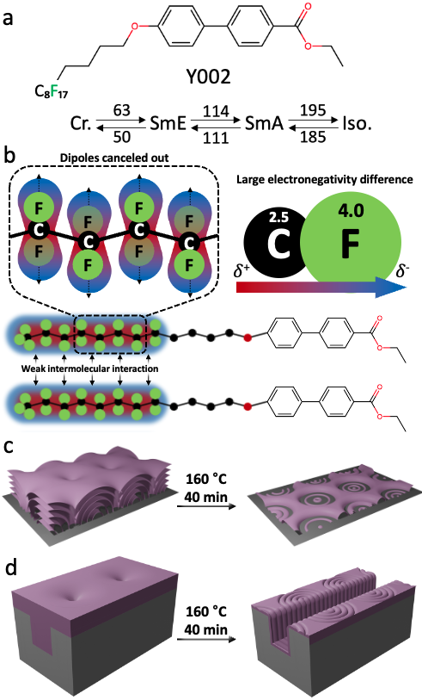
[One column] Figure 1. a) Molecular structure and phase transition temperature of Y002. b) Appearance of strong dipoles formed by the large electronegativity of fluorine. These cancel out and less intermolecular induced polarization occurs. c) Schematic images of the TFCD structure composed of Y002 of the SmA phase on flat Si substrate and the concentric circle pattern formed after sublimation.

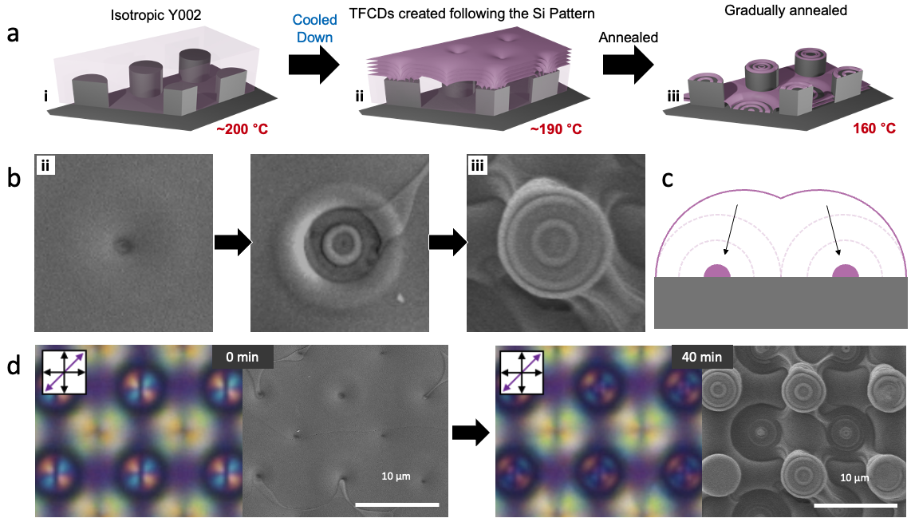
Figure 2. a) The sublimation process of Y002 on a Si pattern; i. The substrate is heated to 200 °C to achieve isotropic state. ii. When cooled at a rate of 5 °C/min, the arrangement of TFCDs is significantly influenced by the Si substrate pattern beneath the Y002 surface. iii. The TFCDs are annealed and fixed for less than an hour at 160°C. b) Top-view SEM images of sublimation process of Y002 in circular pillar patterns. c) Side-view schematic image of sublimation process of Y002 in circular pillar patterns. d) Sublimation process and schematic illustration of Y002 in circular pillar patterns array.

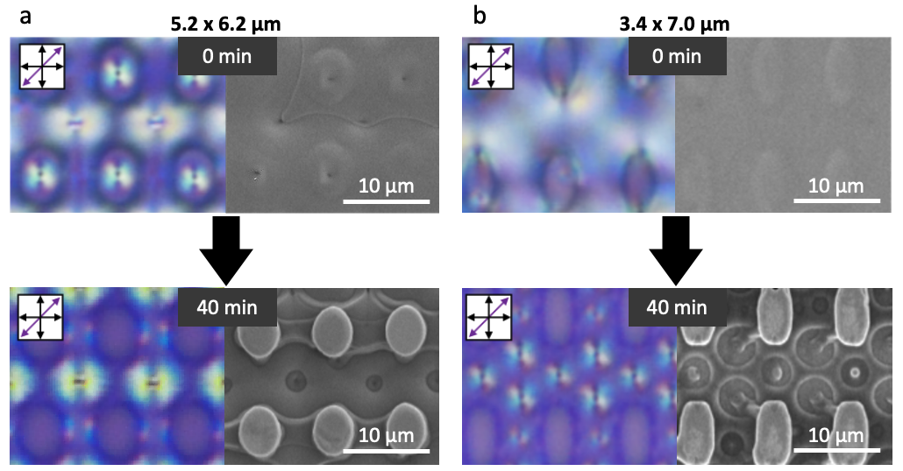
Figure 3. Sublimation process of Y002 in two elliptical pillar patterns. a) 5.2 x 6.2 µm, and b) 3.4 x 7.0 µm.

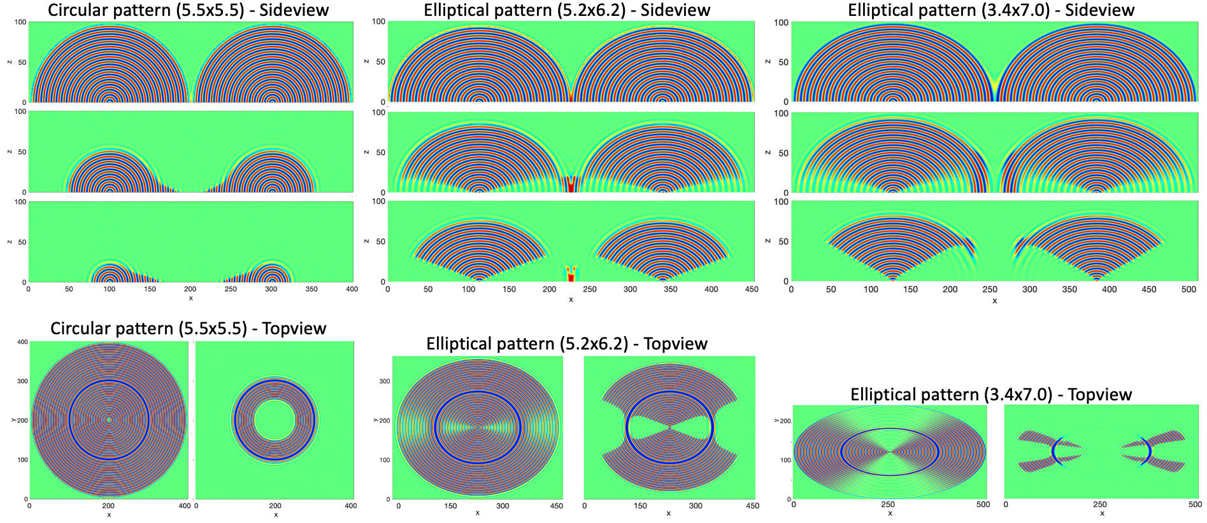
Figure 4. Simulation images of the TFCD droplet sublimation process, with an initial order parameter condition consisting of a half spindle torus with circular and elliptical bases. The blue and red lamellae represent the smectic layering, and the green is a distinct isotropic phase. The thick blue lines on topviews indicate the central circle of the torus.

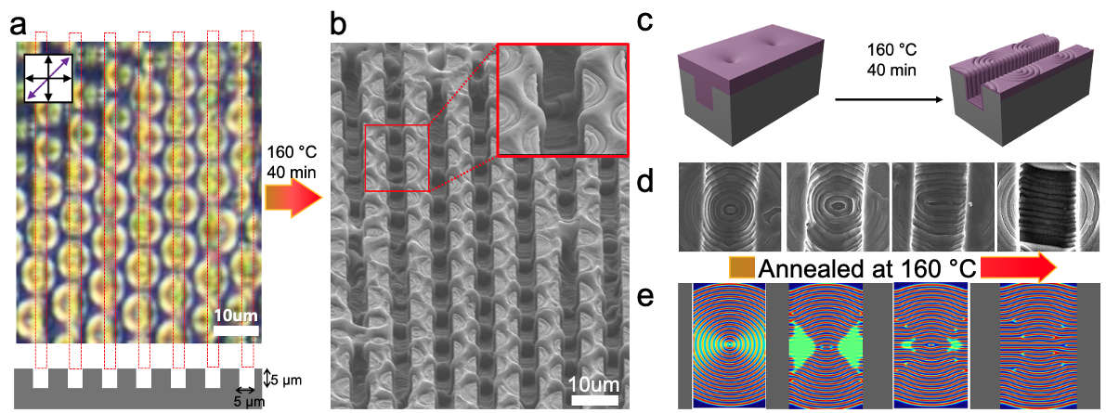
Figure 5. a) Polarized optical microscope (POM) and b) SEM images of sublimation process of TFCDs array on a 5 µm-channel patterned Si wafer. c) Schematic images of sublimation process of TFCDs array. d) Top view of SEM images of sublimation process of TFCDs array. e) Simulation comparisons corresponding to SEM images of each sublimation process.

