React With Redux Certification Training

Module 1: Introduction To Web Development

And React

Assignment Document





© Brain4ce Education Solutions Pvt. Ltd.

Module 1- Introduction To Web Development And React

**Create a React application by following the below steps:**

1. Install Nodejs and create the basic seed of React

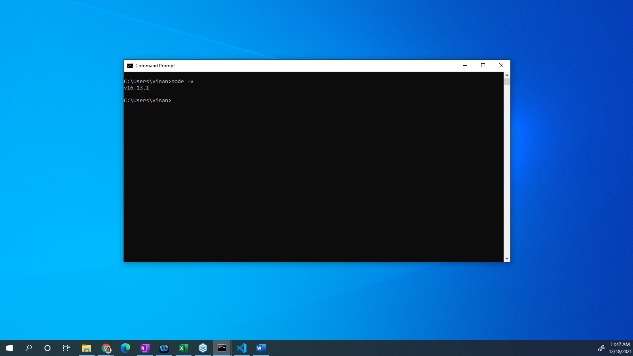

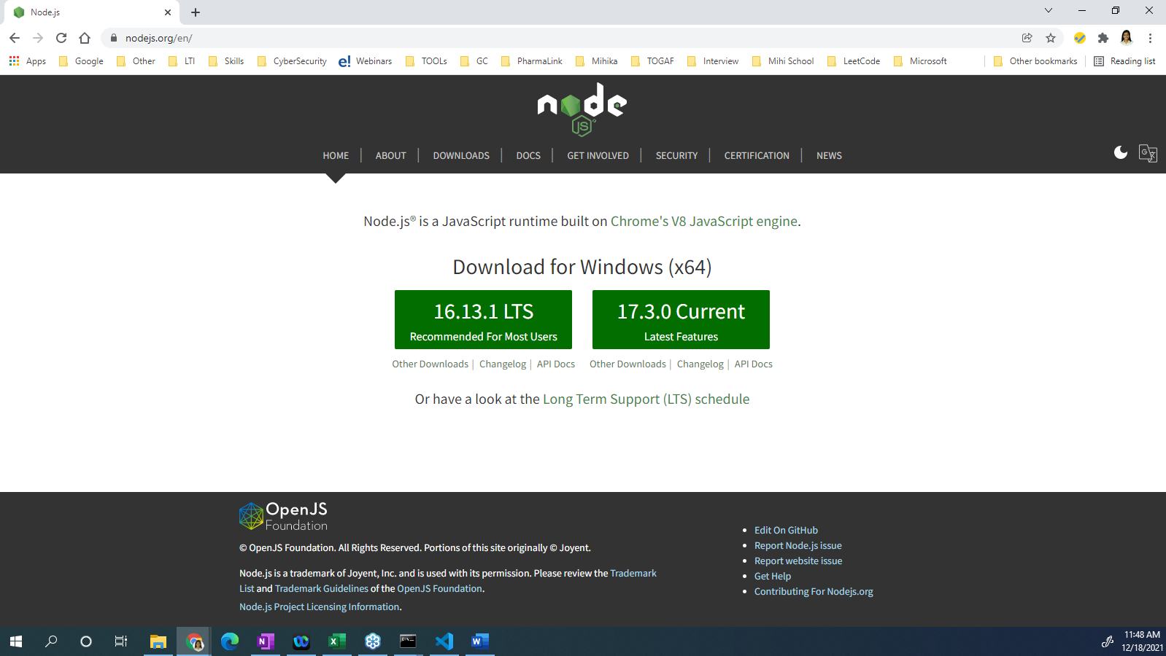

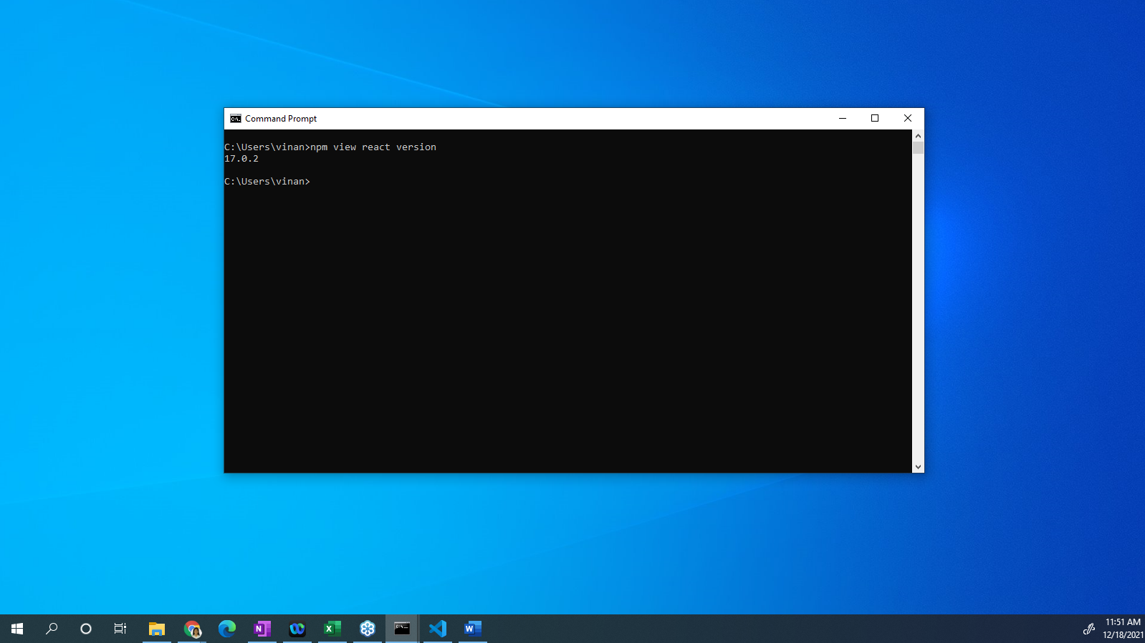

1. Setup the Visual studio code and setup the React application in VS code

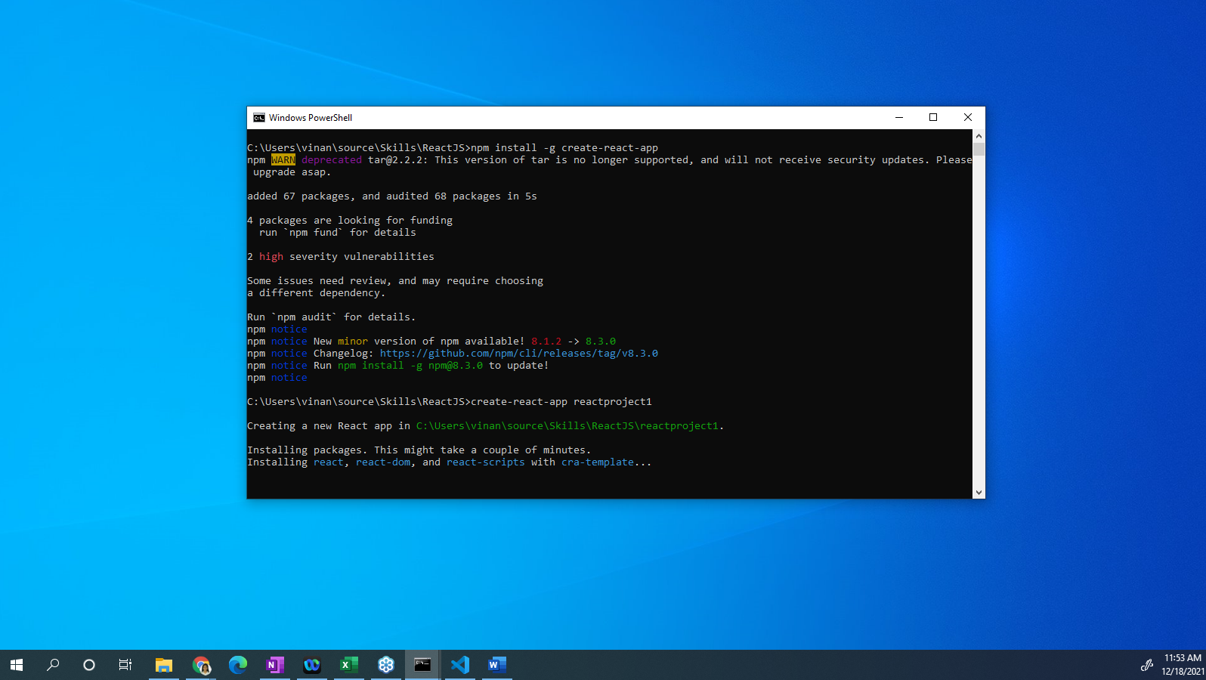

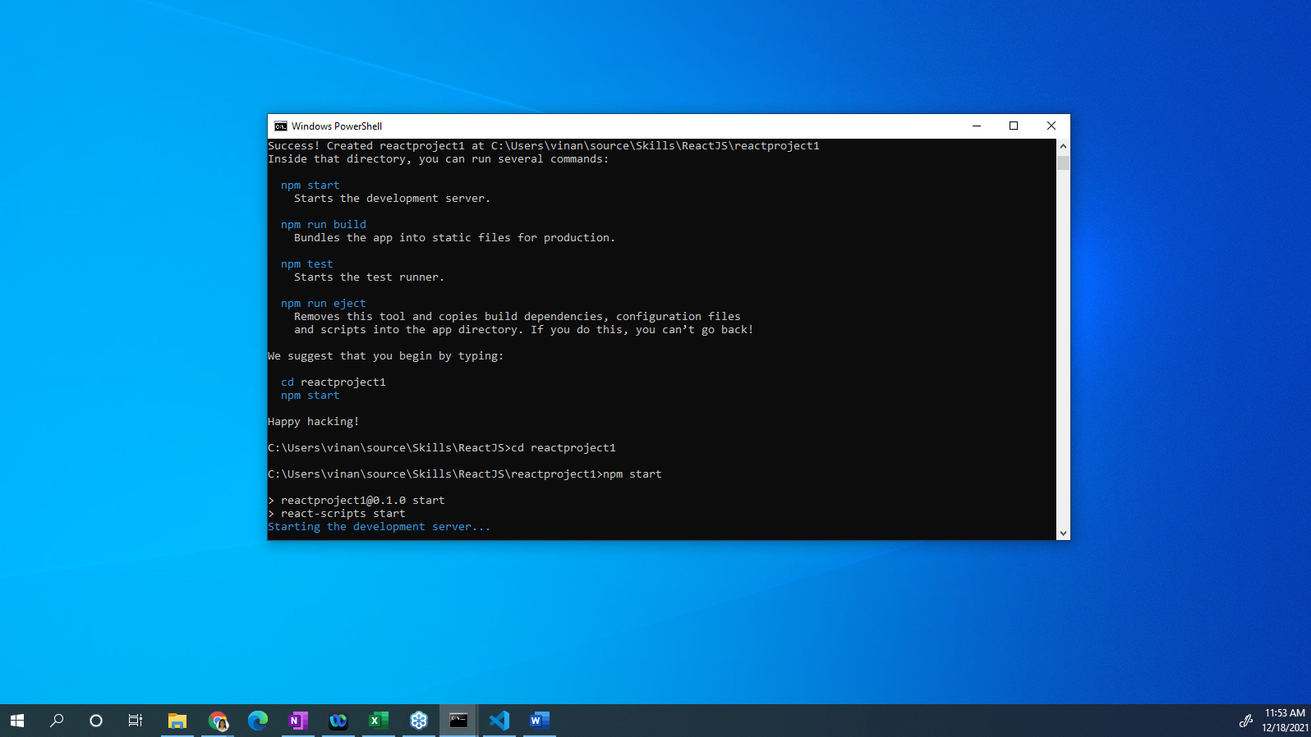

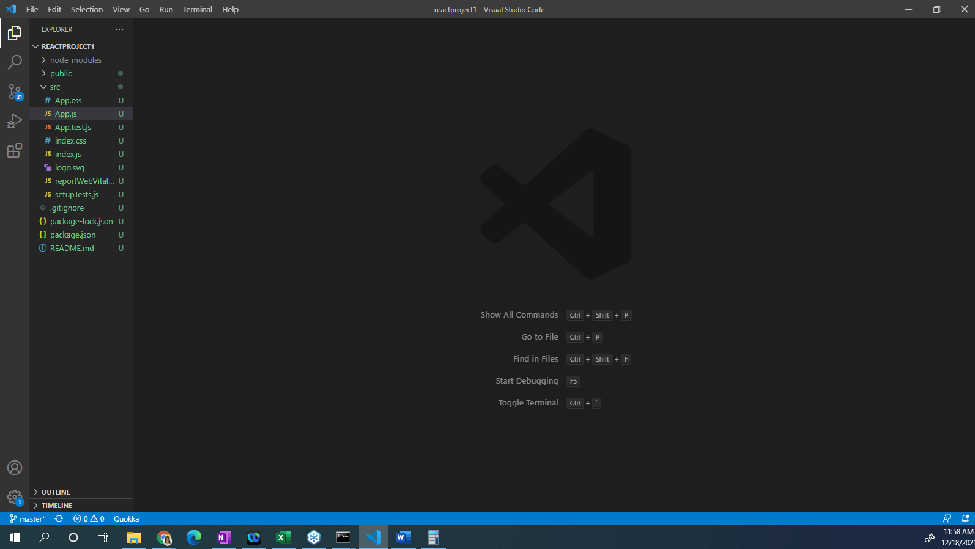

1. Create the ***Home Page*** of the application

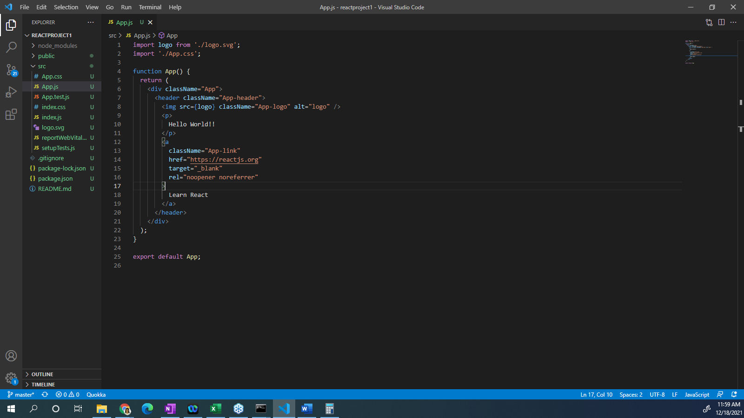

1. Run the application in the browser

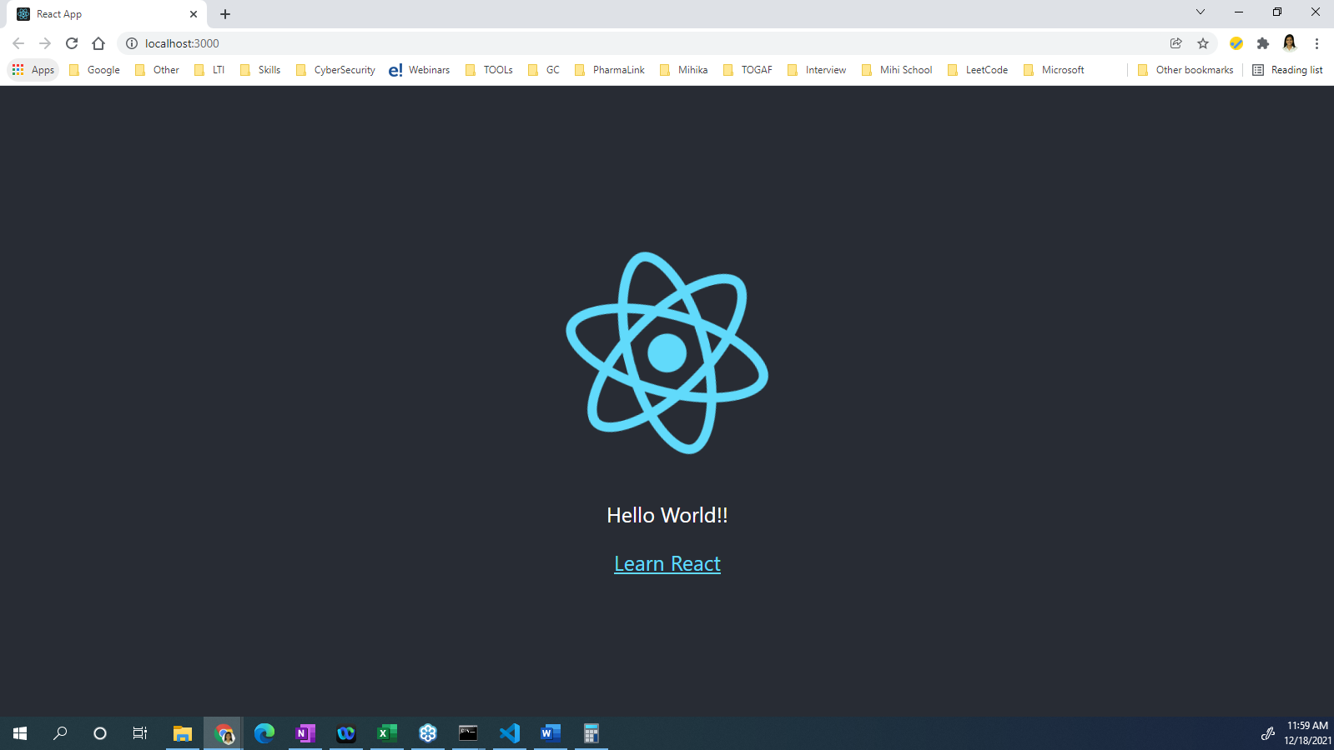

|  |  |
| --- | --- |
| © B r a i n 4 c e E d u c a t i o n S o l u t i o n s P v t . L t d | Page  1 |

