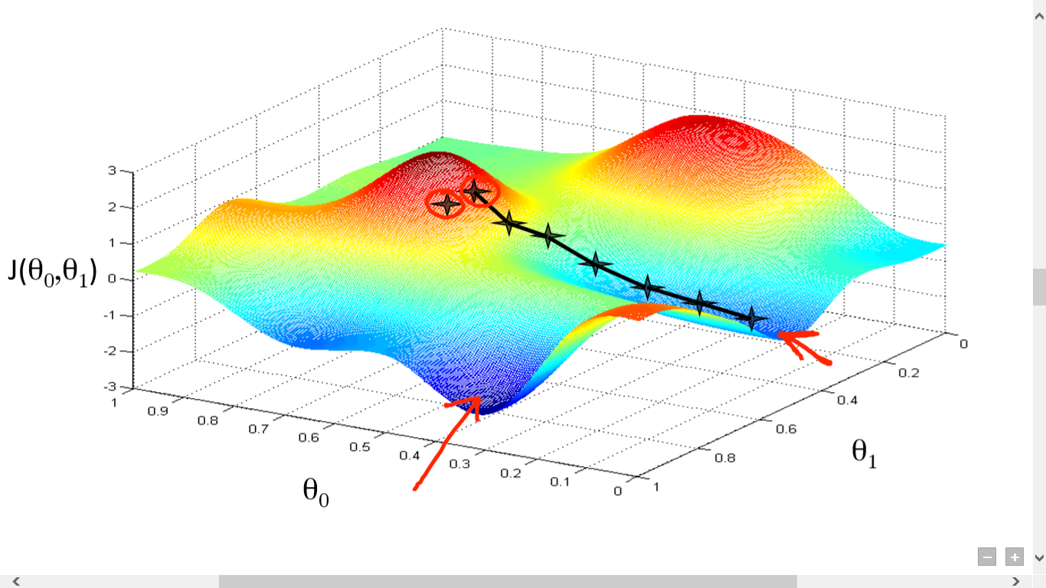

Under the guidance of Dr. Kapil Ahuja

Aman Verma | 170001005

Amanpreet Singh | 170001006

Gradient Descent

Analysis and implementation of algorithms

# Introduction

Gradient Descent is a first order iterative optimization algorithm for finding the minimum of a function. This project mainly deals with the Stochastic Gradient Descent (SGD) algorithm, which is a stochastic approach of gradient descent optimization.  It is called **stochastic** because samples are selected randomly (or shuffled) instead of as a single group or in the order they appear in the training set. SGD finds it’s use in Neural Networks in Deep Learning.

# Objectives

* To analyze the existing algorithms
* To implement few of the available algorithms
* To propose optimizations to the available algorithms if possible

# Overview

Firstly, we’ll analyze the available algorithms on the parameters of Time and Space complexity. This involves conducting an asymptotic analysis as well as run time analysis of the algorithms. We’d also briefly discuss the design strategies of the algorithms.

Next, we’ll try to implement as many algorithms as possible from the pool of existing algorithms and their optimizations and hence, we’d compare the implemented algorithms.

Finally, we would try to propose some sort of optimizations, if possible, to the algorithms present.

# References

1. An overview of gradient descent algorithms – Sebastian Ruder
2. Wikipedia
3. <http://ruder.io/optimizing-gradient-descent/>