AMAZON PRODUCT ANALYSIS QUERY DOCUMENT

A. AMAZON PRODUCT DATA | DATABASE SETUP

Database, Table & Data Load:
Create Database
CREATE DATABASE IF NOT EXISTS amazon_db
CHARACTER SET utf8mb4 COLLATE utf8mb4_unicode_ci;

USE amazon_db;

Create Table
CREATE TABLE amazon_product_data (
product_id VARCHAR(20),
product_name VARCHAR(600),
main_category VARCHAR(50),
sub_category VARCHAR(80),
product_type VARCHAR(80),
discounted_price DECIMAL(10,2),
actual_price DECIMAL(10,2),
discount_percentage VARCHAR(10),
calculated_discount VARCHAR(10),
rating DECIMAL(3,1),
savings DECIMAL(10,2),
rating_count VARCHAR(20),
about_product TEXT,
user_id MEDIUMTEXT,
user_name MEDIUMTEXT,
review_id MEDIUMTEXT,
review_title MEDIUMTEXT,
review_content MEDIUMTEXT,
img_link MEDIUMTEXT,
product_link MEDIUMTEXT
) CHARACTER SET utf8mb4 COLLATE utf8mb4_unicode_ci;

Load Data
SET GLOBAL local_infile = 1;

LOAD DATA LOCAL INFILE '/Users/mutyalavinay/Downloads/amazon_product_data.csv'
INTO TABLE amazon_product_data
CHARACTER SET utf8mb4
FIELDS TERMINATED BY ',' ENCLOSED BY '"'
LINES TERMINATED BY '\n'
IGNORE 1 LINES;

Data Cleaning & Type Conversion
set sql_safe_updates = 1;

UPDATE amazon_product_data
SET
discount_percentage =
NULLIF(REGEXP_REPLACE(TRIM(discount_percentage), '[^0-9.-]', ''), ''),
calculated_discount =
NULLIF(REGEXP_REPLACE(TRIM(calculated_discount), '[^0-9.-]', ''), ''),
rating_count =
NULLIF(REPLACE(TRIM(rating_count), ',', ''), '');

Alter table amazon_product_data
Modify column discount_percentage decimal(5,2),
Modify column calculated_discount decimal(10,2),
Modify column rating_count Bigint;

B. AMAZON PRODUCT ANALYSIS | SUMMARY

KPIs:
Total Records
SELECT count(*) from amazon_product_data;
[Result screenshot to be added]
Total Products
Select count(Distinct product_id) as Total_products from amazon_product_data;
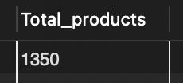
Average Discounted Price
select round(avg(discounted_price),2) as avg_discounted_price from amazon_product_data;
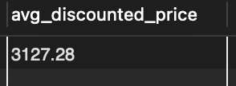
Average Discount Percentage
select round(avg(discount_percentage),2) as avg_discount from amazon_product_data;
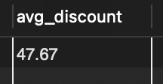
Average Rating
select round(avg(rating),2) as avg_rating from amazon_product_data;
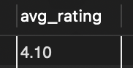
Total Ratings
select sum(rating_count) as Total_Ratings from amazon_product_data;
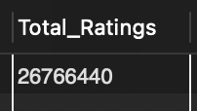

C. AMAZON PRODUCT ANALYSIS | CATEGORY OVERVIEW
Total Products by Main Category
select main_category, count(distinct product_id) as Total_products
from amazon_product_data
group by main_category
order by Total_products desc;
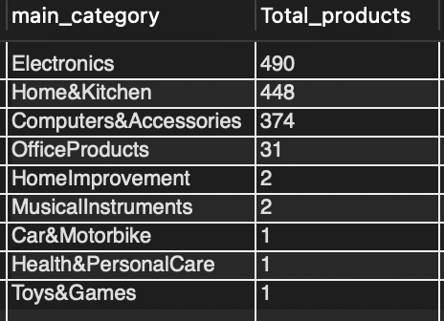
Average Rating by Main Category
select main_category, round(avg(rating),2) as avg_rating
from amazon_product_data
group by main_category
order by avg_rating desc;
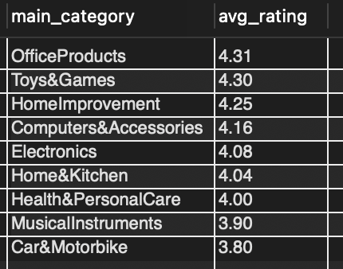
Average Price & Savings by Main Category
select main_category,
round(avg(actual_price),2) as avg_actual_price,
round(avg(discounted_price),2) as avg_discounted_price,
round(avg(actual_price-discounted_price),2) as avg_savings
from amazon_product_data
group by main_category
order by avg_savings desc;
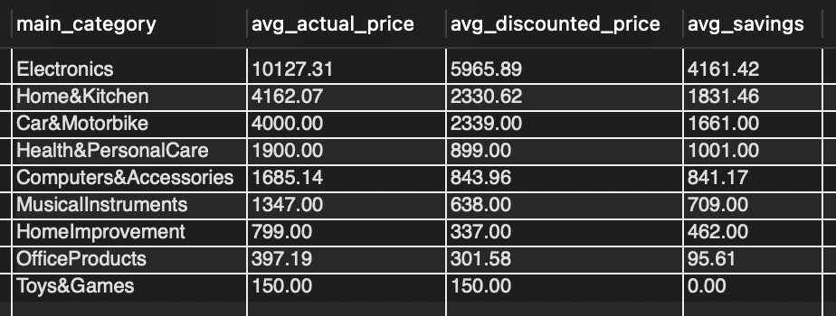
Category Performance Grade
with category_performance as (
select main_category,
count(distinct product_id) as Total_products,
round(avg(rating),2) as avg_rating
from amazon_product_data
group by main_category
)
select *,
case
when avg_rating>=4.0 then 'Excellent'
when avg_rating >=3.5 then 'Good'
when avg_rating >=3.0 then 'Average'
else 'Below Average' end as Grade
from category_performance;
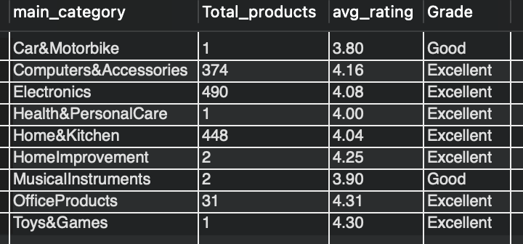

D. AMAZON PRODUCT ANALYSIS | PRODUCT OVERVIEW
Top 10 Most Rated Products
select product_name, main_category, rating, rating_count
from amazon_product_data
order by rating_count desc
limit 10;
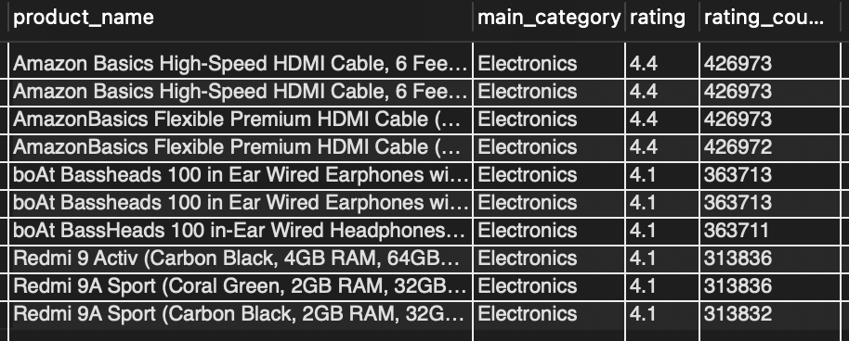
Discount vs Rating (All Products)
select product_id, product_name, discount_percentage, rating, rating_count
from amazon_product_data
where discount_percentage is not null and rating is not null
order by discount_percentage desc;
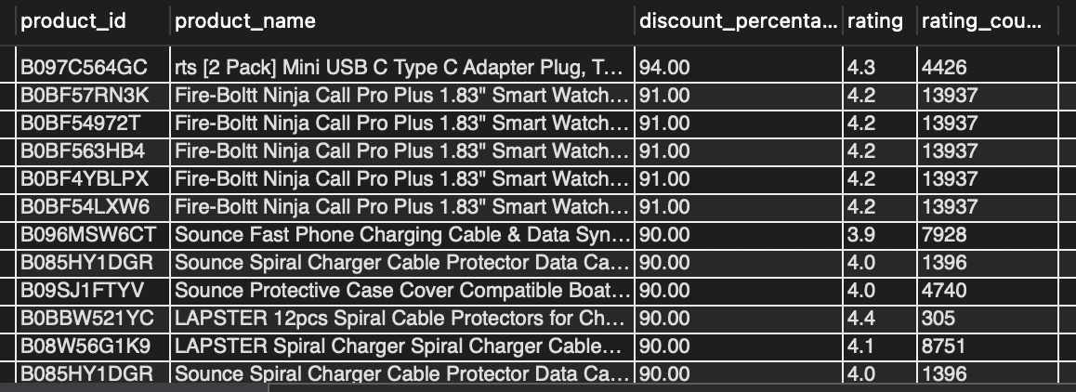
Top 10 Products by Discount
select product_id, product_name, main_category, actual_price, discount_percentage
from amazon_product_data
order by discount_percentage desc
limit 10;
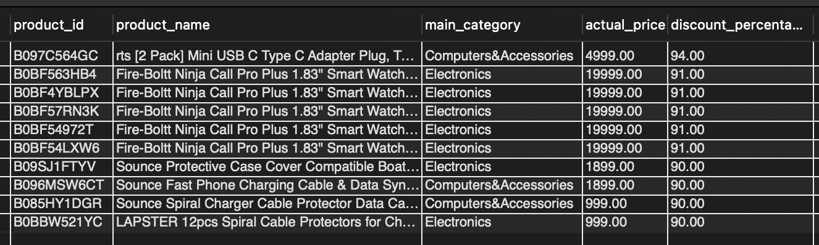
Top 5 Products per Category (Rank & Dense Rank)
With ranked_products as (
select product_id,
product_name,
main_category,
rating,
rating_count,
rank() over(partition by main_category order by rating desc) as product_rank,
dense_rank() over(partition by main_category order by rating desc) as product_dense_rank
from amazon_product_data
)
select *
from ranked_products where product_rank <= 5
order by main_category, product_rank;
[Result screenshot to be added]

