BANK LOAN REPORT QUERY DOCUMENT

A. BANK LOAN REPORT | SUMMARY

KPIs:
Total Loan Applications
select count(id) as total_loan_applications from financial_loan;
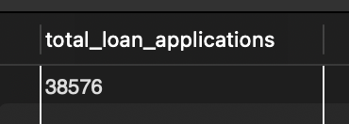
MTD Loan Applications
select count(id) as MTD_total_applications
from financial_loan
where month(issue_date) = 12 and year(issue_date) = 2021;
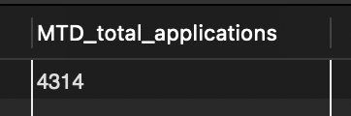
PMTD Loan Applications
select count(id) as PMTD_total_applications
from financial_loan
where month(issue_date) = 11 and year(issue_date) = 2021;
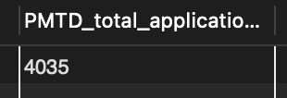

Total Funded Amount
select sum(loan_amount) as Total_funded_amount from financial_loan;
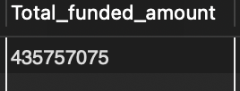
MTD Total Funded Amount
select sum(loan_amount) as MTD_Total_funded_amount from financial_loan
where month(issue_date) = 12 and year(issue_date) = 2021;
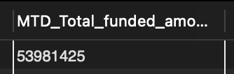
PMTD Total Funded Amount
select sum(loan_amount) as PMTD_Total_funded_amount from financial_loan
where month(issue_date) = 11 and year(issue_date) = 2021;
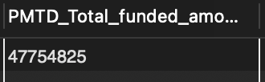

Total Amount Received
select sum(total_payment) as Total_amount_received from financial_loan;
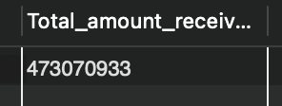
MTD Total Amount Received
select sum(total_payment) as MTD_Total_amount_received from financial_loan
where month(issue_date) = 12 and year(issue_date) = 2021;
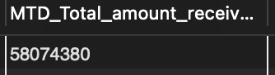
PMTD Total Amount Received
select sum(total_payment) as PMTD_Total_amount_received from financial_loan
where month(issue_date) = 11 and year(issue_date) = 2021;
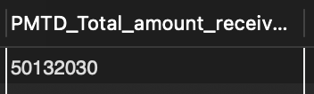

Average Interest Rate
select round(avg(int_rate)*100,2) as average_interest from financial_loan;
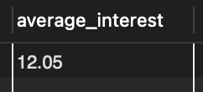
MTD Average Interest Rate
select round(avg(int_rate)*100,2) as MTD_average_interest from financial_loan
where month(issue_date) = 12 and year(issue_date) = 2021;
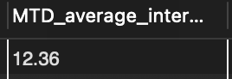
PMTD Average Interest Rate
select round(avg(int_rate)*100,2) as PMTD_average_interest from financial_loan
where month(issue_date) = 11 and year(issue_date) = 2021;
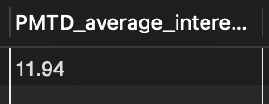

Avg DTI
select round(avg(dti)*100,2) as Avg_DTI from financial_loan;
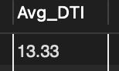
MTD Avg DTI
select round(avg(dti)*100,2) as MTD_Avg_DTI from financial_loan
where month(issue_date) = 12 and year(issue_date) = 2021;
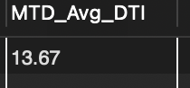
PMTD Avg DTI
select round(avg(dti)*100,2) as PMTD_Avg_DTI from financial_loan
where month(issue_date) = 11 and year(issue_date) = 2021;
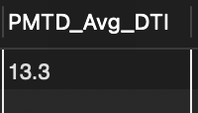

GOOD LOAN ISSUED
Good Loan Percentage
select round((count(case when loan_status = 'Fully Paid' or loan_status = 'Current' then id else Null end)
/ count(id)) * 100, 2) as Good_loan_percentage
from financial_loan;
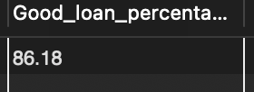
Good Loan Applications
select count(id) as Good_loan_applications from financial_loan
where loan_status = 'Fully Paid' or loan_status = 'Current';
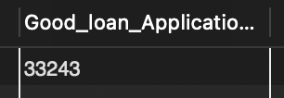
Good Loan Funded Amount
select sum(loan_amount) as Good_loan_funded_amount from financial_loan
where loan_status = 'Fully Paid' or loan_status = 'Current';
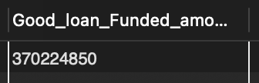
Good Loan Amount Received
select sum(total_payment) as Good_loan_received_amount from financial_loan
where loan_status = 'Fully Paid' or loan_status = 'Current';
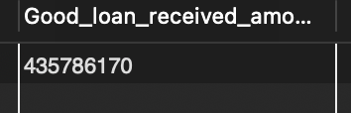

BAD LOAN ISSUED
Bad Loan Percentage
select round((count(case when loan_status = 'Charged Off' then id else Null end)
/ count(id)) * 100, 2) as Bad_loan_percentage
from financial_loan;
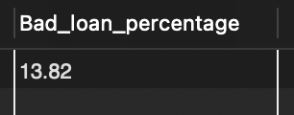
Bad Loan Applications
select count(id) as Bad_loan_applications from financial_loan
where loan_status = 'Charged Off';
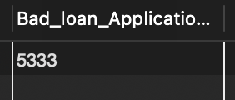
Bad Loan Funded Amount
select sum(loan_amount) as Bad_loan_funded_amount from financial_loan
where loan_status = 'Charged Off';
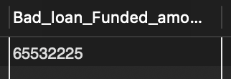
Bad Loan Amount Received
select sum(total_payment) as Bad_loan_received_amount from financial_loan
where loan_status = 'Charged Off';
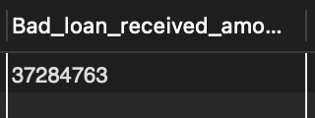

LOAN STATUS
Loan Status Summary
select loan_status, count(id) as Total_loan_applications, sum(loan_amount) as Total_funded_amount,
sum(total_payment) as Total_received_amount, round(avg(int_rate)*100,2) as Avg_interest_rate,
round(avg(dti)*100,2) as Avg_DTI
from financial_loan
group by loan_status;
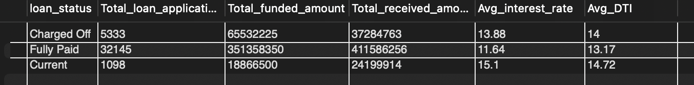
Loan Status | MTD (December 2021)
select loan_status, sum(loan_amount) as MTD_Total_funded_amount,
sum(total_payment) as MTD_Total_received_amount
from financial_loan
where month(issue_date) = 12 and year(issue_date) = 2021
group by loan_status;
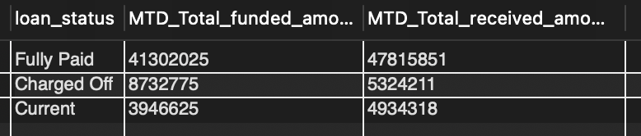

B. BANK LOAN REPORT | OVERVIEW
MONTH
select MONTH(issue_date) as Mon, MONTHNAME(issue_date) as Month_name, count(id) as Total_applications,
sum(loan_amount) as total_funded_amount, sum(total_payment) as total_received_amount
from financial_loan
group by Mon, Month_name
order by Mon;
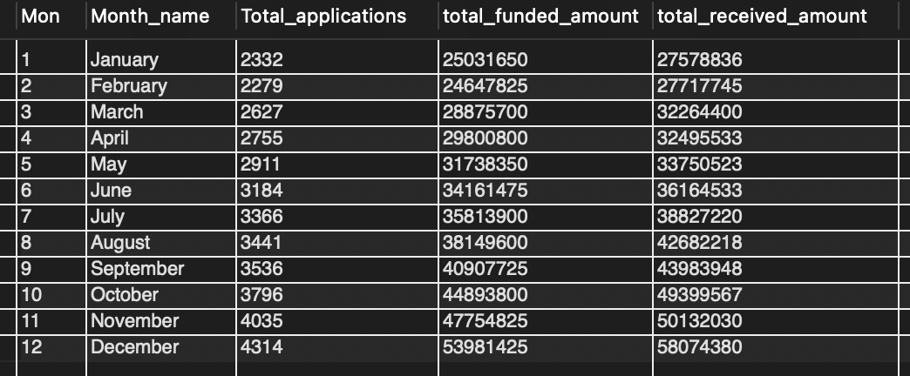
STATE
select address_state, count(id) as Total_applications, sum(loan_amount) as total_funded_amount,
sum(total_payment) as total_received_amount
from financial_loan
group by address_state
order by total_funded_amount desc;
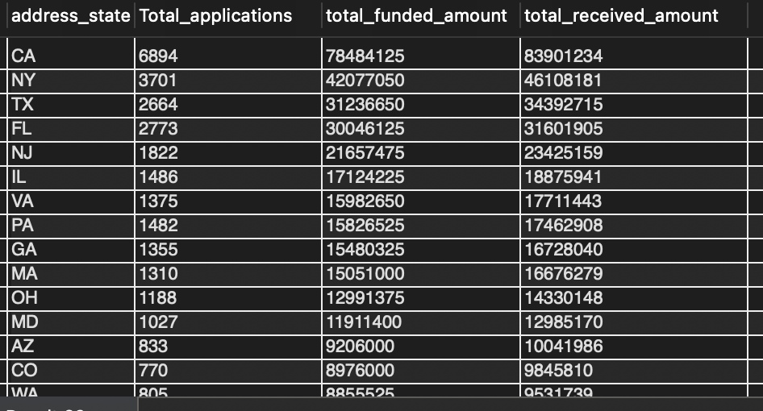
TERM
select term, count(id) as Total_applications, sum(loan_amount) as total_funded_amount,
sum(total_payment) as total_received_amount
from financial_loan
group by term
order by term;
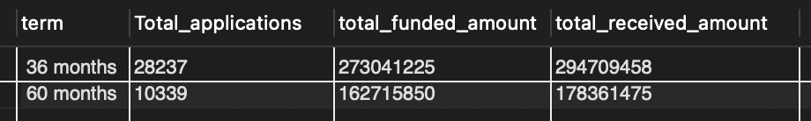
EMPLOYEE LENGTH
select emp_length, count(id) as Total_applications, sum(loan_amount) as total_funded_amount,
sum(total_payment) as total_received_amount
from financial_loan
group by emp_length
order by emp_length;
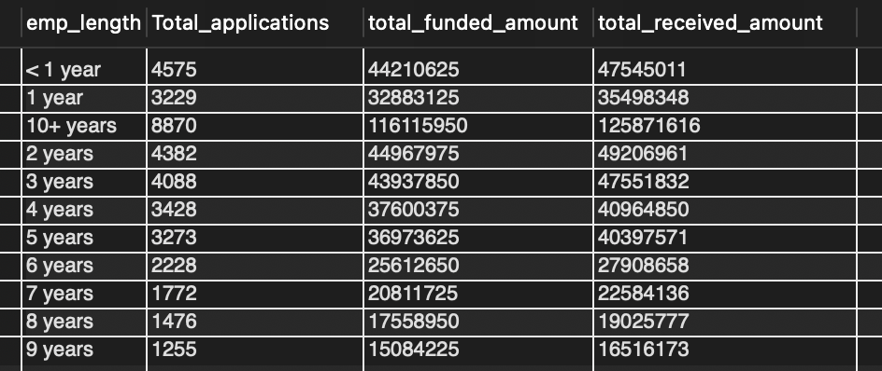
PURPOSE
select purpose, count(id) as Total_applications, sum(loan_amount) as total_funded_amount,
sum(total_payment) as total_received_amount
from financial_loan
group by purpose
order by Total_applications desc;
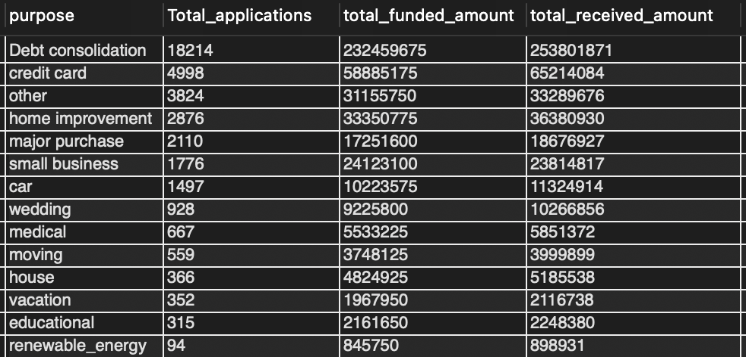
HOME OWNERSHIP
select home_ownership, count(id) as Total_applications, sum(loan_amount) as total_funded_amount,
sum(total_payment) as total_received_amount
from financial_loan
group by home_ownership
order by Total_applications desc;
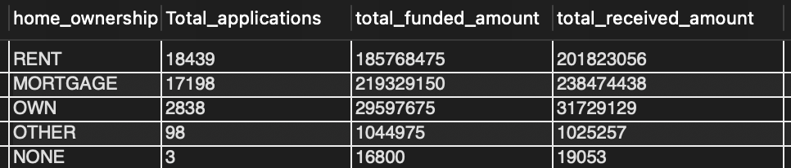
Note: Filters can be applied to any of these queries by adding a WHERE condition (for example, where grade = 'A').

