Case Study: Setting up a Secure CI/CD Pipeline for Juice Shop Web Application on AWS

Introduction:

This case study outlines the step-by-step process of setting up a secure CI/CD pipeline for the Juice Shop web application hosted on AWS. The objective is to integrate Static Application Security Testing (SAST) using SonarQube and Dynamic Application Security Testing (DAST) using OWASP ZAP, generate an output report.

Repository:

The code for the Juice Shop web application is available at https://github.com/juice-shop/juice-shop.git

Process:

1. Setup a AWS server with Jenkins, SonarQube, OWASP ZAP and Juice-Shop application:

- Login with AWS Console and select EC2 service in it.
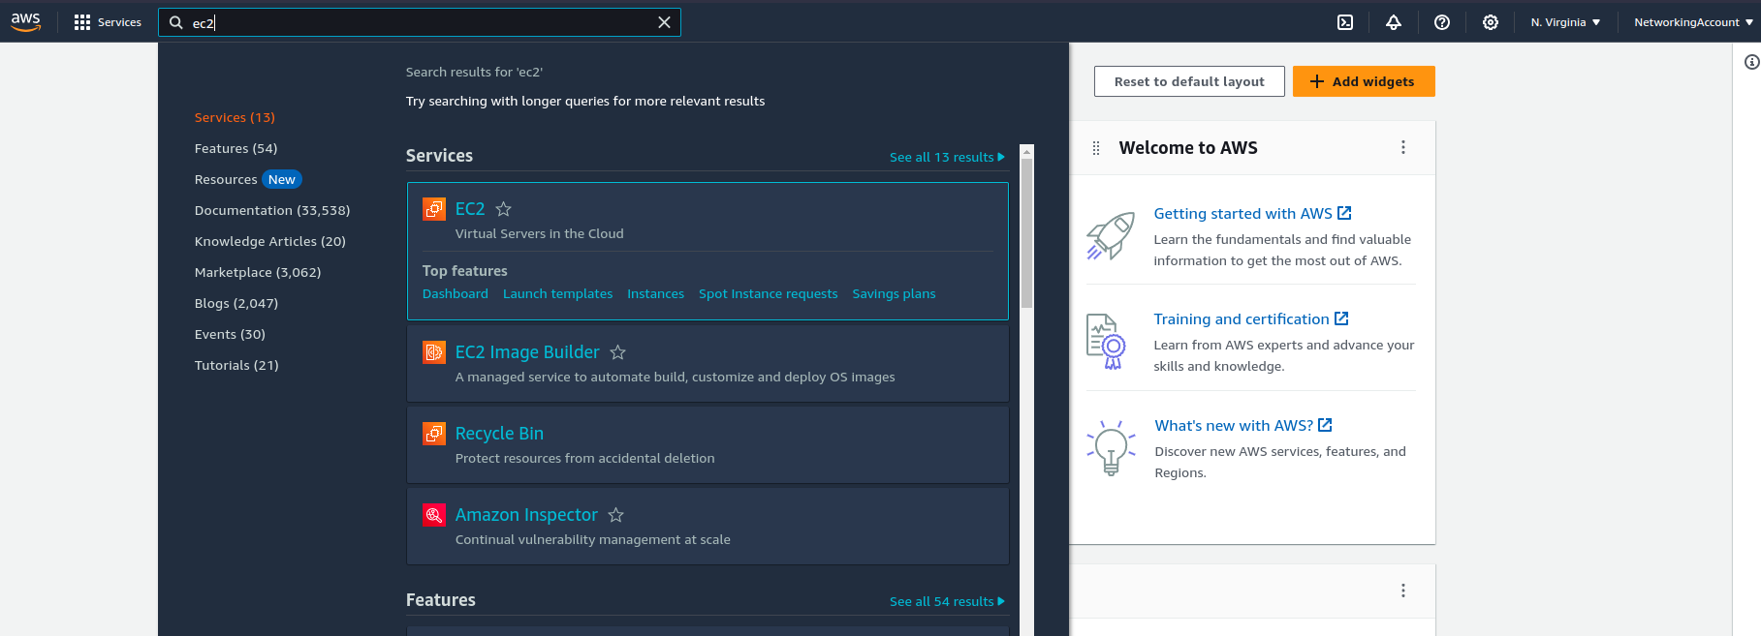

- Click on Launch instance.
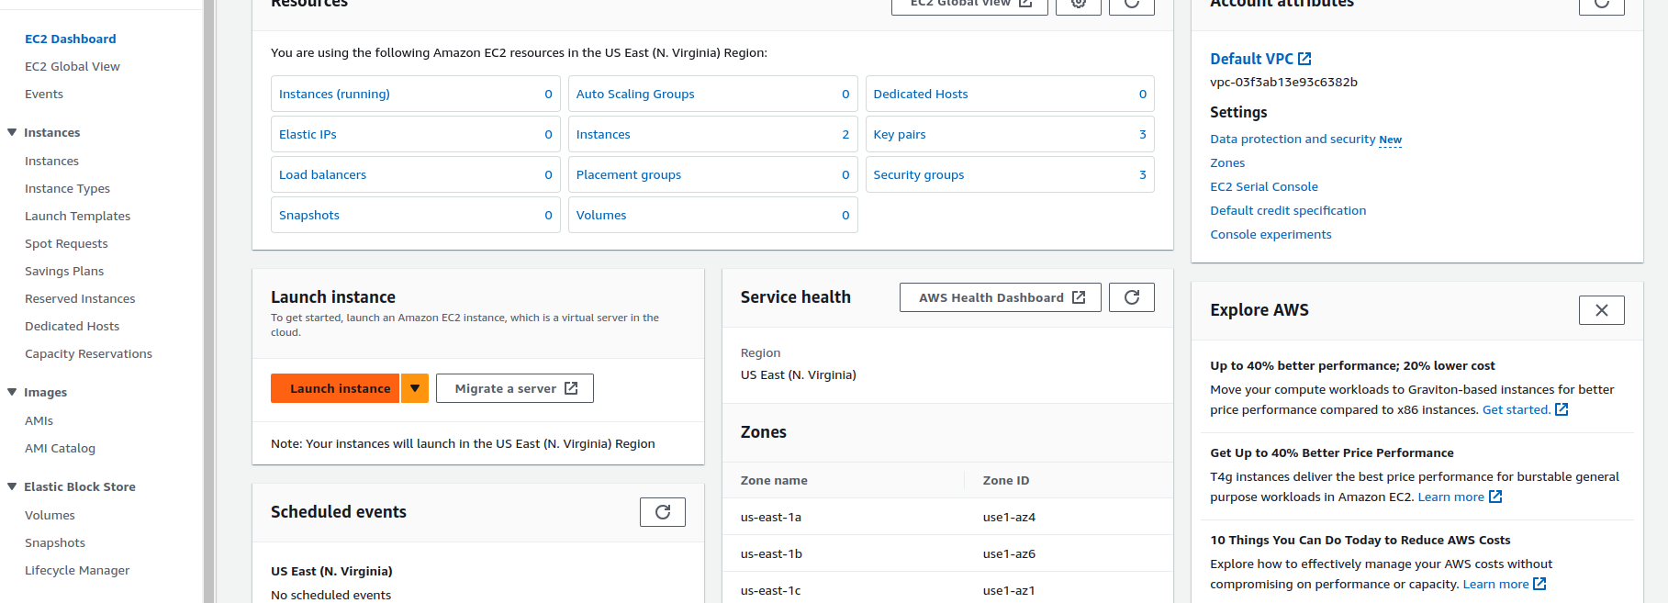
- Give the name & select the instance type & ami to launch the instance.
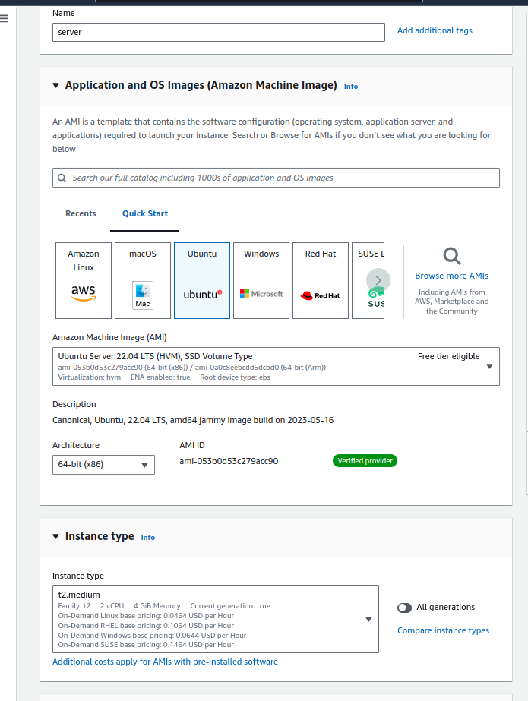

- Let the configuration be default & launch the instance.

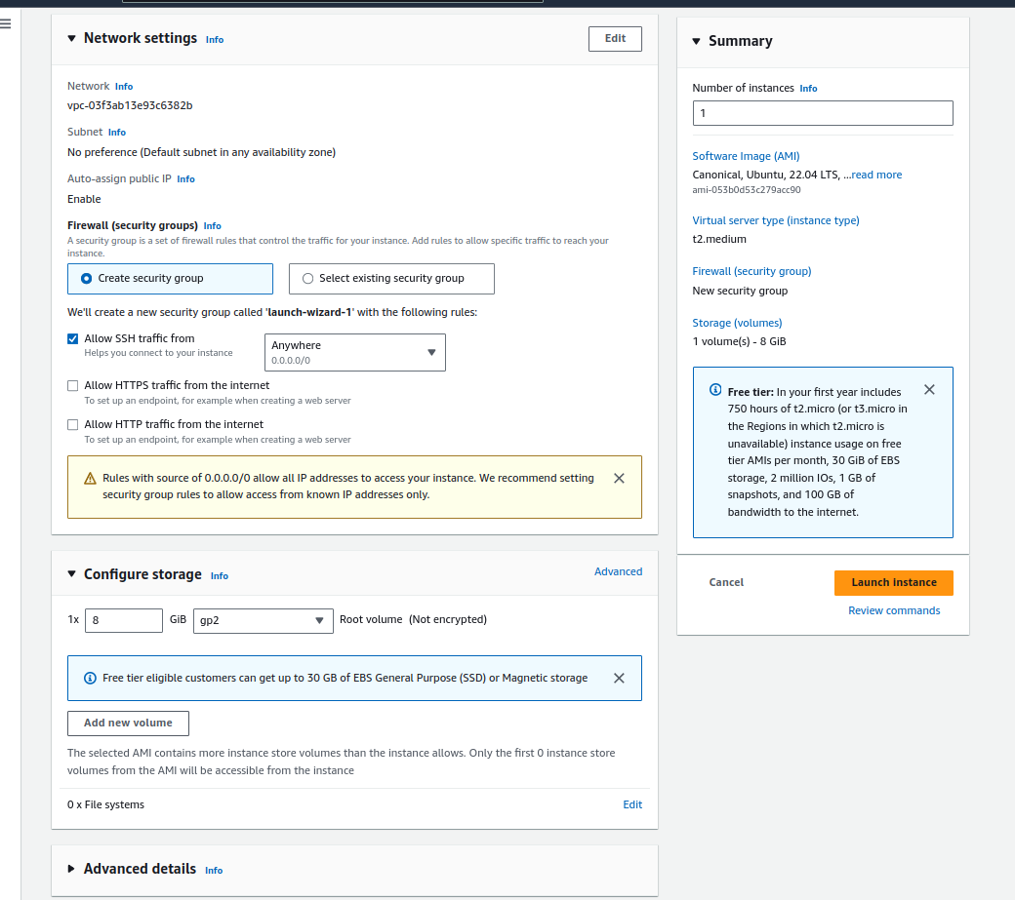
- It will take time to create instance. Go to ec2 instance page and select the created instance & select the security tab below:
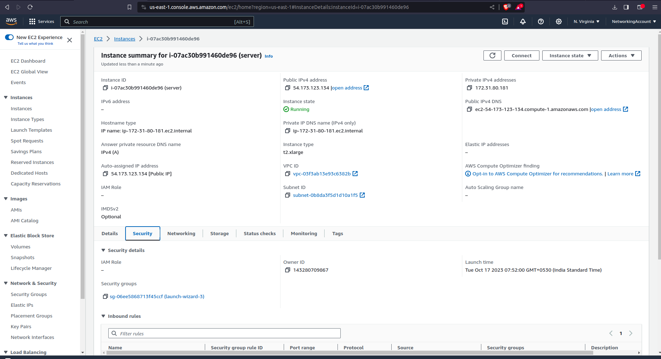

- click on security-group to add ingress traffic in port 80,8080 & 9000 for application, jenkins & sonarqube.
- Go to inbound rules tab and click on edit inbound rules and add as below & save it:

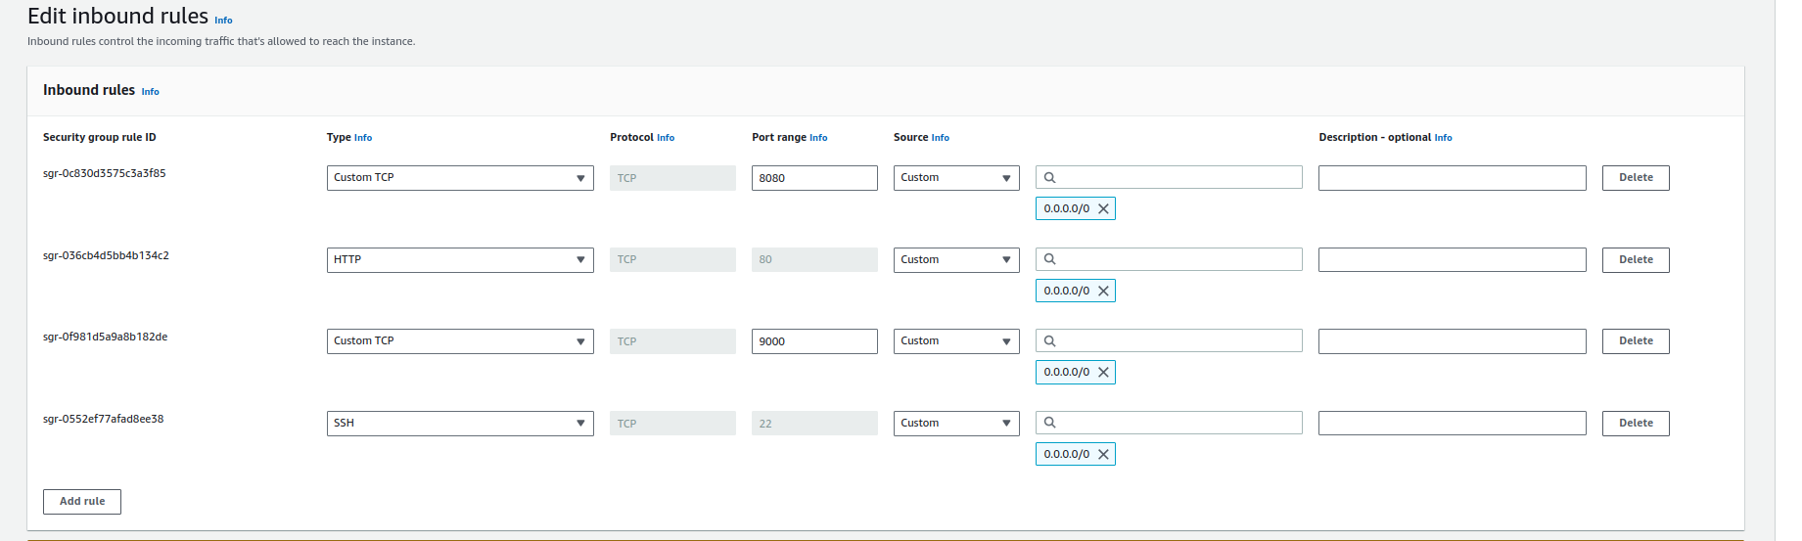
- Go to instance page & connect to instance via aws console:
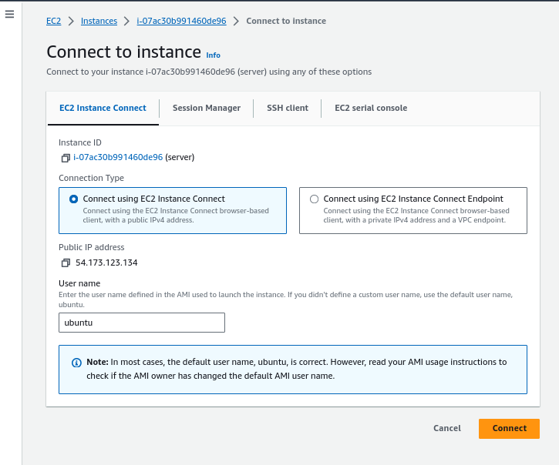

- Run the below script to install all required depends & softwares:

sudo su
mkdir /juice-shop && cd /juice-shop
apt-get update -y
apt-get install openjdk-11-jdk -y
apt install docker.io -y
docker pull bkimminich/juice-shop
docker run --name=juice-shop-app -d -p 80:3000 bkimminich/juice-shop:latest
curl -fsSL https://pkg.jenkins.io/debian-stable/jenkins.io-2023.key | sudo tee \
/usr/share/keyrings/jenkins-keyring.asc > /dev/null
echo deb [signed-by=/usr/share/keyrings/jenkins-keyring.asc] \
https://pkg.jenkins.io/debian-stable binary/ | sudo tee \
/etc/apt/sources.list.d/jenkins.list > /dev/null
apt-get update -y
apt-get install jenkins -y
mkdir -p /juice-shop/sonarqube && cd /juice-shop/sonarqube
wget https://binaries.sonarsource.com/Distribution/sonarqube/sonarqube-10.2.1.78527.zip
wget https://builds.openlogic.com/downloadJDK/openlogic-openjdk/17.0.8+7/openlogic-openjdk-17.0.8+7-linux-x64.tar.gz
apt install unzip
unzip sonarqube-10.2.1.78527.zip
tar -xvf openlogic-openjdk-17.0.8+7-linux-x64.tar.gz
chmod -R 777 ./../sonarqube/
exit
export SONAR_JAVA_PATH=/juice-shop/sonarqube/openlogic-openjdk-17.0.8+7-linux-x64/bin/java
/juice-shop/sonarqube/sonarqube-10.2.1.78527/bin/linux-x86-64/sonar.sh start

sudo su
mkdir -p /juice-shop/zap && cd /juice-shop/zap
wget https://github.com/zaproxy/zaproxy/releases/download/v2.13.0/ZAP_2.13.0_Linux.tar.gz
tar -xvf ZAP_2.13.0_Linux.tar.gz
mkdir -p /juice-shop/nodejs && cd /juice-shop/nodejs
wget https://nodejs.org/dist/v20.8.0/node-v20.8.0-linux-x64.tar.xz
tar -xvf node-v20.8.0-linux-x64.tar.xz
ln -s /juice-shop/nodejs/node-v20.8.0-linux-x64/bin/node /usr/bin/node
mkdir -p /juice-shop/sonarqube/sonar-scanner && cd /juice-shop/sonarqube/sonar-scanner
wget https://binaries.sonarsource.com/Distribution/sonar-scanner-cli/sonar-scanner-cli-5.0.1.3006-linux.zip
unzip sonar-scanner-cli-5.0.1.3006-linux.zip
ln -s /juice-shop/sonarqube/sonar-scanner/sonar-scanner-5.0.1.3006-linux/bin/sonar-scanner /usr/bin/sonar-scanner
apt install git -y
apt install npm -y
wget https://dl.google.com/linux/direct/google-chrome-stable_current_amd64.deb
sudo apt install ./google-chrome-stable_current_amd64.deb

- The above commands will deploy the UI, jenkins, sonarqube, zap & other required dependenices.
- You can be able to see the UI at http://PUBLIC_IP:80
- You can be able to see jenkins at http://PUBLIC_IP:8080
- You can be able to see soanrqube at http://PUBLIC_IP:9000
- Setup Jenkins & install plugins required like github, pipeline, sonarqube and etc.

2. Setup a CI/CD Pipeline:

- Set up a CI/CD pipeline using Jenkins with the following Jenkinsfile.
- Click on New Item in the Jenkins & select the pipeline job & paste the jenkins script in the pipeline editor.
- Add the SonarQube & NodeJS plugins from Plugin Manager & Configure the NodeJS to use 20.x version.
- Create a token in SonarQube Dashboard & add it to Jenkins credentials.
- Pipeline Script (HyperLink)

3. Run the Pipeline & Reports will generated and available in SonarQube dashboard & Jenkins dashboard. Click the below hyperlinks for the reports generated by my pipeline:
- SAST Report (HyperLink)
- DAST Report (HyperLink)

4. Why I have choose sonarqube as SAST Tool:

- Opensource
- supports a wide range of programming languages
- Can integrate with different Plugins
- easily integrate with CI/CD servers
- Simple Dashboard & Reporting the Quality Gate status. Can be easily understood by developers.
- Good active community support to resolve issues.

5. Why I have choose OWASP ZAP as DAST Tool:

- Open-source
- community support
- user-friendly GUI
- generates easily understandable report with remedies
- web application security testing and is highly effective at finding vulnerabilities in web applications and web services.

6. SAST Report Screenshots:

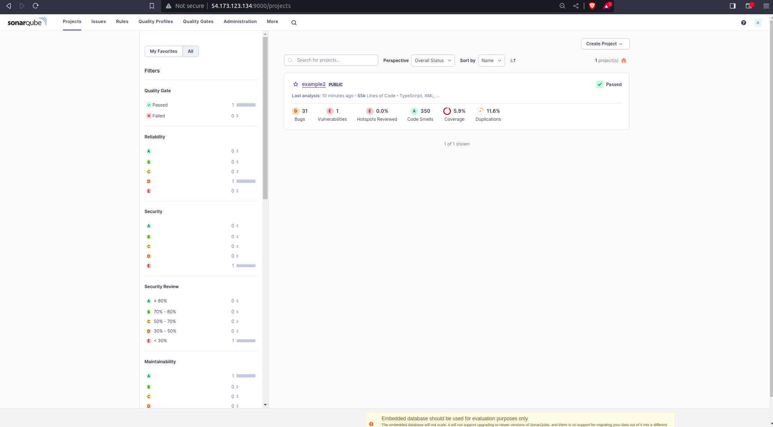

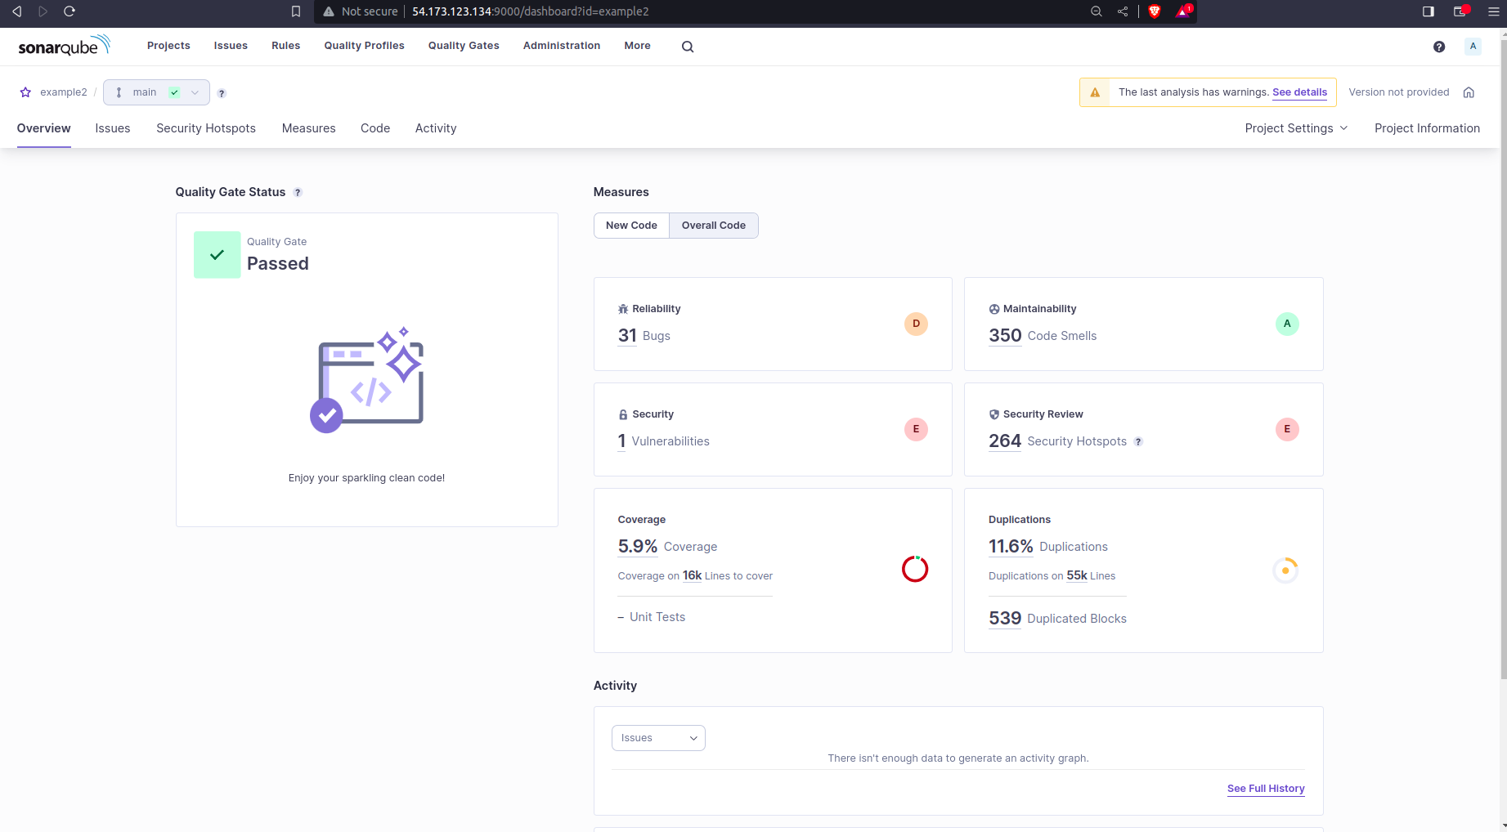

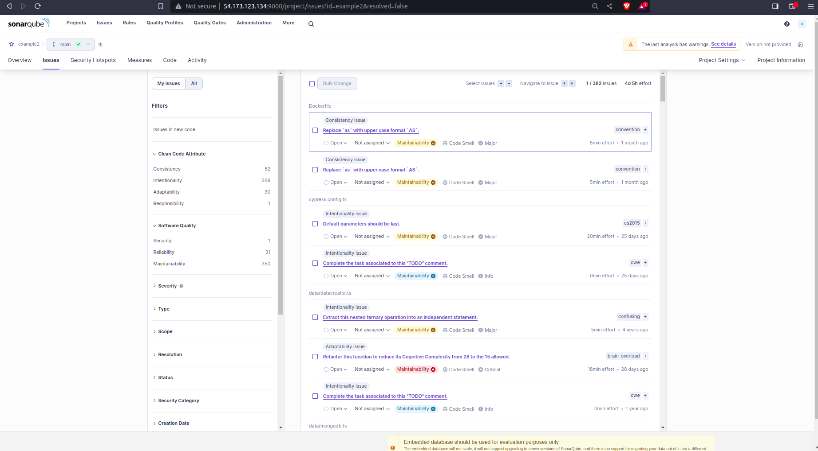
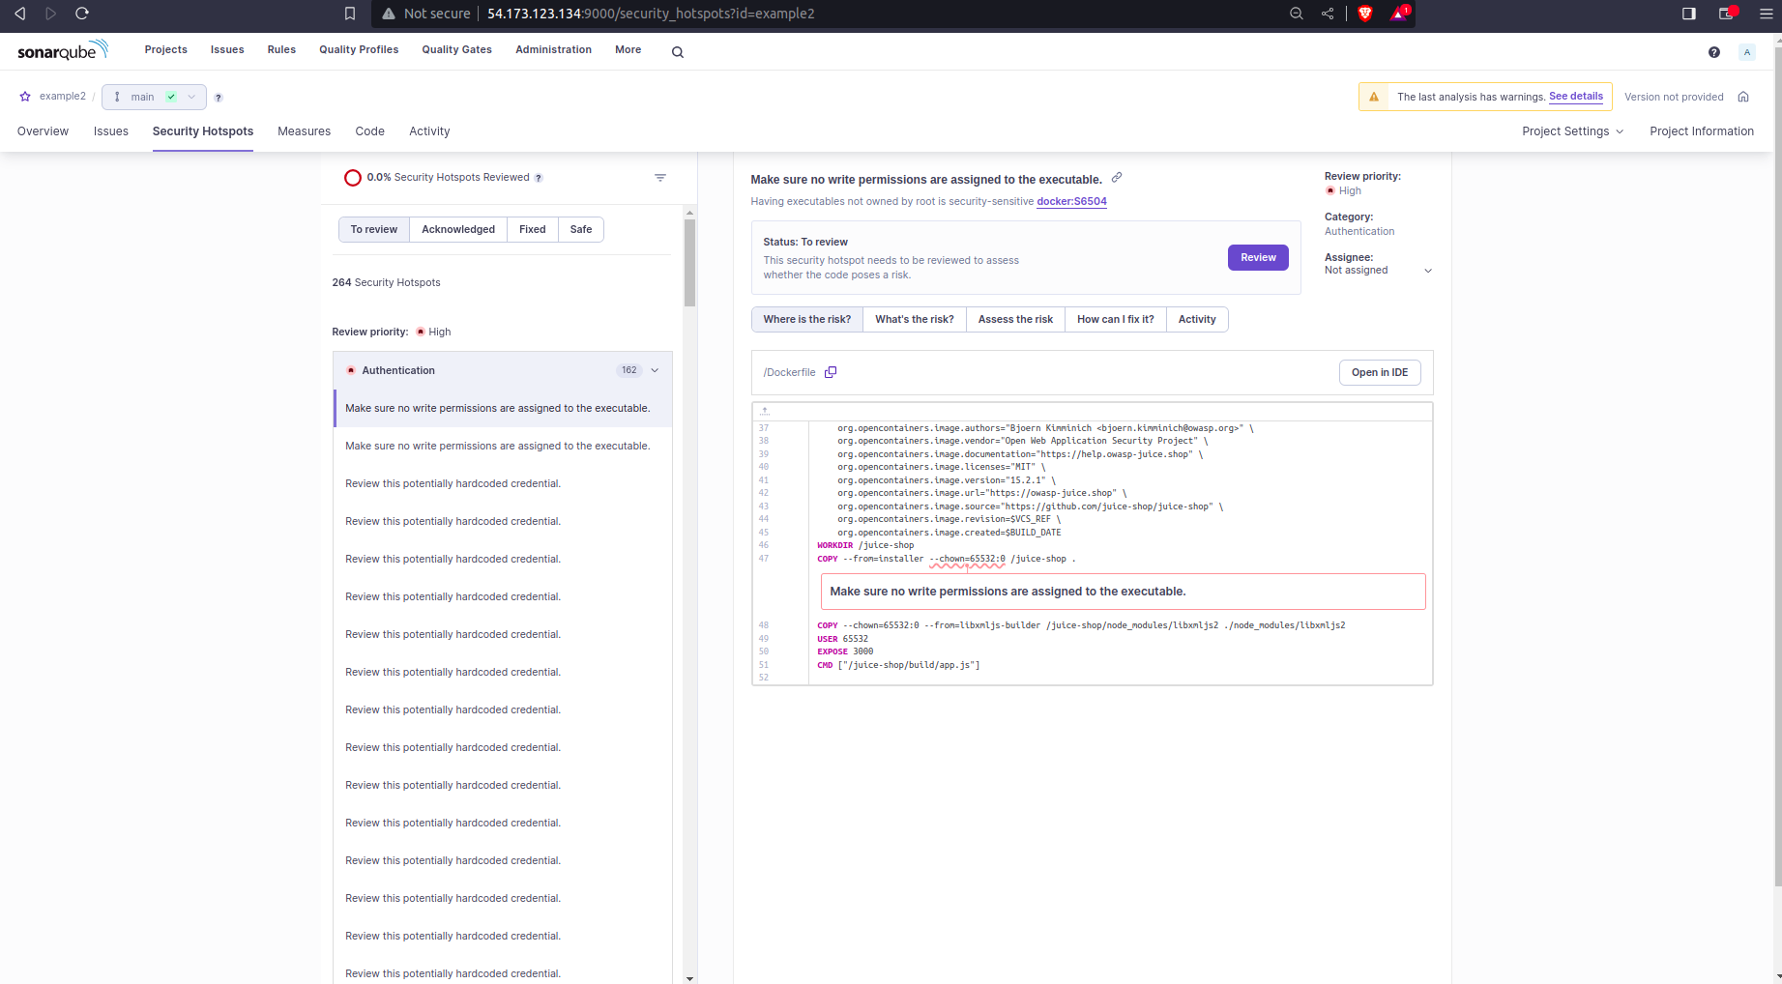

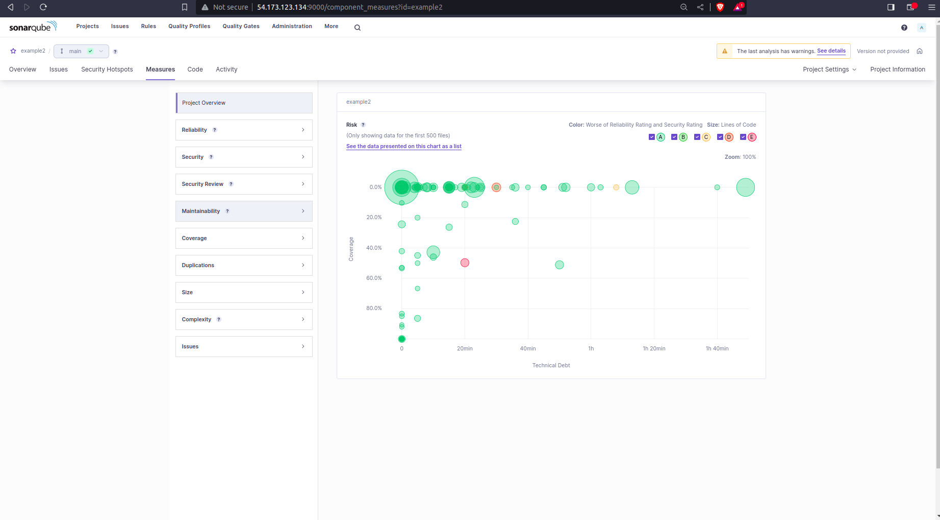

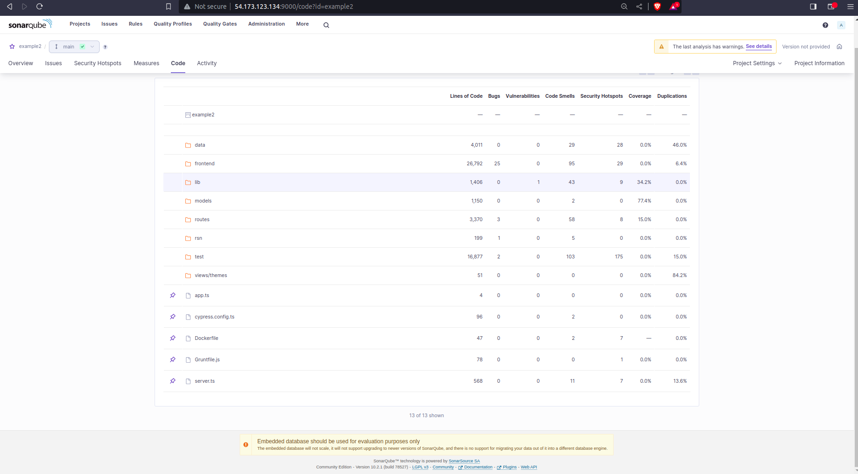

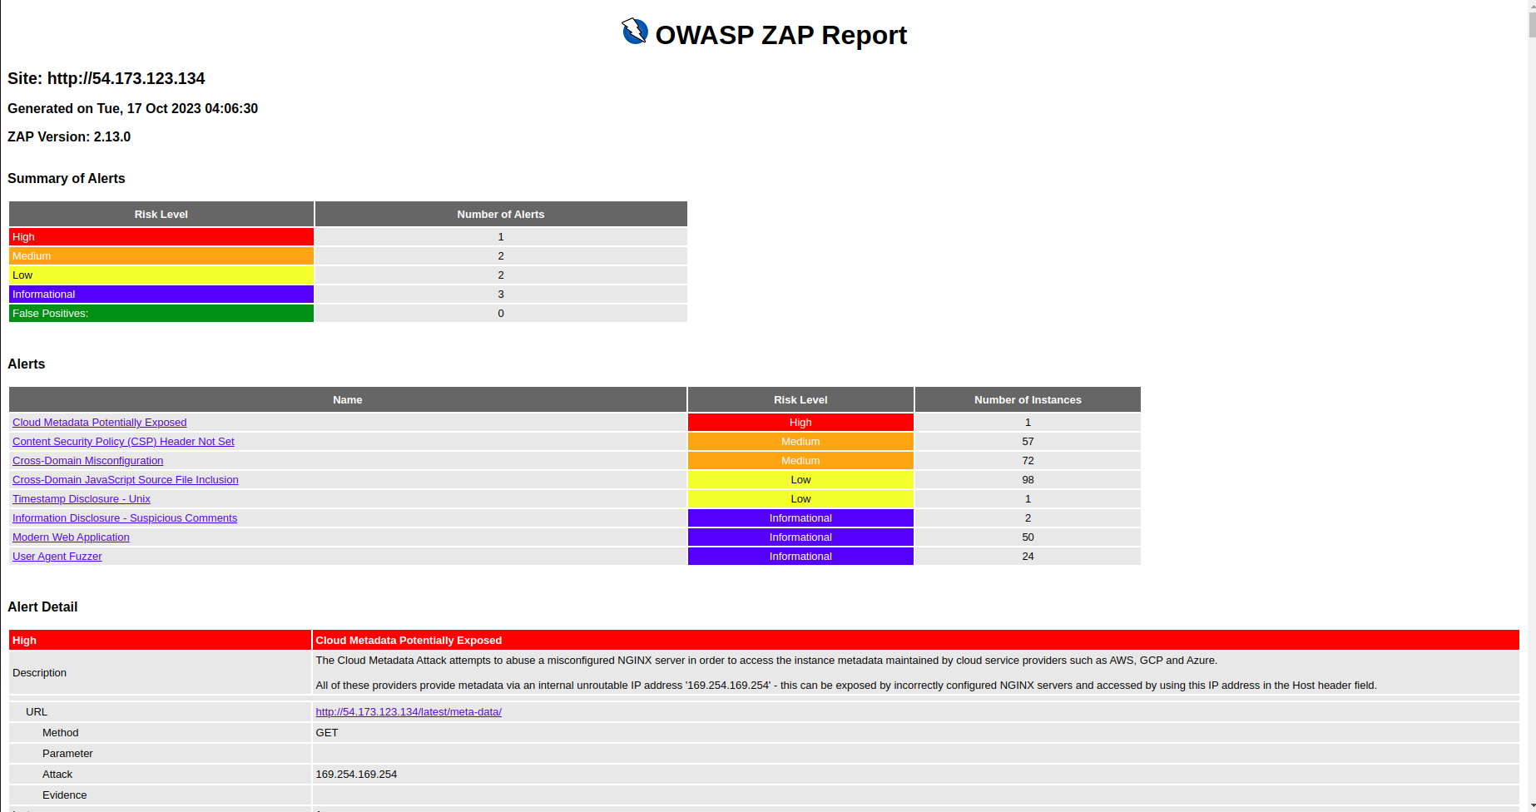
7. DAST ZAP Report:
Report Link: https://vinay-3708.github.io/JUICE-SHOP-DAST-REPORT/

8. Jenkins Screenshots:

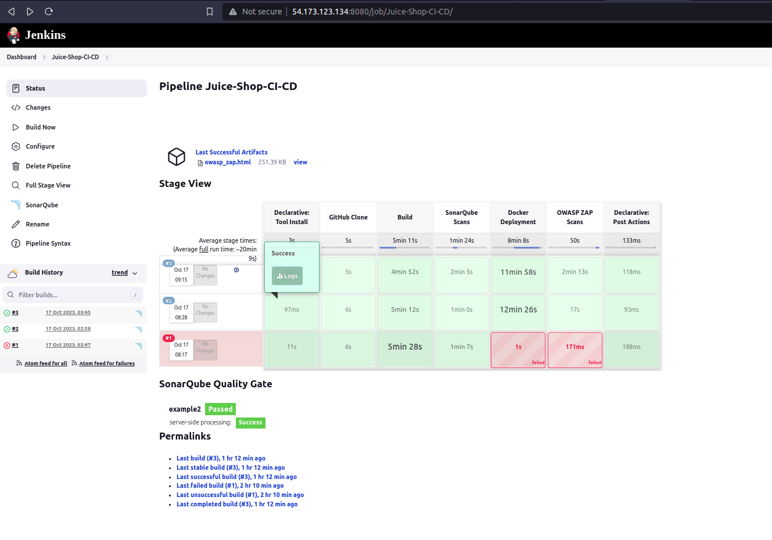

Jenkins Log file: Link (HyperLink)

Jenkins Pipeline Script:
pipeline {
agent any
tools {
nodejs 'node_20.x'
}

stages {
stage('GitHub Clone') {
steps {
echo "Hello"
git branch: 'master',changelog: false, poll: false, url: 'https://github.com/vinay-3708/juice-shop.git'
}
}
stage('Build') {
steps {
sh '''
node -v
npm -v
ls -al
npm install
npm install -g @angular/cli
CHROME_BIN=/usr/bin/google-chrome-stable
echo $CHROME_BIN
npm test
'''
}
}

stage('SonarQube Scans') {
steps {
withSonarQubeEnv(credentialsId: 'SonarQube-Token', installationName: 'SonarQube') {
sh '''
sonar-scanner -Dsonar.projectKey=example2 -Dsonar.sources=. -Dsonar.typescript.lcov.reportPaths=build/reports/coverage/server-tests/lcov.info
'''
}
}
}
stage('Docker Deployment') {
steps {
script {
def container_id=sh(script:"docker ps | grep juice-shop-app | awk -F ' ' '{print \$1}'", returnStdout: true)

sh """
docker build -t juice-shop-app:${BUILD_NUMBER} .
docker stop ${container_id}
docker rm ${container_id}
docker run --name=juice-shop-app -d -p 80:3000 juice-shop-app:${BUILD_NUMBER}
echo "Waiting for 2 mins to become the app fully up & Running......."
sleep 120

"""
}
}
}
stage('OWASP ZAP Scans') {
steps {
sh """
java -jar /juice-shop/zap/ZAP_2.13.0/zap-2.13.0.jar -cmd -port 8081 -quickurl http://54.173.123.134/ -quickout ./owasp_zap.html -quickprogress
"""
}
}
}
post {
always {
archiveArtifacts artifacts: 'owasp_zap.html', followSymlinks: false
cleanWs()
}
}
}

9. SAST Vulnerabilities:

- I have used sonarqube community edition with Version 10.2.1(Build 78527) and Sonar Scanner Version 5.0.1.3006.
- From the SAST Report, I can see only one vulnerability.

- Vulneribility name: Make sure this private key gets revoked, changed, and removed from the code.
  - Description: Developers have used a private key in their code in the lib/insecurity.ts which is exposed in Github Code Repo.
  - Solution: This Private Key has to be revoked in the organisation or wherever it is used. Create a new private key and it has to be fetched from any secret management tools like HashiCorp Vault or AWS Parameter Store or etc.

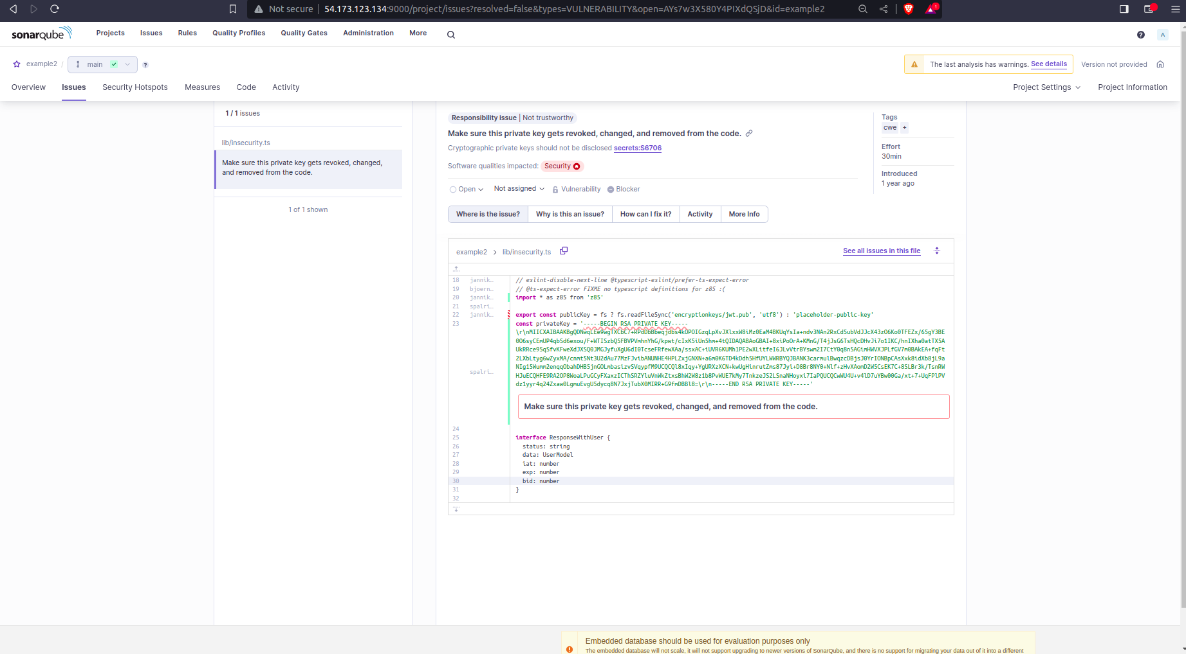

10. DAST Vulnerabilities:

- Vulnerability name: Cloud Metadata Potentially Exposed

  - Description: AWS EC2 can give meta-data like VPC, Subnets, Availability Zone, Security Groups and other AWS data related to EC2 server if we sent request to the latest/meta-data path with host header value as 169.254.169.254.
  - Risk-Level: High
  - Solution: We can disable the instance metadata using aws cli or console. Go to instance and select the “instance settings” and then select “modify instance metadata options”. There, we can disable the instance metadata details. So that we cant be able to fetch the data from this request even from the ec2 server itself.

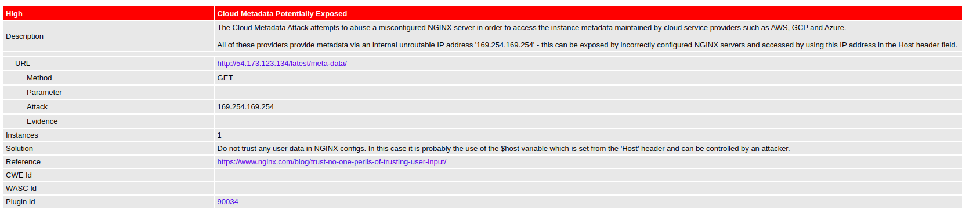

- Vulnerability name: Cross-Domain Misconfiguration

  - Description: Developers have not configured Cross-domain configuration. Cross-Domain configuration is like to allow our pages or content to embedded and display in third-party sites. As the developers didnt mention any specific IPs/hosts to allow this CORS, by default this CORS is allowed by all servers which is vulnerable.
  - Risk-Level: Medium
  - Solution: Developers has to mention to allow particular hosts. So that whenever request comes from that particular host, the Access-Control-Allow-Origin header will have the value of it and then our application will give response to it after checking the host value. Otherwise developers has to disable the CORS policy by default must not allow everyone.

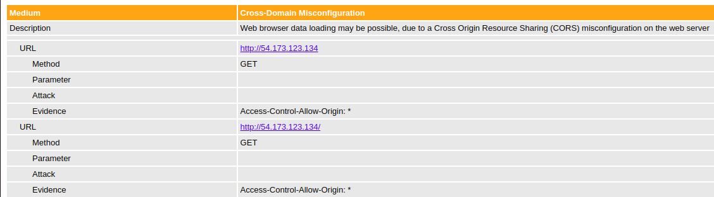

- Vulnerability name: Cross-Domain JavaScript Source File Inclusion

  - Description: Application files are using JavaScript files which are fetched from other sources (URLs) which may be vulnerable if we are fetching those from third party sites. They can change the source code of those javascript files and exploit our application.
  - Risk-Level: Medium
  - Solution: We need to make sure that the code is from our own sites or trusted sites and that source code must not to be accessed by end-users but should be accessed by our application code.
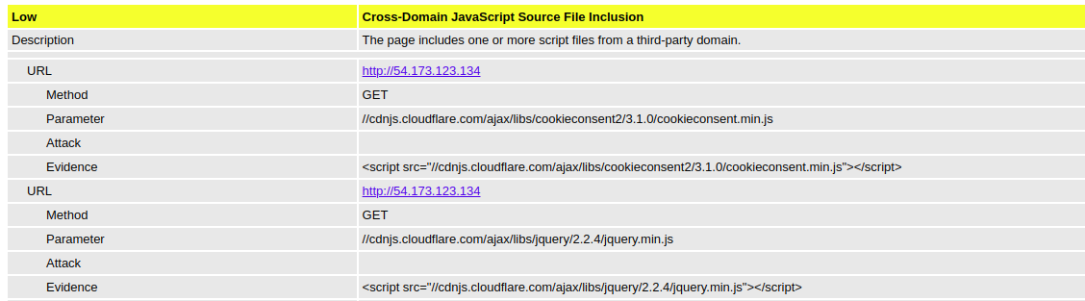

**Due to time-constrains & my current office commitments, I have done my best to complete this task on time

