**Mini Project Report on**



**Misinformation/Fake News Detection in Social Media**



**Submitted in partial fulfillment of the requirement for the award of the degree of**

**BACHELOR OF TECHNOLOGY**

**IN**

**COMPUTER SCIENCE & ENGINEERING**

**Submitted by:**

**Student Name** **University Roll No.**

**Vinay Pandey 2019229**

***Under the Mentorship of***

**Dr. Ashwini Kumar Singh**

**Professor**



**Department of Computer Science and Engineering**

**Graphic Era (Deemed to be University)**

**Dehradun, Uttarakhand**

**July-2023**

GEU logo

**CANDIDATE’S DECLARATION**

I hereby certify that the work which is being presented in the project report entitled **“Misinformation/Fake news detection in Social Media”** in partial fulfillment of the requirements for the award of the Degree of Bachelor of Technology in Computer Science and Engineeringof the Graphic Era (Deemed to be University), Dehradun shall be carried out by the under the mentorship of **Dr. Ashwini Kumar Singh, Professor**, Department of Computer Science and Engineering, Graphic Era (Deemed to be University), Dehradun.

Name : Vinay Pandey University Roll no: 2019229

**Table of Contents**

| **Chapter No.** | **Description** | **Page No.** |
| --- | --- | --- |
| Chapter 1 | Introduction | **1** |
| Chapter 2 | Literature Survey | **4** |
| Chapter 3 | Methodology | **6** |
| Chapter 4 | Result and Discussion | **9** |
| Chapter 5 | Conclusion and Future Work | **11** |
|  | References | **12** |

**Chapter 1**

**Introduction**

False or misleading information that is disseminated without the aim to deceive is referred to as misinformation. It might appear in a variety of ways, such made-up news, altered pictures, or false statements. Because of its quick sharing capabilities, social media is a perfect environment for spreading false information because viral content may quickly reach millions of people. This presents serious problems since it undermines confidence, causes strife, and shapes public opinion. Misinformation needs to be addressed using a variety of strategies, including enhanced algorithms, media literacy programs, and stakeholder collaboration. We may work toward a better informed and reliable digital society by encouraging critical thinking and responsible action.

* 1. **Risks of Fake News**

Social media misinformation has serious consequences and has an effect on people, communities, and societies all over the world. It erodes public confidence in institutions, creates division in communities, and sways public opinion on important topics[1]. Elections can be impacted by false information, which can also make people anxious and possibly give rise to legal issues or cybersecurity risks.

False information can endanger lives and divert vital resources in the face of public health emergencies, impeding efficient responses. Collaboration between social media platforms, users, governments, and civil society is necessary to combat misinformation. A trustworthy online environment can be created by implementing efficient content control, boosting media literacy, and encouraging responsible sharing.

We can lessen the negative consequences of disinformation and build a more knowledgeable and resilient digital society by tackling it as a group. Through these initiatives, we can strengthen the basis for social media usage that is appropriate and guarantee the distribution of accurate information, ultimately helping both individuals and societies.

In this project we are using a dataset of news extracted from Kaggle which contains fake as well as real news from multiple social media spaces to which includes factors like ID, Title, News Article and Label, which is all converted from various formats to text format and stored in a .csv file. We use this dataset to train our Machine Learning Model to Detect whether a news given to it is fake or real.

**1.2 Objective**

Misinformation/Fake news detection refers to the process of using various analytical and classification models to forecast whether a given news could be potentially fake or real. This can involve analyzing other fake and real news data, while reading for key details which distinguish fake ones from real ones like source credibility, author attributions, Date/Context, Quality of Writing etc. This will help you identify whether a given news could be misleading or true which will help you make better decisions and choices in various spheres and also help control the spread of such misleading information.

In this project, we will be utilizing a machine learning model, which is created using Natural Language Processing (NLP) and Passive Aggressive Algorithm. It is a classifier known as Passive Aggressive Classifier which helps us classify whether a given news is fake or real. It includes a variety of online learning algorithms used for binary classification tasks, in this case Fake or Real.

It is designed for taking data one by one or in a sequential way, making it very useful for scenarios when the data is constantly evolving and has to be processed in real time. It can quickly adapt to new data points, but it does not aggressively update its model unless there is a wrongly classified example, making it passive.

Passive Aggressive Algorithms have been successfully applied to various other tasks such as text classifications , sentiment analysis and spam detection.It is very useful in large volumes of data where the data arrives continuously allowing the model to improve itself over the time

**1.3 Applications**

This application would be really helpful to masses in order to recognise what information online is fake and what is real, allowing them to choose and make decisions wisely as well as allowing tech companies to remove such content and creators from their platforms creating a much safer and prevent the spread of misinformation across the web.

**Chapter 2**

**Literature Survey**

# **Fake News Detection on Social Media: A Data Mining Perspective**

Publication Year: 2017

Author: Kai Shu, Amy Salvia, Suhang Wang, Huan Liu, Jililang Tang et al.

Journal Name: ACM SIGKDD Explorations Newsletter

Summary:This paper[2] explores data mining approaches for detecting fake news on social media, including analyzing textual features and user engagement patterns. It provides valuable insights into tackling the challenging issue of fake news in online platforms.

# **FakeBERT: Fake news detection in social media with a BERT-based deep learning approach**

Publication Year: 2021

Author: Rohit Kumar Kaliyar, Anurag Goswami & Pratik Narang

Journal Name: Multimedia Tools and Applications

Summary: In this study[3], the FakeBERT suggested model, which detects bogus news, combines BERT with three parallel 1d-CNN blocks. On the Fake-News dataset, FakeBERT surpasses current state-of-the-art models with an accuracy of 98.90%.The evaluation takes into account a number of variables, including Accuracy, FPR, FNR, and Cross-entropy loss.

FakeBERT's BERT and 1d-CNN block combination enables more effective learning and fake news identification. A pre-trained word embedding model that uses a bidirectional transformer encoder improves the machine's comprehension of context and semantics in textual material. Overall, the findings show how FakeBERT can successfully identify phony news stories in a real-world dataset.

**Early Detection of Fake News on Social Media through Propagation Path Classification with Recurrent and Convolutional Networks**

Publication Year: 2020

Author: Gianmarco De Francisci Morales et al.

Journal Name: Proceedings of the 2020 Web Conference (WWW 2020)

Summary: By examining how information spreads on social media, the study[4] suggests a novel method for identifying bogus news. The model classifies news stories based on how information propagates across networks using recurrent and convolutional networks. With the use of this technique, bogus news can be identified early on, offering useful information for battling false information on social media.

**Summary of Literature Survey:**

Here, I have reviewed various approaches for Fake News Detection. All approaches have their own advantages and disadvantages. BERT Classification is the most effective algorithm to predict fake news but there are some challenges in this method like needing a lot of training data, high computational cost, without GPU data quite slow to train, depending on any previous information for prediction. So we have applied an approach with Passive Aggressive Algorithms which are able to give upclose results without utilizing much resources giving us a reasonably accurate solution in a relatively less time and resources.

**Chapter 3**

**Methodology**

**3.1 Tools and Technologies Used**

**Python :** Python is the language being used for this project. This is due to its many community-based characteristics, such as the fact that it has a wealth of potent tools available for scientific computing packages. Pandas and NumPy are two well-known and free software packages. These packages will drastically reduce and vary the amount of code required to create a certain program. Repetition becomes quick and effective as a result. The code written is shorter and easy to write. Hence Python was best suited for the project.

**Jupyter Notebook :** Users can create and share documents with live code, equations, visualizations, and narrative text using the interactive computing environment of Jupyter Notebook[5]. Its ability to handle many programming languages makes it a flexible tool for scientific research, machine learning, data analysis, and visualization. Users may describe their workflow, analyze data, and run code cells in real-time. Data scientists, academics, and educators choose Jupyter Notebook because it combines explanatory text with code to encourage repeatability and cooperation. It is an indispensable tool for data exploration and experimentation due to its intuitive interface and broad library support.

**Sci-Kit Learn :** A popular open-source machine learning package in Python, Scikit-learn[6] provides a wide range of tools for data mining and analysis. Scikit-learn offers a variety of techniques for supervised and unsupervised learning, such as classification, regression, clustering, and dimensionality reduction, with a straightforward and effective API. Both novices and experts may use it easily because it offers data preprocessing, model evaluation, and hyperparameter adjustment. Academics, researchers, and business people frequently turn to the library because of its emphasis on usability and thorough documentation for creating reliable and scalable machine learning solutions.

**3.2 Proposed Workflow**

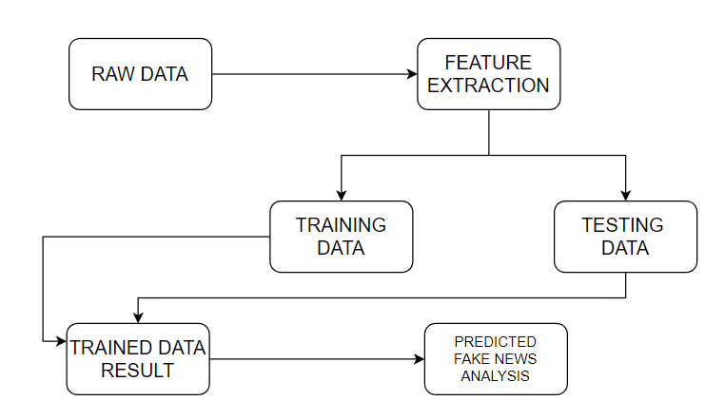

**Figure 3.2.1** Proposed System Architecture and Workflow

The system presented here composes of five modules:-

1. Input as Dataset

2. Pre-processing

3. Data splitting

4. Build & Model train a Passive Aggressive Classifier using Vectored Data from TF-IDF

5. Output as Predicted Result

Data of the News Articles and Labels have been taken from a website named Kaggle. The data is then cleaned, scaled accordingly, and then split into training and testing datasets, after which a TF-IDF vectorizer is used to perform NLP on the data whose vectored values are then used to train our Passive Aggressive Classifier Model.

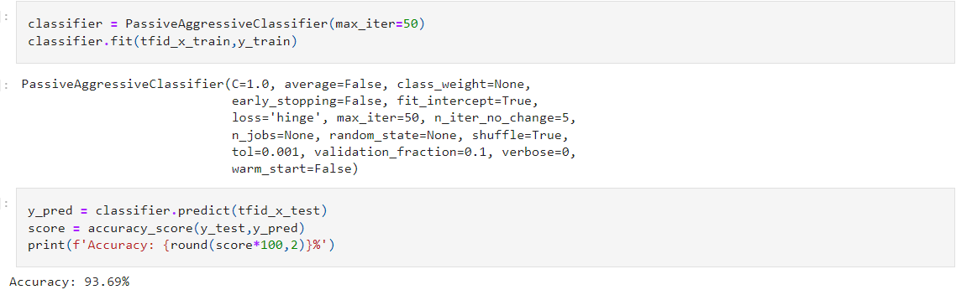

**Figure 3.2.2** Code for the Passive Aggressive Classifier Model with a 93% accuracy on test data

**3.3 Passive Aggressive Classifier Architecture**

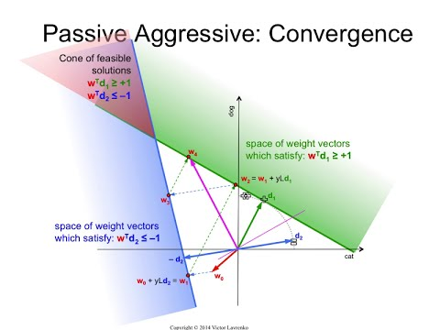

**Figure 3.3.1** Mathematical model for Convergence of Passive Aggressive Algorithm

For binary classification tasks, the Passive-Aggressive (PA) algorithm is a flexible online learning approach that is frequently employed, especially when data is sent sequentially or in real-time streams. It works effectively in contexts that change quickly and with non-stationary data distributions. The algorithm's core strength comes in its capacity to do minimal model parameter modifications while remaining passive (non-reactive) for cases that are successfully identified and turning aggressive in the face of incorrect classifications.The PA method maintains a linear decision boundary that distinguishes the two classes in binary classification. The algorithm makes a label prediction for a new example based on the current model. If the forecast is accurate, it remains inactive and doesn't modify its parameters, maintaining its stability and preventing an excessive response to small changes in the data. The algorithm turns aggressive and modifies its model parameters right away to fix the fault, though, if the forecast is inaccurate and points to a misclassification.

For jobs involving online learning and non-stationary data, the Passive-Aggressive algorithm is a useful tool in the toolbox of machine learning algorithms, in conclusion. Its effective and widespread use in a variety of applications along with its quick adaptation to new data have elevated this algorithm to the status of a key player in the machine learning community.

**Chapter 4**

**Result and Discussion**

By following the described methodology, a TF-IDF Vectorizer was used to extract word weight using Natural Language Processing (NLP) whose output was used to train a Passive Aggressive Classifier which can tell with a good accuracy about whether a particular news is fake or real. Since we used an PAC model, we are able to achieve this with a sequential stream of data . Utilizing this model for testing on some cases of news is given below

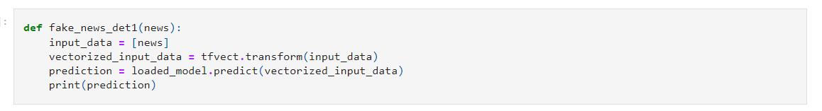

**Figure 4.1** Function Definition for using Fake news Detection Model



**Figure 4.2** Test News 1



**Figure 4.3** Test News 2



**Figure 4.4** Test News 3

As we can see, the model is able to provide fairly accurate results, however in the last case, the model gives a false positive. Hence the model though well Trained still has few limitations and does not perform correctly in all conditions.

Training the model on more contextual parameters like date and source would improve the accuracy however the data classification in all the use cases would increase the load and complexity of the model considerably

**Chapter 5**

**Conclusion and Future Work**

Through this project, I have developed a system that can predict if a news is likely to be fake or real fairly accurately based solely on the content information. It has the potential to be applied to various fact checking and social media platforms to ensure the validity and credibility of the user generated content and maintain a better standard of content for these platforms.

However it is important to note that the model is based on a single parameter and multiple parameters would ensure that the results being generated are fairly accurate, also the facts and news should be independently fact checked and fed to the model so that it can get better over time, because the model cannot predict the credibility with hundred percent accuracy and serves to provide a general idea of falseness or trueness surrounding any given news or fact.

Although numerous machine learning models like BERT with higher accuracy are available, this model can be further enhanced by giving it a graphical interface, as well as training it with increased parameters like dates, sources, online presence etc. and better language processing techniques, like Coreference Resolution, Named Entity Disambiguation etc. A GUI could also be made with lightweight frameworks like Flask or Django which could make it easier to use.

**References**

[1] Hunt Allcott, Matthew Gentzkow, “Social Media and Fake News in the 2016 Election”, Journal of Economic Perspectives Vol. 31, NO. 2,Spring 2017

[2] Kai Shu, Amy Salvia, Suhang Wang, Huan Liu, Jililang Tang et al.,”Fake News Detection on Social Media: A Data Mining Perspective” in 2017 ACM SIGKDD Explorations Newsletter

[3] Rohit Kumar Kaliyar, Anurag Goswami & Pratik Narang et al.,”FakeBERT: Fake news detection in social media with a BERT-based deep learning approach” in 2021 Journal of Multimedia Tools and Applications

[4] Gianmarco De Francisci Morales et al.,”Early Detection of Fake News on Social Media through Propagation Path Classification with Recurrent and Convolutional Networks” in 2020 Proceedings of the 2020 Web Conference (WWW 2020)

[5] Project Jupyter.” https://www.jupyter.org (accessed April. 23, 2023).

[6]Scikit-learn: machine learning in Python — scikit-learn 1.3.0 documentation.” https://scikit-learn.org/ (accessed April. 29, 2023).