STARTUPSPARK AI
AI-POWERED STARTUP PITCH AND BUSINESS IDEA GENERATOR

A Project Report Submitted in Partial Fulfillment for the Award of the Degree of
BACHELOR OF TECHNOLOGY
IN INFORMATION TECHNOLOGY

Submitted By
D Vinay (23341A4233)
K Jaswanth (23341A4247)
L Rajesh (23341A05E7)
Bhanu Prakash (23341A4A5)

Under the Esteemed Guidance of
Mrs. Prasanna
Assistant Professor, Department of AIML

DEPARTMENT OF INFORMATION TECHNOLOGY
GMRIT Deemed to be University
GMR Nagar, Rajam – 532127
Vizianagaram District, Andhra Pradesh
October 2026

DEPARTMENT OF INFORMATION TECHNOLOGY
BONAFIDE CERTIFICATE
This is to certify that the project report entitled “STARTUPSPARK AI – AI-POWERED STARTUP PITCH AND BUSINESS IDEA GENERATOR” is the bonafide work submitted by D Vinay (23341A4233), K Jaswanth (23341A4247), L Rajesh (23341A05E7) and Bhanu Prakash (23341A4A5), who have carried out the project under our guidance and supervision as part of their academic project work.
The work presented in this report has been carried out by the above students and, to the best of our knowledge, has not been submitted to any other university or institution for the award of any degree or diploma.
Project Guide | Head of the Department
Mrs. Prasanna  Assistant Professor, Department of AIML  Department of AIML | Dr. K. Srividya  Professor & Head, Department of AIML  Department of IT

The report is submitted for the viva-voce examination held on ____________________.
Internal Examiner | External Examiner
Signature: __________________ | Signature: __________________

ACKNOWLEDGEMENT
We express our sincere gratitude to our project guide, Mrs. Prasanna, Assistant Professor, Department of AIML, Department of AIML, GMRIT Deemed to be University, for the guidance, suggestions and encouragement provided during the development of StartupSpark AI.
We extend our thanks to the Head of the Department of AIML, faculty members and the institution for providing the academic environment and resources required to complete this project. We also acknowledge the developer communities and documentation resources for the technologies used.
Finally, we thank our parents and well-wishers for their continued encouragement and support.
D Vinay – 23341A4233
K Jaswanth – 23341A4247
L Rajesh – 23341A05E7
Bhanu Prakash – 23341A4A5

ABSTRACT
Student innovators and early-stage founders often begin with promising ideas but find it difficult to convert them into structured business concepts. They may be uncertain about the target customer, value proposition, minimum viable product (MVP), risks and the questions that should be asked before investing time in development. Conventional brainstorming and generic pitch templates do not consistently provide a connected path from an initial idea to practical customer validation.
This report presents StartupSpark AI, an AI-powered startup planning assistant developed as a Streamlit web application. The application collects five inputs: the problem or rough idea, target customer, geography, constraints and existing alternatives. It validates the submitted information and uses a prompt-driven generation pipeline to produce a structured concept brief, value proposition, suggested MVP features, risks, assumptions, unverified claims, customer interview questions, a pitch outline and a validation checklist.
The application also includes planning extensions that help users compare alternatives, estimate unit economics using editable assumptions and prepare a two-week experiment plan. It supports a deterministic Demo Mode that can run without an API key and an optional Live Mode integrated with the Groq API. The generated output is intended to support early planning; it does not establish product-market fit or independently verify market and competitor claims.
The project uses Python and Streamlit, with pandas supporting editable unit-economics calculations. Configuration is handled through environment variables and Streamlit secrets, and automated tests are implemented using pytest. The project presentation reports 20 automated tests passed, covering input validation, prompt checks, demo and error handling, extension calculations, experiment-plan output and UI submission.
Keywords: startup ideation, business planning, artificial intelligence, large language models, MVP, value proposition, customer validation, unit economics.

TABLE OF CONTENTS
Bonafide Certificate ........................................................................ 1
Acknowledgement ........................................................................ 2
Abstract ........................................................................ 3
Table of Contents ........................................................................ 4
List of Figures ........................................................................ 5
List of Tables ........................................................................ 6
List of Abbreviations ........................................................................ 7
Chapter 1: Introduction ........................................................................ 8
1.1 Introduction ........................................................................ 9
1.2 Motivation ........................................................................ 10
1.3 Objectives ........................................................................ 11
1.4 Scope ........................................................................ 12
1.5 Responsible Use and Ethics ........................................................................ 13
1.6 Organisation of the Report ........................................................................ 14
Chapter 2: Project Profile ........................................................................ 15
2.1 About the Project ........................................................................ 16
2.2 Team and Responsibilities ........................................................................ 17
2.3 Development Workflow ........................................................................ 18
Chapter 3: Literature Survey ........................................................................ 19
3.1 Introduction ........................................................................ 20
3.2 Problem Statement ........................................................................ 21
3.3 Existing System ........................................................................ 22
3.4 Proposed System ........................................................................ 23
Chapter 4: Domain Analysis ........................................................................ 24
4.1 Startup Ideation and Business Modelling ........................................................................ 25
4.2 Value Proposition and Customer Segments ........................................................................ 26
4.3 Minimum Viable Product ........................................................................ 27
4.4 Customer Discovery and Validation ........................................................................ 28
4.5 Unit Economics and Experimentation ........................................................................ 29
4.6 Responsible Use of Generative AI ........................................................................ 30
Chapter 5: System Specifications ........................................................................ 31
5.1 Hardware Requirements ........................................................................ 32
5.2 Software Requirements ........................................................................ 33
5.3 Functional Requirements ........................................................................ 34
5.4 Non-Functional Requirements ........................................................................ 35
Chapter 6: Technologies Used ........................................................................ 36
6.1 Technology Stack ........................................................................ 37
6.2 Python ........................................................................ 38
6.3 Streamlit ........................................................................ 39
6.4 Groq API and Language Model ........................................................................ 40
6.5 pandas ........................................................................ 41
6.6 Configuration and Secrets ........................................................................ 42
6.7 pytest ........................................................................ 43
Chapter 7: Methodology and System Design ........................................................................ 44
7.1 System Architecture ........................................................................ 45
7.2 Input Collection and Validation ........................................................................ 46
7.3 Prompt Construction and Generation ........................................................................ 47
7.4 Demo and Live Modes ........................................................................ 48
7.5 Structured Brief Generation ........................................................................ 49
7.6 Planning Extensions ........................................................................ 50
7.7 User Interface ........................................................................ 51
7.8 Error Handling and Security ........................................................................ 52
Chapter 8: Implementation, Results and Testing ........................................................................ 53
8.1 Running the Application ........................................................................ 54
8.2 Main Application Workflow ........................................................................ 55
8.3 Screenshots ........................................................................ 56
8.4 Testing and Evaluation ........................................................................ 57
8.5 Deployment ........................................................................ 58
Chapter 9: Conclusion and Future Work ........................................................................ 59
9.1 Conclusion ........................................................................ 60
9.2 Known Limitations ........................................................................ 61
9.3 Future Enhancements ........................................................................ 62
References ........................................................................ 63
Appendix A: Project Structure ........................................................................ 64
Appendix B: Configuration and Setup ........................................................................ 65

LIST OF FIGURES
Figure No. | Name of the Figure | Page No.
7.1 | StartupSpark AI system workflow | 13
7.2 | Concept generation and planning extensions | 14
8.1 | StartupSpark AI home screen | 17
8.2 | Five-input startup idea form | 17
8.3 | Generated startup concept brief | 17
8.4 | Planning extensions interface | 18

LIST OF TABLES
Table No. | Name of the Table | Page No.
2.1 | Team members and responsibilities | 3
5.1 | Hardware requirements | 9
5.2 | Software requirements | 9
6.1 | Technology stack | 11
8.1 | Test coverage summary | 18

LIST OF ABBREVIATIONS
Abbreviation | Full Form
AI | Artificial Intelligence
API | Application Programming Interface
IT | Information Technology
JSON | JavaScript Object Notation
LLM | Large Language Model
MVP | Minimum Viable Product
NLP | Natural Language Processing
UI | User Interface
UX | User Experience

CHAPTER 1: INTRODUCTION

1.1 Introduction
Starting a business requires more than having an idea. An early-stage founder must identify the problem being addressed, understand the people affected by it, define a value proposition and decide what the first version of the solution should contain. The founder must also identify assumptions, examine alternatives and plan how to gather evidence from potential customers.
StartupSpark AI supports this early planning stage. It accepts a rough startup idea and its context through five input fields and converts the information into a structured concept brief. The generated material includes a value proposition, MVP feature suggestions, risks, assumptions, unverified claims, customer interview questions, a pitch outline and a validation checklist. The system also provides focused extensions for comparing alternatives, estimating unit economics and planning a short experiment.

1.2 Motivation
New founders can find startup planning confusing because several decisions are connected. A problem statement without a clearly identified customer can lead to an unfocused solution. A feature list created before customer discovery may result in unnecessary development. Assumptions about demand, pricing or competitors can also be mistaken for established facts.
The motivation behind StartupSpark AI is to make the first stage of planning more organised and actionable. Rather than presenting an idea as a validated business, the application helps users identify what they currently believe, what remains uncertain and what they can do next to learn from potential customers.

1.3 Objectives
- Collect the problem or rough idea, target customer, geography, constraints and existing alternatives.
- Generate a clear startup concept brief and value proposition.
- Suggest a focused set of minimum viable product features.
- Identify key risks, assumptions and claims that require independent verification.
- Prepare customer interview questions, a pitch outline and a validation checklist.
- Provide planning extensions for alternative comparison, unit-economics estimation and a two-week experiment.
- Help founders plan next steps without implying that the idea or market demand has already been validated.

1.4 Scope
The current system focuses on early-stage startup idea structuring and validation planning. Users provide textual inputs through a web interface. The application generates planning content using either a deterministic demonstration path or an optional Groq-powered live generation path. The extensions support structured comparison, editable financial assumptions and short experiment planning.
The application is not a market research platform and does not independently verify competitor information, customer demand, legal requirements or financial projections. Its outputs are suggestions that users should review and validate through real-world research and customer conversations.

1.5 Responsible Use and Ethics
- Transparency: generated suggestions should be treated as planning assistance, not verified facts or guarantees of business success.
- Verification: market, competitor, pricing and demand-related claims require independent validation.
- Privacy: users should avoid submitting confidential, personal or commercially sensitive information.
- Credential safety: API keys are stored through environment variables or application secrets rather than embedded in source code.
- Human judgement: users remain responsible for decisions made using generated concepts, estimates and experiment suggestions.

1.6 Organisation of the Report
Chapter 2 introduces the project and team. Chapter 3 explains the problem and compares existing approaches with the proposed system. Chapter 4 discusses the domain concepts. Chapter 5 lists system specifications, and Chapter 6 describes the technologies. Chapter 7 explains the methodology and design. Chapter 8 presents implementation, testing and deployment details. Chapter 9 concludes the report and outlines future enhancements.

CHAPTER 2: PROJECT PROFILE

2.1 About the Project
StartupSpark AI is an AI-powered startup pitch and business idea generator developed as a web application using Streamlit. It is intended for student innovators and early-stage founders who want to turn an initial problem or idea into a more structured business concept and a practical plan for customer learning.
The application is organised around five core inputs and a generation pipeline. After validation, the inputs are used to build a project-specific prompt. The request is processed through Demo Mode or the configured Groq model, and the result is displayed as a structured brief. Additional planning extensions support alternative comparison, unit economics and two-week experiment planning.
Project repository: https://github.com/vinay-d9/StartupSpark-AI
Deployed application: https://startupspark.streamlit.app/

2.2 Team and Responsibilities
Team Member | Roll Number | Contribution
D Vinay | 23341A4233 | Core application and input workflow: Streamlit interface, five-input startup idea form, main application flow and integration of generated concept output.
K Jaswanth | 23341A4247 | Input validation and AI generation pipeline: validation of required fields, prompt construction, Demo Mode and Groq API integration support.
L Rajesh | 23341A05E7 | Planning extensions: alternative comparison, pandas-based editable unit-economics calculations and two-week experiment-planning functionality.
Bhanu Prakash | 23341A4A5 | Testing and project delivery: pytest test cases, error-handling checks, UI validation, documentation support and deployment coordination.

The supplied presentation identifies the team members but does not specify individual module ownership. Contributions are therefore described generally rather than assigning unverified responsibilities.

2.3 Development Workflow
The development process follows a modular workflow. The Streamlit application collects the idea context, validates required information and passes it into the generation pipeline. The application supports deterministic demo output and optional live generation through the Groq API. The generated result is presented in a structured format, while separate planning extensions address comparison, unit-economics calculations and experiment design. The project is maintained in GitHub and deployed through Streamlit Community Cloud.

CHAPTER 3: LITERATURE SURVEY

3.1 Introduction
Startup planning combines problem discovery, customer segmentation, value proposition design, MVP definition and validation experiments. These activities are often performed using notes, spreadsheets, pitch templates and conversations with mentors. Generative AI introduces a way to organise early inputs and produce draft planning material quickly, but generated content must be reviewed because language models can produce plausible statements that are incomplete or unsupported.

3.2 Problem Statement
Student innovators and early-stage founders may have promising ideas but struggle to convert them into a clear business concept. They may not know how to define the target customer, communicate the value proposition, select the first MVP features or identify the assumptions that need testing. Existing informal planning methods can be fragmented and time-consuming, while generic pitch templates may not provide actionable customer-validation steps. There is a need for a guided system that turns a small set of idea-context inputs into structured planning material while making clear that assumptions and market claims still require validation.

3.3 Existing System
- Unstructured brainstorming and personal notes can leave important decisions scattered across documents.
- Generic pitch templates provide presentation structure but may not help define customer discovery activities.
- Manual competitor and alternative comparisons can be inconsistent when criteria are not organised.
- Informal financial estimates may hide assumptions about price, cost, volume and margin.
- Unverified assumptions can be presented as facts and lead to premature product development.

3.4 Proposed System
StartupSpark AI provides a guided workflow that accepts five key inputs and produces a structured startup concept. It organises the generated response into practical sections, including the concept brief, value proposition, MVP features, risks, assumptions, unverified claims, interview questions, pitch outline and validation checklist. Its planning extensions help users compare alternatives, explore unit economics and outline a two-week experiment.
The system distinguishes deterministic Demo Mode from Live Mode. Demo Mode provides template-based output without requiring an API key. Live Mode uses the configured Groq integration to generate context-dependent content. The output is a starting point for further investigation rather than evidence that a market opportunity has been proven.

Advantages
- Provides a guided way to convert rough startup ideas into structured planning material.
- Connects concept generation with customer interview and validation activities.
- Highlights assumptions and unverified claims instead of treating all generated content as established facts.
- Offers planning extensions for comparison, editable unit economics and short experiments.
- Can be demonstrated without an API key through deterministic Demo Mode.

CHAPTER 4: DOMAIN ANALYSIS

4.1 Startup Ideation and Business Modelling
Startup ideation is the process of identifying a problem or opportunity and exploring a possible solution. A business concept becomes clearer when the problem, intended customer, proposed solution, constraints and alternatives are considered together. StartupSpark AI uses these dimensions as the basis for its five-input form.

4.2 Value Proposition and Customer Segments
A value proposition explains why a particular customer segment may find a product or service useful. Defining the target customer helps a founder avoid describing a solution for an overly broad audience. The application uses the target-customer and problem inputs to draft a value proposition and a more coherent concept brief. These drafts should be tested with intended users.

4.3 Minimum Viable Product
A minimum viable product is a limited first version intended to test important assumptions with the least practical scope. Instead of attempting to build every possible feature, founders identify the smallest set of capabilities that can deliver or test the core value proposition. StartupSpark AI suggests MVP features to help users focus initial development effort.

4.4 Customer Discovery and Validation
Customer discovery involves speaking with potential users to understand their needs, current workarounds and willingness to adopt a proposed solution. Interview questions should explore actual experiences rather than simply asking whether someone likes an idea. A validation checklist turns uncertain assumptions into actions that can gather evidence.

4.5 Unit Economics and Experimentation
Unit economics examines the revenue and cost associated with a defined unit of a product or service. Early estimates depend on assumptions such as selling price, variable cost, customer volume and acquisition costs. StartupSpark AI includes an editable unit-economics planning extension supported by pandas. A short experiment provides a time-bounded way to test a specific assumption; the two-week planner helps convert a broad validation goal into practical next steps.

4.6 Responsible Use of Generative AI
Generative AI can accelerate drafting and organise information, but its output can be incomplete, inaccurate or overly confident. StartupSpark AI identifies assumptions and unverified claims and communicates that market and competitor claims are not independently verified. Human review and real customer evidence remain necessary.

CHAPTER 5: SYSTEM SPECIFICATIONS

5.1 Hardware Requirements
Component | Requirement
Processor | Modern dual-core processor or better
RAM | 4 GB or more recommended
Storage | Free storage for Python, virtual environment and dependencies
Network | Internet for hosted access and Live Mode API calls; Demo Mode does not require an API key

5.2 Software Requirements
Component | Requirement
Programming language | Python (project environment uses Python 3.12)
Web framework | Streamlit
AI provider | Optional Groq API integration
Planning calculations | pandas
Testing | pytest
Configuration | python-dotenv and Streamlit secrets
Operating system | Windows, macOS or Linux
Deployment | Streamlit Community Cloud
Browser | Any modern web browser

5.3 Functional Requirements
- Collect the problem or rough idea, target customer, geography, constraints and existing alternatives.
- Validate required inputs and report missing or invalid information.
- Construct a project-specific prompt from validated inputs.
- Support deterministic Demo Mode without an API key.
- Support optional live generation through the configured Groq API.
- Display a structured concept brief and value proposition.
- Suggest MVP features and identify risks, assumptions and unverified claims.
- Generate customer interview questions, a pitch outline and a validation checklist.
- Provide extensions for alternative comparison, unit economics and a two-week experiment.
- Handle provider and malformed-response errors with appropriate feedback.

5.4 Non-Functional Requirements
- Usability: guide users through clearly labelled inputs and outputs.
- Reliability: handle invalid inputs and provider failures with appropriate feedback.
- Maintainability: organise functionality into modules rather than a single interface component.
- Security: supply API credentials through environment variables or Streamlit secrets.
- Transparency: do not represent generated suggestions or unverified claims as confirmed facts.
- Portability: support local Python execution and Streamlit Community Cloud deployment.

CHAPTER 6: TECHNOLOGIES USED

6.1 Technology Stack
Layer / Purpose | Technology
User interface | Streamlit
Application logic | Python modules
AI provider | Optional Groq API integration
Configured live model | openai/gpt-oss-20b
Planning calculations | pandas
Default generation path | Deterministic Demo Mode
Testing | pytest
Configuration | python-dotenv and Streamlit secrets
Deployment | Streamlit Community Cloud

6.2 Python
Python is the primary programming language used to implement the application. It supports input processing, prompt construction, model-provider integration, structured result handling and planning calculations.

6.3 Streamlit
Streamlit is the Python framework used to create the interactive web application. It provides input controls and page components to collect startup context and display generated planning output. It also supports deployment through Streamlit Community Cloud.

6.4 Groq API and Language Model
The application includes an optional Groq API integration for live AI generation. The configured model used in the project is openai/gpt-oss-20b. In Live Mode, validated startup inputs are incorporated into a prompt and sent to the provider. Returned content is processed and presented by the application. API access depends on valid credentials and provider availability.

6.5 pandas
pandas supports the unit-economics extension by providing data structures and calculation support for editable planning assumptions. Resulting estimates are intended for exploration and should be reviewed by the user.

6.6 Configuration and Secrets
The project uses python-dotenv for local environment configuration and Streamlit secrets for deployed configuration. Provider credentials and model settings are kept outside application source code. Secret values must not be included in screenshots, public documentation or version control.

6.7 pytest
pytest is used to execute automated tests. The project presentation reports 20 automated tests passed, covering required and missing inputs, prompt checks, demo and error handling, extension calculations, experiment-plan output and UI submission.

CHAPTER 7: METHODOLOGY AND SYSTEM DESIGN

7.1 System Architecture
StartupSpark AI follows a modular workflow that separates user input, validation, prompt construction, generation and presentation. Planning extensions provide additional operations after the initial concept has been generated.
Stage | Description
1. User input | Enter problem or rough idea, target customer, geography, constraints and existing alternatives.
2. Input validation | Check required fields and input constraints.
3. Prompt construction | Assemble validated context into a project-specific prompt.
4. Generation service | Route the request to deterministic Demo Mode or configured Groq model.
5. Structured output | Display the concept brief and associated planning sections.
6. Planning extensions | Compare alternatives, calculate unit economics and plan a two-week experiment.

Fig 7.1: StartupSpark AI system workflow

7.2 Input Collection and Validation
The input form collects five dimensions of the startup idea: problem or rough idea, target customer, geography, constraints and existing alternatives. These fields provide the context required to generate a relevant concept brief. Input validation checks that required information is supplied and that invalid or oversized inputs are handled before generation.

7.3 Prompt Construction and Generation
After validation, the application builds a prompt using the user's five inputs. The prompt guides generation towards a structured business concept rather than an unorganised response. The generation layer can use the deterministic demonstration path or configured live provider. The result is passed to the presentation layer.

7.4 Demo and Live Modes
Demo Mode provides deterministic, template-based output and does not require an API key. This makes it possible to demonstrate the application without depending on an external model provider. The interface identifies demo output as template-based.
Live Mode uses the optional Groq API integration. The application sends the constructed prompt to the configured model and processes the returned content. Live generation can provide more context-sensitive material, but generated content may still be incomplete or incorrect and should be reviewed.

7.5 Structured Brief Generation
The main generation flow produces a structured planning response. Its sections include a concept brief, value proposition, MVP feature suggestions, risks, assumptions, unverified claims, customer interview questions, a pitch outline and a validation checklist. This structure helps users move from an initial idea towards questions and actions that can be tested.

7.6 Planning Extensions

Alternative Comparison
The alternative-comparison extension helps the user examine existing alternatives in a more organised way. It supports consideration of how the proposed concept differs from current options. The comparison is a planning aid and does not independently verify competitor claims.

Unit Economics
The unit-economics extension uses editable assumptions and pandas-supported calculations to help users explore basic financial relationships. Since the result depends on user-provided assumptions, it should be interpreted as an estimate rather than a forecast.

Two-Week Experiment Plan
The experiment-planning extension converts a validation objective into a short, time-bounded plan. It helps founders identify practical activities and evidence to collect over a two-week period.

7.7 User Interface
The user interface is implemented using Streamlit. It presents the five startup inputs, provides a submission path and displays the generated planning result. Additional planning tools are available as extensions to the core concept-generation workflow.

7.8 Error Handling and Security
The application includes checks for required and oversized inputs and tests for provider and malformed-response errors. API credentials are configured through environment variables or Streamlit secrets rather than hard-coded in source files. Users should avoid entering sensitive information because the current application does not provide account-based private storage or persistent project history.

CHAPTER 8: IMPLEMENTATION, RESULTS AND TESTING

8.1 Running the Application
The application can be run locally after installing its Python dependencies and configuring the required environment settings. Follow the current project README so that installed package versions match the repository.
streamlit run app.py

8.2 Main Application Workflow
- Open the StartupSpark AI application.
- Enter the startup problem or rough idea.
- Specify the target customer and geography.
- Provide relevant constraints and existing alternatives.
- Submit the inputs for validation and prompt construction.
- Use the available Demo Mode or Live Mode configuration.
- Review the generated concept brief, value proposition, MVP suggestions, risks and validation material.
- Use planning extensions to compare alternatives, estimate unit economics or plan a two-week experiment.

8.3 Screenshots
Insert genuine screenshots from the completed StartupSpark AI application in the spaces below. Do not use screenshots from the reference group's RecapRoom AI report.
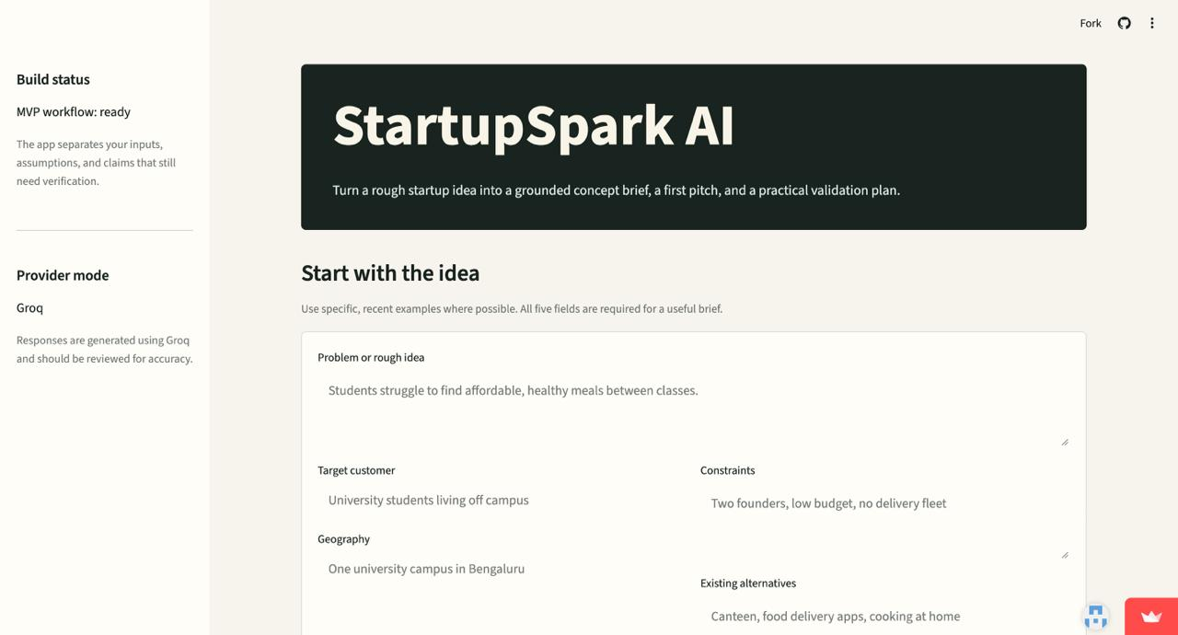
Fig 8.1: StartupSpark AI home screen
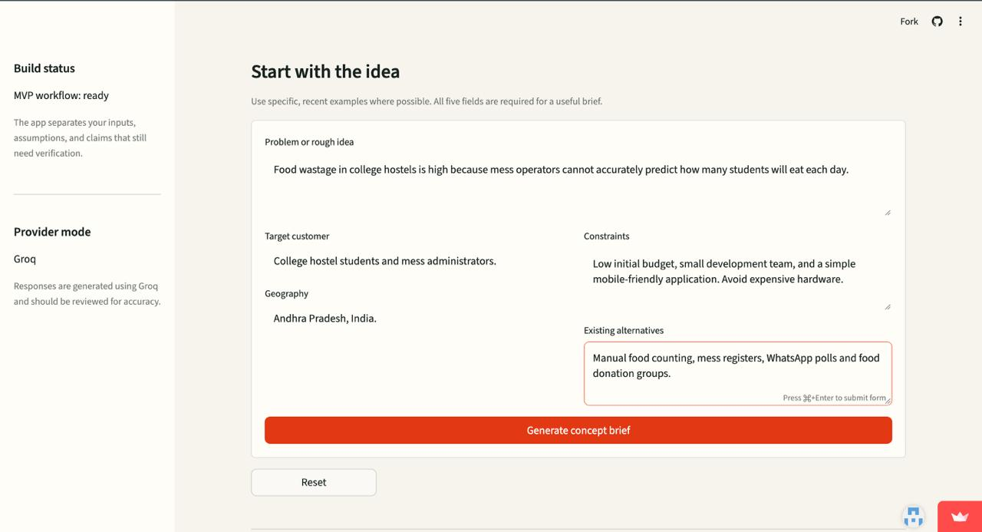
Fig 8.2: Five-input startup idea form
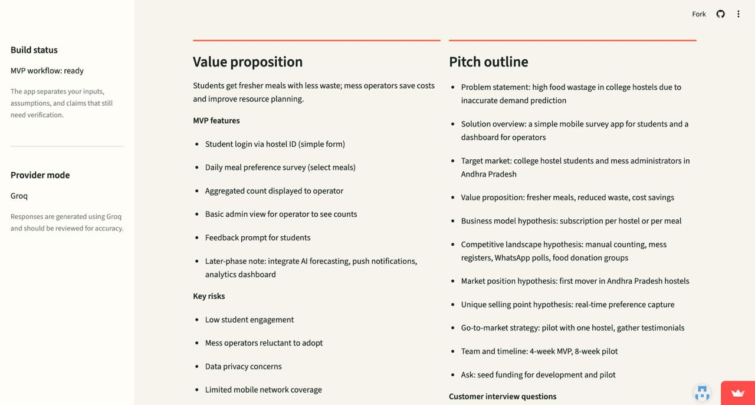
Fig 8.3: Generated concept brief and value proposition

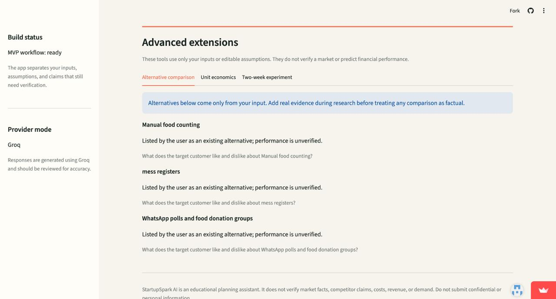
Fig 8.4: Planning extensions – alternative comparison.
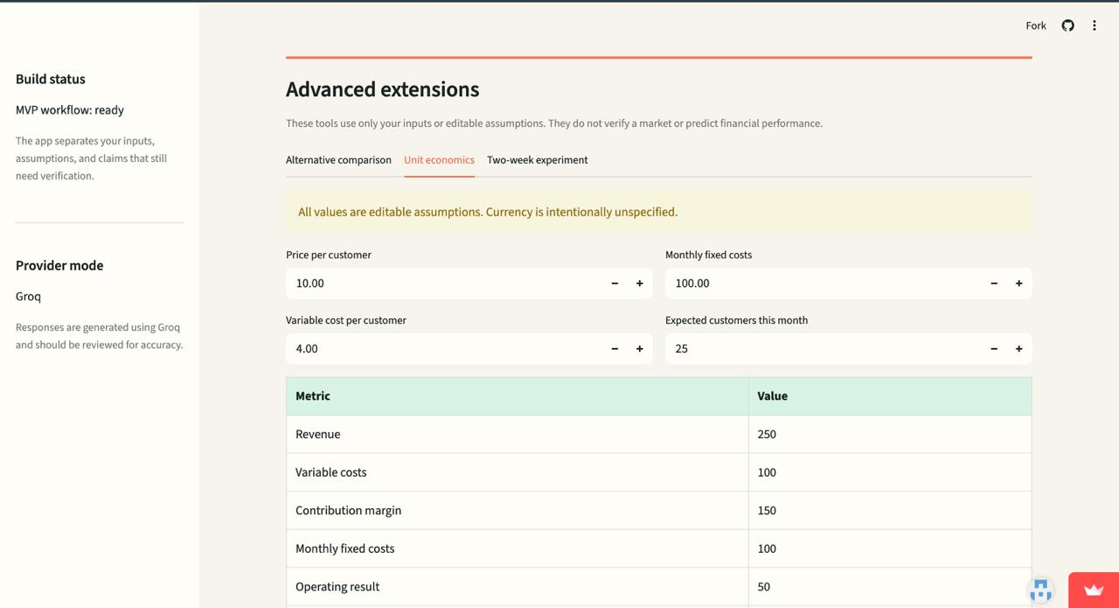
Fig 8.5 : unit economics
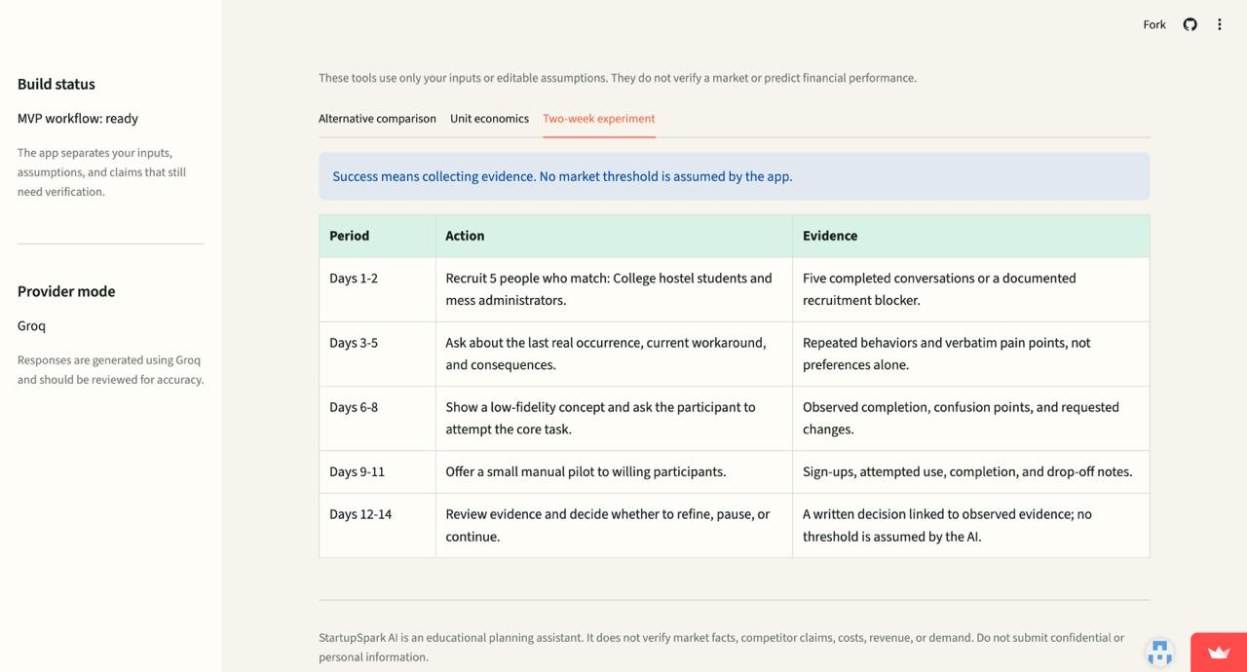
Fig 8.6 : experiment plan
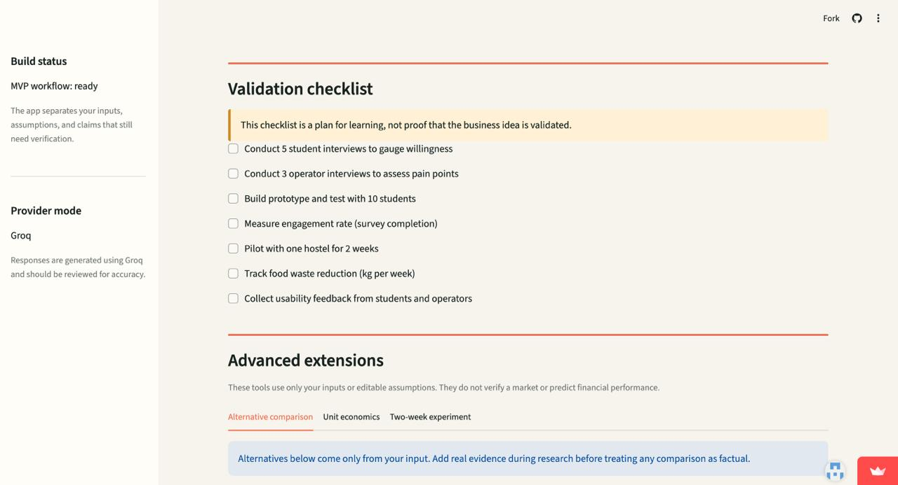
Fig 8.7 : Validation checklist

8.4 Testing and Evaluation
The project presentation reports 20 automated tests passed. The tests are described as covering input validation and prompt checks, demo and error handling, extension arithmetic, experiment-plan generation and UI rendering with valid submission.
Test Area | Coverage described in the project presentation
Input validation | Required and missing inputs; oversized input and validation errors
Prompt and generation | Prompt checks and structured brief generation
Demo and error handling | Deterministic demo behaviour and error handling
Provider response | Provider errors and malformed-response handling
Alternative comparison | Planning extension output for comparing alternatives
Unit economics | Extension arithmetic using editable assumptions
Experiment planning | Two-week experiment-plan output
User interface | UI rendering and valid form submission

Table 8.1: Test coverage summary (20 automated tests passed)

8.5 Deployment
The project is deployed on Streamlit Community Cloud. The application source is maintained in the GitHub repository and the deployed application is available at https://startupspark.streamlit.app/. Provider credentials are configured through deployment secrets rather than committed to the repository.
Source repository: https://github.com/vinay-d9/StartupSpark-AI
Deployed application: https://startupspark.streamlit.app/

CHAPTER 9: CONCLUSION AND FUTURE WORK

9.1 Conclusion
StartupSpark AI provides a guided way for student innovators and early-stage founders to convert a rough business idea into structured planning material. By collecting five key inputs and generating a concept brief, value proposition, MVP feature suggestions, risks, assumptions, interview questions, pitch outline and validation checklist, the application connects early ideation with practical customer-learning activities.
The planning extensions add support for comparing alternatives, exploring unit economics and preparing a two-week experiment. Deterministic Demo Mode allows the application to be demonstrated without an API key, while optional Groq integration supports live AI generation. The project presentation reports 20 automated tests passed across the main validation, generation, extension and UI areas.
The system is a planning assistant rather than proof of market demand. Its main value is helping users identify what they need to investigate and how they might begin testing their assumptions.

9.2 Known Limitations
- Demo Mode uses deterministic template-based output and does not perform live research.
- Market and competitor claims are not independently verified by the application.
- AI-generated content can be incomplete, inaccurate or unsuitable for a particular business context.
- The current application does not provide login, a database, saved history or persistent storage.
- Unit-economics results depend on editable user assumptions and are not verified financial forecasts.
- Customer demand and product-market fit cannot be established by generated output alone.

9.3 Future Enhancements
- Capture and review user feedback to improve the quality and usefulness of generated briefs.
- Improve the clarity, consistency and readability of the generated concept brief.
- Add downloadable concept reports for easier sharing and review.
- Expand validation-plan templates for different startup types and assumptions.
- Improve live-provider reliability and deployment checks.
- Add optional project history with secure storage.

REFERENCES
- Streamlit documentation. https://docs.streamlit.io/
- Python documentation. https://docs.python.org/3/
- Groq API documentation. https://console.groq.com/docs
- pandas documentation. https://pandas.pydata.org/docs/
- pytest documentation. https://docs.pytest.org/
- python-dotenv documentation. https://github.com/theskumar/python-dotenv
- StartupSpark AI project repository. https://github.com/vinay-d9/StartupSpark-AI
- StartupSpark AI deployed application. https://startupspark.streamlit.app/

APPENDIX A: PROJECT STRUCTURE
The project presentation describes StartupSpark AI as a modular application composed of the following functional modules. This module-level structure is reproduced from the project presentation.
1. Input Form
2. Input Validation
3. Prompt and Pipeline
4. AI / Demo Service
5. Structured Brief
6. Planning Extensions
7. Testing Module
The presentation specifies these functional modules but does not provide a complete source-code directory tree. The list above therefore preserves the structure shown in the PPT without inventing file or folder names.

APPENDIX B: CONFIGURATION AND SETUP

B.1 Local Setup
Create and activate a Python virtual environment, install the dependencies listed in requirements.txt and configure the application using the setup instructions in the project README.
# Example setup
python -m venv .venv
# Windows PowerShell
.venv\Scripts\Activate.ps1
# macOS / Linux
source .venv/bin/activate
pip install -r requirements.txt
streamlit run app.py

B.2 Environment Configuration
The application uses environment configuration and Streamlit secrets for provider settings. The exact variable names and accepted values should be taken from the final repository's configuration example and README.
- Keep API credentials outside the source code.
- Do not commit local .env files or expose secret values in screenshots.
- For deployment, configure required credentials through Streamlit Community Cloud secrets.

B.3 Deployment
Deployed application: https://startupspark.streamlit.app/
Source repository: https://github.com/vinay-d9/StartupSpark-AI

