Prepared by: K. Vinay Gupta
Prepared data: 10-06-2026

Proof of Concept (POC)
Multi-Tenant Strapi Architecture & Data Segregation for Venkatadri Hostels

1. Introduction
This POC demonstrates the implementation of a multi-tenant architecture using Strapi v5, and PostgreSQL. The platform enables multiple hostel websites to operate from a single backend while maintaining logical data segregation, dynamic content management, and tenant-specific experiences.

2. Objective of the POC
• Validate a shared-database, multi-tenant architecture.
• Manage multiple hostels from a single Strapi Admin Panel.
• Ensure tenant-specific data isolation and routing.
• Reduce duplication through shared room and facility catalogs.
• Enable onboarding of new hostels with minimal effort.

3. Proposed Solution
Implement a Shared-Database Multi-Site model where the frontend sends the current domain through an x-hostel-domain header. A custom tenant resolver middleware dynamically filters and routes data based on tenant context.

4. Scope of the POC
Included:
• Unified Strapi backend
• Tenant resolver middleware
• Dynamic content rendering
• Tenant-isolated enquiries
• Shared room and facility catalogs

5. Core Features Demonstrated
• Domain-based tenant resolution
• Dynamic branding and content rendering
• Shared catalog relationships
• Booking form room filtering
• Tenant-specific enquiry routing
• Safe localhost fallback support

6. System Architecture
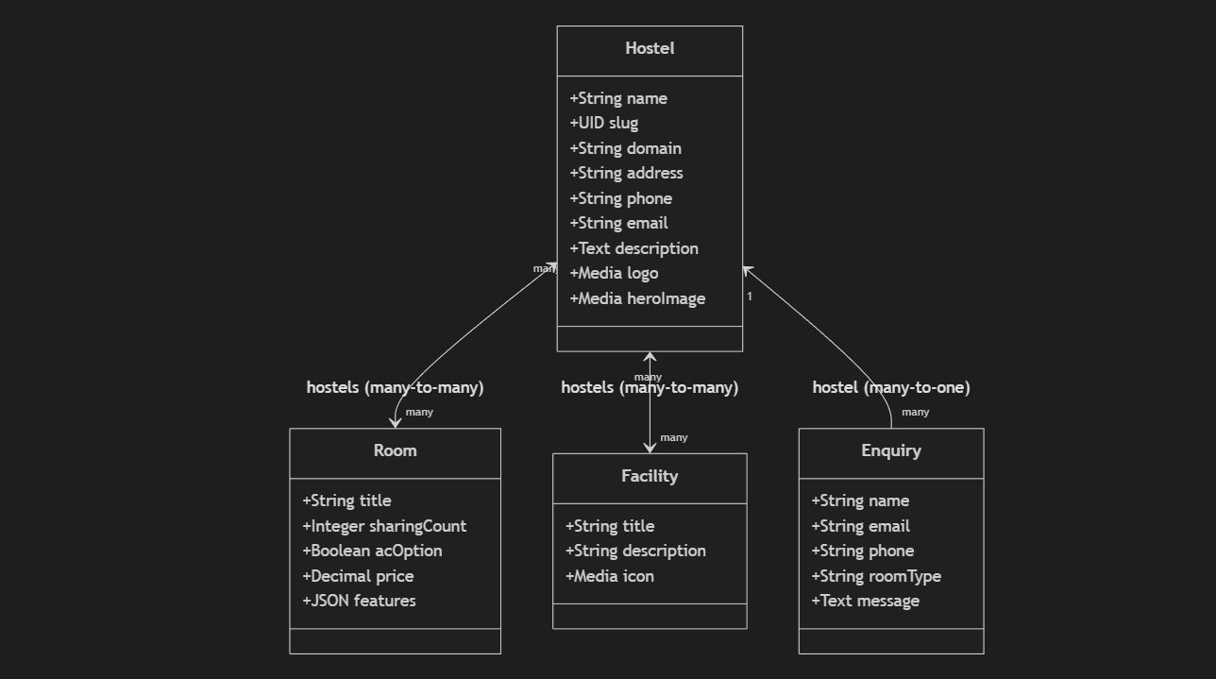
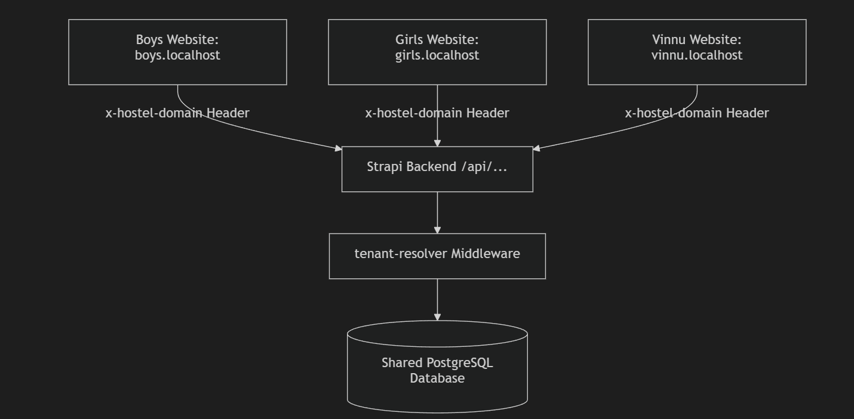

7. Technology Stack
Frontend: React
Backend: Strapi v5
Database: PostgreSQL
Styling: Tailwind CSS
API Layer: Fetch API / React Query
Middleware: Koa.js
Version Control: GitHub

8. Workflow
Step 1: User visits a hostel domain.
Step 2: Frontend extracts hostname and sends request.
Step 3: Backend middleware resolves tenant context.
Step 4: Dynamic filters are applied.
Step 5: Filtered data is returned and rendered.

9. Sample Use Cases
• Boys and Girls hostel separation
• Franchise landing pages
• Tenant-specific enquiry management
• Dynamic room and facility allocation

10. Sample Demo Scenario
Input: Visit vinnu.localhost
Output:
• Dynamic logo and branding
• Tenant-specific hero image
• Filtered room listings
• Hostel-specific contact information

11. Success Metrics (KPIs)
• Query overhead below 5ms
• Zero data duplication
• Fast onboarding process
• Reliable tenant isolation
• Scalable architecture

12. Risks & Limitations
• Shared schema constraints
• Backend as a single point of failure
• DNS and domain configuration dependency
• Logical isolation instead of physical isolation

13. Expected Outcome
The POC proves that a single Strapi backend can support multiple independent hostel websites while maintaining data segregation, scalability, and operational efficiency.

14. Future Enhancements
• Tenant-specific admin dashboards
• Payment gateway routing
• Analytics segregation
• Role-based access control
• Advanced monitoring and auditing

15. Conclusion
This POC validates the feasibility of implementing a scalable multi-tenant hostel management platform using Next.js, Strapi, and PostgreSQL with middleware-driven tenant isolation.

