Project Name:
HOOT AI – Intelligent Role-Based Communication Skill Analytics & Mentorship Platform

GitHub URL: https://github.com/vinay-gupta-kandula/hoot-ai.git
Description:
The proposed project is an AI-powered interview preparation platform designed to help students improve their communication skills through modules such as listening, speaking, reading, and writing. The system provides separate login access for students, pool mentors, and main mentors, enabling efficient monitoring and guidance throughout the learning process.
The platform uses AI to analyse student performance, generate personalized reports, and identify strengths and weak areas. Mentors can track individual progress through dashboards, while students receive actionable suggestions and leaderboard-based motivation to enhance their interview readiness and placement preparation.

Problem Statement
Students lack a centralized system to track communication skill development, while mentors face difficulty monitoring performance across multiple students, pools, and technologies.
Existing solutions do not provide real-time analytics, role-based insights, or AI-driven recommendations for improvement.

Proposed Solution
HOOT AI provides a unified dashboard system that:
- Tracks student performance across communication modules
- Enables mentors to monitor and guide students effectively
- Provides AI-generated reports, comparisons, and suggestions
- Uses role-based access for controlled data visibility
- Delivers real-time analytics using dashboards

Functional Requirements
Authentication:
- Secure login using Azure AD
- Role-based access (Student, Pool Mentor, Main Mentor-Admin)
- Session management

User Management:
- Create and manage users
- Assign roles, pools, and technologies
- Role-based data access
- Performance Tracking
- Track Speaking, Writing, Listening, Reading scores
- Store test results and time spent
- Maintain historical performance data

Dashboard System:
- Student Dashboard
- KPI metrics (tests, accuracy, time)
- Module-wise performance
- Leaderboard
- Practice test section
- Pool Mentor Dashboard
- View pool students
- Monitor performance and weak areas
- Pool leaderboard
- Technology Mentor Dashboard
- Compare pools
- Analyse technology-level performance

Admin Dashboard:
- Full system overview
- Manage users, pools, technologies
- AI Intelligence
- Generate performance reports
- Compare students with peers
- Suggest improvement areas
- Answer queries like:
- “What is my report?”
- “Where am I lacking?”

Analytics & Visualization
Charts for module comparison:
- Trend analysis
- Leaderboards
- Non-Functional Requirements
- Fast response time (<3 seconds)
- Scalable for multiple users
- Secure data storage
- Role-based access control
- High availability
- Clean and responsive UI

System Architecture
HOOT AI follows a multi-layer architecture:
- Frontend: HTML, CSS,ReactJS
- Student Dashboard
- Pool Mentor Dashboard
- Main Mentor Dashboard
- Skill Modules (Listening, Speaking, Reading, Writing)
- Leaderboard & Reports UI
- Backend: Next.js Server Actions, Node.js
- Authentication & Role Management
- AI Performance Analysis Engine
- Report Generation System
- Progress Tracking & Recommendation Module
- Notification & Feedback System
- Database: PostgreSQL (via Supabase)
- Student Data
- Mentor Data
- Performance Scores
- Reports & Feedback
- Leaderboard Records

Flow:
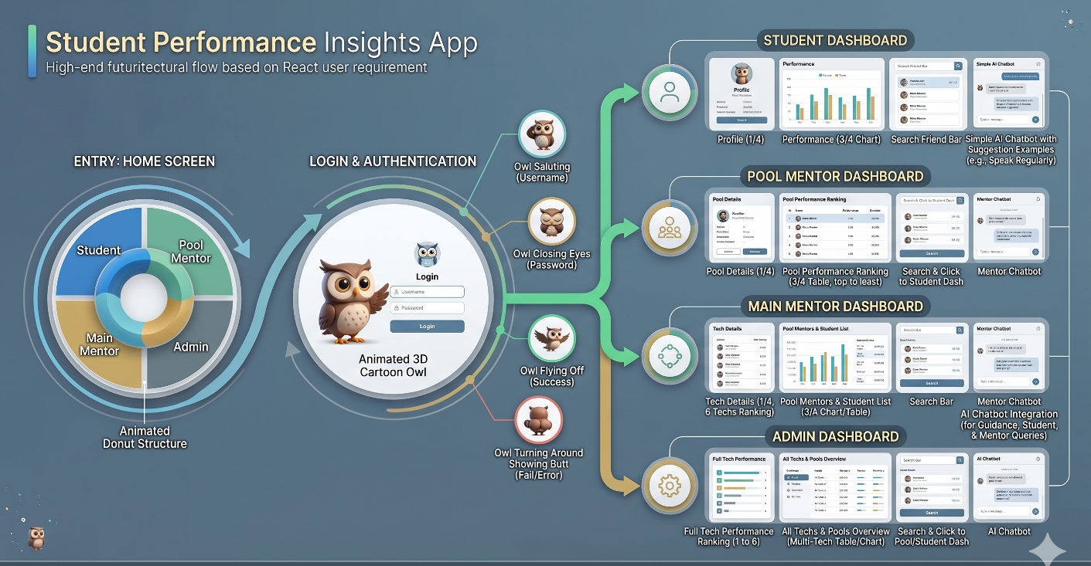

Technologies Used:
- Microsoft PowerApps
- Next.js
- React.js
- TypeScript
- Tailwind CSS
- Shadcn UI
- Supabase
- PostgreSQL
- Supabase Authentication
- Server Actions
- React Hot Toast
- Vercel
- Git & GitHub

In Scope:
- Role-based dashboards
- Student and mentor login system with role-based access.
- Skill-based modules for listening, speaking, reading, and writing.
- AI-generated individual performance reports and improvement suggestions.
- Leaderboard, progress tracking, and mentor monitoring dashboard.

Out of Scope:
- Real-time company recruitment or job placement integration.
- Conducting live interviews with external recruiters.
- Advanced offline learning support without internet access.
- Integration with third-party learning platforms in the initial version.

Future Enhancements:
- AI-based predictive performance analysis
- Notification system (email alerts)
- Integration of mock video interviews with real-time AI feedback.
- Multi-language support and advanced analytics for better learning insights.
- Mobile application support with personalized learning recommendations.

Conclusion
HOOT AI is an AI-powered communication skill analytics and mentorship platform designed to improve students’ interview readiness and placement preparation. It provides role-based dashboards for students, mentors, and administrators to efficiently monitor and manage performance. The platform evaluates speaking, listening, reading, and writing skills using AI-driven analytics and real-time reports.
The system can verify student performance against external drive eligibility criteria and evaluation metrics to identify weaknesses and missing skill areas. Based on the analysis, it provides personalized suggestions and improvement recommendations through an AI chatbot. Mentors can track progress, compare student performance, and guide learners effectively using centralized dashboards.
Using technologies like Next.js, React, and Supabase, HOOT AI delivers a scalable, secure, and intelligent learning environment that enhances communication skills, mentorship, and overall career preparation.

