**Screenshorts**

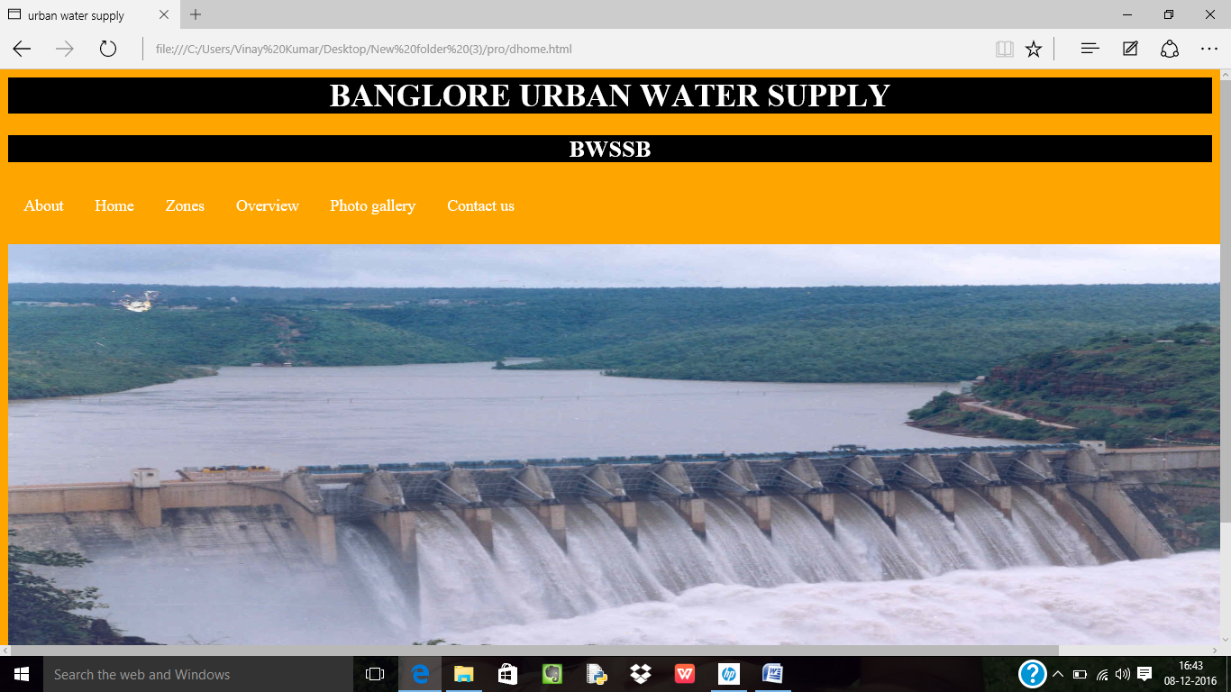

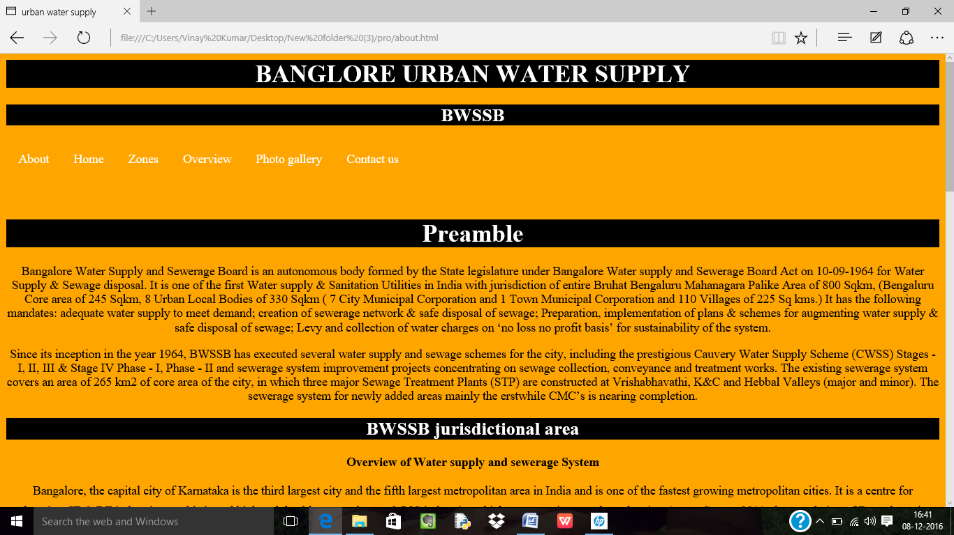

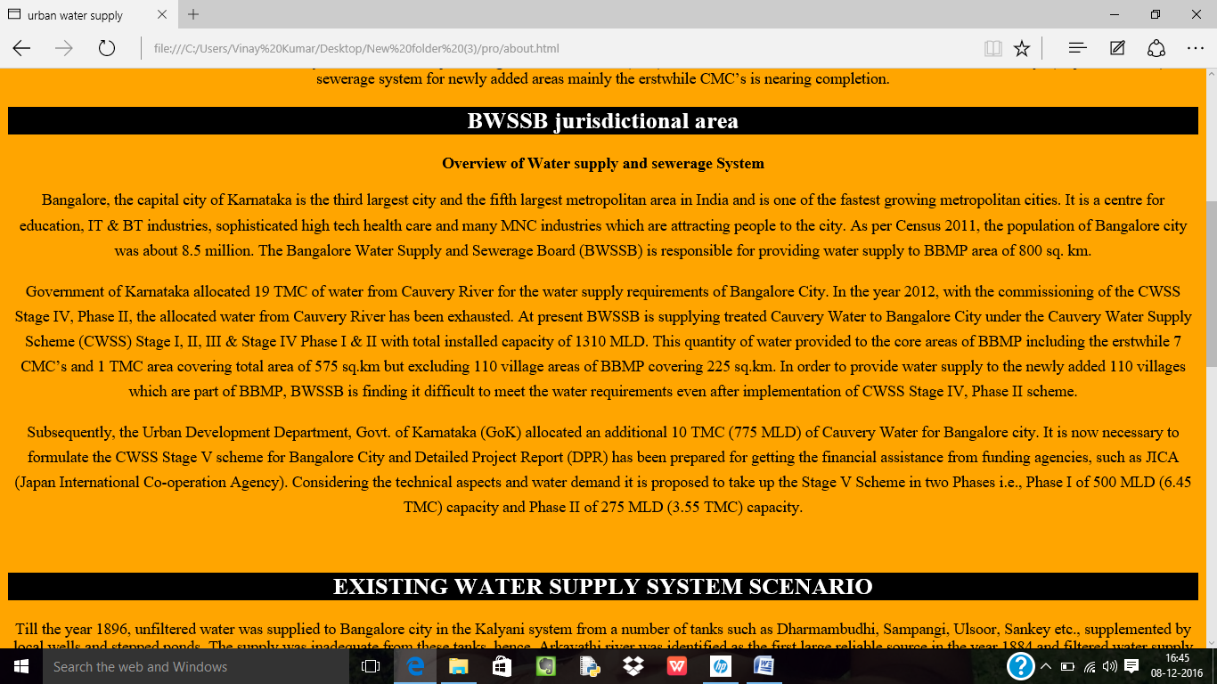

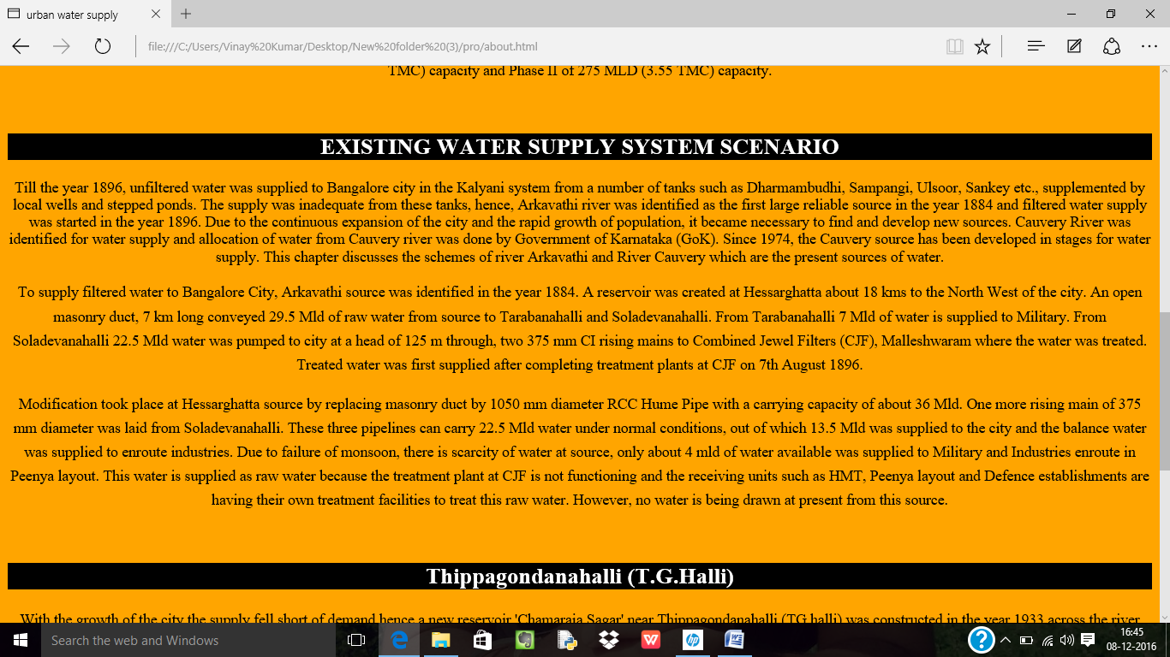

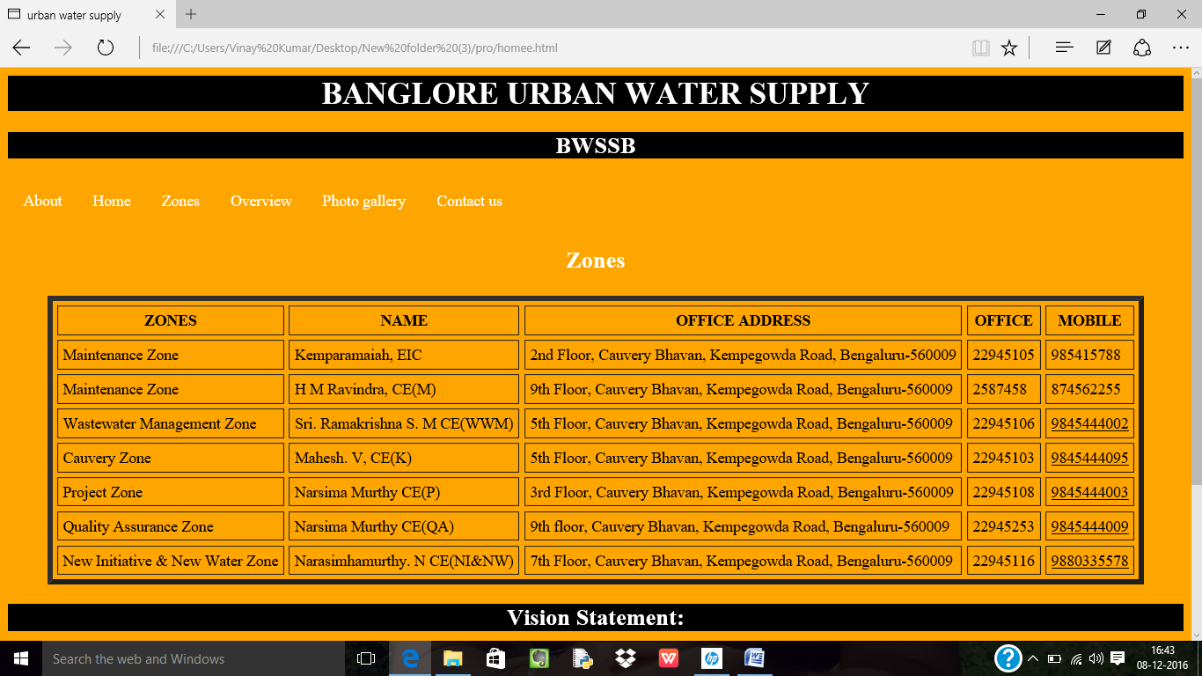

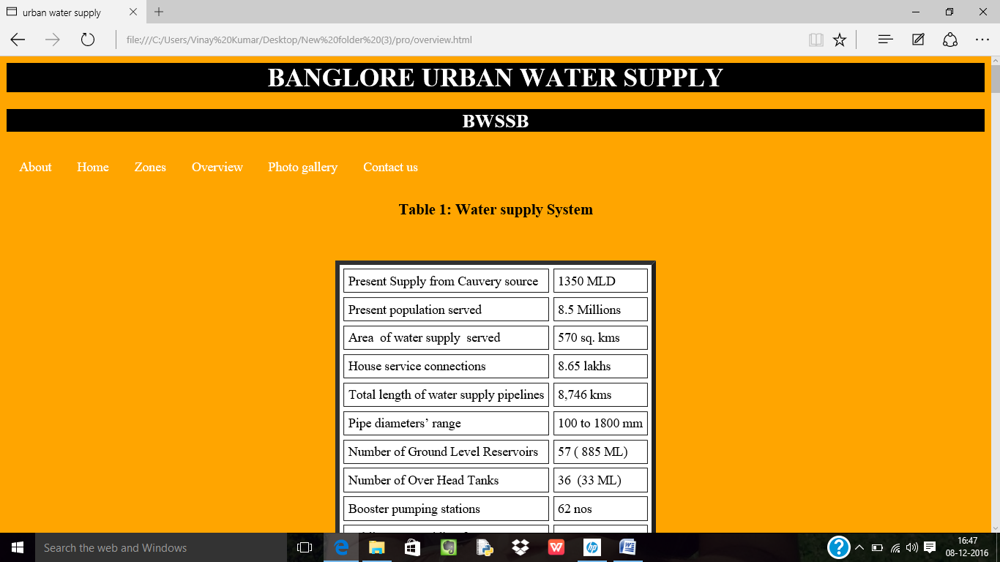

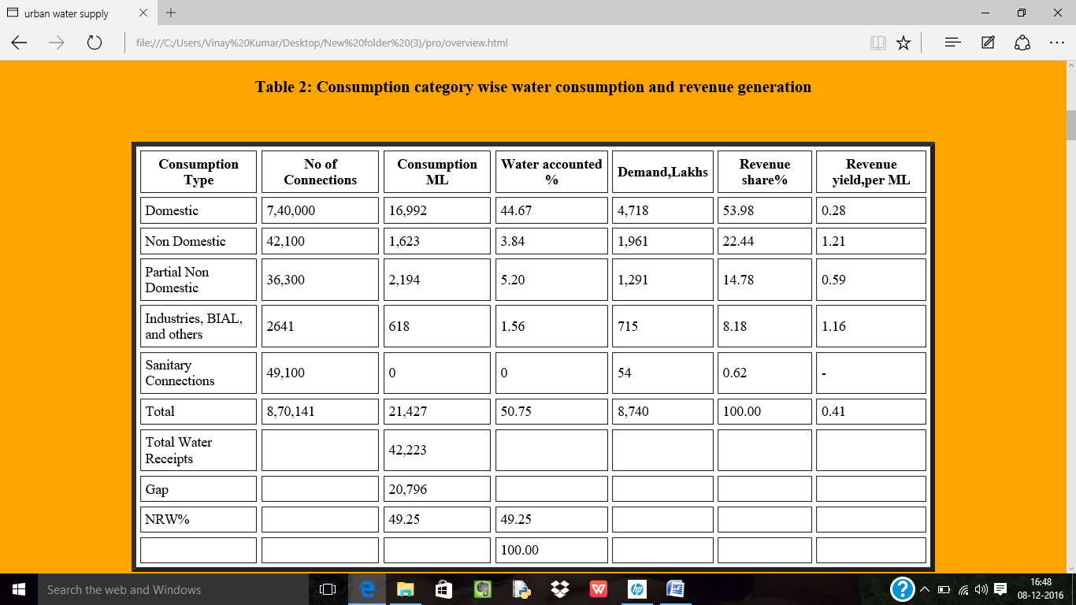

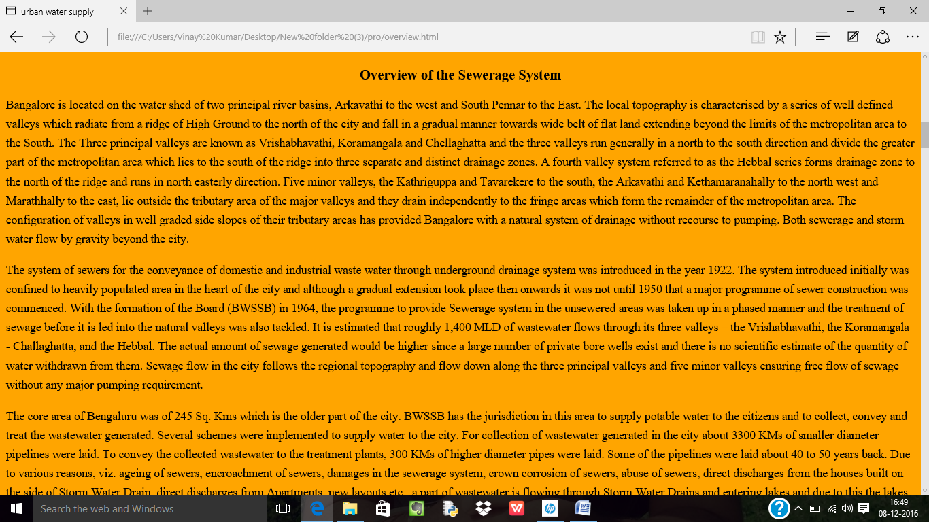

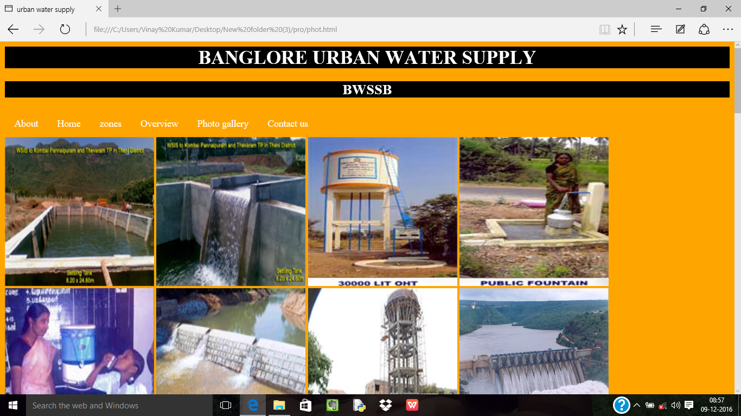

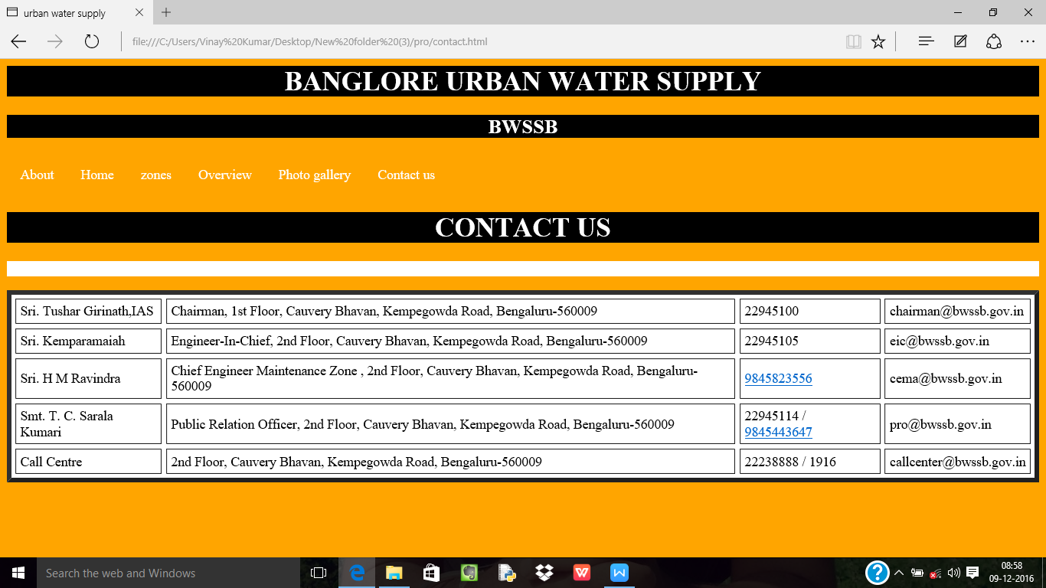

System requirements

Hardware requirements:

Processor - Pentium 4,Corei3

Ram - 512mb

Hard disk - 10gb

Software requirements:

Operating system - Windows 07

Web browser

Future enhancement

A wide rang of wholesale and retail institution plan for and manage water supply to meet current and future demands, it is conceivable that water banked at Bangalore could be used to satisfied the need of urban people planning by providing a temple for integrate regional water supply planning urban water management it discuses opportunities for enhancement of water supplies and avoidance of over exploitation of water resource in the middle east.

CONCLUSION

This report presented a Mini Project work on “ BANGALORE URBAN WATER SUPPLY ” web page development effort prediction,small scale visualization project. Based on the work involved the following conclusion can be made we learn t how to predict software development effort using regression method.by developing such web page, we enriched our knowledge on using various web page,estimating software development effort became easy by using theses web page.

REFERENCE

Coding example for internet.

Coding example for BWSSB.