**A) Retrieving 3 website using Google Dorks and collecting the information of that websites using who-is, Reverse-Ip-Lookup and Wappalyzer.**

*1st website, finding a* ***Pakistani website****.*

**Step1**: Open any Search Engine (Ex: Microsoft Edge) and search for the Pakistan website using the query

**inurl:.pk intext:"administrator" filetype:html**

*This finds the websites which has .pk in url and displays the html pages which belong to admin. (typically login pages).*

This is the result obtained:

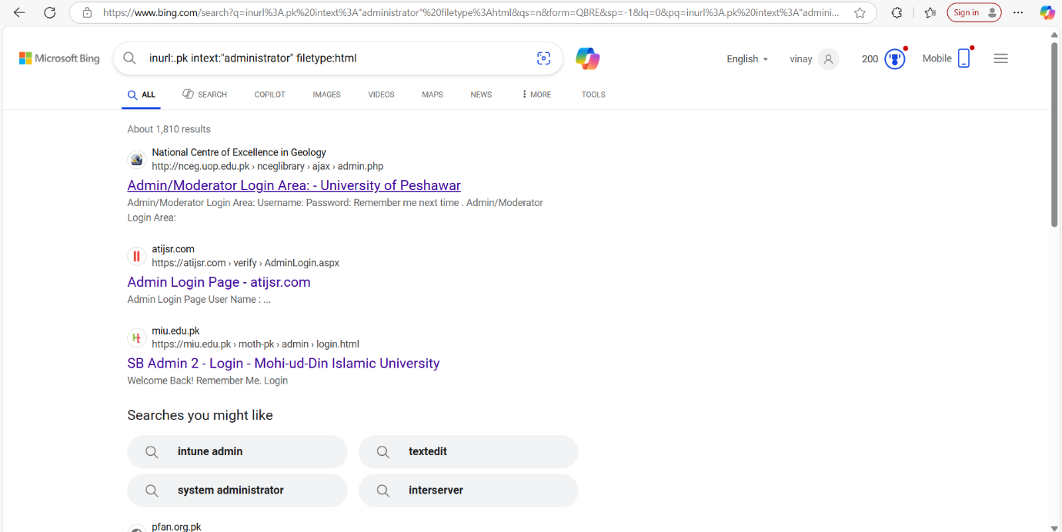

* Since the 1st website uses http protocol which is not secure, so we are entering in to the 4rd website.

**Step2:** To open the website listed just simply double click on it. You can see more websites listed by scrolling down.

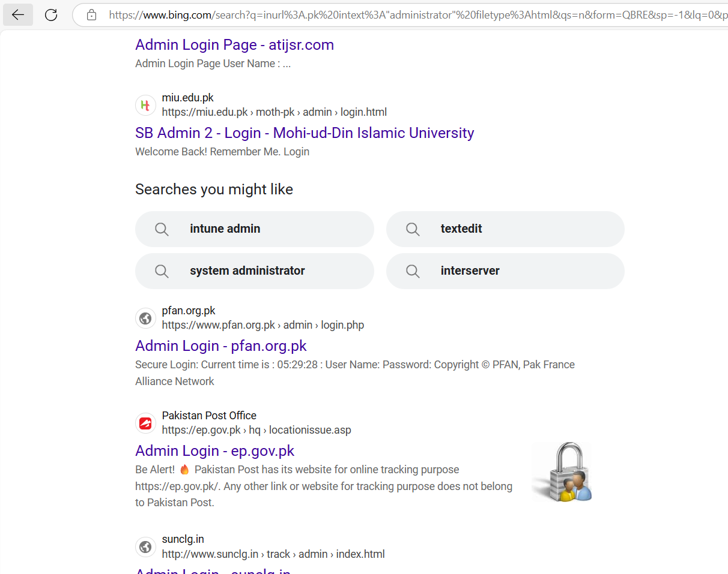

* By double clicking on the url opens up an admin login page as shown below.

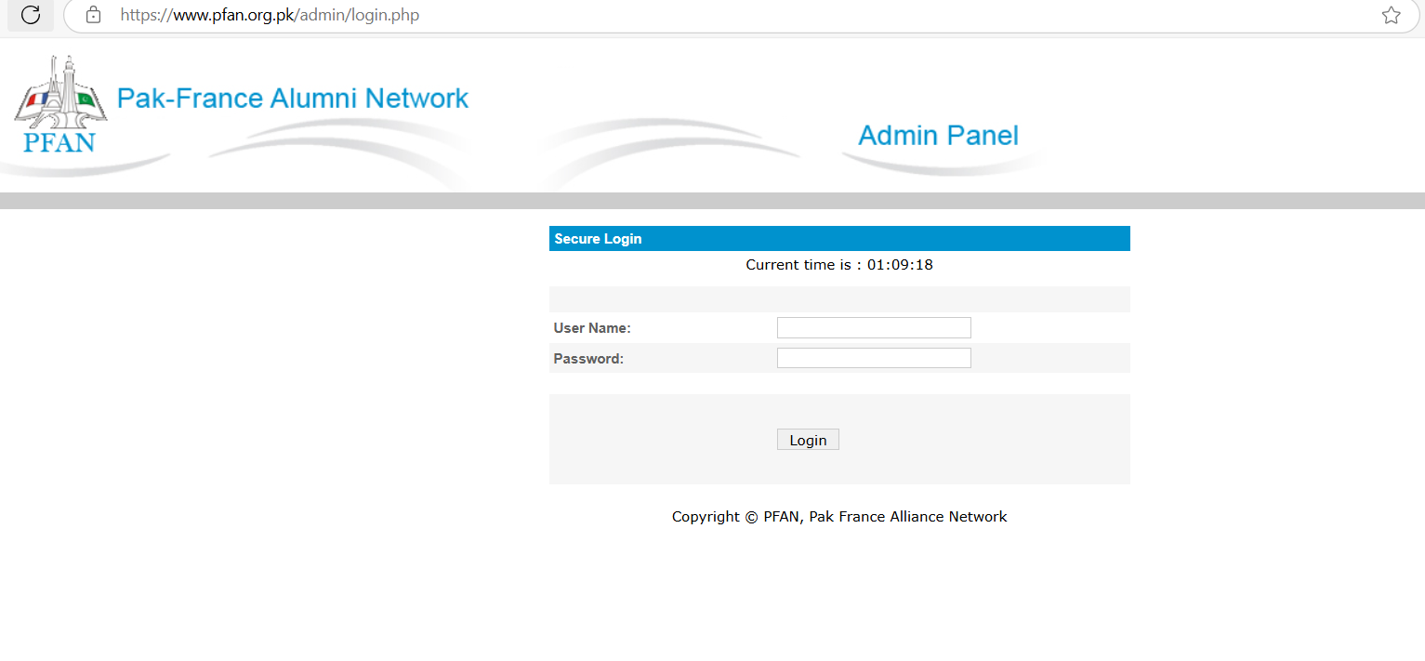

* Through this login page, an attacker can carry out attacks such as SQL injection.

**Step3:** Now open the search engine and search for whois domain tools, paste the website link in the search box as shown below and then click enter.

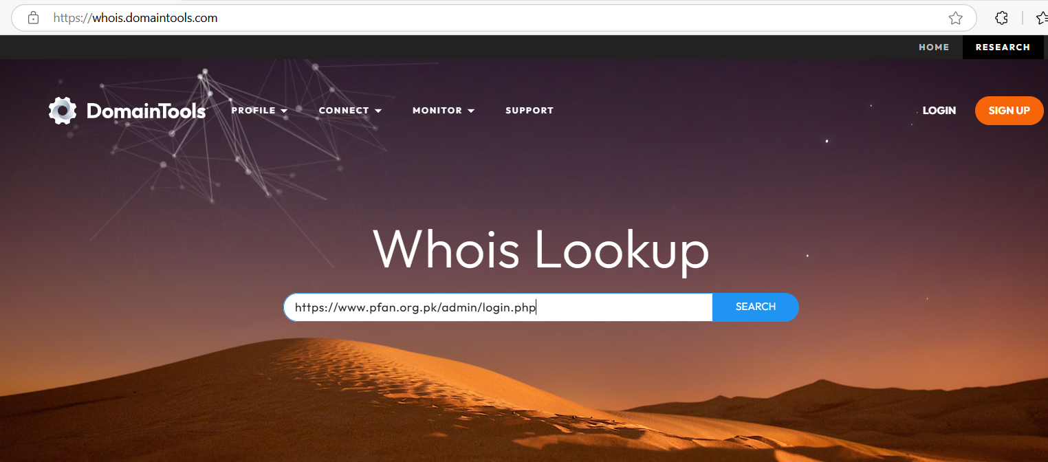

There you can find various details about name servers, IP address, IP location, IP history, days old etc…

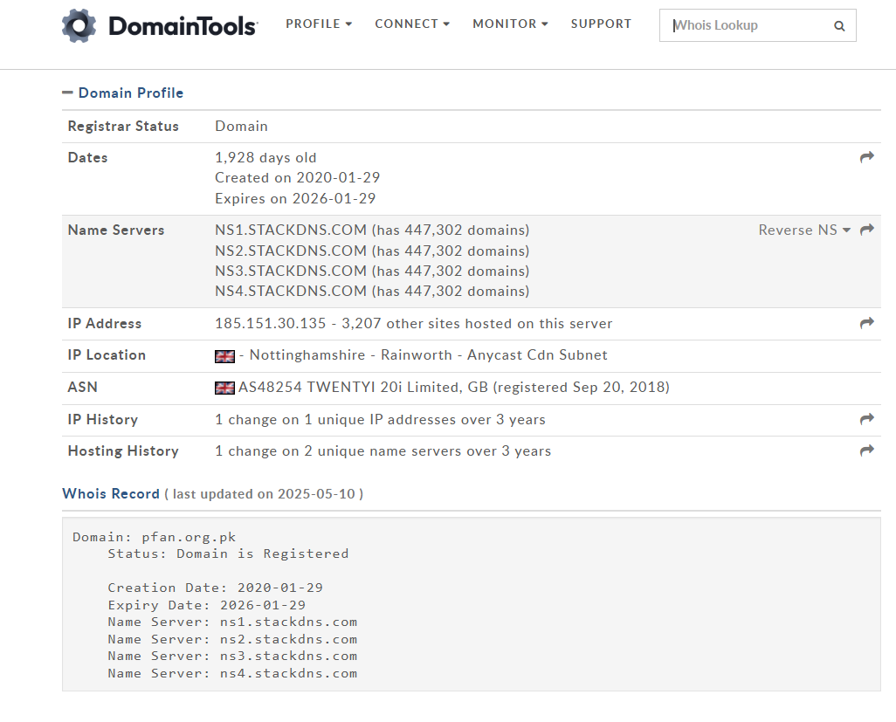

**Step4:** You can make reverse IP lookup which gives the domain names of target IP as shown below. Just click on reverse IP.

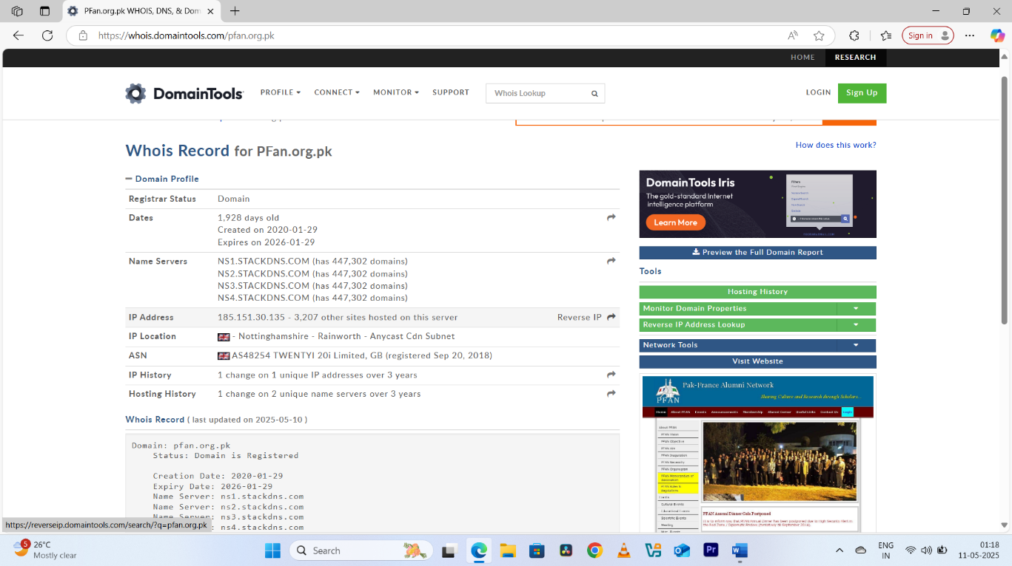

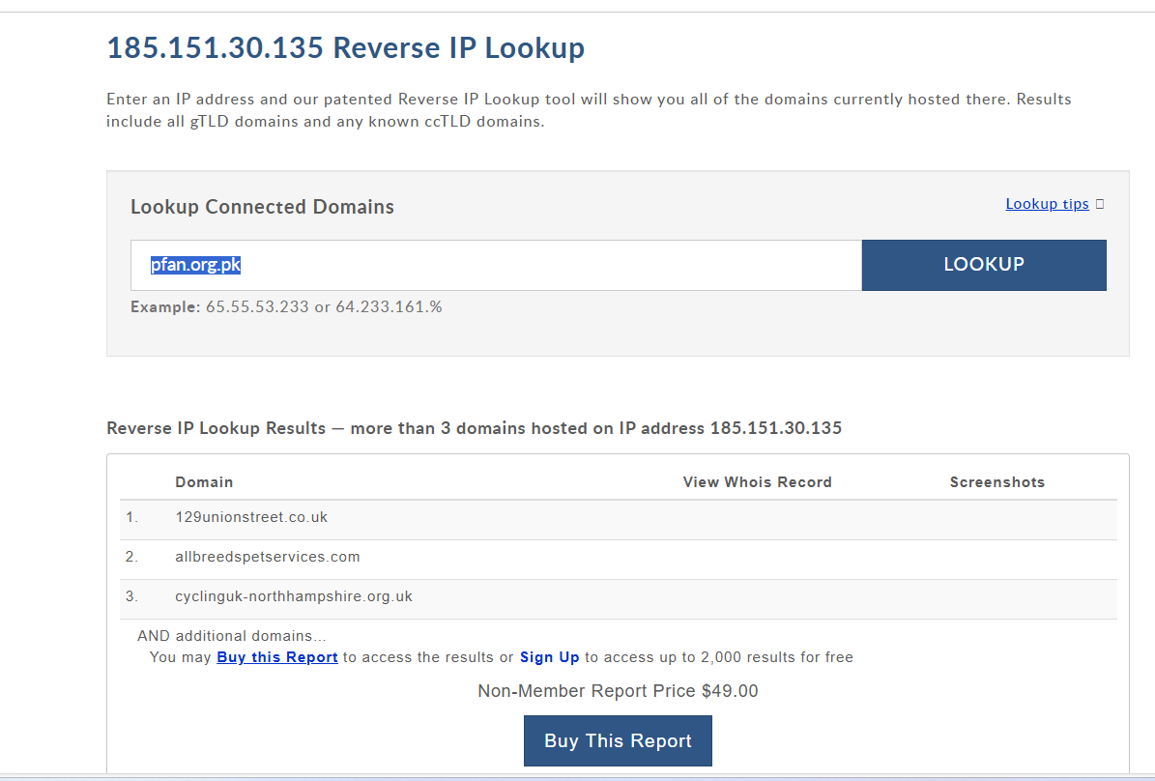

**Step5:** Now install a Wappalyzer browser extension in the browser you are using. The revisit the target website, click on extension icon present at top right corner, select the Wappalyzer extension and it shows the various technologies used by the target in their website as shown below.

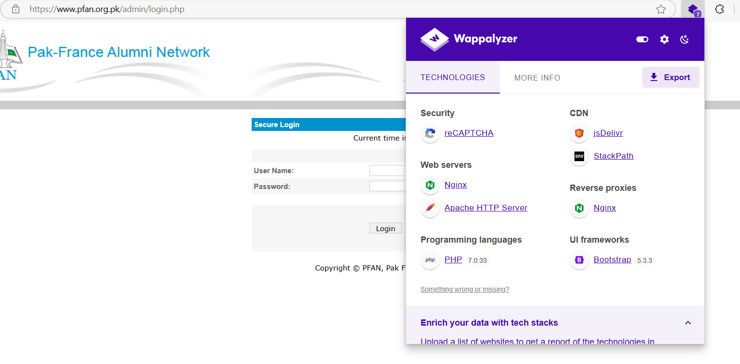

*2st website, finding a UK website*

**Step1**: Open any Search Engine (Ex: Microsoft Edge) and search for the UK website using the query

**inurl:.uk intitle:gov**

*This finds the websites which has .uk in its url and with the title as gov.*

This is the result obtained:

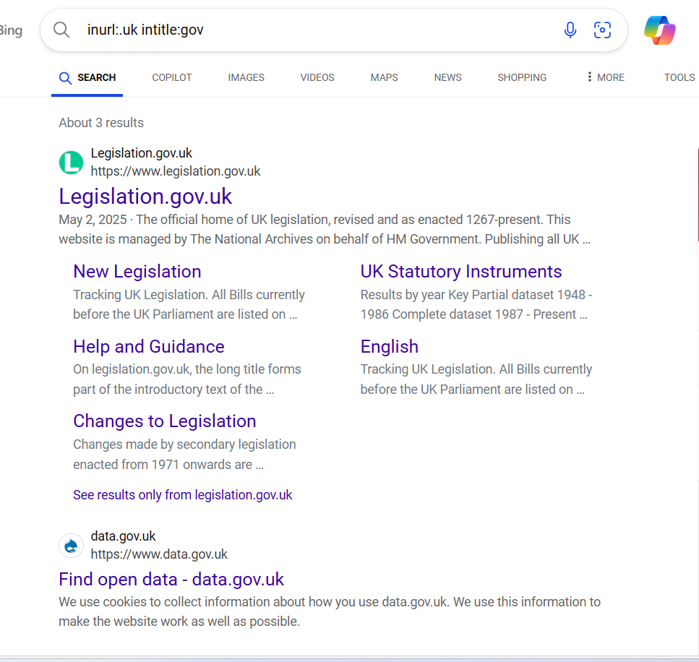

**Step2:** open the first website shown in the search results, the interface of it is as below.

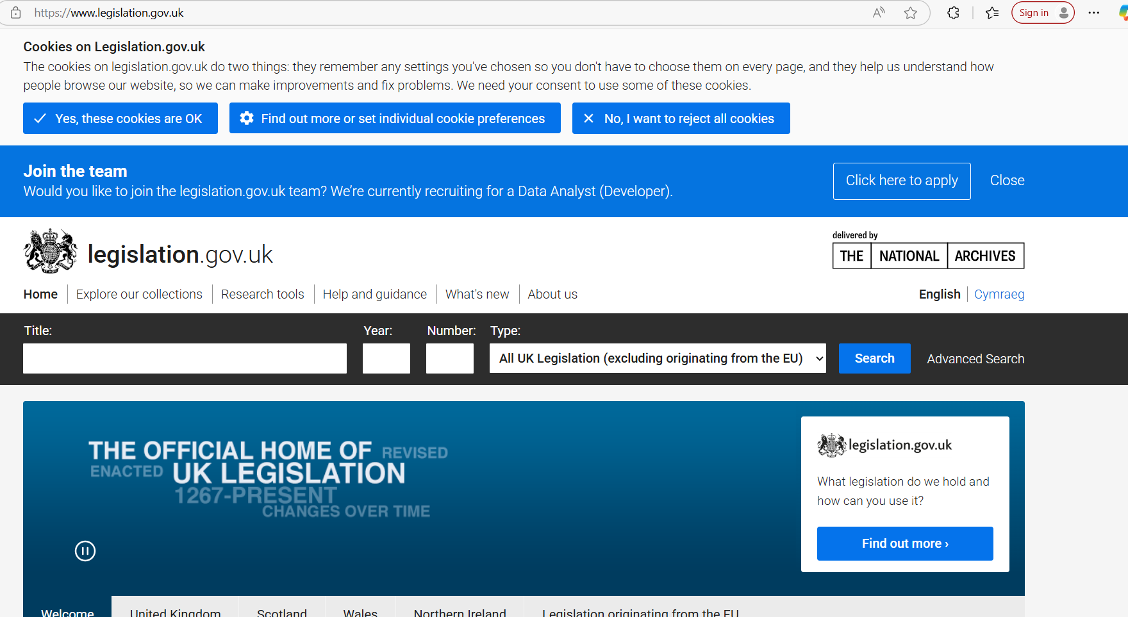

**Step3:** Open who is domain tools, enter the domain name of the website in specified filed then click enter that shows the various results such as IP address, domain names, IP location etc…

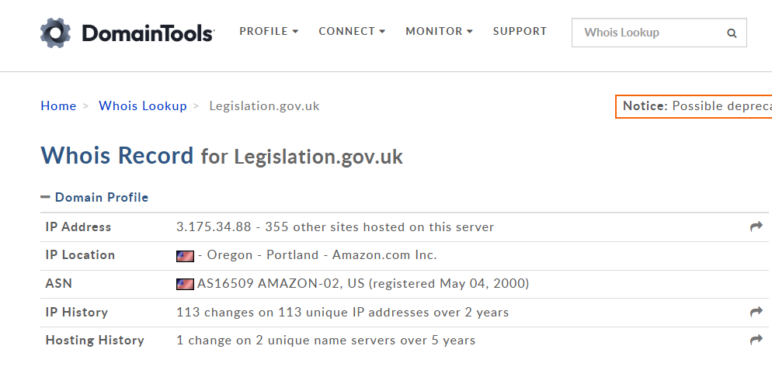

**Step4:** Now click on Reverse IP lookup option, which is just beside the IP address which shows the various results as shown below.



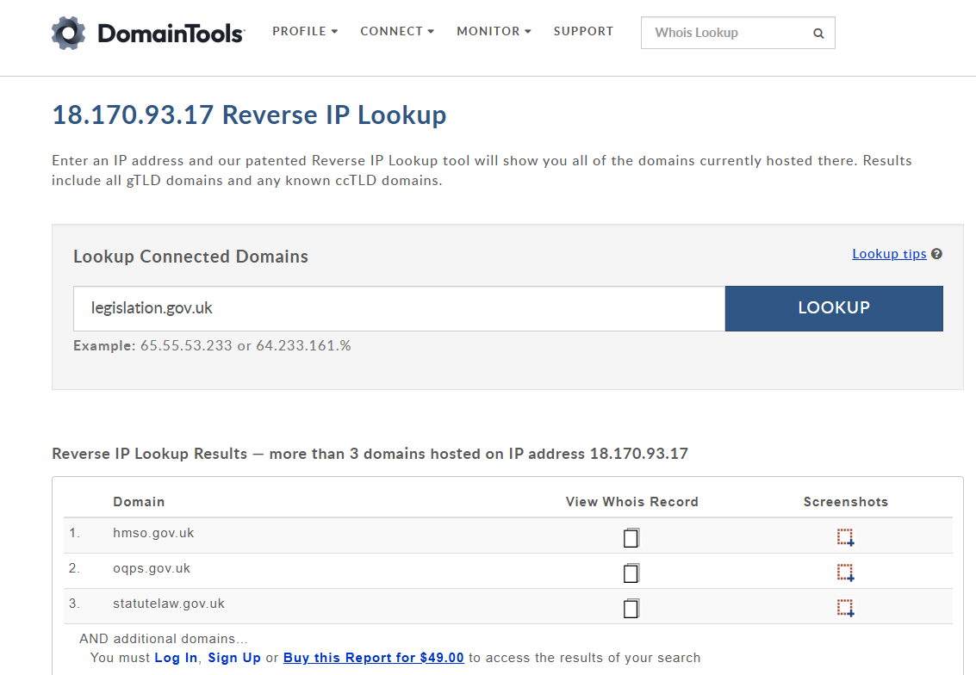

**Step5:** Revisit the website again and click on the extension icon present on top right corner of the search engine and select the Wappalyzer tool to see the technology used in the target websites.

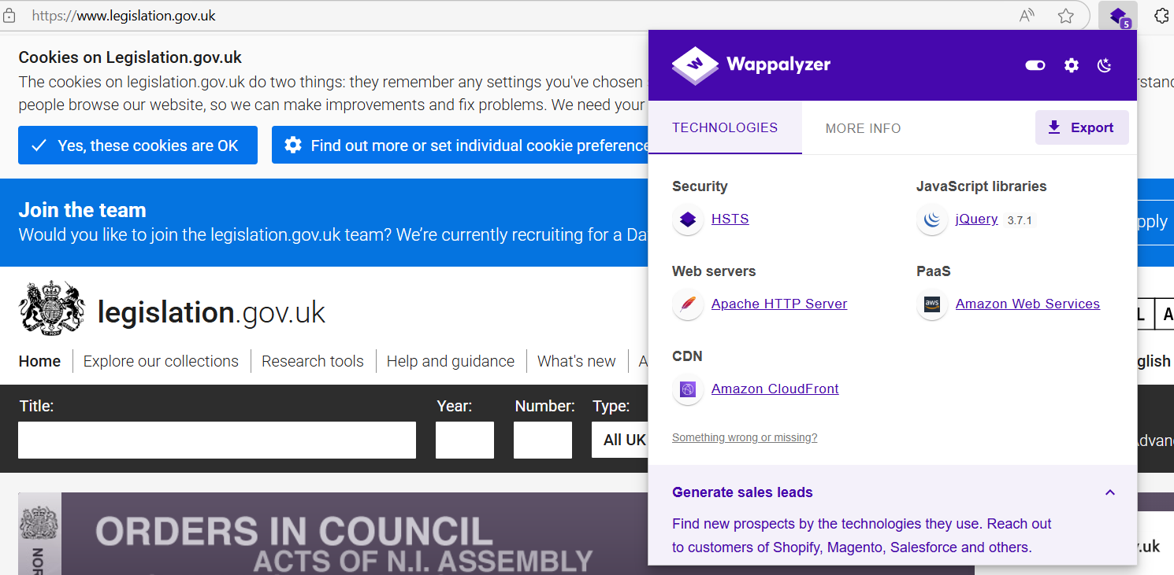

*3st website, finding an INDIAN website*

**Step1**: Open any Search Engine (Ex: Microsoft Edge) and search for the Pakistan website using the query.

**intitle:.gov.in intitile:adminlogin**

*This finds the websites which has .gov.in in their url and title as admin.*

The result obtained as follows: select the first link you found and open it by double on it. The websites image is shown below.

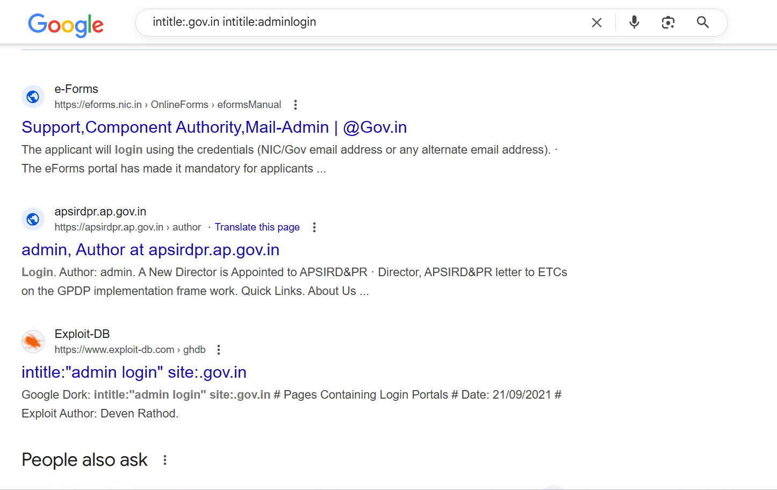

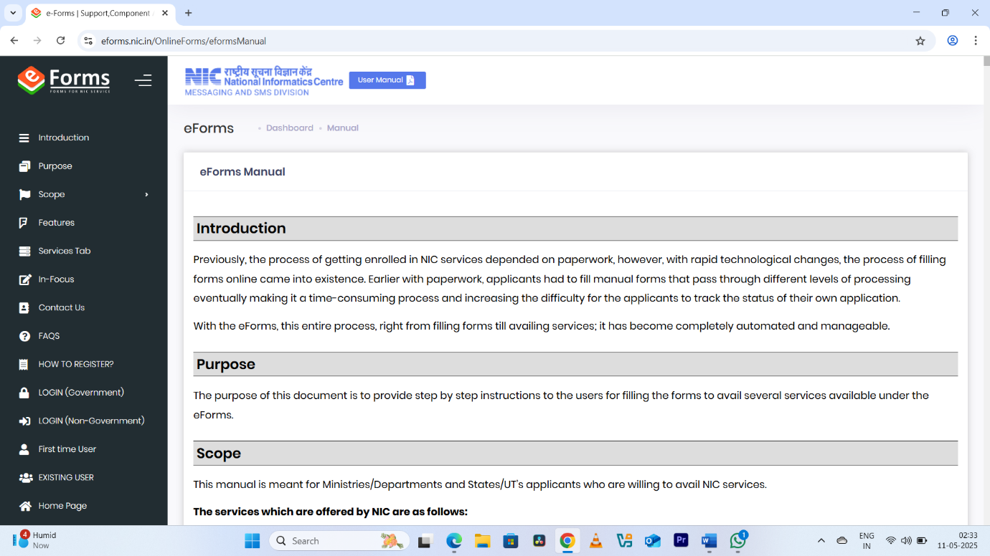

**Step2:** Open whois domain tools and paste the link in the provided search box then click enter to find domain names, IP address, IP location etc…

The result is shown below.

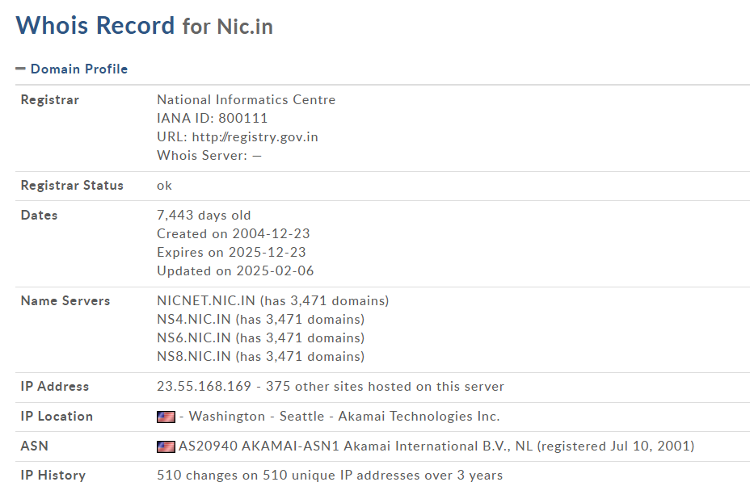

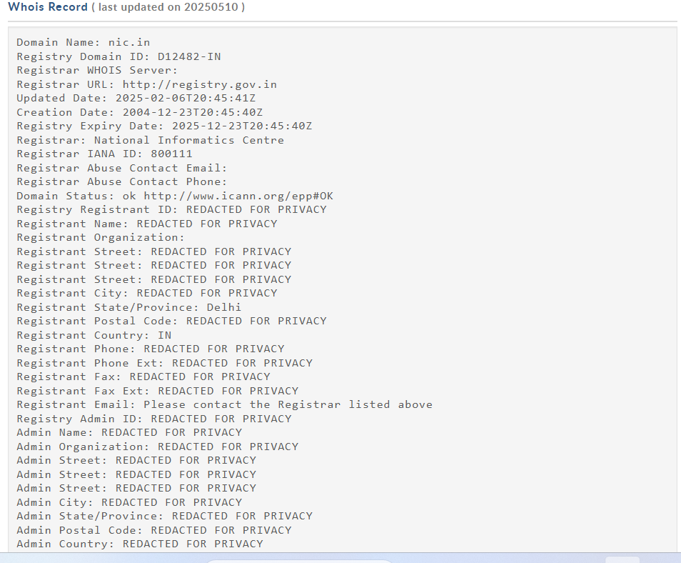

**Step3**: click on reverse IP lookup icon to get domain names through IP.

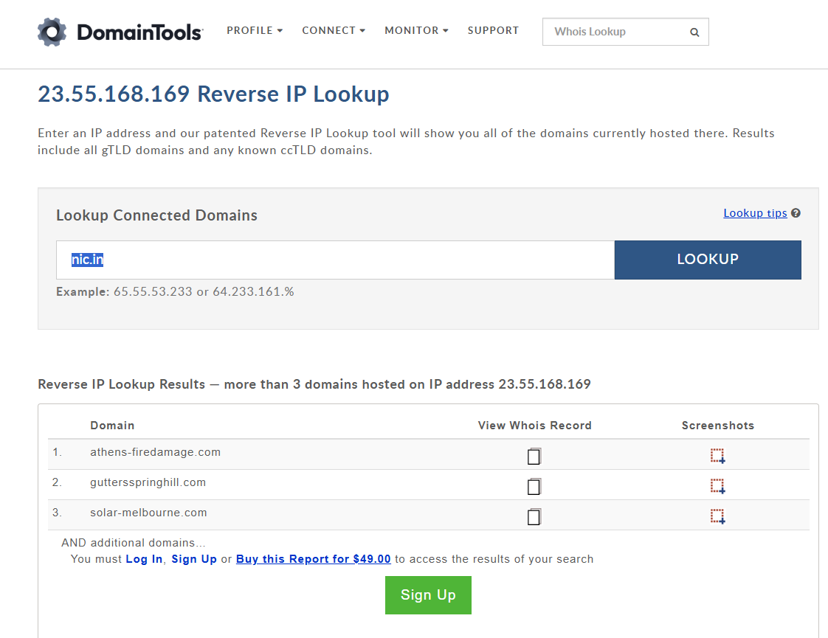

Step4: Now check the technologies used by the target website using wappalyzer tool. That shows as follows:

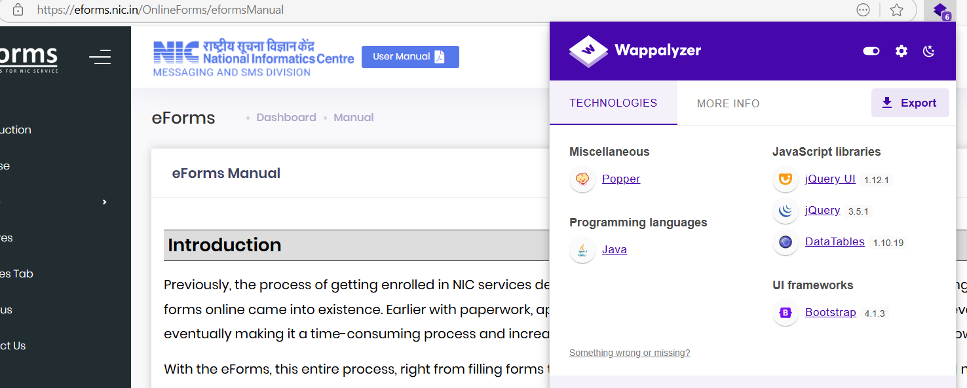

**B)** **Identify the Server Information and Way Back URLs with the tools IdServe and Wayback Machine for above obtained websites.**

*1st for a* ***Pakistani website***

**Step1**: Open Idserve tool and enter the url of the website in specified field. Then click on the button query the server.