Groundwater Level Prediction Using Hybrid Artificial Neural Network with Genetic Algorithm

In this paper we are using Crow Search with Genetic Algorithm and Grey Wolf with Genetic Algorithm to optimize ground water level features. This optimized features will be input to ANN (artificial neural networks) algorithm to train Ground water level prediction. ANN trained model applied on test data to predict water level and then calculate MSE between predicted and test data. MSE refers to difference between actual test data values and predicted values so the lower the MSE the better is the prediction model.

Grey wolf hunt in group by using four different wolfs such as ALPHA wolf which is consider as COMMANDER and take optimal decision. Omega wolf will separate PREY from its group, delta and beta will attack the prey. Same technique we can apply to optimize features where Alpha technique to select optimize features, using delta and beta will calculate fitness of each features and the best fitness features will be selected, omega will help to remove irrelevant features.

Crows will use their intelligence to hide their food from other crow by evaluating fitness between itself and other crows, if crows distance far away then it will hide food and same technique will be applied to optimize features by calculating importance between them, if feature is important then it will yield high accuracy and that feature will be selected otherwise that feature will be rejected.

Genetic algorithm will further optimized features obtained from crow of wolf and then train ANN algorithm.

To optimized features we have use code shown in below screen

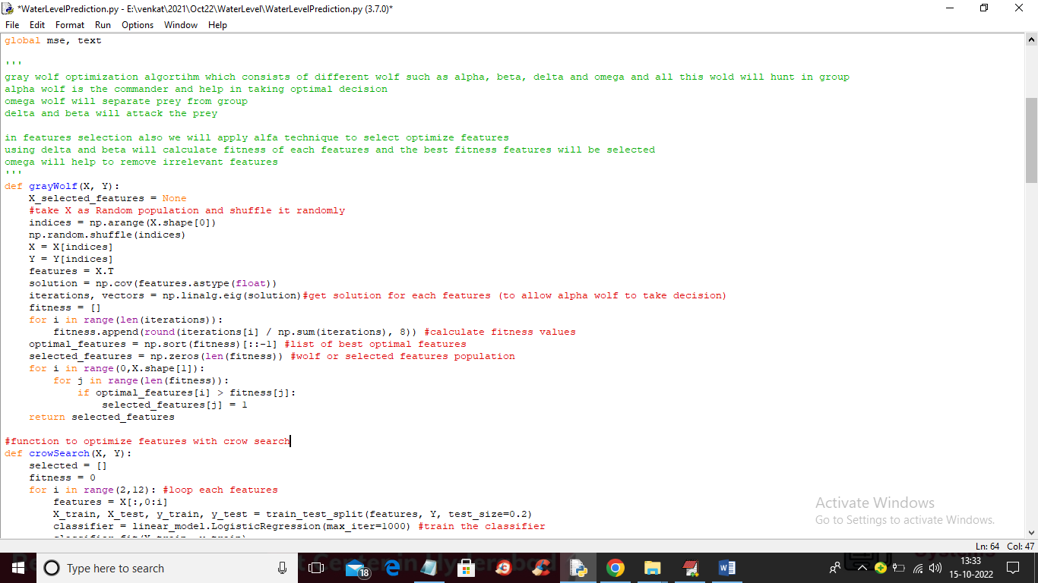

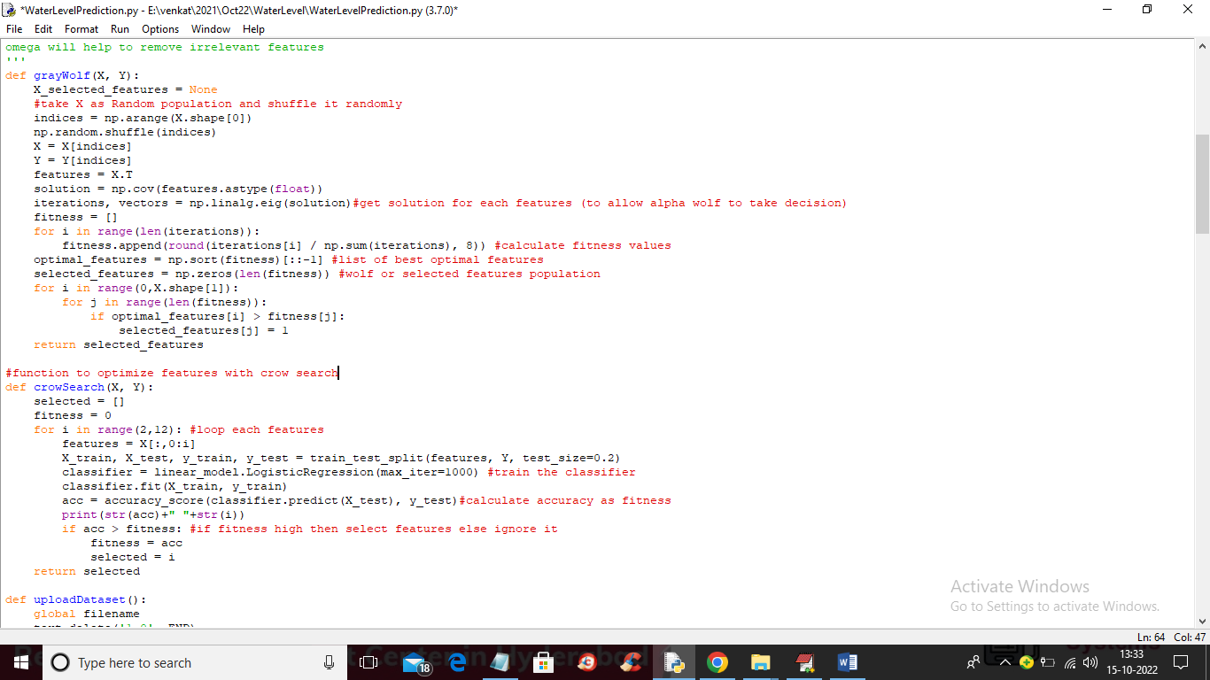

In above two screens read green and red colour comments to know about Grey wolf and Crow Search and in below screen showing code to further optimize features with GA and train with ANN

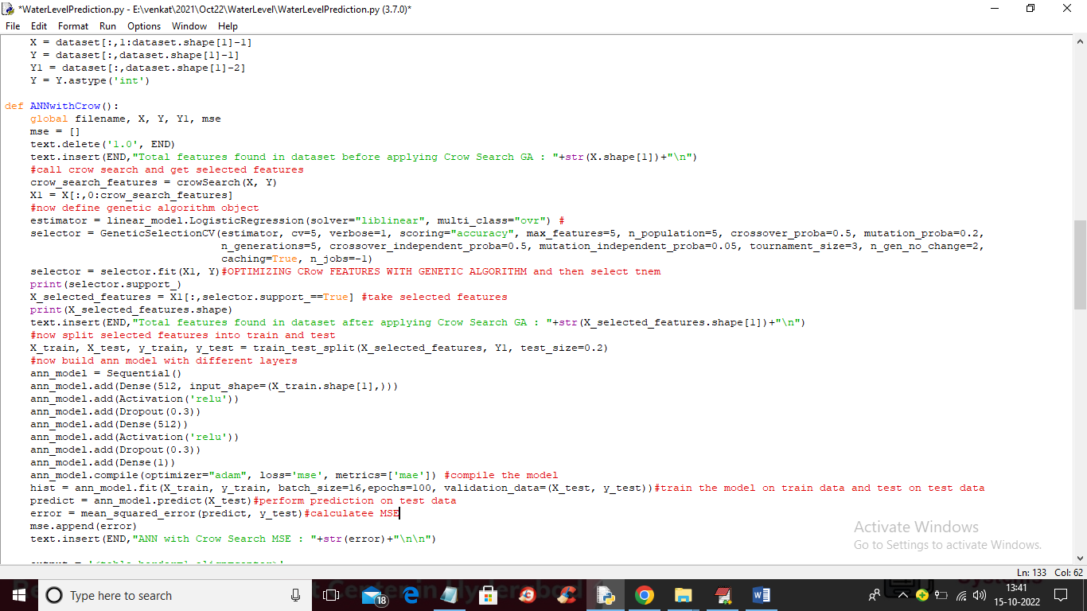

In above screen you can see combine all 3 algorithms such as Crow Search, GA and ANN and then training and perform water level prediction.

To train above algorithms we have used below dataset

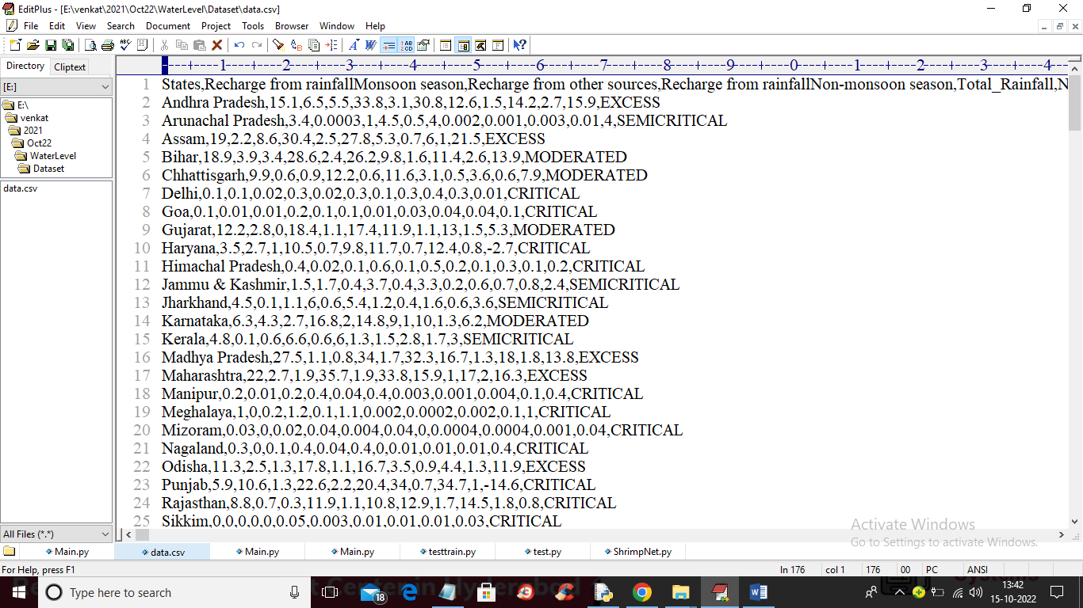

In above screen first row contain dataset column names and remaining rows contains dataset values. So by using above dataset will train models

To implement this project we have designed following modules

1. Upload Ground Water Level Dataset: using this module we will upload dataset to application
2. Preprocess Dataset: using this module we will read dataset and then remove missing values and make processed dataset ready
3. Run ANN with Crow Search GA: processed dataset will be feed into this module to train water level prediction model and calculate MSE
4. Run ANN with Grey Wolf GA: processed dataset will be feed into this module to train water level prediction model and calculate MSE
5. MSE Comparison Graph: using this module we will plot error graph between both algorithms. Less error algorithm will be consider as best

SCREEN SHOTS

To run project double click on ‘run.bat’ file to get below screen

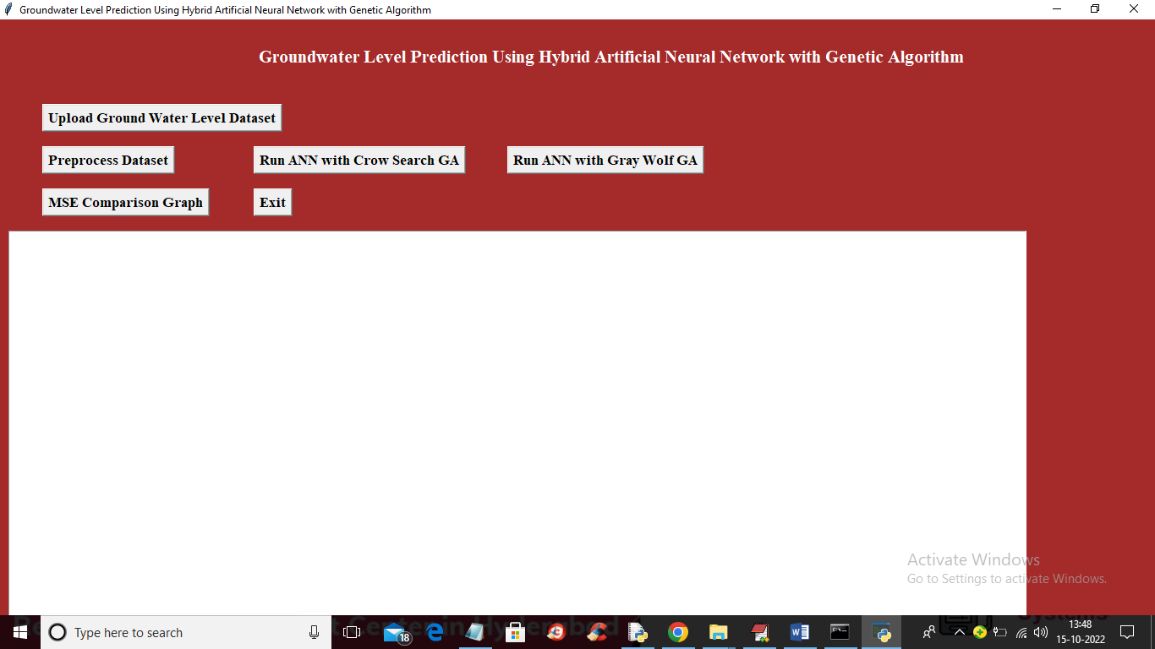

In above screen click on ‘Upload Ground Water Level Dataset’ button to upload dataset and get below output

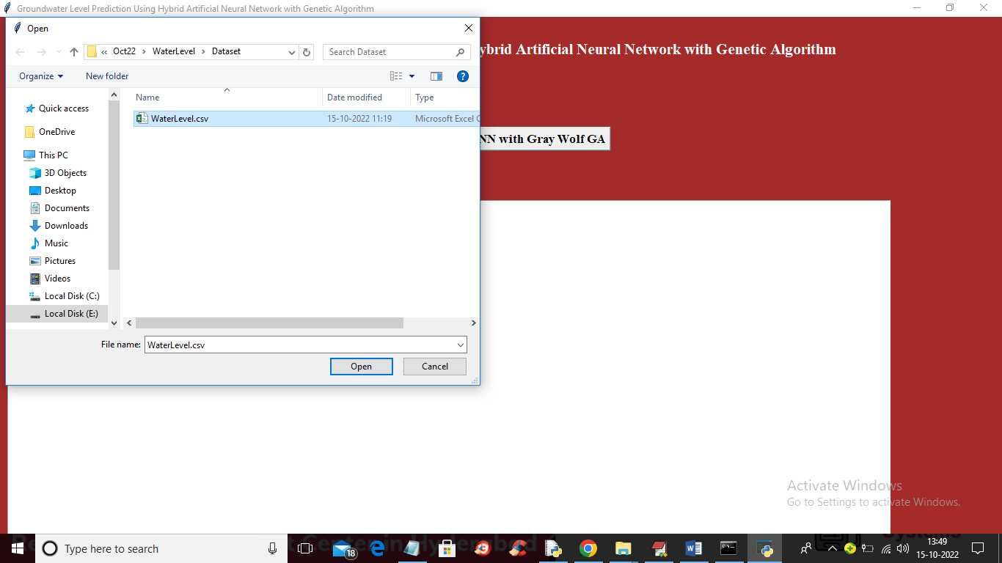

In above screen selecting and uploading ‘WaterLevel.csv’ dataset file and then click on ‘Open’ button to load dataset and get below output

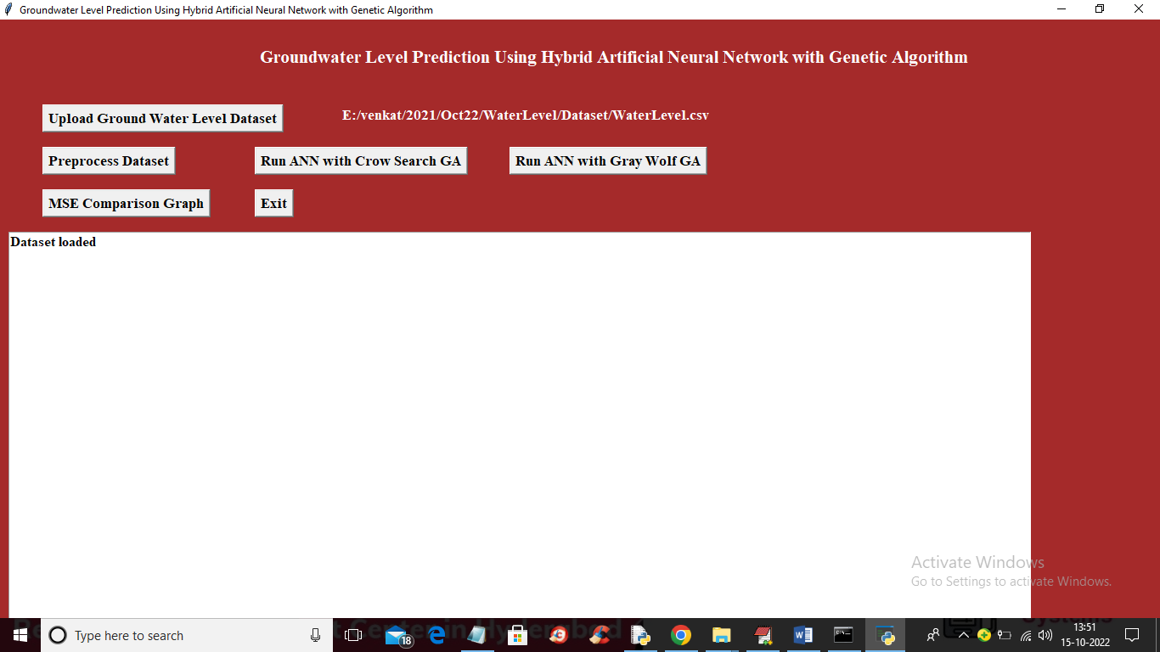

In above screen dataset loaded and now click on “Preprocess Dataset” button to read and clean dataset and get below output

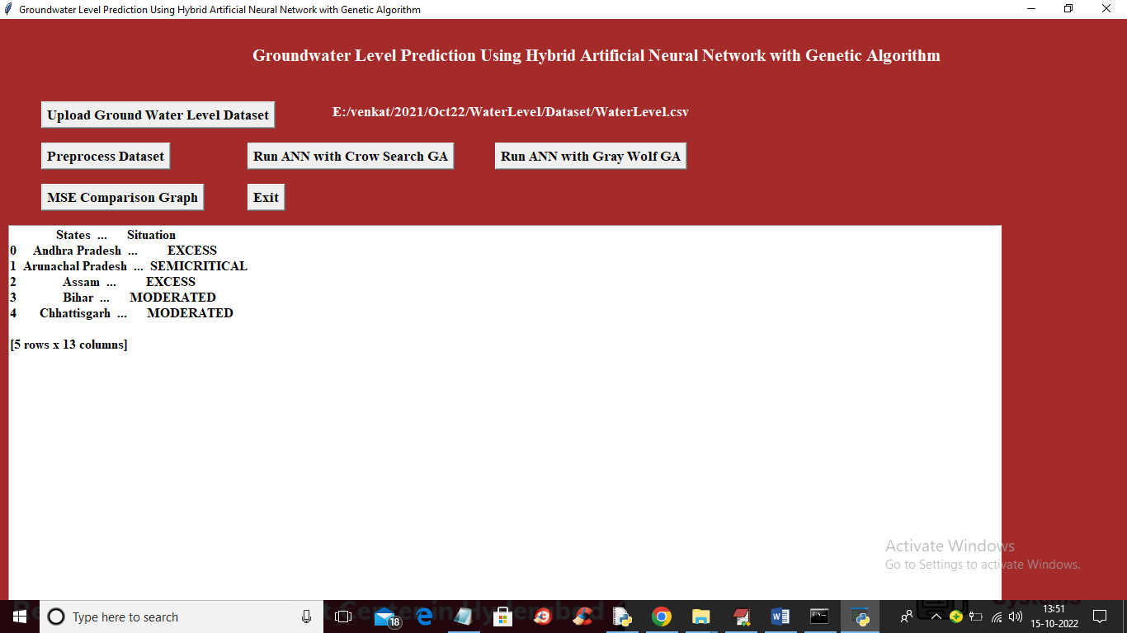

In above screen showing some values from the dataset and now click on ‘Run ANN with Crow Search GA’ button to optimize features and train with ANN to get below output

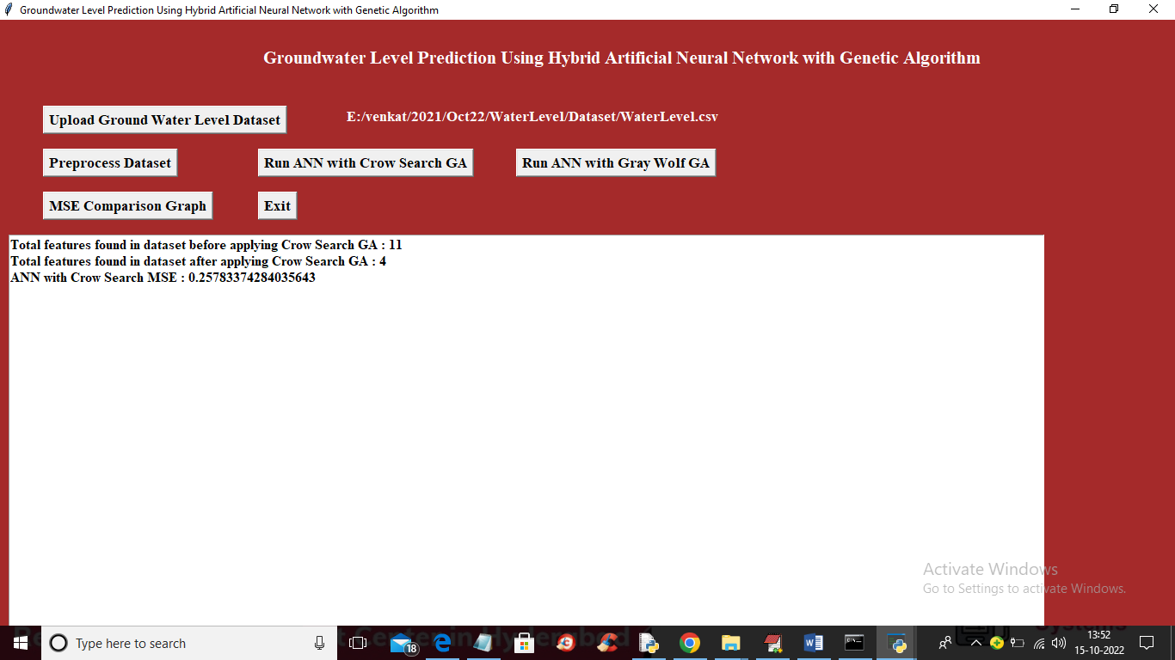

In above screen in first line we can see dataset contains 11 features and after optimization with Crow and GA we got 4 attributes and then training with ANN got 0.25 as the MSE error and below is the prediction output on test data

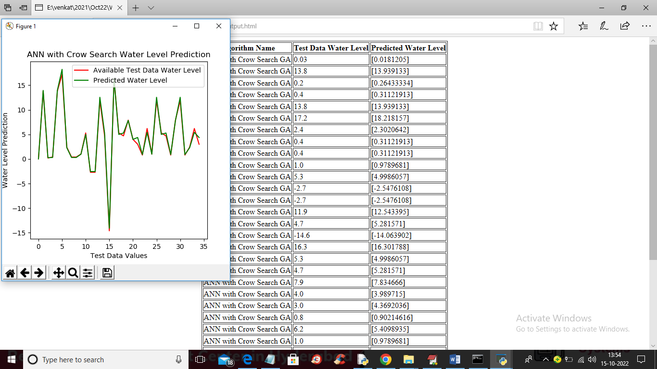

In above screen in tabular output first column contains Algorithm Name and second column contains TEST data water level and 3rd column contains predicted water level and in above table we can see there is minor difference between TEST value and predicted values and in graph also X-axis represents number of test data and y-axis represents Water Level and red line represents TEST water level and green line represents predicted water level and in above graph we can see both lines are fully overlapping so there is only minor difference between predicted and test values and now close above graph and then click on ‘Run ANN with Gray Wolf GA’ button to train ANN with Grey wolf and GA and get below output

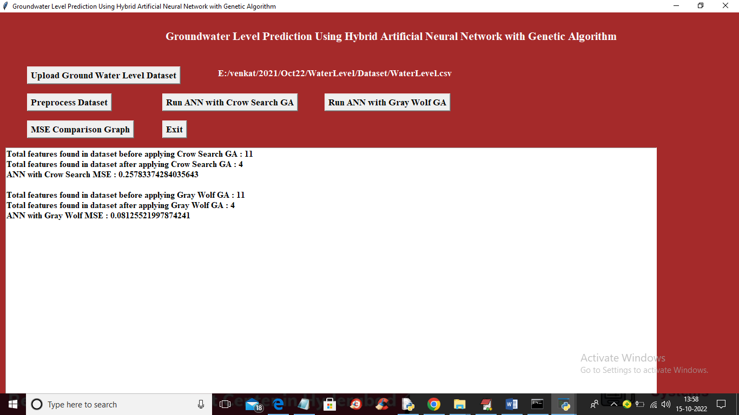

In above screen with Grey wolf also 4 features selected and its MSE is 0.08 and below is the prediction output

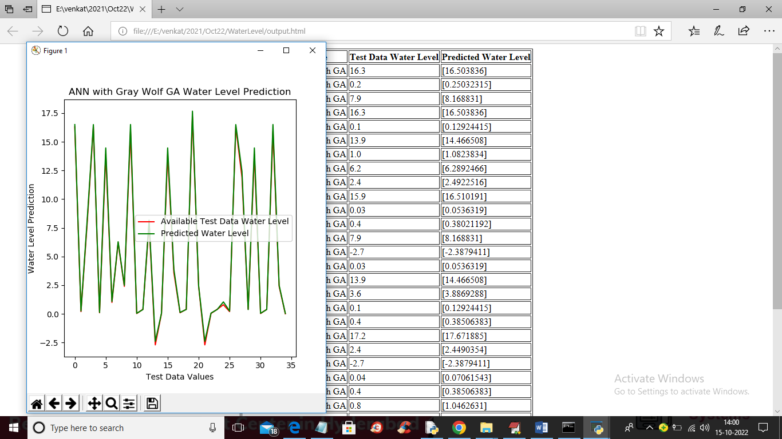

In above screen we can see test and predicted water level in tabular output for Grey wolf and in graph we can see both lines are completely overlap so Grey wolf is giving close prediction so it’s better than crow search and now click on ‘MSE Comparison Graph’ button to get below output

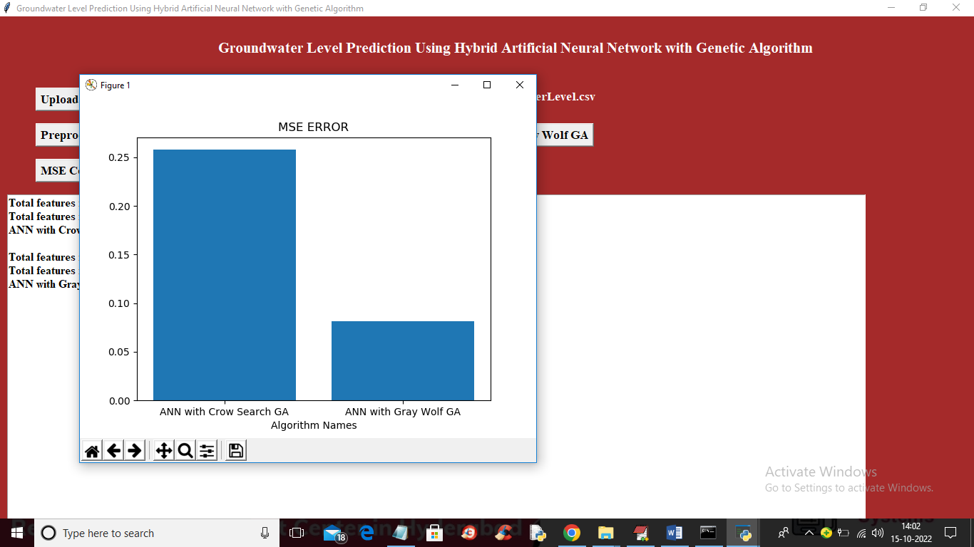

In above graph x-axis represents algorithm names and y-axis represents MSE error and in both algorithms Grey Wolf with GA ANN got less error rate