**MUSIC RECOMMENDER SYSTEM**

**PROJECT SYNOPSIS**

OF MAJOR PROJECT

**BACHELOR OF TECHNOLOGY**

Computer Science and Engineering ‘CSE’

Batch 2019-23

SUBMITTED BY

Vinay Panwar(0103), Vaishnavi Kaushal (0097), Rupali Wanare (0071)



**DEPARTMENT OF COMPUTER SCIENCE AND ENGINEERING**

**SAGE UNIVERSITY, INDORE**

**Synopsis**

**Table of contents**

|  |  |
| --- | --- |
| **Topic** | **Page No.** |
| Introduction | 1 |
| Rationale | 1 |
| Objectives | 1 |
| Literature review | 1 |
| Feasibility study | 1-2 |
| Methodology | 2-3 |
| Conclusion | 3 |

**Introduction: -** Recommender system is a system which helps an algorithm or device to guess something for their respective users. There are many different types of recommender system available in the tech industry and some of them are working positively as other are on the process of continue to innovate to customize the product more and more. With this idea in our mind, we choose to work on a recommender system which helps user to understand their day-to-day requirements and make their decisions with more clearer information in mind. As we all knew that recommender would be really a very deep field to work in as today’s user requirements and daily life activities are much more complex than it looked at the first when we choose to work on all the areas. But after the realization of the problem, we choose to work with the music recommendation system. How are this music application recommending song to their user, we got to learn, this all based on the user’s mood. I mean most of the time user is in happy mood or in natural mood or could be angry. There was so much vast majority of possibilities, so we tried to modularize them in small tasks(modules), like we divided the task in three major phase and worked with and will continue to work on it. Our problem was so basic to recommend any kind of music to a user but which song to refer which user at first looked much complicated.

This model/UI Help user to understand their moods, and also let them decide which song they want to listen to feel their emotions.

**Rationale: -** Music recommendation system is more about finding an accurate product than serving the product. Here our product refers to songs and other (like books, movies, shows, and events) we have to options to recommend. This system purely will work on moods and emotions of users their own and they would’ve full control over their choices and can also suggest us throw our UI that the model did it wrong and we got to work more to accurately customize detection process.

**Objectives: -** We aimed to achieve a realistic product with numerous features like identifying the mood to suggest what going to be the best choice for them. Being in a place where user are the most priority and working on such a product will help us innovate more and more. Achieving an end product is not our main priority, instead our priority is to build a more customized product for users in this challenging environment to make their decision more transparent and fruitful.

**Literature Review: -**We read numerous research paper and had gone throw a lot of the documentation before diving deep into the process of working on the project. We started with the understanding of the problem statement and then finding what the problem was in the statement. From the deep studying about the project, we were going to work on to the overview of similar project available in the industry, that actually helped us decide how our UI would be look like, which might be the process we will have to gone throw and at end what were the requirement to finish the project in quality time. We did read the documentation of modules of python i.e. Tkinter and pandas with random, and also searched about the similar project on GitHub, understand the working of the software code.

We also realized when researching about the requirements, that we will be going to use Spotipy API so we’d also read and watched the tutorials of Spotipy and clearing mentioned to have a Spotipy developer account to use at the code level.

**Feasibility Study: -** The music recommendation system was feasible to build as the requirement of building this process would only require minimum specification and resources which were majorly available opensource. This were the requirements: -

1. **Software** **Requirement: -** Visual studio and visual studio code, jupyter notebook, python environment, module like Tkinter for GUI, Spotipy API, Spotify application, random module, pandas module, good working of respective devices, python environment.
2. **Hardware requirements: -** ram 8 GB and above, hard disk 512 GB and above, model i3 and above, OS win 10/11, internet connection, and device.

**Methodology: -** We decided to use Agile strategy of Software development as we knew this was the only software development life cycle process which deal with ongoing adaption and accept new changes in the process and product. We are a student and don’t know at which point of time we get to update the process or in process. We started with the identification of problem statement to actually finding the problem which we were going to solve and help innovate the solution. We came up with a recommendation system problem but even then that was too large to deal with so we decided to move with music recommendation system. After deciding the problem we started to work on solutions and came with numerous solutions like an application or web-app but at the end we decided to build an UI for user to simplify there decision tree at some level in life.

We decided to add some demo pics of the UI but that’s now the end-users UI we are continuing progressing on it. The images are :-

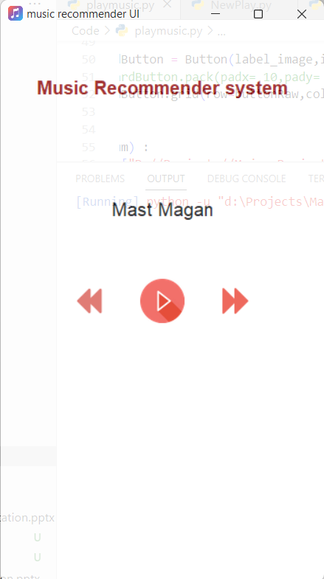

This were the prototype of music player.

The was one more UI as our project includes mood detection feature. So we came up with the solution to detect moods of user using some set of feedback question’s answer and after applying classification machine learning algorithms we helped to find out the actually moods of users.

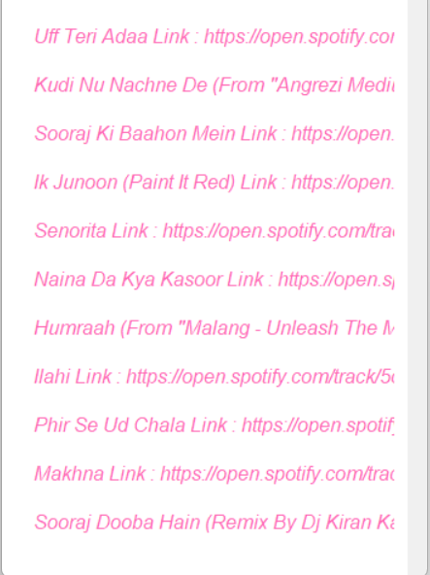

Question After answering the question and detection of mood the

recommended song

**Conclusion: -** Recommending systems are more user reliable as it recommends more customized result. Customized results mean more familiarity and satisfaction to users.

As per the growing needs of user and lack of time, it requires our more effort to give the optimal solutions for the problems. Our team created a widget board which help users to get more insightful brief about their recommendation and customized result. We are working on widget project which help user to get a recommendation for movies, music, and books. Currently we worked only for music recommendation.