Operational Flight Delay Project - Visual Summary

Project Flowchart
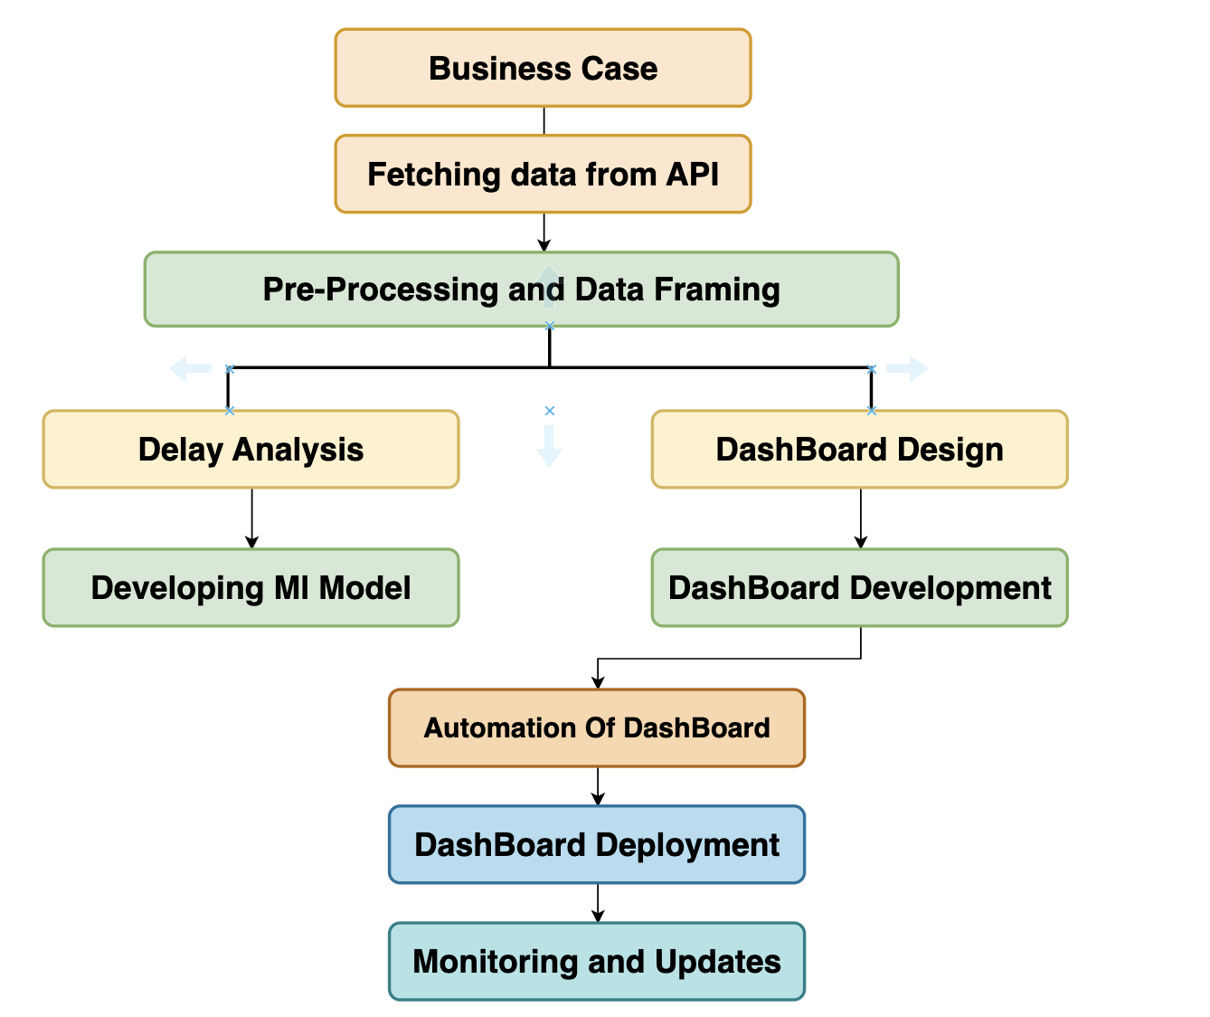
🔁 From API to Automation: A streamlined flow for data-driven decision-making.

Delay Analysis Dashboard
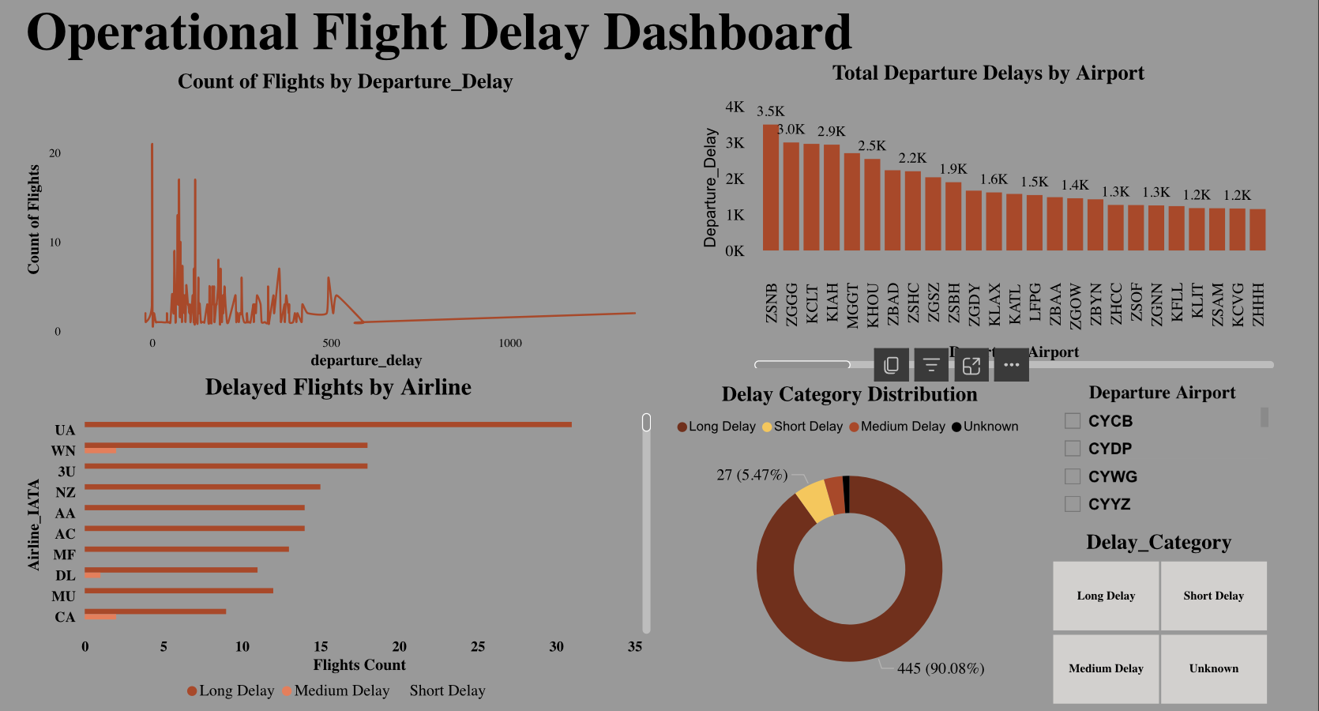
Visualizing delays: Understand where and why delays occur most.

KPI Dashboard with Tree Map
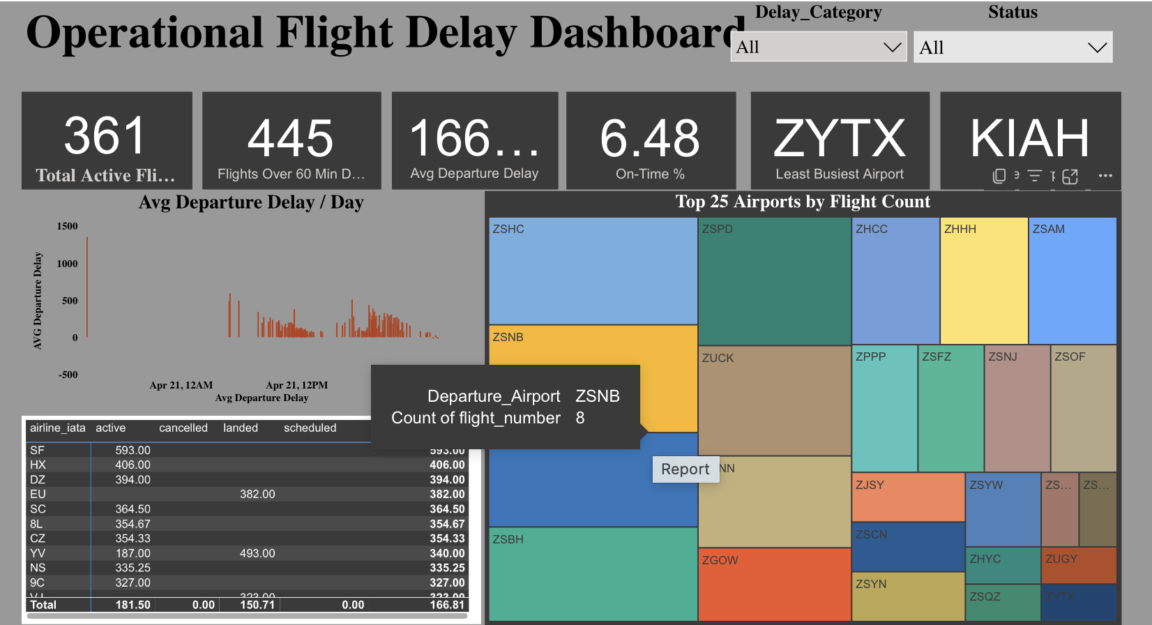
KPI Intelligence: Uncover operational performance with real-time insights.

Logistic Regression Evaluation
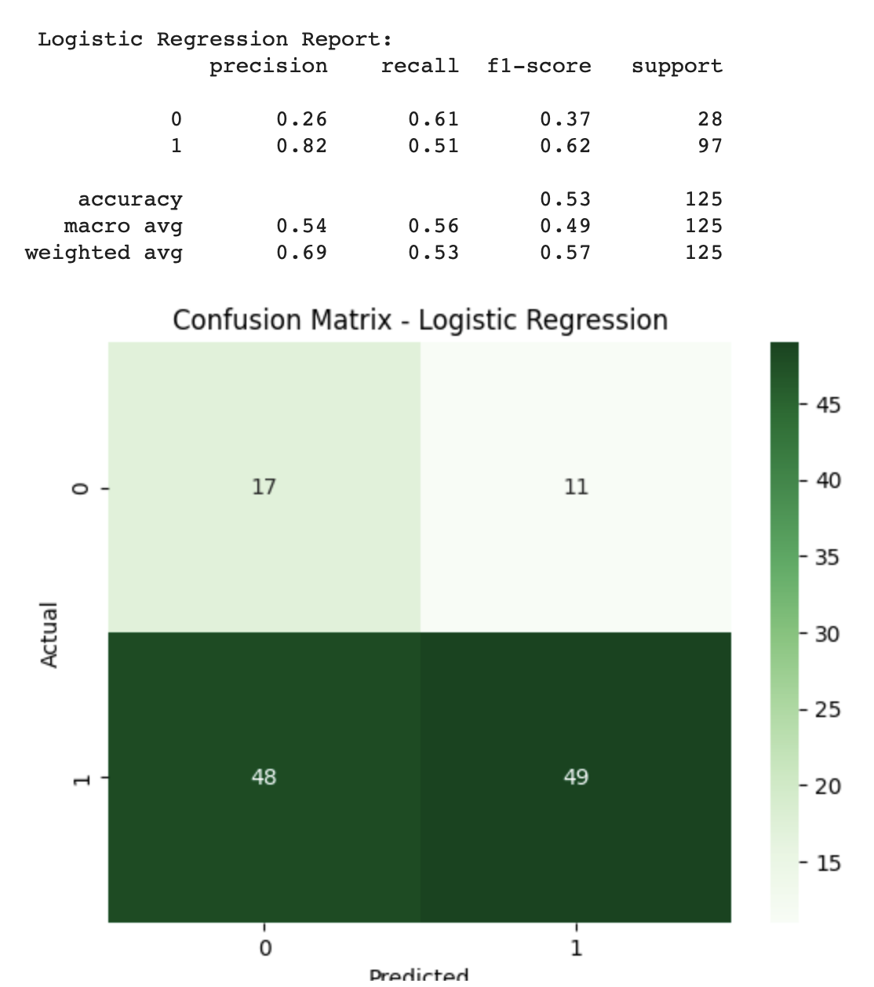
Logistic Regression Model: Moderate performance but room for improvement.

Decision Tree Evaluation
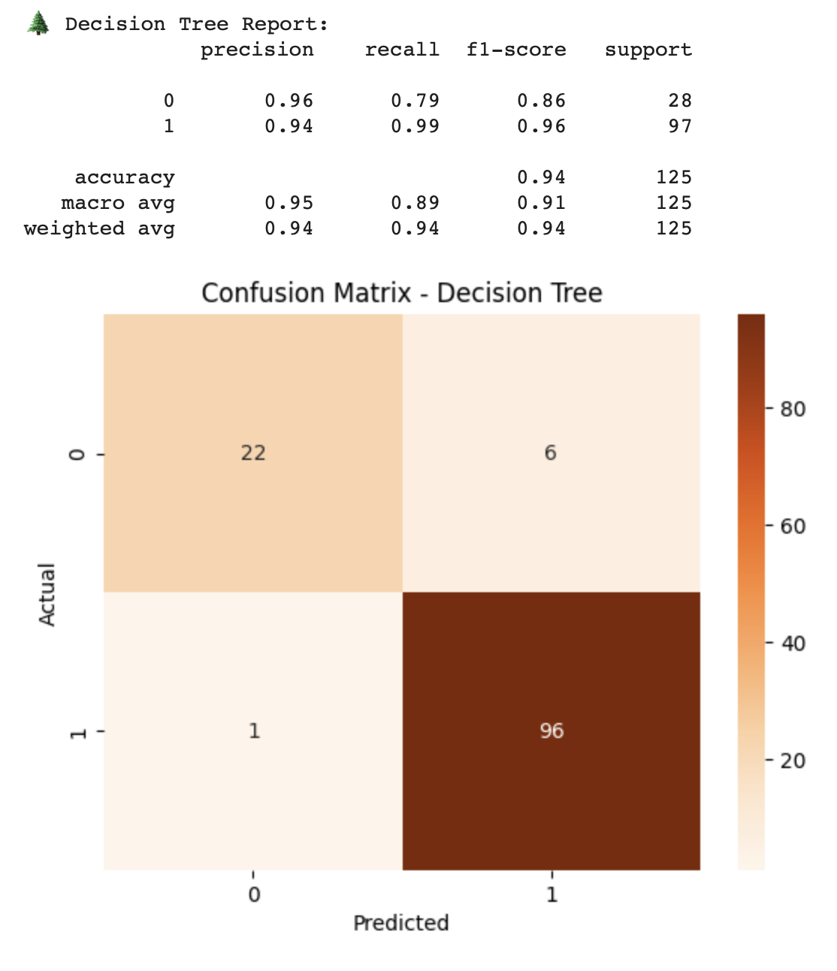
Decision Tree Power: Outstanding model accuracy with high predictive success.

