Nirma University Institute of Technology


Course Code :- 6CS105CC26 Course Name :- Computer Network

Practical - 3

Student Name
Thakor Vinay

Student Roll No.
26MCA061

Faculty In Charge

Dr. Lata Gohil

Implementation of a Local Area Network Using Cisco Packet Tracer

Aim
To implement a Local Area Network (LAN) using Cisco Packet Tracer with both a Switch and a Hub, and test communication between PCs.

Requirements
- Cisco Packet Tracer
- 4 PCs
- 1 Switch
- 1 Hub
- Ethernet cables

IP Configuration
PC | IP Address
PC1 | 198.126.0.1
PC2 | 198.126.0.2
PC3 | 198.126.0.3
PC4 | 198.126.0.4
Subnet Mask: 255.255.255.0

Procedure
- Open Cisco Packet Tracer and place four PCs, a Switch, and a Hub.
- Connect the PCs to the Switch using Ethernet cables and configure their IP addresses.
- Send a test message from 198.126.0.1 to 198.126.0.4 using the Simulation mode.
- Repeat the same LAN setup using a Hub instead of a Switch.
- Verify that the message is successfully delivered between the source and destination PCs.

Implementation
Switch-based LAN:
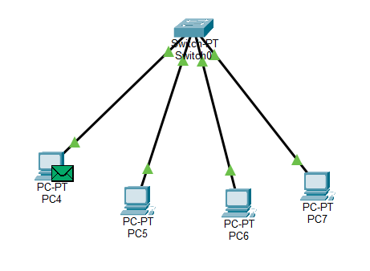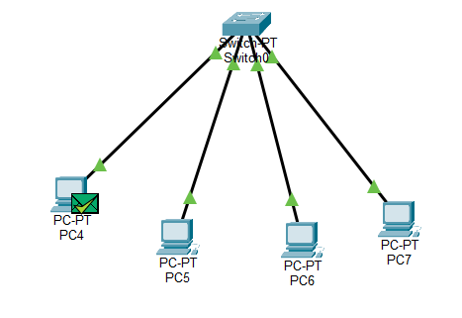

Hub-based LAN:
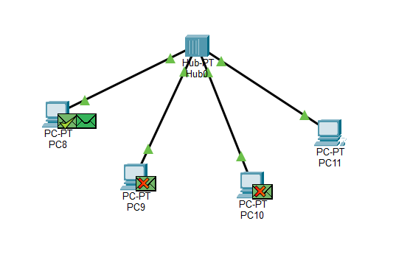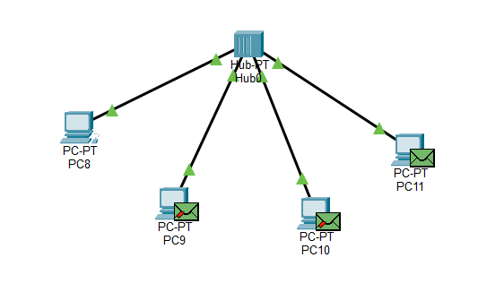

Result
The message sent from 198.126.0.1 to 198.126.0.4 was successfully transmitted using both the Switch and Hub configurations.

Conclusion
Thus, a Local Area Network was successfully implemented in Cisco Packet Tracer using both a Switch and a Hub, and communication between the configured PCs was verified successfully.

