Nirma University Institute of Technology


Course Code :- 6CS105CC26 Course Name :- Computer Network

Practical - 1

Student Name
Thakor Vinay

Student Roll No.
26MCA061

Faculty In Charge

Dr. Lata Gohil

Computer Networks 6CS105CC26 26MCA061 Thakor Vinay
Identification of Various Network-Related Components

1. Connections
A network connector is a hardware fitting attached to the end of a cable that allows it to be plugged into a networking device such as a computer, switch, or hub. Two common connector types are described below.

1.1 RJ-45 Connector
RJ-45 (Registered Jack 45) is an 8-pin/8-position connector used to terminate twisted pair network cables. It is the standard connector used for Ethernet (LAN) connections.
- Has 8 pins arranged in a single row
- Used with twisted pair (UTP/STP) cables
- Terminated using the T568A or T568B wiring standard
- Commonly used to connect computers, switches, and routers
Advantages
- Easy to install and replace
- Low cost
- Supports high-speed Ethernet standards
Disadvantages
- Limited cable run distance without a repeater
- Susceptible to electromagnetic interference
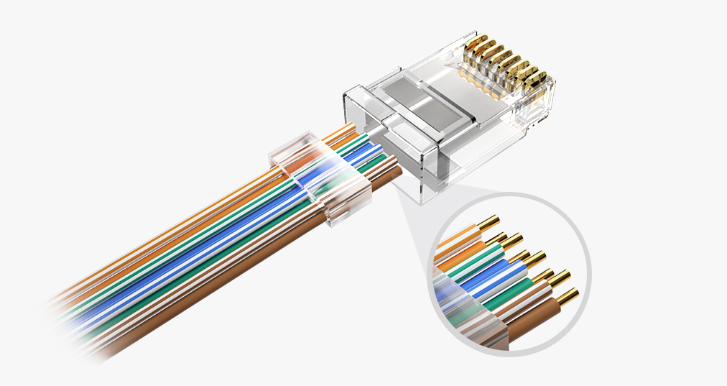
Image source https://www.fs.com/blog/introduction-of-the-rj45-interface-6747.html

1.2 BNC Connector
BNC (Bayonet Neill-Concelman) is a connector used with co-axial cables. It uses a twist-and-lock (bayonet) mechanism to secure the connection.
- Used mainly with co-axial cable
- Provides a quick connect/disconnect bayonet locking mechanism
- Commonly used in older bus-topology (10Base2) Ethernet networks and CCTV systems
Advantages
- Secure locking connection
- Good shielding against interference

Disadvantages
- Largely obsolete for data networks
- Bulkier than RJ-45
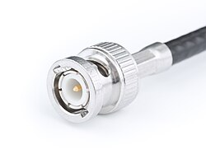
Image source: https://en.wikipedia.org/wiki/BNC_connector

2. Cables
Network cables are the physical medium through which data signals travel between connected devices. Different cable types suit different network requirements.

2.1 Co-axial Cable
Co-axial cable consists of a central copper conductor, an insulating layer, a metallic shield, and an outer jacket. It was widely used in early Ethernet and cable television networks.
- Single copper core surrounded by insulation and shielding
- Offers good resistance to interference due to shielding
Advantages
- Better noise immunity than unshielded cables
- Supports longer cable runs than UTP
Disadvantages
- Bulky and less flexible
- More expensive and harder to install than twisted pair
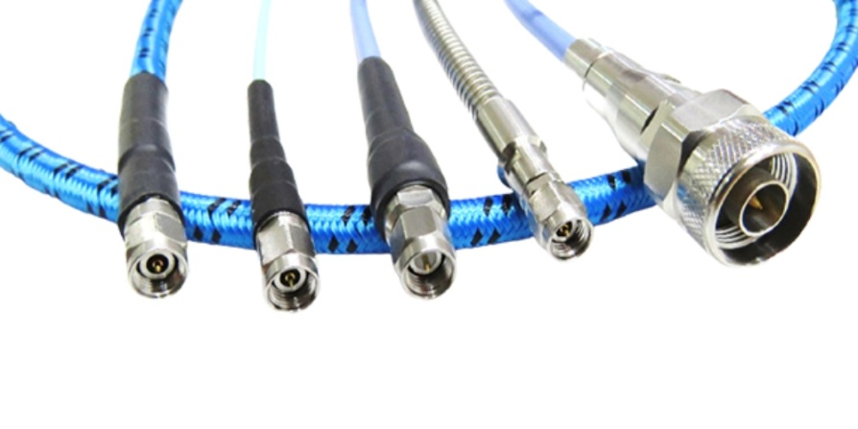
Image source: https://www.hltechmw.com/blog_detail/coaxial-cables

2.2 Twisted Pair Cable
Twisted pair cable consists of pairs of insulated copper wires twisted together to reduce electromagnetic interference and crosstalk.
- Available in shielded (STP) and unshielded (UTP) forms
- Standard medium for modern LAN wiring
Advantages
- Inexpensive and easy to install
- Flexible and lightweight
Disadvantages
- Shorter maximum distance compared to fiber
- More prone to interference than shielded cables
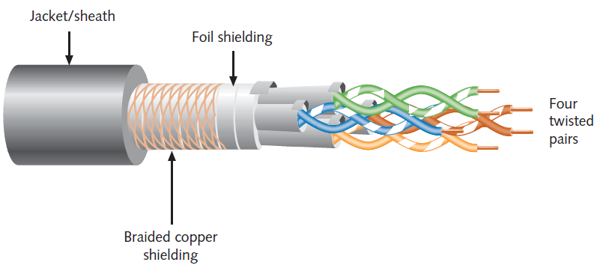
Image source: https://www.wirecablemakingmachine.com/news/shielded-vs-unshielded-network-cable-which-should-you-use.html

2.3 UTP Cable
Unshielded Twisted Pair (UTP) cable is the most common form of twisted pair cabling, used extensively for Ethernet networking.
- No metallic shielding around the wire pairs
- Categorised into standards such as Cat5e, Cat6, Cat6a
Advantages
- Low cost and widely available
- Easy to terminate with RJ-45 connectors
Disadvantages
- More susceptible to electromagnetic interference
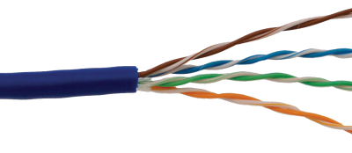
Image source: https://www.electronicsmedia.info/2018/01/02/unshielded-twisted-pair-and-shielded-twisted-pair-cable/

2.4 Cross & Straight Cable
These refer to two different wiring arrangements used when terminating twisted pair cable with RJ-45 connectors, depending on the devices being connected.
- Straight-through cable: both ends wired identically (T568B–T568B); used to connect dissimilar devices, e.g. PC to switch
- Crossover cable: transmit and receive pairs are swapped (T568A–T568B); used to connect similar devices, e.g. PC to PC or switch to switch
Advantages
- Allows flexible direct connections without extra hardware
Disadvantages
- Manual wiring choice can cause connectivity issues if wrong type is used (largely resolved in modern Auto-MDIX devices)
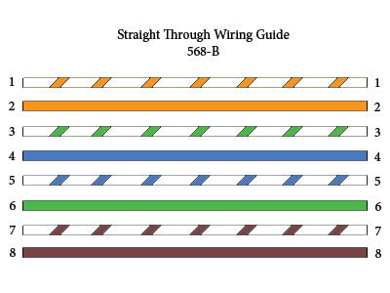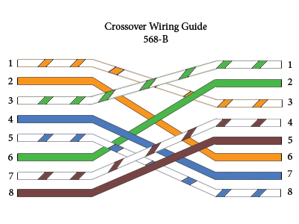
Image source: https://www.computercablestore.com/straight-through-crossover-and-rollover-wiring

3. NIC (Network Interface Card)
A Network Interface Card (NIC) is a hardware component that connects a computer to a network, enabling it to send and receive data. It may be a physical expansion card or an integrated chipset on the motherboard.
- Assigns a unique MAC (Media Access Control) address to the device
- Converts data into electrical, optical, or radio signals for transmission
- Available as wired (Ethernet) or wireless (Wi-Fi) NICs
Advantages
- Enables network connectivity for a device
- Wired NICs offer stable, high-speed connections
Disadvantages
- Wireless NICs can face interference and lower reliability
- Faulty NIC drivers can cause connectivity issues
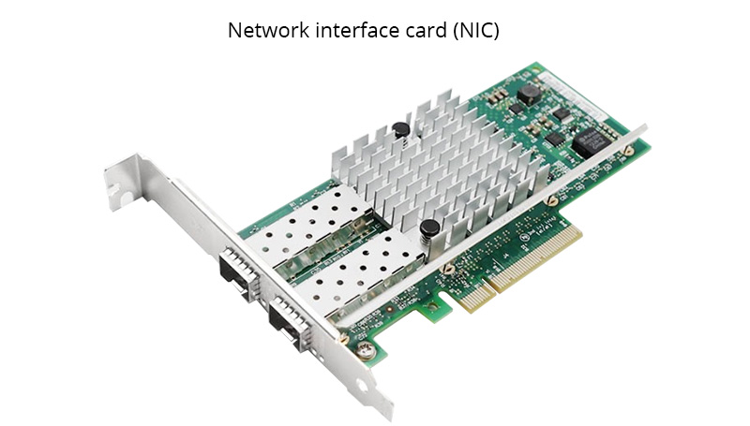
Image source: https://www.qsfptek.com/qt-news/nic-network-interface-card-definition-types-and-functions.html

4. Fiber Optics Cable
Fiber optic cable transmits data as pulses of light through thin strands of glass or plastic fiber, rather than electrical signals over copper.
- Consists of a core, cladding, and protective outer jacket
- Available in Single-mode and Multi-mode variants
- Used for high-speed, long-distance data transmission (backbones, ISPs)
Advantages
- Very high bandwidth and speed
- Immune to electromagnetic interference
- Supports much longer distances than copper
Disadvantages
- Higher cost of cable and installation
- More fragile; requires skilled termination and splicing
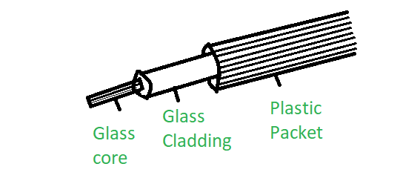
Image source: https://www.geeksforgeeks.org/computer-networks/fiber-optics-and-types/

5. Switch, Hub, and Router
These are networking devices that connect multiple devices within a network and manage the flow of data between them.

5.1 Switch
A network switch connects devices within a LAN and forwards data only to the specific device it is intended for, using MAC addresses.
- Operates mainly at the Data Link Layer (Layer 2)
- Maintains a MAC address table to direct traffic intelligently
Advantages
- Reduces network congestion by directing traffic efficiently
- Supports full-duplex communication
Disadvantages
- More expensive than a hub
- Limited routing capability across different networks

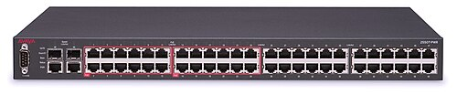
Image source: https://en.wikipedia.org/wiki/Network_switch

5.2 Hub
A hub is a basic networking device that connects multiple devices and broadcasts incoming data to all connected ports, regardless of the intended recipient.
- Operates at the Physical Layer (Layer 1)
- Does not filter or direct traffic; simply repeats signals
Advantages
- Simple and inexpensive
- Easy to set up
Disadvantages
- Causes network congestion and collisions
- No traffic management or security
- Largely replaced by switches
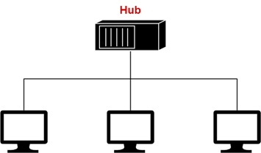
Image source: https://www.tutorialspoint.com/computer_fundamentals/what_is_the_hub.htm

5.3 Router
A router connects multiple networks together and directs data packets between them based on IP addresses, commonly used to connect a LAN to the Internet.
- Operates at the Network Layer (Layer 3)
- Uses routing tables and protocols to determine the best path for data
- Often provides additional features such as NAT, firewall, and DHCP
Advantages
- Connects different networks, including to the Internet
- Provides security features like firewalling and NAT
Disadvantages
- More complex to configure than switches/hubs
- Higher cost
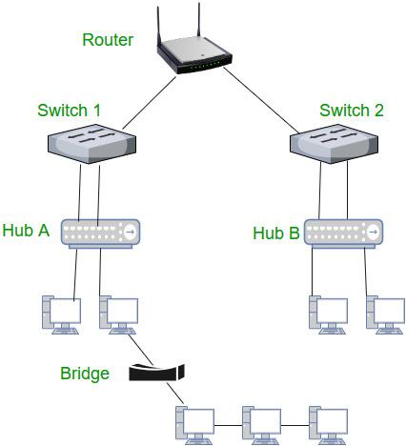
Image source: https://www.geeksforgeeks.org/computer-networks/introduction-of-a-router/

Computer Networks 6CS105CC26 26MCA061 Thakor Vinay
Practice Network-Related Commands

1. Ping
Ping checks whether the host is reachable through an IP network and estimates the round-trip time (RTT) of packets sent to it.
• Basic syntax: ping
• Sends ICMP Echo Request packets and waits for their Echo Reply
• Reports the round-trip time for each packet sent
• Useful to check the connectivity and latency quickly
Output
• Packets sent, received, and lost (packet loss %)
• Minimum, maximum, and average round-trip time
• “Request timed out” if the host is unreachable

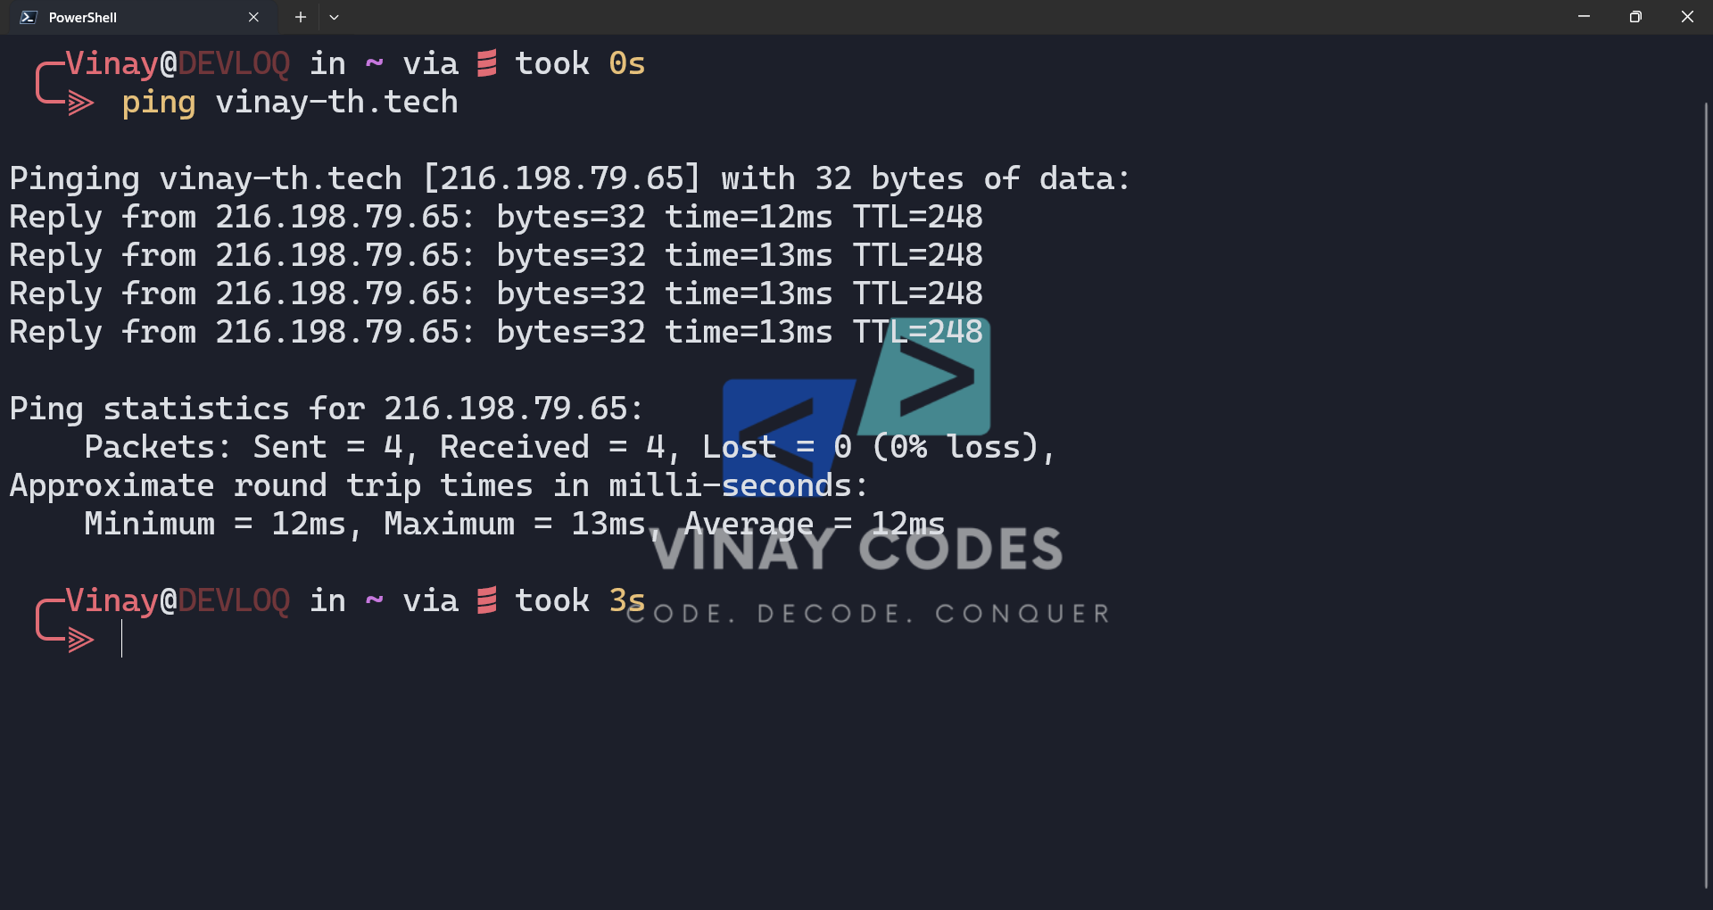

2. Ipconfig
Ipconfig displays the current TCP/IP configuration of a Windows machine and can refresh its DHCP and DNS settings.
- ipconfig – shows basic IP address, subnet mask, and default gateway
- ipconfig /all – shows detailed configuration including MAC address and DNS servers
- ipconfig /release and /renew – release and renew the DHCP-assigned IP address
- ipconfig /flushdns – clears the local DNS resolver cache
Output
- IPv4/IPv6 address, subnet mask, and default gateway per adapter
- Adapter name, physical (MAC) address, and DHCP status
- Confirmation message after release, renew, or flush operations

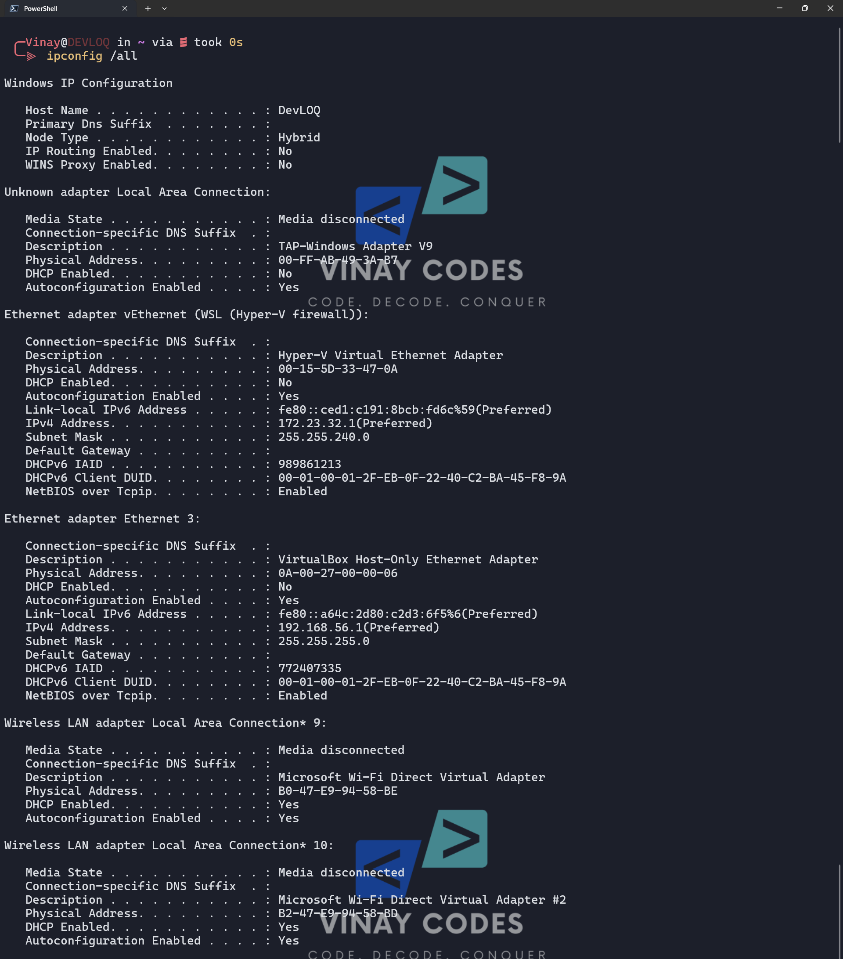

3. Netstat
Netstat displays active network connections, listening ports, and protocol statistics for the local machine.
- netstat – lists active TCP connections
- netstat -a – shows all connections and listening ports
- netstat -n – displays addresses and ports in numerical form
- netstat -b – shows the executable involved in each connection
Output
- Protocol (TCP/UDP), local address, and foreign address with port numbers
- Connection state, e.g. LISTENING, ESTABLISHED, TIME_WAIT
- Process/program name tied to each connection (with -b)

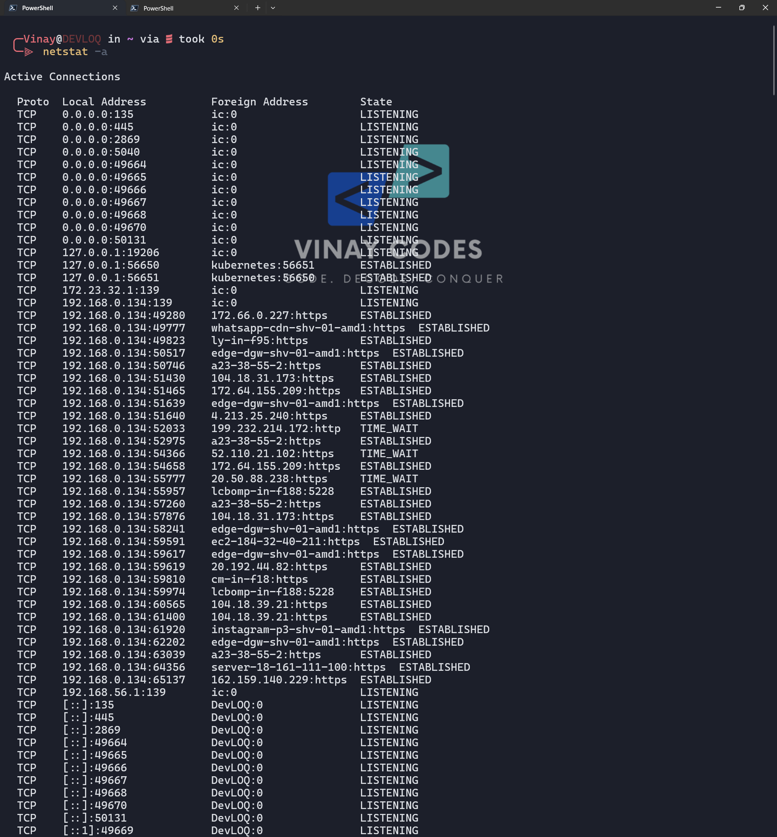

4. Tracert
Tracert (traceroute) traces the path packets take to a destination, showing every intermediate router (hop) along the route.
- Basic syntax: tracert <hostname or IP address>
- Sends packets with increasing TTL values to reveal each hop
- Sends three probes per hop and measures RTT for each
Output
- List of intermediate router IP addresses/hostnames (hops)
- Round-trip time for each of the three probes per hop
- Asterisks (*) / “Request timed out” for hops that do not respond

