Nirma University Institute of Technology


Course Code :- 6CS105CC26 Course Name :- Computer Network

Practical - 1

Student Name
Thakor Vinay

Student Roll No.
26MCA061

Faculty In Charge

Dr. Lata Gohil

Bit Stuffing – Sender and Receiver

Aim
To write a sender and receiver side program to demonstrate bit stuffing, where a frame contains a header, payload, trailer, and starting/ending flags. The payload is read from and written back to a file.

Concept
Bit stuffing is a technique used in data communication to prevent the data from being confused with the special flag sequence used to identify the beginning and end of a frame.
The starting and ending flag used in this program is:
01111110
Whenever five consecutive 1s are found in the payload, the sender automatically inserts a 0 after them.
At the receiver side, this extra 0 is removed to obtain the original payload.

Frame Format
The frame generated by the sender is:
Flag | Header | Stuffed Payload | Trailer | Flag
In this program:
- Flag: 01111110
- Header: 10101010
- Trailer: 01010101
- Payload: Binary data entered by the user
These values are defined in both the sender and receiver programs.

Sender Side
The sender program performs the following steps:
- Takes binary data as input from the user.
- Applies bit stuffing to the payload.
- After every five consecutive 1s, it inserts a 0.
- Creates the complete frame using the flag, header, stuffed payload, and trailer.
- Writes the generated frame into data.txt.
The main bit stuffing function is bitStuff().
For example:
Original payload:
1111111
After bit stuffing:
11111011
The extra 0 is inserted after five consecutive 1s.
The sender creates the frame using:
FLAG + HEADER + stuffedPayload + TRAILER + FLAG
The generated frame is then stored in data.txt.
// Data will be stored in data.txt
// Bits will be stuffed in the payload and sent to the receiver. The receiver will unstuff the bits and write the original data back to the file.
// │ Flag │ Header │ Payload │ Trailer │ Flag │
import java.io.*;
import java.util.*;
import java.nio.file.*;

public class Sender {
static final String FLAG = "01111110";
static final String HEADER = "10101010";
static final String TRAILER = "01010101";

public static String bitStuff(String payload) {
StringBuilder stuffed = new StringBuilder();
int count = 0;

for (char bit : payload.toCharArray()) {
stuffed.append(bit);
if (bit == '1') {
count++;
if (count == 5) {
stuffed.append('0');
count = 0;
}
} else {
count = 0;
}

}
return stuffed.toString();
}

public static void main(String args[]) {
Scanner sc = new Scanner(System.in);

System.out.print("Enter data in binary: ");
String data = sc.nextLine();
String stuffedPayload = bitStuff(data);
System.out.println("Stuffed payload: " + stuffedPayload);

String frame = FLAG + HEADER + stuffedPayload + TRAILER + FLAG;
System.out.println("Frame to be sent: " + frame);

try {
Files.write(Paths.get("data.txt"), frame.getBytes());
System.out.println("Frame written to data.txt");
} catch (IOException e) {
System.out.println("An error occurred while writing to the file.");
e.printStackTrace();
}

sc.close();
}
}

Receiver Side
The receiver reads the frame from data.txt.
It performs the following steps:
- Reads the frame from the file.
- Checks whether the frame starts and ends with the correct flag 01111110.
- Removes the flag, header, and trailer to extract the stuffed payload.
- Applies bit unstuffing.
- Removes the 0 inserted after every five consecutive 1s.
- Writes the original payload back to data.txt.
The receiver uses the bitUnstuff() function for removing the stuffed bits.

Example
Suppose the input payload is:
11111011111

At Sender
The sender finds five consecutive 1s and inserts 0 after each group.
Stuffed payload:
1111100111110
The frame becomes:
01111110 | 10101010 | 1111100111110 | 01010101 | 01111110
This complete frame is written to data.txt.

At Receiver
The receiver extracts the stuffed payload:
1111100111110
It removes the inserted 0s and obtains:
11111011111
The original payload is then written back to data.txt.

import java.io.*;
import java.nio.file.*;

public class Receiver {
static final String FLAG = "01111110";
static final String HEADER = "10101010";
static final String TRAILER = "01010101";

public static String bitUnstuff(String stuffedPayload) {
StringBuilder unstuffed = new StringBuilder();
int count = 0;

for (int i = 0; i < stuffedPayload.length(); i++) {
char bit = stuffedPayload.charAt(i);
unstuffed.append(bit);
if (bit == '1') {
count++;
if (count == 5) {
if (i + 1 < stuffedPayload.length() && stuffedPayload.charAt(i + 1) == '0') {
i++;
}
count = 0;
}
} else {
count = 0;
}
}
return unstuffed.toString();
}
public static void main(String args[]) {
try {
String frame = new String(Files.readAllBytes(Paths.get("data.txt")));
System.out.println("Received frame: " + frame);

if (frame.startsWith(FLAG) && frame.endsWith(FLAG)) {
String payload = frame.substring(FLAG.length() + HEADER.length(), frame.length() - FLAG.length() - TRAILER.length());
System.out.println("Extracted stuffed payload: " + payload);

String unstuffedPayload = bitUnstuff(payload);
System.out.println("Unstuffed payload: " + unstuffedPayload);

Files.write(Paths.get("data.txt"), unstuffedPayload.getBytes());
System.out.println("Original data written to data.txt");
} else {
System.out.println("Invalid frame received.");
}
} catch (IOException e) {
System.out.println("An error occurred while reading from the file.");
e.printStackTrace();
}
}
}

File Handling
The program uses the Java Files class for file operations.
- Sender: writes the generated frame to data.txt.
- Receiver: reads the frame from data.txt and writes the unstuffed/original payload back to the same file.
The initial data.txt contains binary data used by the program.

Example :
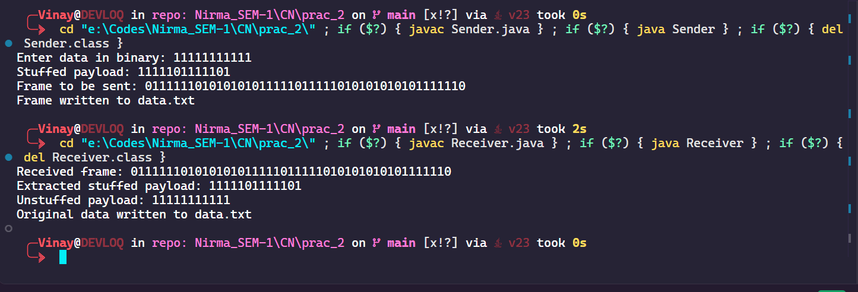

Conclusion
Thus, the sender and receiver programs successfully demonstrate bit stuffing and bit unstuffing. The sender inserts a 0 after every five consecutive 1s, creates a frame with header, payload, trailer, and flags, and stores it in a file. The receiver extracts the payload, removes the stuffed bits, and writes the original data back to the file.

