Nirma University Institute of Technology


Course Code :- 6CS105CC26 Course Name :- Computer Network

Practical - 4

Student Name
Thakor Vinay

Student Roll No.
26MCA061

Faculty In Charge

Dr. Lata Gohil

Aim
To perform switch configuration including configuration of switch ports, VLAN setup, and assigning an IP address to the switch for management purposes.

Implementation
A network was created in Cisco Packet Tracer using one switch (Switch0) and four PCs (PC0, PC1, PC2, PC3). PC0 and PC1 belong to VLAN 10, while PC2 and PC3 belong to VLAN 20. The topology used is shown below.
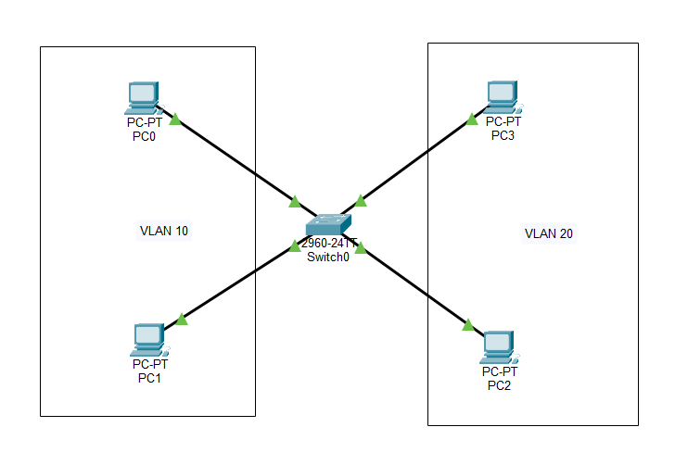
Figure 1: Network topology showing Switch0 with PC0, PC1 in VLAN 10 and PC2, PC3 in VLAN 20
PC0 | 192.168.10.2
PC1 | 192.168.10.3
PC2 | 192.168.20.2
PC3 | 192.168.20.3

1. Assigning an IP address to the switch
The switch was accessed through the CLI and put into global configuration mode. An IP address was assigned to the VLAN 1 interface (the management interface of the switch) so that the switch itself could be reached over the network. A default gateway was also configured.
Switch>enable
Switch#config term
Switch(config)#interface vlan 1
Switch(config-if)#ip address 192.168.1.1 255.255.255.0
Switch(config-if)#no shut
Switch(config-if)#exit
Switch(config)#ip default-gateway 192.168.1.1

2. Configuring a switch port
Interface FastEthernet 0/1 (connected to PC0) was configured with a description, speed and duplex set to auto, and enabled using "no shut".
Switch(config)#interface fa0/1
Switch(config-if)#description connectedToPC0
Switch(config-if)#speed auto
Switch(config-if)#duplex auto
Switch(config-if)#no shut
Switch(config-if)#exit

The status of all ports was then checked using "show interface status", which confirmed Fa0/1 was connected with the description "connectedToPC0", and all ports were still in the default VLAN 1 at this stage.

3. Creating VLANs
Two VLANs were created on the switch: VLAN 10 named "MCA" and VLAN 20 named "BTech".
Switch(config)#vlan 10
Switch(config-vlan)#name MCA
Switch(config-vlan)#exit
Switch(config)#vlan 20
Switch(config-vlan)#name BTech
Switch(config-vlan)#exit

Running "show vlan brief" at this point confirmed that VLAN 10 (MCA) and VLAN 20 (BTech) were created and active, but no ports had been assigned to them yet - all 24 ports were still listed under the default VLAN 1.

4. Assigning ports to VLANs
Ports Fa0/1 and Fa0/2 were set to access mode and assigned to VLAN 10. Ports Fa0/3 and Fa0/4 were set to access mode and assigned to VLAN 20.
Switch(config)#interface range fa0/1-2
Switch(config-if-range)#switchport mode access
Switch(config-if-range)#switchport access vlan 10
Switch(config-if-range)#exit
Switch(config)#interface range fa0/3-4
Switch(config-if-range)#switchport mode access
Switch(config-if-range)#switchport access vlan 20
Switch(config-if-range)#exit

Running "show vlan brief" again confirmed that Fa0/1 and Fa0/2 now belonged to VLAN 10 (MCA), and Fa0/3 and Fa0/4 belonged to VLAN 20 (BTech), while the remaining ports stayed in the default VLAN 1.

5. Saving the configuration
The running configuration was saved to the startup configuration so that the settings persist after a reboot.
Switch#copy running-config startup-config
Destination filename [startup-config]?
Building configuration...
[OK]
Switch#write memory
Building configuration...
[OK]

6. Testing connectivity
PC0 (VLAN 10) was used to ping another device in the same VLAN (192.168.10.3) and a device in the other VLAN (192.168.20.3). The result is shown below.
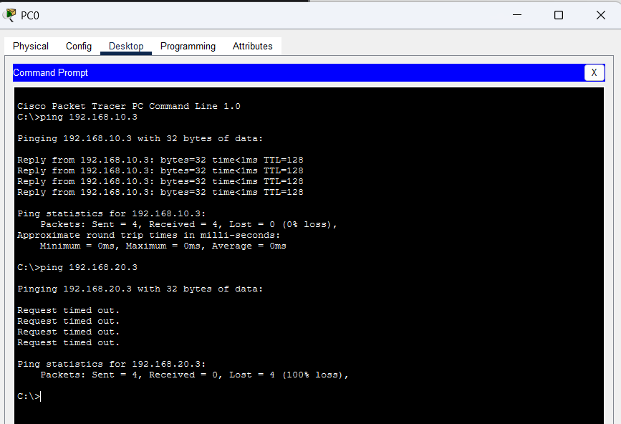
Figure 2: Ping results from PC0 to a device in VLAN 10 (successful) and a device in VLAN 20 (request timed out)
The ping to 192.168.10.3 (same VLAN, VLAN 10) was successful with 0% loss, while the ping to 192.168.20.3 (VLAN 20) failed with 100% loss. This confirms that VLANs were correctly configured and that they separate broadcast domains - devices in different VLANs cannot communicate with each other without a router or a Layer 3 switch to route between them.

Conclusion
The switch was successfully configured with a management IP address, individual switch ports were configured with descriptions and enabled, and two VLANs (VLAN 10 - MCA and VLAN 20 - BTech) were created and assigned to specific ports. The ping test confirmed that devices within the same VLAN can communicate with each other, while devices in different VLANs are isolated, demonstrating that VLAN segmentation was implemented correctly.

