Computer Networks 6CS105CC26 26MCA061 Thakor Vinay
Practice Network-Related Commands

1. Ping
Ping checks whether the host is reachable through an IP network and estimates the round-trip time (RTT) of packets sent to it.
• Basic syntax: ping
• Sends ICMP Echo Request packets and waits for their Echo Reply
• Reports the round-trip time for each packet sent
• Useful to check the connectivity and latency quickly
Output
• Packets sent, received, and lost (packet loss %)
• Minimum, maximum, and average round-trip time
• “Request timed out” if the host is unreachable

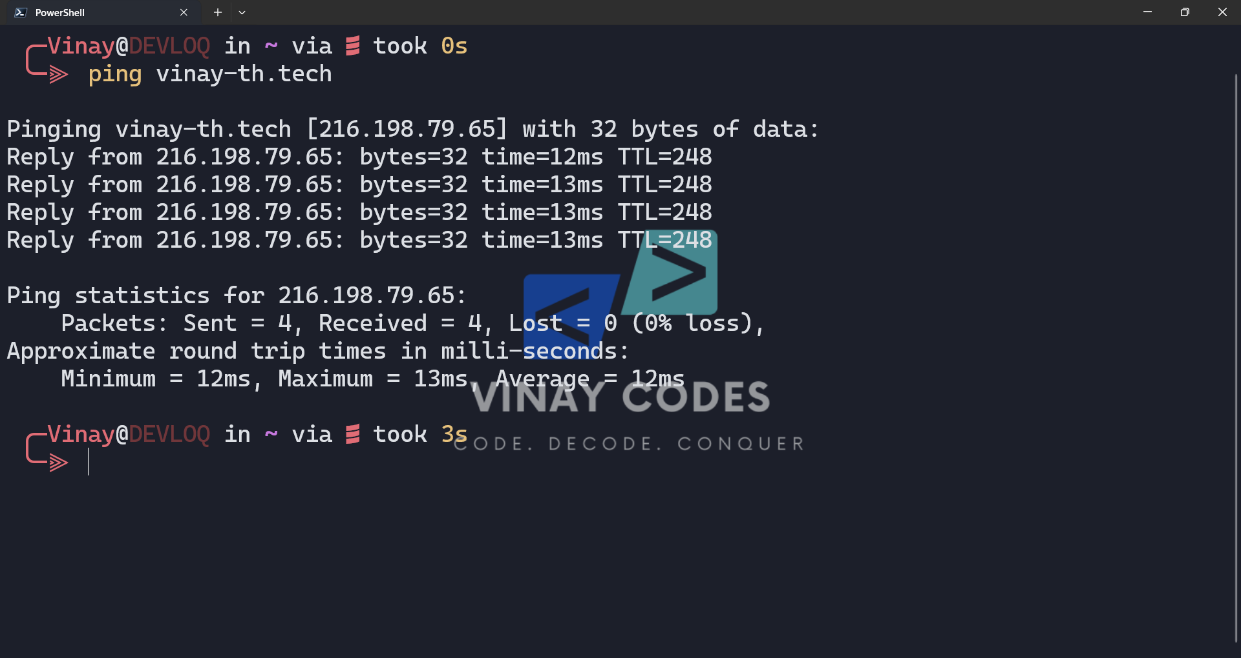

2. Ipconfig
Ipconfig displays the current TCP/IP configuration of a Windows machine and can refresh its DHCP and DNS settings.
- ipconfig – shows basic IP address, subnet mask, and default gateway
- ipconfig /all – shows detailed configuration including MAC address and DNS servers
- ipconfig /release and /renew – release and renew the DHCP-assigned IP address
- ipconfig /flushdns – clears the local DNS resolver cache
Output
- IPv4/IPv6 address, subnet mask, and default gateway per adapter
- Adapter name, physical (MAC) address, and DHCP status
- Confirmation message after release, renew, or flush operations

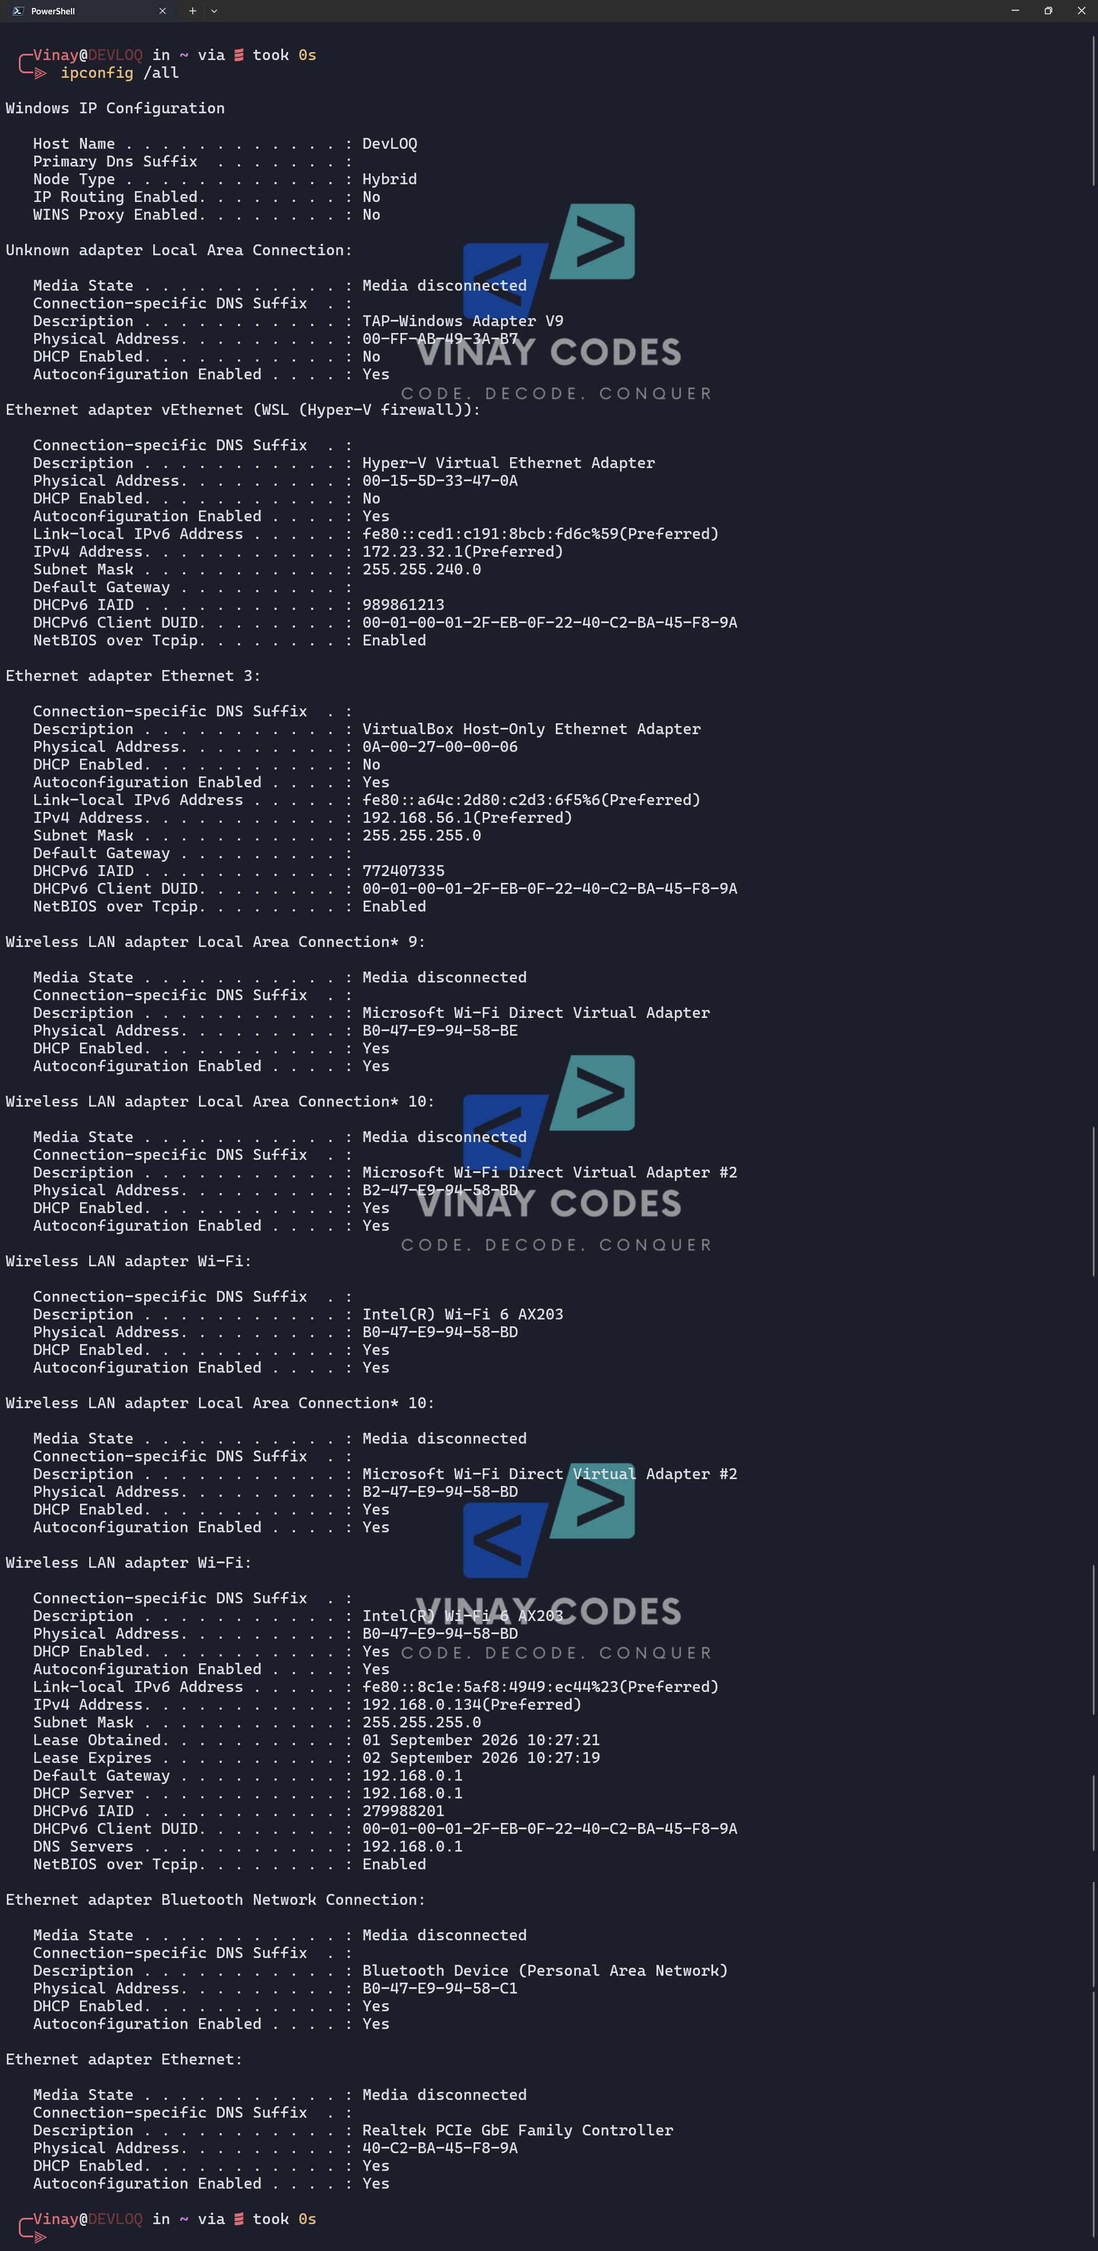

3. Netstat
Netstat displays active network connections, listening ports, and protocol statistics for the local machine.
- netstat – lists active TCP connections
- netstat -a – shows all connections and listening ports
- netstat -n – displays addresses and ports in numerical form
- netstat -b – shows the executable involved in each connection
Output
- Protocol (TCP/UDP), local address, and foreign address with port numbers
- Connection state, e.g. LISTENING, ESTABLISHED, TIME_WAIT
- Process/program name tied to each connection (with -b)

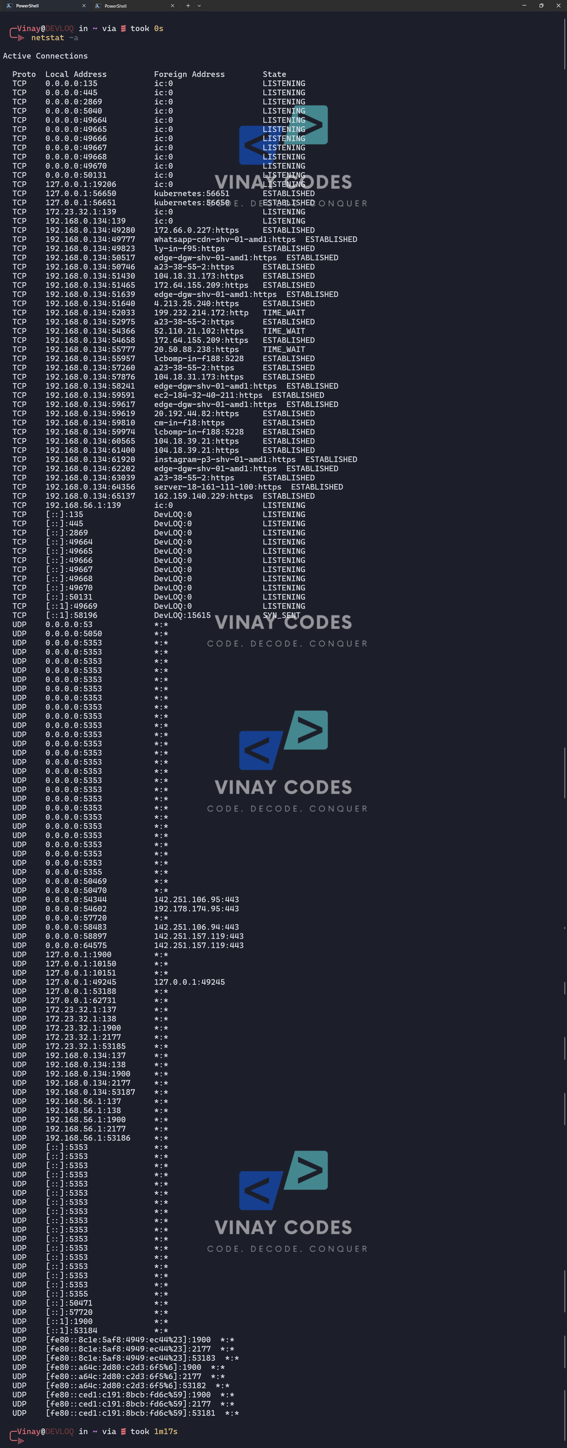

4. Tracert
Tracert (traceroute) traces the path packets take to a destination, showing every intermediate router (hop) along the route.
- Basic syntax: tracert <hostname or IP address>
- Sends packets with increasing TTL values to reveal each hop
- Sends three probes per hop and measures RTT for each
Output
- List of intermediate router IP addresses/hostnames (hops)
- Round-trip time for each of the three probes per hop
- Asterisks (*) / “Request timed out” for hops that do not respond

