NIRMA UNIVERSITY
School of Technology, Institute of Technology
Master of Computer Application (2-Years Programme)
Semester-I
6CS106CC22-Web Technology
List of Practical
Sr. No. | Title | CO |  | Marks |  | Hours
1 | HTML Concepts:  - Design a home page that will display your information, i.e., your resume.  - Demonstrate various list types using appropriate examples.  - Display image on webpage  - Demonstrate special characters  - Create a HTML page which contains the two inline frames. One inline frame contains navigation links and second inline frame contains the details about chapters. Once we clicked on navigation link then it jumps on specific chapter section in second frame. Refer the figure for more detail.  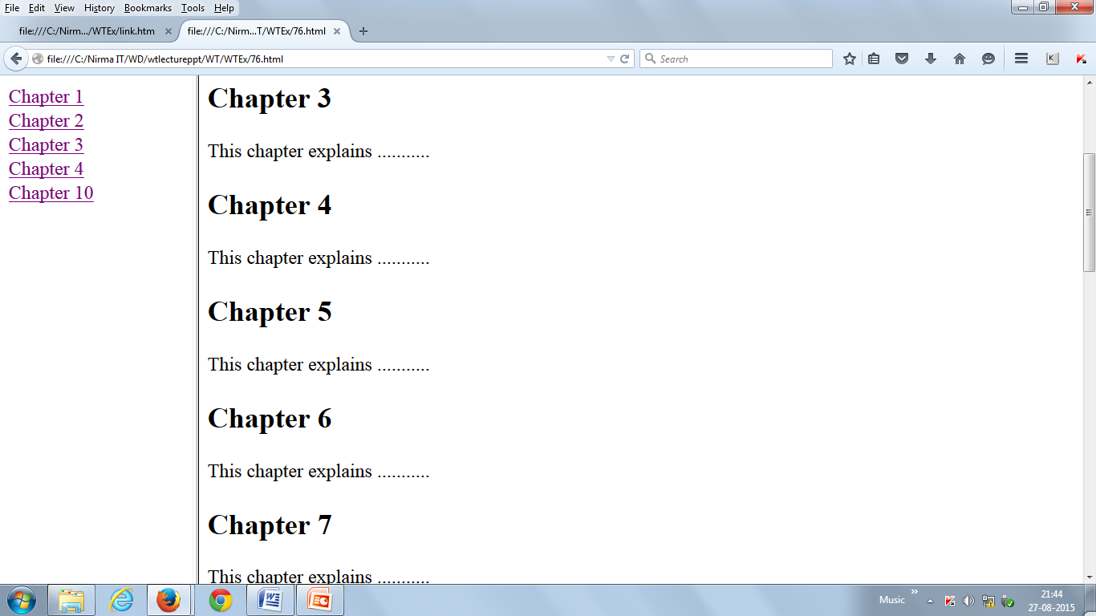 | 1 |  | 10 |  | 6
2 | - Design web pages as per the Table given below:  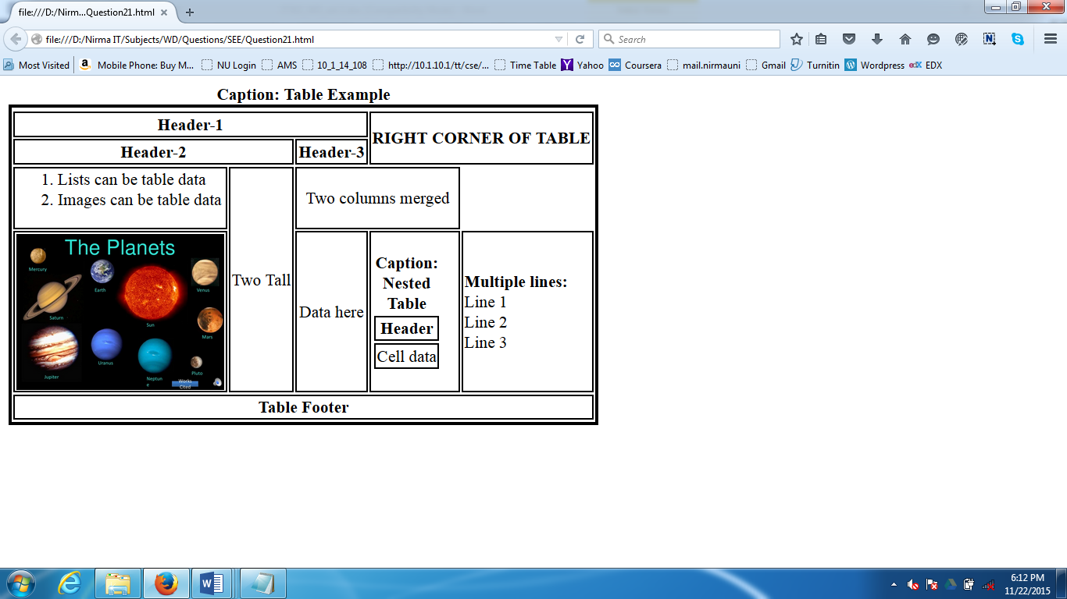 | 1 |  | 10 |  | 6
3 | - Create registration form of your choice. Use appropriate form tags.  Consider the sample examples given below:  Sample 1:  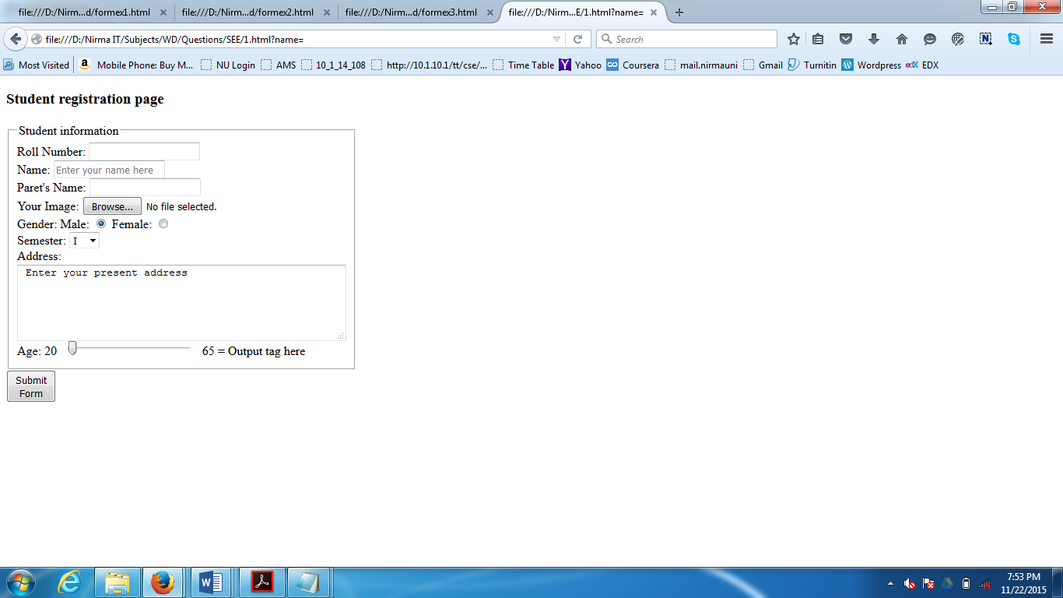  [Figure: Student information]  Field Name Necessary conditions  Roll number Use implicit label for Roll number field  Your Image Only accept the image files.  Semester Use select tag.  Address Use textarea and limit the number of columns to 30 & perform physical wrap on text  Range Use range tag. Range minimum value is 20 and maximum value is 65. When user changes the value using range tag, the output must be changed in output tag.  Sample 2:  Customer Registration Page which contains following fields:  Sr. No. Field name Necessary conditions  Customer ID Use implicit label  Name User can enter maximum 60 characters  Age User can able to enter only numeric value from 18 to 80  Gender: Male and Female Use radio buttons and initially option male is selected  Customer Account type: Basic and Privileged Use input tag list attribute  - ; Photo Only accept image files  Email Use appropriate input tag type attribute  Password  Confirm Password  Homepage URL Use appropriate input tag type attribute  Reset Button  Submit button  Do not use JavaScript for any field. | 1 |  | 10 |  | 6
4 | CSS Concepts:  Implement the Web Pages that demonstrate following concepts (using inline, embedded and external stylesheet):  - Font properties  - Background properties  - Demonstrate various border styles on HTML elements. Also develop code for following figures:    Figure 1    Figure 2 | 2 |  | 10 |  | 6
5 | - Design Web page layout like Gmail home page.  - Implement the CSS animation on div element that change it’s shape from square to circle for half time and change the shape from circle to square for remaining half time. Animation must execute for infinite time.  - Implement the CSS transition on grey colored rectangle division. Once take mouse over the division, perform following effects on division:  - Create border using box shadow concept  - Change shape to ellipse  - Change background color to red  - Use media query for screen and print | 2 |  | 10 |  | 6
6 a | JavaScript Concepts:  - Write a script that perform arithmetic operations on two numbers.  - Write a script to find given number is even or odd.  - Write a script to find factorial of given number.  - Write a Javascript code segment that creates table as shown below using nested for loop.  Use table width="240px" and take 30px as cell height and width. | 3 |  | 10 |  | 6
6 b | - Write a JavaScript to display the current date, current time and display appropriate greeting message according to time slot. (Hint for message: Good Morning, 01/06/2023 09:00:00 AM)  - Design the web page that includes the various types of JavaScript and jquery validations like  - IP address  - Alphanumeric values only  - Date in DD/MM/YYYY format  - Special symbol restriction  - Email must be in proper form.  - Phone number should be minimum of 10 digits  - Required field validation  Password and retype password must be same
7 | Get hands on jQuery  Using jQuery find all textareas, and makes a border. Then adds all paragraphs to the jQuery object to set their borders red. | 3 |  | 10 |  | 6
8 | Get hands on jQuery  Disable the submit button until the visitor has clicked a check box.  Blink text using jQuery.  Hide all headings on a page when they are clicked. | 4 |  | 10 |  | 6
9 | Get hands on Bootstrap.  Demonstrate the implementation of Bootstrap online and offline mode through HTML webpages. | 4 |  | 10 |  | 6
10 | Create the web pages that demonstrate following concepts:  - Develop code on four div elements as shown figures:  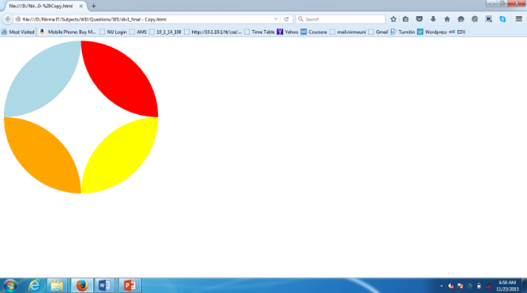 Figure 1 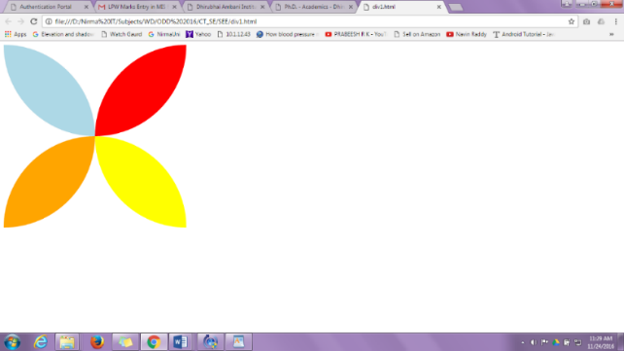 Figure 2 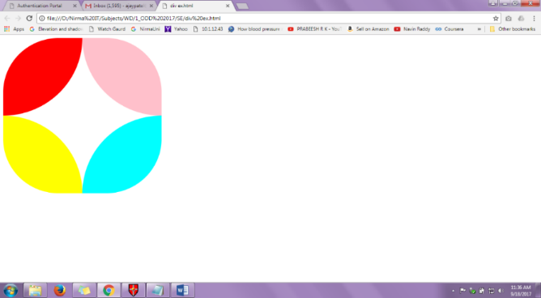 Figure 3  B. Demonstrate Box shadow, Margin, Padding and Outline properties. | 2 |  | 10 |  | 6
 | Total |  |  |  | 100 |  | 60

