UNIX Commands

1. who
- Description: Shows users who are currently logged into the system.
- Example: who
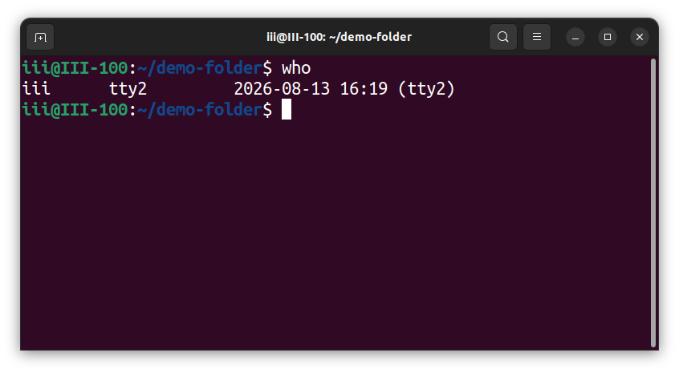

2. whoami
- Description: Displays the username of the current user.
- Example: whoami
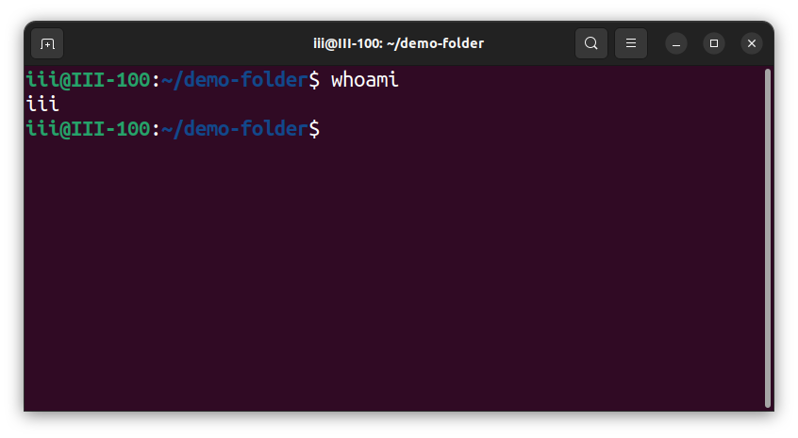

4. touch
- Description: Creates an empty file or updates the timestamp of an existing file.
- Example: touch file.txt
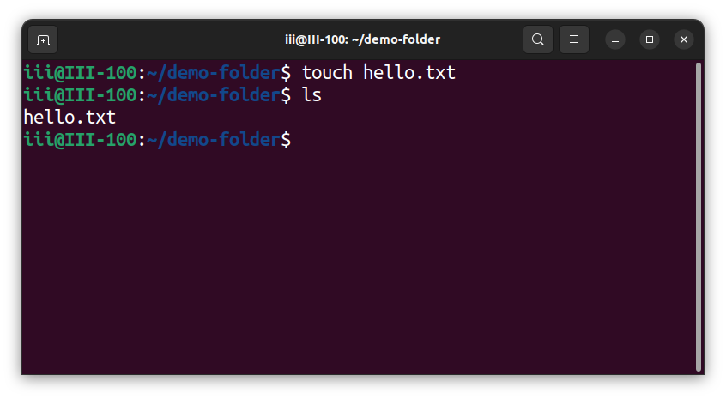

5. cat
- Description: Displays or concatenates file contents. With redirection, it can create, overwrite, or append to a file.
- Example: cat file.txt
- Example: cat > file.txt
- Example: cat >> file.txt
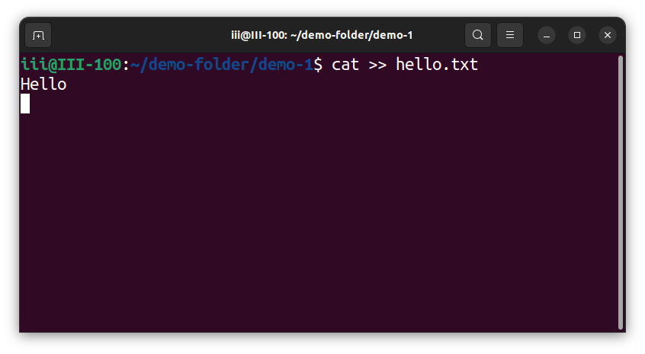

6. cp
- Description: Copies files. Use -r to copy directories and their contents.
- Example: cp file1.txt file2.txt
- Example: cp -r dir1 dir2
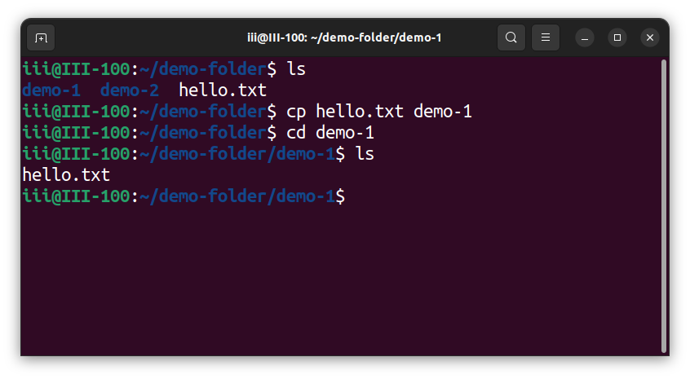
7. rm
- Description: Removes files. Use -r to remove a directory and its contents.
- Example: rm file.txt
- Example: rm -r folder
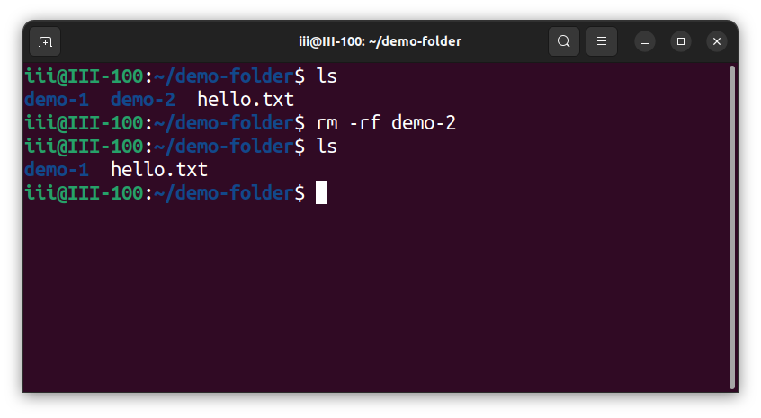

8. mv
- Description: Moves or renames files or directories.
- Example: mv old.txt new.txt
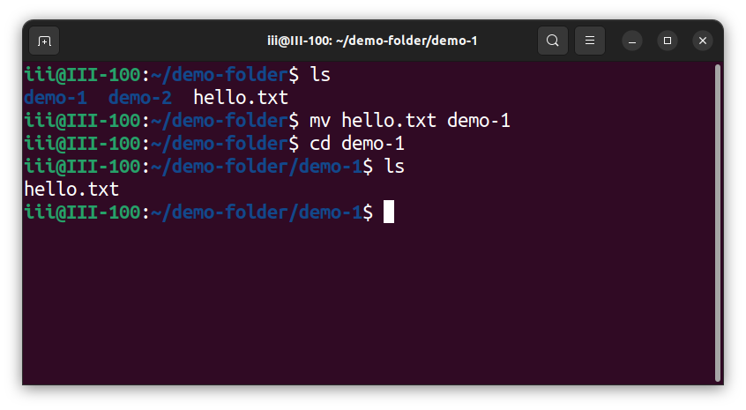
9. ls
- Description: Lists files and directories.
- Example: ls -l
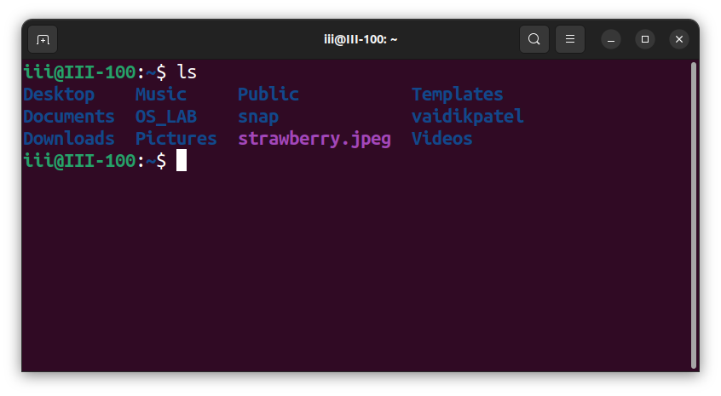

10. ln
- Description: Creates links. By default it creates a hard link; -s creates a symbolic link.
- Example: ln file1 link1
- Example: ln -s target.txt link.txt
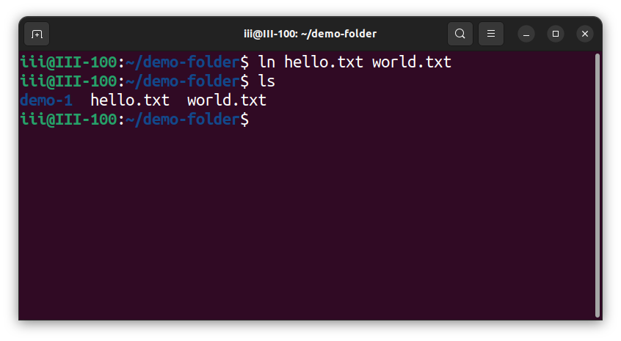
11. chmod
- Description: Changes file or directory permissions.
- Example: chmod 755 script.sh
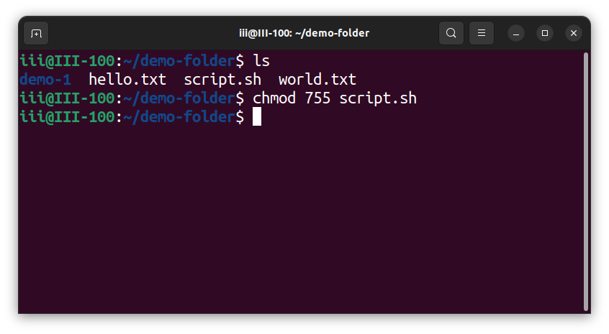

13. pwd
- Description: Prints the current working directory.
- Example: pwd
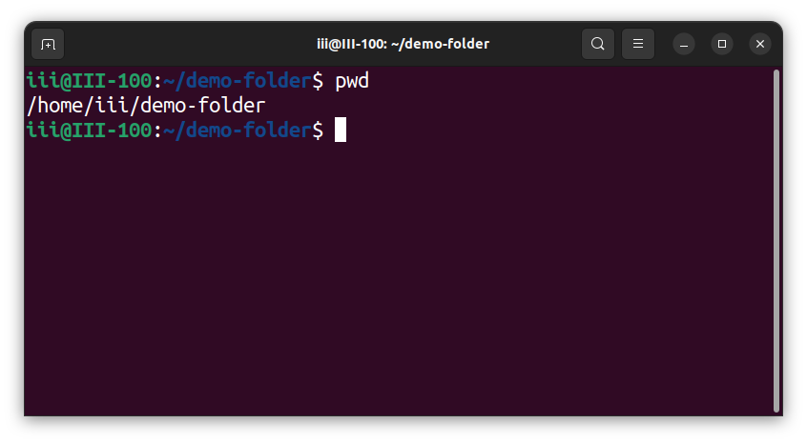

14. mkdir
- Description: Creates a new directory.
- Example: mkdir new_folder
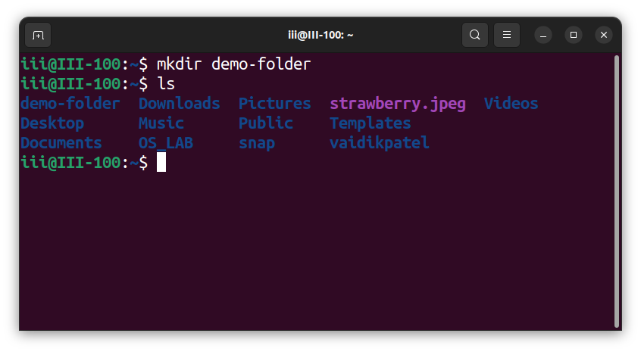

15. rmdir
- Description: Removes an empty directory.
- Example: rmdir old_folder
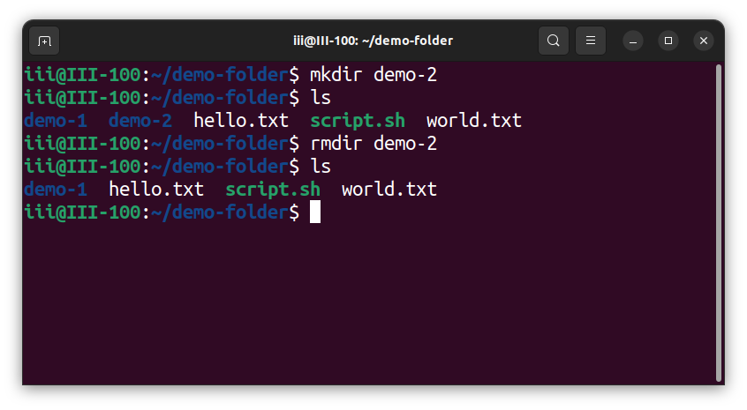

16. cd
- Description: Changes the current working directory.
- Example: cd Documents
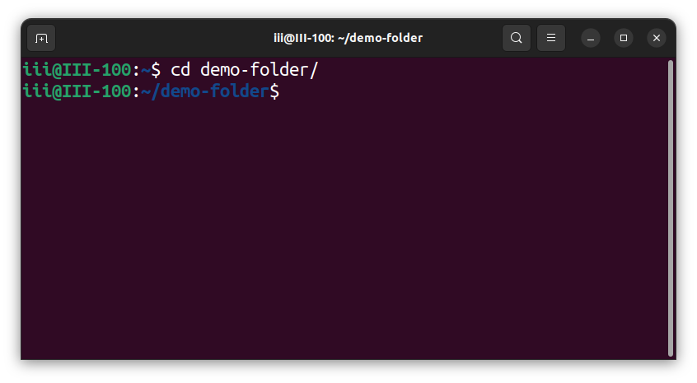

17. bc
- Description: Launches an arbitrary-precision calculator.
- Example: bc
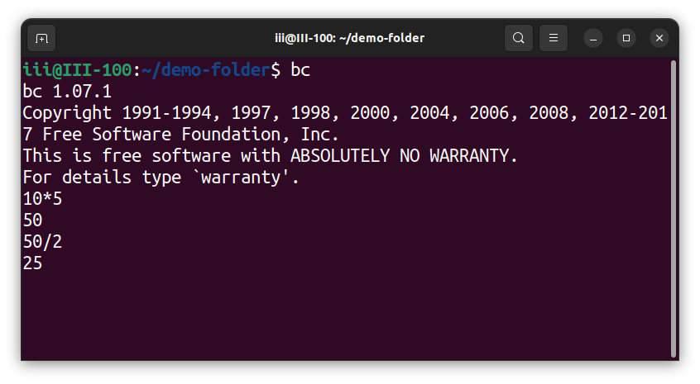

18. bc -l
- Description: Launches bc with its math library enabled.
- Example: bc -l
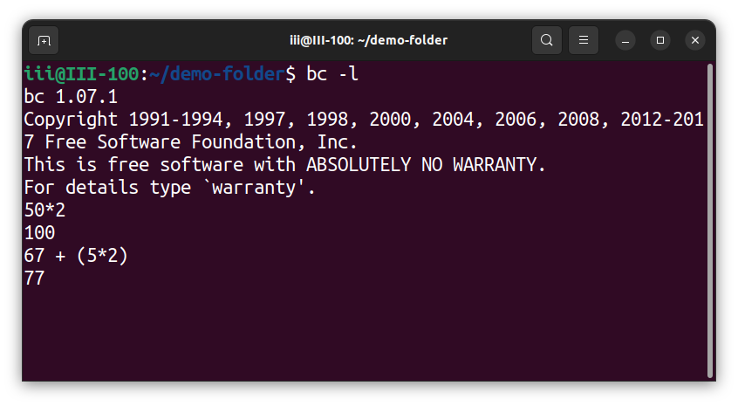

19. expr
- Description: Evaluates expressions.
- Example: expr 5 + 3
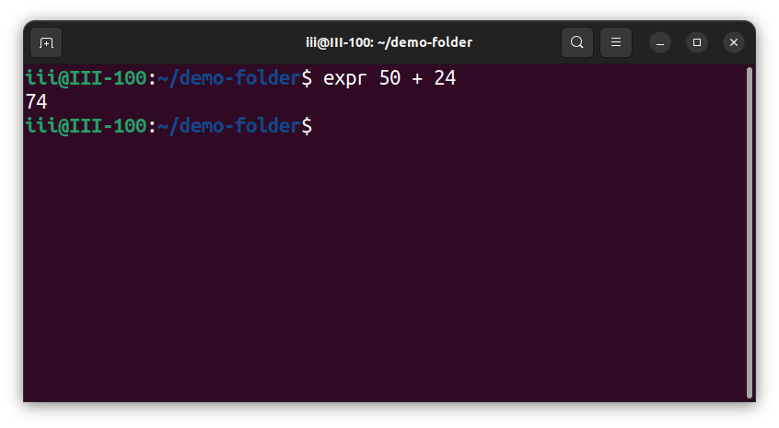

20. factor
- Description: Finds the prime factors of a number.
- Example: factor 60
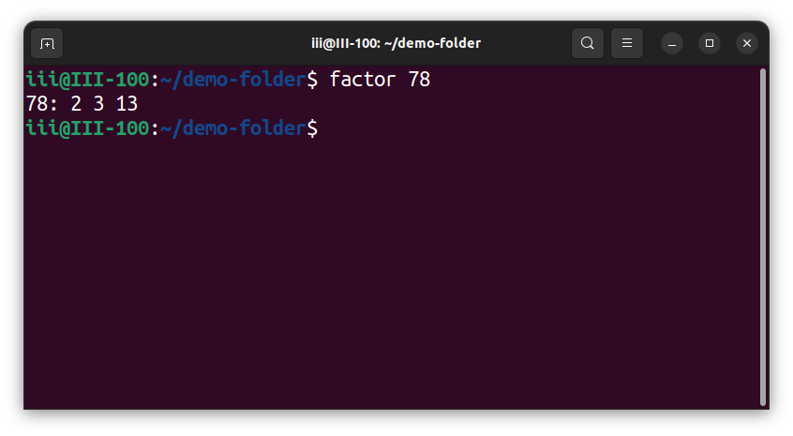

21. logname
- Description: Displays the login name of the current user.
- Example: logname
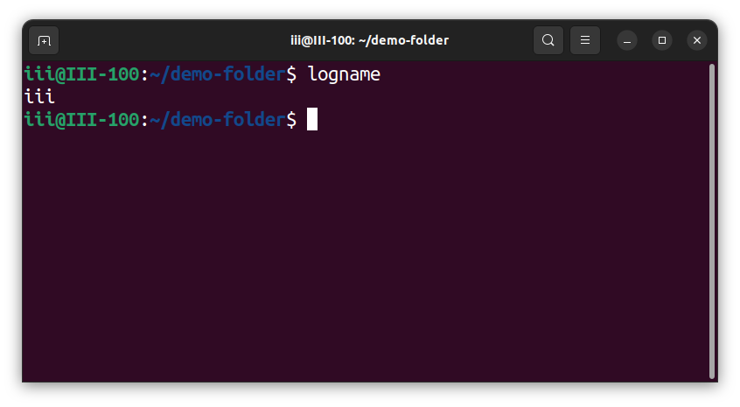
22. uname
- Description: Prints system information.
- Example: uname -a
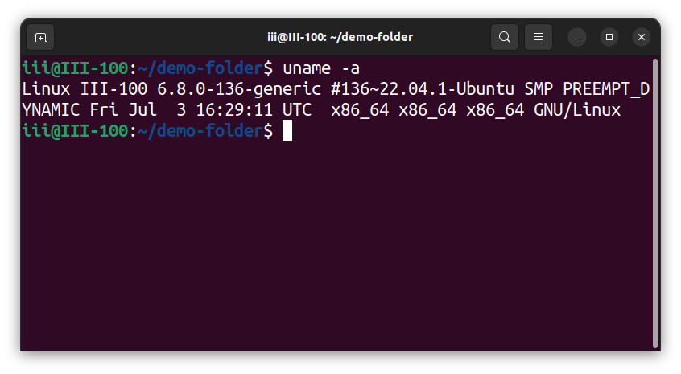

23. tty
- Description: Shows the terminal device associated with the current session.
- Example: tty
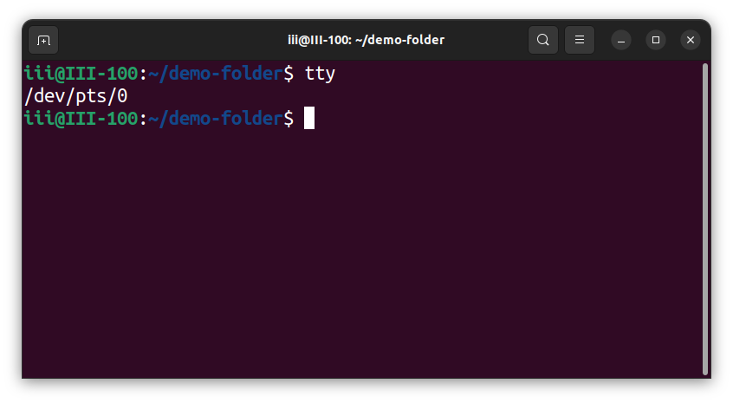

24. date
- Description: Displays or sets the system date and time.
- Example: date
- Example: date "+%d-%m-%Y"
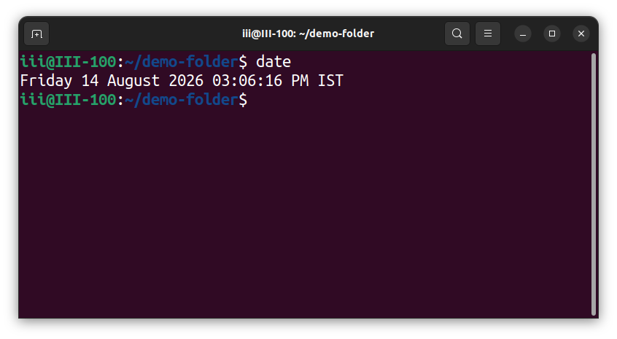

25. df
- Description: Shows disk-space usage. -h displays values in human-readable units.
- Example: df -h
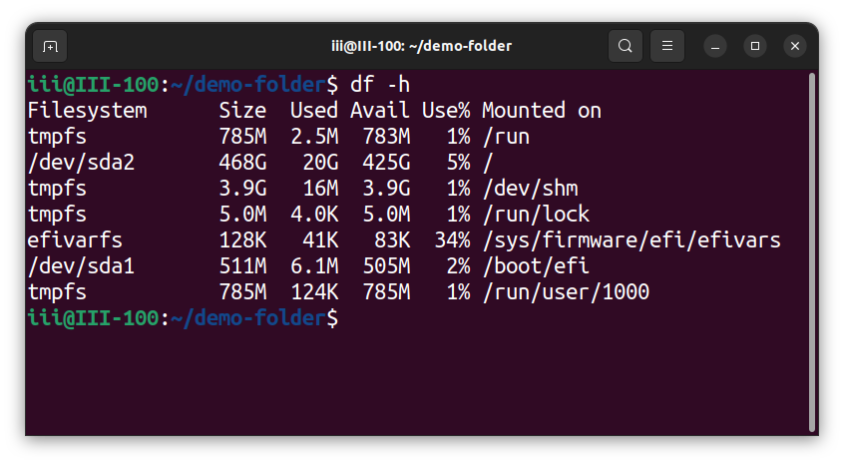
26. du
- Description: Shows disk usage of files and directories. -s gives a summary and -h uses human-readable units.
- Example: du -sh folder/
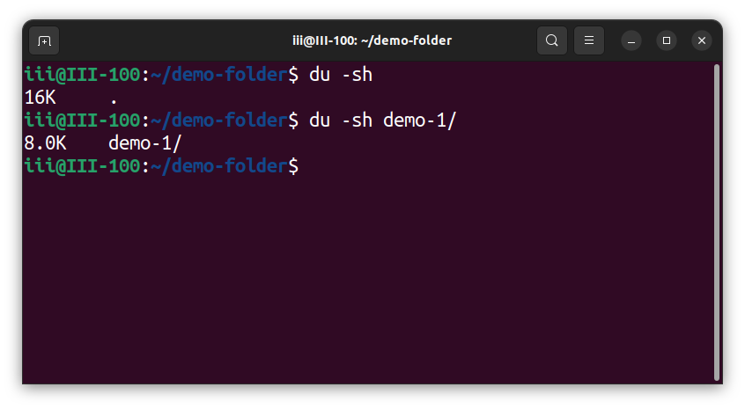

27. ulimit
- Description: Displays or sets shell resource limits.
- Example: ulimit -n
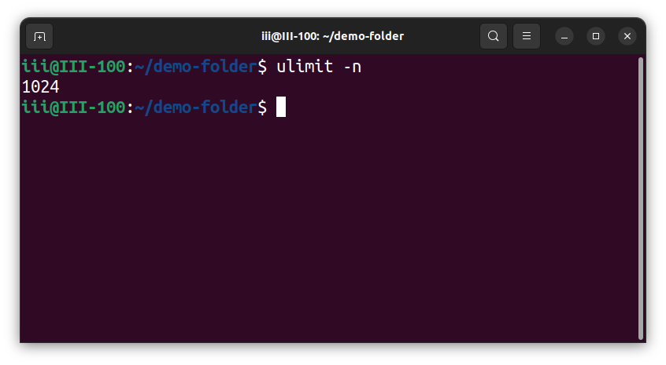
28. cal
- Description: Displays a calendar.
- Example: cal 2025
- Example: cal 07 2025
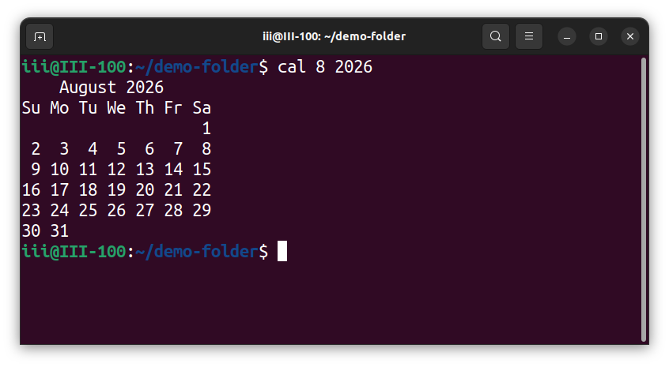

29. ps
- Description: Displays information about active processes.
- Example: ps aux
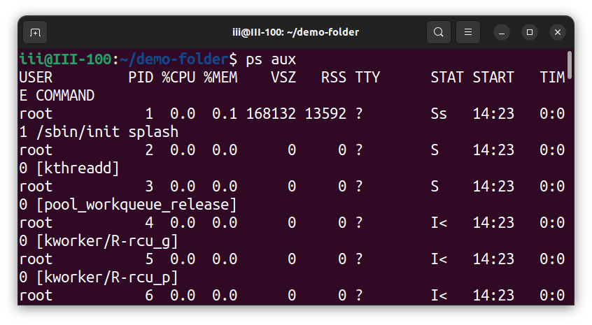
30. kill
- Description: Sends a signal to a process. The default signal normally requests termination.
- Example: kill 1234
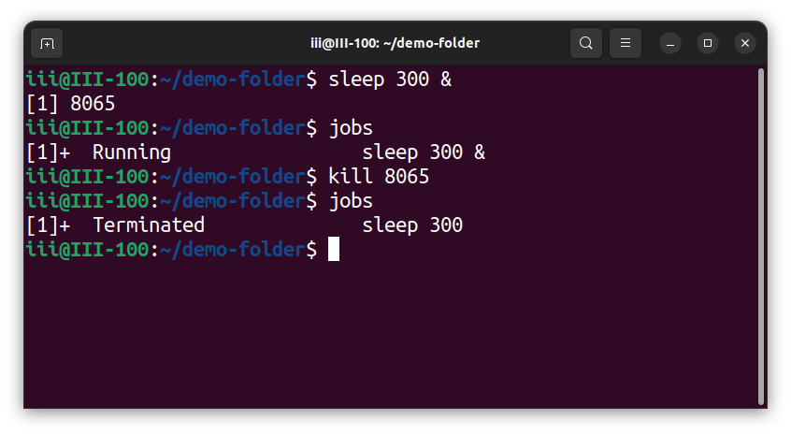

31. nice
- Description: Starts a process with a specified niceness value; a higher niceness generally means lower CPU scheduling priority.
- Example: nice -n 10 command
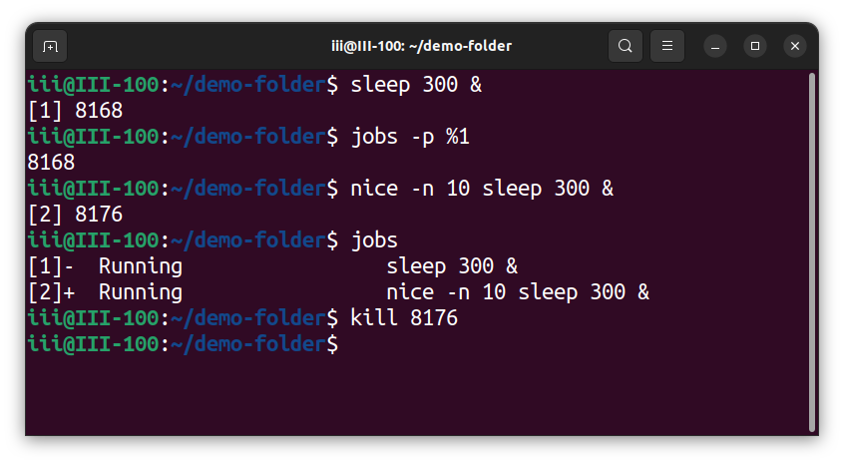
32. read
- Description: Reads input from the user and stores it in a shell variable.
- Example: read name
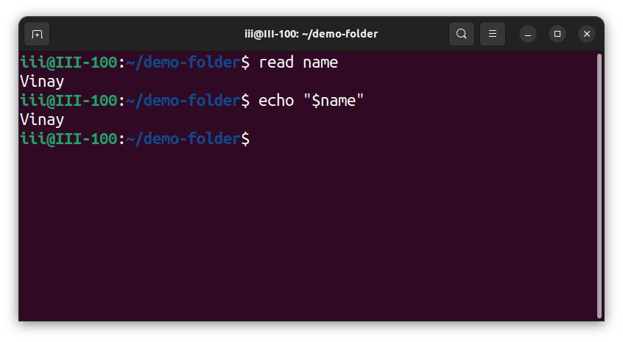

33. echo
- Description: Prints text or other arguments to the terminal.
- Example: echo "Hello World"

34. I/O redirection
- Description: Redirects command input or output. > overwrites a file, >> appends to a file, and < takes input from a file.
- Example: ls > out.txt
- Example: ls >> out.txt
- Example: cat < in.txt
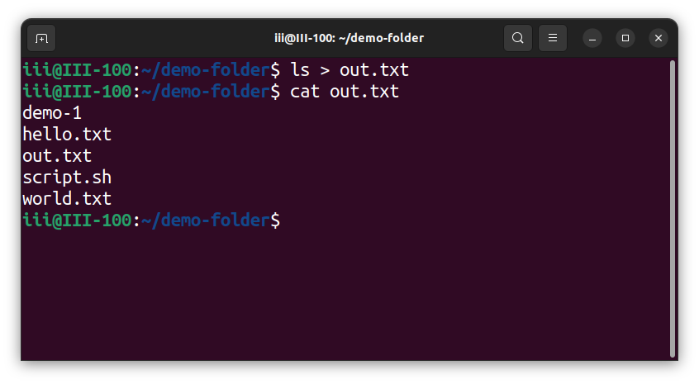

35. top
- Description: Displays real-time information about processes and system resource usage.
- Example: top

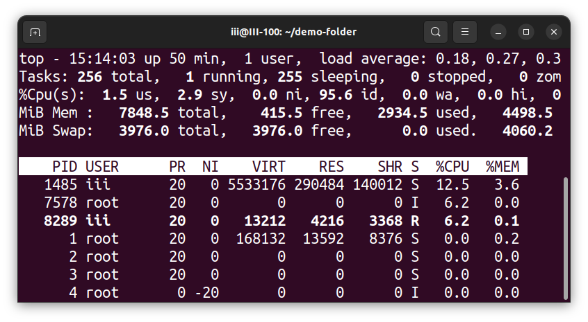

36. bg
- Description: Resumes a suspended job in the background.
- Example: bg
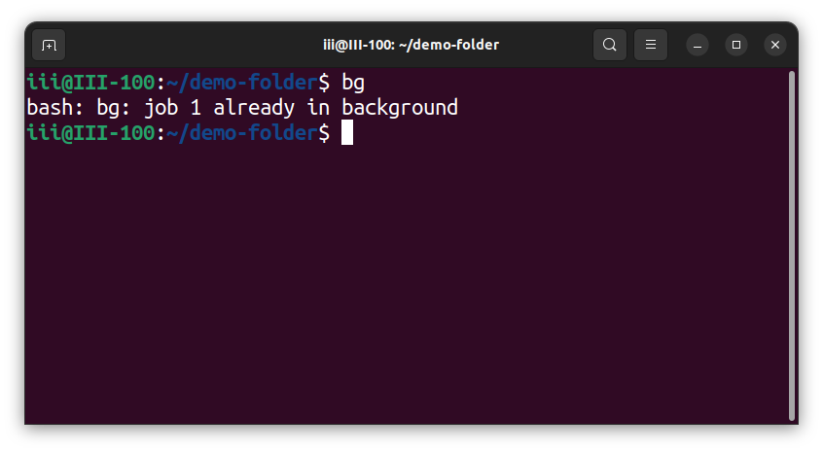

37. fg
- Description: Brings a background job to the foreground.
- Example: fg
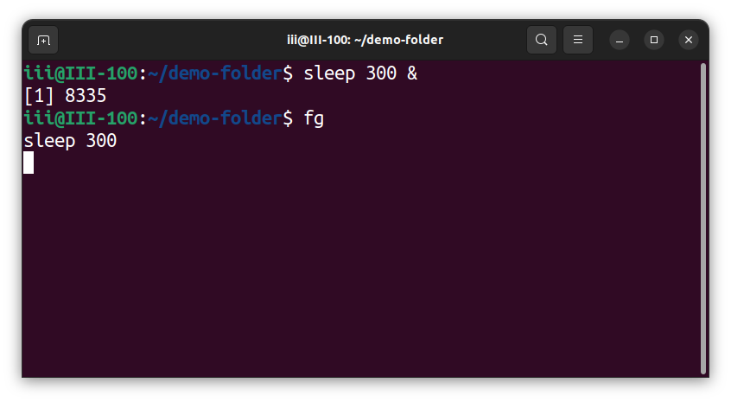

38. jobs
- Description: Lists active jobs managed by the current shell.
- Example: jobs
