RESUME
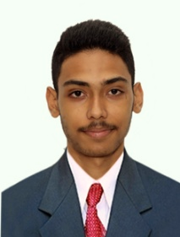

Name: PAVAN SURESH SHET
Email ID: pavanshet2007@gmail.com
Phone No.: +919480458520
Diploma in Computer Technology and IT Infrastructure

Career Objective:
I want to begin my career in Computer Hardware and learn more through practical work in networking and system maintenance and use my skills to help the organization grow.

Qualification | Institution | Branch | Year Of Passing | Percentage | Class
SSLC | Govt. Marikamba P.U. College | - | 2022-2023 | 58.24% | Second Class
Diploma | Nettur Technical Training Foundation- Dharwad | Computer Technology and IT Infrastructure | 2023-2026 | SGPA  (9.01)  CGPA  (8.13) | Distinction
Education:

Academic Performance at NTTF:

1st Sem SGPA | 2nd Sem SGPA | 3rd Sem SGPA | 4th Sem SGPA | 5th Sem SGPA | 6th Sem SGPA | CGPA  (Overall CGPA till 4th Sem)
7.90 | 7.69 | 7.92 | 9.01 | - | - | 8.13

Technical skills:
- PC assembling & Maintenance
- Computer networking
- IoT (Internet of Things)

Achievements:
- Actively participated and Won 3rd place in ROBORANA 1.0.

Certifications:
- Get Connected (Cisco)
- Computer Hardware Basics (Cisco)
- Exploring Computers (Infosys)
- Computer Assembling & Troubleshooting (Infosys)

Personal Details:
Father Name: Suresh Shet
Mother Name: Gayatri Kamat
Date Of Birth: 11th Jun 2007
Address: 425/A1/A2 Mahalasa Krupa, Golgeri Oni, Banavasi road Sirsi, Back side of Dhanvantari hospital-581401
Languages: English, Kannada, Hindi, Konkani.
Hobbies: Outdoor games, video games and watching movies.
Nationality: INDIAN

Declaration:
All this information is true to the best of my knowledge.
Place: Dharwad Pavan Suresh Shet
Date: (Signature)

